Data rip

Unicode vs ASCII when it comes to strings/char arrays will be important:

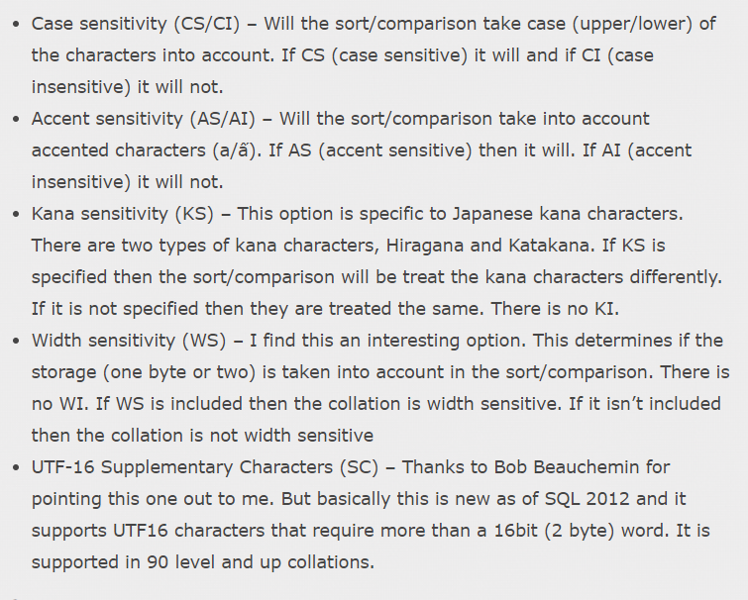- 1 byte (ASCII) vs 2 byte(Unicode)(NVARCHAR) per character

ALWAYS FILL IN DATABASE THAT ARE INDEPENDENT OF OTHERS FIRST