Module:

1. Linear data structures
2. Streams and files
3. Custom data structures
4. Building hierarchies
5. Exceptions
6. Principles and practices for software quality checks
7. Testing

C# Advanced

* Linear data structures
  + Stacks, queues, multidimentional arrays
* Streams and files
* Custom data structures
  + List, Stacks, LinkedList
* Algorithms
  + Recursion, Sorting, Searching

Practical exam:

* 3 problems for 4 hours
* First two problems:
  + stacks and queues, Mult dimentional arrays, Dictionaries
* Last problem: Defining classes

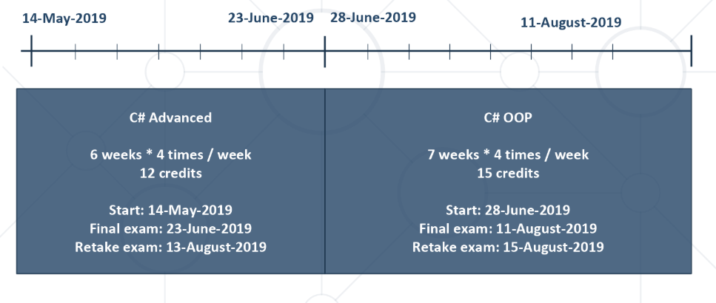

Scoring system:

* Final exam – 95%
* Homework – 5%
* Presence – 5% bonus