Desktop application:

Windows universal -> Blank App (works for windows store)

Software written in C#:

* Mobile – Xamarin
* Desktop – UWP, WinForms, WPF
* Games – Unity,
* Console, IoT, ML.NET – Machine learning
* 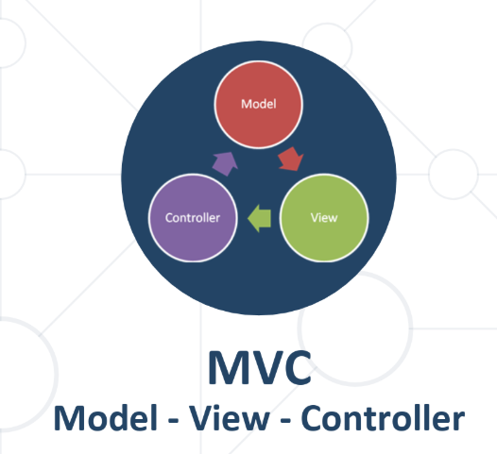Web – WCF, ASP.NET MVC,

MVC

* An architectural pattern
* User is between view and controller

ASP.NET Core be best

For linux:

* qt – c++
* xamarinn
* wait for new .net core

Web 🡪 ASP.NET Core 🡪 Web Application(Model-View-Controller)

For your own console peer to peer chat program: system.net.sockets(udp); tcp client C#;