Scope: where you can access a variable (global, local) <depends on the braketrs>

Lifetime: how long a variable stays in memory

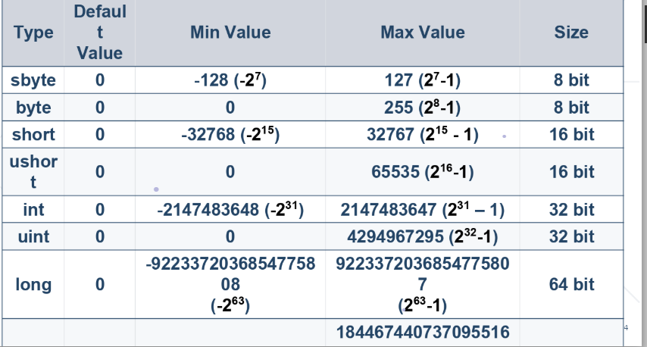

BigInteger – unlimited capacity b0i

0x – indicates hexadecimal values; you can use it as

Int value = 0xFE; A-10, F-15

Decimal – a data type that never goes wrong when it’s being calculated;

Int – 1999/1000 = 1 (the remainder is thrown away) however (1999<as int> / 1000D) will net you a **f**loat or **D**ouble

Do not use float a = 0.33f because the later digits may come out as 0.330000001237878

Floats don’t work the way you intend them always

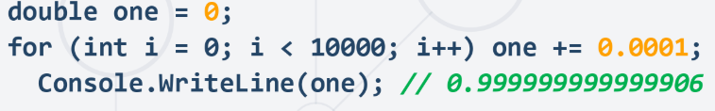

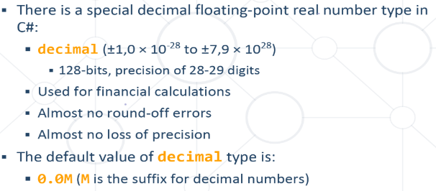Hence **decimals** fix that

Decimal a =0;

a+= 0.01M;

