Example Book

Example Author email@example.com

2024-10-25

# Copyright

A copyright is literally the right to copy a work. With copyright protection, a work is removed from public domain and can only be copied if the owner gives permission, giving owners of a body of work the ability to decide how and when others may use it.

# Authors

A little about page for the authors of the book.

Book dedications are about expressing gratitude. Authors often include a dedication to acknowledge the person or people who inspired the book or to thank someone who supported them during the writing process. Some authors dedicate a book to the memory of a loved one or to a cause or idea.

# Foreword

A foreword is a piece of writing, sometimes placed at the beginning of a book or other piece of literature. Typically written by someone other than the primary author of the work, it often tells of some interaction between the writer of the foreword and the book’s primary author or the story the book tells.

# Preface

A preface or proem is an introduction to a book or other literary work written by the work’s author. An introductory essay written by a different person is a foreword and precedes an author’s preface. The preface often closes with acknowledgments of those who assisted in the literary work.

# Abstract

An abstract is a crisp, short, powerful, and self-contained summary of a research manuscript used to help the reader swiftly determine the paper’s purpose. Although the abstract is the first paragraph of the manuscript it should be written last when all the other sections have been addressed.

# Example Chapter

Example Chapter



**Example Code**

require 'sinatra'   
  
get '/hi' do   
 "Hello World!"  
end

* Library import
* URL mapping
* Response block

-module(hello_world).  
-compile(export_all).  
  
hello() ->  
 io:format("hello world~n").

* A callout behind a custom line comment prefix.

Example Note

Example Warning

Example Important

Example Caution

Example Tip

## Title H1

Referencia a (X, 2005)

### SubTitle H2

Footnote[1].

#### H3

* comment Comment Icon
* file File Icon

Water () is a critical component.

DBML

Vega-Lite

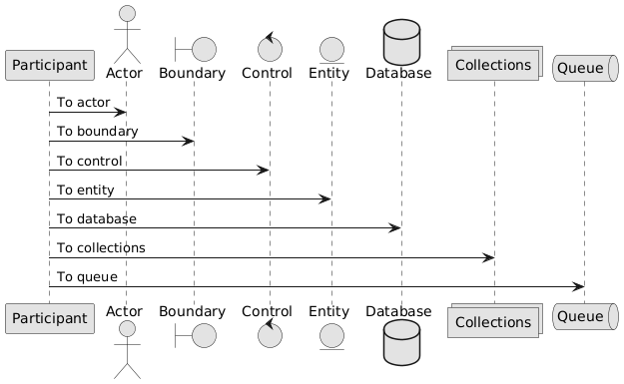

PlantUML

**C4**

Check <https://github.com/plantuml-stdlib/C4-PlantUML>

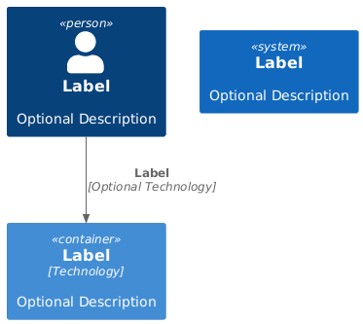

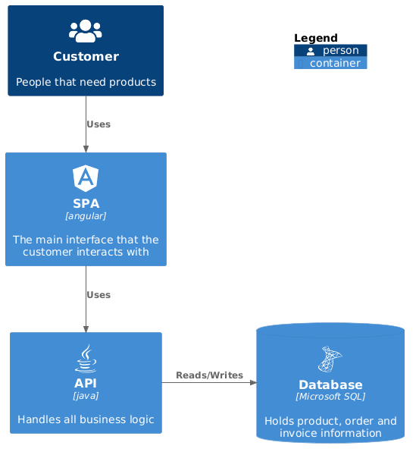

# Example Appendix

This is an Example Appendix

# Glossary

A glossary, also known as a vocabulary or clavis, is an alphabetical list of terms in a particular domain of knowledge with the definitions for those terms. Traditionally, a glossary appears at the end of a book and includes terms within that book that are either newly introduced, uncommon, or specialized.

class

In object-oriented programming, a class is a template definition of the methods and variables in a particular kind of object.

# References

A bibliography is a list of works on a subject or by an author that were used or consulted to write a research paper, book or article. It can also be referred to as a list of works cited. It is usually found at the end of a book, article or research paper.

It is recommended to follow **APA 6th or 7th Edition**.

Remember, you have to cite every piece of information that came from another source, whether or not it is in your own words. Everything cited in the text must appear in the reference list (except personal communication), and everything in your reference list must be something you have referred to in text. Make sure you don’t have anything in one place that isn’t in the other.

For APA the reference list is arranged in alphabetical order of authors' surnames. Arrange by first author’s name, then by second author if you have the same first author, etc.

If a reference has no author, list it alphabetically according to the title. Ignore the words 'A', 'An' and 'The' at the beginning of a corporate author or title for deciding where it fits alphabetically.

If there are two references by the same author, list them in order of publication date with the older one first.

For example:

X, M. (2005). *Something Great*.

# Afterword

An afterword is a literary device that is often found at the end of a piece of literature. It generally covers the story of how the book came into being, or of how the idea for the book was developed.

In publishing, a colophon is a brief statement containing information about the publication of a book such as an "imprint". A colophon may include the device of a printer or publisher.

1. Footnote