# Chapter 3: Design

## 3.1 Introduction

The phase design is the process of converting user’s needs into a suitable form, which helps the programmer in coding and implementation of software development. In the design phase, many critical and strategic decisions are made to achieve the desired functionality and quality that the Book reading system required. These decisions are taken into account to successfully develop the software and carry out its maintenance in a way that the quality of the end product is improved. The types of software design are:

1. Structural design
2. Behavioral design
3. Database design
4. Architecture design
5. UI design

## 3.2 Structural design

Structural design is the methodical investigation of the stability, strength and rigidity of structures. The basic objective in structural analysis and design is to produce a structure ;

The reason to use structural design is that:

1. It describes the architecture of the system.
2. Shows the interrelated components of the system.

### Class diagram

The class diagram is one of the UML (Unified modeling language) static diagram which describes the static structure of the diagram by showing classes, attributes, operations and relationship between the classes/ objects.

The purpose of using class diagram are:

1. It shows the static structure of the system.
2. It has its own simple notation which are simple and easy to use.
3. Helpful for developers to understand the system easily.

Notation that are used in the Class diagram are:

Class notation

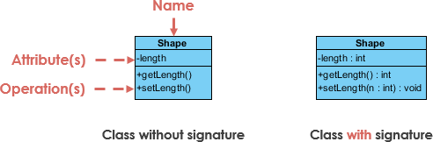

In the above figure the Shape is the name of a class, whereas length is the attributes and getLength () and setLength () are the operation or the function of the shape class. This is how the class is created.

Class relationship notation

1. Inheritance or generalization

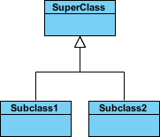

A solid line with a hollow arrowhead is stretched from the child class to the parent class which denotes that the SuperClass can use attributes, operations from the Subclass1 and Subclass2.

1. Simple association



A solid line connection class1 and class2 is know as simple association which means they are connected to each other’s.

1. Aggregation



The aggregation is denoted by a solid line with an unfilled diamond at the association end connected to the class of the composite. The relationship implies that the child class and exits independently of the parents. Example the class2 can still exits if class1 is deleted.

1. Composition



The Composition is denoted by a solid line filled diamond at the association connected to the class of composite. The relationship implies where the child cannot exist independent of the parents. Example if Class1 is deleted then class2 will not have any value so it cannot operate without class1.

1. Dependency



The Dependency is denoted by a dashed line with an open arrow which exists between two classes if changes to the definition of one may cause changes to the other but not the other way around. Example class1 can change it operation and that operation can be used by class2 but if class2 changes than if won’t be implemented in class1.

Class diagram of Book reading software:

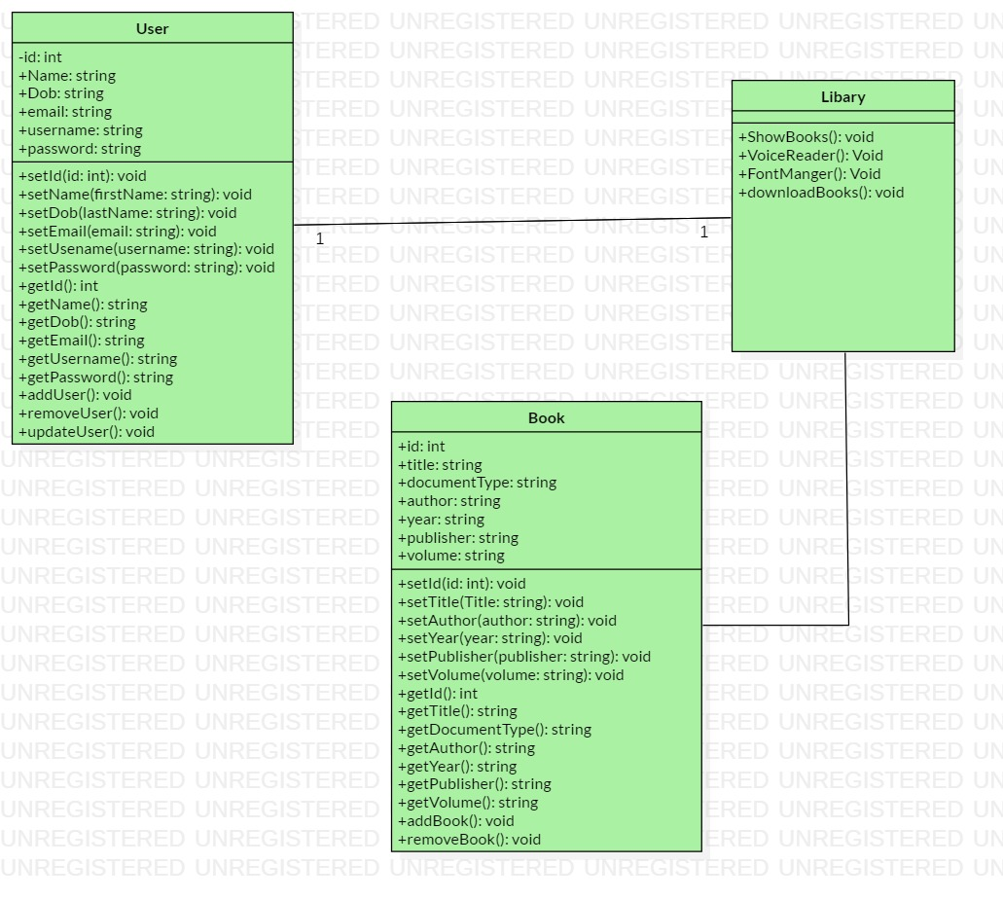

### Data flow diagram

The way of representing the flow of data of a process or a system is known as data flow diagram. The data flow diagram describes the process that are involved in a system to transfer data from input to the file storage and report generation. It uses defined symbols like rectangles, circles and arrows, plus short text labels, to show data inputs, outputs, storage points and the routes between each destination. (What is Data Flow Diagram?, n.d.)

The purpose of using DFD diagram are:

1. It represents the function which capture, manipulate, store and distribute data between system.
2. Simplicity of notation.
3. Determination of physical system construction requirement.

There are two types of data flow diagram notation one of them is called Yourdon and Coad and other one is called Gane and Sarson.

Notation used in data flow diagram are:

|  |  |  |
| --- | --- | --- |
| **Notation** | **Yourdon and Coad** | **Gane and Sarson** |
| External entity |  |  |
| Process |  |  |
| Data store |  |  |
| Data flow |  |  |

1. External entity: Outside system which sends and receives data, communicating with the system.
2. Process: The change of data producing an output is know as process.
3. Data store: Files and repositories that holds information for later use.
4. Data flow: The route that data takes between external entities, process and data store is know as data flow.

The data flow diagram of book reading system is shown below:

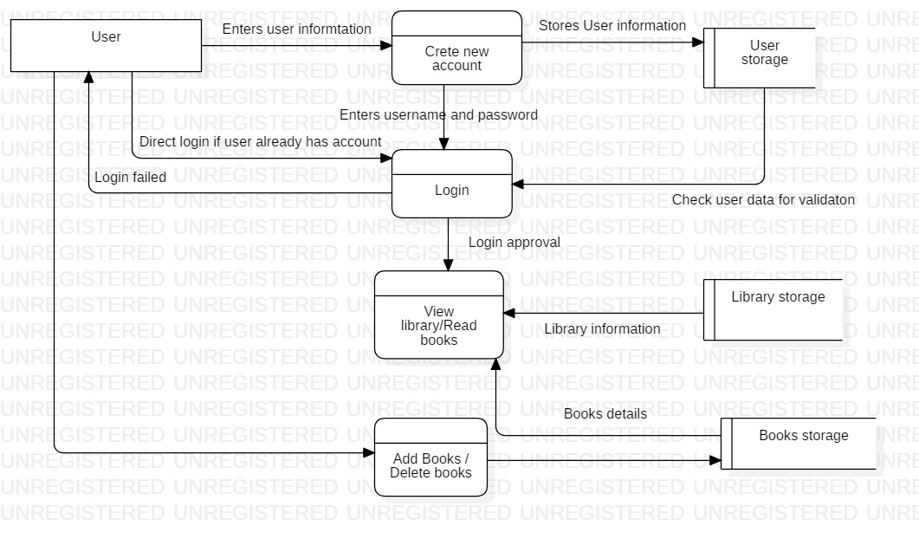

## 3.3 Behavioral design

Behavioral design shows the dynamic behavior of the system and its executing. So, to represent the behavioral of the book reading system I have shown Activity diagram, Sequence diagram.

### Activity diagram:

The activity diagram is one of the UML’s diagram which describes the dynamic aspect of the system. Activity diagram is also a type of flowchart which represent the flow of activity in the system. The Purpose of using activity is to capture the dynamic behavior of the system. It is not only use to visualizing the dynamic nature of the system, but also to use to construct the executable system by using engineering techniques. The activity diagram deal with all type of flow control by using different element like Control flow, Fork, join, Decision etc.

The purpose of using Activity diagram are:

1. To capture the dynamic behavior of the system.
2. To draw the activity of the system.
3. Describes the sequences from one activity to another activity.

Notation that are used in Activity diagram are:

|  |  |  |
| --- | --- | --- |
| **Symbol** | **Name** | **Description** |
|  | Start Symbol | This represent the start of the process or the workflow. |
|  | Activity symbol | Indicates the activities or the process. |
|  | Action flow symbol | Shows the direction flow or control flow. The pointer represents the flow. |
|  | Decision symbol | This symbol represents the branching or merging of various flows with the symbol acting as a frame or container. |
|  | Fork symbol | Splits a single activity into two concurrent activities or more. |
|  | Joint symbol | Combines two concurrent activities into one single activity. |
|  | End symbol | States the end of activity or completion of flow. |
|  | Note symbol | Allows the diagram creator to leave message or note. |

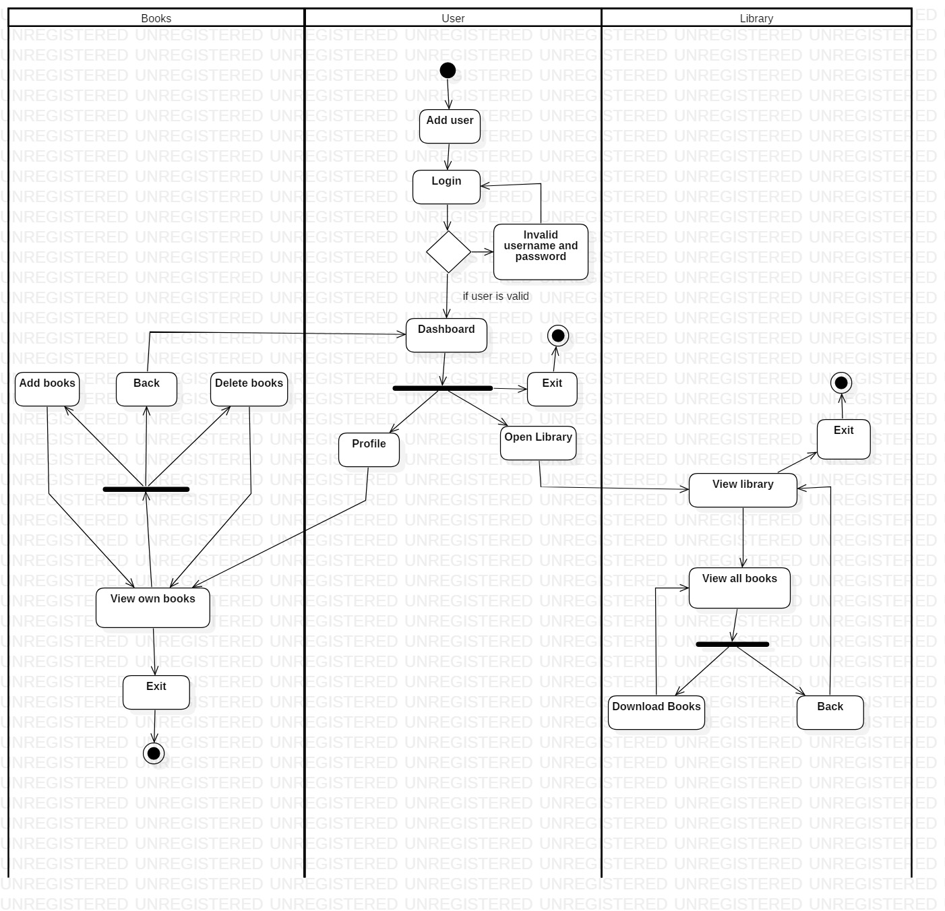

The above activity diagram is of Book reading system where there are there swim lanes. Where user firstly creates a new account after he creates it, he/ she login if the username and password is valid then the user proceed to dashboard, if not then back to Login. In the dashboard the user has two option he/she can read books directly by Open library or can go to he/she profile where the user can add book, delete there books etc. in the open library the user can other written books as well and can also download it for offline reading.

### Sequence diagram:

Sequence diagram is an UML diagram which shows how operation are carried out. It captures the interaction between object. Sequence diagram captures the interaction between user and system. The diagram is time focused and determines the time used by a function.

The purpose of using sequence diagram are:

1. The interaction between user and system is high level.
2. Help to discover architectural, interface and logical problem early.
3. Interaction between object within a collaboration that realizes an operation.

Notation that are used in sequence diagram are given below:

|  |  |  |
| --- | --- | --- |
| **Symbol** | **Name** | **Description** |
|  | Actor symbol | Shows entities that interact with each other. |
|  | Life line symbol | Represent the passage of time. The longer the line the more the time. |
|  | Object symbol | Represent a class or object. |
|  | Activation box | Represents the time needed to complete the task. |
|  | Package symbol | It can be used for labeling the diagram or can contain interactive element of the diagram. |
|  | Option loop symbol | It is used to model if or then scenarios. |
|  | Alternative symbol | It is used for if else scenarios. |
|  | Asynchronous message | Used to send message and continues to next step. |
|  | Synchronous message | Used to send message and wait for the reply. |
|  | Synchronous return message | It is used to send replay message or return message. |
|  | Lost and found message | A lost message contains a dot at the end of the arrowhead to indicate the destination is unknown. A dot at the source of the message indicates a found message with an unknown sender. |

The sequence diagram of book reading system are given below:

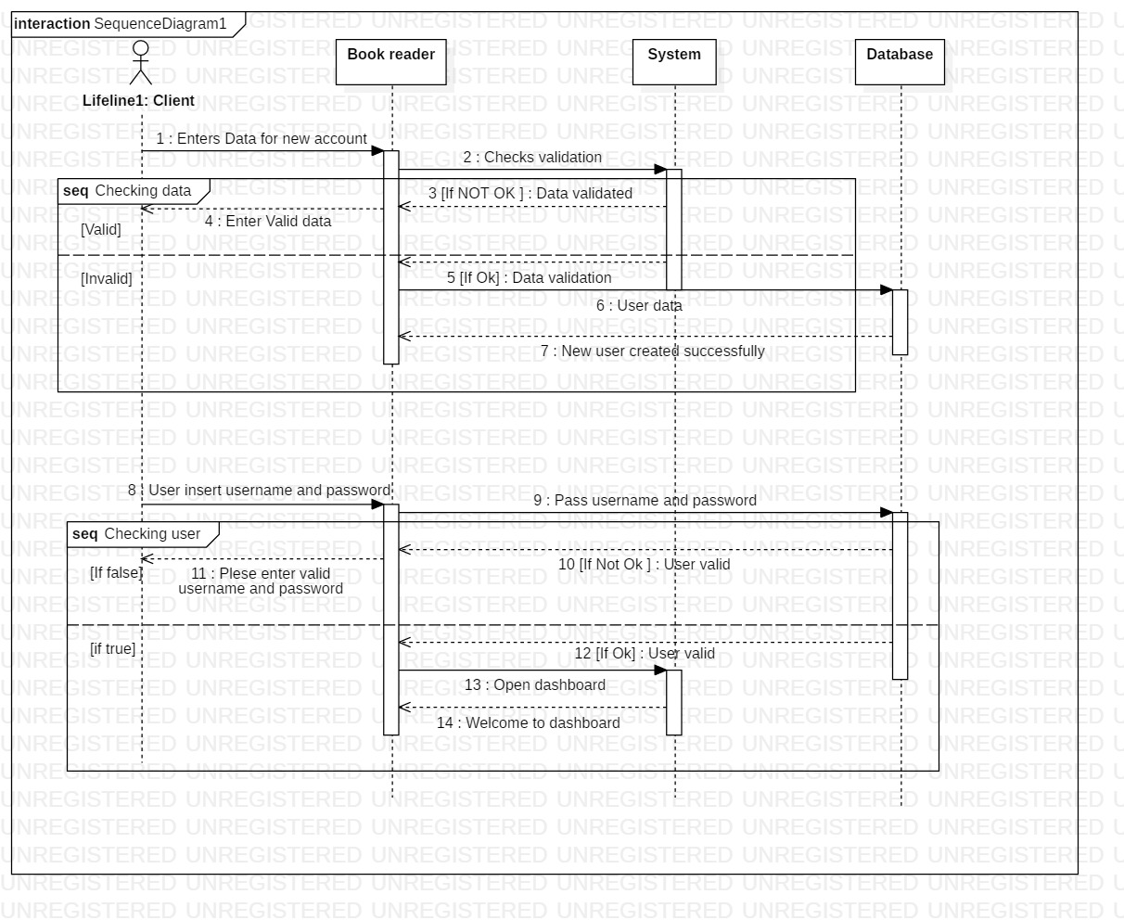As we can see in the figure, Firstly the user creates enters his/her information to create a new account then the data goes to validation if the data is Ok then it goes to the data base and entry is made where if the data was not ok or valid then a message is send to the user saying please enter valid data. After the user has created the account, they can login. In the login process if the username and password is valid then the user goes to dashboard if not then the user gets an message saying the username and password is invalid.

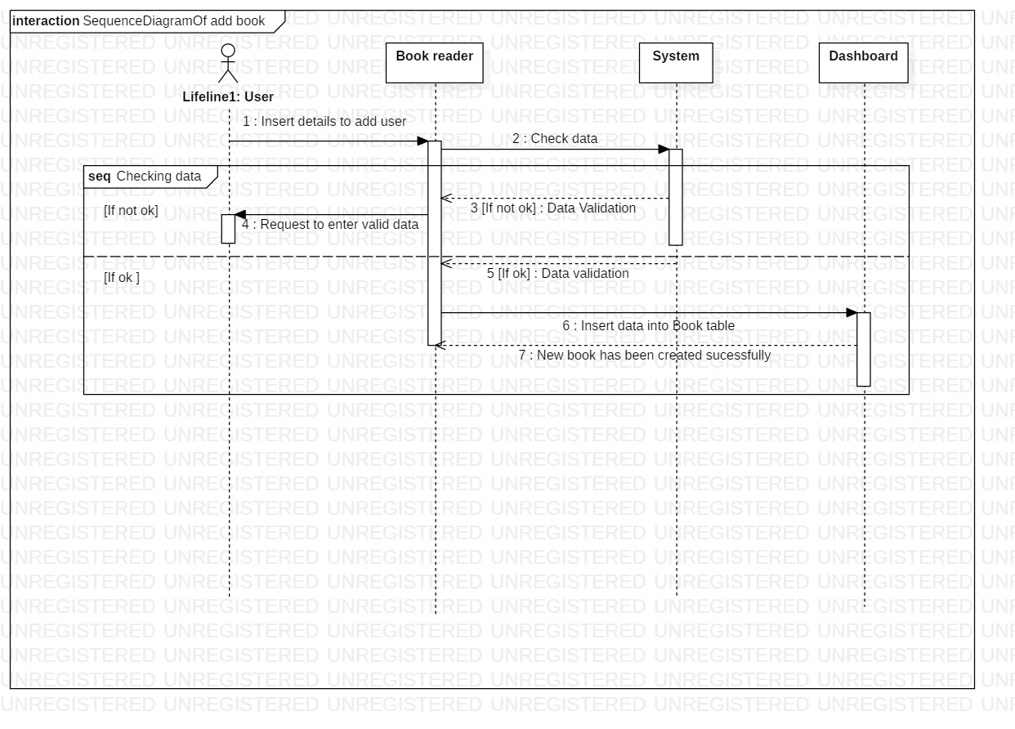

While the user has logged in the user can add book to their profile. In the figure user insert data that are needed to add book then the action is taken place the data goes to the system to check the data is valid or not it the data is not valid then user gets a message to reinter valid data. If the data is valid then the data does to the database and the book will be added.

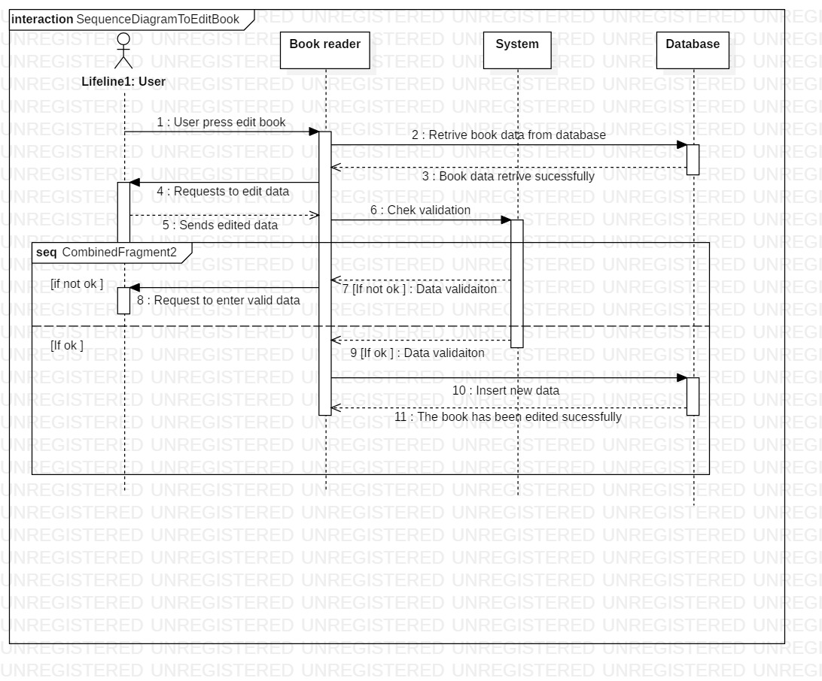

If the user wants to edit the book that are already added then the process is shown in the above diagram. The data is retrieved form the database and shown the book reader where the user can change the data. After the data is changed by the user it goes to the system to check if the data is valid or not. If the data is valid then it goes to the database and the book will be edited successfully. if the data was invalid then the user is requested to enter valid data.

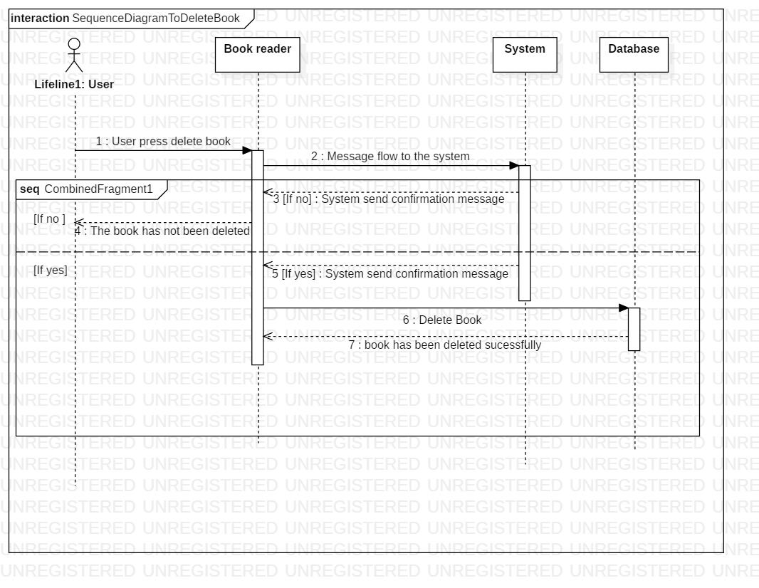

To delete a book user press, delete where the command goes to the system and the system send a message to the user to confirm the delete. If the user says yes then the message is sent to the database to delete the book. If the user says no then a message is sent saying the book is not deleted.

## Database design

The database design helps us to provide logical structure of the system and how data are stored, organized and manipulated. In the database design I will explaining two diagrams for the book reading system and they are:

### Entity relationship diagram:

The Entity relationship diagram is a type of flowchart shows how the entities are interrelated or connected to each other. It also helps us to view all the data that are stored in the certain table or individual table of the database.

The purpose of using ER-Diagram are:

1. ER provides a visual starting point of database design.
2. Helps us to determine information system requirement.
3. A conceptual data model, which lacks specific detail but provides an overview of the scope of the project and how data sets relate to one another.

There are many types of ER -diagram and they use different notation and they have their own style. The notation I have used to create the ER- diagram for the book reading system is Crow’s foot because it is simple and easy to understand.

The notation of Crow’s foot:

|  |  |
| --- | --- |
| Symbol | Name |
|  | Entity symbol |
|  | Attribute symbol |
|  | Zero to many relation |
|  | One or many relation |
|  | Zero to one realtion |
|  | One to one |

ER diagram of book reading system using Crow’s Foot notation.

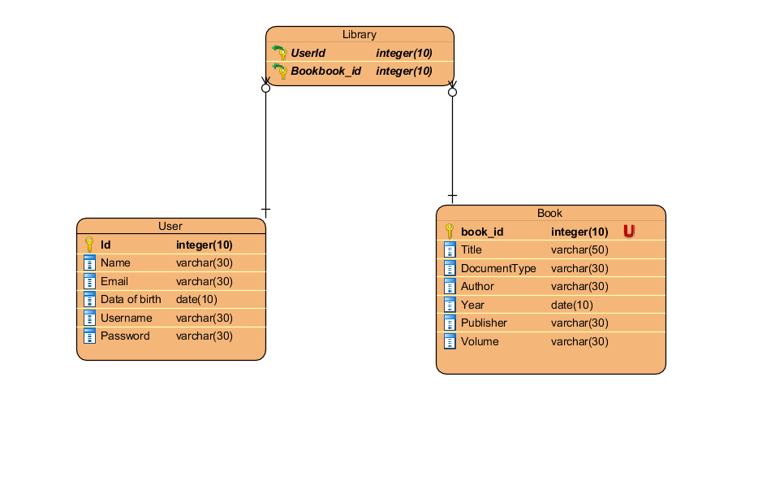As u can see in the above figure there are three tables (User, Book and library) where user the table keeps the records of details like name, email, dob, username, password) etc. where as book keeps the records of books that are going to be added etc. since the book and the user have many to many relationship between them so an associative table is developed which is named Library.

### Data dictionary

Data dictionary is a description of data or items of data which helps the programmer in need. The data dictionary also falls in the database design because it gives brief explanation of the data that are used and what are their roles. The data dictionary diagram of the book reading system is shown below:

|  |  |  |  |  |  |  |
| --- | --- | --- | --- | --- | --- | --- |
| Entity name | Column name | Data type | Length | PK/FK | Nullable | Unique |
| User | Id | Int | 10 | PK | False | True |
| Name | Varchar | 30 |  | False | False |
| Email | Varchar | 30 |  | False | True |
| Date of birth | Date | 10 |  | False | False |
| Username | Varchar | 30 |  | False | True |
| Password | Varchar | 30 |  | False | False |
| Book | Book_id | Int | 10 | PK | False | True |
| Title | Varchar | 50 |  | False | False |
| Document type | Varchar | 30 |  | False | False |
| Author | Varchar | 30 |  | False | False |
| Year | Date | 10 |  | False | False |
| Publisher | Varchar | 30 |  | False | False |
| Volume | Varchar | 30 |  | False | False |
| Library | Userid | Int | 10 | FK | True | False |
| Bookid | Int | 10 | FK | True | False |

## Architecture

Architecture describes the system major components, relationships and how they interact with each other’s. The software architecture also serves as blueprint of the system. The book reading system consists of three tires of architecture (interface or user, logics or server and the database). The interface shows the user information that helps to interact with the system. The logics defines the process and defines the nature of the system. The database keeps stores, provide all the necessary information that are need for the user to use the book reading system. The concept of the three tires method is to manage the system properly so that the system can be changed and managed properly.

The Architecture of the book reading system is shown below:

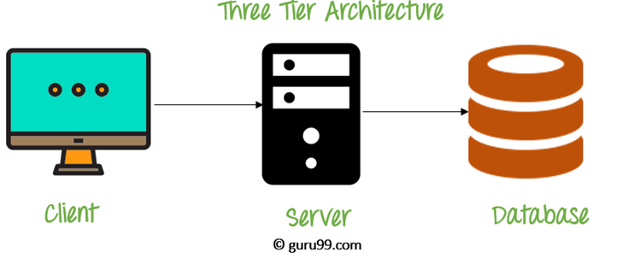

## User interface design

The design of machine and computer for better usability of the product to the user is know as user interface design. User interface design is to maximize the usability and user experience. The user interface design requires a good understanding of users needs or requirement.

In this phase I have created some digital prototype of book reading system with the help Balsamiq software which is good to create digital prototype. The prototype are shown below:

1. Login

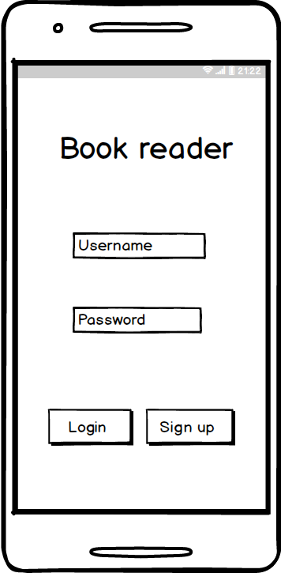

1. Signup

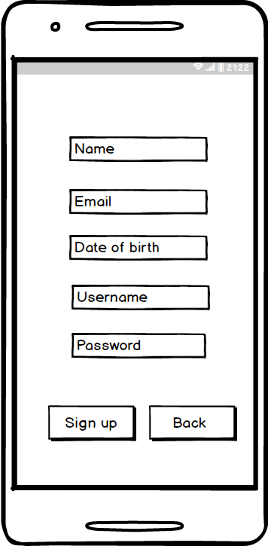

1. Dashboard

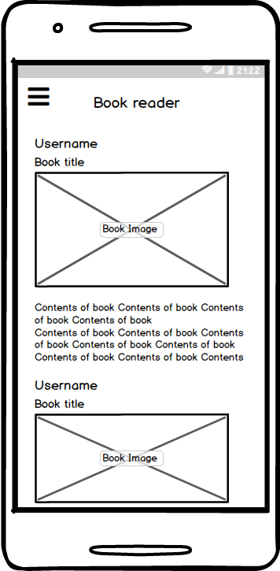

1. User profile

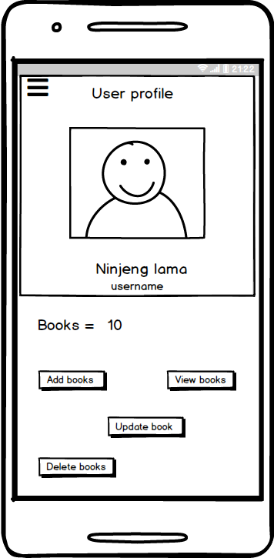

1. Add book

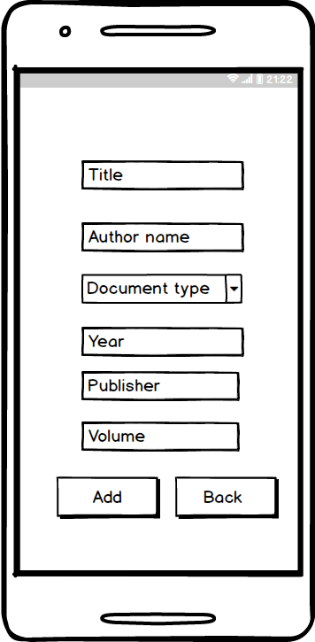

1. View book

