Nick Petty

Homework 1

This report details the creation and deployment of my website. The homepage is at <http://freeb60c4-freeapp.eu.webratio.net>, under the user account [npetty2014@fau.edu](mailto:npetty2014@fau.edu) using the password 2016WebRatio.

# Development

The database uses the structure in the image below. The entities Comment, Class, Profile, and Contact were added to the previously included entities User, Group, and Module. The Comment entity stores comments left by site visitors, the Class entity stores information about classes I’ve taken, the Profile entity stores the information in my profile, and the Contact entity store my contact information.

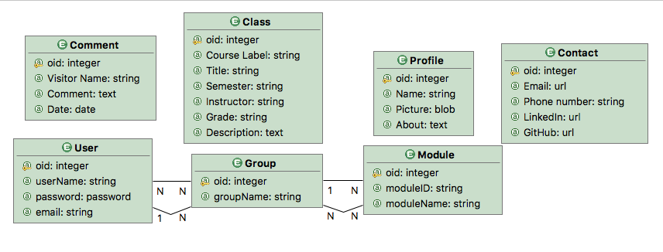

The website’s pages and flows are shown in the image below. Users land on the Welcome page, which displays my profile information. Because of my limited skill with WebRatio, I was not able to implement an administrator system, so forms for adding profile, contact, and class information are in the Form Entry page, linked to from the home page. The Comments page allows users to leave comments about the site via a form. Although only the name and comment are user-input, I added a page element to also save the date when the comment was created. Comments can be searched by keyword, and the results are displayed on a new page which is made to look like a filtered list. The Course Work page uses a master-details list to show the title and name of all the classes, with a Details button that shows the rest of the information about that class. Like the Comments page, this page is also searchable by keyword and displays results in the same manner. OK and KO flows are used whenever the database is updated in the event of an action failure.

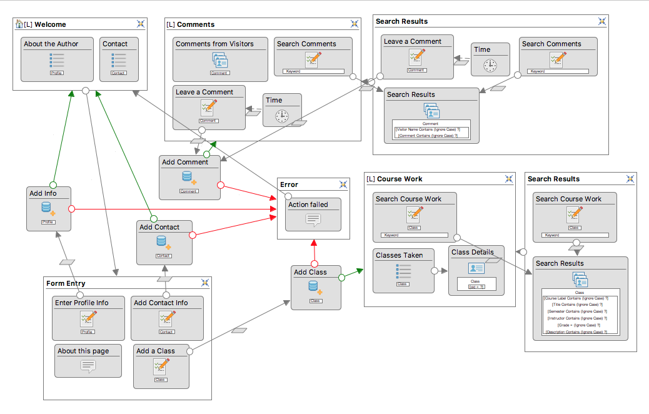

# Appearance

This is the Welcome page as a visitor sees it.

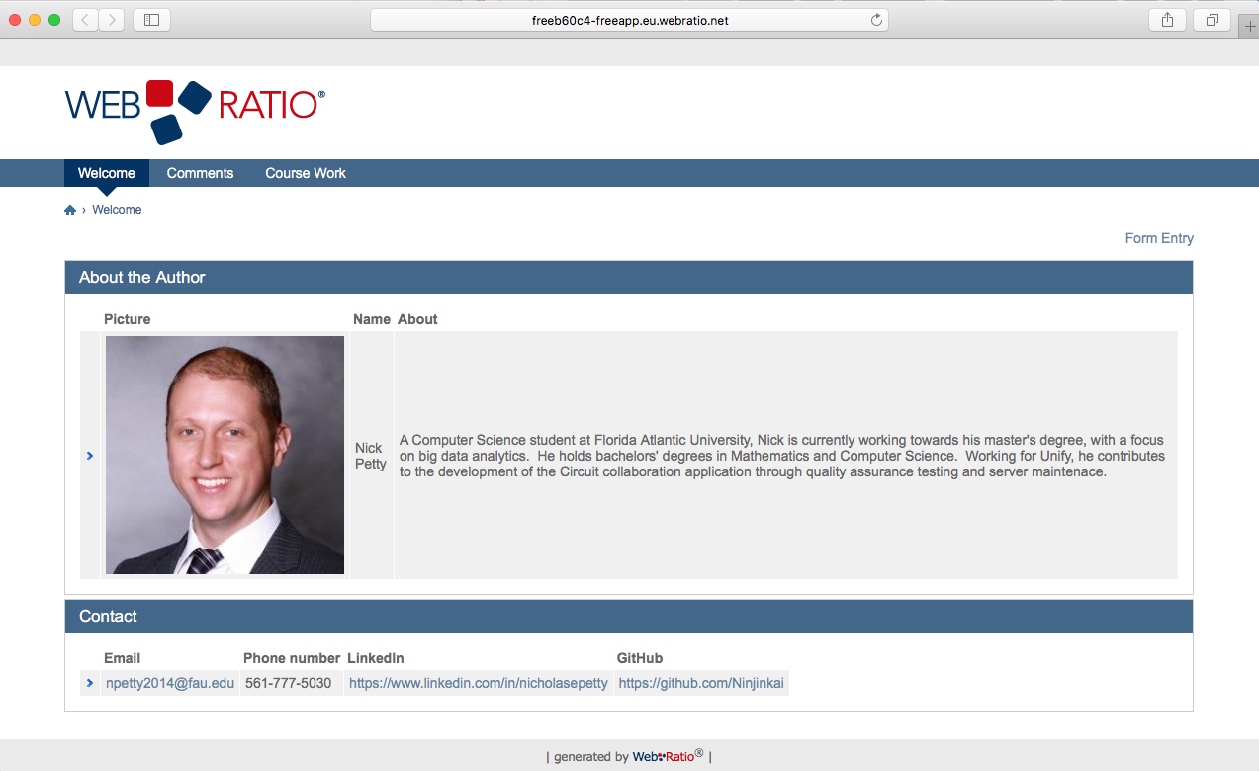

This is the Comments page.

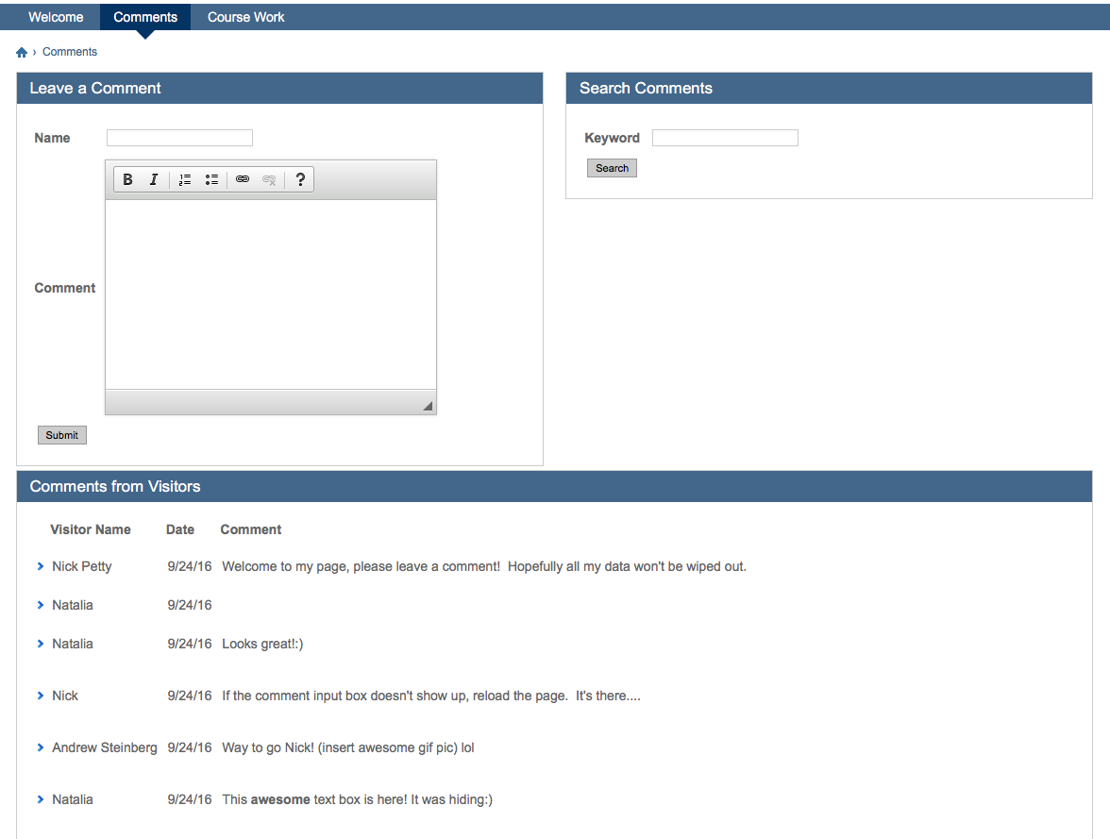

And this is the page after a search for the word “reload” has been made.

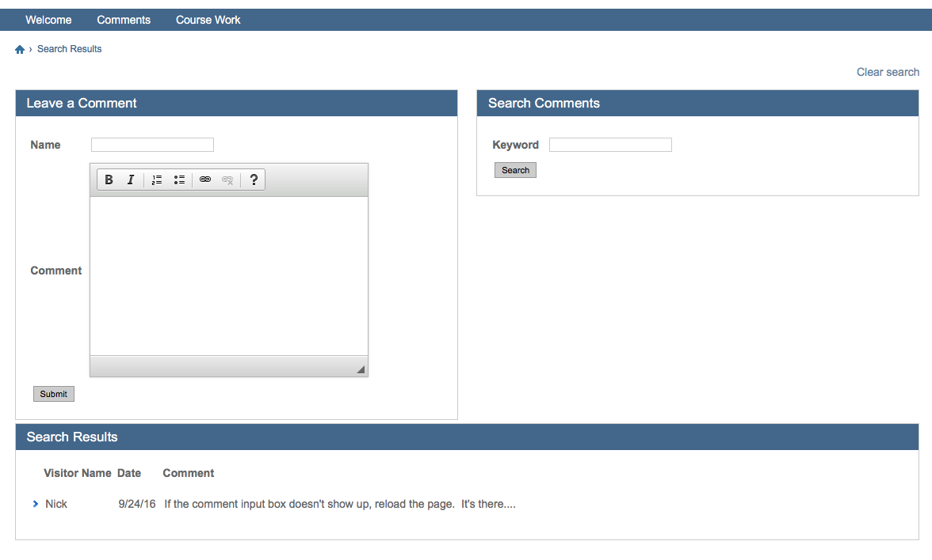

This is the Course Work page without details shown.

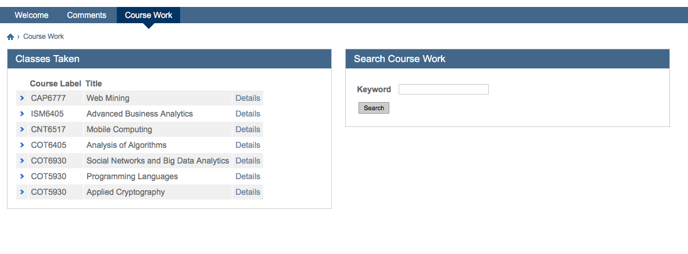

Here is the same page after showing the details for a class.

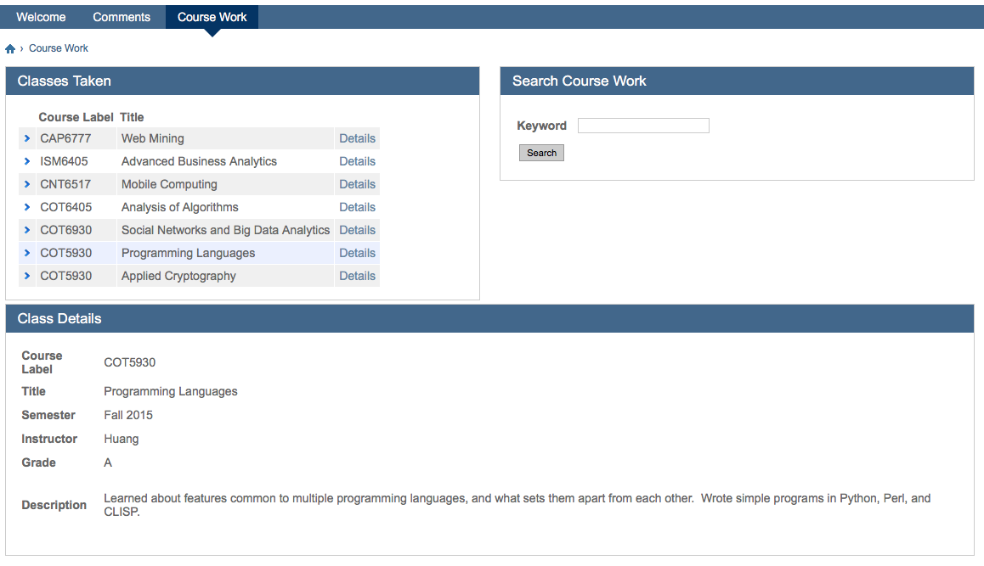

Here are the results of searching the Course Work page for the keyword “analytics.”

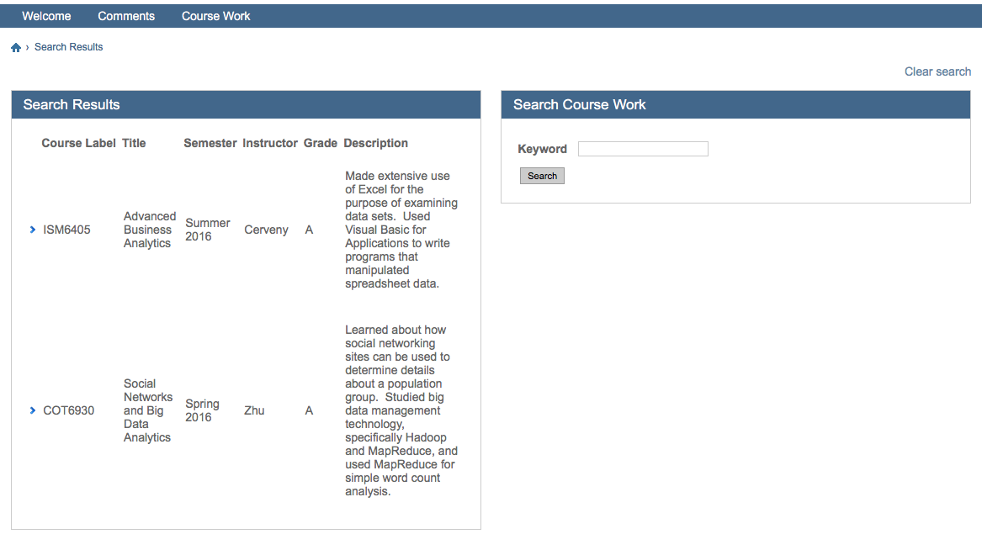

Finally, this is the Form Entry page that is used to add information to my user profile, contact information and course work.

