<Rendezvous> Project
Use-Case Model Survey with Individual use case specifications

Abstract
This document provides an overview of the solution context, scope and high-level functional capabilities for the <Project> project. It catalogs the actors that interact with the system and the use cases that together describe all the ways in which they interact with the system. It also documents the use-case diagrams that show the relationships that exist between the actors and the use cases.

Version History
Date | Version | Author | Description
14/07/2015 | <1.0> | Rendezvous Group | Log in function created to site


An Essential Unified Process Document
Table of Contents
1 Introduction 4
1.1 Document Purpose 4
1.2 Document Scope 4
1.3 Document Overview 4
2 Use-Case Diagrams 5
2.1 <Diagram Name> 5
3 Actor Catalog 5
4 Use-Case Catalog 6
5 Use case Specification x 7
5.1 Introduction 7
5.1.1 Document Purpose 7
5.1.2 Document Scope 7
5.1.3 Document Overview 7
5.2 Brief Description 9
5.3 Preconditions 9
5.4 Basic Flow 9
5.5 Alternative Flows 9
5.5.1 <Area of Functionality> 9
5.5.2 <Area of Functionality> 9
5.6 Post-Conditions 9
5.7 Special Requirements 10
5.8 Extensibility 10
5.9 Scenarios 10
5.10 Additional Information 10

Introduction

Document Purpose
The purpose of this document is to provide an overview of the system use-case model in order to provide a high-level understanding of:
- Context – A visitor, an existing user, web administrator, website system, web moderator
- Scope – a new user joins the service, an existing user creates an event, and an existing user joins an event

Document Scope
The scope of this document is limited to:
- Diagramming and cataloging the system actors and use cases for the <Project> project.
The scope of this document does not include consideration of:
- Detailed specification of each use case – this is provided separately in a Use-Case Specification document for each use case.

Document Overview
This document contains the following sections:
- Brief Description – reminder of why the use case is needed
- Use-Case Model Overview – overview of the use-case model in the form of one or more use-case diagrams with supporting explanatory text
- Actor Catalog – catalog of all system actors
- Use Case Catalog – catalog of all system use-cases
- References – provides full reference details for all documents, white papers and books that are referenced by this document.

- Use-Case Diagrams
This section provides an overview of the use-case model in the form of one or more use-case diagrams with supporting explanatory text.

<Diagram Name>
<Figure 1-1 New User Joins the Service>
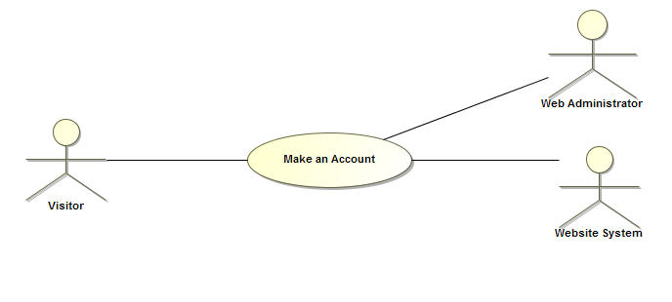

<Figure 1-2 Existing user joins an event>
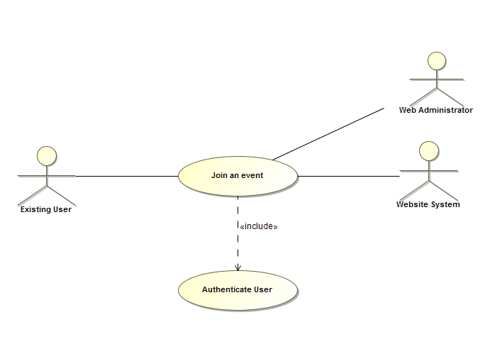
<Figure 1-3 Existing user creates an event>
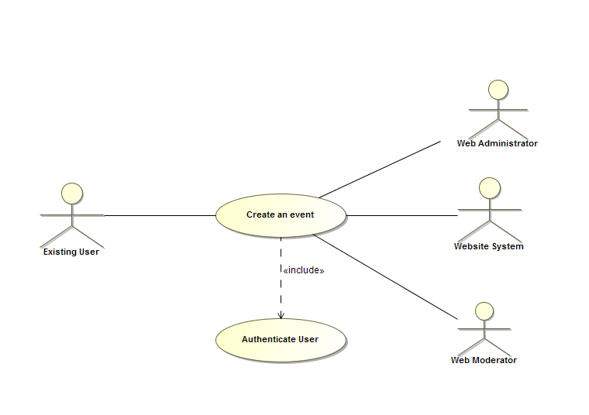

- Actor Catalog
The table below catalogs the system actors, specifying for each actor:
- Name – unique and meaningful name for the actor
- Brief Description – summarizing the role that the actor plays with respect to the system.
Name | Brief Description
Visitor | A guest to the website that currently has no account.
Existing User | Users with an account that can use all of the website’s functionality.
Web Administrator | Makes sure that the functionality of the website Is performing as desired.
Website System | Updates website’s database consistently as new users and existing users create and join events.
Web Moderator | Tasked with approving or disapproving created events
- Use-Case Catalog
The table below catalogs the system use cases, specifying for each use case:
- ID – unique identifier for the use case
- Name – unique and meaningful name for the use case
- Type:
  - Base – end-to end interaction between an actor and the system
  - Inclusion – abstracted common part of many Base Use Cases that is explicitly referenced by these use cases
  - Extension – extension of one or more referenced Base Use-Cases
  - Abstract – use case describing generic aspects of many Base Use Cases which in turn specialize this general case in some way.
- Brief Description – summarizes the use-case purpose in terms of the value produced for its actors and other stakeholders.
ID | Name | Type | Brief Description
0001 | New User | Base | Visitors can use a limited amount of the website’s functionality before being required to sign in
0002 | Join Event | Abstract | Existing Users can join created events.
0003 | Create Event | Abstract | Existing Users can create new events that can be joined by other users.

Use case Specification

5.1 Brief Description: Case 0001-New User
Visitors can use a limited amount of the website’s functionality before being required to sign in.

Preconditions
- Users must have a working internet connection.
- Website must be connected to system’s database.

Basic Flow
- Homepage
- Visitors have the option to create a new account if they desire.
- Visitors can also view existing events stored on the website system’s database.
- Viewing Events
- Visitors can view all existing events, but are unable to interact with them.
- If a visitor wishes to join or create an event, the system checks if they are logged in
- If not, system prompts sign up page to visitor.

Alternative Flows
- Website Maintenance Error
- If website is unable to load and is currently offline, system apologizes to visitors for inconvenience.
- Visitors have the option to contact Web administrators in order to resolve issue.

- Sign Up Error
- Visitor cannot create account due to empty fields during sign up. System will prompt user to fill in blank fields.
- Visitor cannot create account due to username not fitting character limitations or minimum requirements. System will prompt user to re-enter a new username.
- Visitor cannot create account due to username being taken. System will prompt user to re-enter a new username.
- Visitor cannot create account due to password length not satisfying constraints. System will prompt user to re-enter an appropriate password.
- Sign In Error
- Visitor is unable to sign in due to account not existing. System will prompt user to the sign up page.
- Visitor’s newly made account is not stored in system database properly. System will prompt user to sign up page, or to contact a web administrator for further assistance.
- Visitor is unable to sign in due to incorrect password, or username. System prompts user to re-enter credentials.

Post-Conditions
- After sign up, user is directed to home page.
- User now has access to full functionality of the website.
- User can view, create and join events throughout the website.

Extensibility
No public extension points defined.

Scenarios
A scenario is an instance or specific occurrence of a use case. This section lists key representative scenarios for this use-case, listing for each scenario:
- Name – a unique and meaningful name for the scenario
- Flows Exercised – List of the use case flows exercised by the scenario
- Additional Notes – any supporting notes about the scenario or its purpose.
Name | Flows Exercised | Additional Notes

Brief Description: Case 0002-Join Event
Existing users can join created events.

Preconditions
- Users must have a working internet connection.
- Website must be connected to system’s database.
- User must be logged in to an existing account.

Basic Flow
- Homepage
- System will allow users to log in while on the homepage.
- Viewing Events
- Existing users will have the same functionality as visitors; they will be able to view all current events for a specific activity.
- Joining Events
- Existing users will have the added functionality of being able to join an event.
- Once an event is joined, the system will continue to notify user of any changes or messages that are posted that are related to the specific event.

Alternative Flows
- Website Maintenance Error
- If website is unable to load and is currently offline, system apologizes to visitors for inconvenience.
- Visitors have the option to contact Web administrators in order to resolve issue.

- Sign In Error
- Visitor is unable to sign in due to account not existing. System will prompt user to the sign up page.
- Visitor’s newly made account is not stored in system database properly. System will prompt user to sign up page, or to contact a web administrator for further assistance.
- Visitor is unable to sign in due to incorrect password, or username. System prompts user to re-enter credentials.

- Event Error
- Events that have already occurred still display to the user under current events.
- Existing User is unable to join a current event. System will prompt user to notify web administrator or try again later.
- Existing user is not notified properly of changes to events they have already joined.

Post-Conditions
- User can now see the list of joined events.
- User will now be notified by system of any event status changes.

Extensibility
No public extension points defined.

Scenarios
A scenario is an instance or specific occurrence of a use case. This section lists key representative scenarios for this use-case, listing for each scenario:
- Name – a unique and meaningful name for the scenario
- Flows Exercised – List of the use case flows exercised by the scenario
- Additional Notes – any supporting notes about the scenario or its purpose.
Name | Flows Exercised | Additional Notes

Brief Description: Case 0003- Create Event
Existing users can create new events.

Preconditions
- Users must have a working internet connection.
- Website must be connected to system’s database.
- User must be logged in to an existing account.

Basic Flow
- Homepage
- System will allow users to log in while on the homepage.
- Creating events
- System will allow users to create new events for desired activities.
- These new events will automatically notify creators of any message or status changes.

Alternative Flows
- Website Maintenance Error
- If website is unable to load and is currently offline, system apologizes to visitors for inconvenience.
- Visitors have the option to contact Web administrators in order to resolve issue.

- Sign In Error
- Visitor is unable to sign in due to account not existing. System will prompt user to the sign up page.
- Visitor’s newly made account is not stored in system database properly. System will prompt user to sign up page, or to contact a web administrator for further assistance.
- Visitor is unable to sign in due to incorrect password, or username. System prompts user to re-enter credentials.

- Creation Error
- Existing User is not allowed to create events. System will prompt user to contact web administrator.
- User does not create an event due to empty fields during creation page. System will prompt user to fill in blank fields.
- Event is not stored in database properly.

Post-Conditions
- Users will able to see a list of their own created events.
- Users will be able to edit their event’s information regarding time and location.
- Users will be notified of any messages posted to their event, as well as any changes to the status of their event.
- Upon creation, users will be notified by Web Moderators if their event is inappropriate and violates website’s terms and conditions.

Extensibility
No public extension points defined.

Scenarios
A scenario is an instance or specific occurrence of a use case. This section lists key representative scenarios for this use-case, listing for each scenario:
- Name – a unique and meaningful name for the scenario
- Flows Exercised – List of the use case flows exercised by the scenario
- Additional Notes – any supporting notes about the scenario or its purpose.
Name | Flows Exercised | Additional Notes

Example of use case specification
This section provides any additional information required to make the use case more accessible to the stakeholders and the development team.
This template is an extended version of the original template defined by Cockburn [1], in particular extended with a possibility to describe Requested Information Resources often found useful when dealing with data oriented systems. [1] Cockburn, A. Writing Effective Use Cases. ISBN-13: 9780201702255. Addison-Wesley (2001).

Use Case Template | Description | Examples
Use Case Name | Name of the use case | Visualise proposed water height after the tsunami event
Use Case ID | Unique identifier of a use case
Revision and Reference | Revision = version number of use case ID  Reference = URL of the use case (you get the URL by right-clicking on the entry in the index column) | V02, http://SDI.server.de/servlet/is/4900/
Use Case Diagram | Description of the UML use case diagram for the actual use case. The diagram should include extend and include relationships if there is any.  The actual UML diagram figure may be added at the bottom of the template by uploading a bitmap generated from a UML editor.
Status | Status of the use case development | One of the following:  Planned  in progress
Priority of accomplishment (optional) | The priority of the use case to be considered when assessing its importance for a development cycle. | One of the following:  Must have: The system must implement this goal/ assumption to be accepted.  Should have: The system should implement this goal/ assumption: some deviation from the goal/assumption as stated may be acceptable.  Could have: The system should implement this goal/assumption, but may be accepted without it.
Goal | Short description (max. 100 characters) of the goal to be achieved by a realization of the use case. | System generates alerts based on user observations
Summary | Comprehensive textual description of the use case. | The user opens the browser which shows map-window with the water height after the tsunami event in the affected area
Category | Categorisation of use cases according to overall reference architecture. | Context dependent
Actor | List of users of the use case (actors) | Examples may be citizen, administrator or employee of a SDI agency
Primary Actor (initiates) | Actor that initiates the use case execution.
Stakeholder (optional) | Company, institution or interest group concerned by the execution of the use case
Requested Information Resources  (optional) | Information category or object that is required to execute the use case or is being generated during the course of the use case execution.  The requested information resource shall be listed together with its requested access mode (create, read, update or delete) or “manage” which encompasses all access modes. | user observation (read)  user-specific effect (read, update)  alert (manage)
Preconditions | Description of the system/user status statement) that is required to start the execution of the use case.  Note that use cases can be linked to each other via "preconditions“. This means, a precondition for a use case can be either an external event or another use case. In this case the use case ID should be provided in the field „preconditions“. | The user has opened the portal successfully.
Triggers  (optional) | (External) event that leads to the execution of the use case.  Note that use cases can be linked to each other via "triggers“. This means, a trigger for a use case can be either an external event or another use case. In this case the use case ID should be provided in the field "triggers“. | The user chooses water height forecast.
Main success scenario | Numbered sequence of actions (use case workflow) to be carried out during the execution of the use case. | 1. User chooses assessment report.  2. He specifies one or more components (default should be all).  3. He sets a time-frame (last 24 hours, last week, last month)  4. The system shows a report as graphical visualisation.
Extensions | Extension of an action of the main success scenario. The action to be extended shall be referred to by its number (e.g. 1) appended by a letter (e.g. 1a). | 1a. The user defines the temporal extent b. The user defines an unavailable temporal extent. A new dialogue window opens and requires a new temporal extent.
Alternative paths (optional) | Alternate path through the main success scenario w.r.t. an identified action. | 4a. User can select to view report in different formats, e.g. tabular or graphical map
Post conditions | Description of the system/user status (statement) that holds true after the successful execution of the use case. | Report is displayed on the screen.
Non-functional requirements | Description of non-functional requirements for this use case with respect to performance, security, quality of service or reliability. | Display of report expected after 20 seconds at the latest.
Validation statement | List of statements that indicate how to validate the successful realization of the use case.
Notes | Additional notes or comments (also by other users).
Author and date | Author of use case, date of last edition.

