User personas

Mark Hans (Primary persona)
33 | Vienna, Austria | History Teacher
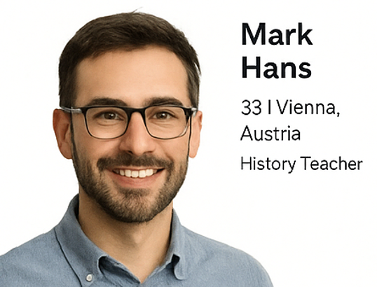
Bio: Mark is a passionate lover of history and culture. He has been working as a history teacher in Vienna for years, spending his free time traveling to destinations rich in cultural heritage. His goal is to explore Dalmatia in a way that goes beyond a typical tourist experience.
Goals:
- Find accommodation near cultural landmarks (Split, Dubrovnik, Šibenik).
- Experience local culture through museums, guides, and traditional events.
- Receive personalized recommendations connecting stays with cultural attractions.
Challenges: On traditional booking platforms, he struggles to find options that combine comfort with meaningful cultural experiences.

Stipe Horvat (Primary persona)
34 | Munich, Germany | Software Engineer

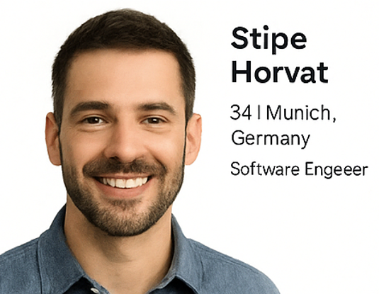
Bio: Stipe is a young professional who works hard and values every moment of relaxation. His idea of a perfect vacation is a mix of beaches, sunshine, and fun. He visits the Adriatic almost every year but wants a more intuitive way to find beachfront apartments.
Goals:
- Find seaside accommodation with great amenities and sea views.
- Explore activities such as diving, boat rides, and beach bars.
- Book quickly and easily without excessive filters or complexity.
Challenges: Existing platforms offer too many generic results without personalization.

Luka Beber (Primary persona)
58 | Zagreb, Croatia | Retired Teacher
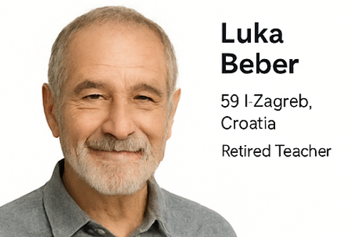
Bio: Luka now prefers peaceful types of holidays. He is no longer interested in crowds or noisy hotels, but in authentic destinations in the Dalmatian hinterland. Enjoying nature, local food, and silence helps him recharge.
Goals:
- Find accommodation in rural Dalmatian areas (Imotski, Drniš, Vrlika).
- Discover local farms and enjoy traditional homemade food.
- Experience nature and the authentic Dalmatian countryside.
Challenges: He struggles to find rural stays, as most platforms don’t highlight them enough.

Marija Novak (secondary persona)
26 | Šibenik, Croatia | Customer Support Agent
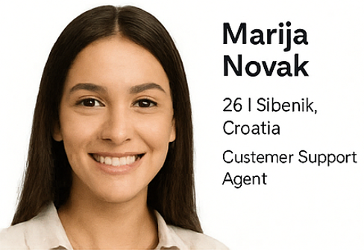
Bio: Marija works in customer support for the app, helping travelers resolve booking issues daily. She knows Dalmatia’s tourist offer well and helps match travelers with apartments that best fit their needs. She’s empathetic, patient, and enjoys helping people from different backgrounds.
Goals:
- Provide fast and friendly support to users.
- Make booking easier and assist in choosing accommodation.
- Collect user feedback to continuously improve the app.
Challenges: Understanding diverse user needs (culture vs. beach vs. peace) and overcoming language barriers.

