Comp E 475

Digital Systems

Homework 4

Student: Nino Nonikashvili

Red ID #: 822059388

13.10.2020

Contents

Task Description 2

Solution 2

Simulation & Verification 2

Comparison 3

Conclusion 3

# Task Description

*I had to:*

* + *Create a code which analises 32bits input and determines whether it is a data, memory or branch instruction. Then, if it happens to be data processing instruction it also determines whether it is immediate type, Register shifted by value" type, Register shifted by register" type or multiplication type. Also I had to use git source control.*

# Solution

* *As the task was very simple, I only had to create a logic which controls specific bits of the 32bits input(inst) and assigns results according to specific conditions to two outputs.I have also created a repository on github and connected my local files to that repository. Here is the code:*

*always @(inst)*

*begin*

*bits[0]=inst[26];*

*bits[1]=inst[27];*

*case(bits)*

*0: begin instype=1;*

*if(inst[25]==1)*

*datainstype=1;*

*else if(inst[4]==0&&inst[25]==0)*

*datainstype=2;*

*else if(inst[7]==0&&inst[4]==1&&inst[25]==0)*

*datainstype=3;*

*else if(inst[24]==0&&inst[6]==0&&inst[5]==0&&inst[7]==1&&inst[4]==1&&inst[25]==0)*

*datainstype=4;*

*else*

*datainstype=0;*

*end*

*1: instype=2;*

*2: instype=3;*

*3: instype=0;*

*endcase*

*end*

# Simulation & Verification

* *Simulations of the first code*

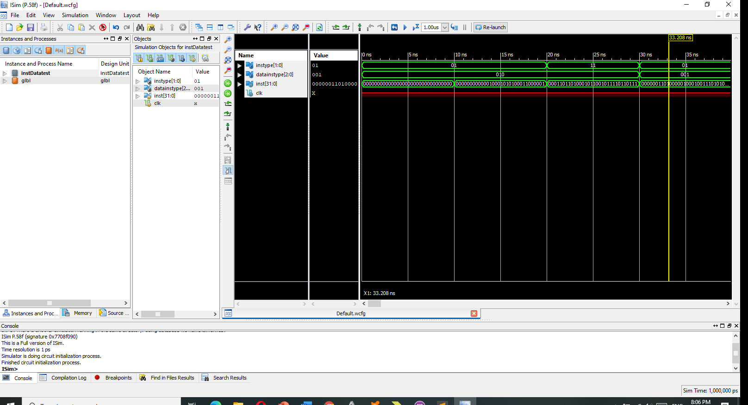

* *Here is the link to my github repository:*

[*https://github.com/NinoNonikashvili/DL475-instructions.git*](https://github.com/NinoNonikashvili/DL475-instructions.git)

# Conclusion

* *The most important part of this homework was to get us familiar with git. I had a good practice of using github.*