

**BidSpirit**

**Supervisor:** *NGUYỄN HẠ VY*

**Semester:** *01*

**Batch No:** T1.2210.A1

**Group No:** *06*

|  |  |  |
| --- | --- | --- |
| **Order:** | **Full name** | **Roll No.** |
| *1.* | *Lê Đức Ngọc Quang* | Student1424182 |
| *2.* | |  | | --- | | *Lê Tiến Phát* | |  | | Student1424170 |
| *3.* | |  | | --- | | *Nguyễn Đăng Khiêm* | |  | | Student1424296 |
| *4.* | |  | | --- | | *Nguyễn Thành Nghĩa* | |  | | Student1424173 |
| *5.* | *Trần Thị Khánh Vân* | Student1427806 |

***Month****:2* ***Year****: 2023*



This is to certify that

**Mr. LÊ ĐỨC NGỌC QUANG Mr. LÊ TIẾN PHÁT Mr. NGUYỄN ĐĂNG KHIÊM**

**Mr. NGUYỀN THÀNH NGHĨA**

**Mrs. TRẦN THỊ KHÁNH VÂN**

Have successfully Designed & Developed

# BidSpirit

Submitted by:

**Ms. NGUYEN HA VY**

Date Of Issue:

Authorized Signature:

# Content

Content Acknowledge Synopsis

Review 1

Review 2

Review 3 ..

Tasksheet ..

# Acknowledge

As we understand that the eProject is a step-by-step learning environment that closely simulates the classroom and Lab-based learning environment into actual implementation. It is a project implementation at your fingertips!! An electronic, live juncture on the machine that allows you to.

* Practice step by step i.e. laddered approach.
* Build a larger more robust application.
* Usage of certain utilities in applications designed by user.
* Single program to unified code leading to a complete application.
* Learn implementation of concepts in a phased manner.
* Enhance skills and add value.
* Work on real-life projects.
* Give a real-life scenario and help to create applications that are more complicated and useful.
* Mentoring through email support.

First of all, I would like to thank India Aptech for allowing my team to work on this fantastic eProject. We had a great experience with eProject this time.

Next, We would like to express my special thanks to our mentor, Ms. Ha Vy for the time and effort that she provided throughout the project. Your helpful advice and suggestions were beneficial to us during the completion of the project. In this respect, We are forever grateful to you.

Besides several mistakes we made in the project, we hope to have more opportunities to widen our knowledge in the web-developing world.

We will try to continue to learn and improve ourselves even more in the future.

Yours Sincerely, Team Group 06.

# Synopsis

The Objective of this program we aim is to give a sample project to work on real- life projects. These applications help us build a larger more robust application.

The objective is not to teach us HTML/JavaScript but to provide us with a real-life scenario and help us create basic applications using the tools.

Hence, we can revise the chapters before we start with the project.

This project is meant for students like us who have completed the module of HTML5. These programs should be done in the Lab sessions with the assistance of the faculty if required.

It is very essential for us that will have a clear understanding of the subject. We think we should go through the project and solve the assignments as per the requirements given.

And get back [***eprojects@aptech.ac.in***](mailto:eprojects@aptech.ac.in) as the assigned schedule.

## Problem Definition

BidSpirit is the world’s leading online marketplace for fine art, antiques, furniture and

collectibles. We make it easy for collectors from around the world to discover and acquire

the items they are most passionate about all in one place.

BidSpirit e-auctioning portal is one of the most preferred sites in the industry. It is

certainly a smart and modern substitute to manual auctions. We aim to provide real-time

pricing and ensure to facilitate wider participation of bidders, thus offering better selling

rates.

BidSpirit e-auction platform has been helping clients carry customized online auctions, in

such a way that their profit is maximized. Now, the time to get stuck in the lengthy

auctioning paperwork has gone; we have brought a revolutionized technique, where the

entire process can be carried under your fingertips.

You are supposed to create a Single-Page-Application and responsive Website for

them with the below mentioned requirement specifications.

The website is to be developed for the Windows Platform using HTML5, JSON,

Angular JS, JavaScript and Geolocation. The site should work well in all leading

browsers including Chrome, IE, Firefox etc.a

The Web site is to be created based on the following requirements.

## Customer Requirements Specifications

### User:

#### input:

* Information on search.
* Data of registered members.
* Feedback to the webmaster.

#### Process:

* Find the searching
* Check the data of registered members.
* Check the feedback of users.

#### Output:

* Result of searching.
* Confirm the data of registered members.
* Confirm the feedback of the users.

### Hardware/ software requirement:

* + **Hardware**
  + **Intel Core i3/i5 Processor or higher**
  + **8 GB RAM or above**
  + **Color SVGA**
  + **500 GB Hard Disk space**
  + **Mouse**
  + **Keyboard**
  + **Software**
  + **Technologies to be used:**
  + **Frontend: HTML5, CSS, Bootstrap, JavaScript, jQuery, AngularJS, XML**
  + **Data Store: JSON files or TXT files**
  + **Other Requirements:**
  + **Operating Portal: Windows**
  + **Browsers: Edge, Chrome, Mozilla Firefox, Safari**

Home

|  |  |
| --- | --- |
| **Document Name**:  Architecture and design of the project | **SWD/Form** No.03/ARD/Ver1.0 |
| **Version** 1.0 | **Page 3** |

User

Menu

Shops

Cart

The Auctions

Products

Location

Feedback

Sponsored Auctions

Upcoming Online Auctions

Completed Auction

About Us

Contact Us

Login

Signup

1. **Interactive with web at Homepage**



1. **Shop**

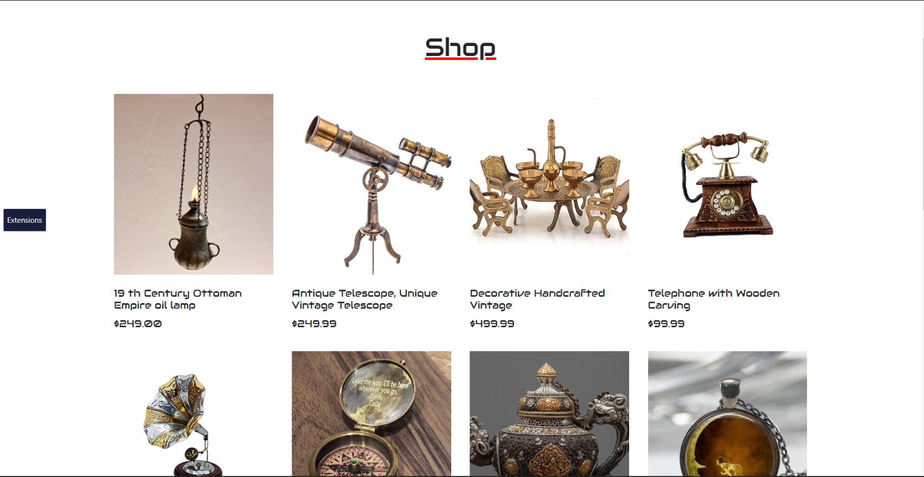

* + When you hover image of products:

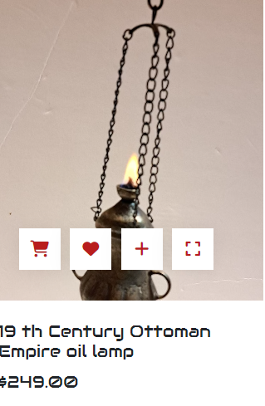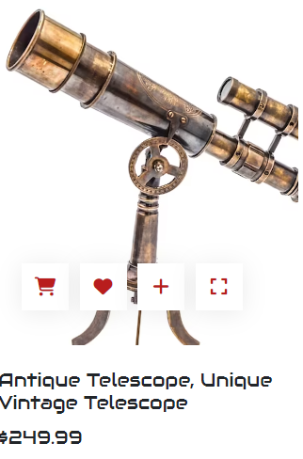

* + When you click the expand icon it will direct you to the product detail:

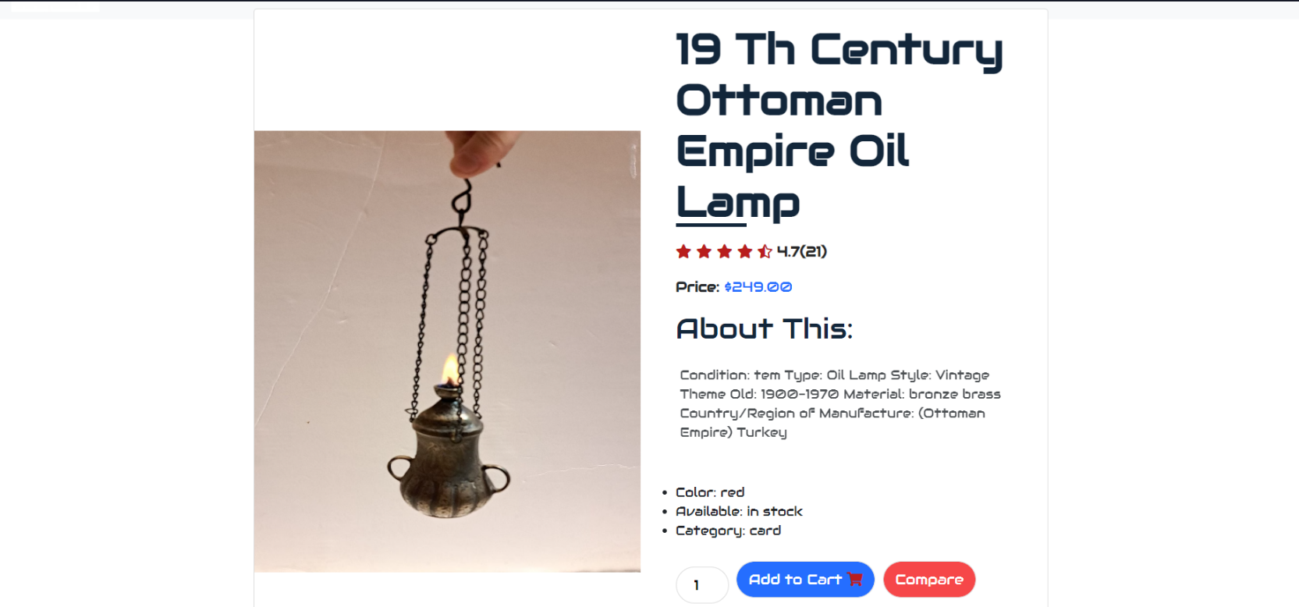

* + If you click cart icon it will add the item to cart with the alert:



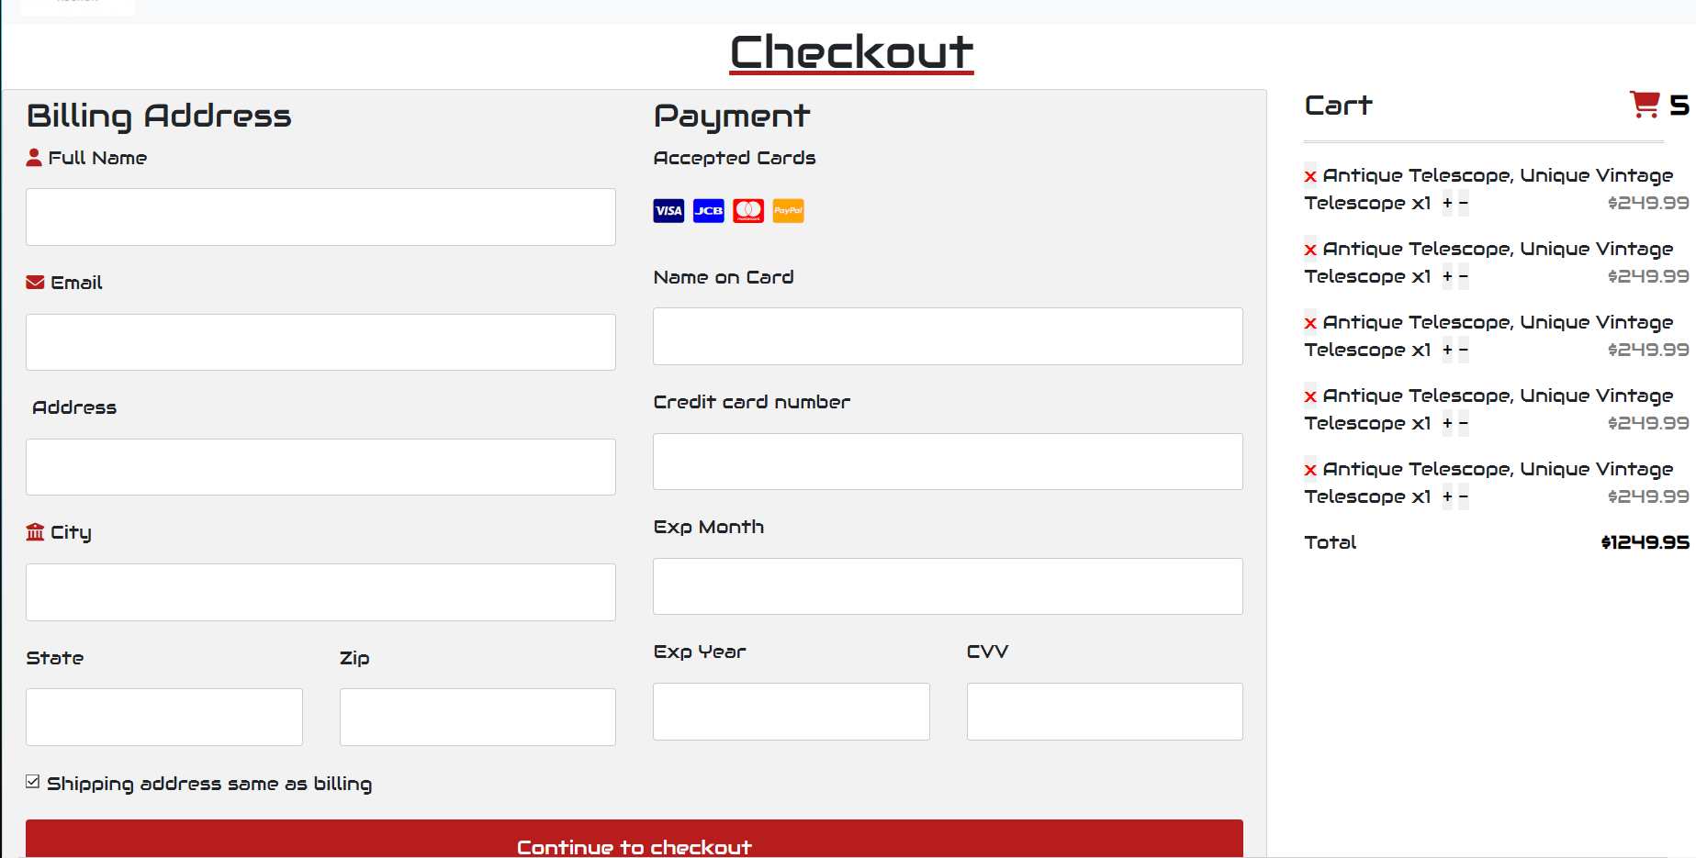

1. **About**

About us page have:

* + Our story, our vision and a little information about stores:
  + Store branch location and group member:

1. **Contact**

Contact page about:

* + Form that you can use contact with store.

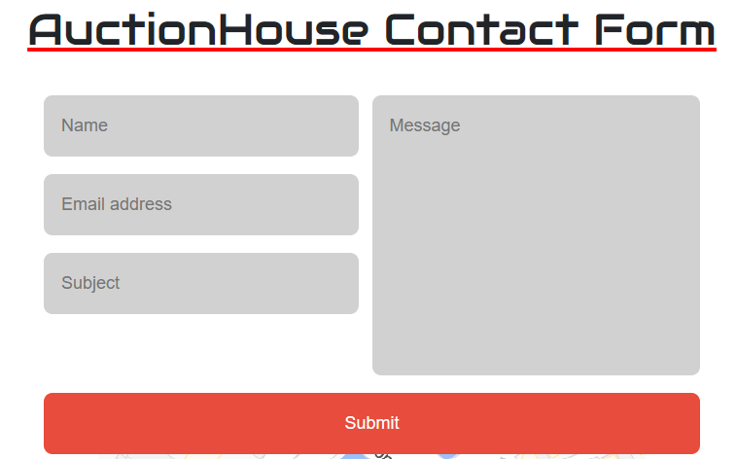

* + Location Store

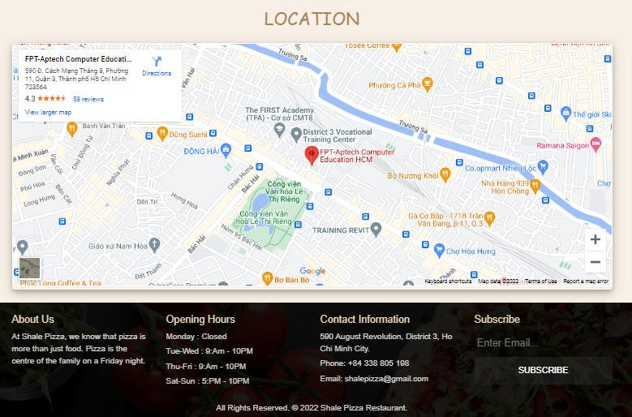

1. **Login/Signup**
   * 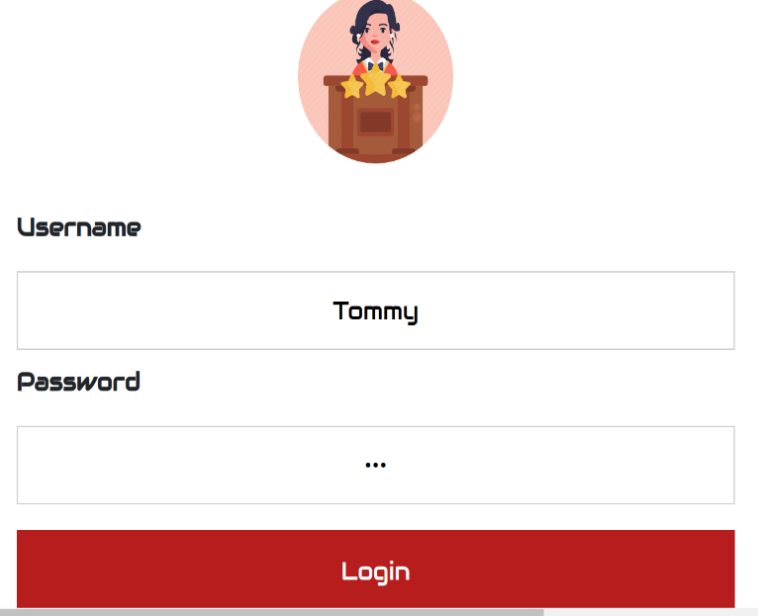Login form and if login success.

* + Signup form and if signup success.

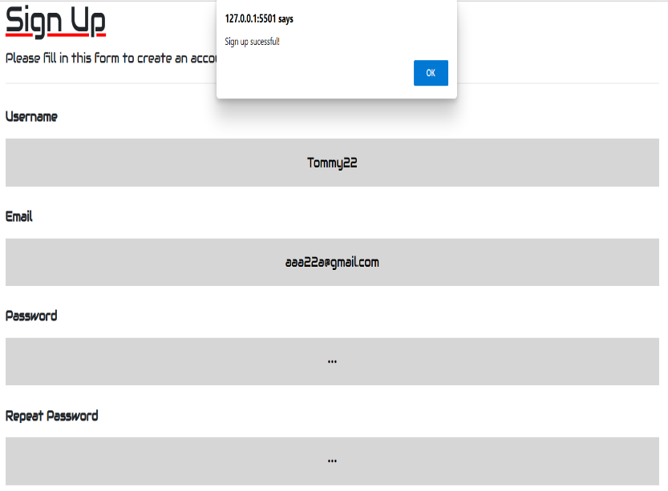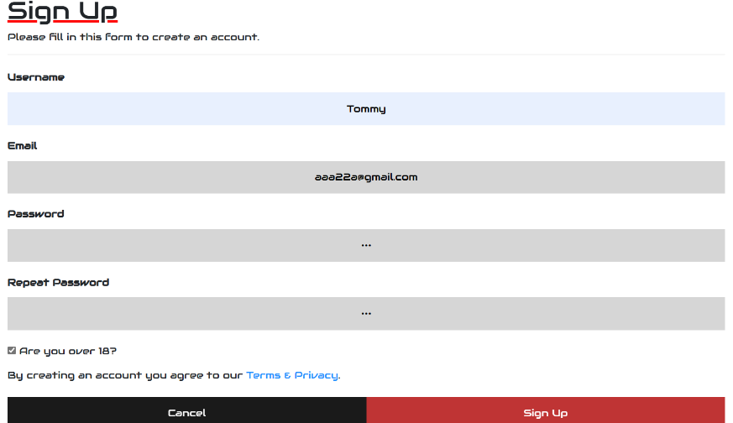

|  |  |  |  |  |
| --- | --- | --- | --- | --- |
| No | Member | Contents | Page Name | Activity Plan |
| Planed Start Date | Actual Start Date | Actual End Date | Status |
| 1 | Nguyễn Đăng Khiêm | Shop | shop.html | 07/01/2023 | 07/01/2023 | 14/02/2023 | 80% |
| Cart | cart.html | 07/01/2023 | 07/01/2023 | 14/02/2023 |
| About | about.html | 07/01/2023 | 07/01/2023 | 14/02/2023 |
| 2 | Lê Tiến Phát | Home page | index.html | 07/01/2023 | 07/01/2023 | 14/02/2023 | 100% |
| Contact | contact.html | 07/01/2023 | 07/01/2023 | 14/02/2023 |
| Signup | signup.html | 07/01/2023 | 07/01/2023 | 14/02/2023 |
|  |  | Login | login.html | 07/01/2023 | 07/01/2023 | 14/02/2023 |
| 3 | Lê Đức Ngọc Quang | Login | login.html | 07/01/2023 | 07/01/2023 | 14/02/2023 | 80% |
| Contact | contact.html | 07/01/2023 | 07/01/2023 | 14/02/2023 |
| 4 | Nguyễn Thành Nghĩa | Shop | shop.html | 07/01/2023 | 07/01/2023 | 14/02/2023 | 75% |
|  |  | Home | home.html | 07/01/2023 | 07/01/2023 | 14/02/2023 |
| 5 | Trần Thị Khánh Vân | About | about.html | 07/01/2023 | 07/01/2023 | 14/02/2023 | 70% |
| Login | login.html | 07/01/2023 | 07/01/2023 | 14/02/2023 |
|  |  |  |  |  |  |

Task sheet