Basic Parts

The several parts below, including sensor parts, switch parts and respond parts, are the basic parts.

|  |  |  |  |  |
| --- | --- | --- | --- | --- |
| Number | Title | Desigener | Function | Remark |
| BBa_3179000 | miR663b-target | iGEM19_SYSU-CHINA | Control mRNA translation | Sense miRNA 663b |
| BBa_3179001 | L7AeO | iGEM19_SYSU-CHINA | L7Ae-Kturn System | Mutation of L7Ae |
| BBa_3179002 | miR885-5p-target | iGEM19_SYSU-CHINA | Control mRNA translation | Sense miRNA885-5p |
| BBa_3179003 | miR592-target | iGEM19_SYSU-CHINA | Control mRNA translation | Sense miRNA592 |
| BBa_3179004 | 2Kt-E1A | iGEM19_SYSU-CHINA | respond parts, kill tumor cells | Initiate adenovirus gene expression and lyse cells |
| BBa_3179004 | 2Kt-E1A+E1B55K | iGEM19_SYSU-CHINA | respond parts, kill tumor cells | Initiate adenovirus gene expression and lyse cells |
| BBa_K1179016 | L7Ae | iGEM13_MIT | Switch parts | Control mRNA translation |
| BBa_K2748001 | rtTA-advanced (reverse tet-controlled transactivator) | iGEM18_SYSU-CHINA | Switch parts | Control mRNA transcription |

Composite Parts

We assembled the basic parts into composite parts to meet the design requirements, such as measuring the effectiveness of the sensory system, the effectiveness of the switching system, the actual effective amount of miRNA, etc.

|  |  |  |  |  |
| --- | --- | --- | --- | --- |
| Number | Title | Parts | Function | Remark |
| BBa_K3179100 | pTREK | pTRE-mi663b-2Kt-EGFP-miR885-5p | Measure the expression of response elements in the system | EGFP is the detection index. |
| BBa_K3179101 | pTREL | pTRE-LeA7-miR592 | Switch system | The gene product L7Ae is part of L7Ae-Kturn system. |
| BBa_K3179102 | pCMV-rtTA3 | pCMV-rtTA3 | Express rtTA3 | Test promoter and search for the suitable one |
| BBa_K3179103 | pUbC-rtTA3 | pUbC-rtTA3 | Express rtTA3 | Test promoter and search for the suitable one |
| BBa_K3179104 | hEF1a-rtTA3 | hEF1α-rtTA3 | Express rtTA3 | Test promoter and search for the suitable one |
| BBa_K3179105 | pTRE-mi663b-2Kt-E1A-miR885-5p | pTRE-mi663b-2Kt-E1A-miR885-5p | Response parts | E1A is a response part that can lyse target cells |
| BBa_K3179106 | pTRE-mi663b-2Kt-E1A-E1B55K-miR885-5p | pTRE-mi663b-2Kt-E1A-E1B55K-miR885-5p | Response parts | E1A and E1B 55K are response parts that can lyse target cells |
| BBa_K3179107 | LSBR5n3 | LSBR5n3 | Measurement parts | The effective amount of target miRNA in cells can be measured by designing miRNA target |

Assembly

In order to test the compatibility between L7Ae-Kturn system and Tet-On system, we constructed pTRE-kt-EGFP plasmid. Three groups of experiments were designed, namely, adding rtTA3 and no L7Ae(L7Ae-), adding L7Ae and rtTA3(L7Ae+), adding neither L7Ae or rtTA3(Control). It can be seen that there are significant differences in the expression of EGFP in the three groups of experiments. (Table.1)

Table.1 the result of the compatibility between L7Ae-Kturn system and Tet-On system

|  |  |  |
| --- | --- | --- |
| L7Ae- | L7Ae+ | Control |
| 10804.33 | 7252.33 | 6533.33 |
| 10921.33 | 9112.33 | 7776.33 |
| 11249.33 | 9562.33 | 8596.33 |

We used pCMV-rtTA3(BBa_K3179102) and hEF1a-rtTA3(BBa_K3179102) to test the effects of different promoters on rtTA3 expression. The results are shown in the figure below.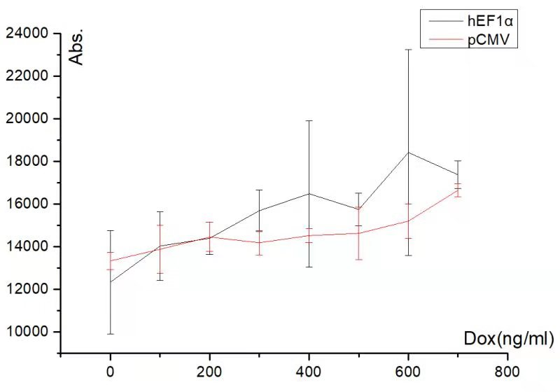

<http://parts.igem.org/File:T-SYSU-CHINA-pCMEhEF1a_rtTA.jpg>

Finally, we used LSBR5n3(BBa_K3179107) to measure the actual effective amount of miRNA in cells, assembled pTREL (BBA _ k317901) with pTRE-mi 663b-2kt-E1A-mir885-5p (BBA _ k3179105) or pTRE-mi 663b-2kt-E1A-E1B 55k-mir885-5p (BBA _ k3179106) to construct our target circuit, packaged into adenovirus, and constructed recombinant oncolytic adenovirus.