# Lab safety

**Rules**

First, we identify certain **rules** and regulations in our country as well as university. These rules can be a comprehensive and detailed guidance, clearly classified the risks in our tasks. Before we started the experiment, received biosafety and biosecurity training both theoretically and practically from our advisor and assistant researchers. By tightly following relevant regulations and instructions, we are able to minimize the risks of organisms infection, injury during the experiment, strain leakage, etc.

**Laboratory training**

Second, our laboratory is classified as safety level II. We have promised to pay much attention to physical protection on our body and strictly follow the standard procedures and protocols provided by team advisors and companys. In the early stage, we will carry out cell experiments and molecular experiments followed by the modified adenovirus. Thus, the laboratory safety level and safety measures we take are far enough to support our experiments. Our laboratory has rich experience in pathogenic microorganisms and has been running smoothly for more than ten years. The laboratory has experienced laboratory management personnel and perfect laboratory management regulations. All our participants have received relevant training on biosafety, and received laboratory standard operation and ethics training in the course. At the same time, professionals from school institutions will also regularly evaluate the safety of the laboratory and give their opinions.

**Project specific safety**

To control the risk of virus infection, we intend to use the adenovirus vector AdEasy system in our experiment. This system is modified by human adenovirus type 5 whose wild type can infect human and cause respiratory discomfort. It can cause occasional or severe viral infection in immunocompromised patients, especially severe respiratory infection and viral hepatitis in organ transplant patients. But since our team members are all in good health and the AdEasy system are well modified, with proper precautions, the probability of being infected is extremely low. And we will not to carry out experiments in vivo, especially when our engineered systems are in testing.

**Waste disposal**

Additionally, the purchase, collection, storage, use, transfer and waste disposal of hazardous chemicals must be strictly implemented in accordance with national laws and regulations and the relevant provisions of the school. Highly toxic chemicals, explosives, narcotic and psychotropic drugs, toxic drugs for medical use and other special items shall strictly implement the "five pairs" management system.

# Assessment of future work

1. The risk of genetic recombination of adenovirus

We used adenovirus (human serum type V) (Ad-5) as the recombination vector and constructed the AdEasy System. The wild type of the virus is able to infect human cells. Among all known cultured human cancer cells in vitro, No Ad-5 homologous sequence is found, and the mechanism of lytic infection of Ad does not involve the reverse transcription or the integration of viral genomes into the host genome. Therefore, as far as the current research results show, AdEasy should be a relatively safe system and have no risk involving integration of viral genomes into the host genome. Among other serum types of the Ad, it is reported that there is a risk that Ad-12 may cause cancer in rodents1. However, no report of other serum types of Ad causing cancer or having the ability to integrate their genome into the host’s has been found.

2. The risk of sudden changes caused by the sponge effect

The definition of the sponge effect is that there are cyclic-RNAs which are capable to adsorb multiple micro-RNAs and reduce their concentration in the cell; however, when these cyclic-RNAs break down, they will release the micro-RNAs they previously adsorbed and cause a sudden increase of concentration of the micro-RNAs. Such effect makes the copy number of transcripts not equal to the effective free concentrations of micro-RNAs. In our system, we use micro-RNA sensors to sense the cellular micro-RNA concentrations so to turn on or off of our killer system.

The expression of micro-RNAs in current databases is copy number of transcripts. However, due to the existence of the sponge effect, the cellular free concentration of micro-RNAs may not be equal to the expression data we got from the databases. If we create the profiles of micro-RNAs based on these data, the risks listed below may be involved: in normal cells, the micro-RNAs which have the profile of higher expression in normal cells and lower/no expression in cancer cells may have lower free concentration due to the sponge effect and the extent of reduction can not be predicted. When the concentration of target micro-RNAs decreases to certain concentration, the interaction between micro-RNAs and their partners can be reduced and

In this regard, we have taken two methods to reduce that risk: First, when we screened the differential expression profile of miRNA, we chose a combination of miRNAs with low absolute expression and high absolute expression, and at the same time, they are also have a large difference in relative expression. Thus, even if the concentration of the originally low expressed miRNA is increased instantaneously, ithe concentration of it will not rise to the same level as that of tumor cells. Secondly, we designed a part for the detection of actual miRNA free amount in vivo. This part uses two identical promoters, with EBFP as the internal reference to indicate the transcript of the miRNA. And mKate could be used to calculate the effective amount of miRNA that binds to the miRNA-target. This allows us to rule out the effects of the sponge effect, taking the actual amount of intracellular miRNAs as an effective amount, and avoiding miRNAs with high transcription but low effective amount as our target miRNAs.

3.off-target effect and Tet-on system

There is no doubt that our design is still at risk of off-target effect although we have designed the system to be as safe as possible, so that it only works on the target cells. But we still have to think: when the system was injected into the body, how could we control the system which triggers off-target effect to make it stop work? At first, we thought of Tet - off system. When off-target effect occurs in the body, patients could take Tet to close system. However, for Tet in the human body, they are passing through by blood, so we cannot expect the time of a drug-to-site delivery. When off-target loci is away from blood vessels, shuting down the system will be ikely to need a long time and we can't even estimate of time to complete drug delivery. It may produce a great safety hidden trouble,. Thus, we decided to adopt Tet - On the system, which is opem only in the presence of DOX. Once the patient stopped taking DOX, it will soon be out of human body metabolization, making the whole system close, which is to prevent the off-target system continues to produce harm

4.Overdose:

In order to achieve the purpose of killing tumors, a certain amount of administration is required. Our system is based on recombinant adenovirus, and a large dose of adenovirus may cause a strong immune response when it enters the human body. The E3 region gene has been knocked out in the AdEasy system, which can effectively reduce the human immune response. At the same time, we compared the different drug concentrations by virus titer and modeling results, and found that it is feasible and safe to pass multiple small doses (The model is below). This will not cause bodies’ immune response, but achieve the purpose of killing tumor cells at the same time.

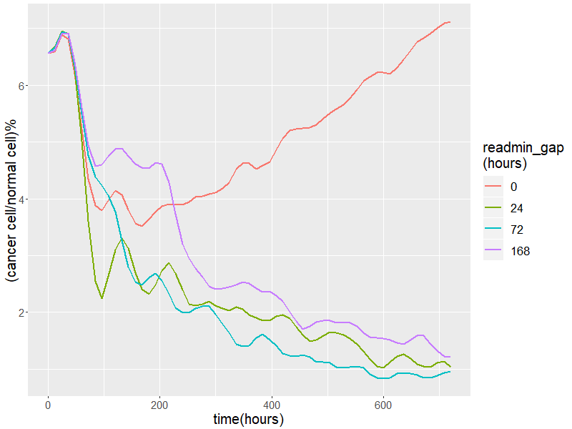

5. Individual differences

The miRNA expression difference profiles we are using now are based on database and papers’ results. Individual differences are common in the population. Different types of tumors, such as colon cancer, have different miRNA expression differences in different individuals. But our system can theoretically act on various miRNA expression profiles. After obtaining the miRNA expression profiles and normal tissues of the cancer cells in the patient, the problem of individual differences can be solved by providing a workable system by adjusting the miRNA-target.

【1】Trentin J J, Yabe Y, Taylor G. The Quest for Human Cancer Viruses: A new approach to an old problem reveals cancer induction in hamsters by human adenovirus[J]. Science, 1962, 137(3533): 835-841.