# Risks from experiments

Identifying the risks is the first step of safety……

***Risk of*** ***organisms infection***: There may exist a risk of being infected by microorganisms during the experimental operation.

***Risk of*** ***injury during the experiment***: Injury may be caused by improper use of instruments by experimental operators during experimental operation.

***Risk of*** ***strain leakage***: Since we will use two different microorganisms in our experiment, risk of strain leakage might exist if relevant regulations and instructions aren’t tightly followed.

***Risk of virus infection:*** We intend to use the adenovirus vector AdEasy system in our experiment. This system is modified by human adenovirus type 5 whose wild type can infect human and cause respiratory discomfort. It can cause occasional or severe viral infection in immunocompromised patients, especially severe respiratory infection and viral hepatitis in organ transplant patients. But since our team members are all in good health and the AdEasy system are modified, with proper precautions, the probability of being infected is extremely low.

***Risks from other aspects of the laboratory***: Our laboratory has rich experience in pathogenic microorganisms and has been running smoothly for more than ten years. The laboratory has experienced laboratory management personnel and perfect laboratory management regulations. All our participants have received relevant training on biosafety, and received laboratory standard operation and ethics training in the course. At the same time, professionals from school institutions will also regularly evaluate the safety of the laboratory and give their opinions.

***Risks from drugs***. The purchase, collection, storage, use, transfer and waste disposal of hazardous chemicals must be strictly implemented in accordance with national laws and regulations and the relevant provisions of the school. Highly toxic chemicals, explosives, narcotic and psychotropic drugs, toxic drugs for medical use and other special items shall strictly implement the "five pairs" management system of double custody, double locking, double receiving and sending, double receiving and double use to prevent the occurrence of theft, loss, false receiving, misuse and other safety accidents.

# Our compliance

Our project aims at avoiding any serious safety problems as much as possible. When infectious particles are used, the risk to researchers should be as low as it can. This risk is minimized by using **L7Ae protein** and **Tet-on system,** which have been proven harmless to human cells and well controllable on the basis of corresponding prodrugs. The potential risks to the public and the environment are minimized by strictly abiding by the rules of **Good Laboratory Practice** (GLP), operating in the BSL2 laboratory, and using the tested miRNA sensor to limit the replication capability of adenovirus.

Minimizing the risks for team members and society is one of the most important issues, especially for us undergraduates. We shall further illustrate the concept of biosafety and our endeavors by quoting and explaining the six guiding principles of safe manipulation gene manipulation biology (GMO) summarized by Kimman et al. in 2008 [1].

1. ***Hazard identification***: Identification of risk assessment have been completed, and all laws and regulations have been considered in accordance with the provisions of the last paragraph.

2. ***Biological containment***: Biological containment refers to the use of organisms with "reduced replication capacity, ineffectiveness, transmissibility and toxicity". For our project, replication-restricted viruses are used, and all other modifications are intended to specifically target the resulting viral vector for a specific cell type. This increase in specificity requires it to cut off fewer infectious viruses associated with wild-type viruses, thus cutting off its natural tendency.

3. ***Concentration and Shell***: All working steps for preparing virus vectors are carried out in BSL II laboratory, and AAV is limited to a separate type II laminar flow cabinet in this laboratory. Cell culture and virus storage are also carried out in separate freezers and incubators. All laboratories and equipment containing virus vectors are specially marked, such as biohazard warning signs.

4. ***Exposure minimization***: This aspect of the exposure minimization guidelines can be performed under "Operator Protection". In our laboratory, exposure is minimized through special marking and replacing sterilized gloves. When the manipulating the viral vectors, care should be taken to avoid liquid droplets, especially aerosols. By inserting or removing materials from laminar flow cabinet and cleaning all equipment after completing the work tasks, we can avoid the possible transfer of virus carriers.

5. ***Physical containment***: We will meet the requirements of physical containment by performing all operations on AAV in BSL II laboratory in which we shall guarantee the number restriction for persons’ entrance in the BSL II laboratory.

# Managing the risks

* **Rules and guidance**

We identified certain **rules and regulations** in our country as well as our university. These rules are in combination of a comprehensive and detailed guidance, clearly classified the risks in our tasks.

**National rules and regulations**. The General requirements for laboratory biosafety are the overall rules of biosafety, keeping most of our actions in the laboratory safe. And most norms in these requirements comply with international standards.

In this handbook, *Laboratories—General Requirements for biosafety*, enacted by the People’s Republic of China (PRC), stated the security classifications, laboratory managements, precautious strategies, waste disposal and all kinds of general requirements and regulations an researcher might encounter in conducting biological experiments. Below is the front page of this coverall handbook.

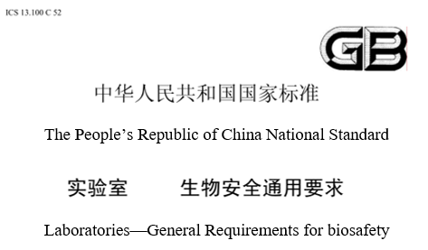

(Click here for the full version of this handbook)

**Rules and regulations in our university**

There is a regulation named *Measures for laboratory safety and environmental protection management* of Sun Yat-sen University, which was established in order to reduce accidents and protect us students and teachers. In this regulation, article 16 is about the management of the biosafety, which sets the general rules for carrying out our experiments safely.

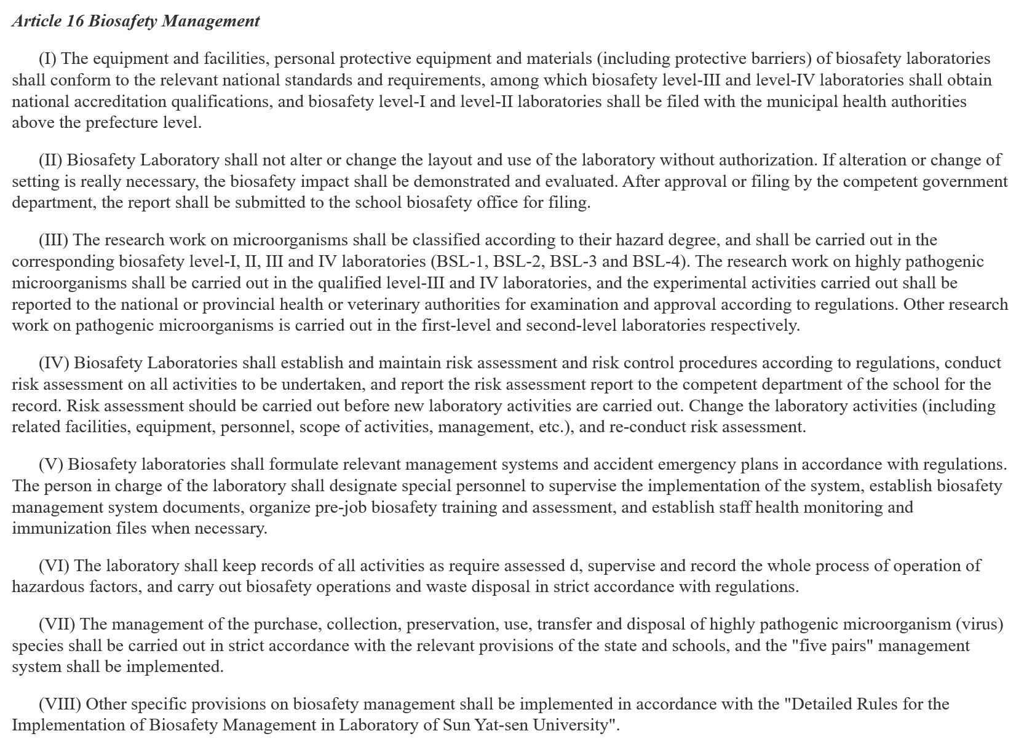

(Click here for the original full version of this regulation)

* **Experts overseeing**

Professor Lu, Yongjun a doctoral advisor of Microbiology in School of Life Sciences, Sun Yat-sen University, is responsible for lab security. His research interest lies in the interactions of pathogenic bacteria/ human microbiome with the host, focusing on the effector protein’s study. His study on the interaction between microorganism and host is termed Cellular Microbiology, the emphasis of which is illuminating the function of bacterial effector proteins.

Meanwhile, Prof. Lu has devoted himself to synthetic biology and has been the advisor of SYSU-China team of Sun Yat-sen University for many years. He is experienced and enthusiastic in the research of synthetic biology as well as iGEM competition. Lu’s Lab mainly focus on the research of pathogenic microorganisms, the safety level of which is much higher than that of modified adenovirus.

Our laboratory is classified as safety level II. In principle, there will be no safety problems in the experiment threatening our lives. Moreover, our instructor, Prof. Lu suggests that we should pay much attention to physical protection on our body and strictly follow the standard experimental manipulation. In the early stage, we will carry out cell experiments and molecular experiments followed by the modified adenovirus. Thus, the laboratory safety level and safety measures we take are far enough to support our experiments.

Concerning the laboratory biosafety, Prof. Lu Professor amended the principle, protocol and feasibility of our experiment. In addition, we received safety training organized by Prof. Lu before we started the wet experiment. In the process of the experiment, we are instructed by professors and assistants to ensure the safety and the proper use of equipment and reagents during our experiment.

* **Laboratory training**

Second, our laboratory is classified as safety level II. We have promised to pay much attention to physical protection on our body and strictly follow the standard procedures and protocols provided by team advisors and company. In the early stage, we will carry out cell experiments and molecular experiments followed by the modified adenovirus. Thus, the laboratory safety level and safety measures we take are far enough to support our experiments. Our laboratory has rich experience in pathogenic microorganisms and has been running smoothly for more than ten years. The laboratory has experienced laboratory management personnel and perfect laboratory management regulations. All our participants have received relevant training on biosafety, and received laboratory standard operation and ethics training in the course. At the same time, professionals from school institutions will also regularly evaluate the safety of the laboratory and give their opinions.

* **Project specific safety**

To control the risk of virus infection, we intend to use the adenovirus vector AdEasy system in our experiment. This system is modified by human adenovirus type 5 whose wild type can infect human and cause respiratory discomfort. It can cause occasional or severe viral infection in immunocompromised patients, especially severe respiratory infection and viral hepatitis in organ transplant patients. But since our team members are all in good health and the AdEasy system are well modified, with proper precautions, the probability of being infected is extremely low. And we will not to carry out experiments in vivo, especially when our engineered systems are in testing.

* **Waste disposal**

Additionally, the purchase, collection, storage, use, transfer and waste disposal of hazardous chemicals must be strictly implemented in accordance with national laws and regulations and the relevant provisions of the school. We also strictly follow the laboratory safety rules as inactivating all the experimental organisms before releasing them outside.

# Risk assessments for future work

1. The risks of genetic recombination of adenovirus

We used adenovirus (human serum type V) (Ad-5) as the recombination vector and constructed the AdEasy System. The wild type of the virus is able to infect human cells. Among all known cultured human cancer cells in vitro, No Ad-5 homologous sequence is found, and the mechanism of lytic infection of Ad does not involve the reverse transcription or the integration of viral genomes into the host genome. Therefore, as far as the current research results show, AdEasy should be a relatively safe system and have no risk involving integration of viral genomes into the host genome. Among other serum types of the Ad, it is reported that there is a risk that Ad-12 may cause cancer in rodents[2]. However, no report of other serum types of Ad causing cancer or having the ability to integrate their genome into the host’s has been found.

2. The risks of sudden changes caused by the sponge effect

The definition of the sponge effect is that there are cyclic-RNAs which are capable to adsorb multiple micro-RNAs and reduce their concentration in the cell; however, when these cyclic-RNAs break down, they will release the micro-RNAs they previously adsorbed and cause a sudden increase of concentration of the micro-RNAs. Such effect makes the copy number of transcripts not equal to the effective free concentrations of micro-RNAs. In our system, we use micro-RNA sensors to sense the cellular micro-RNA concentrations so to turn on or off of our killer system.

The expression of micro-RNAs in current databases is copy number of transcripts. However, due to the existence of the sponge effect, the cellular free concentration of micro-RNAs may not be equal to the expression data we got from the databases. If we create the profiles of micro-RNAs based on these data, the risks listed below may be involved: in normal cells, the micro-RNAs which have the profile of higher expression in normal cells and lower/no expression in cancer cells may have lower free concentration due to the sponge effect and the extent of reduction cannot be predicted. When the concentration of target micro-RNAs decreases to certain concentration, the interaction between micro-RNAs and their partners can be reduced and

In this regard, we have taken two methods to reduce that risk: First, when we screened the differential expression profile of miRNA, we chose a combination of miRNAs with low absolute expression and high absolute expression, and at the same time, they also have a large difference in relative expression. Thus, even if the concentration of the originally low expressed miRNA is increased instantaneously, the concentration of it will not rise to the same level as that of tumor cells. Secondly, we designed a part for the detection of actual miRNA free amount in vivo. This part uses two identical promoters, with EBFP as the internal reference to indicate the transcript of the miRNA. And mKate could be used to calculate the effective amount of miRNA that binds to the miRNA-target. This allows us to rule out the effects of the sponge effect, taking the actual number of intracellular miRNAs as an effective amount, and avoiding miRNAs with high transcription but low effective amount as our target miRNAs.

3. Off-target effect and Tet-on system

There is no doubt that our design is still at risk of off-target effect although we have designed the system to be as safe as possible, so that it only works on the target cells. But we still have to think: when the system was injected into the body, how could we control the system which triggers off-target effect to make it stop work? At first, we thought of Tet - off system. When off-target effect occurs in the body, patients could take Tet to close system. However, for Tet in the human body, they are passing through by blood, so we cannot expect the time of a drug-to-site delivery. When off-target loci is away from blood vessels, shutting down the system will be likely to need a long time and we can't even estimate of time to complete drug delivery. It may produce a great safety hidden trouble. Thus, we decided to adopt Tet - On the system, which is open only in the presence of DOX. Once the patient stopped taking DOX, it will soon be out of human body metabolization, making the whole system close, which is to prevent the off-target system continues to produce harm

4. Overdose

In order to achieve the purpose of killing tumors, a certain amount of administration is required. Our system is based on recombinant adenovirus, and a large dose of adenovirus may cause a strong immune response when it enters the human body. The E3 region gene has been knocked out in the AdEasy system, which can effectively reduce the human immune response. At the same time, we compared the different drug concentrations by virus titer and modeling results, and found that it is feasible and safe to pass multiple small doses (The model is below). This will not cause bodies’ immune response, but achieve the purpose of killing tumor cells at the same time.

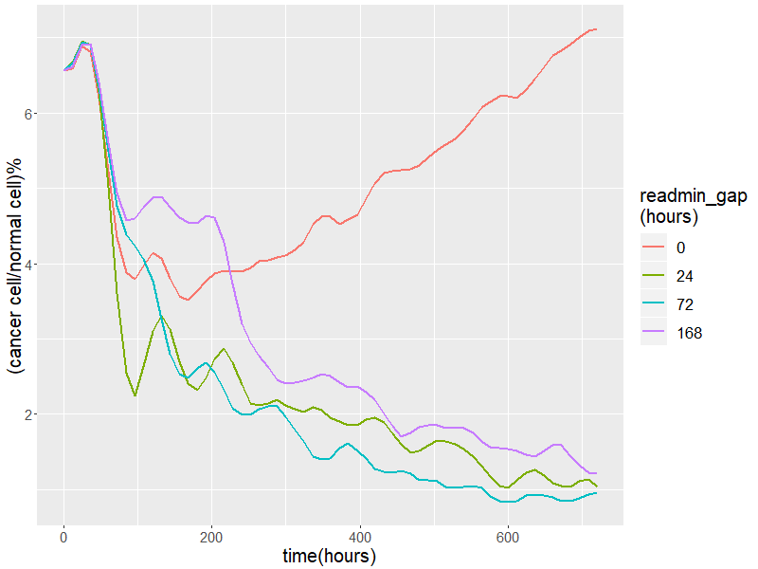

5. Individual differences

The miRNA expression difference profiles we are using now are based on database and papers’ results. Individual differences are common in the population. Different types of tumors, such as colon cancer, have different miRNA expression differences in different individuals. But our system can theoretically act on various miRNA expression profiles. After obtaining the miRNA expression profiles and normal tissues of the cancer cells in the patient, the problem of individual differences can be solved by providing a workable system by adjusting the miRNA-target.

[1] Kimman, Tjeerd G., Eric Smit, and Michel R. Klein. "Evidence-Based Biosafety: a Review of the Principles and Effectiveness of Microbiological Containment Measures." *Clinical Microbiology Reviews* 21.3 (2008): 403-425.

[2]Trentin J J, Yabe Y, Taylor G. The Quest for Human Cancer Viruses: A new approach to an old problem reveals cancer induction in hamsters by human adenovirus[J]. Science, 1962, 137(3533): 835-841.