A simple cellular automata (CA) model was developed to simulate the effect of oncolytic virus therapy against tumors. Different situations, including different tumor sizes as well as tumor numbers, different administration (virus) doses and different re-administration gap methods were simulated and discussed. Though this is a rough demonstration, it provides lots of meaningful information for the further improvement for our project design.

**Part I: Assumption**

Though this modeling was exploratory, it was hoped that in certain conditions the oncolytic virus could eliminate the tumor or at least suppress the tumor growth.

**Part II: Model Description**

**(I) Mechanism**

1. The CA model used has a 400*400 tetragonal grid with Moore Neighbors (i.e. one cell has 8 neighbor cells). All simulations are run in a duration of 720 hours (30 days).

2. For each cell, the **cell status** can be one of dead, normal or cancer.

For dead cells, they can be regarded as an empty space, and also they are not functional. In the simulation, one cell can become dead when it is infected and run out all its lifespan as an infected cell. The empty space may be filled up by division of its neighbor cells.

For normal cells, they can infect, be infected and divide in certain rate.

For cancer cells, they can also infect, be infected and divide, but in a higher rate than normal cells. Notably, they also possess an ability to invade normal cell “tissues” with a specific probability (set as **invade_pro**).

3. For each cell, the **infected status** can be either not infected or infected.

Infected cells can infect their neighbor cells after a certain period (set as **infect_delay**).

**Infect_rate** is another parameter that controls the infection process by regulating the probability of infecting neighbor cells.

The cancer cells have a shorter infect delay and a higher infect rate than the normal cells.

4. For not infected cells, they can divide in a certain time cycle (set as **division_time**).

5. **Infect_frac** is the parameter that regulates the administration dose. When dosing, the ratio of newly infected cells (due to dosing) and total cells is approximately equal to **infect_frac**.

6. **Readmin_gap** sets the gap between two administrations. 0 means no re-administration.

**(II) Simulation Settings**

1. Different tumor situations were considered, including different tumor sizes and tumor numbers. For smaller tumors, their numbers were higher, vice versa; but we set all tumor situations to a similar number of cancer cells (around 1000~3200).

Three sizes of tumors were considered: small, medium and big.

2. Different administration doses were considered: either low dose (infect_frac=0.01) or high dose (infect_frac=0.05). Both of them could be converted into viral TCID50 titer as 1*10-3.12 and 1*10-4.83, respectively, according to [1].

3. Different re-administration gaps were considered for small and medium size of tumors: 24 hours (1 day), 72 hours (3 days) and 168 hours (7 days).

**Part III: Model Results**

**(1) Single-administration method performs well against big tumors but performs poorly against smaller tumors**

The results show that for single-administration method, it can eliminate most of cancer cells and strongly suppress big tumors (Movie S1). For medium size tumors, its effect is moderate but still acceptable. However, for small size tumors, it performs poorly even with high administration dose, and fails to suppress the tumors growth (Fig. 1A). It is suggested that the failure of suppression is caused by the failure of infecting specific tumors and they are left to grow freely (Fig. 2A, Fig. 2B, Movie S2, Movie S3). Smaller the tumor size is, the probability of tumors “escape” infection is higher, and even high single-administration dose can not resolve this problem. Therefore, re-administration methods are considered and simulated later.

The death ratio of any single-administration methods is under 6% (Fig. 1B), and therefore can be considered acceptable for not causing widespread tissue necrosis or further organ failure. However, attention should still be paid when using high dose in actual practice.

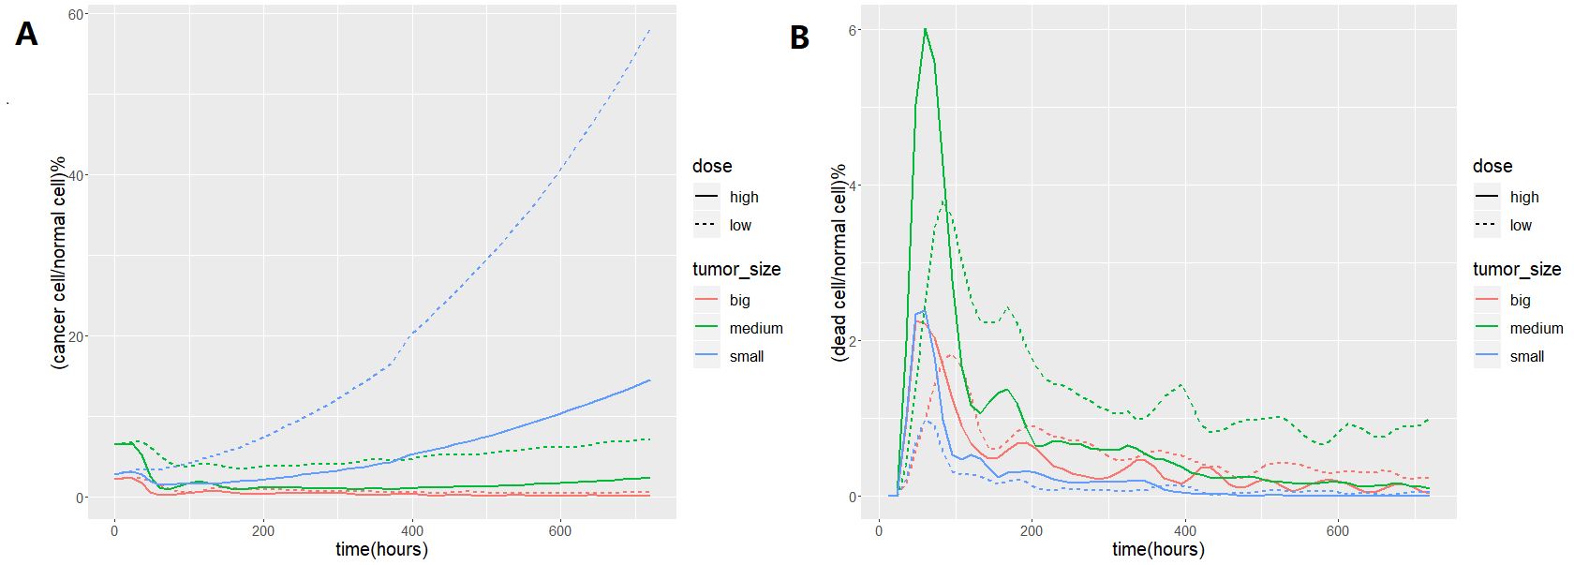

**Figure 1** cancer cell/normal cell ratio (**A**) and dead cell/normal cell ratio (**B**) of single-administration method. Solid line: high dose; dashed line: low dose. Red line: big tumors; green line: medium tumors; blue line: small tumors.

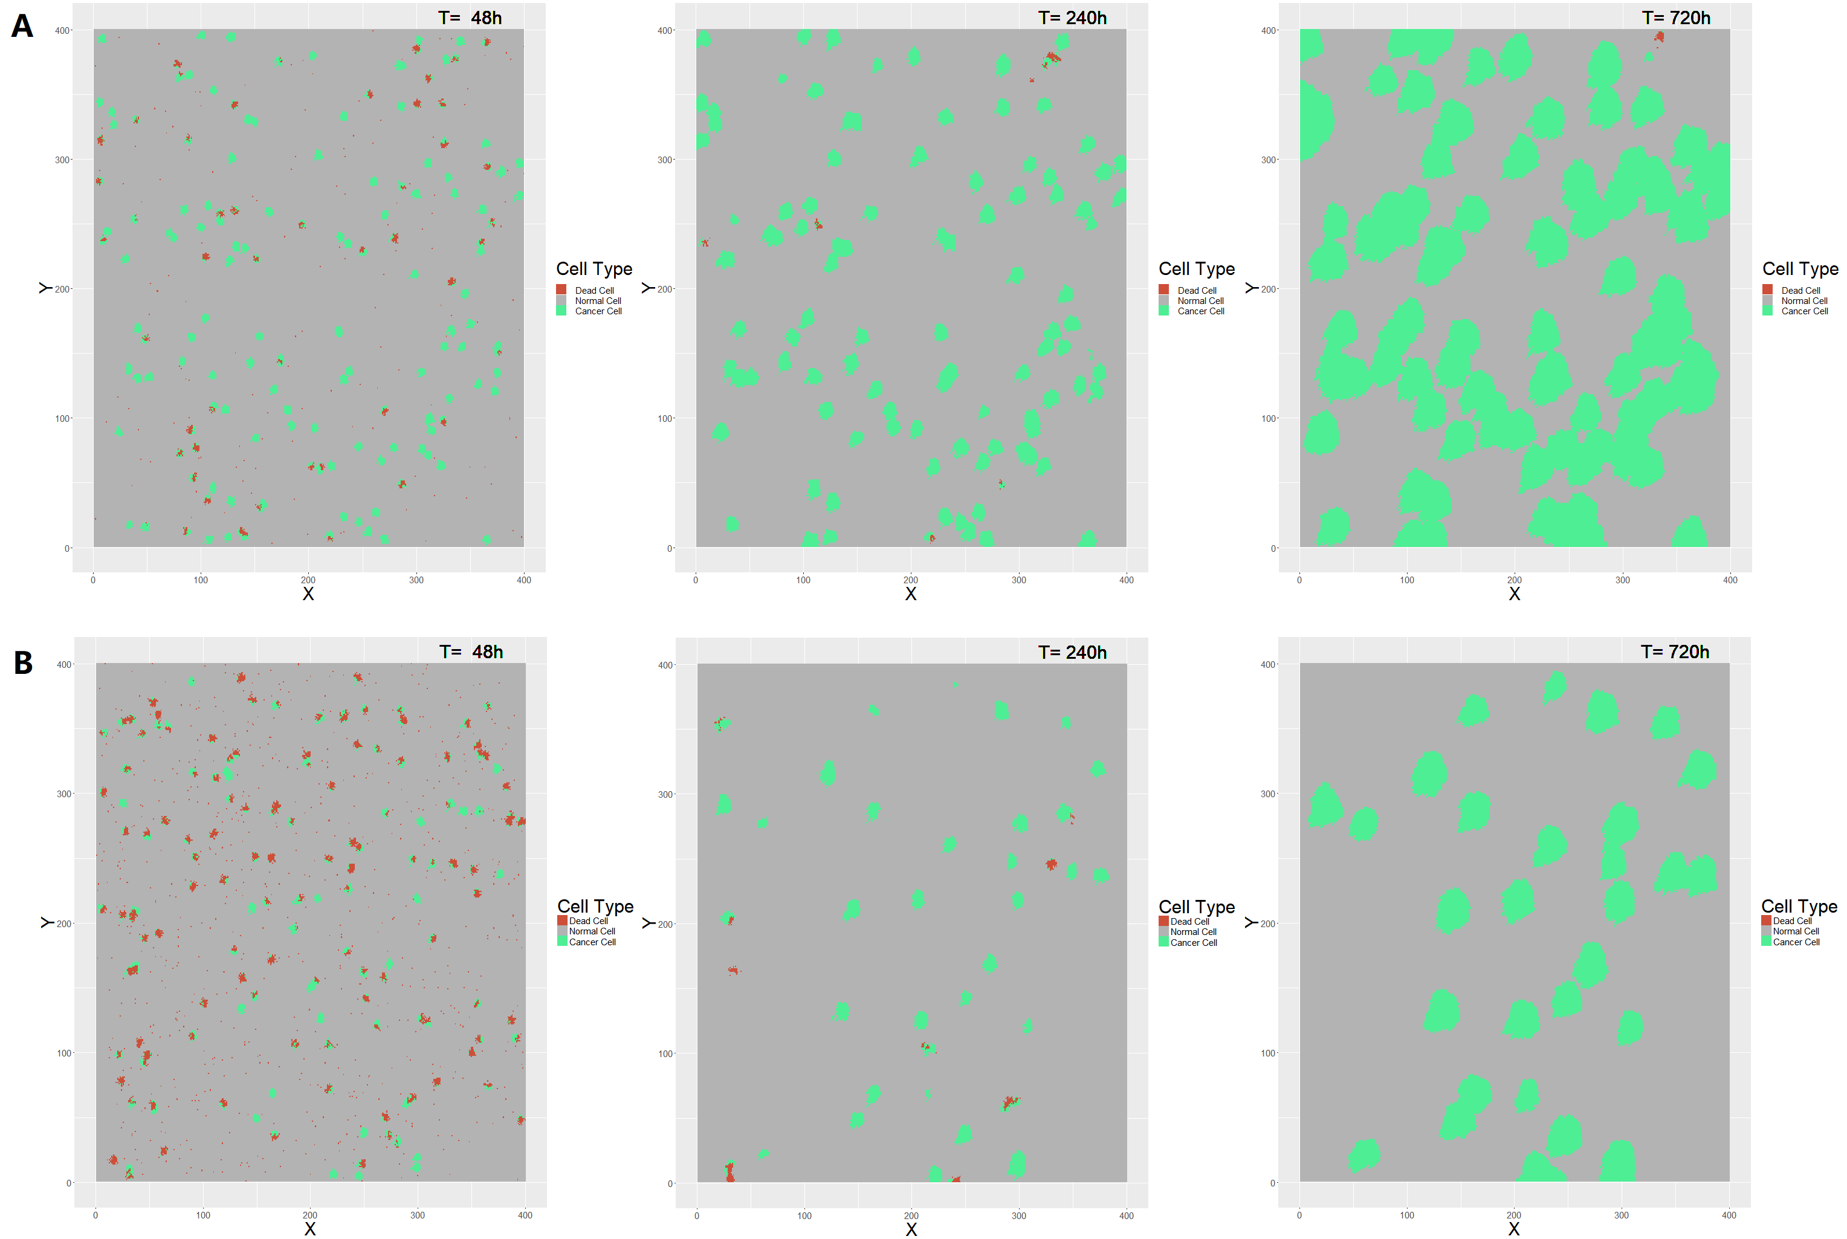

**Figure 2** simulation demonstration for single-administration method against small size tumors with low dose (**A**) or high dose (**B**) at the observation time point of 48 hours (2 days), 240 hours (10 days) and 720 hours (30 days).

**(2) Re-administration methods are effective against smaller tumors**

Since the result above shows that cancer has an escape effect on viral infections, we try to improve treatment by changing the way we give it. The results show that re-administration methods with low dose are quite effective against smaller tumors (Fig. 3A, Fig. 3B) that no matter what the re-administration gap is, they can eliminate most of the cancer cells and suppress the cancer cells in a remarkable low level, under 3%. Notably, even a large re-administration gap (7 days) with low dose can effectively suppress the tumor growth and have similar effect with smaller gap methods (Fig. 4A, Fig. 4B, Movie S4, Movie S5).

Due to epithelial cells regeneration, the death ratio of any re-administration methods is under or near 5%, which means that this therapy won't cause widespread tissue necrosis so to cause organ failure. Based on this simulation, we believe that lysotic virus therapy is safe for solid tumors treatment. (Fig. 3C, Fig. 3D).

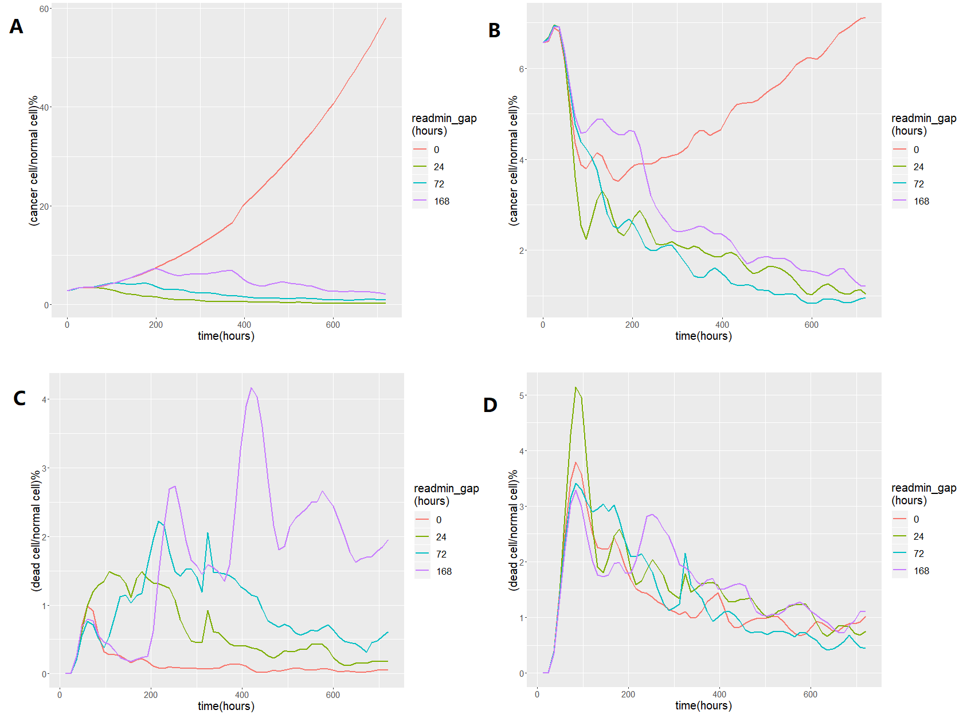

**Figure 3** cancer cell/normal cell ratio of re-administration method against small tumors (**A**) and medium tumors (**B**); dead cell/normal cell ratio of re-administration method against small tumors (**C**) and medium tumors (**D**). Color of lines represents different re-administration gap: red, 0 (no re-administration); green, per 24 hours (1 day); blue, per 72 hours (3 days); purple, per 168 hours (7 days). Notably, the scale of y-axis of each graph is different.

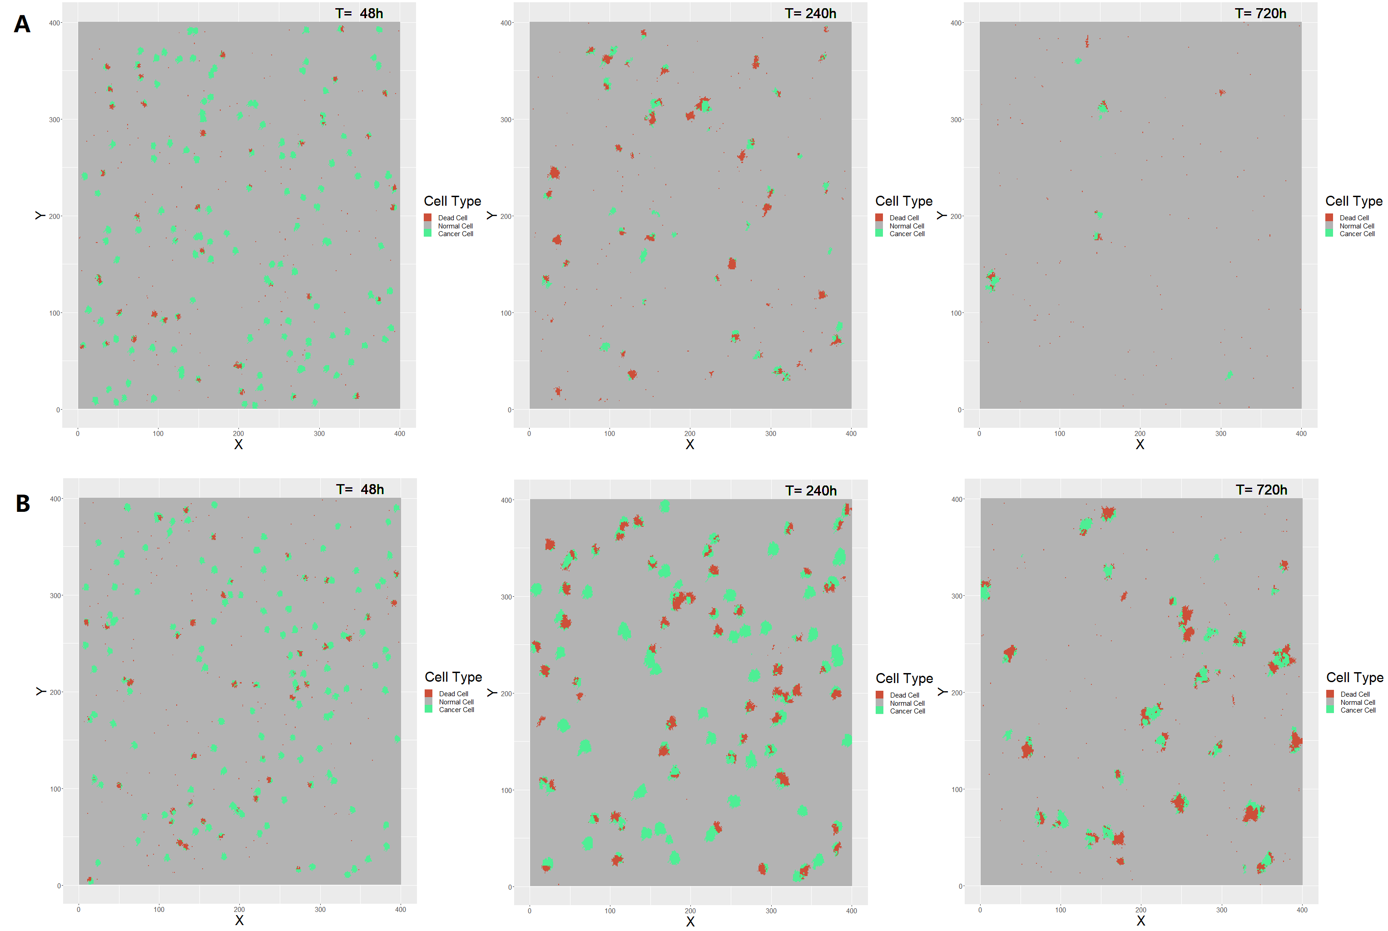

**Figure 4** simulation demonstration for re-administration method against small size tumors with re-administration gap of 24 hours (**A**) or 168 hours (**B**) at the observation time point of 48 hours (2 days), 240 hours (10 days) and 720 hours (30 days).

**Part IV: Relevant Data**

The CA model we used had adapted some simulation parameters from a former work of C. Beauchemin, et al[2], including cell infection patterns and division patterns. TCID50 data in adv. is calculated in our experiment.

**Part V: Conclusion and Discussion**

The model results demonstrate that the oncolytic virus therapy can be effective in different tumor situations. The single-administration method is enough effective for big size tumors, but for smaller size tumors, it is recommended to use re-administration method with certain re-administration gap. Putting possible cost and risk into consideration, low-dose administration is enough for suppress tumor growth of all size of tumors, however, the optimal re-administration gap should be further investigated and be used to improve the effect of therapy.

**References**

[1] Internet Link: http://www.dxy.cn/bbs/topic/14324310

[2] C. Beauchemin, J. Samuel and J. Tuszynski. A simple cellular automaton model for influenza A viral infections (2005). Journal of Theoretical Biology 232, 223-234.

**Supplementary Materials**

Movie S1 Single-administration method against big size tumors with low dose

Movie S2 Single-administration method against small size tumors with low dose

Movie S3 Single-administration method against small size tumors with high dose

Movie S4 Re-administration method with gap of 24 hours against small size tumors with low dose

Movie S5 Re-administration method with gap of 168 hours against small size tumors with low dose