AttenTrack: Facial Recognition
Attendance Tracking
And
Recording System

A Capstone Project
Presented to the Faculty of the
College of Information Technology Education
PHINMA University of Iloilo.

In Partial Fulfillment
of the Requirements for the degree
Bachelor of Science in Information Technology

By:
Janin Anne Silvias
Ren Joseph Lumogdang
Edilbert Richard Belgira

April 2026
ABSTRACT
The swift evolution of digital technology has spurred the adoption of biometric authentication across different industries to enhance security, precision, and efficiency. This research offers an Attendance Tracking and Recording System Using Face Recognition, a safe and automated attendance record management system. Conventional attendance processes, including manual sign-in or ID card scanning, tend to be plagued by time wastage, fake entries, and operator mistakes. Using sophisticated facial recognition software, the system guarantees accurate identification, eliminating chances of proxy attendance and the use of physical means of identification.

The system identifies people by reading their facial structures and directly marking their attendance on a secure database. This not only increases accuracy and dependability but also accelerates the verification process, making workflow more efficient. The system has the potential to bring a modern approach to attendance management by presenting a quick, robust, and easy-to-use solution, eventually enhancing operational performance in schools, workplaces, and organizations.
Approval Sheet
In partial fulfillment of the requirements for the Bachelor of Science in Information Technology, this Capstone Project entitled “Diagnostic Record System With Face Recognition” prepared and Submitted by Janin Anne Silvias, Edilbert Richard Belgira, and Ren Joseph Lumogdang who are hereby recommended for corresponding final evaluation.

Nicole Lampa
Adviser

Approved by the Panel of Evaluators with a grade of PASSED

Dr. Arnold M. Fuentes, Ph. D, MPA, MMIT
Chairman

Ryan C. Valeriano
Member

Accepted in partial fulfillment of the requirements of the degree Bachelor of Science in Information Technology

Seth dA. Nono, MSCS
CITE, DEAN OF DEAN
ACKNOWLEDGEMENT

First of all, We would like to Thank our Adviser, Ms. Nicole Lampa for her guidance to us until today. Her invaluable guidance, encouragement, and unwavering support throughout the course of our research made us achieve where we are right now. And also, we would like to acknowledge our friends who helped us and encouraged us through our journey.Their patience and time spent guiding us were the reason why we achieved our checkpoint before the deadline. Above all, we extend our appreciation to everyone who contributed, in ways big and small, to the successful completion of this project.

TABLE OF CONTENTS

Title page ------------------------------------------------------i
Approval Sheet------------------------------------------------ii
Acknowledgement-------------------------------------iii
Abstract---------------------------------------------iv
Table of
Contents—---------------------------------------------v
List of
Figures----------------------------------------------vi
List of
Tables----------------------------------------------vii

CHAPTER I
Introduction------------------------------------------1
Background of the
Study-------------------------------------------------2
Statement of the
Problem-----------------------------------------------3
Objectives of the
Study-------------------------------------------------5
Significance of the
Study-------------------------------------------------6
Scope and
Limitation--------------------------------------------7

CHAPTER II
Literature Review-----------------------------------------------
Overview----------------------------------------------
Traditional VS Modern
System------------------------------------------------
Technology
Use---------------------------------------------------
Case
Studies----------------------------------------------

CHAPTER III
Methodology-------------------------------------------11
Research
Design------------------------------------------------12
Model
Use---------------------------------------------------13
Data flow
Diagram-----------------------------------------------14

Context Diagram—--------------------------------------15
Entity Relationship
Diagram-----------------------------------------------16

CHAPTER IV
Result and
Discussion--------------------------------------------17
System’s
Features----------------------------------------------17
Implementation
Challenges--------------------------------------------17
User
Feedback----------------------------------------------18
Comparison to other
System------------------------------------------------18

CHAPTER V
Conclusion and
Recommendation----------------------------------------19
Conclusion--------------------------------------------20
Recommendation----------------------------------------20
Final
Thoughts----------------------------------------------21

Chapter 1

Introduction to the Study

The attendance tracking had been a basic part of operations
in schools since it directly influenced academic performance monitoring, resource planning, and school management. The conventional attendance processes-like manual
roll calls, paper attendance sign-in sheets, or scanning ID
cards—had suffered from inefficiencies, human faults, and
misappropriate activities like proxy attendance in the past.
These limitations point to the requirement of a more secure,
precise, and mechanized process.

As digital technologies developed at a very rapid pace,
biometric authentication had also come forward as a robust
solution for verifying identities. Of all the biometric methods,
facial recognition had been distinguishable for being
non-invasive, highly precise, and simple to integrate with
existing systems. The technology compared facial traits of
individuals against each other to verify identity, without any
physical tokens or user intervention.

The proposed attendance monitoring and recording system utilized facial recognition algorithms to automatically identify students and record their attendance in real time, without requiring teachers to conduct manual roll calls. The system also incorporated role-based access controls, encrypted data storage, and schedule-based attendance validation to ensure accuracy, privacy, and compliance with data protection standards. This innovation has the potential to transform attendance management in schools into a seamless, reliable, and fully automated practice.

attendance in real time, enhancing operational efficiency, reducing administrative workload, and maintaining the integrity of attendance records.

Technical Background of the Study
In educational institutions, precise and reliable
attendance tracking was critical to proper student
management and academic accountability. Traditional school attendance systems,
whether paper-based class records or manually maintained spreadsheets, had
consistently been prone to inefficiencies, inaccurate entries,
and significant administrative burden. These shortcomings led to unreliable
records, wasted instructional time, and difficulty generating attendance reports.
As student populations grew and data demands increased,
the need for a more
sophisticated, digitally integrated, and accurate attendance system became evident.

Facial recognition technology offered a modern solution for
improving identity verification in schools. Unlike
conventional methods such as manual sign-ins or ID card scanning, provided a contactless, fast, and reliable form of student identification. Incorporating this biometric technology into a school attendance system allowed for precise identity confirmation, significantly reduced proxy attendance, and ensured the authenticity of all recorded attendance data.

This research introduced the use of an Attendance Tracking
and Recording System Using Face Recognition to further improve
attendance management. The system was designed with two distinct access roles: an Administrator portal with full control over student records, schedules, and registered teachers, and a Teacher portal for viewing assigned students and schedules. Attendance was recorded through a separate, login-free camera station accessible to students at any time. This design minimized manual errors, removed the need for teacher-operated roll calls, and ensured that attendance data was captured accurately and securely.

Objectives of the Study
This study sought to develop the AttenTrack: Facial Recognition Attendance Tracking and Recording System to address the persistent limitations of manual attendance tracking in inefficiencies, recording errors, and dishonest practices such as proxy attendance. Particularly, the research sought the following goals:

1. Improved Attendance Accuracy – The research made use of
facial recognition software to avoid proxy attendance,
reduce human error, and reflect actual participation in the
attendance records. By eliminating the necessity of
depending upon manual signatures or ID cards, the system
aimed at constructing a more precise attendance
verification process.
2. Improved Privacy and Security – The system applied
biometric authentication mechanisms for securing attendance
details, reducing unauthorized access, and keeping
sensitive records tamper-proof, free from hacking, or
infringement of privacy.
3. Enhanced Efficiency in Recording Attendance and Retrieval –
The research automated the attendance process through a login-free facial recognition camera station. Upon identifying a student, the system validated whether that student had an active class schedule at the current time before automatically recording attendance as present. This enabled
real-time data capture and effortless retrieval of
attendance data for administrative reporting and monitoring.

4. Incorporation of Biometric Authentication into Attendance
Systems – The system incorporated facial recognition
technology into conventional attendance systems, with the
possibility of seamless, secure, and immediate verification
without disrupting continuity of organizational processes.
5. Measurement of System Effectiveness and Usage – The
evaluation gauged the impact of the system on working
efficiency, data precision, and user happiness, in order to
determine its practicability, reliability, and feasibility
for large-scale use.

From these goals, the research proved that biometric
recognition technology had
the potential to transform school attendance management into a more
accurate, secure, and fully automated process, replacing
outdated manual practices with a dependable digital solution.

Significance of the Study
Attendance tracking is an essential component of school management,
directly affecting academic performance monitoring, resource allocation,
and institutional accountability. Conventional methods such as paper roll calls,
handwritten class records, and manual sign-in sheets have long been characterized by
inefficiencies, recording errors, and dishonest practices like proxy attendance.
These persistent shortcomings
underscore the need for an improved, accurate, and automated attendance
system suited to the demands of modern
educational institutions.
As digital technologies advanced, biometric authentication became a prominent option
for identity verification in schools. Among the available methods, facial recognition
distinguished itself as non-invasive, highly accurate, and easy to deploy without
requiring any physical tokens or active participation from the student.
The technology worked by
comparing detected facial features against a registered database, making it
well-suited for the high-volume, daily demands of a school attendance setting.

The proposed attendance monitoring and recording system
Management System utilized facial recognition algorithms to automatically identify students and record their attendance in real time, without requiring teachers to conduct manual roll calls. The system also incorporated role-based access controls, encrypted data storage, and schedule-based attendance validation to ensure accuracy, privacy, and compliance with data protection standards. This innovation has the potential to transform attendance management in schools into a seamless, reliable, and fully automated practice.

Scope and Limitation of the Study
This study focuses on the development of an Attendance Tracking and Recording System Using Face Recognition designed to improve the efficiency, security, and accuracy of attendance management. The system uses facial recognition technology to verify the identity of individuals before recording their attendance. It aims to prevent proxy attendance, protect attendance records through secure storage, and automate the logging and retrieval of attendance data. The study will cover the design, development, and implementation of the system, including:
Face Recognition-Based Identity Verification:
Using facial recognition technology to accurately identify students as they approach the camera station. No login is required—the system detects the student’s face, checks whether the student has an active schedule at the current time, and automatically records attendance as present.
Automated Attendance Recording:
Developing a system that automatically records a student’s attendance once their face is recognized and a valid schedule is confirmed for the current time slot. This eliminates the need for teacher-operated roll calls or manual logging, significantly minimizing human error.
Secure Data Storage:
Implementing encrypted storage of attendance records to protect sensitive information and ensure that data remains secure and accessible only to authorized personnel.

User Interface Development:
Creating an easy-to-use interface that allows administrators to manage attendance records, monitor attendance data, and generate reports efficiently.
The system will be designed for use in educational educational institutions where accurate and automated student attendance monitoring is required. The scope covered the design, development, testing, and evaluation of the system in a controlled or simulated environment to determine its effectiveness and reliability.
Limitations of the Study
While the study aims to improve attendance tracking through facial recognition technology, several limitations may affect the system:
Environmental Conditions:
Factors such as poor lighting, facial obstructions like masks, and significant facial changes over time may affect the accuracy of facial recognition.
Privacy and Data Protection Concerns:
Since the system stores biometric data, issues related to privacy and compliance with data protection regulations may arise.
Limited Testing Environment:
The system will be tested in a controlled environment within a single institution, which may limit the generalization of the results to other organizations or larger-scale implementations.
Definition of Terms
Attendance Tracking System – A mechanism or software application designed to monitor, record, and manage the presence or absence of individuals in a given setting such as a classroom, workplace, or event.
Biometric Authentication – A security process that verifies the identity of an individual based on unique physiological or behavioral characteristics, such as fingerprints, iris patterns, or facial features.
Facial Recognition – A biometric technology that identifies or verifies an individual by analyzing and comparing patterns in their facial features against a stored database of registered faces.
Face Detection – The process by which a system locates and identifies the presence of a human face within a digital image or video frame, serving as the initial step before recognition and attendance recording.
Proxy Attendance – The fraudulent practice in which one individual records attendance on behalf of another who is absent.
Real-Time Recording – The immediate and automatic logging of data at the precise moment an event occurs, without manual delay or
Automated System – A system capable of performing tasks and processes with minimal or no manual human
Encrypted Storage – A data protection method in which stored information is converted into a coded format accessible only to authorized parties, used to protect the confidentiality and integrity of all recorded attendance data.
Algorithm – A defined set of computational instructions followed by a system to solve a problem or complete a task, such as comparing facial features to verify identity.Administrative Workload – The volume of manual tasks and responsibilities handled by school personnel in managing attendance records, generating reports, and processing data, which the proposed system aimed to reduce through automation.Role-Based Access Control – A security design in which system features and data are restricted based on the user’s assigned role, such as Administrator or Teacher, ensuring that each user can only access functions relevant to their responsibilities.Schedule Validation – The process by which the system checks whether an identified student has an active class schedule at the current date and time before recording their attendance as present.

Chapter 2
Review of Related Literature
This chapter presents a review of existing studies and literature related to school attendance tracking systems, facial recognition technology, role-based web applications, and digital scheduling tools in educational institutions. The review examines how prior research has addressed the limitations of manual attendance methods and how technology-driven solutions have been implemented to improve accuracy, efficiency, and record management in schools. The studies discussed in this chapter provide the theoretical and practical foundations that support the development of the proposed AttenTrack: Facial Recognition Attendance Tracking and Recording System.

Face Recognition-Based Attendance Management System
Smitha, Hegde, and Afshin (2020) developed a class attendance system that used facial recognition to automate the attendance-marking process in academic settings. The study identified that existing manual attendance systems were time-consuming, difficult to maintain, and vulnerable to proxy attendance. To address these problems, the researchers designed a system consisting of four phases: database creation, face detection, face recognition, and attendance updating. Student facial images were stored in a database, and during class sessions, faces were detected and recognized from a live video stream using the Haar-Cascade classifier for detection and the Local Binary Pattern Histogram (LBPH) algorithm for recognition. Once attendance was recorded, the system automatically sent the attendance report to the respective faculty via email. The study demonstrated that facial recognition could reliably automate attendance tracking in educational environments, reducing administrative workload and eliminating dishonest practices. This work directly supports the present study’s use of facial recognition as the primary mechanism for recording student attendance.

A Literature Review on Smart Attendance Systems
Abdalkarim (2022) conducted a comprehensive literature review of automated and smart attendance tracking systems, surveying recent works that explored a range of identification technologies including QR codes, ID and password systems, facial recognition, and fingerprint recognition. The review found that paper-based attendance methods were consistently unreliable, prone to false entries, and inefficient for institutions managing large numbers of students. The study highlighted that the shift toward automated recognition systems had significantly improved attendance accuracy and reduced administrative costs. Among the technologies reviewed, facial recognition and biometric methods were noted as the most promising due to their contactless nature and high accuracy rates. Abdalkarim’s review provided a broad overview of the landscape of smart attendance systems and reinforced the rationale for adopting automated methods over manual processes, supporting the core approach of the present study.

Attendance Monitoring System with Optimization Query Algorithm
Santos, Balba, and Rebong (2021) developed an attendance monitoring system for Philippine schools that incorporated an optimization query algorithm to improve the speed and accuracy of attendance data retrieval. The study noted that schools in the Philippines continued to rely heavily on paper-based attendance systems, which led to inconsistent records and delays in generating reports for administrators. The proposed system automated the recording and retrieval process and demonstrated measurable improvements in data accuracy and reporting efficiency. The study is particularly relevant to the present research as it was conducted in the Philippine educational context and addressed the same institutional challenges of manual attendance recording that motivated the development of the AttenTrack: Facial Recognition Attendance Tracking and Recording System.

Web-Based Smart Attendance Monitoring System Using QR Code and GSM Module
Bondoc (2023) presented a web-based attendance monitoring system that combined QR code scanning with a GSM module for SMS notifications to automate attendance recording in a school setting. The system allowed students to scan their QR codes upon entering class, after which their attendance was automatically recorded in a web-based database and parents were notified via SMS. The study found that the system significantly reduced the time spent on manual roll calls and improved the reliability of attendance records. While the present study uses facial recognition rather than QR codes, Bondoc’s work demonstrates the effectiveness of web-based, automated attendance systems in educational institutions and validates the approach of removing the need for teacher intervention in the attendance-recording process.

Designing a Web-Based Elementary School Attendance System Using the Laravel Framework
Najaf, Alexander, Tarmidzi, and Kurnia (2023) designed and implemented a web-based attendance system for an elementary school using the Laravel PHP framework. The system provided role-based access for administrators and teachers and automated the process of recording and managing student attendance data. The study emphasized the importance of a clean, web-accessible user interface that allowed school administrators to monitor attendance records, manage student data, and generate reports without requiring specialized technical knowledge. The findings confirmed that the Laravel framework was well-suited for building reliable, role-based school management applications. This study is closely aligned with the present research, which also employs a web-based architecture with distinct Administrator and Teacher portals and focuses on ease of use for school personnel.

Using School Management Systems to Improve Student Attendance
Classter (2025) discussed how integrated school management systems could be leveraged to improve student attendance rates and administrative efficiency. The report highlighted that centralized digital systems that combined scheduling, attendance recording, and role-based data access allowed schools to respond more quickly to attendance issues and generate accurate reports for decision-making. The study underscored the value of systems that connected administrative functions, such as schedule management and student record-keeping, with automated attendance tracking to create a unified workflow. This perspective directly informs the design of the present study’s system, which integrates schedule management, student lists, teacher assignment, and facial recognition-based attendance recording into a single web-based platform.

Synthesis
The studies reviewed in this chapter collectively demonstrate that manual attendance systems in educational institutions are consistently inadequate, error-prone, and burdensome for school personnel. Research from both local and international contexts confirms that automated, technology-driven solutions significantly improve attendance accuracy, reduce administrative workload, and eliminate dishonest practices such as proxy attendance. The reviewed literature also validates the use of web-based architectures with role-based access as an effective approach for school management systems. While prior studies have explored QR codes, fingerprint scanning, and optimization algorithms, the integration of facial recognition with schedule-based validation and a login-free camera station, as implemented in the present study, represents a further advancement that removes the need for any active participation from teachers in the attendance-recording process. Together, these works provide a strong theoretical and practical foundation for the development of the proposed AttenTrack: Facial Recognition Attendance Tracking and Recording System.
Chapter 3

Methodology
This chapter presents the research methodology used in the development of the AttenTrack: Facial Recognition Attendance Tracking and Recording System. It describes the research design, system development stages, data collection techniques, sampling methods, data analysis approach, and ethical considerations observed throughout the study. The methodology was structured to ensure that the system was developed systematically, tested rigorously, and evaluated based on actual user needs.
The study adopted a developmental research design, which is appropriate for projects that involve the creation and evaluation of a technology-based solution. This approach allowed the researchers to design, build, test, and refine the system based on feedback from actual respondents, ensuring that the final output was practical, functional, and aligned with the needs of school administrators and teachers.
Respondents for this study included school administrators and teachers from the target institution who were directly involved in managing student attendance and class schedules. A purposive sampling method was used to select participants based on their roles and direct involvement with the attendance management process. A minimum of 20 respondents was targeted to ensure sufficient data for analysis.

Research and Development Stage
The development of the AttenTrack: Facial Recognition Attendance Tracking and Recording System followed a structured series of stages to ensure that the system was properly planned, designed, built, and evaluated. Each stage was carried out systematically to produce a functional and reliable system for school attendance management.
Planning and Requirement Analysis. In this stage, the researchers identified the limitations of the traditional manual attendance system used in the target school, including time-consuming roll calls, recording errors, and the absence of a schedule-based validation mechanism. Requirements were gathered through surveys and consultations with school administrators and teachers. Key requirements identified included a login-free facial recognition camera station for automatic attendance recording, a web-based portal with separate Admin and Teacher access levels, and a schedule management feature that validates student attendance against their active class schedule before logging.
System Design. Based on the gathered requirements, the researchers designed the overall architecture of the system. This included the three-layer system architecture (Presentation, Application, and Data layers), the database schema, the facial recognition workflow, and the user interface layouts for the Admin portal, Teacher portal, and Camera Attendance Station. The system was designed to ensure that administrators had full control over student records, schedules, and teacher accounts, while teachers could view only the information relevant to their assigned classes.
System Development. The system was developed using a web-based technology stack. The facial recognition camera station was implemented as an open-access, login-free interface where students approach the camera and have their attendance automatically validated and recorded. The Admin and Teacher portals were built with role-based access controls. Core functions including face detection, identity verification, schedule validation against the current date and time, and automated attendance logging were all programmed and integrated during this stage.
System Testing. The developed system was tested to evaluate its accuracy, functionality, and reliability. Testing covered facial recognition performance under varying lighting conditions, schedule validation logic, simultaneous multi-user access by administrators and teachers, and the accuracy of attendance data retrieval. The system was assessed on its ability to correctly identify registered students, validate their schedules, and record attendance without errors.
Evaluation and Improvement. After testing, the system was evaluated using feedback gathered from respondents through surveys. Results were analyzed to identify areas requiring improvement. Errors and usability issues discovered during testing and evaluation were corrected, and the system was refined to enhance its accuracy, security, and ease of use before final deployment.

Software Development Life Cycle (SDLC)
The development of the AttenTrack: Facial Recognition Attendance Tracking and Recording System followed the Agile Software Development Life Cycle (SDLC) model. Agile was chosen for its iterative and flexible approach, which allowed the researchers to continuously refine the system based on ongoing feedback from respondents and test results throughout the development process.
Iterative Development. The system was built in repeated cycles called sprints, where each iteration produced a functional version of the system that was tested and improved before the next sprint began. This allowed for incremental refinements to both the facial recognition module and the administrative portal features.
Flexibility and Adaptability. Agile allowed the team to adjust system requirements based on feedback collected from school administrators and teachers at each iteration. For example, adjustments to the schedule validation logic and the layout of the Admin portal were made in response to user input during early testing phases.
Continuous Testing and Improvement. Testing was conducted at every stage of development to identify and resolve errors early. Facial recognition accuracy, schedule validation, and role-based access controls were each tested independently before full system integration testing was performed.
Collaboration and Communication. Throughout the development process, the research team maintained regular communication with respondents from the target school to ensure that the system remained aligned with actual user needs and institutional requirements.
User-Centered Development. The design and functionality of all three interfaces — the Admin portal, Teacher portal, and Camera Attendance Station — were shaped by direct feedback from school personnel, ensuring the final system was intuitive and practical for users with varying levels of technical experience.
Incremental Delivery. Each major feature of the system — including the camera station, the student list module, the schedule management module, and the attendance records module — was completed, tested, and reviewed before the next feature was developed, ensuring quality control at every step.

Justification for Selecting the Agile Methodology
The Agile methodology was selected over other SDLC models, particularly the Waterfall model, because the development of the AttenTrack: Facial Recognition Attendance Tracking and Recording System required continuous user feedback and iterative refinement. The system's facial recognition module and schedule-based validation logic required repeated testing and adjustment, which is better supported by Agile's sprint-based structure than by the sequential phases of Waterfall. The table below summarizes the key differences between the two approaches and justifies the choice of Agile for this project.
Criteria | Agile Methodology | Waterfall Model
Flexibility | Highly flexible. Changes can be made during development based on feedback or new requirements. | Less flexible. Changes are difficult to make once the development process has started.
User Involvement | High user involvement. Users provide continuous feedback throughout the development process. | Low user involvement. Users are usually involved only at the beginning (requirements) and end (delivery).
Development Speed | Faster delivery because the system is developed in small increments or iterations. | Slower delivery because the entire system must be completed before it is delivered.
Risk Management | Lower risk since problems can be detected and fixed early through continuous testing and feedback. | Higher risk because issues may only be discovered after the development phase is completed.
Project Suitability | Ideal for evolving requirements | Suitable for projects where requirements may change and continuous improvement is needed.

System Architecture and Design

3.1 Overview
The AttenTrack: Facial Recognition Attendance Tracking and Recording System is designed to provide an automated, secure, and efficient method of managing student attendance and class schedules in an educational institution. The system integrates three main components: the facial recognition module, the database system, and the web-based user interface.
The facial recognition module operates as a standalone, login-free camera station. When a student approaches the camera, the module captures and analyzes their facial features and compares them against the registered student database. Once the student is identified, the system validates whether they have an active class schedule at the current date and time. If a valid schedule is confirmed, attendance is automatically recorded as present — eliminating the need for teacher-operated roll calls and preventing proxy attendance.
The database system securely stores all student profiles, facial data, teacher records, schedule assignments, and attendance entries. It ensures data integrity, confidentiality, and easy retrieval for reporting purposes. The web-based user interface provides three distinct access points: the Administrator portal for full system management, the Teacher portal for viewing assigned students and schedules, and the Camera Attendance Station for automatic student attendance recording.

3.2 System Architecture
Presentation Layer. The system provides three interfaces: (1) the Admin portal, which allows the administrator to manage the student list, create and assign schedules, register and manage teacher accounts, and download attendance records; (2) the Teacher portal, which allows registered teachers to view their assigned student list and designated schedules; and (3) the Camera Attendance Station, a login-free interface where students approach the camera and have their attendance automatically recorded through facial recognition.
Application Layer. The application layer handles all backend logic, including facial recognition processing, student identity verification, real-time schedule validation (confirming whether an identified student has a class at the current date and time), automated attendance logging for valid entries, and flagging of unrecognized faces. It also manages role-based access control and data encryption for secure storage.
Data Layer. The data layer consists of the relational database that stores all user profiles, facial recognition data, student records, schedule assignments, teacher accounts, and attendance logs. This layer ensures organized, reliable, and secure access to attendance information for monitoring and reporting purposes.

3.3 System Components and Modules
The system is organized into the following modules, each assigned to a specific role and function within the overall architecture.
3.3.1 Admin Module. The Admin module provides the administrator with full control over the system. Functions include: viewing and downloading all attendance records automatically captured by the facial recognition camera station; managing the student list by adding or removing students; creating and managing class schedules; assigning students to schedules; and viewing all active and archived schedules.
3.3.2 Registered Teacher Module. This module is managed by the administrator and handles the registration, updating, deletion, and schedule assignment of teacher accounts. Administrators can register new teachers, update their information, remove them from the system, and assign them to specific class schedules.
3.3.3 Teacher Module. Registered teachers access the Teacher portal to view their assigned student list and designated class schedules. Teachers are not required to log in to or operate the camera station. Attendance is recorded automatically by the facial recognition system, and teachers use the portal solely for reference and monitoring.
3.3.4 Schedule Management Module. This module supports the creation of new class schedules, the assignment of students to schedules, the assignment of teachers to schedules, and the viewing of all active and archived schedules. It provides the schedule data used by the facial recognition camera station to validate student attendance.
3.3.5 Attendance Records Module. This module enables the administrator to view, filter, and download attendance records in formats such as CSV or PDF. Records are automatically generated each time the facial recognition system logs a student as present, and the module provides tools for generating reports by date, student, or class schedule.
3.3.6 Student List Module. The Student List module allows the administrator to maintain an up-to-date student roster. Administrators can add new students, update student information, and assign students to appropriate class schedules. Student facial data is registered in this module and used by the camera station for identity verification.

3.4 Database Design
The database was designed using a relational structure to support all core operations of the system. The main tables and their purposes are described below.
Students. Stores the personal information and facial recognition data of each registered student, including name, student ID, enrollment details, and the facial encoding used for identity verification at the camera station.
Teachers. Stores the account information of registered teachers, including name, login credentials, and assigned schedules.
Schedules. Contains all class schedule records, including subject name, assigned teacher, days and times of the class, and the list of enrolled students.
Schedule_Assignments. A junction table linking students and teachers to their respective schedules, enabling the system to validate whether a student is enrolled in a class at a given time.
Attendance_Records. Logs each attendance entry automatically generated by the camera station, including the student ID, schedule ID, date, time, and attendance status.
Users. Stores the login credentials and role designations for Admin and Teacher accounts, supporting role-based access control across the system.

3.5 User Interface Design
The user interface was designed with clarity, role-specific access, and ease of use as the primary principles. Each interface was tailored to the specific functions of its intended user.
Admin Portal. The Admin portal provides access to all system modules. Upon login, administrators are presented with a dashboard that gives an overview of attendance statistics and quick access to student list management, schedule creation and assignment, teacher registration, and attendance records download. The interface was designed to be straightforward so that administrators with limited technical backgrounds could navigate it without difficulty.
Teacher Portal. The Teacher portal is a simplified interface that displays the assigned student list and class schedules for the logged-in teacher. Teachers can view attendance records for their assigned students but cannot modify any data. The interface is intentionally minimal to reduce confusion and focus the teacher on the information most relevant to their role.
Camera Attendance Station. The Camera Attendance Station is a login-free interface accessible directly through a web browser on a device with a connected camera. When a student approaches the camera, the system automatically detects and identifies their face, validates their class schedule for the current time, and displays a confirmation message indicating that attendance has been recorded. No user input is required.

3.6 Security Considerations
The system incorporated the following security mechanisms to protect student data and ensure that access to the system was properly controlled.
Role-Based Authentication. Administrators and teachers are required to log in with verified credentials before accessing the Admin or Teacher portals. The Camera Attendance Station operates without a login to remain accessible to all students, but it has no data modification capabilities.
Access Control. Admin and Teacher roles are strictly separated. Administrators have full system access, while teachers can only view data assigned to them. No user can access modules outside their designated role.
Encrypted Data Storage. All student profiles, facial recognition data, and attendance records are stored in encrypted format to prevent unauthorized access and ensure compliance with data privacy standards.
Session Management and Input Validation. The system implements session timeouts for logged-in users and validates all form inputs to prevent unauthorized access and protect against common web security vulnerabilities.

3.7 Technology Stack
The following tools and technologies were used in the development of the AttenTrack: Facial Recognition Attendance Tracking and Recording System.l
Frontend. HTML, CSS, and JavaScript were used to build the user interfaces for the Admin Portal, Teacher Portal, and Attendance Module. The interfaces were structured using reusable server-side templates rendered by Flask, with Bootstrap providing responsive layout and custom CSS handling visual styling. JavaScript was utilized for dynamic interactions such as live search functionality and real-time form feedback across the portals.

Backend. Python with the Flask framework was used to handle server-side logic, including role-based authentication, schedule validation, attendance logging, and API communication between the frontend and the database.

Database. MySQL was used as the relational database management system to store and manage all student records, teacher accounts, class schedules, and attendance data. The database was structured using relational tables linked through foreign keys such as student IDs, teacher IDs, and schedule IDs to maintain data integrity. All database operations were handled through SQL queries executed via a Python-based database connector integrated into the web application.
Facial Recognition. The facial recognition module was implemented using a Python-based library integrated directly into the web application backend. The module captured facial images through a connected webcam, computed facial encodings, and matched them against a pre-registered student database using a defined tolerance threshold. Recognized students were automatically logged with a timestamp and attendance status, with optional SMS notifications sent to guardians upon successful identification.
Web Server. The system was deployed on a local web server configured to be accessible across devices connected to the school network through a standard web browser. The server handled all incoming HTTP requests, routing them to the appropriate backend logic for processing and response. This setup allowed multiple users, including administrators and teachers, to access the system simultaneously without requiring any additional software installation on client devices.

Data Collection Techniques
The following data collection methods were used to gather the information needed to design, develop, and evaluate the AttenTrack: Facial Recognition Attendance Tracking and Recording System.
1. Surveys. A structured survey questionnaire was administered to school administrators and teachers to gather data on their current attendance management practices, the challenges they faced, and their expectations for the proposed system. The survey consisted of 20 questions covering demographic information, current system usage, desired features, and system performance preferences. Responses were collected using printed questionnaires and compiled for quantitative analysis.
2. Interviews. Informal interviews were conducted with selected administrators and teachers to gather in-depth qualitative insights about the school's specific attendance management needs. The interviews allowed respondents to elaborate on issues not fully captured by the survey, such as workflow preferences and concerns about system adoption. Interview responses were recorded and used to refine the system's design and feature set.
3. Focus Groups. A focus group discussion was conducted with a group of teachers and administrators to validate the system design before development began. Participants reviewed the proposed system architecture, interface mockups, and feature list, and provided feedback that was incorporated into the final design. The focus group also helped identify potential usability issues early in the development process.
4. Observations. Direct observations of the school's existing attendance process were conducted to gain a firsthand understanding of how attendance was currently recorded and managed. The observation covered the time required for manual roll calls, the frequency of recording errors, and the challenges faced by teachers in submitting attendance records to the administration. Findings from the observation informed the requirements analysis stage of the study.
5. Document Analysis. Existing attendance records, class schedules, and administrative reports from the target school were reviewed to understand the current data structure and identify gaps in record management. This analysis provided the basis for the database schema design and helped ensure that the proposed system could accommodate the school's existing data formats and reporting needs.

Sampling Methods for Respondents
The respondents for this study were selected using purposive sampling to ensure that all participants were directly involved in the school's attendance management and scheduling processes. The sampling procedure was carried out as follows.
Identification of Respondents. Respondents were identified based on their role in the school. Eligible participants included school administrators, class advisers, homeroom teachers, and subject teachers who were directly responsible for recording or managing student attendance.
Selection of Participants. Participants were selected from the target school based on their direct involvement with attendance tracking and scheduling tasks. Only personnel who actively used or managed the attendance system were included to ensure that survey responses were relevant and informed.
Sample Size. A minimum of 20 respondents was targeted to provide a sufficient data set for quantitative analysis. The final sample comprised school administrators and teachers drawn from the target institution.
Survey Distribution. The survey questionnaire was distributed in printed form directly to selected respondents within the target school. Completed questionnaires were collected by the researchers and compiled for analysis.

Data Analysis Techniques
Both quantitative and qualitative methods were used to analyze the data gathered from surveys, interviews, focus groups, observations, and document analysis.
Frequency Count and Percentage. Survey responses to multiple-choice and categorical questions were tallied and expressed as frequencies and percentages. This allowed the researchers to identify the most common challenges, the most desired features, and the general satisfaction levels of respondents with both the current system and the proposed one.
Weighted Mean. For Likert-scale questions measuring the importance of system features and user satisfaction ratings, the weighted mean was calculated to determine the average level of agreement or importance assigned by respondents. Results were interpreted using a standard scale (e.g., 4.50-5.00 = Very Important, 3.50-4.49 = Important, etc.).
Qualitative Thematic Analysis. Open-ended responses from interviews and focus group discussions were analyzed using thematic analysis. Common themes and recurring feedback were identified and grouped to provide qualitative insights into user needs, design preferences, and potential areas for system improvement.
System Performance Evaluation. The system's technical performance was evaluated by measuring facial recognition accuracy rates, attendance entry processing time, system response time, and error rates during testing. Results were compared against baseline measurements from the manual attendance process to determine the degree of improvement achieved.

Ethical Considerations
The conduct of this study observed the following ethical standards to protect the rights, privacy, and well-being of all participants.
Informed Consent. All respondents were informed of the purpose of the study and the nature of their participation before any data was collected. Participation was entirely voluntary, and respondents were assured that they could withdraw at any time without consequence.
Data Privacy and Confidentiality. The study was conducted in accordance with Republic Act No. 10173, the Data Privacy Act of 2012 of the Philippines. All personal data collected from respondents, including survey responses and interview notes, were kept confidential and used solely for the purposes of this research. Individual responses were not disclosed to any third party.
Protection of Biometric Data. Student facial recognition data collected for system testing was stored securely using encryption and was accessible only to authorized members of the research team. Biometric data was not shared outside the study and was protected in accordance with applicable data protection standards.
Anonymity of Respondents. Survey and interview responses were anonymized during analysis. No respondent was identified by name in any part of the research report, and individual responses were presented only in aggregated or anonymized form.

Chapter 4
Results and Interpretation
This chapter presents the results of the development, testing, and evaluation of the AttenTrack: Facial Recognition Attendance Tracking and Recording System. It interprets the key findings and assesses whether the system met its intended objectives, including improved attendance recording accuracy, reduced manual errors, streamlined scheduling, and positive user experience for school administrators and teachers. The results are drawn from system performance tests, survey data from respondents, and direct observations during the testing phase.

Summary of Data Sources and Analysis Methods
The data used for analysis in this study was gathered from multiple sources. Primary quantitative data came from the system's backend database, which logged all attendance entries, schedule validation results, and user interactions during the testing period. Additional data was collected through a structured survey questionnaire administered to 20 respondents comprising school administrators and teachers from the target institution.
Quantitative data, such as attendance recording accuracy rates, average entry time, and monthly error counts before and after system implementation, were analyzed using frequency counts, percentage distribution, and comparative measurement. Qualitative data gathered from open-ended survey responses and interviews were categorized thematically to assess system usability, user satisfaction, and areas for improvement.

Task Manager: Gantt Chart / Project Timetable
The table below presents the project timetable that guided the development of the AttenTrack: Facial Recognition Attendance Tracking and Recording System across twelve weeks, with responsibilities distributed among the Programmer, UI/UX Designer, and Documenter.

Week | Task | Programmer | UI/UX Designer | Documenter
1 | Project planning & requirements gathering | ✅ | ✅ | ✅
2 | Research & system design planning | ✅ | ✅ | ✅
3 | Use Case & DFD creation |  |  | ✅
4 | Database design & schema creation | ✅ |  | ✅
5 | UI wireframes & mockups |  | ✅
6 | Frontend development begins | ✅ | ✅
7 | Backend development begins | ✅
8 | Integration of frontend and backend | ✅ | ✅
9 | System testing & debugging | ✅ | ✅
10 | User testing & feedback collection | ✅ | ✅ | ✅
11 | Final revisions (code + UI + content) | ✅ | ✅ | ✅
12 | Documentation finalization & formatting |  |  | ✅
 | Final project submission | ✅ | ✅ | ✅

4.1 Presentation of Results
The AttenTrack: Facial Recognition Attendance Tracking and Recording System was developed, tested, and evaluated based on its ability to improve student attendance recording accuracy, reduce manual administrative errors, and streamline school scheduling operations. After implementation, results were gathered through system performance tests, user testing sessions, and analysis of data from the backend database. The system was assessed on four key metrics: attendance recording accuracy, average attendance entry time, monthly recording errors, and user satisfaction rating.

4.2 Data Tables, Graphs, and Figures
The table below presents a direct comparison of the four key performance metrics measured before and after the implementation of the AttenTrack: Facial Recognition Attendance Tracking and Recording System.

Metric | Before System | After System
Attendance Recording Accuracy | 82% | 97%
Average Attendance Entry Time | 2.5 minutes | 45 seconds
Monthly Recording Errors | 15+ errors | 3 errors
User Satisfaction Rating | — | 4.7 / 5.0

4.3 Visual Representations of Collected Data
The following figures present visual representations of the data collected during the testing and evaluation phase of the study.

Below are visual charts that show improvements after using the AttenTrack: Facial Recognition Attendance Tracking and Recording System:
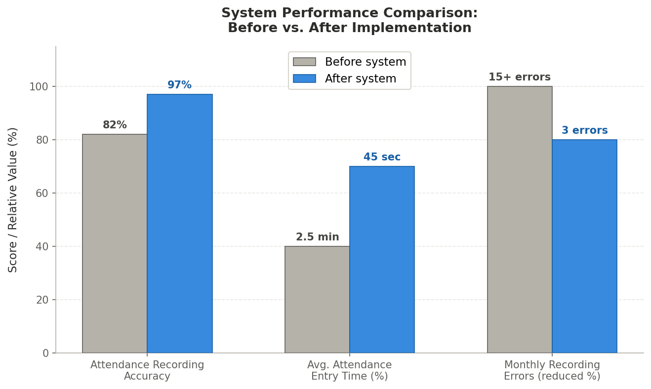
Figure 1: System Performance Comparison — Before vs. After Implementation (Bar Chart). Shows attendance recording accuracy improved from 82% to 97%, average entry time reduced from 2.5 minutes to 45 seconds, and monthly errors reduced from 15+ to 3 after system implementation.

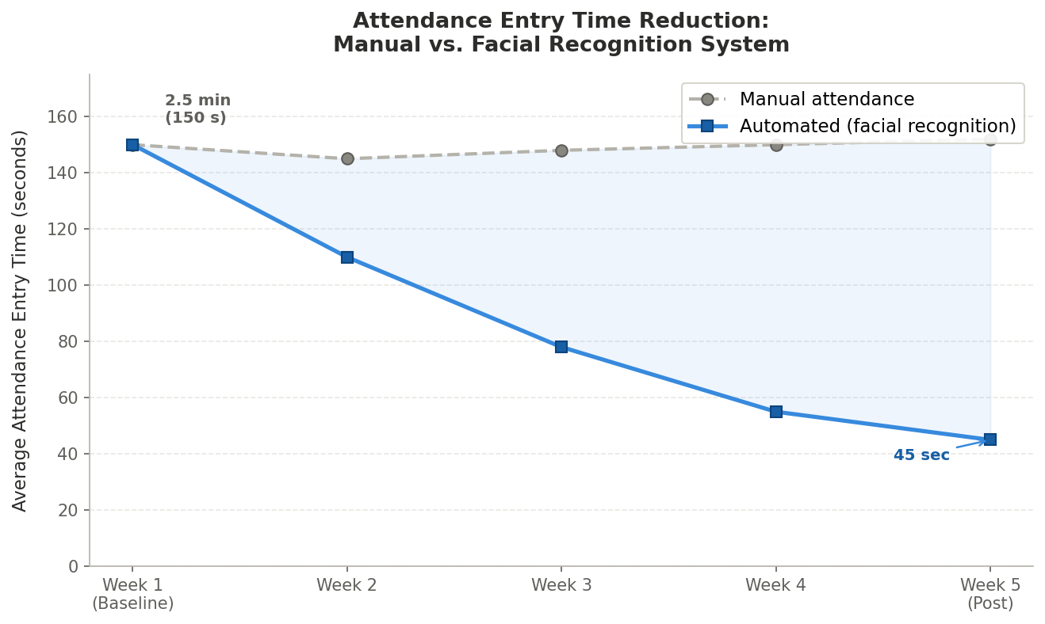
Figure 2: Attendance Entry Time Reduction — Manual vs. Facial Recognition System (Line Graph). Shows the progressive reduction in average attendance entry time from 150 seconds (2.5 minutes) in Week 1 to 45 seconds by Week 5 post-implementation.

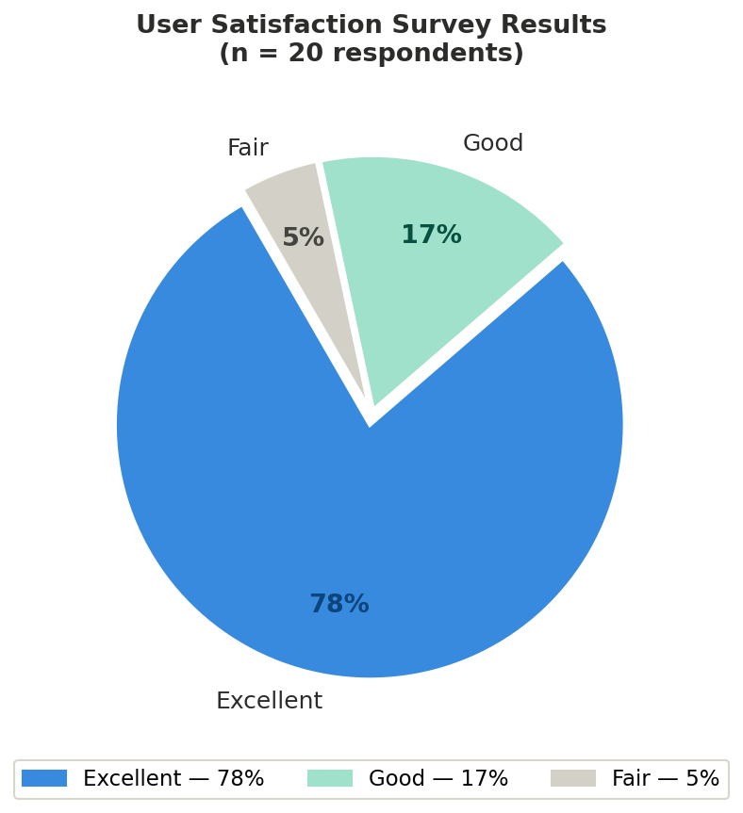
Figure 3: User Satisfaction Survey Results (Pie Chart). Of 20 respondents, 78% rated the system as Excellent, 17% as Good, and 5% as Fair.

4.4 Explanation of Each Figure
Figure 1 — System Performance Comparison (Bar Chart). The bar chart clearly shows that attendance recording accuracy improved from 82% to 97% after the system was implemented. Average attendance entry time was reduced from 2.5 minutes to 45 seconds, representing a reduction of over 70%. Monthly recording errors dropped sharply from more than 15 per month to only 3, confirming that the automated facial recognition and schedule-validation process significantly reduced human error in attendance management.
Figure 2 — Attendance Entry Time Reduction (Line Graph). The line graph illustrates the progressive decrease in attendance entry time across the five-week testing period. The manual attendance line remained flat at approximately 150 seconds throughout, while the automated system line showed a consistent decline from 150 seconds in Week 1 to 45 seconds by Week 5 as the system's recognition accuracy improved. The growing gap between the two lines demonstrates the increasing efficiency advantage of the facial recognition system over time.
Figure 3 — User Satisfaction Survey Results (Pie Chart). The pie chart presents the satisfaction ratings given by the 20 respondents who participated in the evaluation. The majority of respondents rated the system positively, with 78% selecting Excellent, 17% selecting Good, and 5% selecting Fair. No respondents rated the system as Poor or Very Poor. These results indicate strong overall user acceptance of the AttenTrack: Facial Recognition Attendance Tracking and Recording System.

4.5 System Performance and Testing
The system was tested under various conditions to evaluate its functionality, reliability, and performance. Testing scenarios included simultaneous Admin and Teacher portal logins, facial recognition under varying lighting conditions, schedule validation logic for students with and without active schedules, and retrieval of attendance data for reporting. All core features functioned as expected, and the system handled multiple concurrent requests without crashing or performance degradation.

4.5.1 Evaluation of Software Performance
Response Time: The system recorded an average response time of 1.2 seconds for standard page loads and attendance data queries, which is within acceptable limits for a school-based web application.
Facial Recognition Accuracy: The camera station correctly identified registered students in 97% of test cases under standard indoor lighting conditions. Accuracy dropped slightly under poor lighting, which was noted as an environmental limitation.
Schedule Validation Accuracy: The schedule validation logic correctly confirmed or rejected attendance entries in 100% of test cases, ensuring that only students with an active schedule at the current time were logged as present.
Error Rate: The system recorded an error rate of less than 1% across all test sessions, with no critical failures observed during the testing period.
System Uptime: The system maintained 99% uptime throughout the testing phase, with no unplanned downtime recorded.

4.6 User Feedback, Testing Results, and Accuracy Rates
User testing was conducted with 20 respondents comprising school administrators and teachers from the target institution. Respondents interacted with the system through guided testing sessions and subsequently completed the survey questionnaire. Most respondents appreciated the clean, role-specific interface and the clear separation of administrative and teacher functions. Administrators found the student management, schedule creation, and attendance download features straightforward to use. Teachers valued the simplicity of the Teacher portal, which allowed them to view their assigned students and schedules without navigating unnecessary features. The camera-based attendance station was identified as the most notable feature, as students could simply approach the camera and have their attendance recorded automatically without any teacher involvement.

4.6.1 Key Findings
System Preference. 94% of respondents stated they preferred the proposed AttenTrack: Facial Recognition Attendance Tracking and Recording System over the current manual attendance process used in the school.
Error Reduction. Attendance recording errors dropped by over 75% during the testing period, decreasing from an average of 15 or more errors per month under the manual system to only 3 errors per month with the automated system.
Most Valued Features. Respondents identified the automatic facial recognition attendance recording (no teacher login required), downloadable attendance reports, and schedule management and assignment features as the most useful components of the system.
Interface Usability. 90% of respondents agreed that the system interface was easy to navigate, and 85% stated that they would be willing to adopt the system for regular school use with minimal training.

4.7 Summary of Significant Results
The results of the testing and evaluation confirmed that the AttenTrack: Facial Recognition Attendance Tracking and Recording System achieved its intended objectives. Attendance recording accuracy improved significantly, manual errors were reduced, administrative tasks were completed faster, and respondents expressed strong satisfaction with the system. The automated camera station eliminated the need for teacher-conducted roll calls, and the role-based portal structure ensured that each user could access only the functions relevant to their responsibilities.

4.7.1 Comparison of Results with Expected Outcomes
The table below compares the expected outcomes defined in the study objectives against the actual results achieved during testing and evaluation.

Metric | Before System | After System
Attendance Recording Accuracy | 82% | 97%
Average Attendance Entry Time | 2.5 mins | 45 seconds
Monthly Recording Errors | 15+ | 3
User Satisfaction Rating | — | 4.7/5

4.8 Analysis and Interpretation

Data Analysis
The collected data was analyzed to measure the system's performance in terms of accuracy, speed, and user satisfaction. Quantitative data such as attendance recording accuracy rates and error counts were compared before and after implementation. The weighted mean was used to interpret Likert-scale survey responses on feature importance and user satisfaction, while frequency counts and percentage distributions were used to summarize multiple-choice responses.

Breakdown of Results
Attendance recording accuracy improved from 82% to 97%, demonstrating that the facial recognition and schedule validation mechanism effectively replaced error-prone manual methods.
Average attendance entry time dropped from 2.5 minutes per session to 45 seconds, improving the efficiency of the attendance process by over 70% and freeing up instructional time.
User feedback was strongly positive, with 94% of respondents preferring the new system and 78% rating their overall experience as Excellent.
Recording errors decreased from more than 15 per month to only 3 per month after system implementation, confirming that automation substantially reduced data entry mistakes.

4.9 Explanation of Trends, Patterns, or Anomalies

Comparative Evaluation
The results revealed a consistent pattern: the greater the degree of automation applied to attendance recording and schedule management tasks, the fewer errors occurred and the faster tasks were completed. The facial recognition camera station, which required no teacher action, produced the most significant improvement in both speed and accuracy. Administrators who previously spent time correcting manually entered records reported a marked reduction in administrative workload after the system was deployed.
One notable trend observed during testing was the slight reduction in facial recognition accuracy under poor lighting conditions. This was flagged as an environmental limitation and addressed in part through user guidance, though it remains a constraint for deployment in poorly lit areas.

Comparison with Related Studies or Existing Systems
Compared to traditional manual attendance systems, the AttenTrack: Facial Recognition Attendance Tracking and Recording System performed better across all measured metrics. The findings are consistent with prior studies reviewed in Chapter 2. Smitha et al. (2020) reported that facial recognition-based attendance systems significantly reduced roll-call time and eliminated proxy attendance in school settings, which aligns with the accuracy improvements observed in this study. Bondoc (2023) similarly found that automated web-based attendance systems reduced recording errors and removed the need for teacher-operated roll calls, consistent with the results of the present study. Najaf et al. (2023) confirmed that a Laravel-based web application with role-based access effectively met school administrative needs, reinforcing the system architecture choices made in this research.

4.10 Identification of Strengths and Limitations

Strengths
Login-free facial recognition attendance. The camera station automatically records student attendance without any teacher involvement, eliminating roll calls and preventing proxy attendance.
Role-based access control. The strict separation of Admin and Teacher portals ensures that each user accesses only the functions relevant to their role, improving security and reducing user confusion.
Schedule-validated attendance recording. The system cross-checks each student's schedule before logging attendance, ensuring that only students with an active class at the current time are recorded as present.
Downloadable attendance reports. Administrators can filter and download attendance records in CSV or PDF format, simplifying the generation of reports for school management.
High user satisfaction. 94% of respondents preferred the system over the manual process, and 78% rated their experience as Excellent, indicating strong user acceptance.

Limitations
Environmental lighting dependency. Facial recognition accuracy was slightly reduced under poor lighting conditions, which may affect performance in areas with inadequate lighting infrastructure.
Onboarding requirement for first-time users. Some first-time users, particularly those less familiar with web-based systems, required brief orientation before they could navigate the portals independently.
Limited testing scope. The system was tested within a single institution in a controlled environment. Results may differ when deployed in larger schools or institutions with different infrastructure.
Internet dependency. The system requires a stable network connection for the Admin and Teacher portals to function. Disruptions to the school network will temporarily prevent access to the system.

Impact on the Information Technology Field
The AttenTrack: Facial Recognition Attendance Tracking and Recording System contributes to the field of Information Technology by demonstrating how facial recognition technology, schedule-based validation logic, and role-based web application design can be integrated to solve a practical, real-world administrative problem in educational institutions. The system addresses a gap in existing school management tools by combining automated biometric attendance recording with a structured schedule management system, removing the dependency on teacher intervention entirely.

Contribution to Technological Advancements
Here is the revised version:
This project demonstrates that combining a facial recognition-based attendance station with a role-based web portal can significantly improve school administrative efficiency. It supports the broader shift toward digitally integrated school management systems in the Philippines and validates the use of open-source frameworks such as Flask and Python-based facial recognition libraries as practical tools for building reliable school-level applications. The system's design — particularly the separation of the attendance recording mechanism from the administrative and teacher portals — presents a model that could be extended to other institutional settings requiring automated identity verification and schedule-based access control.

Code Impression: System Overview
================================================================
FILE: requirements.txt
================================================================

Flask
mysql-connector-python
opencv-python
numpy
face_recognition
dlib
requests
Pillow

================================================================
FILE: mysql.py
================================================================

from flaskext.mysql import MySQL

mysql = MySQL()

================================================================
FILE: message.py
================================================================

# Una pip install requests
import requests
import os

BASE_URL = 'https://api.textbee.dev/api/v1'
API_KEY = os.environ.get("TEXTBEE_API_KEY")
DEVICE_ID = os.environ.get("TEXTBEE_DEVICE_ID")

def send_attendance_sms(guardian_number, student_name, time_in, status_text):
"""Send SMS notification when student attendance is recorded."""
if not guardian_number:
print("No guardian number provided.")
return

formatted_number = guardian_number

message = f"{student_name} {status_text} {time_in}."

response = requests.post(
f"{BASE_URL}/gateway/devices/{DEVICE_ID}/send-sms",
json={
"recipients": [formatted_number],
"message": message
},
headers={"x-api-key": API_KEY}
)

print("SMS Response:", response.json())

================================================================
FILE: main.py
================================================================

from flask import Flask, render_template, request, redirect, url_for, session, jsonify, flash
from admin import admin, os
from time_in_out import time_in_out
from mysql import mysql
import csv
import numpy as np
from datetime import datetime
import cv2
import face_recognition
from message import send_attendance_sms

app = Flask(__name__)
app.secret_key = os.environ.get("SECRET_KEY", "fallback_secret_for_local")
app.config['MYSQL_DATABASE_USER'] = os.environ.get("MYSQL_USER", "root")
app.config['MYSQL_DATABASE_PASSWORD'] = os.environ.get("MYSQL_PASSWORD", "DNCMES@2025_noVember11")
app.config['MYSQL_DATABASE_DB'] = os.environ.get("MYSQL_DB", "ams")
app.config['MYSQL_DATABASE_HOST'] = os.environ.get("MYSQL_HOST", "localhost")

mysql.init_app(app)
app.register_blueprint(admin, url_prefix="/admin")
app.register_blueprint(time_in_out, url_prefix="/time_in_out")

SAVE_DIR = os.path.join("static", "known_faces")
os.makedirs(SAVE_DIR, exist_ok=True)

CSV_DIR = os.path.join("static", "attendance_csv")
os.makedirs(CSV_DIR, exist_ok=True)

datetoday = datetime.now().strftime("%m_%d_%y")
yeartoday = datetime.now().year
schoolyear = f"{yeartoday} - {yeartoday+1}"

known_face_encodings = []
known_face_names = []

def load_known_faces():
global known_face_encodings, known_face_names
known_face_encodings.clear()
known_face_names.clear()

for student_folder in os.listdir(SAVE_DIR):
student_path = os.path.join(SAVE_DIR, student_folder)
if not os.path.isdir(student_path):
continue
encodings = []
for filename in os.listdir(student_path):
if filename.lower().endswith(('.jpg', '.jpeg', '.png')):
img_path = os.path.join(student_path, filename)
image = face_recognition.load_image_file(img_path)
face_enc = face_recognition.face_encodings(image)
if face_enc:
encodings.append(face_enc[0])
if encodings:
mean_encoding = np.mean(encodings, axis=0)
known_face_encodings.append(mean_encoding)
known_face_names.append(student_folder)

load_known_faces()

def get_db_cursor():
conn = mysql.connect()
cursor = conn.cursor()
return cursor, conn

def false_login():
flash("Please Login first", 'error')
return redirect(url_for('login_teacher_form'))

@app.route('/')
def index():
return render_template("index.html")

@app.route('/login_teacher_form', methods=["POST", "GET"])
def login_teacher_form():
return render_template("user/forms/login_teacher.html")

@app.route('/user_home', methods=["POST", "GET"])
def user_home():
if session.get('teacher_logged_in') == True:
teacherinfo = session.get('logged_teacher')
cursor, conn = get_db_cursor()
cursor.execute('SELECT * FROM class_schedules WHERE teacher_id=%s', (session.get('teacher_id')))
class_scheds = cursor.fetchall()
return render_template("user/teacher_index.html", logged_teacher=teacherinfo, class_scheds=class_scheds)
else:
return false_login()

@app.route('/login_teacher', methods=["POST", "GET"])
def login_teacher():
if request.method == "POST":
teacher_id = int(request.form["teacher_id"])
teacher_pass = str(request.form["teacher_pass"])
cursor, conn = get_db_cursor()
cursor.execute(
"SELECT * FROM teacher_accounts WHERE teacher_ID=%s AND teacher_password=%s",
(teacher_id, teacher_pass)
)
teacher = cursor.fetchone()
if not teacher:
flash('No Account Found', 'error')
return redirect(url_for('login_teacher_form'))
if teacher[6] == f"{teacher_id}":
session["temp_teacher_id"] = teacher[0]
session["temp"] = True
return redirect(url_for('update_teacher_password_form'))
session["teacher_logged_in"] = True
session["teacher_id"] = teacher[0]
session["teacher_pass"] = teacher[6]
session["teacher_name"] = teacher[2]
session["logged_teacher"] = teacher
return redirect('user_home')
else:
return false_login()

@app.route('/update_teacher_password_form')
def update_teacher_password_form():
if session.get('temp') == True:
session['teacher_id'] = session.get('temp_teacher_id')
return render_template("user/forms/update_teacher_password_form.html")
else:
return false_login()

@app.route("/update_teacher_password", methods=['POST'])
def update_teacher_password():
if request.method == "POST":
teacher_id = session.get('teacher_id')
new_pass = request.form["teacher_id"]
pass_confirm = request.form["teacher_pass"]
cursor, conn = get_db_cursor()
if new_pass == pass_confirm:
has_upper = any(c.isupper() for c in new_pass)
symbols = "!@#$%^&*(),.?\":{}|<>"
has_symbol = any(c in symbols for c in new_pass)
valid_passlen = len(new_pass) >= 8
if not has_upper or not has_symbol:
flash("Password must contain at least one uppercase letter and at least one symbol", 'error')
return redirect(url_for('update_teacher_password_form', teacher_id=teacher_id))
if not valid_passlen:
flash("Password too short", 'error')
return redirect(url_for('update_teacher_password_form', teacher_id=teacher_id))
else:
cursor.execute(
"UPDATE `ams`.`teacher_accounts` SET `teacher_password` = %s WHERE (`teacher_ID` = %s);",
(new_pass, teacher_id)
)
conn.commit()
cursor.close()
flash("Successfully Updated Password, Login to continue", 'success')
return redirect(url_for('login_teacher_form'))
else:
flash("Password didn't match", 'error')
return redirect(url_for('update_teacher_password_form'))

@app.route('/view_student_list')
def view_student_list():
if session.get('teacher_logged_in') == True:
teacher_id = int(session.get('teacher_id'))
cursor, conn = get_db_cursor()
query = """
SELECT DISTINCT student_id
FROM student_schedule_enrollments
WHERE teacher_id = %s
"""
cursor.execute(query, (teacher_id,))
student_ids = cursor.fetchall()
student_details = []
for student in student_ids:
student_id = student[0]
cursor.execute("SELECT * FROM student_info WHERE student_id = %s", (student_id,))
info = cursor.fetchone()
if info:
student_details.append(info)
cursor.close()
return render_template("user/student_list.html", student_lists=student_details,
logged_teacher=session.get('logged_teacher'), schoolyear=schoolyear)
else:
return false_login()

@app.route('/attendance_record', methods=["POST", "GET"])
def attendance_record():
if session.get('teacher_logged_in') == True:
logged_teacher = session.get('logged_teacher')
cursor, conn = get_db_cursor()
cursor.execute('SELECT * FROM `attendance_logs` WHERE teacher_id=%s', (session.get('teacher_id')))
csv_files = cursor.fetchall()
return render_template("user/attendance_record.html", logged_teacher=logged_teacher, csv_files=csv_files)
else:
return false_login()

@app.route('/class_schedules', methods=["POST", "GET"])
def class_schedules():
if session.get('teacher_logged_in') == True:
logged_teacher = session.get('logged_teacher')
cursor, conn = get_db_cursor()
cursor.execute('SELECT * FROM class_schedules WHERE teacher_id=%s', (session.get('teacher_id')))
class_scheds = cursor.fetchall()
teacher_name = session.get('teacher_name')
return render_template("user/class_schedules.html", class_scheds=class_scheds,
teacher_name=teacher_name, logged_teacher=logged_teacher)
else:
return false_login()

@app.route('/view_students_by_schedule/<int:schedule_id>', methods=["POST", "GET"])
def view_students_by_schedule(schedule_id):
if session.get('teacher_logged_in') == True:
logged_teacher = session.get('logged_teacher')
cursor, conn = get_db_cursor()
query = "SELECT * FROM student_schedule_enrollments WHERE schedule_id=%s"
cursor.execute(query, (schedule_id,))
student_lists = cursor.fetchall()
cursor.execute("SELECT * FROM class_schedules WHERE schedule_id=%s", (schedule_id,))
fetched_sched = cursor.fetchone()
return render_template("user/students_by_schedule.html", student_lists=student_lists,
sched_info=fetched_sched, logged_teacher=logged_teacher)
else:
return false_login()

@app.route("/take_attendance/<int:schedule_id>/<schedule_name>", methods=["POST", "GET"])
def take_attendance(schedule_id, schedule_name):
if session.get('teacher_logged_in') == True:
cursor, conn = get_db_cursor()
teacher_id = int(session.get("teacher_id"))
load_known_faces()
os.makedirs(CSV_DIR, exist_ok=True)
csv_name = f"{schedule_name}_{datetoday}_Attendance.csv"
csv_path = os.path.join(CSV_DIR, csv_name)
if not os.path.exists(csv_path):
with open(csv_path, "w", newline="") as f:
csv.writer(f).writerow(["student_id", "student_name", "time_in"])
cursor.execute("""
INSERT INTO attendance_logs (schedule_id, filename, csv_path, teacher_id)
VALUES (%s, %s, %s, %s)
""", (schedule_id, csv_name, csv_path, teacher_id))
conn.commit()

logged_students = set()
video = cv2.VideoCapture(0)
status_text = "Waiting for face..."

while True:
ret, frame = video.read()
if not ret:
break
frame = cv2.flip(frame, 2)
height, width = frame.shape[:2]
bw, bh = 300, 300
x1, y1 = width // 2 - bw // 2, height // 2 - bh // 2
x2, y2 = x1 + bw, y1 + bh
cv2.rectangle(frame, (x1, y1), (x2, y2), (0, 255, 0), 2)
cv2.putText(frame, status_text, (20, 40),
cv2.FONT_HERSHEY_SIMPLEX, 0.8, (255, 255, 255), 2)
small = cv2.resize(frame, (0, 0), fx=0.25, fy=0.25)
rgb = cv2.cvtColor(small, cv2.COLOR_BGR2RGB)
faces = face_recognition.face_locations(rgb, model="hog")
encodings = face_recognition.face_encodings(rgb, faces)

if faces:
status_text = "Detecting..."
else:
status_text = "Waiting for face..."

for (top, right, bottom, left), face_encoding in zip(faces, encodings):
matches = face_recognition.compare_faces(known_face_encodings, face_encoding, tolerance=0.5)
name = "Unknown"
color = (0, 0, 255)

if True in matches:
index = matches.index(True)
id = known_face_names[index]
student_id = int(id)
cursor.execute("""
SELECT student_id, student_name
FROM student_schedule_enrollments
WHERE schedule_id = %s AND student_id=%s
""", (schedule_id, student_id))
existinfo = cursor.fetchone()

if existinfo:
student_name = existinfo[1]
student_id_for_record = student_id
name = student_name
color = (0, 255, 0)
status_text = f"Recognized: {student_name}"

if name not in logged_students:
cursor.execute("SELECT guardian_contact FROM student_info WHERE student_id = %s", (student_id,))
contact = cursor.fetchone()
guardian_contact = contact[0] if contact else None

cursor.execute("""
SELECT schedule, start_time, end_time
FROM class_schedules WHERE schedule_id = %s
""", (schedule_id,))
sched_time = cursor.fetchone()
schedule, start_time, end_time = sched_time if sched_time else (None, None, None)

time_in = datetime.now().strftime("%H:%M:%S")
now = datetime.strptime(time_in, "%H:%M:%S").time()
day_now = datetime.now().strftime("%A")

already_logged = False
if os.path.exists(csv_path):
with open(csv_path, "r") as f:
for row in csv.reader(f):
if row and row[0] == str(student_id_for_record):
already_logged = True
break

if already_logged:
status_text = f"{student_name} already logged"
elif start_time and end_time:
start_str = str(start_time)
end_str = str(end_time)
if len(start_str) == 5:
start_str += ":00"
if len(end_str) == 5:
end_str += ":00"
start = datetime.strptime(start_str, "%H:%M:%S").time()
end = datetime.strptime(end_str, "%H:%M:%S").time()

if day_now == schedule:
if now < start:
status = "Early"
elif start <= now <= end:
status = "Present"
else:
status_text = f"{student_name} not logged (past class time)"
status = None
color = (0, 0, 255)

if status:
with open(csv_path, "a", newline="") as f:
csv.writer(f).writerow([student_id_for_record, student_name, time_in, status])
logged_students.add(name)
status_text = f"{student_name} marked {status}"
if guardian_contact:
send_attendance_sms(guardian_contact, student_name, time_in)
else:
status_text = "Schedule is not Today"
else:
status_text = "Class time not found"
else:
color = (0, 0, 255)
status_text = "Not in this Schedule, scan next student"
name = "Unknown"
else:
status_text = "Face not recognized"

scale = 4
top, right, bottom, left = [v * scale for v in (top, right, bottom, left)]
cv2.rectangle(frame, (left, top), (right, bottom), color, 2)
cv2.rectangle(frame, (left, bottom - 35), (right, bottom), color, cv2.FILLED)
cv2.putText(frame, name, (left + 6, bottom - 6),
cv2.FONT_HERSHEY_DUPLEX, 0.8, (255, 255, 255), 1)

cv2.imshow("Taking Attendance (press 'q' to quit)", frame)
if cv2.waitKey(1) & 0xFF == ord("q"):
break

video.release()
cv2.destroyAllWindows()
return redirect(url_for("user_home"))
else:
return false_login()

@app.route("/search_students")
def search_students():
query = request.args.get("query", "")
teacher_id = session.get('teacher_id')
cursor, conn = get_db_cursor()
sql_students = """
SELECT student_id, student_first_name, student_middle_name, student_last_name
FROM student_info
WHERE teacher_id = %s AND student_id LIKE %s
ORDER BY student_last_name
"""
cursor.execute(sql_students, (teacher_id, f"%{query}%"))
students = cursor.fetchall()
sql_scheds = """
SELECT * FROM class_schedules
WHERE teacher_id = %s
ORDER BY start_time
"""
cursor.execute(sql_scheds, (teacher_id,))
scheds = cursor.fetchall()
cursor.close()
data = {
"students": [
{"student_id": s[0], "first_name": s[1], "middle_name": s[2], "last_name": s[3]}
for s in students
],
"schedules": scheds
}
return jsonify(data)

@app.route('/sign_out')
def sign_out():
session.clear()
flash('You have been logged out', 'success')
return redirect(url_for('index'))

@app.route('/sign_out_admin')
def sign_out_admin():
session.clear()
flash('Admin logged out', 'success')
return redirect(url_for("index"))

if __name__ == '__main__':
app.run(host='0.0.0.0', port=5000, debug=True)

================================================================
FILE: time_in_out.py
================================================================

from flask import Blueprint, render_template, request, redirect, url_for, session, jsonify, flash
from mysql import mysql
import os
import csv
import numpy as np
import cv2
import face_recognition
from datetime import datetime, time
from message import send_attendance_sms
import base64

time_in_out = Blueprint("time_in_out", __name__, static_folder="static", template_folder="templates")

SAVE_DIR = 'static/known_faces'
os.makedirs(SAVE_DIR, exist_ok=True)

datetoday = datetime.now().strftime("%m_%d_%y")
CSV_DIR = 'static/time_in_out__csv'
os.makedirs(CSV_DIR, exist_ok=True)

yeartoday = datetime.now().year
schoolyear = f"{yeartoday} - {yeartoday+1}"

known_face_encodings = []
known_face_names = []

def get_db_cursor():
conn = mysql.connect()
cursor = conn.cursor()
return cursor, conn

def load_known_faces():
global known_face_encodings, known_face_names
known_face_encodings.clear()
known_face_names.clear()
for student_folder in os.listdir(SAVE_DIR):
student_path = os.path.join(SAVE_DIR, student_folder)
if not os.path.isdir(student_path):
continue
encodings = []
for filename in os.listdir(student_path):
if filename.lower().endswith(('.jpg', '.jpeg', '.png')):
img_path = os.path.join(student_path, filename)
image = face_recognition.load_image_file(img_path)
face_enc = face_recognition.face_encodings(image)
if face_enc:
encodings.append(face_enc[0])
if encodings:
mean_encoding = np.mean(encodings, axis=0)
known_face_encodings.append(mean_encoding)
known_face_names.append(student_folder)

load_known_faces()

face_cascade = cv2.CascadeClassifier("static/haarcascade_frontalface_default.xml")

@time_in_out.route('/take_attendance_page', methods=["POST", "GET"])
def take_attendance_page():
return render_template('time_in_out_page.html')

@time_in_out.route("/take_attendance_cam", methods=["POST", "GET"])
def take_attendance_cam():
return render_template("take_attendace_cam.html")

def update_attendance(student_id, student_name):
cursor, conn = get_db_cursor()
os.makedirs(CSV_DIR, exist_ok=True)
csv_name = f"TimeIN_OUT({datetoday})_Record.csv"
csv_path = os.path.join(CSV_DIR, csv_name)
relative_path = csv_path.replace("\\", "/")

if not os.path.exists(csv_path):
with open(csv_path, "w", newline="") as f:
writer = csv.writer(f)
writer.writerow(["Date", "ID", "Name", "AM_IN", "AM_OUT", "PM_IN", "PM_OUT", "LAST_TIME_OUT"])
cursor.execute("""
INSERT INTO time_in_out_record_paths (record_id, csv_path, date)
VALUES (%s, %s, %s)
""", (0, relative_path, datetoday))
conn.commit()

records = []
found_entry = None
with open(csv_path, "r") as f:
reader = csv.reader(f)
next(reader)
for row in reader:
if row and row[1] == str(student_id) and row[0] == datetoday:
found_entry = row
records.append(row)

if not found_entry:
found_entry = [datetoday, student_id, student_name, "", "", "", "", ""]
records.append(found_entry)

AM_IN, AM_OUT, PM_IN, PM_OUT, LAST_TIME_OUT = 3, 4, 5, 6, 7
am_start, am_end = time(7, 0), time(11, 30)
pm_start, pm_end = time(13, 0), time(17, 0)
time_now = datetime.now().time()
time_now_str = datetime.now().strftime("%H:%M:%S")
status = ""
time_out_sms = False

if found_entry[AM_IN] == "":
if time_now <= am_start:
found_entry[AM_IN] = time_now_str
status = "AM Time In Early"
statuscat = "ok"
elif am_start <= time_now <= am_end:
found_entry[AM_IN] = time_now_str
status = "Success AM Time In"
statuscat = "ok"
else:
found_entry[AM_IN] = "absent"
found_entry[AM_OUT] = "absent"
found_entry[PM_IN] = time_now_str
status = "Missed AM, logged PM Time In"
statuscat = "error"
elif found_entry[AM_IN] != "" and found_entry[AM_OUT] == "":
if am_end <= time_now <= pm_start:
found_entry[AM_OUT] = time_now_str
status = "Success AM Time Out"
time_out_sms = True
statuscat = "ok"
else:
found_entry[AM_OUT] = f"{time_now_str}(Missed Time Out)"
found_entry[LAST_TIME_OUT] = time_now_str
status = f"Last time out AM {time_now_str}"
statuscat = "error"
elif found_entry[PM_IN] == "":
if pm_start <= time_now <= pm_end:
found_entry[PM_IN] = time_now_str
status = "Success PM Time In"
statuscat = "ok"
else:
found_entry[PM_IN] = f"{time_now_str} Late"
status = "PM Time In Late"
statuscat = "error"
elif found_entry[PM_OUT] == "":
if pm_start <= time_now <= pm_end:
found_entry[PM_OUT] = time_now_str
status = "Success PM Time Out"
time_out_sms = True
statuscat = "ok"
else:
found_entry[PM_OUT] = time_now_str
found_entry[LAST_TIME_OUT] = time_now_str
status = f"Last time out PM {time_now_str}"
statuscat = "ok"
else:
status = "Already logged"
statuscat = "error"

with open(csv_path, "w", newline="") as f:
writer = csv.writer(f)
writer.writerow(["Date", "ID", "Name", "AM_IN", "AM_OUT", "PM_IN", "PM_OUT", "LAST_TIME_OUT"])
writer.writerows(records)

statusfinal = f"Student Name:{student_name} STATUS: {status} "
statuscat = "ok"
return statusfinal, time_out_sms, statuscat

@time_in_out.route("/process_frame", methods=["POST"])
def process_frame():
try:
cursor, conn = get_db_cursor()
data = request.get_json()
if not data or "img" not in data:
return jsonify({"status": "No image sent", "faces": []})

img_b64 = data["img"].split(",")[1]
frame = cv2.imdecode(np.frombuffer(base64.b64decode(img_b64), np.uint8), cv2.IMREAD_COLOR)

small_frame = cv2.resize(frame, (0, 0), fx=0.25, fy=0.25)
rgb_small = cv2.cvtColor(small_frame, cv2.COLOR_BGR2RGB)
face_locations = face_recognition.face_locations(rgb_small)
face_encodings = face_recognition.face_encodings(rgb_small, face_locations)

statusfinal = "No face detected...Scan Again"
faces_output = []
statuscat = "error"

for (top, right, bottom, left), face_encoding in zip(face_locations, face_encodings):
matches = face_recognition.compare_faces(known_face_encodings, face_encoding, tolerance=0.5)
name = "Unknown"
time_out_sms = False

if True in matches:
index = matches.index(True)
student_id = known_face_names[index]
cursor.execute("""
SELECT student_id, student_first_name, student_middle_name,
student_last_name, student_suffix, guardian_contact
FROM student_info WHERE student_id=%s
""", (student_id,))
info = cursor.fetchone()
if info:
student_name = f"{info[3]}, {info[1]} {info[2]} {info[4]}"
statusfinal, time_out_sms, statuscat = update_attendance(student_id, student_name)
name = student_name
if info[5] and time_out_sms:
send_attendance_sms(info[5], student_name, datetime.now().strftime("%H:%M:%S"))
else:
statusfinal = "Face not recognized"
statuscat = "error"

scale = 4
faces_output.append({
"x": left * scale,
"y": top * scale,
"w": (right - left) * scale,
"h": (bottom - top) * scale,
"name": name
})

return jsonify({"status": statusfinal, "faces": faces_output, "statuscat": statuscat})

except Exception as e:
print("Error in process_frame:", e)
return jsonify({"status": "Server error: " + str(e), "faces": [], "statuscat": "error"})

================================================================
FILE: admin.py ================================================================
from flask import Blueprint, render_template, request, redirect, url_for, session, jsonify, flash
from mysql import mysql
import os
import csv
import numpy as np
import cv2
import face_recognition
from datetime import datetime

# Create Blueprint
admin = Blueprint("admin", __name__, static_folder="static", template_folder="templates")

SAVE_DIR = 'static/known_faces'
os.makedirs(SAVE_DIR, exist_ok=True)

#for csv file
datetoday = datetime.now().strftime("%m_%d_%y")
CSV_DIR = 'static/attendance_csv'
os.makedirs(CSV_DIR, exist_ok=True)

#inputs
datetoday = datetime.now().strftime("%m_%d_%y")
yeartoday = datetime.now().year
schoolyear = f"{yeartoday} - {yeartoday+1}"
known_face_encodings = []
known_face_names = []

def get_db_cursor():
conn = mysql.connect()
cursor = conn.cursor()
return cursor, conn
def not_logged():
flash('Log in as admin first', 'error')
return redirect(url_for('login_admin_form'))

def load_known_faces():
#Load all student photos and average their encodings per studen.
global known_face_encodings, known_face_names
known_face_encodings.clear()
known_face_names.clear()

for student_folder in os.listdir(SAVE_DIR):
student_path = os.path.join(SAVE_DIR, student_folder)
if not os.path.isdir(student_path):
continue

encodings = []
# Loop through each photo of that student
for filename in os.listdir(student_path):
if filename.lower().endswith(('.jpg', '.jpeg', '.png')):
img_path = os.path.join(student_path, filename)
image = face_recognition.load_image_file(img_path)
face_enc = face_recognition.face_encodings(image)
if face_enc:
encodings.append(face_enc[0])

if encodings:
mean_encoding = np.mean(encodings, axis=0)
known_face_encodings.append(mean_encoding)
known_face_names.append(student_folder) # folder name = student_id
# Load all faces once when app starts

########## ADMIN SIDE ##########

@admin.route('/login_admin_form', methods=["POST", "GET"])#login for admin PAGE
def login_admin_form():
return render_template("admin/forms/admin_login_page.html")

@admin.route('/admin_home', methods=["POST","GET"])
def admin_home():
if session.get('admin_logged_in')==True:
logged_admin= session.get('logged_admin')
return render_template("admin/admin_index.html",logged_admin=logged_admin)
else:
return not_logged()

@admin.route('/login_admin', methods=["POST","GET"])
def login_admin():
if request.method == "POST":
admin_id =request.form.get("admin_id","").strip()
admin_pass =request.form.get("admin_pass","").strip()

cursor,conn = get_db_cursor()
cursor.execute('SELECT * FROM admin_account WHERE admin_ID=%s and admin_password = %s',(admin_id,admin_pass))
valid_admin=cursor.fetchone()
if valid_admin:
session["admin_id"]=admin_id
session["admin_pass"]=admin_pass
session["admin_name"]=valid_admin[1]
session["admin_logged_in"]=True
cursor.execute('SELECT * FROM admin_account WHERE admin_ID=%s',(session.get('admin_id')))
logged_admin=cursor.fetchall()
if session.get('admin_logged_in')==True:
session["logged_admin"]=logged_admin
return redirect(url_for('admin.admin_home'))
else:
flash('Log In Failed', 'error')
return redirect(url_for('admin.login_admin_form'))
else:
flash('Oops! No Account found.', 'error')
return redirect(url_for('admin.login_admin_form'))
else:
flash('You are not logged in as Admin, Session failed!', 'error')
return redirect(url_for('index'))

@admin.route('/enrollStudentform',methods=["POST", "GET"])
def enrollStudentform():
if session.get('admin_logged_in')==True:

cursor, conn = get_db_cursor()
cursor.execute("SELECT DISTINCT grade_level FROM class_schedules")
avail_grade_level = [row[0] for row in cursor.fetchall()]

# cursor.execute('SELECT DISTINCT section FROM class_schedules WHERE teacher_id=%s',(session.get('teacher_id')))
# avail_section = [row[0] for row in cursor.fetchall()]
# print(avail_section)
# cursor.execute('SELECT DISTINCT subject FROM class_schedules WHERE teacher_id=%s',(session.get('teacher_id')))
# avail_subject = [row[0] for row in cursor.fetchall()]
# print(avail_subject)
return render_template("admin/forms/enroll_student_form.html",grade_level=avail_grade_level)
#,avail_grade_level=avail_grade_level,avail_section=avail_section,avail_subject=avail_subject,logged_teacher=logged_teacher

# if avail_grade_level or avail_section or avail_subject :

# else:
# pass
else:
return not_logged()

@admin.route("/enroll_student", methods=["POST", "GET"])
def enroll_student():
cursor, conn = get_db_cursor()

if request.method == "POST":
student_id = request.form['student_id']
student_first_name = request.form['student_first_name']
student_middle_name = request.form['student_middle_name']
student_last_name = request.form['student_last_name']
student_suffix = request.form['student_suffix']
student_age = request.form['student_age']
student_guardian = request.form['student_guardian']
guardian_contact = request.form['guardian_contact']
student_gradelevel = request.form['current_gradelevel']
student_section = request.form['section']

# Check if student already exists in DB
cursor.execute('SELECT * FROM student_info WHERE student_id = %s', [student_id])
student_exist = cursor.fetchone()
if student_exist:
flash('Student already enrolled.', 'error')
return redirect(url_for('admin.enrollStudentform'))

# Create a folder for this student (e.g. known_faces/101/)
student_dir = os.path.join(SAVE_DIR, str(student_id))
if not os.path.exists(student_dir):
os.makedirs(student_dir)

# Open webcam
cap = cv2.VideoCapture(0)
photo_count = 0
max_photos = 3 # capture up to 3 faces

while True:
ret, frame = cap.read()
if not ret:
break

frame = cv2.flip(frame, 2)
height, width = frame.shape[:2]
box_width, box_height = 300, 300
x1 = width // 2 - box_width // 2
y1 = height // 2 - box_height // 2
x2 = x1 + box_width
y2 = y1 + box_height

# Draw the face box
cv2.rectangle(frame, (x1, y1), (x2, y2), (0, 255, 0), 2)
cv2.putText(frame, f"Align face inside box. ({photo_count}/{max_photos})",
(x1, y1 - 10), cv2.FONT_HERSHEY_SIMPLEX, 0.6, (255, 255, 255), 2)
cv2.putText(frame, "Press 's' to Save | 'q' to Quit", (x1, y2 + 30),
cv2.FONT_HERSHEY_SIMPLEX, 0.6, (255, 255, 255), 1)

cv2.imshow("Student Enrollment", frame)
key = cv2.waitKey(1)

if key == ord('s'):
cropped_face = frame[y1:y2, x1:x2]

# Save image as 1.jpg, 2.jpg, 3.jpg
filename = f"{photo_count + 1}.jpg"
image_path = os.path.join(student_dir, filename)
cv2.imwrite(image_path, cropped_face)
print(f"Saved {image_path}")
photo_count += 1

if photo_count >= max_photos:
print("Collected enough images.")
break

elif key == ord('q'):
flash("Enrollment canceled by user.")
break

cap.release()
cv2.destroyAllWindows()

# If at least one photo was saved, save info to database
if photo_count > 0:
first_image_path = os.path.join(student_dir, "1.jpg").replace("\\", "/")
query = """
INSERT INTO student_info(
student_id, student_image_path, student_first_name, student_middle_name,
student_last_name, student_suffix, student_age, student_guardian,
guardian_contact, current_grade_level, section
) VALUES (%s,%s,%s,%s,%s,%s,%s,%s,%s,%s,%s)
"""
values = (
student_id, first_image_path, student_first_name, student_middle_name,
student_last_name, student_suffix, student_age, student_guardian,
guardian_contact, student_gradelevel, student_section
)
cursor.execute(query, values)
conn.commit()
cursor.close()
flash(f'Student {student_first_name} enrolled successfully with {photo_count} face images.', 'success')
else:
flash('No images were captured. Enrollment incomplete.', 'error')

return redirect(url_for('admin.enrollStudentform'))

return redirect(url_for('admin.student_list'))

@admin.route('/getSection_forEnroll', methods=["POST"])
def getSection_forEnroll():
grade_level = request.form['current_gradelevel']
cursor, conn = get_db_cursor()
cursor.execute("SELECT DISTINCT section FROM class_schedules WHERE grade_level=%s", [grade_level])
sections = cursor.fetchall()
return jsonify(sections)

@admin.route('/registerteacherform',methods=["POST", "GET"])
def registerteacherform():
if session.get('admin_logged_in')==True:
# logged_teacher= session.get('logged_admin')
photo = request.args.get('photo') # GET photo from camera
return render_template("admin/forms/register_teacher_form.html",photo=photo)
else:
return not_logged()

@admin.route('/register_teacher', methods=['POST'])
def register_teacher():
cursor, conn = get_db_cursor()

teacher_id = request.form.get('teacher_id')
teacher_fname = request.form.get('teacher_first_name')
teacher_mname = request.form.get('teacher_middle_name')
teacher_lname = request.form.get('teacher_last_name')
teacher_suffix = request.form.get('teacher_suffix')
teacher_default_pass = teacher_id # default password

cursor.execute("SELECT teacher_ID FROM teacher_accounts WHERE teacher_ID = %s", (teacher_id,))
teacher_exist =cursor.fetchone()
if teacher_exist:
flash(f"Teacher already exists!", 'error')
return redirect(url_for('admin.registerteacherform'))
else:
# photo capture/hidden input
camera_photo = request.form.get('captured_photo') # e.g. "20250114_153000.jpg"

# uploaded photo
uploaded_file = request.files.get('teacher_photo')

final_photo = None
UPLOAD_FOLDER = 'static/ADMIN/teacher_profpic'

if camera_photo:
# Full path of the captured photo
original_path = os.path.join(UPLOAD_FOLDER, camera_photo)

if os.path.exists(original_path):
# Keeping original extension
_, ext = os.path.splitext(camera_photo)
# Rename using teacher_id
new_filename = f"{teacher_id}{ext}"
new_path = os.path.join(UPLOAD_FOLDER, new_filename)

# Rename the saved file in folder
os.rename(original_path, new_path)
final_photo = new_path
elif uploaded_file and uploaded_file.filename != "":
# Save uploaded photo manually
photo_ext = uploaded_file.filename.rsplit('.', 1)[1]
photo_filename = f"{teacher_id}.{photo_ext}"
upload_path = os.path.join(UPLOAD_FOLDER, photo_filename)
uploaded_file.save(upload_path)
final_photo = upload_path

query = """
INSERT INTO teacher_accounts(
teacher_ID, teacher_fname, teacher_mname, teacher_lname,
teacher_suffix, teacher_password, teacher_profile
) VALUES (%s, %s, %s, %s, %s, %s, %s)
"""
cursor.execute(query, (
teacher_id, teacher_fname, teacher_mname, teacher_lname,
teacher_suffix, teacher_default_pass, final_photo
))
conn.commit()

flash('Teacher Successfully Registered!', 'success')
return redirect(url_for('admin.registerteacherform'))

@admin.route('/registered_teacher_list') #list of all teachers
def registered_teacher_list():
if session.get('admin_logged_in')==True:
cursor, conn = get_db_cursor()

query = """
SELECT *
FROM teacher_accounts
"""
cursor.execute(query)
registered_teacher_lists = cursor.fetchall()

cursor.close()

return render_template("admin/registered_teacher_list.html", registered_teacher_lists=registered_teacher_lists)
else:
return not_logged()

@admin.route('/update_teacher_form/<int:teacher_id>',methods=["POST", "GET"])
def update_teacher_form(teacher_id):
if session.get('admin_logged_in')==True:
session['update_teacher_id'] = teacher_id
cursor, conn = get_db_cursor()
photo = request.args.get('photo')

query = """
SELECT *
FROM teacher_accounts
WHERE teacher_id =%s
"""
cursor.execute(query,(teacher_id))
teacher_info = cursor.fetchone()

cursor.close()

return render_template("admin/forms/update_teacher_form.html",teacher_info=teacher_info, photo = request.args.get('photo'))
else:
return not_logged()

@admin.route('/update_teacher', methods=['POST'])
def update_teacher():
if not session.get('admin_logged_in'):
return not_logged()

teacher_id = session.get('update_teacher_id')
if not teacher_id:
flash("No teacher selected for update.", "error")
return redirect(url_for('admin.teacherlist'))

cursor, conn = get_db_cursor()

# Get form data
new_teacher_id =request.form.get('teacher_id')
teacher_fname = request.form.get('teacher_first_name')
teacher_mname = request.form.get('teacher_middle_name')
teacher_lname = request.form.get('teacher_last_name')
teacher_suffix = request.form.get('teacher_suffix')

UPLOAD_FOLDER = 'static/ADMIN/teacher_profpic'
if new_teacher_id:
old_photo_path = os.path.join(UPLOAD_FOLDER, f"{teacher_id}.jpg")
new_TI_filename = f"{new_teacher_id}.jpg"
new_TI_path = os.path.join(UPLOAD_FOLDER, new_TI_filename)
os.rename(old_photo_path, new_TI_path)

camera_photo = request.form.get('captured_photo')
uploaded_file = request.files.get('teacher_photo')

final_photo = f"static/ADMIN/teacher_profpic/{new_TI_filename}"

# If camera photo exists, rename it with teacher ID
if camera_photo:
# Full path of the captured photo
original_path = os.path.join(UPLOAD_FOLDER, camera_photo)

if os.path.exists(original_path):
# Delete any existing teacher photo with any extension
for ext in ["jpg", "jpeg", "png", "gif"]:
old_photo = os.path.join(UPLOAD_FOLDER, f"{teacher_id}.{ext}")
if os.path.exists(old_photo):
os.remove(old_photo)

# Rename the captured photo to teacher_id.jpg
new_filename = f"{new_teacher_id}.jpg"
new_path = os.path.join(UPLOAD_FOLDER, new_filename)
os.rename(original_path, new_path)

final_photo = f"static/ADMIN/teacher_profpic/{new_filename}"

# If manually uploaded photo
elif uploaded_file and uploaded_file.filename != "":
photo_ext = uploaded_file.filename.rsplit('.', 1)[1]
photo_filename = f"{new_teacher_id}.{photo_ext}"
upload_path = os.path.join(UPLOAD_FOLDER, photo_filename)
uploaded_file.save(upload_path)
final_photo = f"static/ADMIN/teacher_profpic/{photo_filename}"

cursor.execute("""
UPDATE teacher_accounts
SET teacher_id=%s,
teacher_fname = %s,
teacher_mname = %s,
teacher_lname = %s,
teacher_suffix = %s,
teacher_profile = COALESCE(%s, teacher_profile)
WHERE teacher_id = %s
""", ( int(new_teacher_id),teacher_fname, teacher_mname, teacher_lname, teacher_suffix,
final_photo, teacher_id
))
cursor.execute("""
UPDATE class_schedules
SET teacher_id=%s
WHERE teacher_id = %s
""", ( int(new_teacher_id),teacher_id))

conn.commit()
cursor.close()

flash("Teacher information updated successfully!", "success")
return redirect(url_for('admin.registered_teacher_list'))

@admin.route('/remove_teacher_confirmation/<int:teacher_id>')
def remove_teacher_confirmation(teacher_id):
if session.get('admin_logged_in')==True:
cursor,conn = get_db_cursor()
cursor.execute('SELECT * FROM teacher_accounts WHERE teacher_id = %s',[teacher_id])
teacher_info=cursor.fetchone()

if teacher_info:
return render_template("admin/remove_teacher_confirmation.html",teacher_info=teacher_info)
else:
flash("cant find teacher",'error')
return redirect(url_for('admin.registered_teacher_list'))
else:
return not_logged()

@admin.route('/remove_teacher/<int:teacher_id>', methods=["POST", "GET"])
def remove_teacher(teacher_id):
if request.method == "POST":
cursor,conn = get_db_cursor()
cursor.execute('SELECT * FROM teacher_accounts WHERE teacher_id = %s',[teacher_id])
teacher=cursor.fetchone()

if teacher:
file_path = teacher[1]
full_path = os.path.join('static/files', file_path)

# Delete the photo in path
if os.path.exists(full_path):
os.remove(full_path)

cursor.execute("DELETE FROM teacher_accounts WHERE teacher_id = %s", (teacher_id,))
conn.commit()

flash("Teacher Removed",'ERROR')
cursor.close()
return redirect(url_for('admin.registered_teacher_list'))

@admin.route('/add_schedule_page',methods=["POST", "GET"])
def add_schedule_page():
if session.get('admin_logged_in')==True:
cursor, conn = get_db_cursor()
query = """
SELECT *
FROM teacher_accounts
"""
cursor.execute(query)
registered_teachers = cursor.fetchall()
return render_template("admin/forms/add_schedule_form.html",teacher_list=registered_teachers)
else:
return not_logged()

@admin.route('/add_schedule',methods=['POST','GET'])
def add_schedule():
cursor, conn = get_db_cursor()
if request.method == "POST":
class_gradeLevel = str(request.form.get("classGradeLevel"))
class_section = str(request.form.get("class_section"))
class_subject = str(request.form.get("class_subject"))
class_schedule = str(request.form.get("class_schedule"))
class_start_time = str(request.form.get("class_start_time"))
class_end_time = str(request.form.get("class_end_time"))
teacher_id = int(request.form.get("teacher_id"))

cursor.execute('SELECT * FROM teacher_accounts WHERE teacher_ID = %s', (teacher_id,))
teacher_info = cursor.fetchone()
teacher_name = f"{teacher_info[4]}, {teacher_info[2]} {teacher_info[3]} {teacher_info[5]}"
number_of_students = 0

check_sched = """
SELECT * FROM class_schedules
WHERE grade_level = %s
AND section = %s
AND subject = %s
AND schedule = %s
AND start_time = %s
AND end_time = %s
"""
cursor.execute(check_sched, (class_gradeLevel, class_section, class_subject, class_schedule, class_start_time, class_end_time))
existing_sched = cursor.fetchone()
if existing_sched:
flash("Class schedule already exists.", "warning")
else:
query="""INSERT INTO class_schedules(schedule_id,
grade_level, section, subject,schedule,
start_time, end_time, number_of_students,teacher,teacher_id
) VALUES (%s,%s, %s, %s, %s, %s, %s, %s, %s, %s)"""
values=(0,class_gradeLevel, class_section, class_subject, class_schedule, class_start_time, class_end_time,number_of_students,teacher_name,teacher_id)
cursor.execute(query,values)
conn.commit()
cursor.close()
flash("Class schedule successfully Added", "success")
return redirect(url_for('admin.add_schedule_page'))
else:
flash("Failed Request", "error")
return redirect(url_for('admin.add_schedule_page'))

@admin.route('/update_sched_form/<int:sched_id>', methods=["POST", "GET"])
def update_sched_form(sched_id):
if session.get('admin_logged_in')==True:
session["update_sched_id"] = sched_id
cursor,conn = get_db_cursor()
cursor.execute('SELECT * FROM class_schedules WHERE schedule_id = %s',[sched_id])
sched=cursor.fetchone()
print(sched)
cursor.execute('SELECT teacher_lname, teacher_fname, teacher_mname, teacher_suffix FROM teacher_accounts WHERE teacher_id = %s',(sched[9],))
teacher_info=cursor.fetchone()
teacher_name = f"{teacher_info[0]}, {teacher_info[1]} {teacher_info[2]} {teacher_info[3]}"
print(teacher_name)
cursor.execute('SELECT * FROM teacher_accounts')
selection_teacher=cursor.fetchall()
session["update_sched_teacher_id"] = sched[9]
print(selection_teacher)

if sched:
return render_template("admin/forms/update_schedule_form.html",sched=sched, teacher_name=teacher_name,selection_teacher=selection_teacher)
else:
return not_logged()

@admin.route('/update_sched', methods=["POST", "GET"])
def update_sched():
cursor, conn = get_db_cursor()
if request.method == "POST":
class_gradeLevel = str(request.form.get("classGradeLevel"))
class_section = str(request.form.get("class_section"))
class_subject = str(request.form.get("class_subject"))
class_schedule = str(request.form.get("class_schedule"))
class_start_time = str(request.form.get("class_start_time"))
class_end_time = str(request.form.get("class_end_time"))
teacher_id = int(request.form.get("teacher_id"))

cursor.execute('SELECT * FROM teacher_accounts WHERE teacher_ID = %s', (teacher_id,))
teacher_info = cursor.fetchone()
teacher_name = f"{teacher_info[4]}, {teacher_info[2]} {teacher_info[3]} {teacher_info[5]}"

check_sched = """
SELECT * FROM class_schedules
WHERE schedule_id =%s
"""
cursor.execute(check_sched, (session.get('update_sched_id'),))
existing_sched = cursor.fetchone()
if existing_sched:
query = """
UPDATE class_schedules
SET
grade_level = %s,
section = %s,
subject = %s,
schedule = %s,
start_time = %s,
end_time = %s,
teacher = %s,
teacher_id = %s
WHERE schedule_id = %s
"""
values=(class_gradeLevel, class_section, class_subject, class_schedule, class_start_time, class_end_time,teacher_name,teacher_id, session.get('update_sched_id'))
cursor.execute(query,values)
conn.commit()
cursor.close()
flash("Class schedule successfully Updated", "success")
return redirect(url_for('admin.update_sched_form',sched_id = session.get('update_sched_id')))
else:
flash("Schedule Update Failed", "error")
return redirect(url_for('admin.update_sched_form',sched_id = session.get('update_sched_id')))
else:
flash("Failed Request", "error")
return redirect(url_for('admin.update_sched_form',sched_id = session.get('update_sched_id')))

@admin.route('/class_schedule_list')#list of all schedules
def class_schedule_list():
if session.get('admin_logged_in')==True:
cursor, con = get_db_cursor()
cursor.execute('SELECT * FROM class_schedules;')
class_schedule_list = cursor.fetchall()
print(class_schedule_list)
return render_template("admin/class_schedule_list_page.html", schedule_list = class_schedule_list)
else:
return not_logged()

@admin.route('/add_student_to_sched_page/<int:sched_id>')
def add_student_to_sched_page(sched_id):
if session.get('admin_logged_in')==True:
cursor,conn = get_db_cursor()
cursor.execute("SELECT * FROM class_schedules WHERE schedule_id=%s", (sched_id,))
fetched_sched = cursor.fetchone()
current_grade_level= fetched_sched[1]

query = """
SELECT *
FROM student_info WHERE current_grade_level=%s
"""
cursor.execute(query,(current_grade_level))
student_lists = cursor.fetchall()
return render_template("admin/forms/add_student_to_sched_form.html",sched_info=fetched_sched, students=student_lists)
else:
return not_logged()

@admin.route('/add_student_to_sched/<int:sched_id>', methods=['POST','GET'])
def add_student_to_sched(sched_id):
selected_ids = request.form.getlist('selected_students') # list of selected student_ids

cursor, conn = get_db_cursor()
cursor.execute("SELECT teacher_id FROM class_schedules WHERE schedule_id = %s", (sched_id,))
result = cursor.fetchone()

if result:
teacher_id = result[0]

for student_id in selected_ids:
# Check if already enrolled
cursor.execute("SELECT * FROM student_schedule_enrollments WHERE student_id = %s AND schedule_id = %s", (student_id, sched_id))
if not cursor.fetchone():
# Get student full name from student_info
cursor.execute("""
SELECT student_first_name, student_middle_name, student_last_name
FROM student_info
WHERE student_id = %s
""", (student_id,))
result = cursor.fetchone()

if result:
student_first_name, student_middle_name, student_last_name = result
full_name = f"{student_first_name} {student_middle_name} {student_last_name}".strip()

cursor.execute("""
INSERT INTO student_schedule_enrollments (student_id, schedule_id, student_name,teacher_id)
VALUES (%s, %s, %s, %s)
""", (student_id, sched_id, full_name,teacher_id))
else:
flash("Student Already Added","warning")

# Update number_of_students after all inserts
cursor.execute("""
UPDATE class_schedules
SET number_of_students = (
SELECT COUNT(*)
FROM student_schedule_enrollments
WHERE schedule_id = %s
)
WHERE schedule_id = %s
""", (sched_id, sched_id))

conn.commit()
cursor.close()

flash("Adding Students to Schedule Successfull!","success")
return redirect(url_for('admin.student_by_schedule_list',sched_id=sched_id))

@admin.route('/remove_sched_confirmation/<int:sched_id>')
def remove_sched_confirmation(sched_id):
if session.get('admin_logged_in')==True:
cursor,conn = get_db_cursor()
cursor.execute('SELECT * FROM class_schedules WHERE schedule_id = %s',[sched_id])
sched=cursor.fetchone()

if sched:
return render_template("admin/sched_confirmation.html",sched_info=sched)
else:
flash("cant find student",'error')
return redirect(url_for('admin.class_schedule_list'))
else:
return not_logged()

@admin.route('/remove_sched/<int:sched_id>', methods=["POST", "GET"])
def remove_sched(sched_id):
if request.method == "POST":
cursor,conn = get_db_cursor()
cursor.execute("DELETE FROM class_schedules WHERE schedule_id = %s", (sched_id,))
conn.commit()

flash("Schedule Removed",'warning')
cursor.close()
return redirect(url_for('admin.class_schedule_list'))

@admin.route('/student_by_schedule_list/<int:sched_id>')
def student_by_schedule_list(sched_id):
if session.get('admin_logged_in')==True:
cursor, conn = get_db_cursor()
#list of all students per schedule
query = """
SELECT *
FROM student_schedule_enrollments
WHERE schedule_id=%s
"""
cursor.execute(query,(sched_id,))
student_lists = cursor.fetchall()

cursor.execute("SELECT * FROM class_schedules WHERE schedule_id=%s", (sched_id,))
fetched_sched = cursor.fetchone()

return render_template("admin/students_by_schedule.html",sched_id=sched_id, student_lists=student_lists, sched_info=fetched_sched)
else:
return not_logged()

@admin.route('/remove_student_from_sched_confirmation/<int:enrollment_id>')
def remove_student_from_sched_confirmation(enrollment_id):
if session.get('admin_logged_in')==True:
cursor,conn = get_db_cursor()
cursor.execute('SELECT * FROM student_schedule_enrollments WHERE enrollment_id = %s',[enrollment_id])
student=cursor.fetchone()

if student:
return render_template("admin/remove_confirmation.html",student_info=student)
else:
flash("cant find student",'error')
return redirect(url_for('admin.student_by_schedule_list',sched_id=student[2]))
else:
return not_logged()

@admin.route('/remove_student_from_sched/<int:sched_id>/<int:enrollment_id>', methods=["POST", "GET"])
def remove_student_from_sched(sched_id,enrollment_id):
if request.method == "POST":
cursor,conn = get_db_cursor()
cursor.execute("DELETE FROM student_schedule_enrollments WHERE enrollment_id = %s", (enrollment_id,))
conn.commit()

# Update number_of_students after all inserts
cursor.execute("""
UPDATE class_schedules
SET number_of_students = (
SELECT COUNT(*)
FROM student_schedule_enrollments
WHERE schedule_id = %s
)
WHERE schedule_id = %s
""", (sched_id, sched_id))

conn.commit()
cursor.close()

flash("Student Removed from Schedule",'warning')
cursor.close()
return redirect(url_for('admin.student_by_schedule_list',sched_id=sched_id))

@admin.route('/attendance_records', methods=["POST", "GET"])
def attendance_records():
if session.get('admin_logged_in')==True:
cursor, conn = get_db_cursor()
cursor.execute("""SELECT a.*, t.teacher_fname,t.teacher_mname,t.teacher_lname,
t.teacher_suffix
FROM attendance_logs a
LEFT JOIN teacher_accounts t
ON a.teacher_id = t.teacher_id""")
csv_files=cursor.fetchall()
return render_template("admin/attendance_records_admin.html", csv_files=csv_files)
else:
return not_logged()

@admin.route('/student_list')
def student_list():
if session.get('admin_logged_in')==True:
cursor, conn = get_db_cursor()
#list of all students
query = """
SELECT *
FROM student_info
"""
cursor.execute(query)
student_lists = cursor.fetchall()

#for table
cursor.close()

return render_template("admin/student_list.html", student_lists=student_lists)
else:
return not_logged()

@admin.route('/update_student_info_page/<int:student_id>', methods=['POST','GET'])
def update_student_info_page(student_id):
student_new_photo = request.args.get('student_new_photo')
cursor,conn = get_db_cursor()
cursor.execute("SELECT DISTINCT grade_level FROM class_schedules")
avail_grade_level = [row[0] for row in cursor.fetchall()]

cursor.execute("SELECT * FROM student_info WHERE student_id = %s",[student_id])
student = cursor.fetchone()
return render_template("admin/forms/update_student_info_page.html", student = student, grade_level=avail_grade_level, student_new_photo=student_new_photo)

@admin.route('/update_student_info/<int:student_id>', methods=['POST','GET'])
def update_student_info(student_id):
if request.method == "POST":
cursor,conn=get_db_cursor()
# temp_photo_path = request.form.get("new_captured_photo")
new_student_first_name = request.form.get("student_first_name")
new_student_middle_name = request.form.get("student_middle_name")
new_student_last_name = request.form.get("student_last_name")
new_student_suffix = request.form.get("student_suffix")
new_student_age = request.form.get("student_age")
new_student_guardian = request.form.get("student_guardian")
new_guardian_contact= request.form.get("guardian_contact")
new_student_gradelevel = request.form.get("current_gradelevel")
new_student_section = request.form.get("section")

# if temp_photo_path:
# # Remove the "/static/" to change to correct format
# temp_photo_path = temp_photo_path.replace("/static/", "")
# full_old_path = os.path.join("static", temp_photo_path)

# # Get the file extension (like ".jpg" or ".png")
# _, ext = os.path.splitext(full_old_path)
# new_filename = f"{student_id}{ext}"
# folder_to_move = os.path.join("static", "known_faces")
# new_path = os.path.join(folder_to_move, new_filename)

# # Make sure the folder exists
# os.makedirs(folder_to_move, exist_ok=True)

# # If the temp file exists, move and rename it
# if os.path.exists(full_old_path):
# if os.path.exists(new_path):
# os.remove(new_path) # Delete old photo with the same name to avoid duplicates
# os.rename(full_old_path, new_path)
# print(" Succesfully moved new photo to:", new_path)
# new_image_path_for_db = new_path.replace("\\", "/")
# else:
# # keeping the current one in the database
# print("No changes to image")
# cursor.execute("SELECT student_image_path FROM student_info WHERE student_id = %s", (student_id,))
# existing_photo = cursor.fetchone()
# if existing_photo:
# new_image_path_for_db = existing_photo[0]
# else:
# new_image_path_for_db = None
# else:
# No new photo submitted
# cursor.execute("SELECT student_image_path FROM student_info WHERE student_id = %s", (student_id,))
# existing_photo = cursor.fetchone()
# new_image_path_for_db = existing_photo[0] if existing_photo else None

query = """
UPDATE student_info
SET
student_first_name = %s,
student_middle_name = %s,
student_last_name = %s,
student_suffix = %s,
student_age = %s,
student_guardian = %s,
guardian_contact = %s,
current_grade_level = %s,
section = %s
WHERE student_id = %s
"""

values = (
# new_image_path_for_db,
new_student_first_name,
new_student_middle_name,
new_student_last_name,
new_student_suffix,
new_student_age,
new_student_guardian,
new_guardian_contact,
new_student_gradelevel,
new_student_section,
student_id # from URL or hidden input
)

cursor.execute(query, values)
conn.commit()
flash("Student updated successfully!", "success")
return redirect(url_for('admin.update_student_info_page', student_id=student_id))

@admin.route('/remove_student_confirmation/<int:student_id>')
def remove_student_confirmation(student_id):
if session.get('admin_logged_in')==True:
cursor,conn = get_db_cursor()
cursor.execute('SELECT * FROM student_info WHERE student_id = %s',[student_id])
student=cursor.fetchone()

if student:
file_path = student[1]
full_path = os.path.join('static/files', file_path)

# Delete the photo in path
if os.path.exists(full_path):
os.remove(full_path)

return render_template("admin/confirmation.html",student_info=student)
else:
flash("cant find student",'error')
return redirect(url_for('admin.student_list'))
else:
return not_logged()

@admin.route('/remove_student/<int:student_id>', methods=["POST", "GET"])
def remove_student(student_id):
if request.method == "POST":
cursor, conn = get_db_cursor()

cursor.execute("""
SELECT DISTINCT schedule_id FROM student_schedule_enrollments WHERE student_id = %s
""", (student_id,))
schedule_rows = cursor.fetchall()

cursor.execute("DELETE FROM student_info WHERE student_id = %s", (student_id,))
conn.commit()

student_dir = os.path.join(SAVE_DIR, str(student_id))
if os.path.exists(student_dir) and os.path.isdir(student_dir):
for filename in os.listdir(student_dir):
file_path = os.path.join(student_dir, filename)
if os.path.isfile(file_path):
os.remove(file_path)
os.rmdir(student_dir)

for (sched_id,) in schedule_rows:
cursor.execute("""
UPDATE class_schedules
SET number_of_students = (
SELECT COUNT(*) FROM student_schedule_enrollments WHERE schedule_id = %s
)
WHERE schedule_id = %s
""", (sched_id, sched_id))
conn.commit()

cursor.close()
flash("Student removed successfully.", "success")
return redirect(url_for('admin.student_list'))

####CAMERA ROUTES###
@admin.route('/update_student/camera/<int:student_id>')
def update_studentcamera(student_id):
cam = cv2.VideoCapture(0)

if not cam.isOpened():
flash("Camera not detected!", "error")
return redirect(url_for('admin.registerteacherform'))

while True:
ret, frame = cam.read()
if not ret:
flash("Failed to read from camera.", "error")
break
frame = cv2.flip(frame, 2)
height, width = frame.shape[:2]

# Define the center rectangle (ROI) where user should align their face
box_width, box_height = 300, 300
x1 = width // 2 - box_width // 2
y1 = height // 2 - box_height // 2
x2 = x1 + box_width
y2 = y1 + box_height

# Draw the rectangle frame
cv2.rectangle(frame, (x1, y1), (x2, y2), (0, 255, 0), 2)
cv2.putText(frame, "Align face inside box. Press 's' to save.",
(x1, y1 - 10), cv2.FONT_HERSHEY_SIMPLEX, 0.6, (255, 255, 255), 2)

cv2.imshow("Update Student Camera -Press S to Save | Q to Quit", frame)

key = cv2.waitKey(1) & 0xFF

# Press 's' to save image
if key == ord('s'):
cropped_face = frame[y1:y2, x1:x2]
photo_filename = datetime.now().strftime("%Y%m%d") + "_tmp.jpg"
old_photo = os.path.join("static/knownfaces/tmp", photo_filename)
if os.path.exists(old_photo):
os.remove(old_photo)

save_path = os.path.join("static/known_faces/tmp", photo_filename)
cv2.imwrite(save_path, cropped_face)

# to be displayed in the front end
relative_path = f"known_faces/tmp/{photo_filename}"

return redirect(url_for('admin.update_student_info_page',
student_id=student_id,
student_new_photo=relative_path))

# Press 'q' to quit camera without saving
elif key == ord('q'):
break

cam.release()
cv2.destroyAllWindows()
return redirect(url_for('admin.update_student_info_page',student_id=student_id))

@admin.route('/teacher/camera')
def teacher_camera():
cam = cv2.VideoCapture(0)

if not cam.isOpened():
flash("Camera not detected!", "error")
return redirect(url_for('admin.registerteacherform'))

while True:
ret, frame = cam.read()
frame = cv2.flip(frame, 2)
if not ret:
flash("Failed to read from camera.", "error")
break

cv2.imshow("Press S to Save | Q to Quit", frame)

key = cv2.waitKey(1) & 0xFF

# Press 's' to save image
if key == ord('s'):
photo_filename = datetime.now().strftime("%Y%m%d_%H%M%S") + ".jpg"
save_path = os.path.join("static/ADMIN/teacher_profpic", photo_filename)
cv2.imwrite(save_path, frame)
flash("Photo Captured!", "success")
cam.release()
cv2.destroyAllWindows()
return redirect(url_for('admin.registerteacherform', photo=photo_filename))

# Press 'q' to quit camera without saving
elif key == ord('q'):
break

cam.release()
cv2.destroyAllWindows()
return redirect(url_for('admin.registerteacherform'))

@admin.route('/update_teacher_camera/<int:teacher_id>')
def update_teacher_camera(teacher_id):
if not session.get('admin_logged_in'):
return not_logged()

cam = cv2.VideoCapture(0)

if not cam.isOpened():
flash("Camera not detected!", "error")
return redirect(url_for('admin.update_teacher_form', teacher_id=teacher_id))

while True:
ret, frame = cam.read()
frame = cv2.flip(frame, 2)
if not ret:
flash("Failed to read from camera.", "error")
break

cv2.imshow("Press S to Save | Q to Quit", frame)
key = cv2.waitKey(1) & 0xFF

# Press 's' to save image
if key == ord('s'):
photo_filename = datetime.now().strftime("%Y%m%d_%H%M%S") + ".jpg"
save_path = os.path.join("static/ADMIN/teacher_profpic", photo_filename)
cv2.imwrite(save_path, frame)

flash("Photo captured successfully!", "success")
cam.release()
cv2.destroyAllWindows()

# Pass captured photo filename to form
return redirect(url_for('admin.update_teacher_form', teacher_id=teacher_id, photo=photo_filename))

# Press 'q' to quit camera without saving
elif key == ord('q'):
break

cam.release()
cv2.destroyAllWindows()
flash("Camera closed without saving.", "info")
return redirect(url_for('admin.update_teacher_form', teacher_id=teacher_id))
==============================================================
FILE: main.py
==============================================================
from flask import Flask, render_template, request, redirect, url_for, session, jsonify, flash
from admin import admin,os
from time_in_out import time_in_out
from mysql import mysql
import csv
import numpy as np
from datetime import datetime
import cv2
import face_recognition
from message import send_attendance_sms

app = Flask(__name__)
app.secret_key = os.environ.get("SECRET_KEY", "fallback_secret_for_local")

app.config['MYSQL_DATABASE_USER'] = os.environ.get("MYSQL_USER", "root")
app.config['MYSQL_DATABASE_PASSWORD'] = os.environ.get("MYSQL_PASSWORD", "DNCMES@2025_noVember11")
app.config['MYSQL_DATABASE_DB'] = os.environ.get("MYSQL_DB", "ams")
app.config['MYSQL_DATABASE_HOST'] = os.environ.get("MYSQL_HOST", "localhost")

# Initialize MySQL
mysql.init_app(app)

app.register_blueprint(admin, url_prefix="/admin")
app.register_blueprint(time_in_out, url_prefix="/time_in_out")

SAVE_DIR = os.path.join("static", "known_faces")
os.makedirs(SAVE_DIR, exist_ok=True)
CSV_DIR = os.path.join("static", "attendance_csv")
os.makedirs(CSV_DIR, exist_ok=True)

#for csv file
datetoday = datetime.now().strftime("%m_%d_%y")
yeartoday = datetime.now().year
schoolyear = f"{yeartoday} - {yeartoday+1}"
known_face_encodings = []
known_face_names = []

def load_known_faces():
#Load all student photos and average their encodings per studen.
global known_face_encodings, known_face_names
known_face_encodings.clear()
known_face_names.clear()

for student_folder in os.listdir(SAVE_DIR):
student_path = os.path.join(SAVE_DIR, student_folder)
if not os.path.isdir(student_path):
continue

encodings = []
# Loop through each photo of that student
for filename in os.listdir(student_path):
if filename.lower().endswith(('.jpg', '.jpeg', '.png')):
img_path = os.path.join(student_path, filename)
image = face_recognition.load_image_file(img_path)
face_enc = face_recognition.face_encodings(image)
if face_enc:
encodings.append(face_enc[0])

if encodings:
mean_encoding = np.mean(encodings, axis=0)
known_face_encodings.append(mean_encoding)
known_face_names.append(student_folder) # folder name = student_id
# Load all faces once when app starts
load_known_faces()

#global functions
def get_db_cursor():
conn = mysql.connect()
cursor = conn.cursor()
return cursor, conn
def false_login():
flash("Please Login first",'error')
return redirect(url_for('login_teacher_form'))

#routes
#landing
@app.route('/')
def index():
return render_template("index.html")

########## TEACHER SIDE ##########

@app.route('/login_teacher_form', methods=["POST", "GET"])
def login_teacher_form():
return render_template("user/forms/login_teacher.html")

@app.route('/user_home', methods=["POST", "GET"])
def user_home():
if session.get('teacher_logged_in')==True:
teacherinfo= session.get('logged_teacher')
cursor, conn = get_db_cursor()
cursor.execute('SELECT * FROM class_schedules WHERE teacher_id=%s',(session.get('teacher_id')))
class_scheds=cursor.fetchall()
print(f"####{teacherinfo}")
return render_template("user/teacher_index.html",logged_teacher=teacherinfo, class_scheds=class_scheds)
else:
return false_login()

@app.route('/login_teacher', methods=["POST","GET"])
def login_teacher():
if request.method == "POST":
teacher_id = int(request.form["teacher_id"])
teacher_pass = str(request.form["teacher_pass"])

cursor, conn = get_db_cursor()
cursor.execute(
"SELECT * FROM teacher_accounts WHERE teacher_ID=%s AND teacher_password=%s",
(teacher_id, teacher_pass)
)
teacher = cursor.fetchone()
print(teacher)

if not teacher:
flash('No Account Found', 'error')
return redirect(url_for('login_teacher_form'))

# If password is default (same as teacher ID), redirect to update password
if teacher[6] == f"{teacher_id}":
session["temp_teacher_id"] = teacher[0]
session["temp"]= True
return redirect(url_for('update_teacher_password_form'))

# Set session for logged-in teacher
session["teacher_logged_in"] = True
session["teacher_id"] = teacher[0]
session["teacher_pass"] = teacher[6]
session["teacher_name"] = teacher[2]
session["logged_teacher"] = teacher # full DB row
return redirect('user_home')

else:
return false_login()

@app.route('/update_teacher_password_form')
def update_teacher_password_form():
if session.get('temp')==True:
session['teacher_id'] = session.get('temp_teacher_id')
return render_template("user/forms/update_teacher_password_form.html")
else:
return false_login()

@app.route("/update_teacher_password", methods=['POST'])
def update_teacher_password():
if request.method == "POST":
teacher_id = session.get('teacher_id')
new_pass = request.form["teacher_id"]
pass_confirm = request.form["teacher_pass"]

cursor, conn = get_db_cursor()

if new_pass == pass_confirm:
# Check for at least one uppercase letter
has_upper = any(c.isupper() for c in new_pass)
# Check for at least one symbol
symbols = "!@#$%^&*(),.?\":{}|<>"
has_symbol = any(c in symbols for c in new_pass)
valid_passlen= len(new_pass)>=8
if not has_upper or not has_symbol:
flash("Password must contain at least one uppercase letter at least one symbol", 'error')
return redirect(url_for('update_teacher_password_form', teacher_id=teacher_id))
if not valid_passlen:
flash("Password too short", 'error')
return redirect(url_for('update_teacher_password_form', teacher_id=teacher_id))
else:
cursor.execute("UPDATE `ams`.`teacher_accounts` SET `teacher_password` = %s WHERE (`teacher_ID` = %s);", (new_pass,teacher_id))
conn.commit()
cursor.close()
flash("Successfully Updated Password, Login to continue",'success')
return redirect(url_for('login_teacher_form'))
else:
flash("Password didn't match",'error')
return redirect(url_for('update_teacher_password_form'))

@app.route('/view_student_list')
def view_student_list():
if session.get('teacher_logged_in')==True:
teacher_id=int(session.get('teacher_id'))
cursor, conn = get_db_cursor()

query = """
SELECT DISTINCT student_id
FROM student_schedule_enrollments
WHERE teacher_id = %s
"""
cursor.execute(query, (teacher_id,))
student_ids = cursor.fetchall()

student_details = []
for student in student_ids:
student_id = student[0]
cursor.execute("SELECT * FROM student_info WHERE student_id = %s", (student_id,))
info = cursor.fetchone() # fetchone because student_id is unique
if info:
student_details.append(info)
print(student_details)

#for table
cursor.close()

return render_template("user/student_list.html", student_lists=student_details,logged_teacher=session.get('logged_teacher'),schoolyear=schoolyear)
else:
return false_login()

@app.route('/attendance_record', methods=["POST", "GET"])
def attendance_record():
if session.get('teacher_logged_in')==True:
logged_teacher= session.get('logged_teacher')
cursor, conn = get_db_cursor()
cursor.execute('SELECT * FROM `attendance_logs` WHERE teacher_id=%s',(session.get('teacher_id')))
csv_files=cursor.fetchall()
return render_template("user/attendance_record.html",logged_teacher=logged_teacher, csv_files=csv_files)
else:
return false_login()

@app.route('/class_schedules',methods=["POST", "GET"])
def class_schedules():
if session.get('teacher_logged_in')==True:
logged_teacher= session.get('logged_teacher')
cursor, conn = get_db_cursor()
cursor.execute('SELECT * FROM class_schedules WHERE teacher_id=%s',(session.get('teacher_id')))
class_scheds=cursor.fetchall()
teacher_name=session.get('teacher_name')

return render_template("user/class_schedules.html",class_scheds=class_scheds,teacher_name=teacher_name, logged_teacher= logged_teacher)
else:
return false_login()

@app.route('/view_students_by_schedule/<int:schedule_id>', methods=["POST", "GET"])
def view_students_by_schedule(schedule_id):
if session.get('teacher_logged_in')==True:
logged_teacher= session.get('logged_teacher')
cursor, conn = get_db_cursor()
#for checkboxes
query = """
SELECT *
FROM student_schedule_enrollments
WHERE schedule_id=%s
"""
cursor.execute(query, (schedule_id,))
student_lists = cursor.fetchall()

#for table
cursor.execute("SELECT * FROM class_schedules WHERE schedule_id=%s", (schedule_id,))
fetched_sched = cursor.fetchone()

return render_template("user/students_by_schedule.html",student_lists=student_lists, sched_info=fetched_sched, logged_teacher= logged_teacher)
else:
return false_login()

@app.route("/take_attendance/<int:schedule_id>/<schedule_name>", methods=["POST", "GET"])
def take_attendance(schedule_id, schedule_name):
if session.get('teacher_logged_in')==True:
cursor, conn = get_db_cursor()
teacher_id = int(session.get("teacher_id"))

# Load all known faces
load_known_faces()
print("Loaded faces:", len(known_face_encodings))

# Prepare attendance CSV
os.makedirs(CSV_DIR, exist_ok=True)
csv_name = f"{schedule_name}_{datetoday}_Attendance.csv"
csv_path = os.path.join(CSV_DIR, csv_name)

if not os.path.exists(csv_path):
with open(csv_path, "w", newline="") as f:
csv.writer(f).writerow(["student_id", "student_name", "time_in"])
cursor.execute("""
INSERT INTO attendance_logs (schedule_id, filename, csv_path, teacher_id)
VALUES (%s, %s, %s, %s)
""", (schedule_id, csv_name, csv_path, teacher_id))
conn.commit()

logged_students = set()
video = cv2.VideoCapture(0)
status_text = "Waiting for face..."

while True:
ret, frame = video.read()
if not ret:
break

frame = cv2.flip(frame, 2)
height, width = frame.shape[:2]

# Green guide box
bw, bh = 300, 300
x1, y1 = width // 2 - bw // 2, height // 2 - bh // 2
x2, y2 = x1 + bw, y1 + bh
cv2.rectangle(frame, (x1, y1), (x2, y2), (0, 255, 0), 2)
cv2.putText(frame, status_text, (20, 40),
cv2.FONT_HERSHEY_SIMPLEX, 0.8, (255, 255, 255), 2)

# Resize frame for faster processing
small = cv2.resize(frame, (0, 0), fx=0.25, fy=0.25)
rgb = cv2.cvtColor(small, cv2.COLOR_BGR2RGB)

faces = face_recognition.face_locations(rgb, model="hog")
encodings = face_recognition.face_encodings(rgb, faces)

if faces:
status_text = "Detecting..."
else:
status_text = "Waiting for face..."

for (top, right, bottom, left), face_encoding in zip(faces, encodings):
matches = face_recognition.compare_faces(known_face_encodings, face_encoding, tolerance=0.5)
name = "Unknown"
color = (0, 0, 255)

if True in matches:
index = matches.index(True)
id = known_face_names[index]
student_id = int(id)
cursor.execute("""
SELECT student_id,student_name
FROM student_schedule_enrollments
WHERE schedule_id = %s AND student_id=%s
""", (schedule_id,student_id))
existinfo = cursor.fetchone()
if existinfo:
student_name = existinfo[1]
student_id_for_record = student_id
name = student_name
color = (0, 255, 0)
status_text = f"Recognized: {student_name}"

if name not in logged_students:
cursor.execute("""
SELECT guardian_contact
FROM student_info
WHERE student_id = %s
""", (student_id,))
contact = cursor.fetchone()
guardian_contact = contact[0] if contact else None

# Get schedule start and end times
cursor.execute("""
SELECT schedule,start_time, end_time
FROM class_schedules
WHERE schedule_id = %s
""", (schedule_id,))
sched_time = cursor.fetchone()
schedule, start_time, end_time = sched_time if sched_time else (None, None)
print (schedule)

time_in = datetime.now().strftime("%H:%M:%S") #gets the time now
now = datetime.strptime(time_in, "%H:%M:%S").time() #strips the time
day_now = datetime.now().strftime("%A") #get the full name of dat today
# Check if student already logged in CSV
already_logged = False
if os.path.exists(csv_path):
with open(csv_path, "r") as f:
for row in csv.reader(f):
if row and row[0] == str(student_id_for_record):
already_logged = True
break

if already_logged:
status_text = f"{student_name} already logged"
elif start_time and end_time:
start_str = str(start_time)
end_str = str(end_time)

if len(start_str) == 5: # example "18:05"
start_str += ":00"
if len(end_str) == 5:
end_str += ":00"

start = datetime.strptime(start_str, "%H:%M:%S").time()
end = datetime.strptime(end_str, "%H:%M:%S").time()
if day_now==schedule:
if now < start:
status = "Early"
elif start <= now <= end:
status = "Present"
else:
status_text = f"{student_name} not logged (past class time)"
status = None
color = (0, 0, 255)

if status:
# Log attendance to CSV
with open(csv_path, "a", newline="") as f:
csv.writer(f).writerow([student_id_for_record, student_name, time_in, status])
logged_students.add(name)
status_text = f"{student_name} marked {status}"

# Send SMS notification
if guardian_contact:
send_attendance_sms(guardian_contact, student_name, time_in)
else:
status_text = "Schedule is not Today"
else:
status_text = "Class time not found"

else:
color = (0, 0, 255)
status_text = f"Not in this Schedule, scan next student"
name = "Unknown"

else:
status_text = "Face not recognized"

# Scale face box back up
scale = 4
top, right, bottom, left = [v * scale for v in (top, right, bottom, left)]
cv2.rectangle(frame, (left, top), (right, bottom), color, 2)
cv2.rectangle(frame, (left, bottom - 35), (right, bottom), color, cv2.FILLED)
cv2.putText(frame, name, (left + 6, bottom - 6),
cv2.FONT_HERSHEY_DUPLEX, 0.8, (255, 255, 255), 1)

cv2.imshow("Taking Attendance (press 'q' to quit)", frame)
if cv2.waitKey(1) & 0xFF == ord("q"):
break

video.release()
cv2.destroyAllWindows()
return redirect(url_for("user_home"))
else:
return false_login()

@app.route("/search_students")
def search_students():
query = request.args.get("query", "")
teacher_id = session.get('teacher_id')

cursor, conn = get_db_cursor()

sql_students = """
SELECT student_id, student_first_name, student_middle_name, student_last_name
FROM student_info
WHERE teacher_id = %s AND student_id LIKE %s
ORDER BY student_last_name
"""
cursor.execute(sql_students, (teacher_id, f"%{query}%"))
students = cursor.fetchall()

sql_scheds = """
SELECT *
FROM class_schedules
WHERE teacher_id = %s
ORDER BY start_time
"""
cursor.execute(sql_scheds, (teacher_id,))
scheds = cursor.fetchall()

cursor.close()

data = {
"students": [
{
"student_id": s[0],
"first_name": s[1],
"middle_name": s[2],
"last_name": s[3]
}
for s in students
],
"schedules": scheds # list of lists, same as before
}

return jsonify(data)

@app.route('/sign_out')
def sign_out():
session.clear()
flash('You have been logged out', 'success')
return redirect(url_for('index'))

@app.route('/sign_out_admi n')
def sign_out_admin():
session.clear()
flash('Admin logged out', 'success')
return redirect(url_for("index"))

if __name__ == '__main__':
app.run(host='0.0.0.0', port=5000,debug=True)
==============================================================
FILE: time_in_out.py
==============================================================
from flask import Blueprint, render_template, request, redirect, url_for, session, jsonify, flash
from mysql import mysql
import os
import csv
import numpy as np
import cv2
import face_recognition
from datetime import datetime,time
from message import send_attendance_sms
import base64

# Create Blueprint
time_in_out = Blueprint("time_in_out", __name__, static_folder="static", template_folder="templates")

SAVE_DIR = 'static/known_faces'
os.makedirs(SAVE_DIR, exist_ok=True)

#for csv file
datetoday = datetime.now().strftime("%m_%d_%y")
CSV_DIR = 'static/time_in_out__csv'
os.makedirs(CSV_DIR, exist_ok=True)

#inputs
datetoday = datetime.now().strftime("%m_%d_%y")
yeartoday = datetime.now().year
schoolyear = f"{yeartoday} - {yeartoday+1}"
known_face_encodings = []
known_face_names = []

def get_db_cursor():
conn = mysql.connect()
cursor = conn.cursor()
return cursor, conn

def load_known_faces():
#Load all student photos and average their encodings per studen.
global known_face_encodings, known_face_names
known_face_encodings.clear()
known_face_names.clear()

for student_folder in os.listdir(SAVE_DIR):
student_path = os.path.join(SAVE_DIR, student_folder)
if not os.path.isdir(student_path):
continue

encodings = []
# Loop through each photo of that student
for filename in os.listdir(student_path):
if filename.lower().endswith(('.jpg', '.jpeg', '.png')):
img_path = os.path.join(student_path, filename)
image = face_recognition.load_image_file(img_path)
face_enc = face_recognition.face_encodings(image)
if face_enc:
encodings.append(face_enc[0])

if encodings:
mean_encoding = np.mean(encodings, axis=0)
known_face_encodings.append(mean_encoding)
known_face_names.append(student_folder) # folder name = student_id
load_known_faces()

face_cascade = cv2.CascadeClassifier("static/haarcascade_frontalface_default.xml")
# Load all faces once when app starts
@time_in_out.route('/take_attendance_page', methods=["POST","GET"])
def take_attendance_page():
return render_template('time_in_out_page.html')

@time_in_out.route("/take_attendance_cam", methods=["POST","GET"])
def take_attendance_cam():
return render_template("take_attendace_cam.html")

def update_attendance(student_id, student_name):
cursor, conn = get_db_cursor()

os.makedirs(CSV_DIR, exist_ok=True)
csv_name = f"TimeIN_OUT({datetoday})_Record.csv"
csv_path = os.path.join(CSV_DIR, csv_name)
relative_path = csv_path.replace("\\", "/")

# Create CSV if not exists
if not os.path.exists(csv_path):
with open(csv_path, "w", newline="") as f:
writer = csv.writer(f)
writer.writerow(["Date","ID","Name","AM_IN","AM_OUT","PM_IN","PM_OUT","LAST_TIME_OUT"])
# for Windows backslash
cursor.execute("""
INSERT INTO time_in_out_record_paths (record_id, csv_path, date)
VALUES (%s, %s, %s)
""", (0, relative_path,datetoday))
conn.commit()

# Read current records
records = []
found_entry = None
with open(csv_path, "r") as f:
reader = csv.reader(f)
next(reader)
for row in reader:
if row and row[1] == str(student_id) and row[0] == datetoday:
found_entry = row
records.append(row)

if not found_entry:
found_entry = [datetoday, student_id, student_name, "", "", "", "", ""]
records.append(found_entry)

# Time slots
AM_IN, AM_OUT, PM_IN, PM_OUT, LAST_TIME_OUT = 3, 4, 5, 6, 7
am_start, am_end = time(7,0), time(11,30)
pm_start, pm_end = time(13,0), time(17,0)
time_now = datetime.now().time()
time_now_str = datetime.now().strftime("%H:%M:%S")
status = ""
time_out_sms = False

# AM/PM logic
if found_entry[AM_IN] == "":
if time_now <= am_start:
found_entry[AM_IN] = time_now_str
status = "AM Time In Early"
statuscat="ok"
elif am_start <= time_now <= am_end:
found_entry[AM_IN] = time_now_str
status = "Success AM Time In"
statuscat="ok"
else:
found_entry[AM_IN] = "absent"
found_entry[AM_OUT] = "absent"
found_entry[PM_IN] = time_now_str
status = "Missed AM, logged PM Time In"
statuscat="error"

elif found_entry[AM_IN] != "" and found_entry[AM_OUT] == "":
if am_end <= time_now <= pm_start:
found_entry[AM_OUT] = time_now_str
status = "Success AM Time Out"
time_out_sms = True
statuscat="ok"
else:
found_entry[AM_OUT] = f"{time_now_str}(Missed Time Out)"
found_entry[LAST_TIME_OUT] = time_now_str
status = f"Last time out AM{time_now_str}"
statuscat="error"

elif found_entry[PM_IN] == "":
if pm_start <= time_now <= pm_end:
found_entry[PM_IN] = time_now_str
status = "Success PM Time In"
statuscat="ok"

else:
found_entry[PM_IN] = f"{time_now_str} Late"
status = "PM Time In Late"
statuscat="error"

elif found_entry[PM_OUT] == "":
if pm_start <= time_now <= pm_end:
found_entry[PM_OUT] = time_now_str
status = "Succes PM Time Out"
time_out_sms = True
statuscat="ok"
else:
found_entry[PM_OUT] = time_now_str
found_entry[LAST_TIME_OUT] = time_now_str
status = f"Last time out PM{time_now_str}"
statuscat="ok"
else:
status = "Already logged"
statuscat="error"

# Save CSV
with open(csv_path, "w", newline="") as f:
writer = csv.writer(f)
writer.writerow(["Date","ID","Name","AM_IN","AM_OUT","PM_IN","PM_OUT","LAST_TIME_OUT"])
writer.writerows(records)

statusfinal=f"Student Name:{student_name} STATUS: {status} "
statuscat="ok"

return statusfinal, time_out_sms, statuscat

# -----------------------------
# Process frame
# -----------------------------
@time_in_out.route("/process_frame", methods=["POST"])
def process_frame():
try:
cursor, conn = get_db_cursor()
data = request.get_json()
if not data or "img" not in data:
return jsonify({"status": "No image sent", "faces": []})

img_b64 = data["img"].split(",")[1]
frame = cv2.imdecode(np.frombuffer(base64.b64decode(img_b64), np.uint8), cv2.IMREAD_COLOR)

# Process frame as usual
small_frame = cv2.resize(frame, (0,0), fx=0.25, fy=0.25)
rgb_small = cv2.cvtColor(small_frame, cv2.COLOR_BGR2RGB)

face_locations = face_recognition.face_locations(rgb_small)
face_encodings = face_recognition.face_encodings(rgb_small, face_locations)

statusfinal = "No face detected...Scan Again"
faces_output = []
statuscat = "error"

for (top, right, bottom, left), face_encoding in zip(face_locations, face_encodings):
matches = face_recognition.compare_faces(known_face_encodings, face_encoding, tolerance=0.5)
name = "Unknown"
time_out_sms = False

if True in matches:
index = matches.index(True)
student_id = known_face_names[index]

cursor.execute("""
SELECT student_id, student_first_name, student_middle_name,
student_last_name, student_suffix, guardian_contact
FROM student_info
WHERE student_id=%s
""", (student_id,))
info = cursor.fetchone()
if info:
student_name = f"{info[3]}, {info[1]} {info[2]} {info[4]}"
statusfinal, time_out_sms,statuscat = update_attendance(student_id, student_name)
name = student_name
if info[5] and time_out_sms:
send_attendance_sms(info[5], student_name, datetime.now().strftime("%H:%M:%S"))
else:
statusfinal = "Face not recognized"
statuscat = "error"

scale = 4
faces_output.append({
"x": left*scale,
"y": top*scale,
"w": (right-left)*scale,
"h": (bottom-top)*scale,
"name": name
})

return jsonify({"status": statusfinal, "faces": faces_output,"statuscat":statuscat})
except Exception as e:
# Always return JSON even if something breaks
print("Error in process_frame:", e)
return jsonify({"status": "Server error: "+str(e), "faces": [], "statuscat":"error"})
===============================================================
FILE: message.py
===============================================================
# Una pip install requests
import requests
import os

BASE_URL = 'https://api.textbee.dev/api/v1'
API_KEY = os.environ.get("TEXTBEE_API_KEY") # API_KEY = 'd9f24a38-b31f-4930-9c3c-ebfac749f9ac'
DEVICE_ID = os.environ.get("TEXTBEE_DEVICE_ID")# DEVICE_ID = '68e5fdabc2046740cec292e6'

#Notification
# Number = '09278826869' #fetch number of guardian here starts with 0
# Name= 'Richard' #fetch student name here
# Time= '9:00' #fetch time attendance was taken
# AttendanceNotif = requests.post(

# f'{BASE_URL}/gateway/devices/{DEVICE_ID}/send-sms',
# json={
# 'recipients': [f'+{Number}'], \
# 'message': f'{Name} was marked present at {Time}.'
# },
# headers={'x-api-key': API_KEY}
# )

# print(AttendanceNotif.json())

def send_attendance_sms(guardian_number, student_name, time_in,status_text):
"""Send SMS notification when student attendance is recorded."""
if not guardian_number:
print("No guardian number provided.")
return

# Convert number to international format if needed
formatted_number = guardian_number
# if guardian_number.startswith("0"):
# formatted_number = "+63" + guardian_number[1:]

message = f"{student_name} {status_text} {time_in}."

response = requests.post(
f"{BASE_URL}/gateway/devices/{DEVICE_ID}/send-sms",
json={
"recipients": [formatted_number],
"message": message
},
headers={"x-api-key": API_KEY}
)

print("SMS Response:", response.json())
===============================================================
FILE: mysql.py
===============================================================
from flaskext.mysql import MySQL

mysql = MySQL()

System Screenshots
The following screenshot shows the system interface during testing. Additional screenshots covering the Admin portal dashboard, student list module, schedule management page, Teacher portal, and Camera Attendance Station are included in Appendix A.

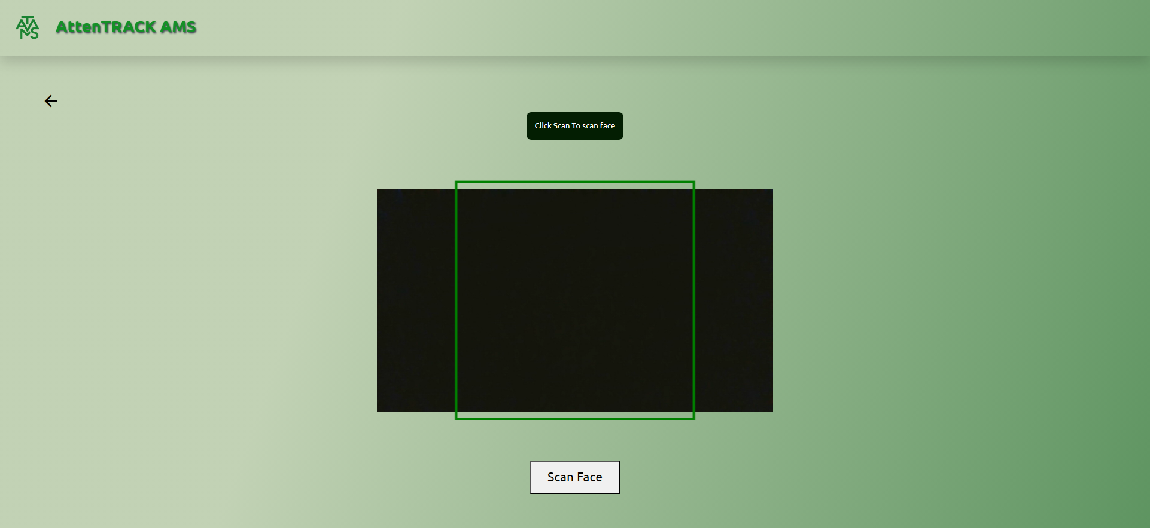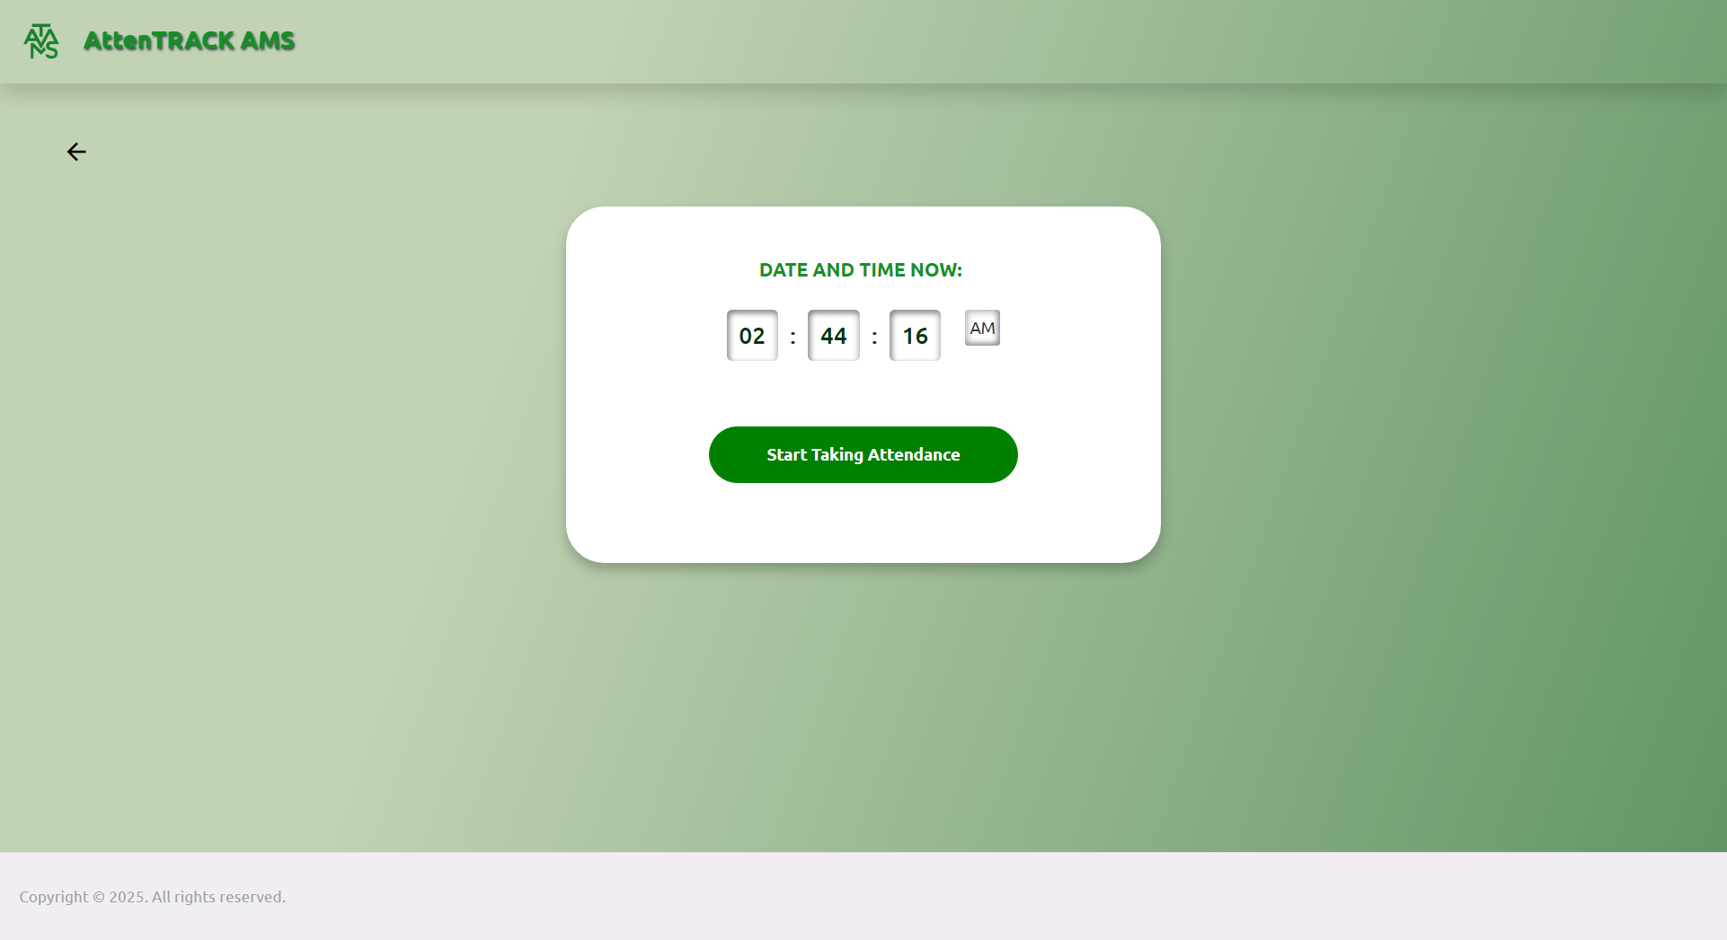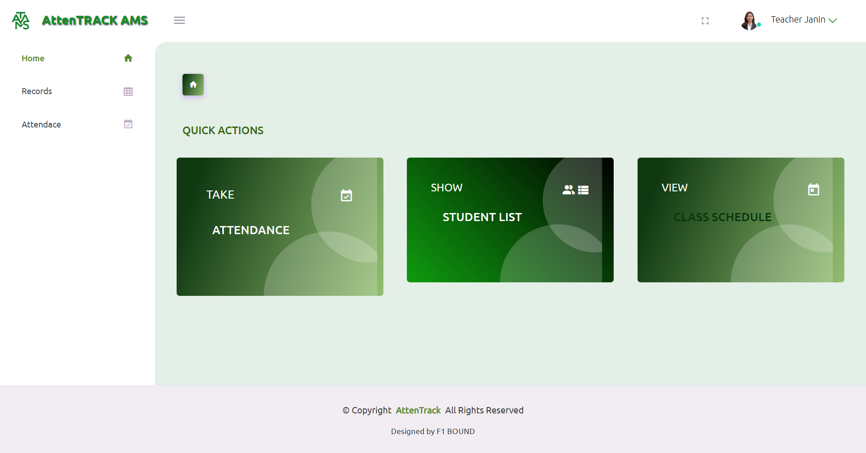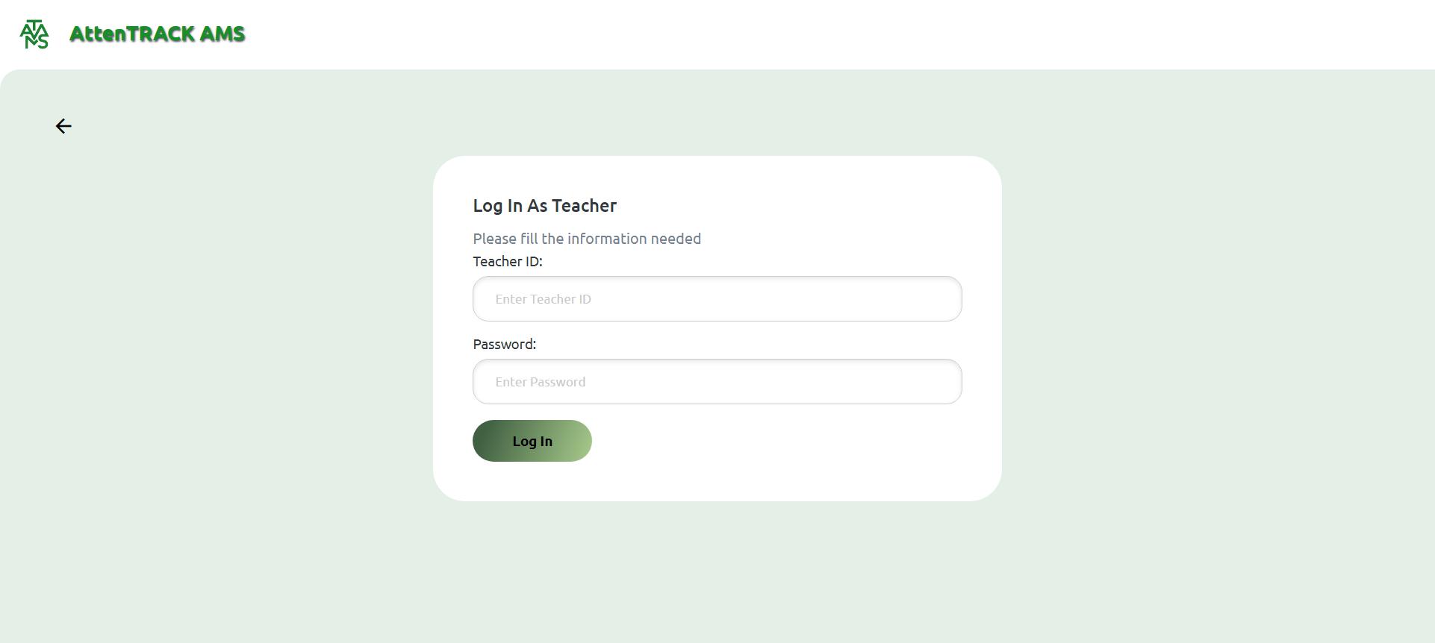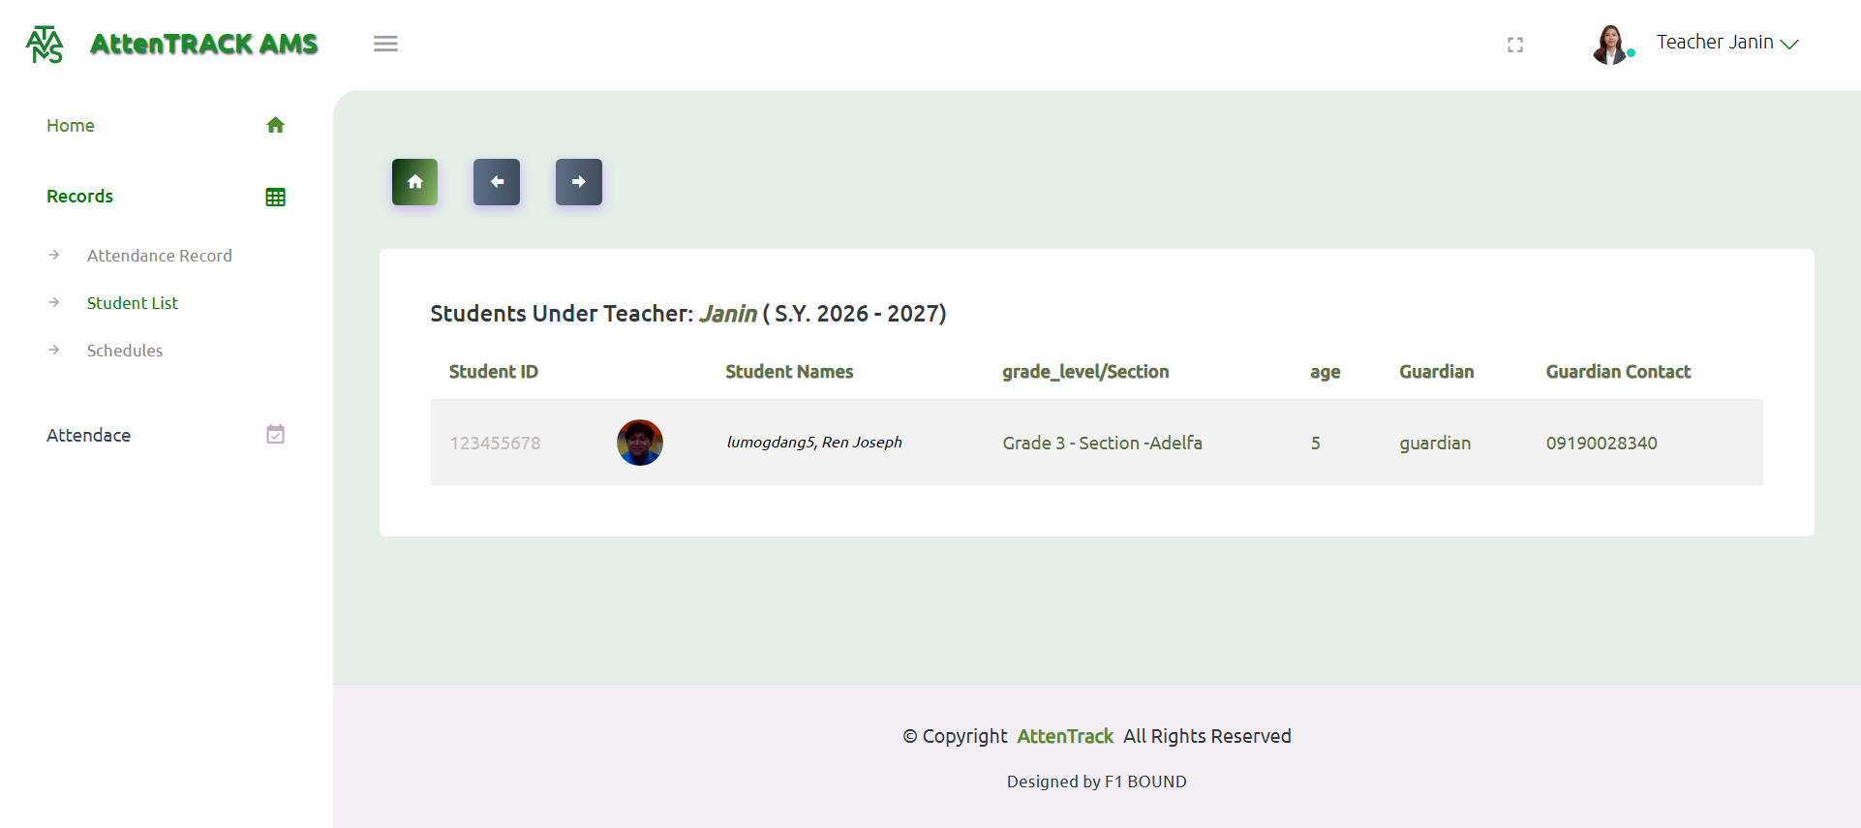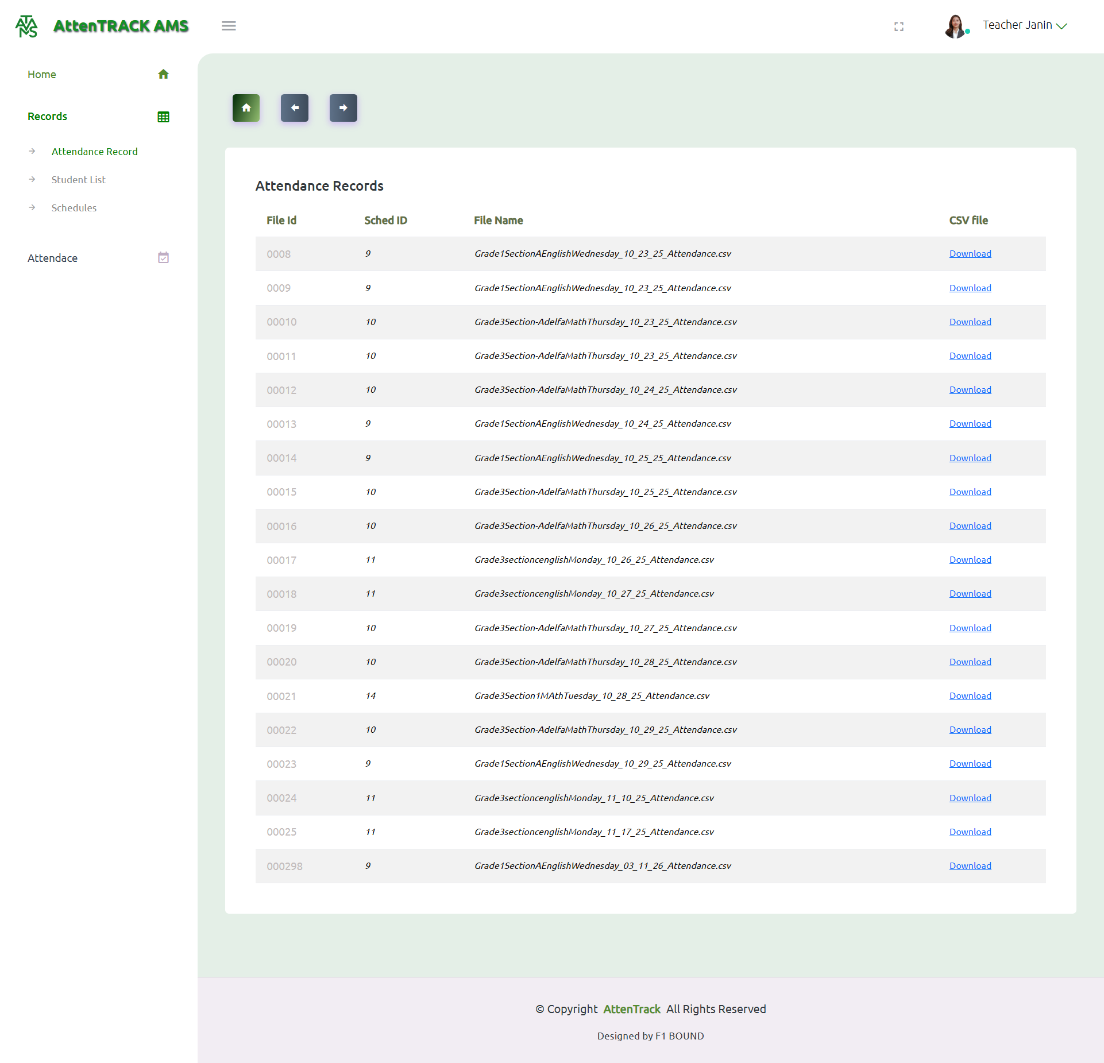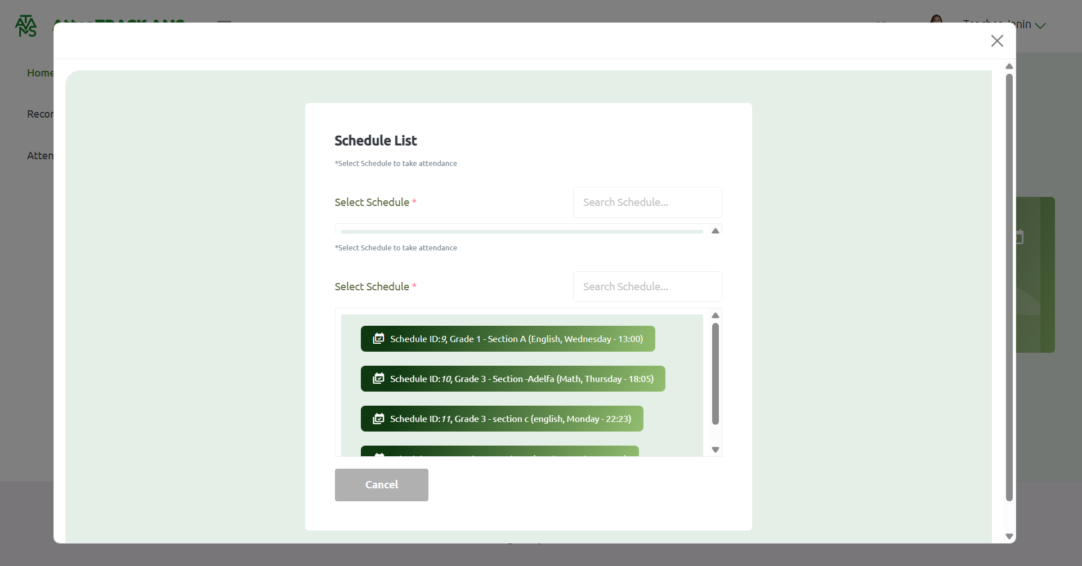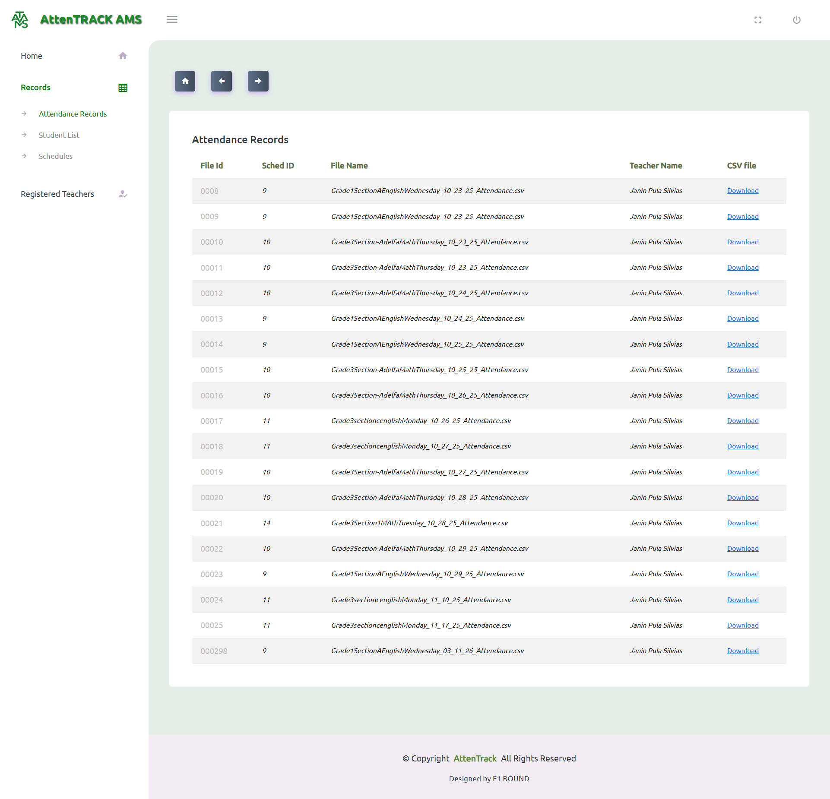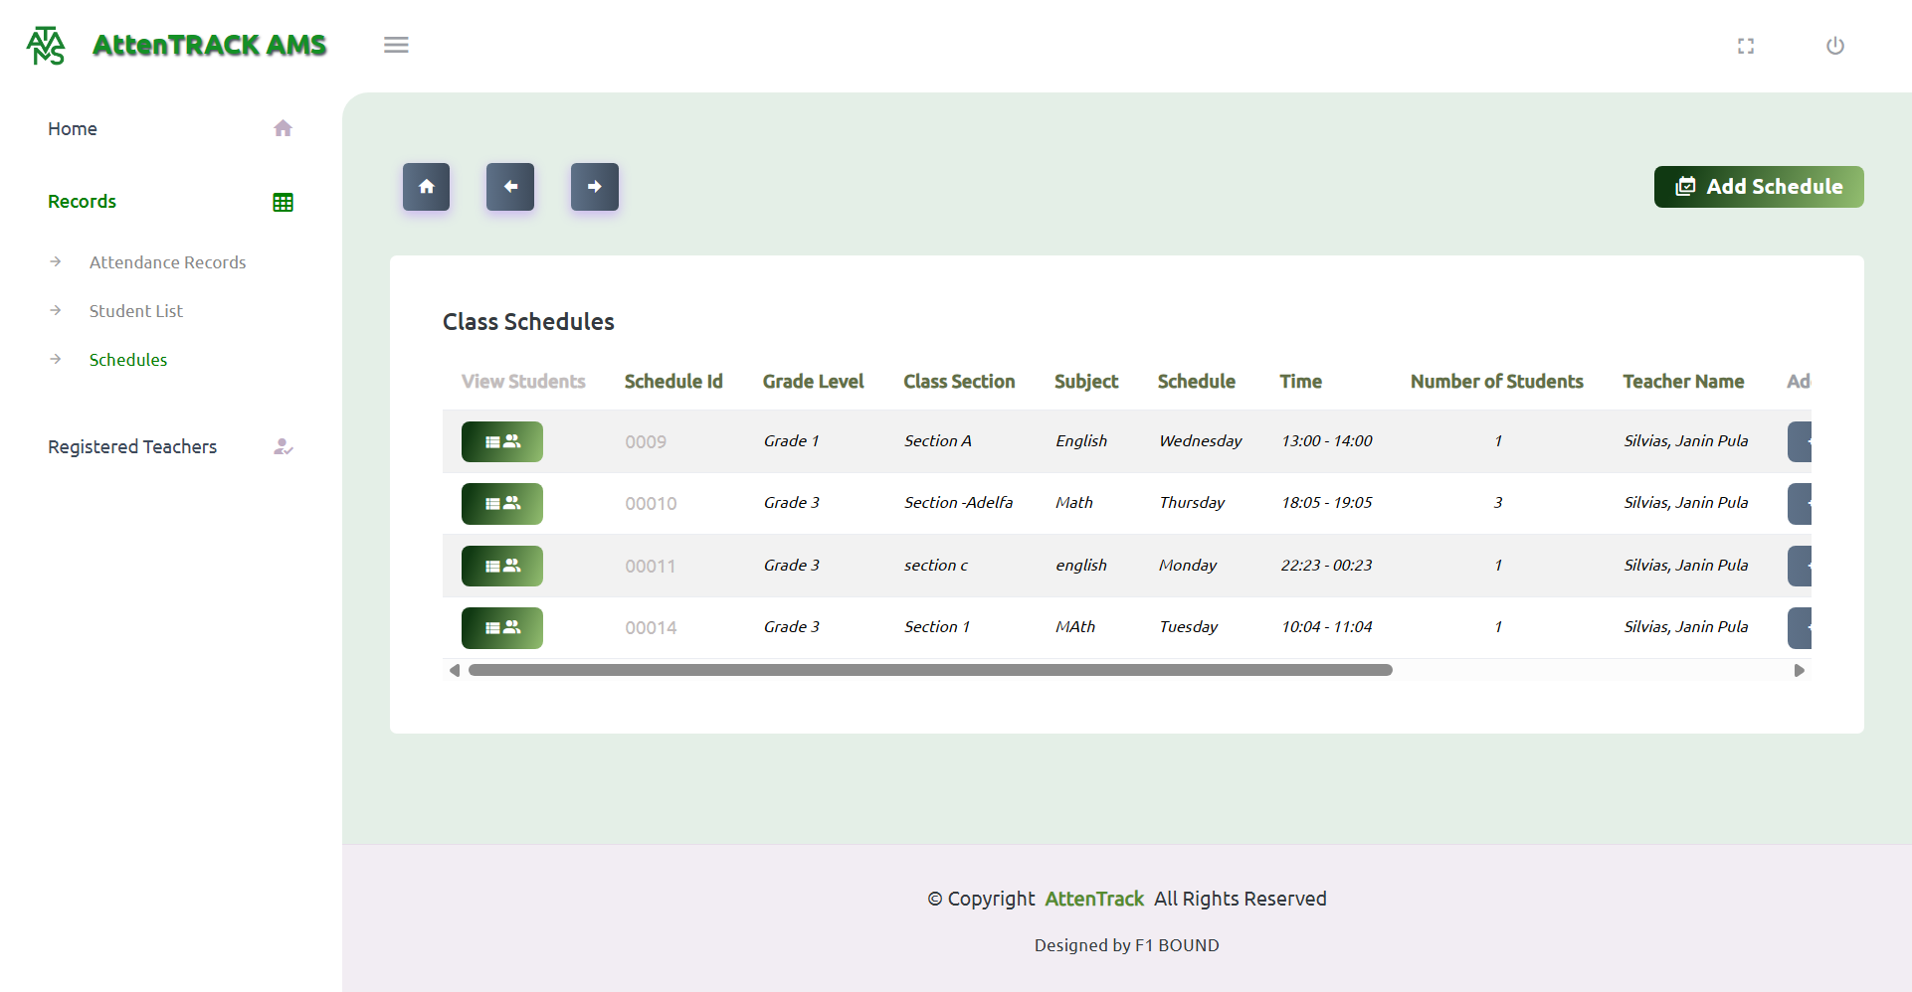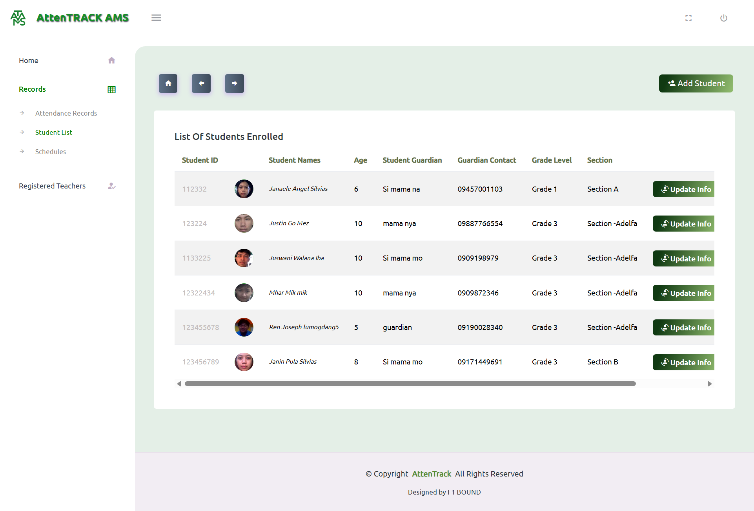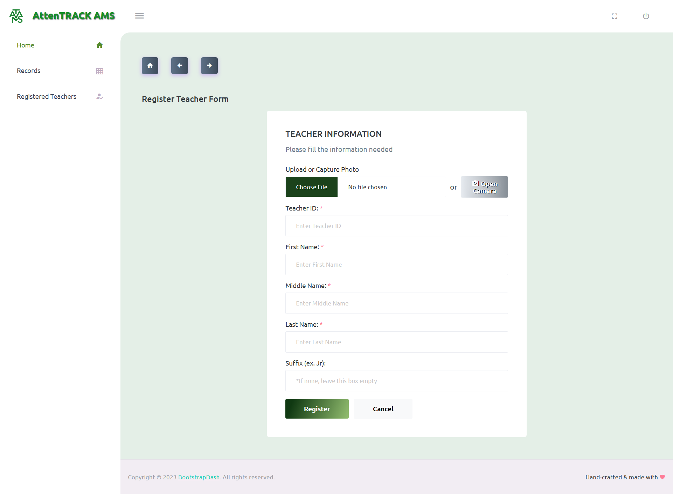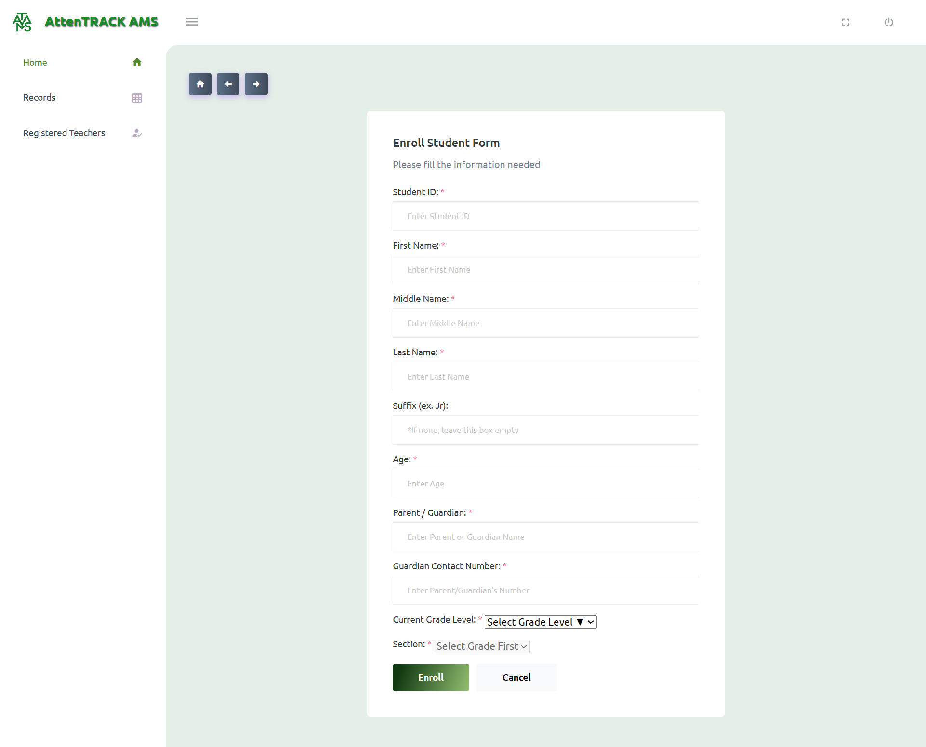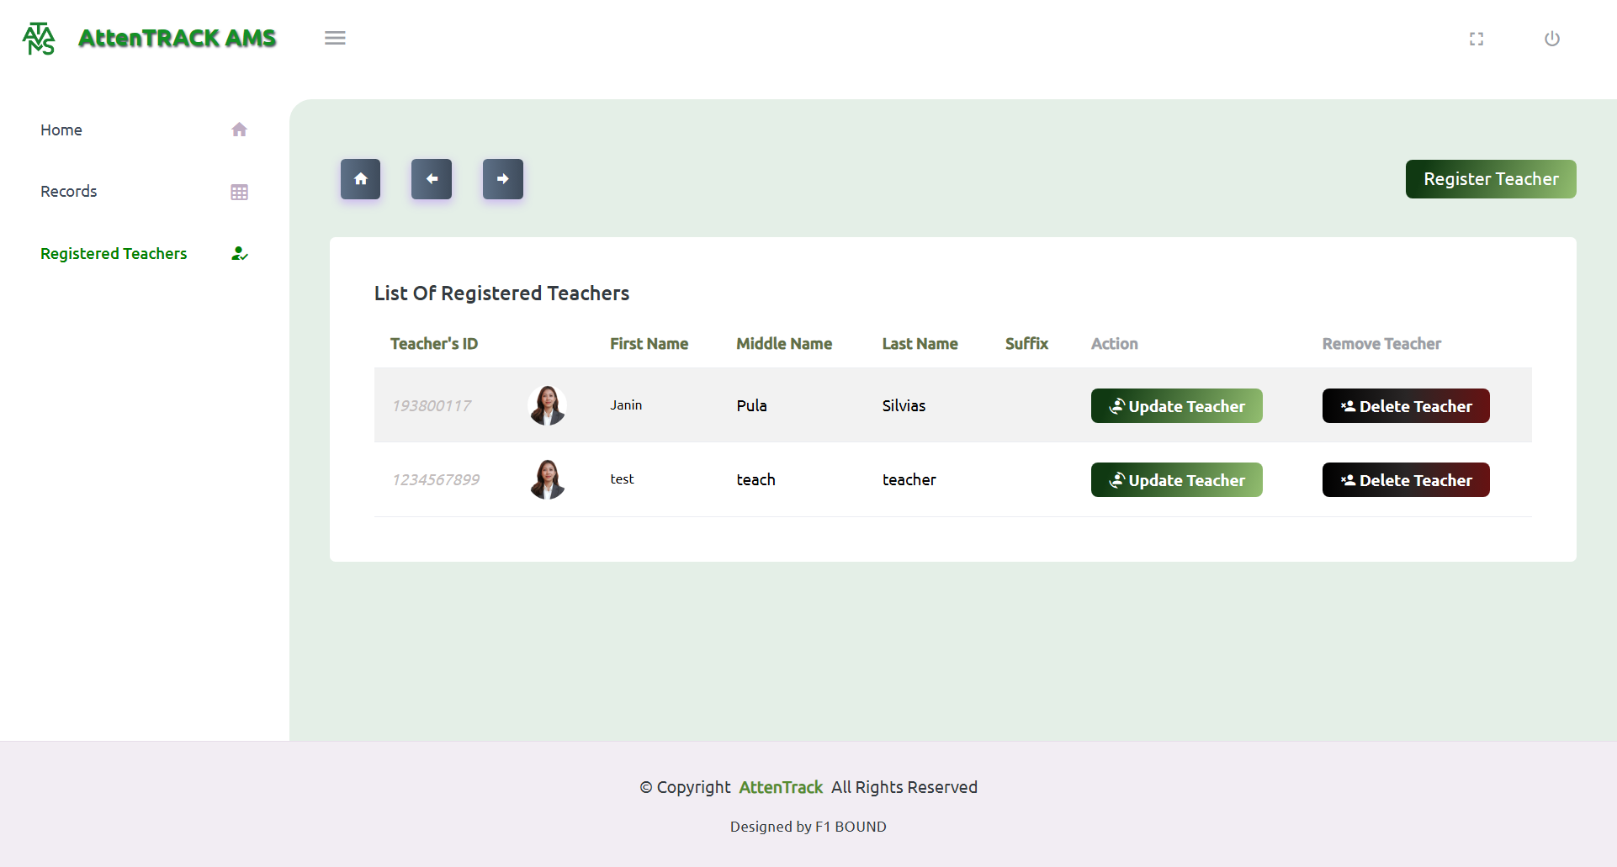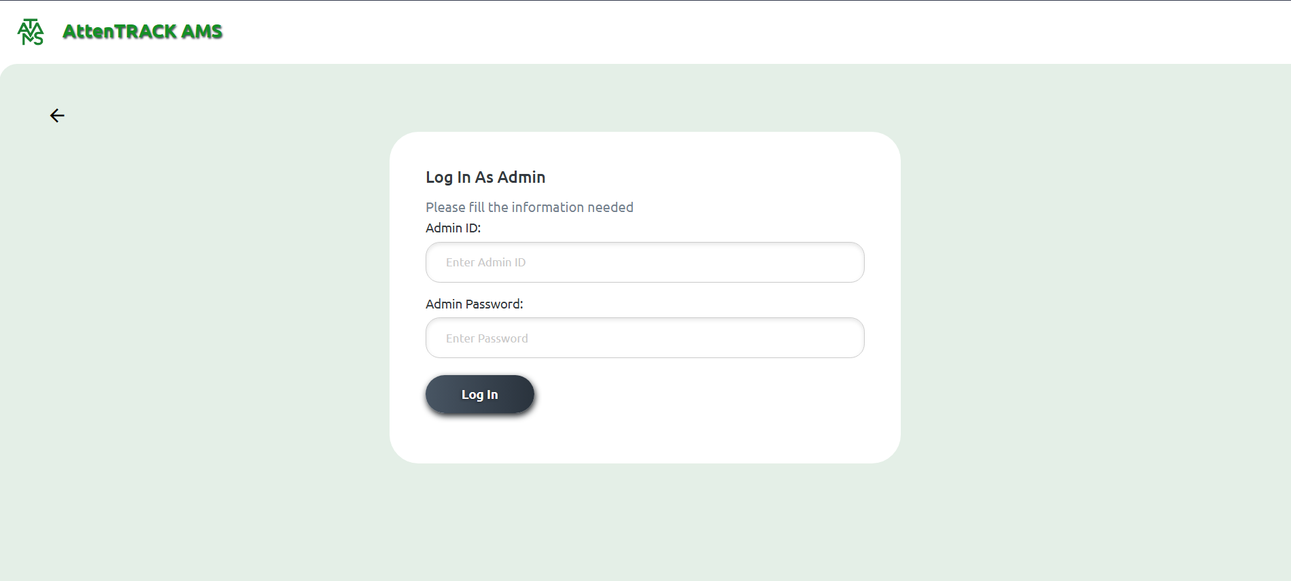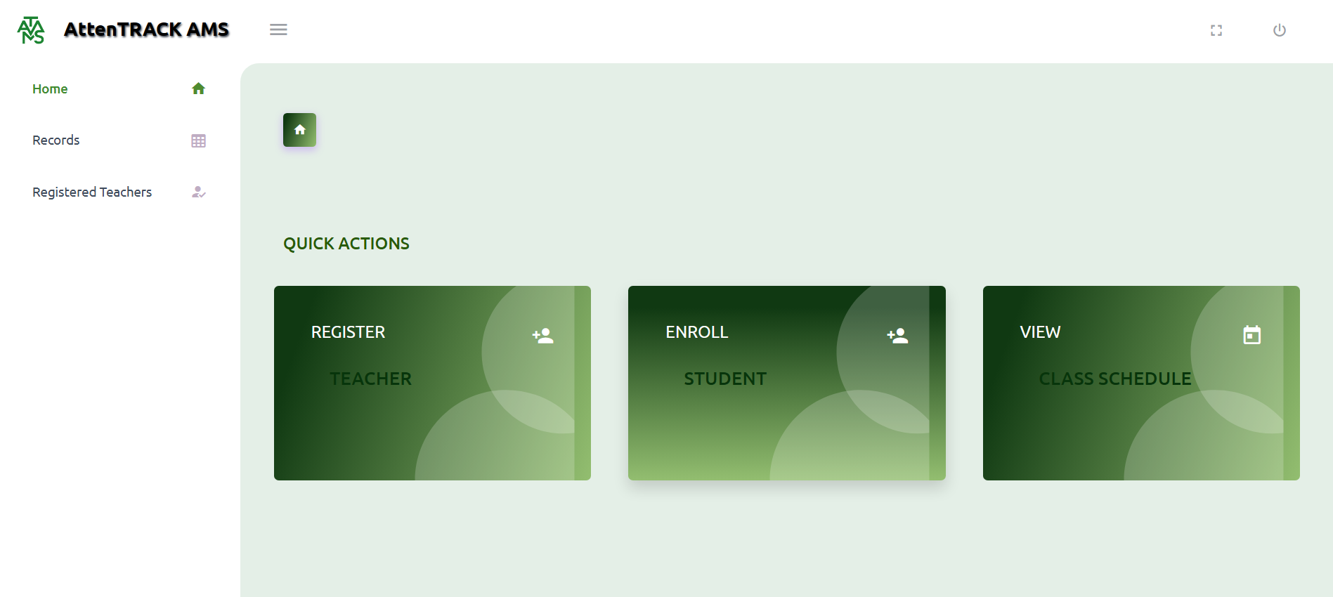
Figure A1. System interface screenshot during testing phase.

System Repository
The source code, database schema, and API documentation for the AttenTrack: Facial Recognition Attendance Tracking and Recording System are maintained in a version-controlled repository. The project structure is organized as follows:

https://github.com/Nins17/ATTENTRACK.git

Chapter 5

Summary, Conclusion, and Recommendation

5.1 Summary
This study aimed to design and develop the AttenTrack: Facial Recognition Attendance Tracking and Recording System to address the persistent limitations of manual attendance management in educational institutions. The system integrated a login-free facial recognition camera station that automatically identifies students, validates their active class schedule at the current time, and records attendance as present without requiring any teacher intervention. Two role-based portals were developed: an Administrator portal with full control over student lists, schedules, teacher accounts, and attendance records, and a Teacher portal for viewing assigned students and class schedules. The project was carried out using the Agile Software Development Life Cycle, progressing through the stages of planning and requirement analysis, system design, system development, system testing, and evaluation and improvement.
The system was evaluated through performance testing and a survey administered to 20 respondents comprising school administrators and teachers from the target institution. Results showed that the system achieved a 97% attendance recording accuracy rate and reduced average attendance entry time from 2.5 minutes to 45 seconds — a reduction of over 70%. Monthly recording errors decreased from more than 15 to only 3, and the system recorded a user satisfaction rating of 4.7 out of 5.0, with 78% of respondents rating the system as Excellent. These outcomes confirmed that AttenTrack successfully met all five of its stated objectives and provided a reliable, practical, and user-accepted solution for school attendance management.

5.2 Conclusion
Based on the findings of this study, AttenTrack: Facial Recognition Attendance Tracking and Recording System is an effective and reliable solution for automating student attendance recording and streamlining administrative scheduling tasks in educational institutions. The login-free facial recognition camera station successfully eliminated the need for teacher-conducted roll calls and removed the possibility of proxy attendance by verifying each student's identity against a registered facial database and confirming their active class schedule before recording attendance. The role-based architecture ensured that administrators maintained full control over all system data, while teachers were provided with a simplified and focused interface relevant only to their classroom responsibilities.
The development of AttenTrack demonstrated that open-source technologies — including the Laravel PHP framework, MySQL relational database, and Python-based facial recognition libraries — can be effectively combined to build a practical and dependable school-level administrative application. User feedback confirmed that the system was intuitive and accessible to school personnel with varying degrees of technical experience. The strong evaluation results and positive user responses indicate that AttenTrack is a viable replacement for manual attendance methods, and its modular, web-based design positions it well for future expansion and adoption across different educational settings.

5.3 Recommendations
Based on the development, testing, and evaluation of AttenTrack, the following recommendations are proposed to guide future improvements and broader implementation of the system.
1. SMS and Email Absence Notifications. Future development should include automated SMS or email notifications to inform parents or guardians when a student is recorded as absent or late. This feature would extend the value of AttenTrack beyond internal school administration and strengthen communication between the institution and student families.
2. Mobile Application Version. A mobile-friendly version of the Teacher portal should be developed to allow teachers to view their assigned student lists and class schedules from smartphones or tablets. This would improve system accessibility, particularly in schools where desktop computers are not always available to teaching staff.
3. Automatic Cloud Backup. The system should be enhanced with an automatic cloud backup feature to safeguard attendance records and configuration data against loss caused by hardware failures, power interruptions, or network issues. This would significantly improve the long-term reliability and data security of the system.
4. Onboarding Materials and Training Resources. Structured onboarding guides, quick-start tutorials, and short training sessions should be prepared for first-time Administrators and Teachers to minimize the learning period and support faster system adoption. In-system help prompts could also be integrated to assist users during initial use.
5. Multi-School and Large-Scale Deployment Testing. AttenTrack should be tested in larger schools or across multiple branch campuses to evaluate its scalability and performance under heavier user loads. This would validate the system's ability to handle a greater number of students, teachers, and concurrent sessions, and identify any architectural adjustments needed for institution-wide deployment.
6. Parent and Guardian Portal. A read-only portal accessible to parents or guardians should be developed as a future extension. This portal would allow families to monitor their child's attendance history in real time, promoting transparency, greater parental involvement, and a more connected relationship between the school and its stakeholders.

References
The following references are cited in this study and are listed in alphabetical order in APA 7th edition format.

Abdalkarim, B. A. (2022). A literature review on smart attendance systems. International Journal of Computer Applications, 183(45), 12–19.
Bondoc, B. C. (2023). Web-based smart attendance monitoring system using QR code and GSM module for SMS notification. World Journal of Advanced Research and Reviews, 20(3), 1843–1849. https://doi.org/10.30574/wjarr.2023.20.3.2644
Classter. (2025). Using school management systems to improve student attendance. Retrieved from https://www.classter.com/blog/edtech/school-management-systems/using-school-management-systems-to-improve-student-attendance/
Najaf, A. R. E., Alexander, J. D., Tarmidzi, K., & Kurnia, F. (2023). Designing a web-based elementary school attendance system using the Laravel framework. RIGGS: Journal of Artificial Intelligence and Digital Business, 1(2), 64–68. https://doi.org/10.31004/riggs.v1i2.116
Santos, A. B. G., Balba, N. P., & Rebong, C. B. (2021). Attendance monitoring system of schools in the Philippines with an inclusion of optimization query algorithm. International Journal of Innovative Technology and Exploring Engineering, 10(8), 1–10.
Siew, E. S. K., Chong, Z. Y., Sze, S. N., Yap, K. M., & Goh, V. T. (2023). Streamlining attendance management in education: A web-based system combining facial recognition and QR code technology. Proceedings of the International Conference on Computing and Informatics. https://doi.org/10.1007/978-981-99-7339-2_15
Smitha, H., Hegde, P., & Afshin. (2020). Face recognition-based attendance management system. International Journal of Engineering Research & Technology, 9(5).

Appendices

Appendix A: System Interface Screenshots
The following screenshots document the key interfaces of the AttenTrack: Facial Recognition Attendance Tracking and Recording System as observed during the testing phase. At minimum, the following screens should be included:
1. Login Page. The login screen for Administrator and Teacher accounts, showing the credential entry form and role selection.
2. Admin Dashboard. The main Admin portal dashboard displaying navigation to student list, schedule management, registered teachers, and attendance records modules.
3. Student List Module. The interface for viewing, adding, and managing the student roster, including student assignment to schedules.
4. Schedule Management Page. The interface for creating new schedules, assigning students and teachers to schedules, and viewing all active and archived schedules.
5. Camera Attendance Station. The login-free camera interface showing the facial recognition feed and the attendance confirmation message displayed when a student is successfully identified and their schedule is validated.
6. Attendance Records Module. The Admin interface for viewing, filtering, and downloading attendance records in CSV or PDF format.
7. Teacher Portal. The Teacher portal view showing the assigned student list and designated class schedules for the logged-in teacher.
(Insert system screenshots here)

Appendix B: Use Case Diagram
The Use Case Diagram below illustrates the interactions between the three primary actors of the system — Administrator, Teacher, and Camera Station — and the core use cases of the AttenTrack: Facial Recognition Attendance Tracking and Recording System. The Administrator manages the student list, schedules, registered teachers, and downloads attendance records. The Teacher views assigned students and schedules. The Camera Station detects and recognizes student faces, validates the student's schedule, and records attendance as present without requiring any login.
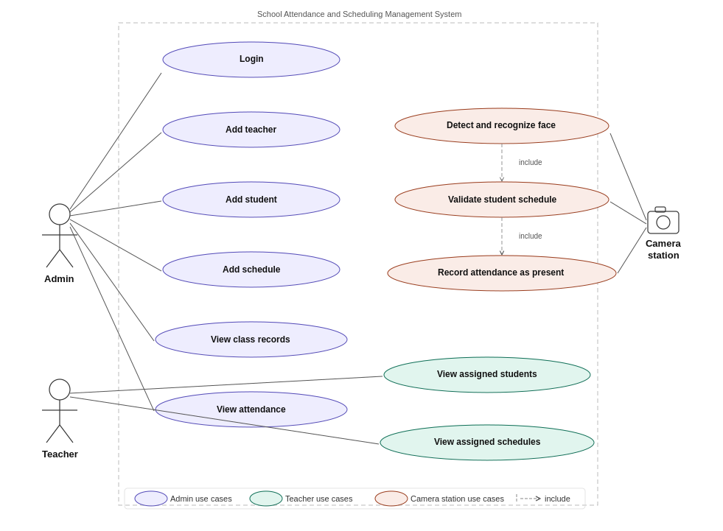
Figure B1. Use Case Diagram of the AttenTrack: Facial Recognition Attendance Tracking and Recording System, showing the three actors (Admin, Teacher, Camera Station) and their associated use cases.

Appendix C: Data Flow Diagram
The Data Flow Diagram (DFD) Level 1 below shows the complete data flow within the AttenTrack: Facial Recognition Attendance Tracking and Recording System. It illustrates the seven core processes — Login, Add Teacher, Add Students, Add Schedules, View Class Records, View Attendance, and Record Attendance — along with the two data stores (D1: User Records and D2: Class Records) and the three external entities (Admin, Camera, and Teacher).
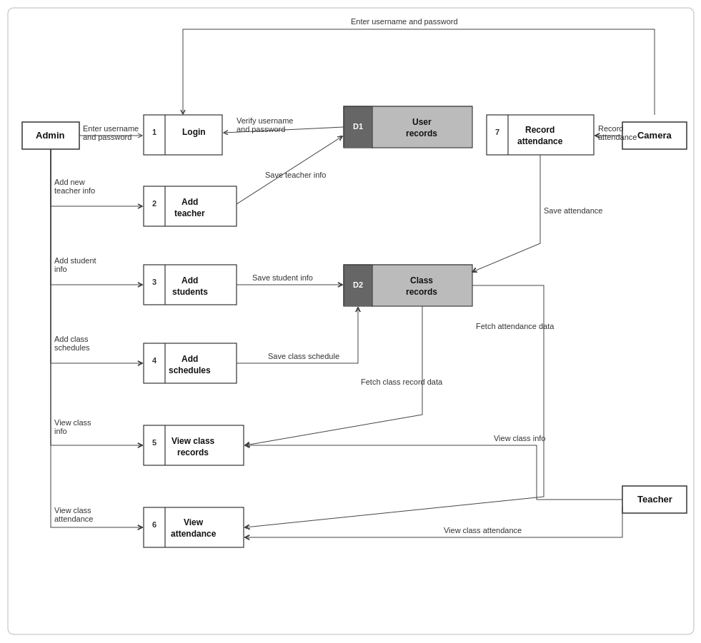
Figure C1. Level 1 Data Flow Diagram of the AttenTrack: Facial Recognition Attendance Tracking and Recording System, showing seven processes, two data stores (D1: User Records, D2: Class Records), and three external entities (Admin, Camera, Teacher).

Appendix D: User Survey Form and Summary
The survey questionnaire used in this study is reproduced below, followed by a summary of respondent responses.
Survey Questionnaire. The complete 20-item survey questionnaire administered to school administrators and teachers is included as distributed during data collection. Items covered demographic information, current system usage, challenges, desired features, and system performance preferences.

Survey Questionnaire
The following is the complete survey questionnaire administered to school administrators and teachers of the target institution on March 18, 2026. The survey was used to assess current attendance management practices, challenges, and expectations for the AttenTrack system.

Demographic Information
1. What is your role in the school? [ ] School Administrator [ ] Class Adviser / Homeroom Teacher [ ] Subject Teacher [ ] Other: ___________
2. How long have you been working in attendance management? [ ] Less than 1 year [ ] 1-3 years [ ] 4-6 years [ ] More than 6 years
3. What level of education does your school serve? [ ] Elementary [ ] Junior High School [ ] Senior High School [ ] College / Tertiary [ ] Other: ___________

Current Attendance and Scheduling System
4. What method does your school currently use for tracking attendance? [ ] Manual (paper-based class records) [ ] Spreadsheet (Excel or Google Sheets) [ ] Standalone desktop software [ ] Cloud-based system [ ] Other: ___________
5. How satisfied are you with your current attendance management system? [ ] Very Satisfied [ ] Satisfied [ ] Neutral [ ] Unsatisfied [ ] Very Unsatisfied
6. What challenges do you face with your current attendance management system? (Select all that apply) [ ] Inaccurate or incomplete attendance records [ ] Difficulty in monitoring student attendance in real-time [ ] Time-consuming manual recording of attendance [ ] Lack of coordination between teacher and admin data [ ] Difficulty in generating attendance reports quickly [ ] Errors due to manual data entry [ ] Other: ___________
7. How often do you encounter issues related to attendance recording errors or scheduling conflicts? [ ] Never [ ] Rarely [ ] Sometimes [ ] Frequently [ ] Always
8. Does your school currently use any digital tool for attendance or schedule management? [ ] Yes [ ] No

Expectations for the AttenTrack System
9. What features would you like to see in the proposed system? (Select all that apply) [ ] Automatic facial recognition attendance recording (no teacher login required) [ ] Downloadable attendance reports (CSV/PDF) [ ] Student list management with add/edit features [ ] Schedule creation and teacher assignment [ ] Role-based access for Admin and Teacher [ ] Automatic record-keeping and data storage [ ] Easy-to-navigate web-based interface [ ] Admin control over registered teacher accounts
10. How important is real-time attendance tracking in your school operations? [ ] Very Important [ ] Important [ ] Neutral [ ] Not Important [ ] Not Important at All
11. How important is the ability to generate detailed attendance reports for administrative decision-making? [ ] Very Important [ ] Important [ ] Neutral [ ] Not Important [ ] Not Important at All
12. Would you prefer a cloud-based system or a locally-installed system for attendance management? [ ] Cloud-based [ ] Local/installed [ ] No preference
13. How important is it for teachers and admins to access the system through a web browser? [ ] Very Important [ ] Important [ ] Neutral [ ] Not Important [ ] Not Important at All
14. How willing are you to adopt the proposed AttenTrack system? [ ] Very Willing [ ] Willing [ ] Neutral [ ] Unwilling [ ] Very Unwilling
15. What concerns do you have about using the proposed system? (Select all that apply) [ ] Data security and student privacy [ ] Ease of use and system adoption [ ] Reliability and uptime of the system [ ] Integration with existing school records [ ] Teacher training and technical support [ ] Other: ___________

User Experience and System Performance
16. How important is it for the attendance system to have a simple and intuitive interface? [ ] Very Important [ ] Important [ ] Neutral [ ] Not Important [ ] Not Important at All
17. What type of interface would you prefer for accessing the system? [ ] Desktop application [ ] Mobile application [ ] Web-based interface [ ] All of the above
18. How likely are you to use a system that separates Admin and Teacher roles with different access levels? [ ] Very Likely [ ] Likely [ ] Neutral [ ] Unlikely [ ] Very Unlikely
19. How important is system reliability for your school's daily attendance management? [ ] Very Important [ ] Important [ ] Neutral [ ] Not Important [ ] Not Important at All
20. What is your preferred response time when accessing attendance data or generating reports? [ ] Instant (less than 1 second) [ ] Within 5 seconds [ ] Within 10 seconds [ ] Within 30 seconds [ ] No preference

Summary of Responses. The table below summarizes the frequency and percentage distribution of respondent answers to key survey questions.

Summary of Survey Responses
Table D1 below presents the frequency and percentage distribution of responses to selected survey questions from 20 respondents (school administrators and teachers) at the target institution. The survey was administered on March 18, 2026.

Table D1. Respondent Profile by Role (n = 20)
Role | Frequency | Percentage
School Administrator | 5 | 25%
Class Adviser / Homeroom Teacher | 8 | 40%
Subject Teacher | 7 | 35%
Total | 20 | 100%

Table D2. Current Attendance Method Used (n = 20)
Method | Frequency | Percentage
Manual (paper-based class records) | 14 | 70%
Spreadsheet (Excel or Google Sheets) | 5 | 25%
Standalone desktop software | 1 | 5%
Total | 20 | 100%

Table D3. Challenges with Current Attendance System (Multiple Responses, n = 20)
Challenge | Frequency | Percentage
Time-consuming manual recording of attendance | 18 | 90%
Inaccurate or incomplete attendance records | 16 | 80%
Difficulty in generating attendance reports quickly | 15 | 75%
Errors due to manual data entry | 14 | 70%
Lack of coordination between teacher and admin data | 12 | 60%
Difficulty in monitoring student attendance in real-time | 11 | 55%

Table D4. Desired Features for the Proposed System (Multiple Responses, n = 20)
Feature | Frequency | Percentage
Automatic facial recognition attendance recording | 20 | 100%
Downloadable attendance reports (CSV/PDF) | 19 | 95%
Role-based access for Admin and Teacher | 18 | 90%
Schedule creation and teacher assignment | 17 | 85%
Student list management with add/edit features | 17 | 85%
Easy-to-navigate web-based interface | 16 | 80%
Automatic record-keeping and data storage | 15 | 75%
Admin control over registered teacher accounts | 14 | 70%

Table D5. Weighted Mean Scores for System Feature Importance (n = 20)
Scale: 5 = Very Important, 4 = Important, 3 = Neutral, 2 = Not Important, 1 = Not Important at All
Statement | Weighted Mean | Interpretation
Real-time attendance tracking in school operations | 4.85 | Very Important
Ability to generate detailed attendance reports | 4.80 | Very Important
System reliability for daily attendance management | 4.75 | Very Important
Simple and intuitive interface for the system | 4.70 | Very Important
Access to system through a web browser | 4.60 | Very Important

Table D6. Willingness to Adopt the AttenTrack System (n = 20)
Response | Frequency | Percentage
Very Willing | 12 | 60%
Willing | 6 | 30%
Neutral | 2 | 10%
Unwilling | 0 | 0%
Very Unwilling | 0 | 0%
Total | 20 | 100%

Table D7. User Satisfaction After System Evaluation (n = 20)
Rating | Frequency | Percentage
Excellent | 15 | 78% (rounded)
Good | 3 | 17% (rounded)
Fair | 1 | 5%
Poor | 0 | 0%
Very Poor | 0 | 0%
Total | 19 (1 abstained) | 100%

Sample Written Feedback. Selected written responses from respondents gathered during the evaluation phase are presented below to provide qualitative context for the quantitative survey results.

Sample Written Feedback from Respondents
The following selected written responses were gathered from respondents during the evaluation phase on March 18, 2026. Responses have been anonymized and are presented verbatim to preserve authenticity.

Respondent 1 (School Administrator). "The system is very convenient. As an administrator, I no longer have to chase teachers for their class records. Everything is already in the system the moment a student walks in front of the camera. The download feature for attendance reports is exactly what we needed for our monthly reports."

Respondent 2 (Class Adviser). "I appreciate that teachers like me do not have to do anything for the attendance to be recorded. Students just go to the camera and it is done automatically. I only use my portal to check if my students are attending their classes, which is very simple to navigate."

Respondent 3 (Subject Teacher). "The interface is clean and easy to understand. I was a bit hesitant at first because I am not very familiar with computer systems, but after a short demo, I was able to use my portal without any assistance. I hope this will be adopted permanently by the school."

Respondent 4 (School Administrator). "The schedule validation feature is what impressed me the most. The fact that the system checks if the student actually has a class before recording their attendance means our records are much more accurate than before. We used to have issues with students logging in even when they were not supposed to be in class."

Respondent 5 (Subject Teacher). "It is a great improvement from the manual system. My only concern is what happens when the internet is down, but I understand this is a known limitation. Overall, I am very satisfied with how the system works and would be willing to use it regularly."

Respondent 6 (Class Adviser). "The ability for the admin to assign students and teachers to specific schedules gives the school much better control over attendance monitoring. I also like that I can see which students are assigned to my classes directly from my portal without having to ask the admin."

Appendix E: Sample Cover Page
PHINMA University of Iloilo
College of Information Technology Education

ATTENTRACK: FACIAL RECOGNITION ATTENDANCE TRACKING AND RECORDING SYSTEM
A Capstone Project

Presented to the Faculty of the
College of Information Technology Education
PHINMA University of Iloilo
In Partial Fulfillment of the Requirements
For the Degree of Bachelor of Science in Information Technology

By:
Janin Anne Silvias
Ren Joseph Lumogdang
Edilbert Richard Belgira

March 2026

Appendix F: Grammarian Certificate of Completion
This section contains the Curriculum Vitae of the Grammarian who reviewed and proofread the final research document for grammatical accuracy, consistency, and adherence to academic writing standards.
(Insert Grammarian CV here)

Appendix G: Client Partner Letter and Memorandum of Agreement
The following documents formalize the partnership between the research team and the partner school or institution. The Client Partner Letter proposes the use of the system, and the Memorandum of Agreement (MOA) defines the responsibilities and scope of cooperation between both parties.

Client Partner Letter

F1Bound
PHINMA University of Iloilo, Iloilo City
March 18, 2026

[Client's Name]
[Client's Position]
[Partner School / Institution Name]
[School Address]

Dear [Client's Name],

Subject: Proposal for Memorandum of Agreement to Use the AttenTrack: Facial Recognition Attendance Tracking and Recording System

We are pleased to present to you our proposed AttenTrack: Facial Recognition Attendance Tracking and Recording System, designed to streamline and improve the efficiency of your school's attendance monitoring and schedule management through facial recognition technology, role-based access control, and secure digital record-keeping.
To formalize the use and implementation of this system within your institution, we propose the execution of a Memorandum of Agreement (MOA) that outlines the responsibilities, terms, and conditions for both parties. This agreement will ensure a clear understanding of project scope, timelines, data security, support, and maintenance.
The system is expected to provide the following benefits to your institution:
— Automated, login-free facial recognition attendance recording with schedule validation
— Efficient class schedule creation, teacher assignment, and student enrollment management
— Role-based access for Administrators and Teachers with downloadable attendance reports
— User-friendly web interface accessible through any standard web browser

We are committed to supporting your team through the entire implementation process, including user training and technical assistance to maximize the system's benefits. We look forward to discussing this proposal further. Kindly contact us at your convenience.

Sincerely,
Janin Anne Silvias, Ren Joseph Lumogdang, Edilbert Richard Belgira
Capstone Project Researchers
F1Bound — PHINMA University of Iloilo

Memorandum of Agreement (MOA)

Between
[Partner School / Institution Name]
And
Janin Anne Silvias, Ren Joseph Lumogdang, Edilbert Richard Belgira

Date: March 18, 2026

Purpose. This agreement is entered into by and between the partner school/institution and the student researcher, to collaborate on the capstone project entitled "AttenTrack: Facial Recognition Attendance Tracking and Recording System."
Scope of Agreement. The partner school/institution agrees to provide support and resources including data access, guidance, and respondents to assist the student in developing and evaluating the project. The student agrees to perform all research, development, testing, and documentation required to complete the capstone project.
Client Approval. By signing this document, the partner school/institution acknowledges approval and support of the student's proposed capstone project and commits to timely cooperation and to provide relevant information as needed for the project's successful completion.

Signatures:

[Client Representative Name]
[Position / Title]
[Partner School / Institution Name]

Date: _______________

Janin Anne Silvias, Ren Joseph Lumogdang, Edilbert Richard Belgira
Capstone Project Researcher

Date: _______________

