Solitaire

# User Interface

## Example

Example interface from Google’s solitaire game (source: <https://www.google.com/search?q=solitaire>)

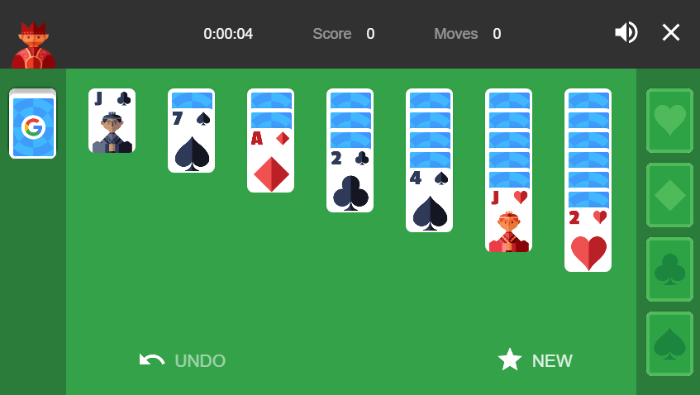

Annotated picture, with labels for important parts of the interface.

## Notes

1. Each card will be a panel object with the image set to either the front or back of a card
   1. Image needed for each card
   2. Image needed for back of cards, possibly customizable
2. Empty stock, foundations, tableau, and waste need a panel object with a picture but will be static
3. When the player holds the mouse down on a card which can be moved it will follow their cursor until the mouse is no longer held down. If the card is over a valid drop location it will be moved to the drop location, otherwise it will return to where it was taken from.
   1. Cards that can be moved are either:
      1. At the top of the waste pile
      2. At the top of a tableau
      3. At the top of a foundation
   2. Valid drop locations are:
      1. On top of a tableau if that card meets the requirements to be on top of the previous card in the tableau. Requirements are:
         1. Value of the new card must be one lower than the value of the previous card. Order: King (13), Queen (12), Jack (11), 10 through 2, Ace (1)
         2. Must be a different colour from the previous card. Hearts and Diamonds suites are red, Spades and Clubs suites are black.
         3. If a tableau is empty then the card must be a king
      2. On top of a foundation if that card meets the requirements to be on top of the foundation. Requirements are:
         1. Value of the new card must be one higher than the value of the previous card, or an ace if the foundation is empty
         2. Suite of the new card must match the suite of the foundation

# Card Class

Each card will have:

1. Suite. Must be either Clubs, Diamonds, Hearts, or Spades
2. Value. Range of 0 to 13. Each value represents
   1. 0: Base of foundation
   2. 1: Ace
   3. 2 through 10: Numeric cards
   4. 11: Jack
   5. 12: Queen
   6. 13: King