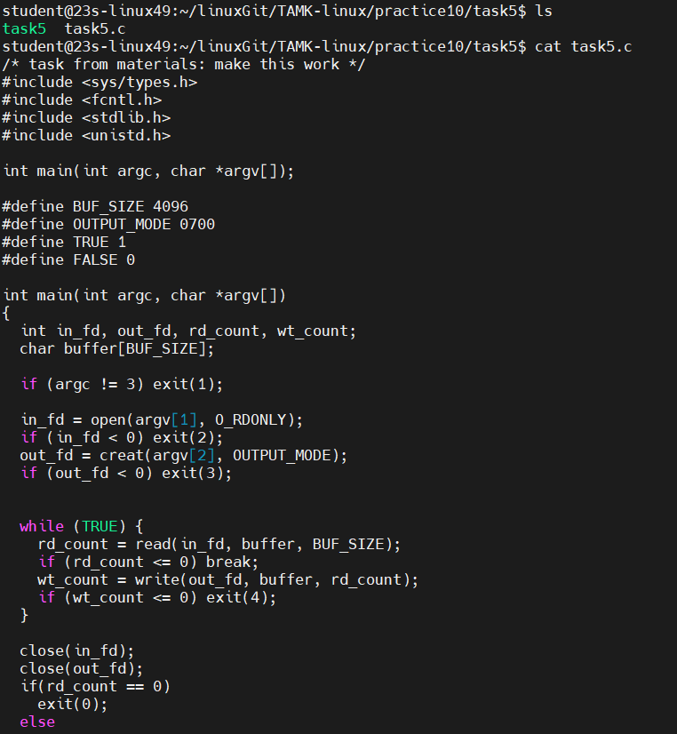

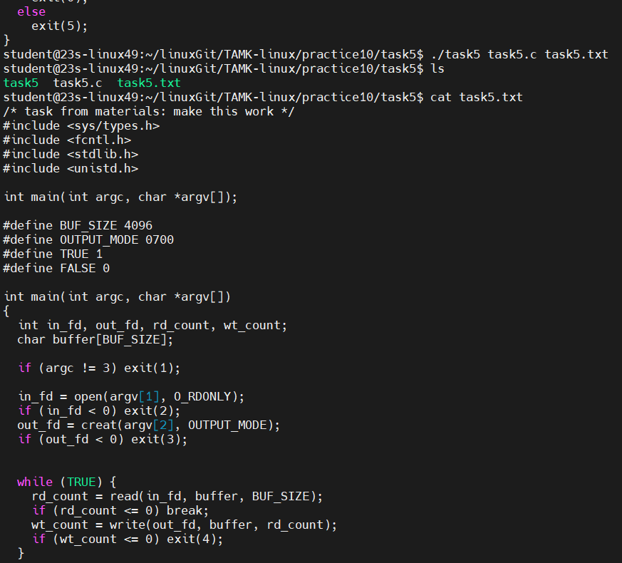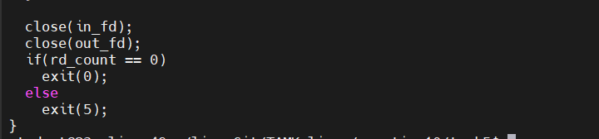

task5.c

/* task from materials: make this work */

#include <sys/types.h>

#include <fcntl.h>

#include <stdlib.h>

#include <unistd.h>

int main(int argc, char *argv[]);

#define BUF_SIZE 4096

#define OUTPUT_MODE 0700

#define TRUE 1

#define FALSE 0

int main(int argc, char *argv[])

{

int in_fd, out_fd, rd_count, wt_count;

char buffer[BUF_SIZE];

if (argc != 3) exit(1);

in_fd = open(argv[1], O_RDONLY);

if (in_fd < 0) exit(2);

out_fd = creat(argv[2], OUTPUT_MODE);

if (out_fd < 0) exit(3);

while (TRUE) {

rd_count = read(in_fd, buffer, BUF_SIZE);

if (rd_count <= 0) break;

wt_count = write(out_fd, buffer, rd_count);

if (wt_count <= 0) exit(4);

}

close(in_fd);

close(out_fd);

if(rd_count == 0)

exit(0);

else

exit(5);

return 0;

}