ASSIGNMENT-3

Submitted by: Nintu Punnoose

Roll no: 42

**Class Diagram For Hotel Management System**

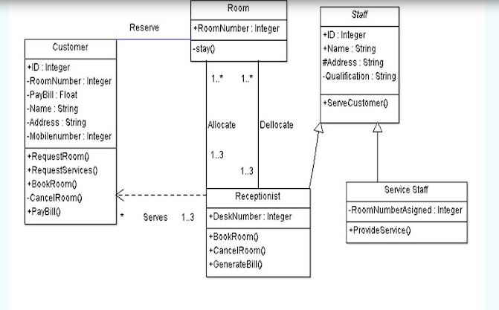

**Class Diagram For Attendence Management System**

