

|  |
| --- |
| Business Template  **MUSEUM** |
| **Logo / Image** |

Contents

1 Business Description 3

1.1 Business background 3

1.2 Problems. Current Situation 3

1.3 The benefits of implementing a database. Project Vision 3

2 Model description 3

2.1 Definitions & Acronyms 3

2.2 Logical Scheme 3

2.3 Objects 3

# 

# Business Description

## Business background

The museum is currently facing challenges in managing its growing collection of artworks, exhibition schedules, and visitor transactions. Information is scattered across various systems, making it difficult to track the performance of exhibitions, maintain accurate records, and provide meaningful analytics for decision-making.

## Problems. Current Situation

The museum currently struggles with inefficient data management, as information is scattered across disconnected systems, leading to errors and difficulty in analyzing exhibition performance and visitor trends. Manual data handling results in inconsistent records, and the lack of insights hampers effective resource allocation and decision-making.

## the Benefits of implementing a database. Project Vision

Implementing a unified database will streamline data management, improve reporting and analytics, and automate processes, reducing errors and manual effort. This system will enhance decision-making, optimize resource allocation, and provide scalability for future growth, ultimately improving operational efficiency and the visitor experience.

# Model description

## Definitions & Acronyms

The database is structured in 3rd normal form and establishes relationships between key entities such as artists, collections, exhibitions, visitors, tickets, transactions, and exhibition_artists. Key concepts include foreign keys for linking data and primary keys to uniquely identify records.

## Logical Scheme

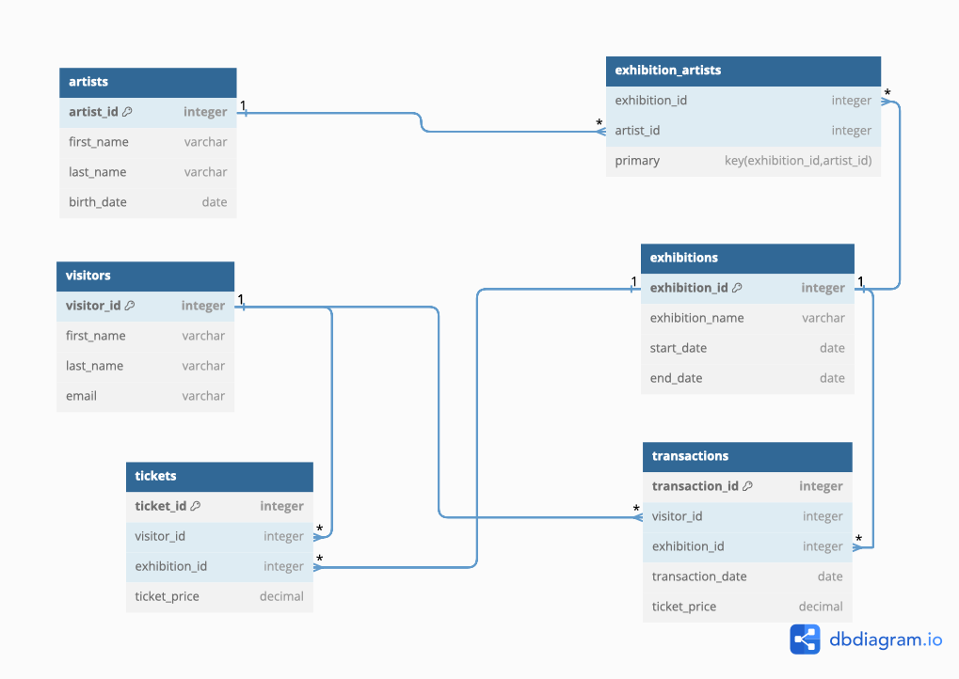

## Objects

Table Description

Stores information about the artists whose works are featured in the museum.

|  |  |  |  |
| --- | --- | --- | --- |
| Table Name | Field name | Field Description | Data Type |
| artists | artist_id | Unique identifier for an artist | SERIAL, PRIMARY KEY |
| first_name | Artist's first name | Varchar (100) |
| last_name | Artist's last name | Varchar (100) |
| birth_date | Artist's birth date | DATE |

Comments on table relationships

The artists table is referenced by the collections and exhibition_artists tables, linking artists to specific collections and exhibitions.

Example with data

|  |  |  |  |
| --- | --- | --- | --- |
| artist_id | first_name | last_name | birth_date |
| 1 | giorgi | pirosmani | 1862-12-04 |

Table Description

Stores information about the artworks exhibited in the museum.

|  |  |  |  |
| --- | --- | --- | --- |
| Table Name | Field name | Field Description | Data Type |
| exhibitions | exhibition_id | Unique identifier for an exhibition | SERIAL |
| exhibition_name | Name of the exhibition | VARCHAR(255) |
| start_date | Exhibition start date | DATE |
| end_date | Exhibition end date | DATE |

Comments on table relationships

The exhibitions table is related to the tickets, transactions, and exhibition_artists tables. It connects to the tickets table through exhibition_id and is linked to artists via exhibition_artists.

Example with data

|  |  |  |  |
| --- | --- | --- | --- |
| exhibition_id | exhibition_name | start_date | end_date |
| 1 | Georgian Art Exhibition | 2024-10-01 | 2024-10-15 |

Table Description

Stores information about exhibitions held at the museum.

|  |  |  |  |
| --- | --- | --- | --- |
| Table Name | Field name | Field Description | Data Type |
| collections | collection_id | Unique identifier for a collection | SERIAL |
| collection_name | Name of the collection | VARCHAR(255) |
| artist_id | ID of the artist (foreign key) | INT |
| acquisition_date | Date when the collection was acquired | DATE |
| value | Estimated value of the collection | NUMERIC |

Comments on table relationships

The collections table has a foreign key relationship with the artists table, linking each collection to an artist.

Example with data

|  |  |  |  |  |
| --- | --- | --- | --- | --- |
| collection_id | collection_name | artist_id | acquisition_date | value |
| 1 | Pirosmani’s Masterpieces | 1 | 2024-09-15 | 5000000.00 |

Table Description

Stores information about the visitors to the museum.

|  |  |  |  |
| --- | --- | --- | --- |
| Table Name | Field name | Field Description | Data Type |
| visitors | visitor_id | Unique identifier for a visitor | SERIAL |
| first_name | Visitor's first name | VARCHAR(100) |
| last_name | Visitor's last name | VARCHAR(100) |
| email | Visitor's email address | VARCHAR(100) |
| phone | Visitor's phone number | VARCHAR(20) |

Comments on table relationships

The visitors table is referenced by the tickets and transactions tables, connecting visitors to their ticket purchases and exhibition visits.

Example with data

|  |  |  |  |  |
| --- | --- | --- | --- | --- |
| visitor_id | first_name | last_name | email | phone |
| 1 | Nino | Jorjadze | [nino.jorjadze@example.com](mailto:nino.jorjadze@example.com) | +995551234567 |

Table Description

Stores details of the visits made by visitors to the museum.

|  |  |  |  |
| --- | --- | --- | --- |
| Table Name | Field name | Field Description | Data Type |
| tickets | ticket_id | Unique identifier for a ticket | SERIAL |
| visitor_id | ID of the visitor (foreign key) | INT |
| exhibition_id | ID of the exhibition (foreign key) | INT |
| purchase_date | Date of ticket purchase | DATE |
| ticket_price | Price of the ticket | NUMERIC |

Comments on table relationships

The tickets table has foreign key relationships with both the visitors and exhibitions tables, linking visitors to the exhibitions they attend.

Example with data

|  |  |  |  |  |
| --- | --- | --- | --- | --- |
| ticket_id | visitor_id | exhibition_id | purchase_date | ticket_price |
| 1 | 1 | 1 | 2024-10-01 | 15.00 |

Table Description

Stores information about donations made to the museum.

|  |  |  |  |
| --- | --- | --- | --- |
| Table Name | Field name | Field Description | Data Type |
| exhibition_artists | exhibition_id | ID of the exhibition (foreign key) | INT |
| artist_id | ID of the artist (foreign key) | INT |

Comments on table relationships

This table represents the many-to-many relationship between artists and exhibitions. It links each artist to the exhibitions they participate in.

Example with data

|  |  |
| --- | --- |
| exhibition_id | artist_id |
| 1 | 1 |