Business Process Exercise - Inventory Module

Table of Contents
1. Create & Configure Products 2
1.1 Creating a new product in the inventory module 2
2. Warehouse Configuration & Location Mapping 3
2.1 Configuring warehouse and creating locations in the warehouse 3
Incoming Shipments (Receiving Goods) 3
Outgoing Shipments (Shipping Goods) 4
Understanding Locations in Odoo Inventory 4
Warehouse vs. Location 4
Key Features 5
The 3 Location Types 5
3. Inventory Adjustments & Barcoded Stock Takes 6
3.1 Scheduling stock counts (Inventory Manager) 6
3.2 Counting via Barcode Application 6
3.3 Committing stock counts (Inventory Manager) 7
3.4 Review reports on stock counts (Inventory Manager) 7
4. Replenishments 8
4.1 Creating reordering rules for the Products (Procurement Manager) 8
4.2 Configuring lead times for products 8
5. Inter-warehouse Transfers 9
5.1 Requesting stock from another warehouse (Store Manager) 9
5.2 Approving inter-store transfer requests (Store Manager) 9
5.3 Automated inter-warehouse transfers based on reordering rules 10
6. Transfer Operations 11
6.1 Scraping stocks (Inventory Manager) 11
6.2 Viewing value of scrapped stocks (Accounting User) 11
6.3 Unreserving & reserving stocks (Store Manager) 12
7. Deliveries 13
7.1 Creating delivery batches & planning delivery schedules (Warehouse Manager) 13
7.2 Assigning delivery to trucks (Warehouse Manager) 14

1. Create & Configure Products

1.1 Creating a New Product in the Inventory Module
Note: A Product can be created from Sales and Purchase modules also.
Steps:
- In the Inventory module, navigate to the Products menu, select Products.
- Click on New. A Product form will pop up, where you can configure:

Product Configuration Options
i. Types of Products: Goods / Service / Combo (defining as Goods helps with tracking quantity, location, inventory valuation, and replenishment).
ii. Product Categories: Help dictate accounting properties, forced storage removal strategies (FIFO/FEFO), and cost methods. Examples: Appliances, Kitchen, Bedroom, Electronics, Home Office.
iii. Product Pricing: Configure Sales & Cost Prices. Enable AVCO (Average Cost) or FIFO for furniture items to support reliable balance sheet valuation.
iv. Product Images: For display in e-commerce, POS, etc.
v. Product Descriptions: In Sales tab — add description for E-commerce and Quotation; in Point of Sales tab — add description for POS.
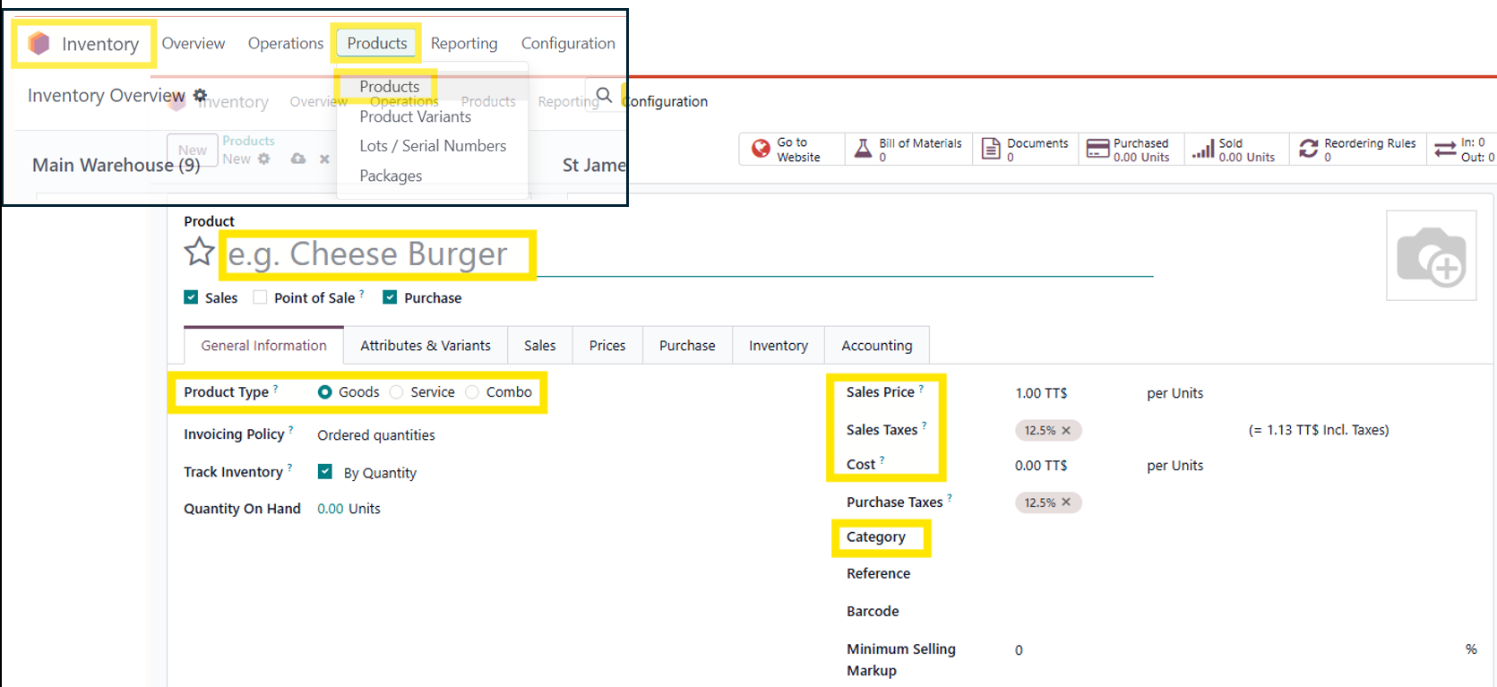

2. Warehouse Configuration & Location Mapping

2.1 Configuring Warehouse and Creating Locations in the Warehouse
Steps:
- In the Inventory module, navigate to the Configuration menu, select Warehouses. Click on New to create a new warehouse.
- You can configure: Name, Address, Store Manager, Incoming & Outgoing Shipments steps, Resupply from specific warehouse.

Incoming Shipments (Receiving Goods)
This setting defines the workflow for handling products arriving at your warehouse from suppliers.

Receive and Store (1 Step)
Goods are received directly into their final storage location.
Best for: Small warehouses with no staging or quality check needs.

Receive then Store (2 Steps)
Goods are first received in an input/staging area, then moved to final storage.
Best for: Separating the unloading process from the shelving process.

Receive, Quality Control, then Store (3 Steps)
Goods arrive at the receiving dock, move to a dedicated quality control zone for inspection, and are only moved to final storage once approved.
Best for: Industries with strict quality standards (e.g., food, pharma, electronics).
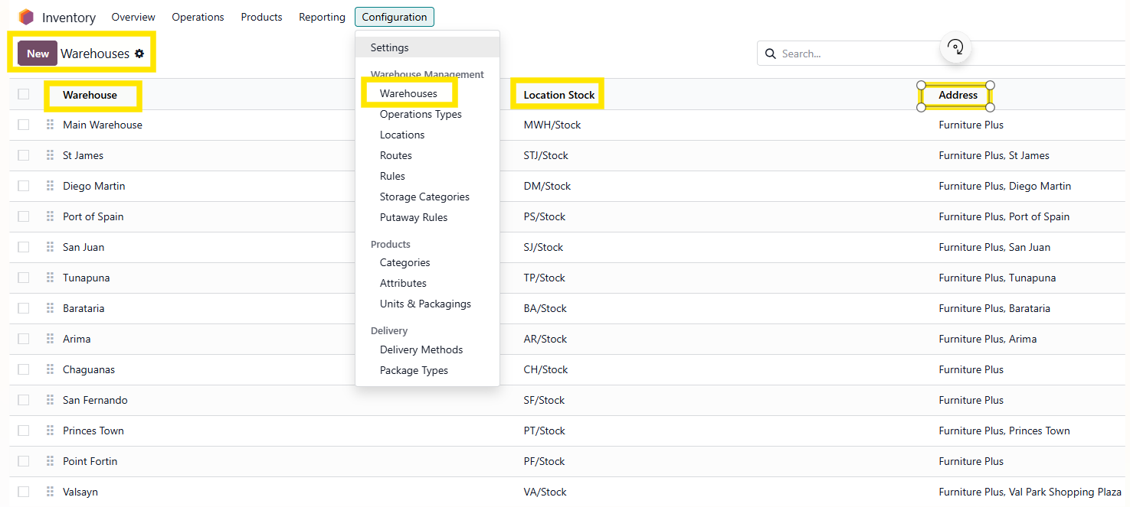

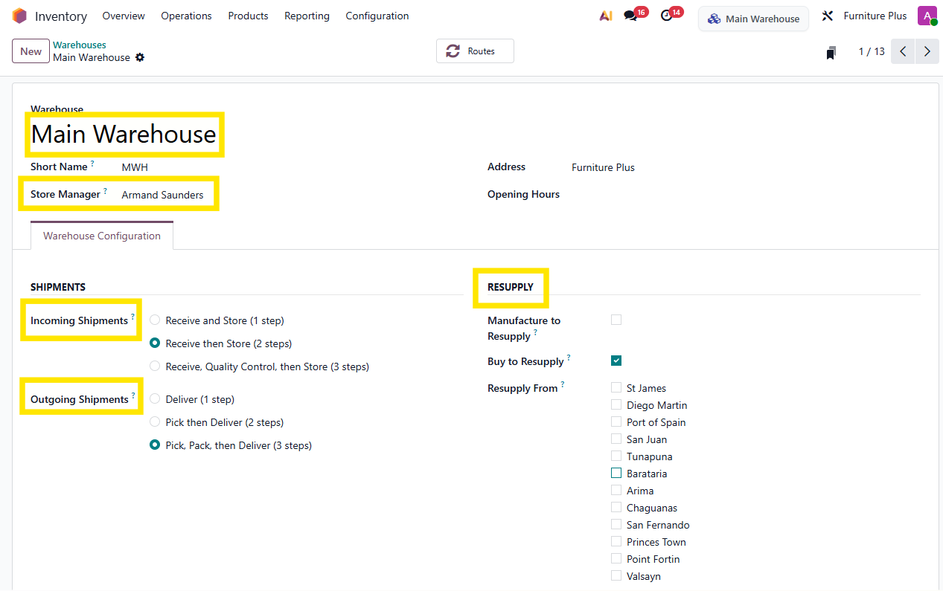

Outgoing Shipments (Shipping Goods)
This setting defines the workflow for picking, packing, and dispatching products to customers.

Deliver (1 Step)
Goods are taken directly from stock and loaded onto the delivery vehicle.
Best for: Small businesses with a simple, direct shipping process.

Pick then Deliver (2 Steps)
Goods are picked from stock and brought to an output/shipping area, where they are then loaded and delivered.
Best for: Separating inventory picking from the actual dispatch process.

Pick, Pack, then Deliver (3 Steps)
Goods are picked from stock, moved to a packing station to be boxed/wrapped, and then transferred to the shipping dock for final delivery.
Best for: E-commerce or larger warehouses that require custom packaging, parcel labeling, or order consolidation.

Understanding Locations in Odoo Inventory

Warehouse vs. Location
Warehouse: The actual, physical building or facility where your inventory is kept (e.g., "Main Warehouse").
Location: A specific, designated space inside a warehouse where products are stored (e.g., a shelf, an aisle, or a bin).

Key Features
- Hierarchical Structure: Locations can be organized in a parent-child structure for precise tracking (e.g., WH/Stock/Zone A/Shelf 1).
- No Capacity Hard Limits: Standard locations act as logical organizers rather than rigid, physically restricted slots.
- Automated Rules: Locations can be linked to customized Putaway and Removal Strategies (such as FIFO or FEFO).

The 3 Location Types
Odoo uses different location types to track exactly where stock is (and where it goes):
1. Physical (Internal) Locations:Actual areas within your warehouse owned by you (e.g., Stockrooms, Loading Docks). Items stored here directly affect your internal stock valuation.
2. Partner Locations:Spaces representing external entities like Vendors or Customers. Used as the origin or destination point for tracking orders leaving or entering your system.
3. Virtual Locations:Non-physical places used for administrative and tracking purposes. Crucial for managing Scrap, Inventory Adjustments (Loss), and goods in Transit between sites.

Creating a New Location
- In the Configurations menu, select Locations, click on New to create a new location.
- In the Location form, you can configure: Name, Parent Location, Type, Category, Barcode, Enable Replenishments, Cyclic Counting, Removal strategies for Logistics.

3. Inventory Adjustments & Barcoded Stock Takes

3.1 Scheduling Stock Counts (Inventory Manager)
- In the Inventory module, navigate to the Configuration menu, select Location. Under Cyclic Counting, set the inventory frequency days, which will auto-update Last Inventory & Next Expected dates. The products in the location will be automatically flagged for count when due.
- To request a count for specific products in a location, navigate to the Operations menu, select Physical Inventory, choose the product, and select Request a Count. Assign a user, schedule, and confirm.
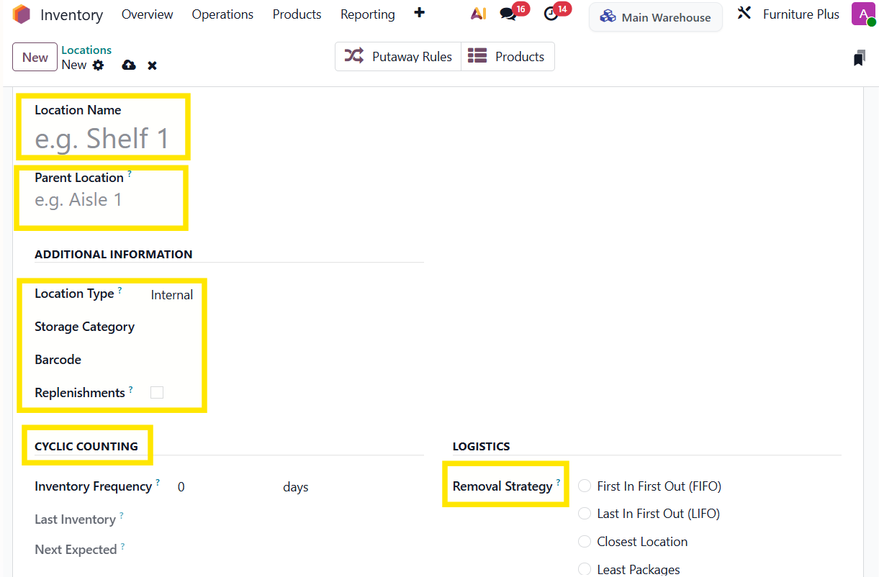

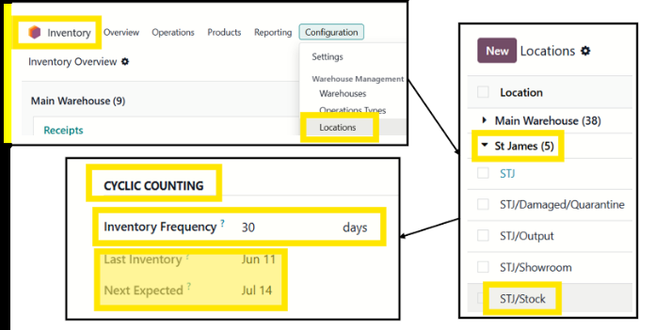

3.2 Counting via Barcode Application (Store User)
- Open the Barcode app on your device (mobile or a barcode scanner), select Count Inventory.
- Scan the Location barcode first, then scan the Product barcode. Scan multiple times to increase the count, or click the pencil icon to manually type in the counted quantity.
- Once a row is complete, click Apply Now or Wait for Review.
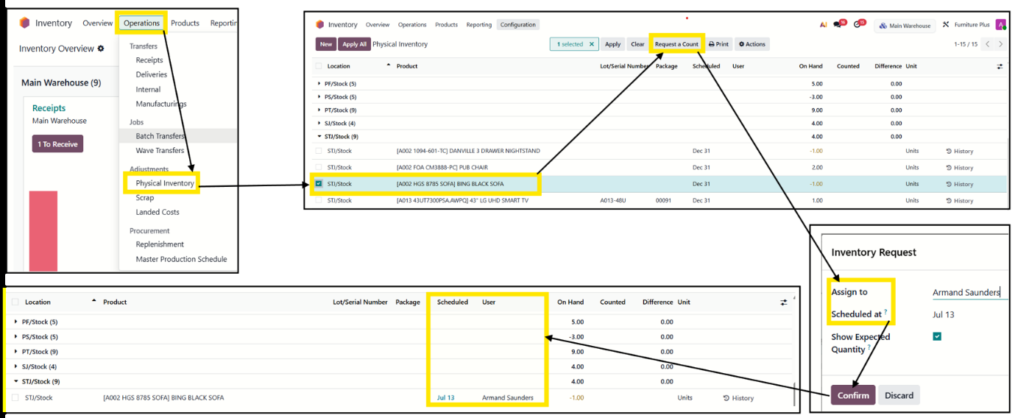

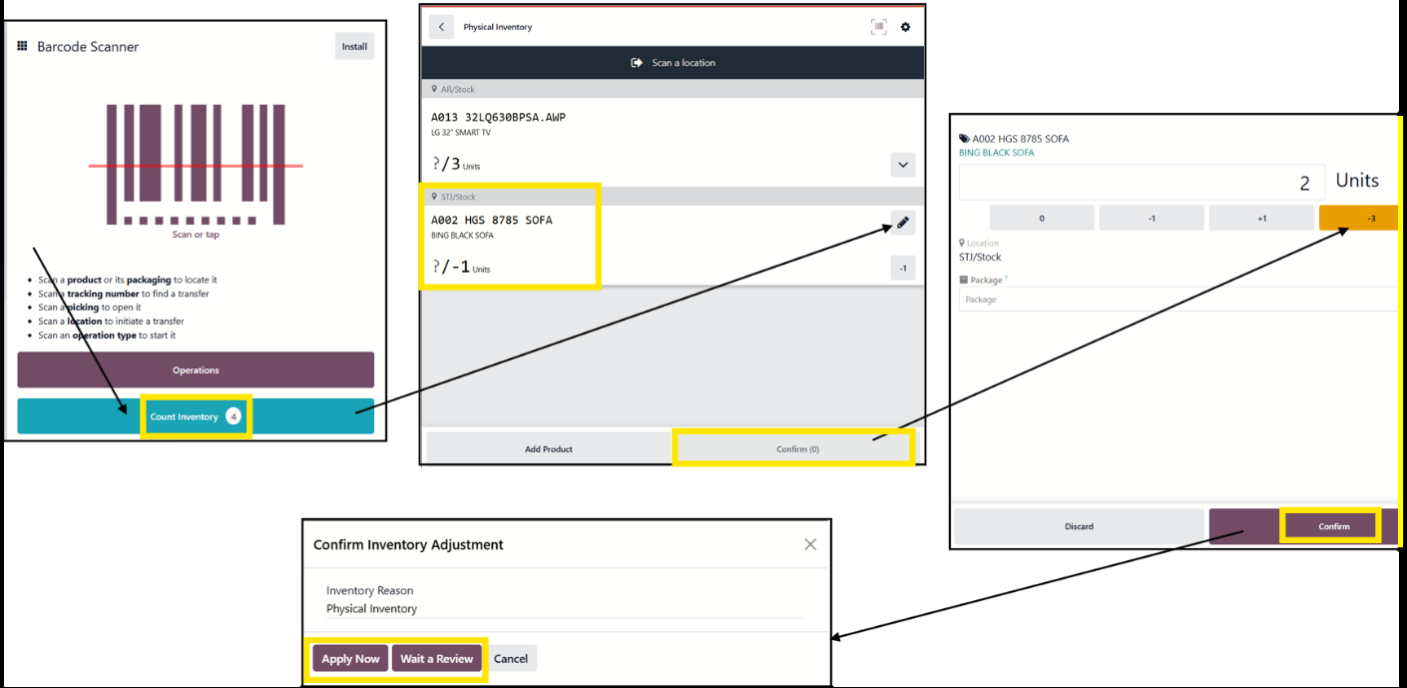

3.3 Committing Stock Counts (Inventory Manager)
Note: The counts submitted by users are reviewed and approved to update physical stock levels.
- In the Inventory module, navigate to Operations, select Physical Inventory. You will see a list of products with On-hand and counted quantities. Review the lines and select Apply / Apply All for multiple counts if accurate.
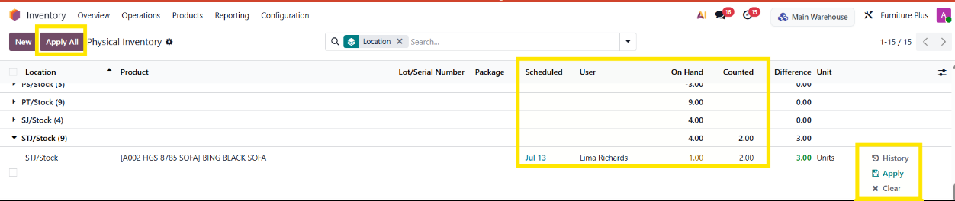

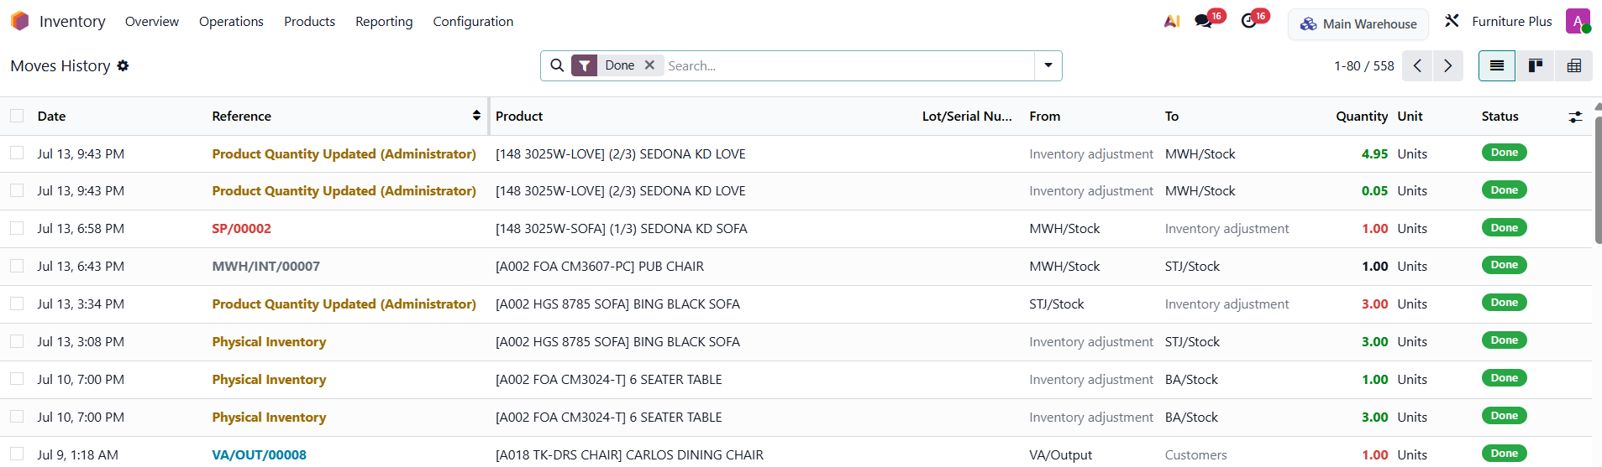

3.4 Review Reports on Stock Counts (Inventory Manager)
- In the Inventory app, navigate to the Reporting menu, select Stock to view all of the stock you hold in different warehouses or Locations. Select Moves History to view all the moves inside your warehouse.

4. Replenishments

4.1 Creating Reordering Rules for Products (Procurement Manager)
- You can set reordering rules for products in the Product form or in the Inventory module. In the Operations menu, select Replenishment. You will see all the rules set for all products.
- Click on New to create a reordering rule for any product. Set a minimum and maximum limit; the To Order count will be auto-updated based on the forecast.
- Click on Automate to automatically create a Purchase Order for the product when the on-hand quantity drops below the minimum, or click on Order to manually order the product.
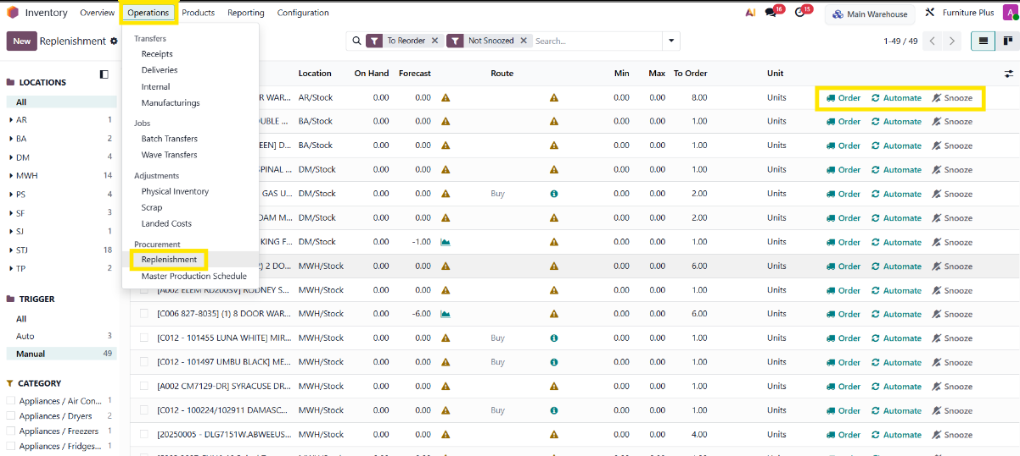

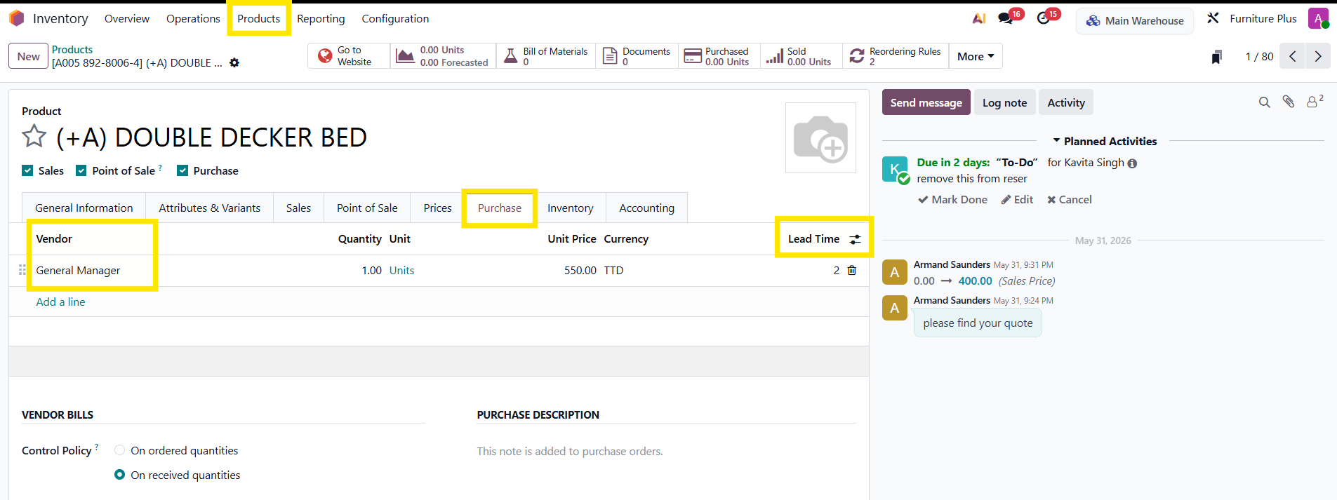

4.2 Configuring Lead Times for Products
- In the Product form, Purchase tab, you can configure a vendor and add a lead time. When a reordering rule is triggered and the on-hand quantity falls below the minimum, the Purchase Order will be auto-updated with the vendor and to-order quantity based on the forecast, with delivery based on the lead time updated here.
- You can also add customer lead times — the number of days it will take you to prepare the order for shipment. Set Product Lead Time (Per Product).

5. Inter-warehouse Transfers

5.1 Requesting Stock from Another Warehouse (Store Manager)
- In the Inventory module, navigate to Operations, select Internal. Click on New, select Operation Type, Source & Destination Location, add the product and demand quantity, mark as To-Do / Validate.
- Based on the availability of the product, the status will change for the transfer (e.g., Ready if available).
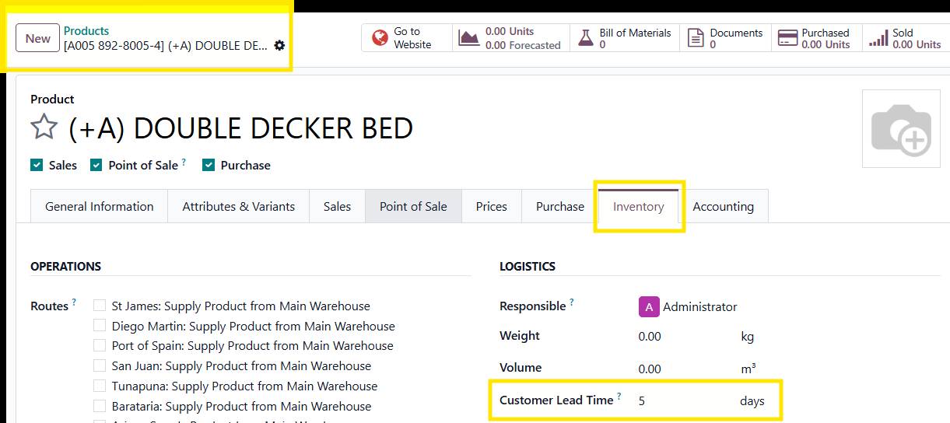

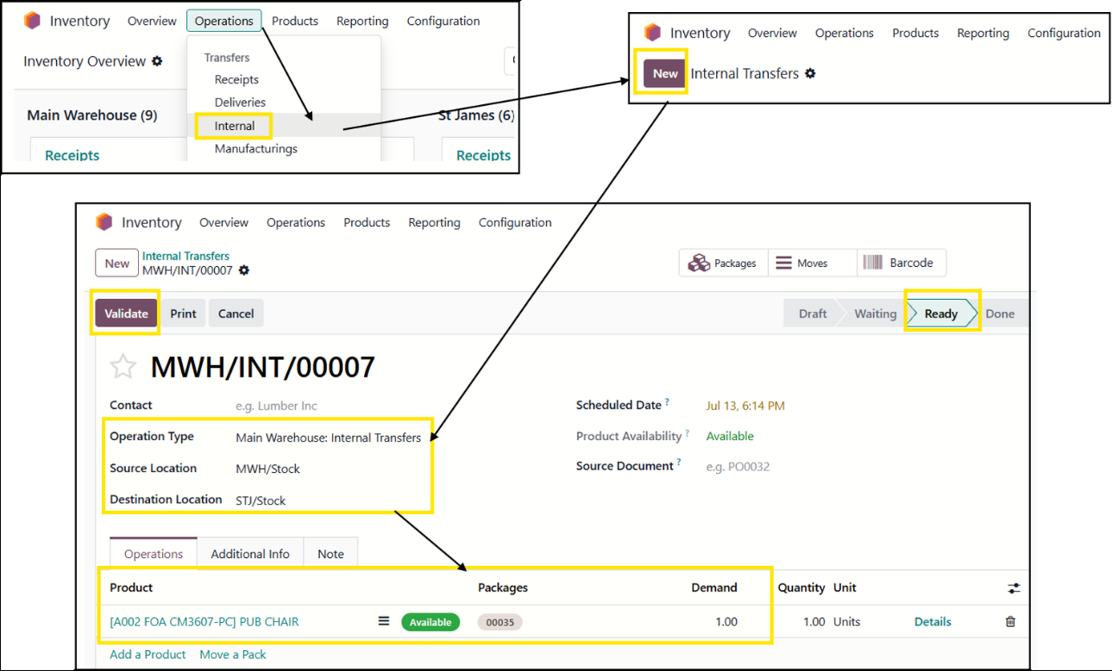

5.2 Approving Inter-Store Transfer Requests (Store Manager)
- The transfer can be verified and validated by the store manager. Once the transfer is complete, a notification email will be sent to the receiving store manager.
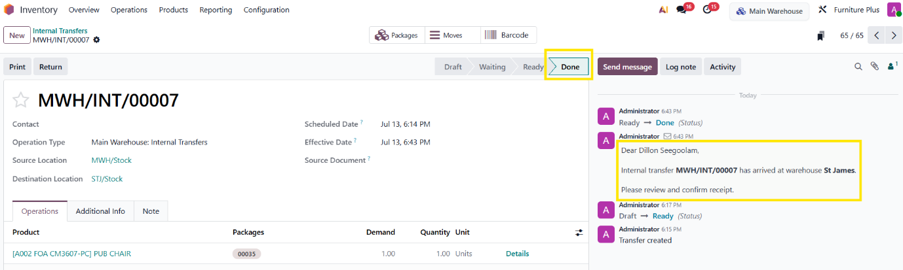

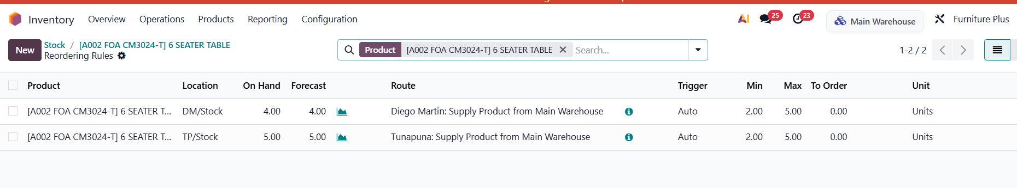

5.3 Automated Inter-warehouse Transfers Based on Reordering Rules
Based on your replenishment rules configured on each product, the system can automate your product reorderings, as mentioned in Section 4.1. Once the system triggers a replenishment rule for your stock, it will create several transfers. For example, there may be two rules using the Route to request stocks from the Main Warehouse. In this case, a picking will be created in the Main Warehouse to fulfill the demand in the stores.
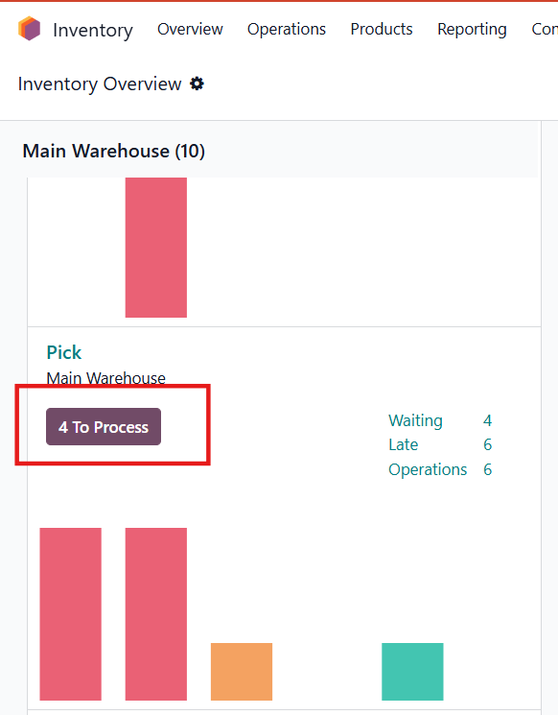

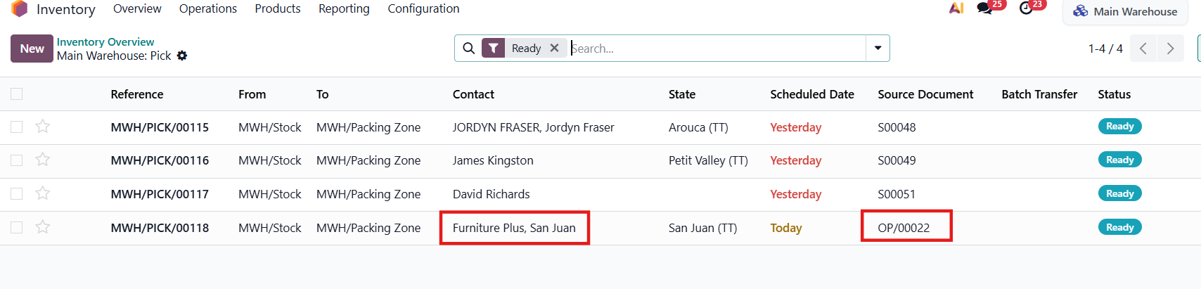

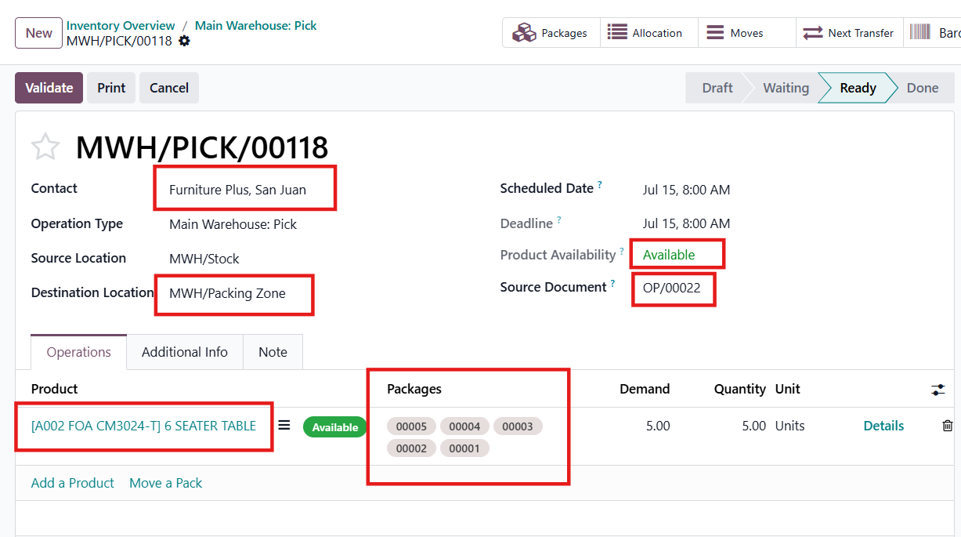

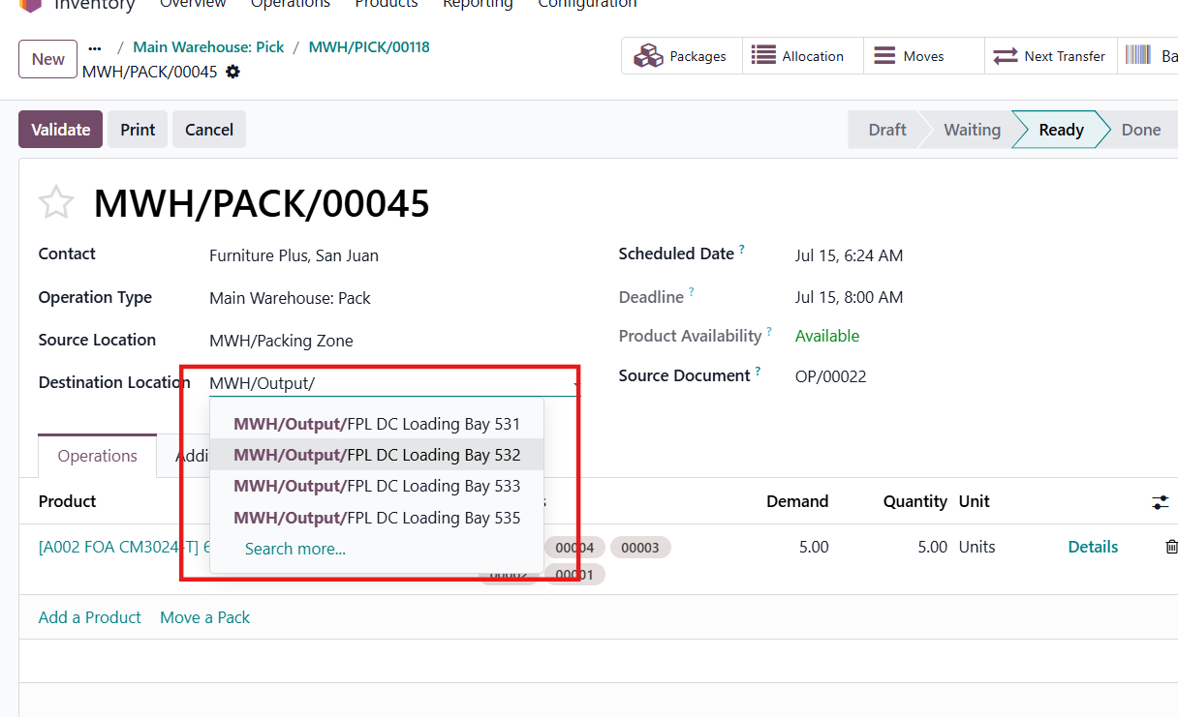

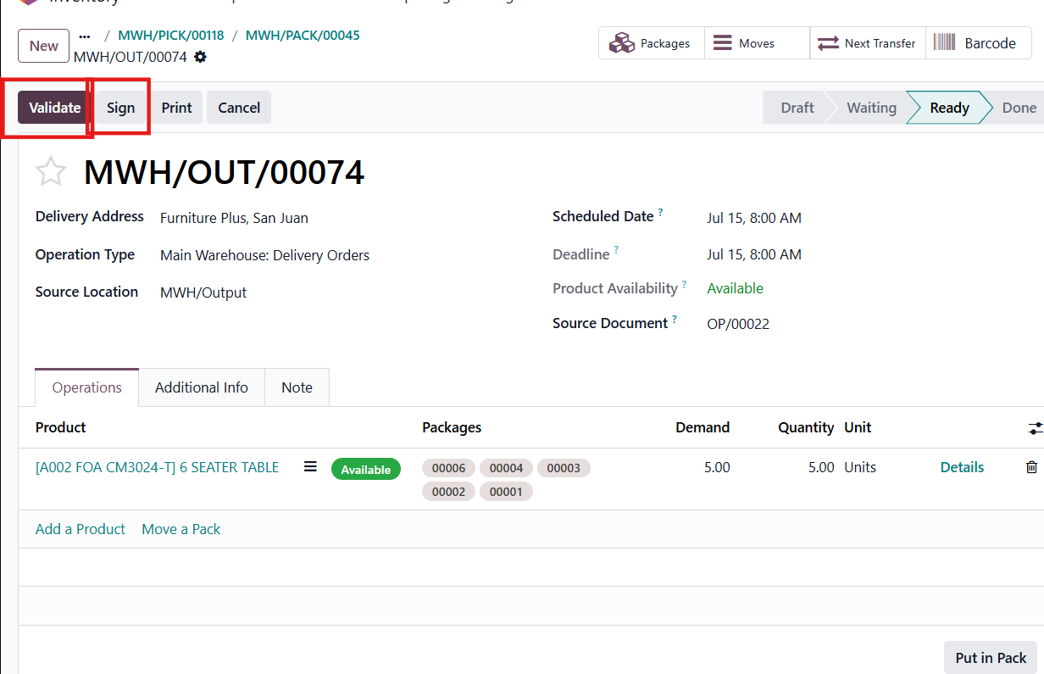

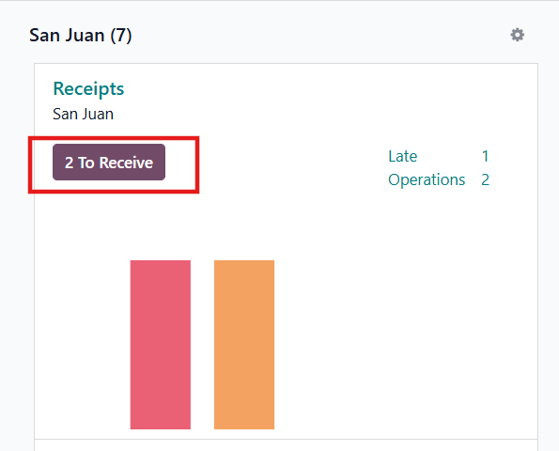

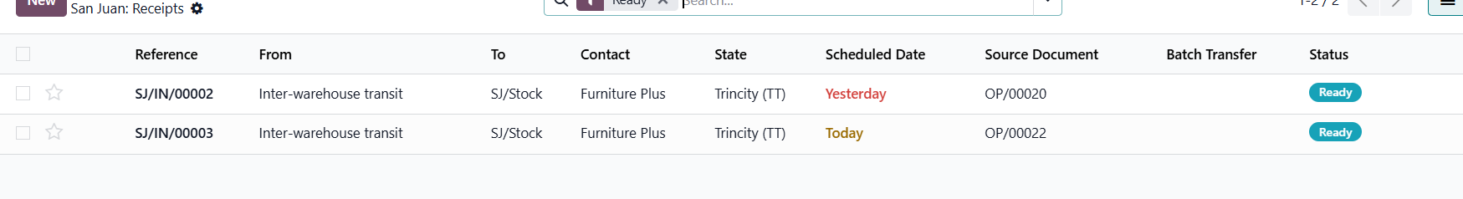

6. Transfer Operations

6.1 Scraping Stocks (Inventory Manager)
- Items can be scrapped from your inventory. When items are scrapped, the system will credit your inventory and debit the scrapped account on the location for your scrap. Another word for scrap may be "write off" or "condemn." When scrapping, state your reason, then validate.
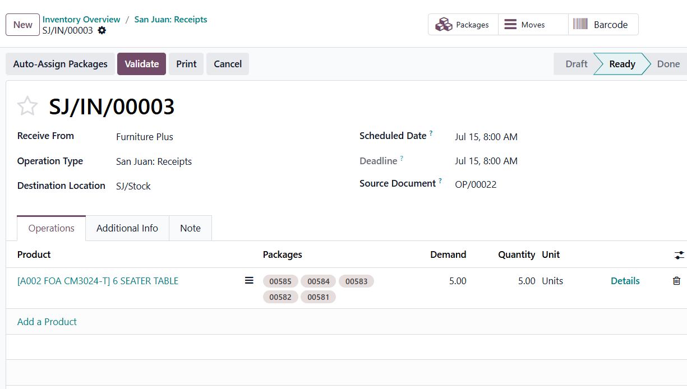

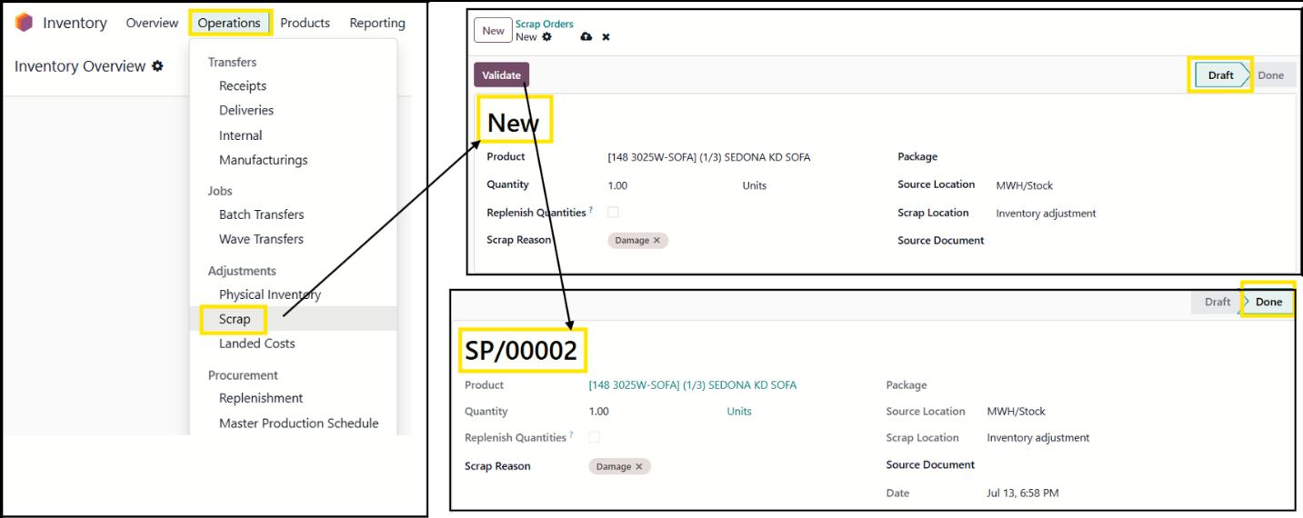

6.2 Viewing Value of Scrapped Stocks (Accounting User)
- In the Accounting module, navigate to Review, select Inventory Valuation to view real-time automated asset balances.
- Once scrapped, this will create a journal entry. In this case, the cost of the item that was scrapped was 186.53, so the journal entry will reflect this. It will also show the scrapping number as a reference in the journal.
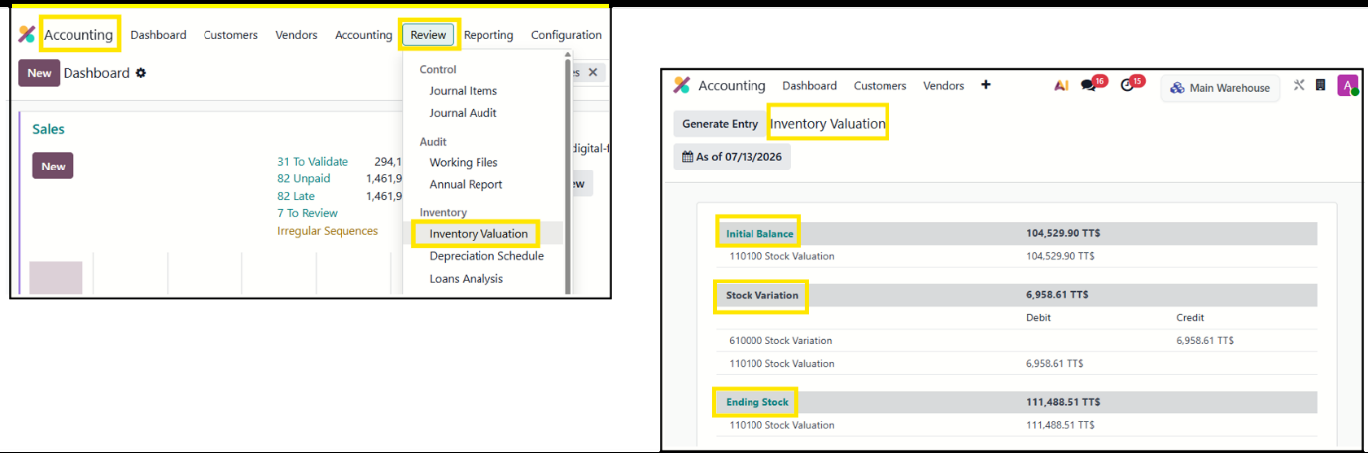

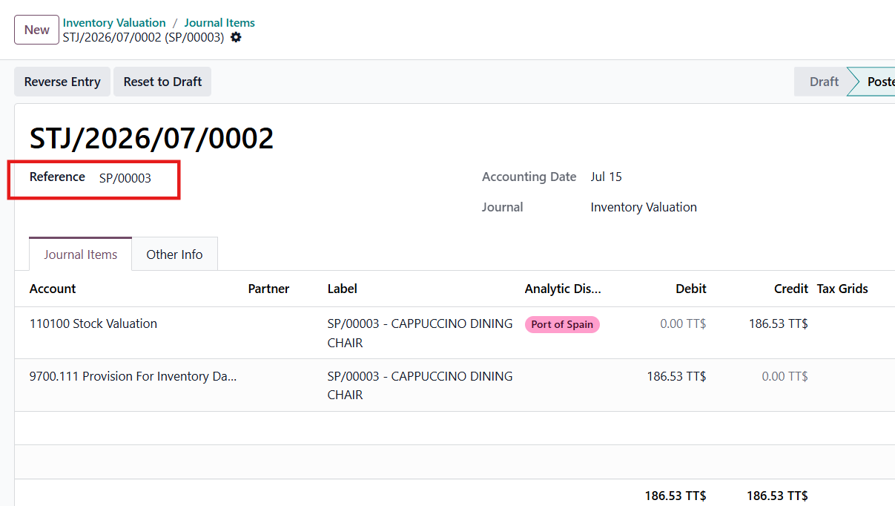

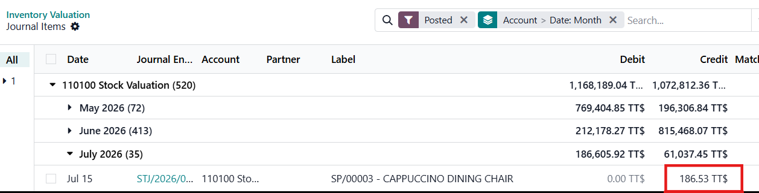

6.3 Unreserving & Reserving Stocks (Store Manager)
In some cases, as the manager, you may need to unreserve inventory and transfer or assign it to another order.
- In the screenshots below, we can see two transfers — one is available and the other is not. We are going to unreserve MWH/PICK/00125 and assign it to MWH/PICK/00126. Click on Available (green button) or Unavailable (red button).
- The forecast report opens up. Click on Unreserve for a non-priority order and complete the priority order first.
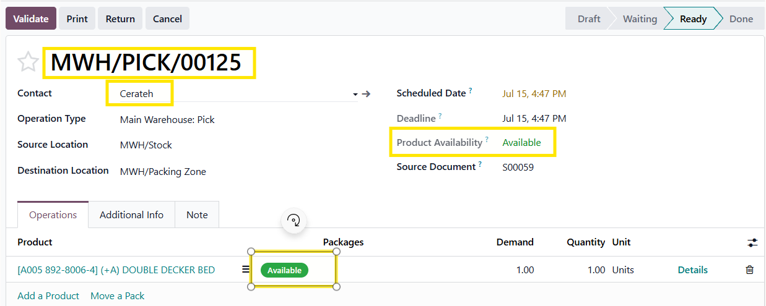

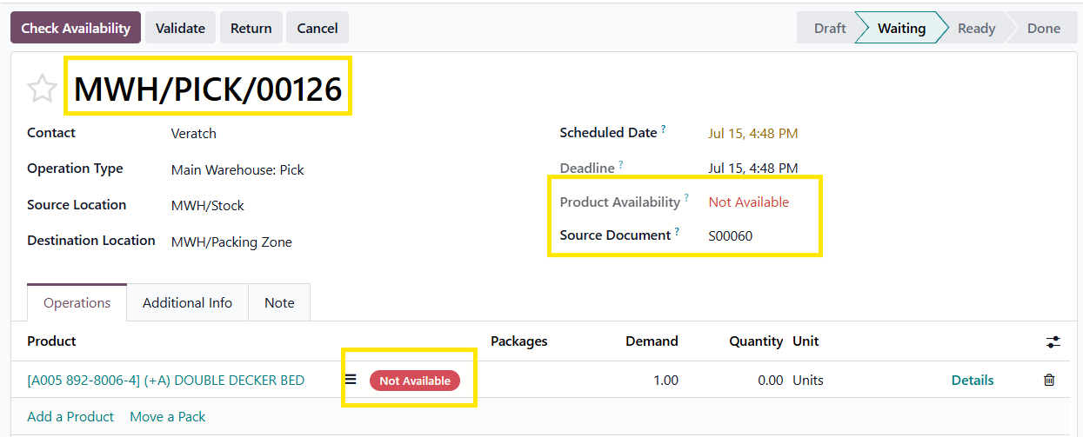

7. Deliveries

7.1 Creating Delivery Batches & Planning Delivery Schedules (Warehouse Manager)
As a warehouse manager, I can plan out my delivery schedules. This can be done by updating the schedule date on the outgoing transfer.
By changing your scheduled date, you can prioritize your delivery schedule. It must also be noted that from the Sales Order, a CSR can set the promised delivery date, and this will also show up in your schedule date when planning your deliveries. This can be done by going to the Other Info tab on your Sales Order.
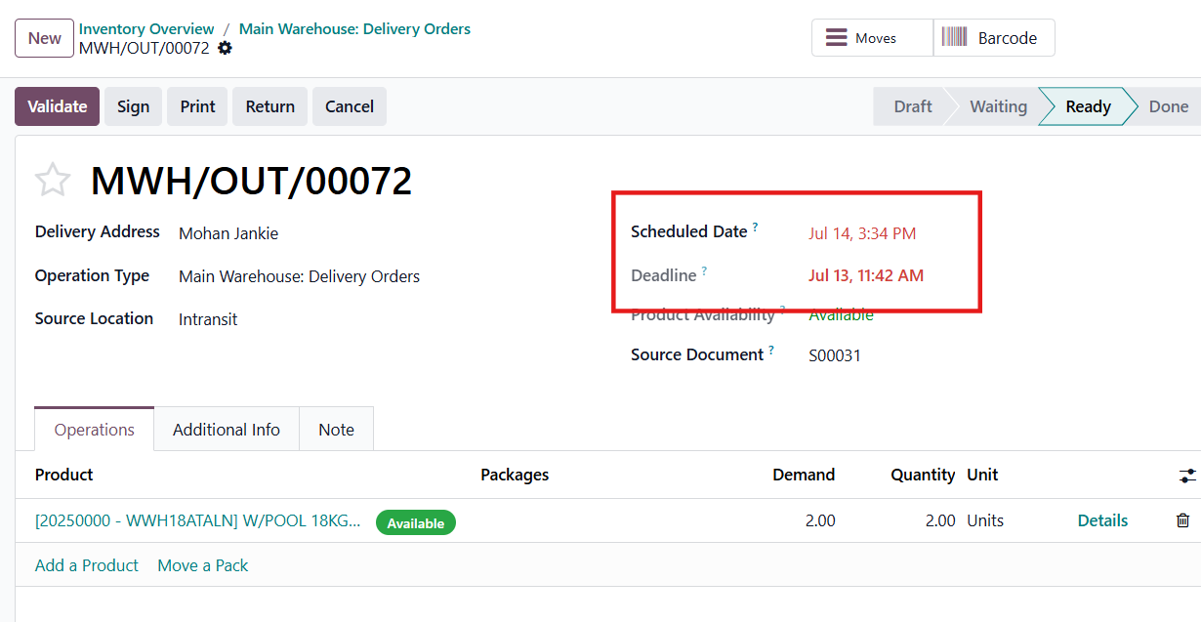

7.2 Assigning Delivery to Trucks (Warehouse Manager)
Now that we have finished the pick and pack and items are packed to the correct bays, it is time to batch your deliveries and assign them to trucks.
In the screenshot above, I am showing the packing operations, where I will assign all the Arima transfers to a different bay vs. the San Juan transfers.
Transfers are now being batched together.
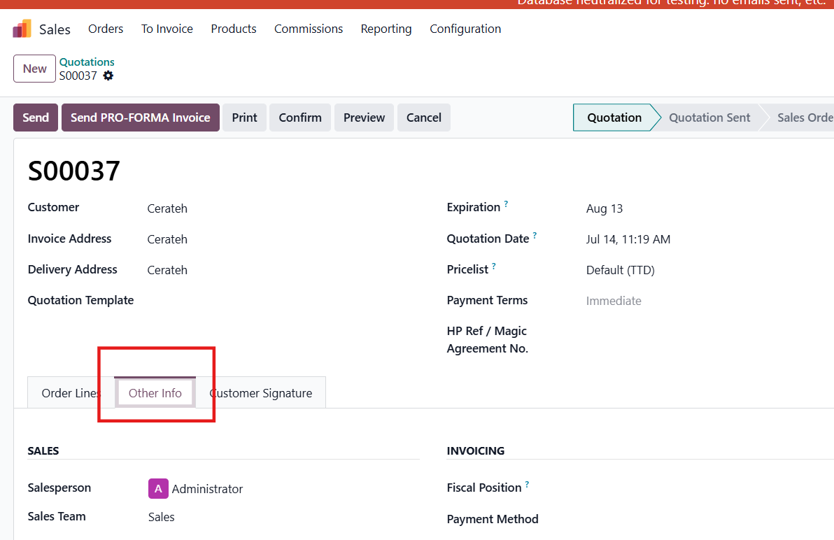

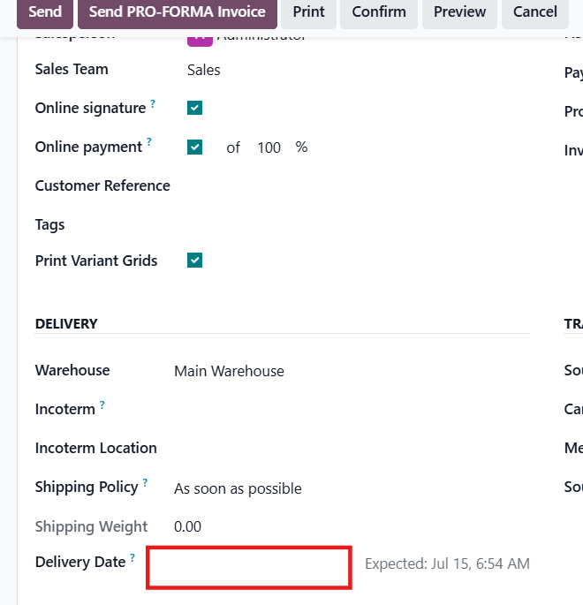

When creating the batch, we add a description (e.g., "San Juan delivery on truck pdf3435"). This can be any descriptive name for the batch that is going on the truck. Then we assign a responsible person / driver and press Confirm.
From here, click on the Batches to assign the trucks.
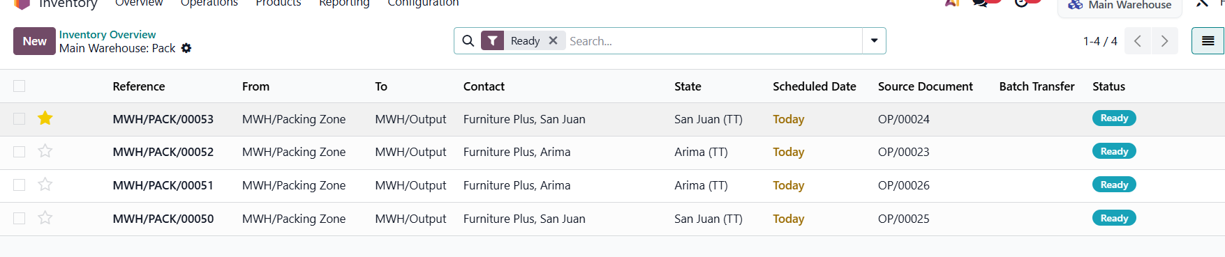

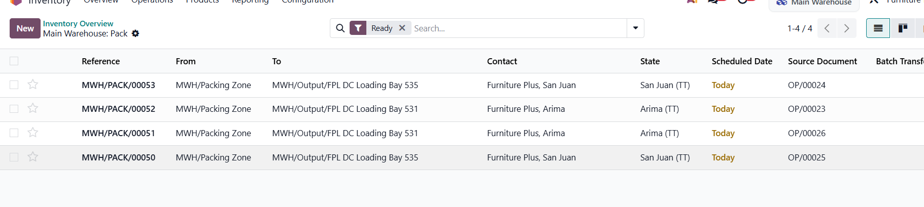

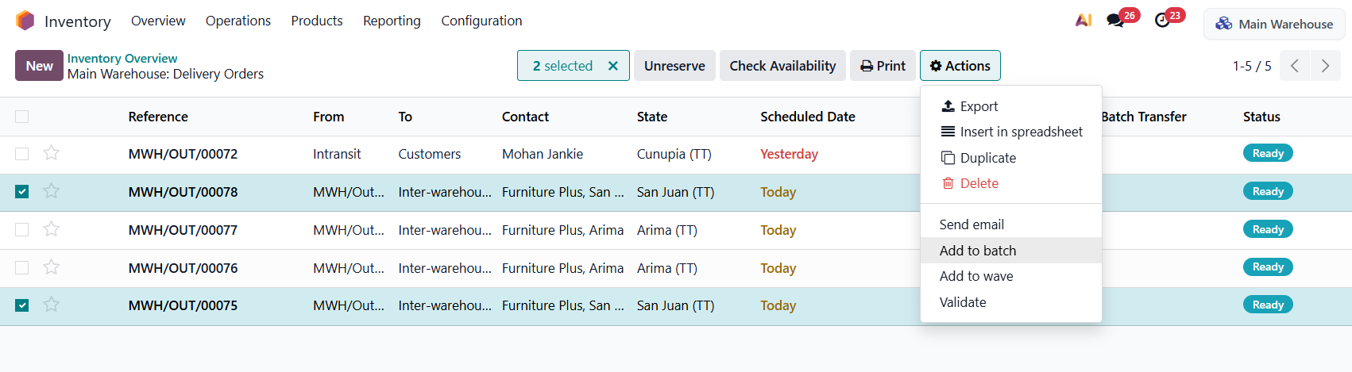

Once trucks are assigned, the system will automatically calculate and let you know if the truck is overweight or overpacked. This only works if the product weight and volume has already been set on the product template and the truck has been assigned to a category that has the truck size and weight configured.
On the Transfer tab within the batch, the driver can see all the individual orders.
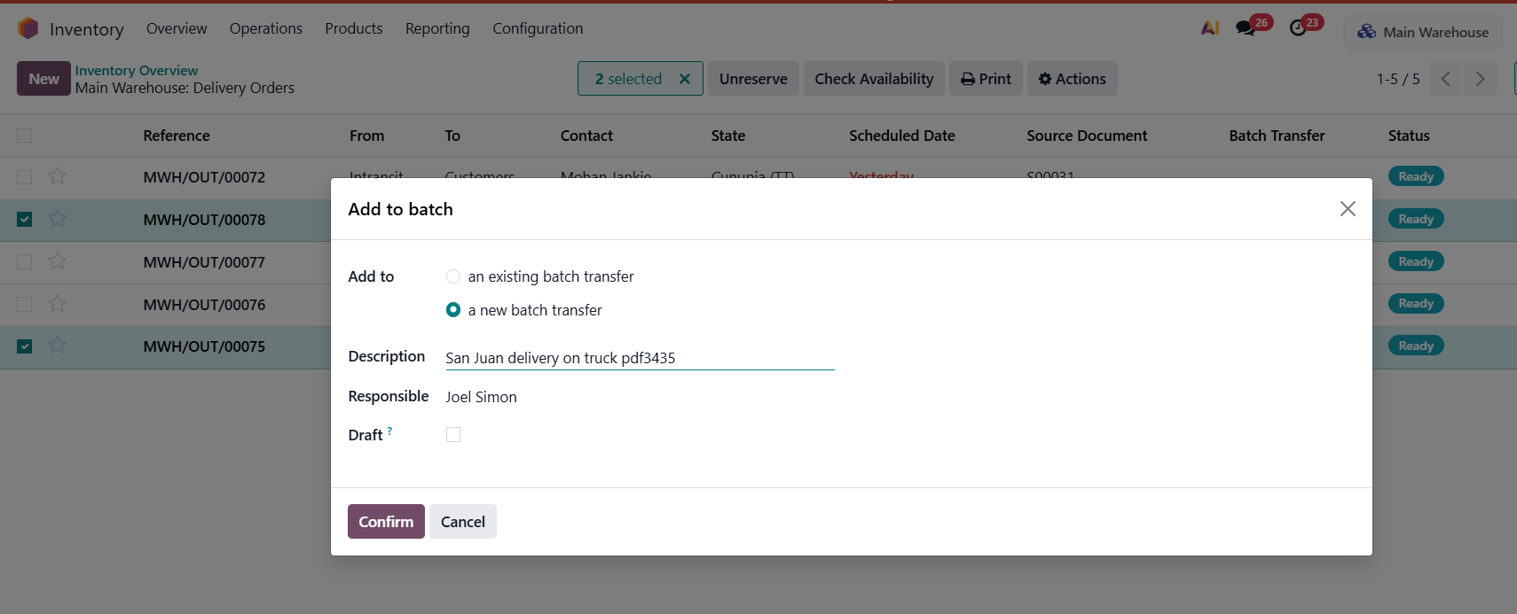

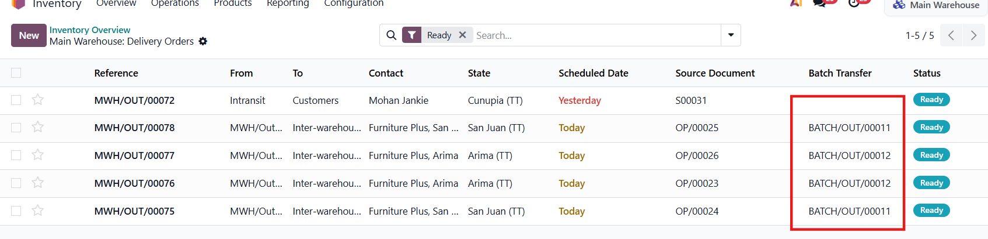

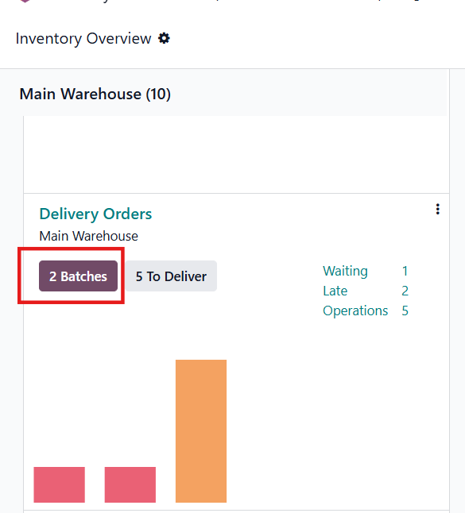

If clicked, this will show the transfer details.
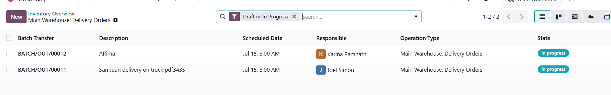

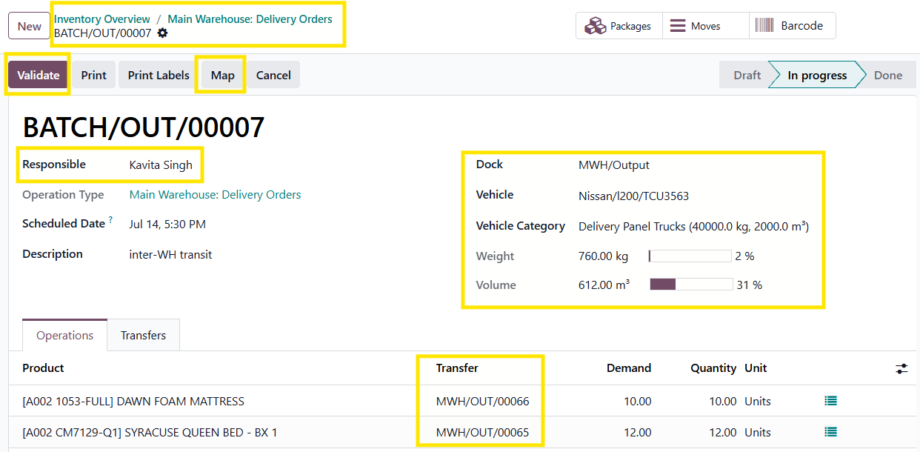

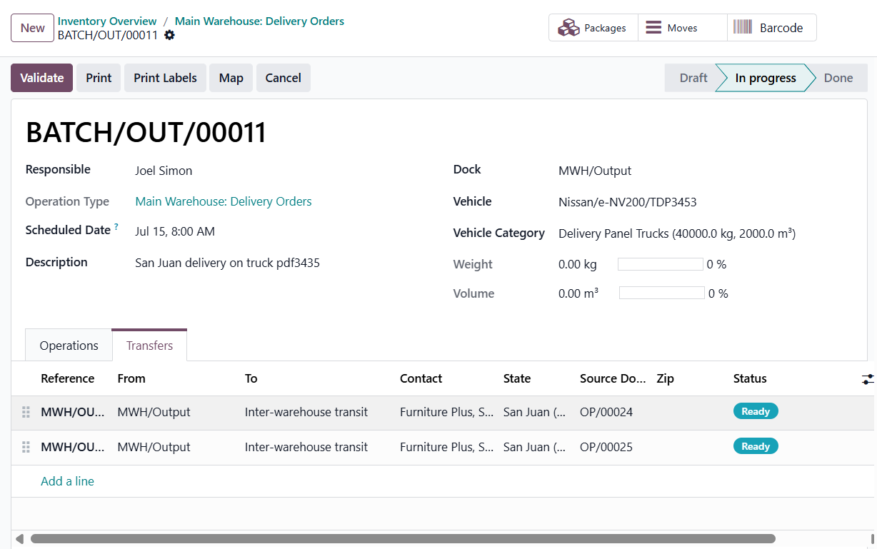

Now that the driver has a batch assigned, he can view the map and plan out his route. To do this, select Map, and this will load up the map. From there, you can press Google Map and use that service.
