Mini Bijou Activity Sheet 1: Colours ANSWERS
A/ Draw a line to match up the French colours with the English colours below.

rouge white
bleu red
blanc blue

B/ Say these three colours out loud in French. Try to remember how to pronounce them – check out the colours pronunciation guide below if you like (there are lots of other colours too!)
https://www.youtube.com/watch?v=JkQGN86qTag

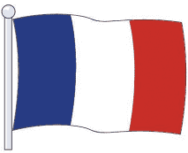
C/ Colour in the flag below with the colours of the French flag, then write the colours below each section of the flag.

bleu blanc rouge

D/ Using the colours above, write your answers to the following questions, IN FRENCH.

- What colour is snow? blanc

- Out of the 3 colours above, which one is your favourite? Your own answer here (Sue’s is bleu)

- What colour is a tomato? rouge

- Which of the colours above contains 4 letters? bleu


E/ Language detective
Can you find out how to write these colours in French?
- yellow = jaune 2. pink = rose

