Mini Bijou Activity Sheet 1: Colours
A/ Draw a line to match up the French colours with the English colours below.

rouge white
bleu red
blanc blue

B/ Say these three colours out loud in French. Try to remember how to pronounce them – check out the colours pronunciation guide below if you like (there are lots of other colours too!)
https://www.youtube.com/watch?v=JkQGN86qTag

C/ Colour in the flag below with the colours of the French flag, then write the colours below each section of the flag.
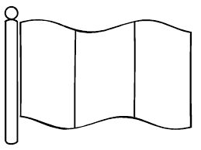

D/ Using the colours above, write your answers to the following questions, IN FRENCH.

- What colour is snow? ........................................

- Out of the 3 colours above, which one is your favourite? ………………………………….

- What colour are tomatoes? ………………………………….

- Which of the French colours above contains 4 letters? …………………………………..

E/ Language detective
Can you find out how to write these colours in French?
- yellow = ……………………………… 2. pink = ………………………………………

Now head to the ANSWERS page to check your answers

