Repositorio: https://github.com/Nipa99/PracticaDespliegueWordPress.git
Pipeline
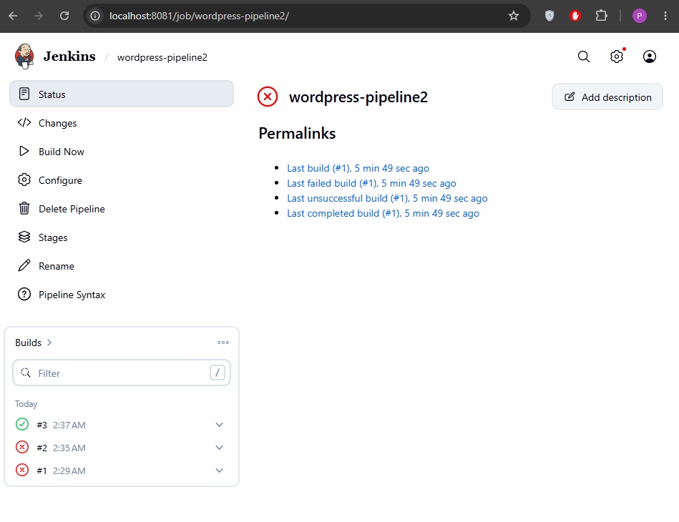
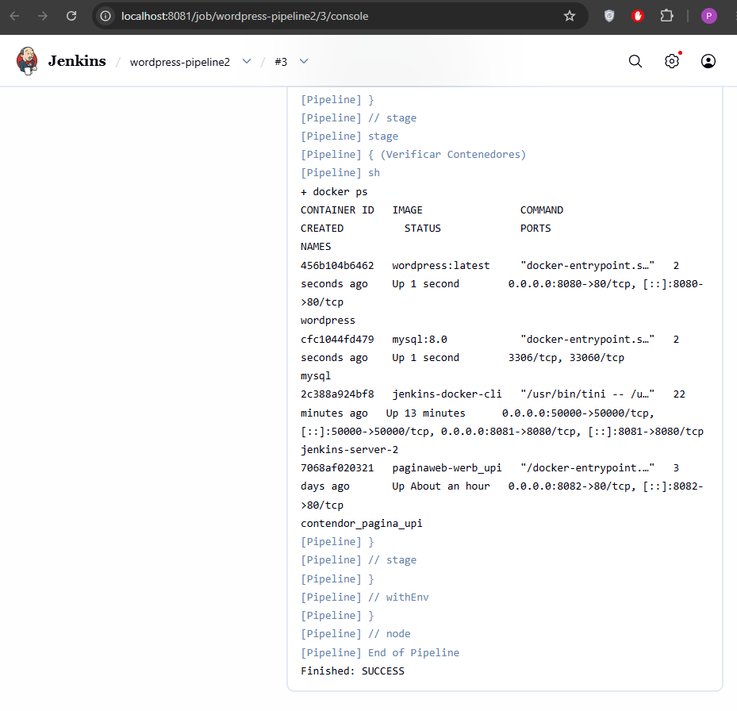

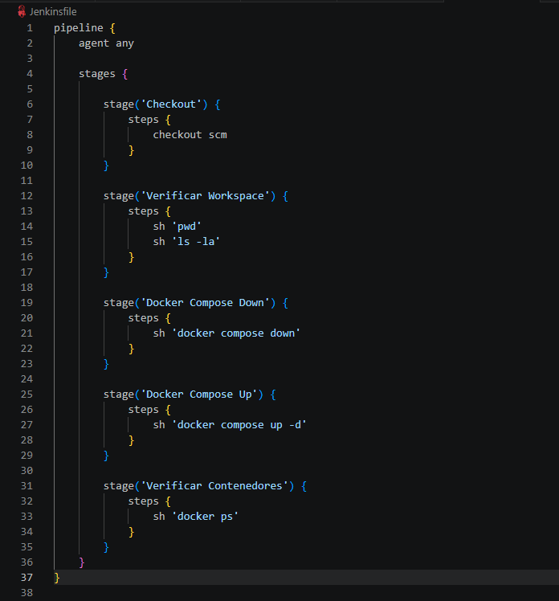

docker ps

docker network ls
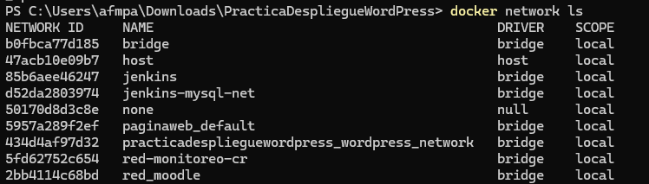

docker volume ls
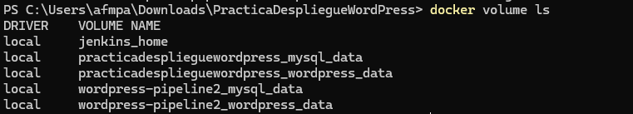

Pantalla inicial de WordPress.
