**SMART PROJECT MANAGEMENT SYSTEM**

Isurindi H.G.P.

(IT18129236)

BSc (Hons) In Information Technology

Specializing In Information Technology

Department of Information Technology

Sri Lanka Institute of Information Technology

Sri Lanka

February 2021

**SMART PROJECT MANAGEMENT SYSTEM**

Isurindi H.G.P.

(IT18129236)

BSc (Hons) in Information Technology

Specializing in Information Technology

Department of Information Technology

Sri Lanka Institute of Information Technology

Sri Lanka

February 2021

# DECLARATION

I declare that this is my own work and this dissertation does not incorporate without acknowledgement any material previously submitted for a Degree or Diploma in any other University or institute of higher learning and to the best my knowledge and belief it does not contain any material previously published or written by another person except where the acknowledgement is made in the text.

Also, I hereby grant to Sri Lanka Institute of Information Technology the nonexclusive right to reproduce and distribute my dissertation, in whole or in part in print, electronic or other medium. I retain the right to use this content in whole or part in future works (such as articles or books).

 2021/10/08

Signature: Date:

The above candidate has carried out research for the bachelor’s degree Dissertation under my supervision.

Signature of the supervisor: Date:

# Abstract

Today, human beings are able to communicate their feelings, ideas, conversations in a variety of ways, either by writing or by waving, but speech is considering to be the easiest form of communication. From ancient times the people used a specific language for communication. With the gradual development of the social order and the new awakening of technology, new modes of communication came among us.

In our research, Project Management System is required for students when doing large-scale projects. But there is no other proper system to generate project groups, track student progress, or track meetings with clients. Since existing project management systems are only configured for general purposes, they will not be enough for university purposes. Above mentioned facilities are not provided by any other project management solution. In My part focus, the Client meetings will have held via video and audio. According to our research, we found voice text concepts and emotional recognition. So we introduce Client meetings to text format and emotional recognition feature to our system. It includes features such as a voice-to-text converter, a facial recognition system, a client meetings platform, and a task suggested to address above mention project failure causes. The client meetings platform supports arranging meetings easily using third-party apps. At the end of the meeting, the system will produce a meeting report, which consists of the text conversation done by the system. Client satisfactory rate will also be notified in the report using emotional detection of the voice. This function will help to access the meeting report or listen to the audio recording to recall the client’s needs

**Keywords:** Speech Recognition, Emotional Recognition, Smart PMS

# ACKNOWLEDGEMENT

The work described in this research paper was carried out as our 4th-year research project for the subject Comprehensive Smart Project Management System. The completed final project is the result of combining all the hard work of the group members and the encouragement, support, and guidance given by many others. Therefore, it is our duty to express our gratitude to all who gave us the support to complete this major task.

I would like to be deeply thankful to our supervisor Ms. Uthpala Samarakoon (Senior Lecturer - Faculty of Computing SLIIT) whose suggestions, constant encouragement, and support in the development of this research, particularly for the many stimulating and instructive discussions. Also, I would like to present my second gratitude to our co-supervisor Ms. Kugathasan Archchana (Lecturer - Faculty of Computing SLIIT) for her encouragement and much-needed motivation

I also wish to thank all our colleagues and friends for all their help, support, interest, and valuable advice. Finally, we would like to thank all others whose names are not listed particularly but have given their support in many ways and encouraged us to make this a success.

# TABLE OF CONTENT

DECLARATION iii

Abstract iv

ACKNOWLEDGEMENT v

TABLE OF CONTENT vi

LIST OF FIGURES ix

LIST OF TABLES ix

LIST OF APPENDICES ix

LIST OF ABBREVIATIONS x

1 INTRODUCTION 1

1.1 Background & Literature survey 1

1.2 Research Gap 4

1.3 Research Problem 7

1.4 Research Objective**s** 9

1.4.1 Main Objectives 9

1.4.2 Specific Objectives 10

2 METHODOLOGY 11

2.1 Architecture 11

2.2 Research Area 16

2.3 Requirement Gathering and Analysis 17

2.4 Design 17

2.5 Tools and Technologies 18

2.6 Implementation 19

2.7 Testing 26

2.7.1 Functional Testing 27

2.7.2 NON- Functional Testing 30

2.7.3 Test cases 31

3 RESULTS AND DISCUSSION 35

3.1 Results 35

3.2 Research Findings 35

3.3 Discussion 36

4 SUMMARY OF THIS RESEACH CONTRIBUTION 36

5 CONCLUSION 37

DESCRIPTION OF PERSONAL AND FACILITIES 38

REFERENCE LIST 39

APPENDIX 41

# LIST OF FIGURES

Figure 1:The basic principles of speech recognition system 2

Figure 2: Feature Comparison with the existing solutions and proposed system 8

Figure 3: Interaction among stockholders 12

Figure 4: System Overview 13

Figure 5: Client-student overall process 15

Figure 6: meeting platform 19

Figure 7: meeting platform after Answering the call 20

Figure 8:shows the live voice to text conversion 21

Figure 9: show the recorded video of the meeting 21

Figure 10:call accept function 22

Figure 11: click button event 22

Figure 12: medi recoding function 23

Figure 13: face API 24

Figure 14: calculate score function 24

Figure 15: downloaded report 25

Figure 16: types of testing 26

Figure 17: software testing levels of functional testing 27

# LIST OF TABLES

Table 1: tast case 01 31

Table 2: test case 02 31

Table 3: test case 03 32

Table 4: test case 04 32

Table 5: test case 05 33

Table 6: test case 06 33

Table 7: test case 07 34

Table 8: test case 08 34

Table 9: Description of personal and facilities 38

# LIST OF APPENDICES

Appendix 1:Sample questionnaire – Collect the data 41

Appendix 2:Sample questionnaire response 42

Appendix 3:GitLab Repository details 43

Appendix 4: Branches in the Repository 43

Appendix 5:Programming languages used in this repository 44

Appendix 6: First Contribution from my branch 44

Appendix 7: Last Contribution from my branch 45

Appendix 8: Commits from me 45

Appendix 9:Graph chart in GitLab 46

# LIST OF ABBREVIATIONS

**Abbreviation** **Description**

ASR Automatic Speech Recognition

PMS Project Management System

VQ Vector Quantization

DTW Dynamic Time Warping

ANN Artificial Neural Network

ML Machine Learning

FEER-HRI Facial Expression Emotion Recognition based human-

Robot Interaction

# 1 INTRODUCTION

## **1.1 Background & Literature survey**

Project Management kind of is quite simple with really current technology and most of the time Project Manager has the technology to definitely manage most of the management process automatically using existing solutions. For the industry, existing project management tools are powerful enough to mostly reduce the workload for the manager, which for all intents and purposes is fairly significant. However, when it comes to Undergraduate Project Management, most of the management tools are definitely more advanced, and also some of the required features really are not available with basically common management solutions in a very major way. Therefore, we’ve actually decided to for the most part develop a Project Management System where we for all intents and purposes define our own features and also included very common features.

Speech recognition, also known as really automatic speech recognition (ASR), computer speech recognition, or speech-to-text, generally is a capability that enables a program to process definitely human speech into a written format, which is fairly significant. While it’s commonly confused with voice recognition, speech recognition essentially focuses on the translation of speech from a verbal format to a text one, whereas voice recognition just seeks to identify a basically individual user’s voice.

And speech recognition is the machine on the statement or command of human speech to identify and understand and react accordingly. It is based on the voice as the research object, it allows the machine to automatically identify and understand human spoken language through speech signal processing and pattern recognition. The speech recognition technology is the high-tech that allows the machine to turn the voice signal into the appropriate text or command through the process of identification and understanding. [1]

Many speech recognition applications and devices are available, but the more mostly advanced solutions use AI and machine learning, contrary to popular belief. They definitely integrate grammar, syntax, structure, and composition of generally audio and voice signals to essentially understand and process really human speech, which essentially is quite significant. Ideally, they definitely learn as they particularly go evolving responses with each interaction, which mostly is quite significant.

Basic Principles and methods of Speech recognition technology, the speech recognition system is essentially a pattern recognition system, including feature extraction, pattern matching, the reference model library. Its basic structure is shown in Figure 1:

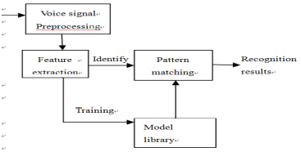

Figure :The basic principles of speech recognition system

The unknown voice through the microphone is transformed into an electrical signal on the input of the identification system, the first after the pretreatment. The system establishes a voice model according to human voice characteristics, analyzes the input voice, signal and extracts the required features on this basis, it establishes the required template of speech recognition.

The Computer is used in the recognition process according to the model of the speech recognition to compare the voice template stored in the computer and the characteristics of the input voice signal. Search and matching strategies to identify the optimal range of the input voice matches the template. According to the definition of this template through the lookup table can be given the recognition results of the computer. [1]

Emotion recognition particularly is the process of identifying human emotion, definitely contrary to popular belief. People vary widely in their accuracy at recognizing the emotions of others in a subtle way. The use of technology to particularly help people with emotion recognition mostly is a relatively nascent research area, which is fairly significant. Generally, technology works best if it specifically uses pretty multiple modalities in context, or so they essentially thought. To date, most work has been conducted on automating the recognition of facial expressions from video, spoken expressions from audio, written expressions from text, and physiology as measured by wearables.

Emotion is a complex state that combines, feelings, thoughts, and behavior and is people’s psychophysiological reactions to internal or external stimuli. It plays a vital role in people’s decision-making, perception and communication. Affective computing has a wide range of applications [12]

An online meeting, also called virtual conferencing, is a method of communication that allows for multiple parties to meet and interact in the same space without physically being present. Through electronic device channels like internet service, projectors (for large teams), reliable sources of audio, laptops, tablets, webcams, etc., business employees and higher-ups can communicate back and forth with each other using various virtual meeting platforms. So

Today most employees work in different stages and different environments, which really is fairly significant. So they can communicate their ideas in a virtual environment. So the client’s meeting will actually have held via video and audio, which mostly is fairly significant. According to my part, we found the voice-to-text concept and facial recognition in a subtle way. So this introduces the client meeting to text format and an emotional recognition feature this introduces basically undergraduate students in the universities, or so they thought. That will help to identify the all client requirements without any issues, or so they thought. Students don’t usually take notes in a meeting and it mostly is not necessary if the student basically is able to mostly remember all the details and plans made with the client.

As our research, we are going to develop speech to text feature when doing client meetings. So the students don’t need to take notes or other things. Clients will propose the projects. There is a publicly access interface which can be used by clients as a project marketplace -And also clients can track the project with coordination. Finally, At the end of the meeting, the system will produce a meeting report, which consists of the text conversation done by the system. Client satisfactory rate will also be notified in the report using text emotional detection. This function will help to access the meeting report or listen to the audio recording to recall the client’s needs

## **1.2 Research Gap**

# In my research part, there are several existing systems related to Speech Recognition [2][4][5][6] and Emotional Recognition [12]. Above mentioned research solutions and systems are modern and configured systems. The problem is what is the research part that is different from other emotional and speech recognition. Those existing systems are outputting only a result that is related to face or speech. That means when we consider emotional recognition, the system gives a result related to facial expressions. From the Speech recognition, the system gives some texts related to his or her voice.

Another research that represents “Voice Identification Using Classification Algorithms” found the recognition of a person by his voice is one of the forms of biometric authentication, which makes it possible to identify a person by a combination of unique voice characteristics and refers to dynamic methods of biometrics. Speaker recognition is a technology that can automatically identify the speaker based on the speech waveform, which reflects the physiological and behavioral characteristics of speech parameters from the speaker. Like traditional speaker recognition systems, there are two stages, namely, training and testing. These are the main stages of speaker recognition. Learning is the process of extracting phonetic characteristics from a speaker that has already been recorded or saved as a sample, storing them in a database, and familiarizing the system with the characteristics of the speaker’s voice. Testing is the process of comparing questionable sound and phonetic characteristics from a speaker recognition database. Two popular sets of features, often used in the analysis of the speech signal are the Mel frequency cepstral coefficients (MFCC) and the Linear Prediction Cepstral Coefficients (LPCC). The most popular recognition models are vector quantization (VQ), dynamic time warping (DTW), and artificial neural network (ANN) [2]

Another research found of speech recognition related on “The Kaldi Speech Recognition Toolkit”. In this research they use the Kaldi speech recognition toolkit for convert the speech recognition. So they describe the design of Kaldi, a free, open-source toolkit for speech recognition research. Kaldi provides a speech recognition system based on finite-state transducers (using the freely available OpenFst), together with detailed documentation and scripts for building complete recognition systems. Kaldi is written is C++, and the core library supports modeling of arbitrary phonetic-context sizes, acoustic modeling with subspace Gaussian mixture models (SGMM) as well as standard Gaussian mixture models, together with all commonly used linear and affine transforms [5]

In our system, we are going to develop that using those two recognition systems. We get the output same as the above mention research solution for those recognition systems and generate a report. The report will include the speech recognition system’s text report and the Emotional recognition system’s client satisfaction rate. We are going to use Machine Learning to develop that two algorithms and to generate the final report of the client meetings. Those two models can configure using existing systems. But we have to develop those models also.

However, we have to develop the client publicity access interface too. When the client publishes a project, a student can start bidding. After that client can refer students’ profiles or group profiles. Then the client can start communicating with them. We create the meeting platform will allow students to do video meetings with the client to concerning the project. As mentioned in this research above, students can get outsource projects from our system. To concerning the client after they can create meetings, the system will do real-time voice-to-text converting and shows them up on the screen. The students do not need to take the notes client’s requirements. At the end of the meeting, can download the client speech as a requirement document. Also, the system can record the session in audio format, which can be retrieved after the meeting. Recording can download after the meeting

At the end of the meeting the system will produce a meeting report, which consists of the text conversation done by the system. The client satisfactory rate will also be notified in the report using emotional detection. That existing research, introduce emotional recognition using face recognition. To take the emotional output they use the face recognition concept. It means that research previews the real-time emotional part with the video. But in this research, we provide a text output as an emotional recognition output because this research provides a meeting platform to interact with the client. Also, Real-time voice recognition and the overall satisfaction rate will display within the system and calculate the satisfaction rate, we need the emotional recognition output as a text. So we can calculate the satisfaction rate as good or bad.

This function will help to access the meeting report or listen to the audio recording to recall the client’s needs and. So the student can get an idea about the client is happy or not. Also they don’t need to worry about take down notes in client requirements.

## **1.3 Research Problem**

Undergraduate project management is challenging when it comes to group projects. Even though there are many existing project management systems such as the Microsoft project, Jira, and Red-mine, most of them were developed for the general purpose. Hence, some important specific features which are useful when managing student projects such as automatic group formation, project tracking and notification generation on project progress are not available in those systems. Even though there are many project management systems available for general purpose, many of them are not very useful when it comes to group projects. This is because many of them were built for specific purpose only.

When the project is for a specific client, it is important to track the progress of the project by the client and give feedback. Also, even if there is a client connected to the project, project coordinators cannot track their meeting details and what they communicated with the client. Students also get into trouble in this situation. The student doesn’t usually take notes in a meeting and it is not necessary if the student was able to remember all the details and plans made with the client. After few days they don’t even know what they are doing. It is better to have any solution to auto generate a report of the meeting and content. With current systems we have not found any solutions to this matter. Client also find difficulty to track project progress and clients may also blame for the project coordinators for any failures.

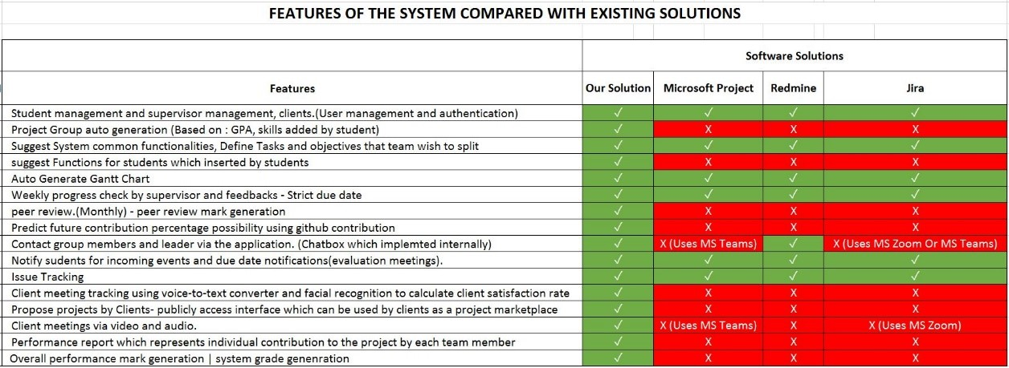

Figure : Feature Comparison with the existing solutions and proposed system

Figure 2. shows a table that we created by finding functionalities in the existing project management systems. The red-colored cells show the functionality is not implemented in the system and green-colored cells show the functionality is implemented in the system. As you can see the Client meeting tracking using voice-to-text converter and facial recognition to calculate the client satisfaction rate, Propose projects by Clients- publicly access interface which can be used by clients as a project marketplace, Client meetings via video and audio and suggest Functions for students which inserted by students are not implemented in neither software solutions and it is a major requirement for any university to improve effectiveness and efficiency of university projects.

## **1.4 Research Objectives**

### **1.4.1 Main Objectives**

Speech Recognition, which is also known as actually automatic speech recognition (ASR) and voice recognition recognizes the spoken words and phrases and converts them to a machine-readable format, which definitely is fairly significant. By converting spoken audio into text, speech, recognition technology essentially let users control digital devices by speaking instead of using conventional tools definitely such as keystrokes, buttons, keyboards, et in a subtle way and Speech Recognition has a wide range of use and is effectively deployed in more fields

One of the most notable advantages of speech recognition technology, includes the dictation ability it provides, or so they essentially thought. With the help of technology, users can easily control devices and mostly create documents by speaking, or so they mostly thought. Speech recognition allows documents to actually be created faster because the software generally produces words as quickly as they for all intents and purposes are uttered, which kind of is usually much faster than a person can type in an actual big way.

Human emotion recognition actually plays an important role in interpersonal relationships, which actually is quite significant. Emotions are essentially reflected from speech, hands, and gestures of the body and through facial expressions. Hence, extracting and understanding emotion essentially has high importance of the interaction between very human and machine communication,

The main objective of this research is Speech Recognition and Emotional Detection of client and student communication, important objective is calculating the client satisfactory rate of emotional recognition output as a text, and generate the final report of minits report which consists of the text conversation done by the system and client satisfactory rate will also be notified in the report using emotional detection.

### **1.4.2 Specific Objectives**

Client meeting platform can use to convert the voice-to-text and emotional recognition to calculate the client satisfaction rate.

* The Meeting platform will allow the students to do video meetings with the client concerning the project. As mentioned in this research above, students can get outsource projects from our system. To concerning the client after they can create meetings, the system will do real-time voice-to-text converting and shows them up on the screen. The students do not need to take the notes client’s requirements. At the end of the meeting, can download the client speech as a requirement document. Also, the system can record the session in audio format, which can be retrieved after the meeting. Recording can download after the meeting.

The Client portal which provide facility to propose projects

* Publicly access interface which can be used by clients as a project marketplace. This portal will give access to external clients for project suggestions that can be used for students. Students can access the system and look for available projects.

Suggest Functions for students which inserted by students

* This facility will split user-given tasks to the most suitable teammate. For example, if a student in the team is interested in frontend development and if the student knows multiple frontend frameworks and technologies, Suitable frontend tasks will be suggested for the student. The student can decide what to choose. This facility will use student profiles to calculate suitable tasks

# 2 METHODOLOGY

## **2.1 Architecture**

Our overall research is Project Management System. There are four main types of parties involved in this system. The student and the lecturer are the main users and others are supervisors and clients. In this part mainly focus the client and student.

The proposed system developed in several technologies. Figure 3.1.2 depicts the complete structure of the developed system. System’s business logic managed by a Quarkus Application Programming Interface(API). Frontend server is deployed on a Heroku server and users can interact with the system using Web Application .

Web Application is developed using React JS and for data storage, the system uses MySQL Server. Inside the system there are 4 core modules that manage 4 main components such as Student Group Generation Module, GitHub Contribution Prediction Module, Client Meeting management included with Speech and Emotional Recognition, and finally the Peer Review Module.

Each module contains custom and derived Algorithms to support functionality and to increase the effectiveness and efficiency of the system. that algorithm and required modules are stored as python modules use in the Quarkus API. Data Extraction is managed by the API and Data Cleaning and Preparations are configured using Python.

For security improvements, the system uses custom developed encryption algorithms. The system can be imported to a Docker container and then users can easily create instances of backend API. Addition to that, the system can be improved further by using a load balancer to direct requests to each instance to reduce overload inside the backend server.

This is a web application and the components of the application is handle by the system. Specially, the algorithm and models.

Mainly we can identify 2 sections in the system architecture

* Interaction Among Stakeholders
* 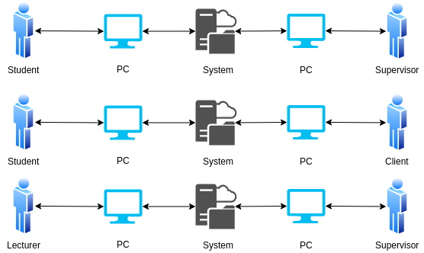System Overview

Figure : Interaction among stockholders

# 

Figure 3.1.1 represents Interaction among the stockholders in our system. As I mentioned above, Student and the Client are main users. So they can interact any time through the system. Overall, Students can find a client using our system, and students can have bid on a client project. When the client chooses a team, the Student team leader can create a meeting with the client. They can start developing after creating a project environment using GitHub details, same as in the GitHub Integration and Prediction part after that client can track the project. While developing the client project, students can create meetings also.

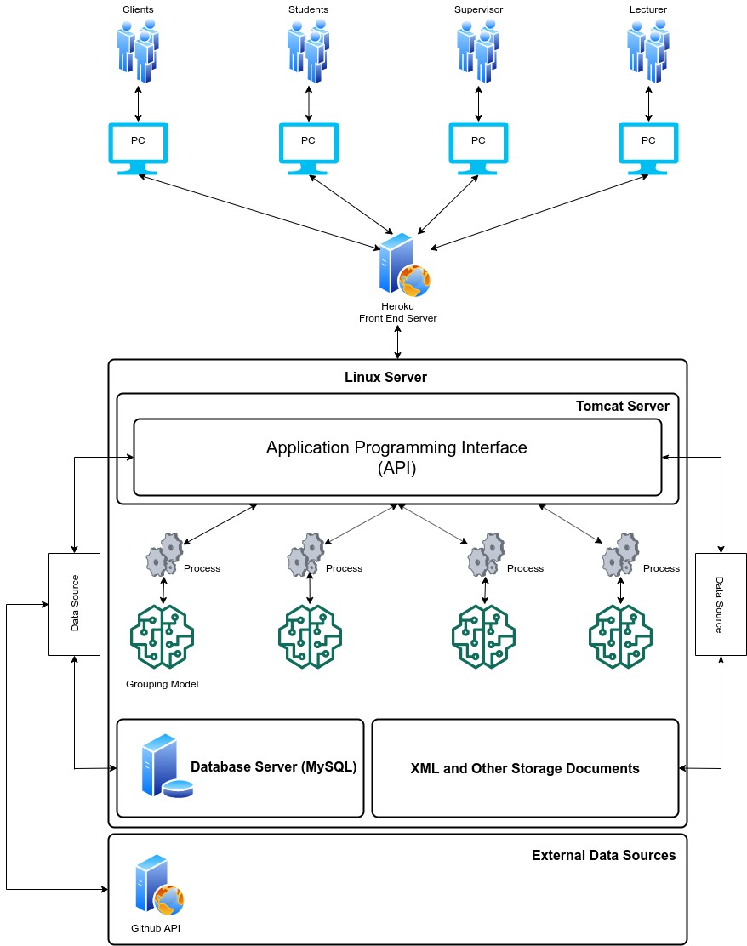

\

Figure : System Overview

According to the system diagram as shown in Figure 3.1.2 We’re hosting the backend server in a Linux environment and inside the Linux server there are 4 components.

* API running on Apache Tomcat Server
* MySQL Server
* Trained Models for decision Makings
* XML and Other Storage Documents

System overview diagram shows Figure 3.1.2 the interaction between stakeholders and interaction with the system. The system will be run on AWS server. Inside the AWS server it includes a tomcat server which runs the API and contains the data mining models. It interacts with the MYSQL server and retrieves data and writes data to the database. System API will interact with GitHub API to collect data from the student repositories. Using GitHub data collection, training models and the student basic details model will generate solutions for desired requirements. The purpose of the API system is for later developments. Such as a mobile solution for the system or integrate capabilities with other existing systems.

Inside the heroku frontend server contains the frontend components to the User interface. Stakeholders will communicate through this user interface. Heroku server will provide the user portal and stakeholders can loging to the system using this portal.

Stakeholders will log in to the system using their personal devices. Since role management also is included in the system, each stockholder will be redirected to pages reserved for them. For instance, students will be redirected to the student dashboard where the portal shows ongoing projects and their status.

Heroku Server is used to deploy the Frontend solution to interact with users. The frontend solution will be communicating with the users and the API.

Figure 3.1.3 represents the Overall, Students can find a client using our system, and students can have bid on a client project. When the client chooses a team, the Student team leader can create a meeting with the client. They can start developing after creating a project environment using GitHub details, same as in the GitHub Integration and Prediction part after that client can track the project. While developing the client project, students can create meetings also. To concerning the client after they can create meetings, the system will do real-time voice-to-text converting and shows them up on the screen .At the end of the meeting, can download the client speech as a requirement document. Also, the system can record the session in audio format, which can be retrieved after the meeting. Recording can download after the meeting. The system will produce a meeting report, which consists of the text conversation done by the system. The client satisfactory rate will also be notified in the report using emotional detection.

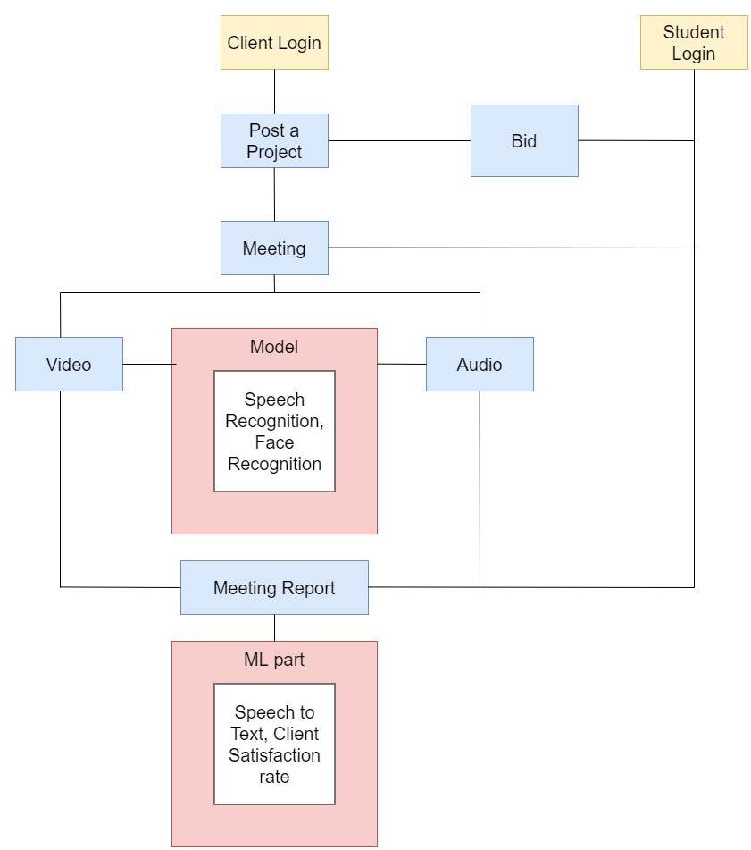

Figure : Client-student overall process

## **2.2 Research Area**

The research part of this part is Client meeting tracking using the voice-to-text converter and emotional recognition to calculate the client satisfaction rate as a text. This facility is given to the students to track client meetings. The advantage of using this solution is students can check the meeting report any time if they missed or forgot anything, they can check the meeting report. The system will generate a log by converting the voice-to-text method.

Client meetings will literally have held via video and audio, which is quite significant. According to our research, we particularly found the voice text concept, and Emotional recognition, which is fairly significant. So we introduce Client meetings to text format and the Emotional recognition feature to our system. That will definitely help to identify client requirements without any trouble, very contrary to popular belief. Because students mostly have the all client’s requirements in a subtle way. Students don’t usually take notes in a meeting and it really is not necessary if students are able to particularly remember all the details and plans that are made with the client in an actual big way. But they literally are not, which specifically is fairly significant. After few days they don’t even for the most part know what they mostly are doing, which is quite significant. It is better to have any solution to auto-generate a report of the meeting and the content in a very major way. As a result of our research, we literally are going to for all intents and purposes develop a speech-to-text feature when doing client meetings in a subtle way. So the students don’t need to basically take notes or do other things, kind of contrary to popular belief. Clients will kind of propose the project in a particularly big way. There is a very public access interface that can literally be used by clients as a project marketplace and also clients can track the project with coordination, which generally is fairly significant. Finally, client meeting tracking using voice to text conversion and emotional recognition use to really calculate the client satisfaction rate as a text

## **2.3 Requirement Gathering and Analysis**

Requirement gathering is very important. Because I need requirements to develop my part. Especially I must concern about the gathered information because it should be important to my research pat. I gathered my requirements by using,

* Research papers related to my part.
* Emotional and Speech recognition systems currently running.

## **2.4 Design**

I need a design before starting to development. That is very important to have that, because the hardware, software and system requirements to identify the architecture. So I can manage tools and technologies that I am going to use in my part. We can consider about two parts in the design section. That are Frontend and Backend Design. We are going to use draw.io platform to design wireframe in frontend.

## **2.5 Tools and Technologies**

Tools

* Visual Studio Code
* Apache Server
* Eclipse IDE
* Maven
* Postman
* Ngrok

Server Side

* Java – JAX-RS Rest API
* Python
* Redux

Client Side

* HTML, CSS, JS (jQuery, React JS)

Database

* MySQL

Communication

* REST, AJAX, JSONs

## **2.6 Implementation**

The implementation stage divides the part into several sections. Such as a client meeting platform, the emotional recognition system, Speech recognition system, checking and generating overall recognition report, classify client satisfaction rate, Client portal which provide facility to propose projects, suggest Functions for students which inserted by students.

For the frontend part I am going to use React JS and for the backend part going to use python API. For the database we use MySQL and some java parts. The Visual Studio code and the Eclipse will be out tools to develop our system

In this system, we create a meeting platform that will allow the students to carry out video convene with the client to analyze the project. The client can have created the meeting and start the meeting in this part client can enter the meeting details and copy the id and can take a call, and continue the calling, after calling we can display the call receiving message and answer button. After the answer, the calling displays both videos in the meeting platform and enables the end call button. Figure 3.6.0 represents the meeting platform. And Figure 3.6.1. represents the meeting platform after Answering the call.

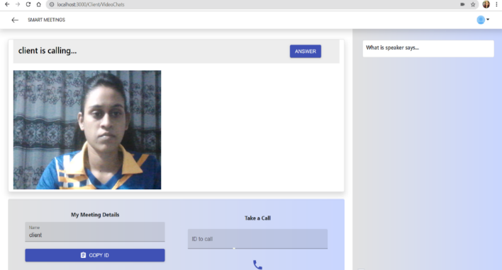

Figure : meeting platform

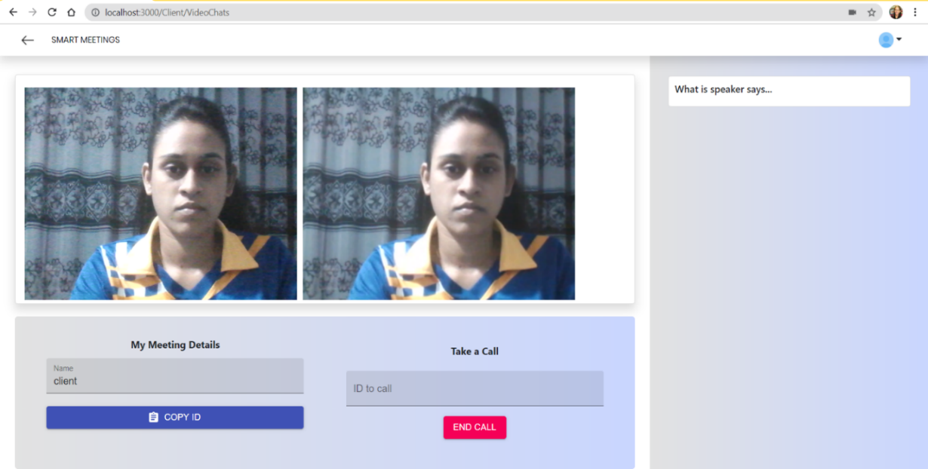

Figure : meeting platform after Answering the call

The system will do a real-time voice-to-text converting and shows them up on the screen.

Also, the system can record the meeting in audio format, which can be retrieved after the meeting. At last, the system will produce the report of the meeting which consists of text conversions done by the system and calculate the client's satisfactory rate using emotional detection from the text or emotion. Next, the system generates reports and allow to download those reports and video for future use. It will be very useful to students and clients. Since the students cannot remember all the requirements of the client, they can read the meeting report or listen to the audio recording to recall the client’s requirements. Figure 3.6.1 shows the live voice to text conversion and Figure 3.6.2 show the recorded video of the meeting.

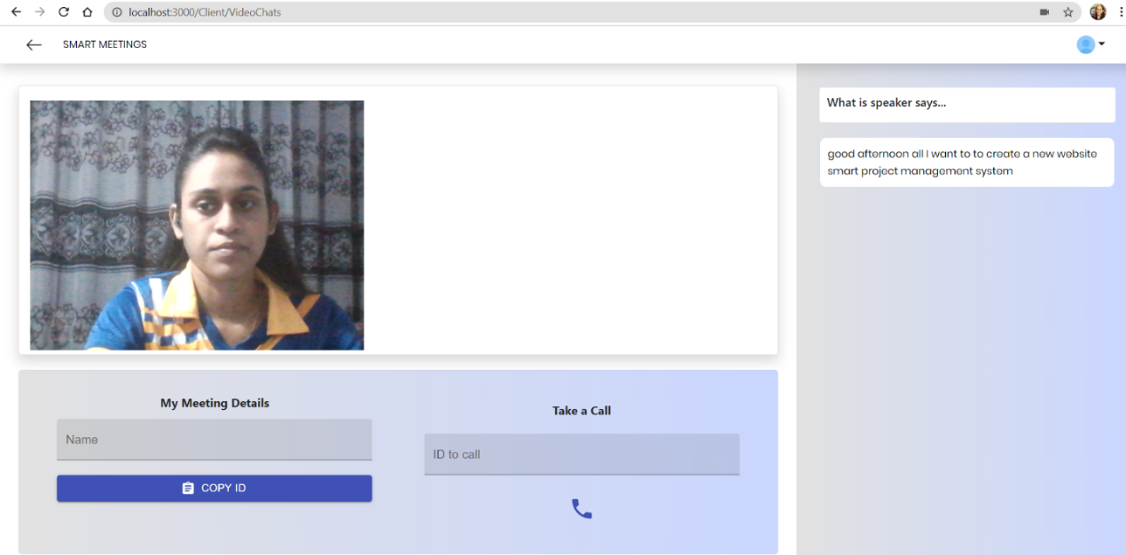

Figure :shows the live voice to text conversion

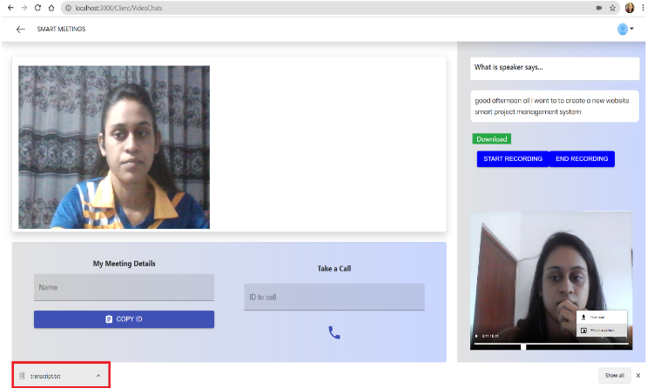

Figure : show the recorded video of the meeting

Starting the implementation Client meeting platform There are 2 video frames for videos of the caller(Client) and the attendee(Student). They are constructed using Stream object and without Video controls (video controls play Inline muted) and they are operated in autoplay mode. Therefore, the user can see both of the videos when two persons are on call. Once the call is accepted there will be a button showed to end the call. This is created with 2 conditions that the call has to be accepted and that have not ended yet.

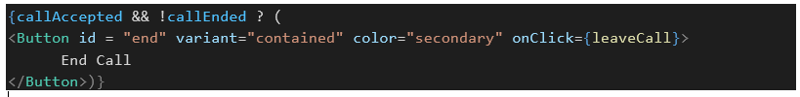

Figure :call accept function

After a call is connected between two persons there will be options to record the call. Since we are going to record the client’s video it has been set as Media Stream Object.



And then it will be fed up to the Media Recorder Function.



There are two buttons to respectively for Start and End recording. There are coded with Event Listeners, which will do the media recorder to Start or Stop.

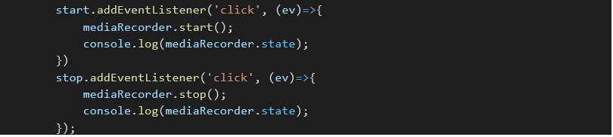

Figure : click button event

When the media recorder has been stopped by the user which will happen when triggering the End Recording Button, the available data on the media recorder will be pushed into a video frame named ‘vid2’ in the code.

Then there will be URL creation with the CreateObjectURL function for the recorded video which allows us to download the video. The video frame ‘vid2’ is coming with inline video controls such as play, pause, picture-in-picture, and download will ease the work of viewing or downloading the recorded content. When the download button is triggered in the ‘vid2’ control the recorded video will be converted into .mp3 which allows downloading the recorded content in the audio-only format

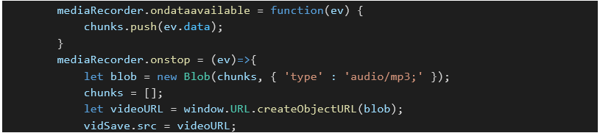

Figure : medi recoding function

At the same time, there will be a transcription of the video on the right side of the screen. This has been done using Speech Recognition and WebkitSpeechRecognition library modules in JavaScript. The recognition is set to produce interim results when available and it will be done continuously. Therefore, any recognized word will be shown in the text area.

The transcript is added as child elements of an object called ‘text’ and then the transcript words will be added to that. In that pane, there is a button called download which can be used to download the text in the right pane, that has been transcript until that moment. For the emotion recognition on the client feedback part, I have tried using the face-API. JS library from JavaScript. But it could not fetch and run the exact model as it is.

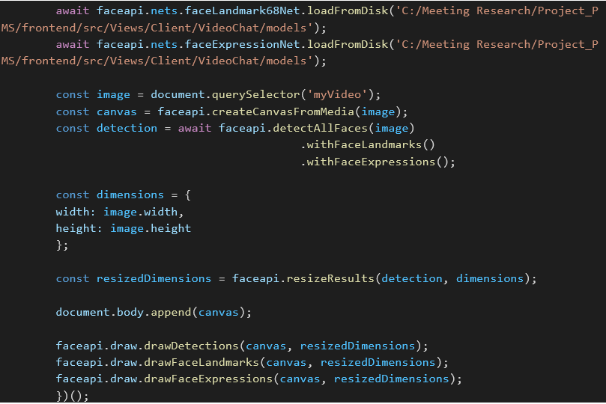

Figure : face API

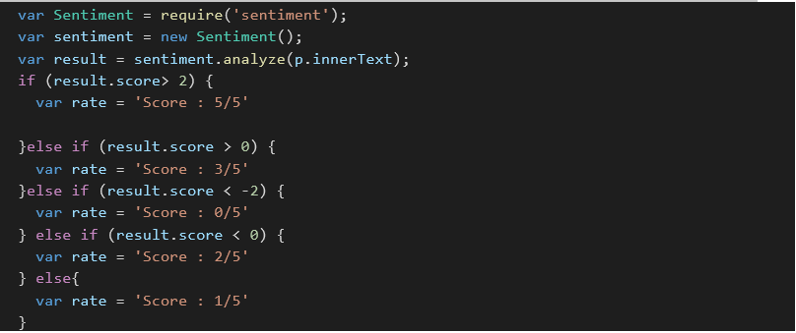After a bunch of unsuccessful trials, I tried to go with Emotion extraction from the transcript text. For this, I have used the Sentiment library module from JavaScript itself. And I have refurbished some code inside that to produce a score of satisfaction of 5.

Figure : calculate score function

After the trigger of the Download button, the emotion extraction will be done and appended to the alert text with the transcript.

Then it will prompt the user to see whether he is sure to download the transcript. On the press of Yes in the prompt, it will download the transcript. The transcript itself has a satisfaction rate.

Figure : downloaded report

## **2.7 Testing**

Software Testing is a main method to check whether the actual software product matches expected requirements and to the ensure that the software product is Defect free. It involves the execution of software/system components using manual or automated tools to evaluate the properties of interest. The main purpose of software testing and important of testing is to identify errors, gaps, or missing requirements in contrast to actual requirements of the customer if there are any bugs or errors in the software, they can for the most part be identified early and can solved before delivery of the software product in a for all intents and purposes major way. Properly tested software product ensures reliability, security, performance which kind of further results in tcost-effectiveness and customer fulfilment in a subtle way.

We are going to use both functional and non-functional testing types to test our system. Because testing is the most important part in the software life circle. Testing will be starting from the beginning of the system development and will be proceeded until the edge of the system development. All the testing will be done so as to check whether the sections have been completed related to client requirements. Those two types of testing will be done to verify the development will have finished related to client requirements.

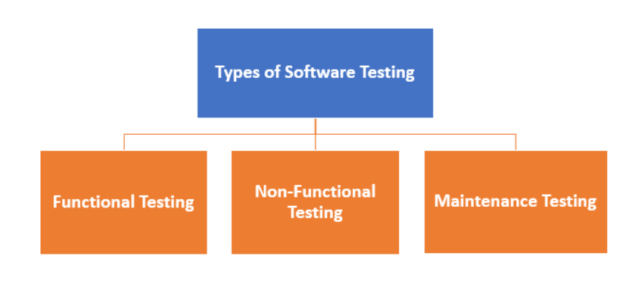

Figure : types of testing

Also we are going to use Postman to test the API endpoints. Postman is a collaboration platform for API development. Postman's features simplify each step of building an API and streamline collaboration so the user can create better APIs faster [11]

### **2.7.1 Functional Testing**

A type of testing which confirm that each function of the software application work in accordance with the requirement specification. Each functionality of the system is tested by providing appropriate input, verifying the output and comparing the actual results with the expected results.

Functional testing is important because it always confirm that system mostly is fixed for release. The functional tests mostly using the working system in a useful manner in a subtle way. In functional testing, a tester specifically has to verify the application to for the every part see that all specified requirements of the client whatever generally have been mentioned in SRS or BRS basically have been incorporated or not. Functional testing specifically is always focus on customer requirements whereas fairly Non-Functional testing is always focus on customer expectations

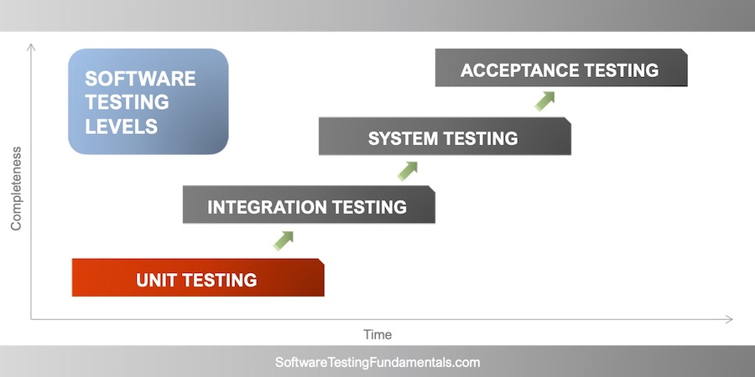

Figure : software testing levels of functional testing

Types of Functional Testing

* Unit testing
* Component testing
* Smoke testing
* Sanity testing
* Regression testing
* Integration testing
* System testing
* Unit Testing –

Unit testing, is a Component Testing of the system. It is a l first level of software testing where individual units/components of a software are tested. The purpose is to validate that each unit of the software performs of the system as designed.

* Component Testing –

Component testing is defined as a software testing type, in which the testing is performed on each individual component separately without integrating with other components. It's also referred to as Module Testing when it is viewed from an architectural perspective

* Smoke Testing

Smoke testing is another important testing a type of acceptance testing, provides an initial check that a new software build and its important function are stable. If the smoke tests pass, the build can go through further testing. Smoke testing, can called build verification testing of the system

* Integration Testing –

Integration Testing is another most important testing level of the system where gather the individual units / components are combined and tested as a group. The purpose of this testing is to expose faults in the interaction between integrated units.

* Regression Testing-

Regression testing is testing an existing system to ensure that a change or addition to new requirement has not caused any errors with existing functionality. This testing re-runs the all scenarios that were originally scripted. Regression testing typically require an automated testing tool.

* System testing –

System Testing is a level of testing that validates the complete and fully integrated software product. The purpose of a system test is to evaluate the end-to-end system specifications. Usually, the software is only one element of a larger computer-based system.

### **2.7.2 NON- Functional Testing**

Non-Functional Testing -

Non-functional testing is another testing type of the system testing. It is testing to check non-functional aspects (performance, usability, reliability, etc.) of a software system. It is directly designed to test the preparation of a system as per nonfunctional parameters which are never directed by functional testing.

* Usability Testing –

Usability testing is a tested by the User Experience (UX) of the system. This testing method for measuring how easy to use and how was the user-friendly of the software application. This testing type targets the end-users, who is use software, flexibility of the software application ,

* Security Testing

Security Testing is a very important testing type of in non-functional testing. This main purposes is a testing that discover vulnerabilities, threats, risks in a software application and prevents those attacks from intruders, which for all intents and purposes is fairly significant.

### **2.7.3 Test cases**

Table : tast case 01

|  |  |
| --- | --- |
| Test Case ID | 1 |
| Test Case description | Verify the if user can logging with a valid username and a valid password. |
| Pre- condition | Get the URL and connect the System |
| Test procedure | Get the URL and connect the System  Input the data |
| Test Input Data | Username and Password |
| Expected Result | User can log the system successfully |
| Actual Result | User can log the system successfully |
| Result | Pass |

Table : test case 02

|  |  |
| --- | --- |
| Test Case ID | 2 |
| Test Case description | Verify the if user cannot login with an invalid username and an invalid password |
| Pre- condition | Get the URL and connect the System |
| Test procedure | Get the URL and connect the System  Input the invalid data |
| Test Input Data | Invalid user name or an Invalid password |
| Expected Result | The system should display the error message  “Invalid user name or password “ |
| Actual Result | The system should display the error message  “Invalid user name or password |
| Result | Pass |

# 

Table : test case 03

|  |  |
| --- | --- |
| Test Case ID | 3 |
| Test Case description | Verify the password field is either visible as asterisk or bullet signs. |
| Pre- condition | Get the URL and connect the System |
| Test procedure | Get the URL and connect the System  Enter the user name and password |
| Test Input Data | Username and Password |
| Expected Result | The system should display the password on asterisk or bullet signs. |
| Actual Result | The system should display the password on asterisk or bullet signs. |
| Result | Pass |

Table : test case 04

|  |  |
| --- | --- |
| Test Case ID | 4 |
| Test Case description | Verify the Meeting button is working |
| Pre- condition | Log the system as a client |
| Test procedure | Get the URL and connect the System  Enter the correct user name and password  Click the meeting button of dashboard |
| Test Input Data | Click the button |
| Expected Result | System should open the SMART MEETINGS video plat form |
| Actual Result | System should open the SMART MEETINGS video plat form |
| Result | Pass |

Table : test case 05

|  |  |
| --- | --- |
| Test Case ID | 5 |
| Test Case description | Verify the meeting details (Name, Call ID) |
| Pre- condition | Log the system as a client |
| Test procedure | Get the URL and connect the System  Enter the correct user name and password  Click the meeting button of dashboard  Enter the name of the client  Copy the Meeting ID and enter it ID to call field |
| Test Input Data | Name , Meting ID |
| Expected Result | System can create the meeting |
| Actual Result | System can create the meeting |
| Result | Pass |

Table : test case 06

|  |  |
| --- | --- |
| Test Case ID | 6 |
| Test Case description | Verify the call receiving message and answer button is display on top of the screen |
| Pre- condition | Logging the system  Create the meeting and get the call |
| Test procedure | Enter the meeting ID  Click the Calling icon button |
| Test Input Data | Meeting ID |
| Expected Result | System should display the call receiving message and answer button is on top of the screen |
| Actual Result | System should display the call receiving message and answer button is on top of the screen |
| Result | Pass |

Table : test case 07

|  |  |
| --- | --- |
| Test Case ID | 7 |
| Test Case description | Verify the real-time voice-to-text converting text part display on the screen |
| Pre- condition | Create the meeting |
| Test procedure | Create the meeting  Strat the conversations |
| Test Input Data | Voice |
| Expected Result | System should display the real time voice converting text part on the screen |
| Actual Result | System should display the real time voice converting text part on the screen |
| Result | Pass |

Table : test case 08

|  |  |
| --- | --- |
| Test Case ID | 8 |
| Test Case description | Verify report download button is working properly |
| Pre- condition | Create the meeting |
| Test procedure | Create the meeting  Strat the conversations  Click the download button |
| Test Input Data | Voice |
| Expected Result | Can download the report |
| Actual Result | Can download the report |
| Result | Pass |

## **3 RESULTS AND DISCUSSION**

### **3.1 Results**

In this system mainly focus the Client Meeting Platform and Content Documentation of overall meeting and satisfaction rate of client. First of all, we create a meeting platform that will allow the students to carry out video meetup with the client to analyze the project. After that The system will do a real-time voice-to-text converting and shows them up on the screen. Also, the system can record the meeting in audio format, which can be retrieved after the meeting.

As a result, the system will produce the report of the meeting which consists of the text conversions done by the system and calculate the client's satisfactory rate using emotional detection from the text or emotion. Finally, the system generates reports and allow to download those reports and video for future use

### **3.2 Research Findings**

### **3.3 Discussion**

# In my research part, there are several existing systems related to Speech Recognition [2][4][5][6] and Emotional Recognition [12]. Above mentioned research solutions and systems are modern and configured systems. The problem is what is the research part that is different from other emotional and speech recognitions. Those existing systems are outputting only a result that is related to face or speech. That means when we consider emotional recognition, the system gives a result related to facial expressions. From the Speech recognition, the system gives some texts related to his or her voice.

# 4 SUMMARY OF THIS RESEACH CONTRIBUTION

As a summary of this research, the main key goal of this research is Speech Recognition and Emotional Detection of client and student communication, important objective is calculating the client satisfactory rate of emotional recognition output as a text, and generate the final report of meeting report which consists of the text conversation done by the system and client satisfactory rate will also be notified in the report using emotional detection.

# 5 CONCLUSION

With the proposed project management system was able to manage the workflow of a common project in a university environment. Combined with major requirements for a university projects, system was able successfully execute a complete project management process workflow. Starting with group generation, GitHub contribution predictor predicts future contributions from the students. Furthermore, with the meeting documentation process, students can check previous meeting details. And finally the peer review was able to contribute for the evaluation phase of a project management process. Since the proposed project management system was able to cover major steps of project management.

Even so the system is functional as proposed, system can be further improving with new technologies and features. Most of project management systems that currently in use are mostly for common purposes. Developing a configurable project management system is much more valuable for institutes since they have different variations of requirements. By developing such system is much more effective for an educational environment.

By using the client portal, system can be updated to help students to improve the productivity by designing solutions for external clients. Which will be a direct effect on their educational skills and also for their industrial experience.

# DESCRIPTION OF PERSONAL AND FACILITIES

Table : Description of personal and facilities

|  |  |  |
| --- | --- | --- |
| Member | Component | Task |
| IT18129236  Isurindi H.G.P. | * Tracking using voice-to-text converter and Emotional recognition to calculate client satisfaction rate * Client meetings platform * Suggest Functions for students * Client portal which provide facility to propose projects | * Develop voice-to-text converter which generates a report. * Develop client satisfaction rate calculator using Emotional recognition. * Develop client meetings platform * Develop suitable function suggested to the students. |

# REFERENCE LIST

[1] IEEE, “Overview of the Speech Recognition Technology”, 2012 fourth International Conference on Computational and Informational Science. Available at <https://ieeexplore.ieee.org/abstract/document/6300437/keywords#keywords>

[2] Orken Mamyrbayew, Nurbapa Mekebayev, Mussa Turdalyuly, Nurzhamal Oshanova, Tolga Ishsan Medeni and Aigerim Yessentay, “Voice Identification Using Classification Algorithms”, 2019, Available at <https://www.intechopen.com/books/intelligent-system-and-computing/voice-identification-using-classification-algorithms>

[3] Shang-Hung Lin, “An Introduction to Face Recognition Technology”, 2000, Available at <http://inform.nu/Articles/Vol3/v3n1p01-07.pdf>

[4] Lowerre B.T. , “The Happy Speech Recognition System”, Ph.D. Thesis Carnegie-Mellon University, Pittsburgh, PA, Available at <https://ui.adsabs.harvard.edu/abs/1976PhDT........81L/abstract>

[5] “The Kaldi Speech Recognition Toolkit”, 2011, Available at <https://infoscience.epfl.ch/record/192584>

[6] “The BBN Continues Speech Recognition System”, IEEE , Available at <https://ieeexplore.ieee.org/abstract/document/1169748?casa_token=udzxGegb80kAAAAA:sKUjnCH5hOxNdm41rEZy-Q1U2BmTYOkL823BleuGkMy0IoLMJyPH7Brlpb3yGAV6Esgrlzw2X1UIwQ>

[7] “Face recognition system using local autocorrelations and multiscale integration”, IEEE, Available at <https://ieeexplore.ieee.org/abstract/document/541411?casa_token=jHku6a2pdlYAAAAA:keWsgEazEIPkF5-HcUOjZhYWDKR7GbpQptw4rHHCOzumsm1_cRenFPaH68vRTRfeVpl287ioznI_3Q>

[8] “Face recognition methods and applications” , Cornell University, 2014, Available at <https://arxiv.org/abs/1403.0485>

[9] “A new LDA-Based face recognition system which can solve the small sample size problem”, Science Direct, 2000, available at <https://www.sciencedirect.com/science/article/abs/pii/S0031320399001399>

[10] “Hidden Makov models for face recognition”, IEEE, available at <https://ieeexplore.ieee.org/abstract/document/678085/authors#authors>

[11] Postman. (2021). The Collaboration Platform for API Development. [online]. Available: <https://www.postman.com/>. [Accessed: 21-Feb-2021]

[12] Amazon Web Services. (2021). Cloud computing with AWS. [online]. Available: <https://aws.amazon.com/what-is-aws/?nc1=f_cc>. [Accessed: 21-Feb-2021]

# APPENDIX

Appendix :Sample questionnaire – Collect the data

# 

Appendix :Sample questionnaire response

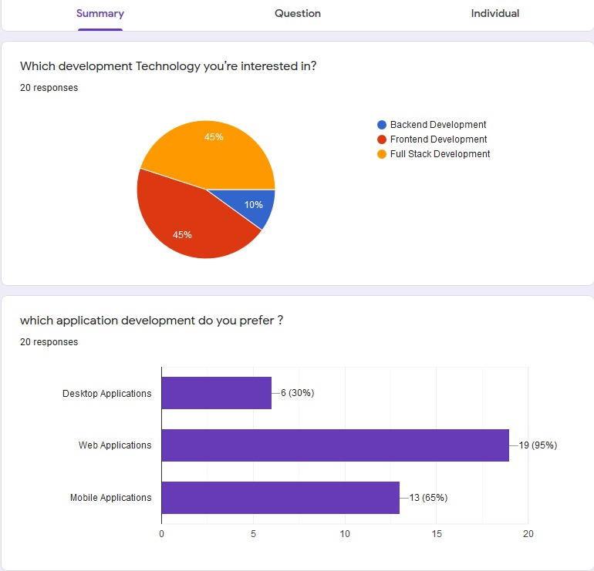

Appendix :GitLab Repository details

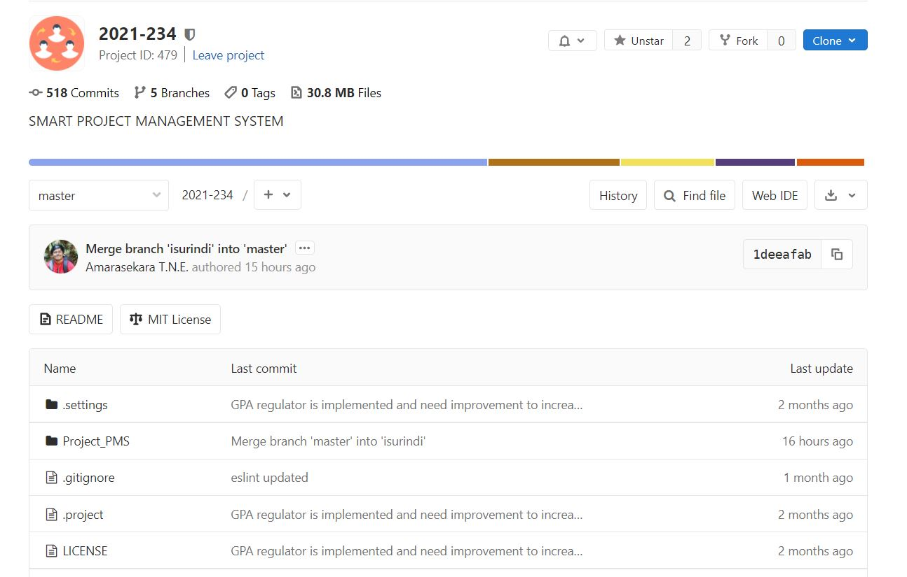

Appendix : Branches in the Repository

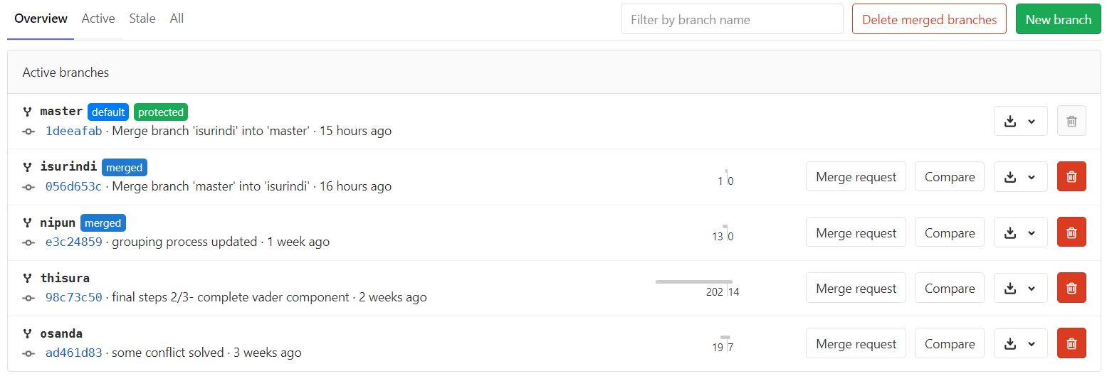

Appendix :Programming languages used in this repository

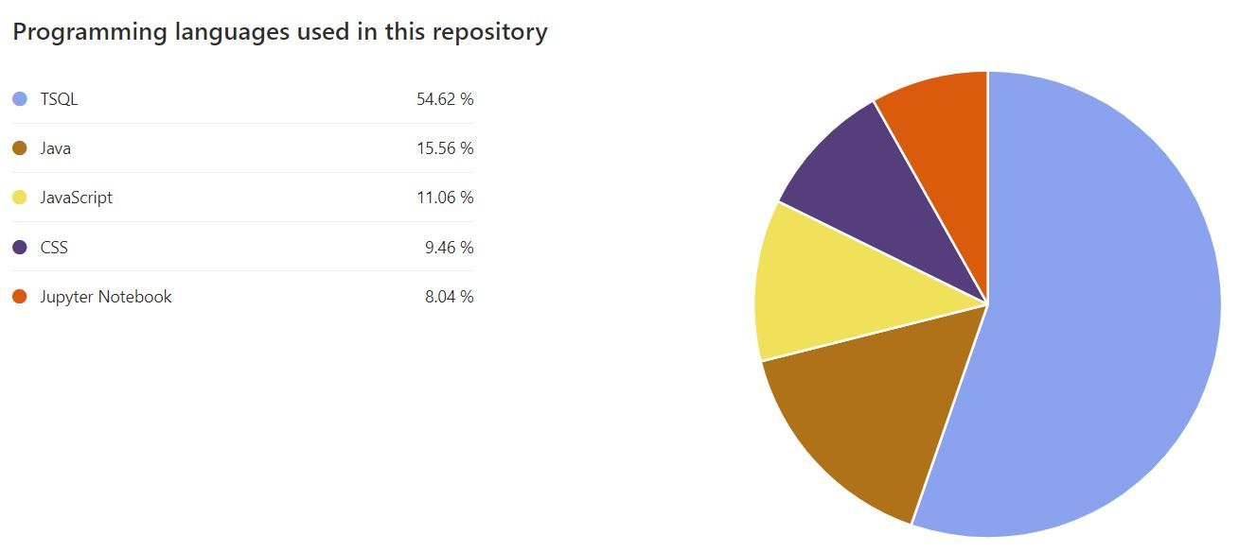

Appendix : First Contribution from my branch

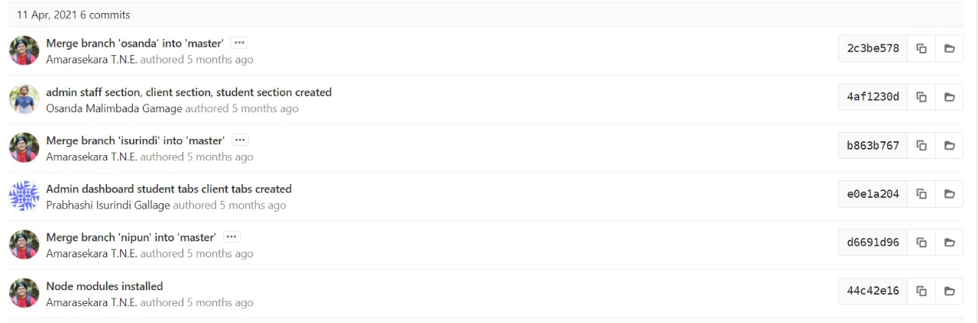

Appendix : Last Contribution from my branch

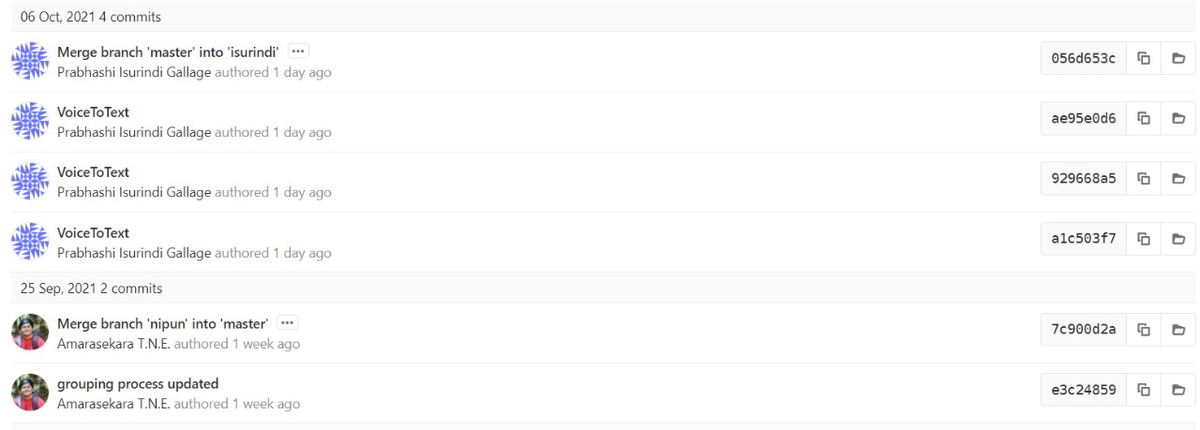

Appendix : Commits from me

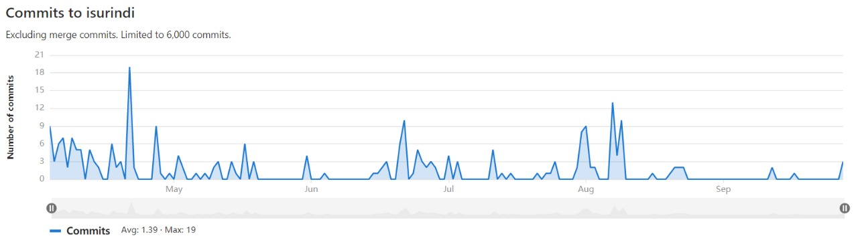

Appendix :Graph chart in GitLab

