|  |  |
| --- | --- |
|  | **Sri Lanka Institute of Information Technology** |



PROJECT REGISTRATION FORM

|  |
| --- |
|  |

(This form should be completed and uploaded to the Cloud space on or before XXXXXXXXX)

The purpose of this form is to allow final year students of the B.Sc. (Hon) degree program to enlist in the final year project group. Enlisting in a project entails specifying the project title and the details of four members in the group, the internal supervisor (compulsory), external supervisor (may be from the industry) and indicating a brief description of the project. The description of the project entered on this form will not be considered as the formal project proposal. It should however indicate the scope of the project and provide the main potential outcome.

|  |  |
| --- | --- |
| PROJECT TITLE  (As per the accepted topic assessment form) | Smart Project: An Automated Project Management System for Group Projects |

|  |  |
| --- | --- |
| RESEARCH GROUP  **(as per the Topic assessment Form)** | Elearning and Education |

|  |  |  |
| --- | --- | --- |
| PROJECT NUMBER | 2021-234 | (will be assigned by the lecture in charge) |

PROJECT GROUP MEMBER DETAILS: (Please start with group leader’s details)

|  |  |  |  |  |
| --- | --- | --- | --- | --- |
|  | **STUDENT NAME** | **STUDENT NO.** | **CONTACT NO.** | **EMAIL ADDRESS** |
| Format | Perera C.D.D | ITxxxxxxxx | 0712345678 | itxxxxxxxx@my.sliit.lk |
| 1 | Amarasekara T.N.E. | IT18009446 | 0711294033 | [It18009446@my.sliit.lk](mailto:It18009446@my.sliit.lk) |
| 2 | Isurindi H.G.P. | IT18129236 | 0702295315 | [it18129236@my.sliit.lk](mailto:it18129236@my.sliit.lk) |
| 3 | Navanjana E.H.D.T.D. | IT18003642 | 0715143474 | [it18003642@my.sliit.lk](mailto:it18003642@my.sliit.lk) |
| 4 | Gamage O.M. | IT18140330 | 0767398558 | [it18140330@my.sliit.lk](mailto:it18140330@my.sliit.lk) |

**SUPERVISOR, CO_ SUPERVISOR Details**

|  |  |
| --- | --- |
| **SUPERVISOR Name** | **CO-SUPERVISOR Name** |
| **Ms Uthpala Samarakoon** | **Ms.Archana  Kugathasan** |
| **Signature** | **Signature** |
| **Attach the email as Appendix 1** | **Attach the email as Appendix 2** |
|  |  |
| **01/23/2021** | **01/23/2021** |

|  |  |  |  |  |  |
| --- | --- | --- | --- | --- | --- |
| EXTERNAL SUPERVISOR Details (if any, may be from the industry) | | | | | |
|  |  |  |  | **Attach the email as Appendix 3** |
| Name | Affiliation | Contact Address | Contact Numbers | Signature/Date |

|  |  |  |
| --- | --- | --- |
| ACCEPTANCE BY CDAP MEMBER (This part will be filled by the RP team) | | |
|  |  |  |
| Name | Signature | Date |

PROJECT DETAILS

|  |
| --- |
| Brief Description of your Research Problem: (extract from the topic assessment form) |
| Undergraduate project management is challenging when it comes to group projects. Even though there are many existing project management systems such as Microsoft project, Jira, and Redmine, most of them were developed for general purpose. Hence, some important specific features which are useful when managing student projects such as automatic group formation, project tracking and notification generation on project progress are not available in those systems.  One of the major problems in group projects is fair group formation. Self-group formation by students in group project is not successful due to various issues. In such situations a group may have included only the best students in the batch and there is a possibility of left out weak students. Then the weak students may have to form a group which is not successful. In the other hand, when the university is taking the responsibility for grouping, usually the process is random grouping using a student list. There are some online tools which can be used for grouping. Those tools also use random group generation using an existing student list, which is not effective and fair. There are some separate tools to do the process which is not connected with project management tools. Those tools are available in standalone and web-based applications. Hence, a university should use a combination of different tools to accomplish the tasks of project management. Hence there is a requirement of a system where project grouping can be done fairly and effectively.  Another major issue was tracking the project progress. There is no project tracking system and it leads to project failures. In the other hand, students usually do not use any version controlling and it is a bad practice to avoid version controlling since the project is a group project. Version control systems (VCSs) are used to store and reconstruct past versions of program source code. In industry almost all the IT companies use version controlling systems to update their systems and also to carry out their projects and source codes. It is very important to maintain secure source codes and manage individual contributions. Problem is students are not familiar with version controlling. Use of version controlling systems can solve another problem of underestimating project duration which can cause incomplete projects within the specified time. So, incorporating version controlling facility in project management is another important aspect in project management.  Moreover, in existing project management tools there is no specific way to detect the free riders in the group. If the required activities submitted to the system in the given time of the project timeline system, consider it as a successful submission. There are no ways implement to track their performance and progress status with their project team. If the system can detect the free riders in a team, it will lead to reduce group conflicts and effectively differentiate student performance. So, it will be a fair ground to all the project members including project group leader.  When the project is for a specific client, it is important to trach the progress of the project by client and give feedback. Also, even if there is a client connected to the project, project coordinators cannot track their meeting details and what they communicated with the client. Students also get into trouble in this situation. Students doesn’t usually take notes in a meeting and it is not necessary if student able to remember all the details and plans that made with client. But they are not. After few days they don’t even know what they are doing. It is better to have any solution to auto generate a report of the meeting and the content. With current systems we have not found any solutions to this matter. Client also find difficulty to track project progress and clients may also blame for the project coordinators for any failures. |
| Description of the Solution: (extract from the topic assessment form)  “Smart Project” is the final outcome of this research which is a comprehensive project management platform with advanced features such as auto group formation, auto peer review, auto progress tracking incorporates with GitHub and with a client space.  Project group auto-generation will be based on several factors such as student GPA (grade point average), Skills, and the pro-rata status. As a Result, when the system generating a group, average group GPA will be considered to make a balanced group.  Peer-assessment is a mutual process between project members which improves the quality of the project work. Peer-assessments will improve cooperative learning because it assesses the efforts and contributions of their project members. Peer reviewing within a team will help to keep the team stable, hence it will show if someone is not comfortable with assigned tasks or it will detect the free-riders in the team. The system will assign a mark for each peer review it gets from a team member and it will be based on the questionnaire and the feedback paragraph provide on the peer review form.  Reward basis timeline with weekly tasks Implement reward basis weekly tasks will encourage students to complete their tasks continuously because of their deadlines and marks rewarded to them according to their difficulty levels.it will also detect the free-riding attempts. Reward basis timeline will improve the performance of the project and it will help project group to maintain their weekly progress. When design the reward basis timeline we will consider facts like assign personally meaningful and relevant tasks and make assignments moderately and appropriately challenging. It will avoid conflicts with other group tasks to encourage students to focus on personal mastery and skill development with grades or performance relative to others. It will help students develop personal achievable learning goals and it can help supervisors to give feedback on learning strategies to help students become aware of their current skill levels and set realistic expectation. So reward basis timeline will practice for promoting competence motivation.  The system will predict future contributions with percentages and possibilities using GitHub contribution. So we are going to use GitHub API to collect data and analysis GitHub Repositories .and users API can track the code, commits, User contribution, task completion for the relevant project. All we have to do is, pass the project Repository URL with the credentials. So supervisors and team members can get a rough idea about the project progress and speed of their project work. We are introducing this feature to identify each student do their work by themselves. Not the same person doing the entire project. That will track using commit progress. There is a doubt. Yes, we have GitHub and we can use that to predict this problem. But in our system, we create a group first. Then assign a lecturer or a supervisor. After that supervisor will assign task to complete the project and the team leader has to create a repository in GitHub and add the GitHub repository link to the system. So the system will predict the progress and generate the progress evaluation. Our system will do the entire solution. That is the solution proposed to track the project part. Finally, it will generate a mark using GitHub progress and it will get implemented on system grade for the project.  Client meetings will have held via video and audio. According to our research, we found voice to text concept and facial recognition. So we introduce Client meeting to text format and facial recognition feature to our system. That will help to identify client requirements without any trouble. Because students have the all client’s requirements. Students doesn’t usually take notes in a meeting and it is not necessary if student able to remember all the details and plans that made with client. But they are not. After few days they don’t even know what they are doing. It is better to have any solution to auto generate a report of the meeting and the content. As a result of our research, we are going to develop speech to text feature when doing client meetings. So the students don’t need to take notes or other things. Clients will propose the projects. There is a publicly access interface which can be used by clients as a project marketplace and also client can track the project with coordination. Finally, client meeting tracking using voice to text conversion and facial recognition use to calculate the client satisfaction rate. |

|  |
| --- |
| Main expected outcomes of the project: (extract from the topic assessment form) |
| A Project Management System to improve team work and Automate current project management system. |

WORKLOAD ALLOCATION (**extract from the topic assessment form after correcting the suggestions given by the topic assessment panel.**)

(Please provide a brief description about the workload allocation)

|  |  |
| --- | --- |
| MEMBER 1 | ………………………………………………………………………………………………………………………………………………………… |
| * Project Group auto generation according to student’s given technological skills. Using Development technologies, preferred programming languages and previous projects. Using these parameters system will generate project groups non randomly and expecting to achieve maximum accuracy for fairness in project grouping. To achieve maximum accuracy students also should be honest about their skills. This grouping system is using student added skills and their known programming languages and technologies. If student add technologies that they haven’t learn, the system generated groupings will not be accurate. But to increase this accuracy, we’ll be using GitHub repositories and profiles to verify included details such as used programming technologies. Fuzzy clustering algorithm will do the rest of the grouping process using extracted user data. * System user managements. This section implements authentication systems and role management. Expecting to improve system security and user management. System basically holds information about students, module lecturers, supervisors and client details which will be used in system internal processes and also in communication systems. For the user verifications and confirmations, we’re using user given email. Since the frontend development will be done using React JS, session details will be stored in session Storage. For sending mails to account confirmations and password resets, we’ll be using javax.mail java library. All user login details will be stored in the MySQL database. * Suggest common tasks. This process will be an additional support for students. After registering the project to the system, this will suggest common functions that can be included in the system. System will not force them to choose these suggested functions. Students can freely decide if they want to use them. Basically what this process does is matching the description of the project with the existing project data and extract suitable functions for the defined project. After each project done by the students, project details with all project tasks and objectives will be recorded in the database. These recorded tasks and objective later can be used to suggest common tasks and objective for new projects. * Auto Generate Gantt Chart. In this section system will generate a gantt chart using student defined tasks, given weight values and also given expected time period. System will calculate most suitable time durations for each tasks and develop a gantt chart for the project. For this process user have to include some parameters with the tasks. When a student creates a task, he should define an expected time period and a weight value between 1 – 10. Using time periods, system can identify if sum of the time periods is exceeding the given time period and using the weight values system will change tasks time periods fairly. Students can check the gantt chart and they can later change time periods as they like. But if it exceeds again system will reconfigure gantt chart to avoid time period exceeds. After the completion of a defined task, system will lock the gantt chart and it cannot be changed again. | |

|  |  |
| --- | --- |
| MEMBER 2 | ………………………………………………………………………………………………………………………………………………………… |
| * Client meeting tracking using voice-to-text converter and facial recognition to calculate client satisfaction rate. This facility is given to the students to track client meetings. Advantage of using this solution is student can check the meeting logs anytime. If they missed or forgot anything, they can check the meeting log. System will generate a log by converting voice to text method. Also if the camera turned on by the client, System will recognize facial expressions and it will give an output about client’s overall satisfaction during the meeting. * Client meetings platform. This platform will provide facilities to arrange meetings and host meetings with clients instead of using a third party application. * Client portal which provide facility to propose projects. publicly access interface which can be used by clients as a project marketplace. These portal will give access to external clients for project suggestions that can be used for students. Students can access the system and look for available projects. * suggest Functions for students which inserted by students. This facility will split user given tasks to most suitable team mate. For example, if a student in the team is interested in frontend development and if the student knows multiple frontend frameworks and technologies, Suitable frontend tasks will be suggested for the student. Student can decide what to choose. This facility will use student profiles to calculate suitable tasks. | |

|  |  |
| --- | --- |
| MEMBER 3 | ………………………………………………………………………………………………………………………………………………………… |
| * Peer review mark generation based on monthly peer review reports. Peer review mark based on the average of monthly peer review marks which is gather by peer review form using question structure and feedback paragraph. These peer reviews can be used to evaluate each student. Honesty is a huge issue when it comes to project work. This peer review session will evaluate students’ performance by their own team members.   Reinforcement learning    For our reward base timeline, we are using **reinforcement learning** to implement the reward functions. the process of the agent observing the environment output consisting of a reward and the next state, and then acting upon that is based on Markov Decision Process(MDP). It provides a mathematical framework for decision making in situations where outcomes are partly random and partly under the control of a decision maker.  We will be using **text analysis** to analyze the peer review content. Text analysis works with the concepts, the meaning of the text. Text analysis can be used to check if the peer review is positive or negative and what is the main topic of the content.to get the opinion of those feedback we will be using **sentiment analysis** so we can identify emotion in those texts.   * Weekly progress check by supervisor and feedbacks. In this section supervisors can check their assigned group’s progress and if a supervisor misses a progress evaluation, this system will inform supervisor to check the group performance. Also this system will check weekly peer reviews submitted or not. If students didn’t complete their peer review session before the due date, system will lock the peer review session and it cannot be done later. Also student will be informed via mail to finish the review before the due date on the day before the due date. * Contact group members and leader via the application. Students can contact group’s supervisor using this feature. It’s a chat box like WhatsApp which can be used to communicate with team mates and share information. Communication will be an end-to-end encrypted communication to improve security. * performance mark generation. This section is the end result of the complete process. This will be a result that system will generate according to their group performances and activeness. This mark will be generated for the whole group which give an idea to the observer about their team work abilities. | |

|  |  |
| --- | --- |
| MEMBER 4 | ………………………………………………………………………………………………………………………………………………………… |
| * Predict future contribution percentage possibility using GitHub contribution. This solution is to track the project progress and also team mate’s contributions to the project. Using GitHub contribution percentage, system will predict the future contribution to the project. GitHub API can track the project and all you have to do is set the project URL to the system. Then the system will take each contributor’s progress with volume of code, quality of code, commits, each contributor’s start date and end date for the project and generate a common mark to predict the future contribution. This process will be applied to each student. This uses commits, project tasks and timeline created in the start to track the project progress with volume of the code, quality of the code and using extracted data, system will generate prediction about future contributions by each student. Using this facility system can identify if there is a risk of leading to an incomplete project or not. * Issue Tracking System. This is similar to stackoverflow. Different groups have different skilled students. Some of the students may have not known enough to solve an issue that might risk of stuck in workload. This solution is created to get inside help in the project. Team member can post issues that he came up with and team members can help to solve the issue. This solution is implement to improve team working skills. * Notify students for incoming events and due date notifications. This facility is a notification system to inform due dates of current tasks and events. Such as evaluations and group assignments which interacts with project. Most university students having this issue. Most of the time they do not check course web and they miss some of important due date. This system is implemented to reduce that risk. * Performance report which represents individual contribution to the project by each team member. This facility is to generate an individual mark for their overall performance. This will be helpful to show as evidence in interviews. Experience is the key for everything, and most of the time students fail to show that because there are no visible evidences. Only repositories of their projects. This marking system also can be used to evaluate individual student performance in final evaluation meetings. | |

DECLARATION (Students should add the Digital Signature)

“We declare that the project would involve material prepared by the Group members and that it would not fully or partially incorporate any material prepared by other persons for a fee or free of charge or that it would include material previously submitted by a candidate for a Degree or Diploma in any other University or Institute of Higher Learning and that, to the best of our knowledge and belief, it would not incorporate any material previously published or written by another person in relation to another project except with prior written approval from the supervisor and/or the coordinator of such project and that such unauthorized reproductions will construe offences punishable under the SLIIT Regulations.

We are aware, that if we are found guilty for the above mentioned offences or any project related plagiarism, the SLIIT has right to suspend the project at any time and or to suspend us from the examination and or from the Institution for minimum period of one year”.

|  |  |  |  |
| --- | --- | --- | --- |
|  | **STUDENT NAME** | **STUDENT NO.** | **Signature** |
| 1 | Amarasekara T.N.E. | IT18009446 |  |
| 2 | Isurindi H.G.P. | IT18129236 |  |
| 3 | Navanjana E.H.D.T.D. | IT18003642 |  |
| 4 | Gamage O.M. | IT18140330 |  |

Appendix 1

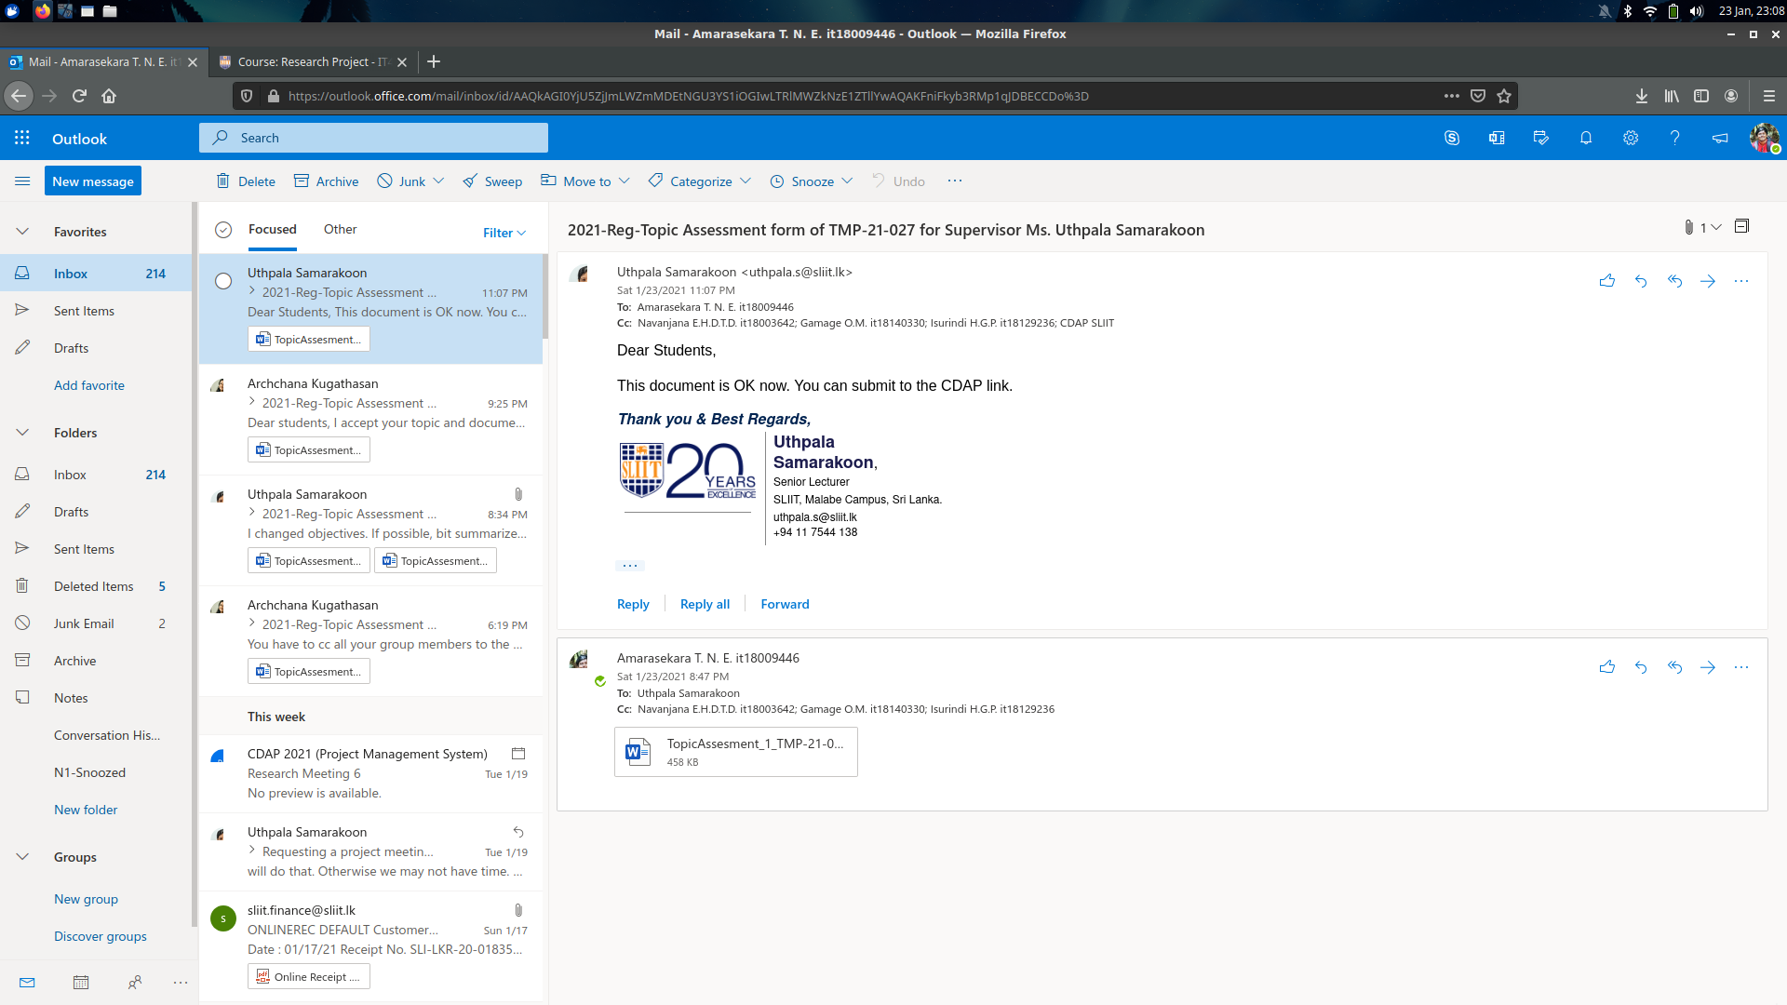

Appendix 2

