

**Sri Lanka Institute of Information Technology Sri Lanka**

**SMART PROJECT MANAGEMENT SYSTEM**

**K-Means Based Automated Student Group Generation**

**2021-234**

**Log Book**

Group Number: 2021_234

Member: Amarasekara T.N.E (IT18009446)

Table of Contents

1. MS Teams Management ii

Figure 1 – Useful information storage iii

Figure 2 – Tasks definer in the excel sheet iii

Figure 3 – Meeting records with the meeting recording link iv

Figure 4 – Tasks overview of completed and in progress task records in the system. iv

Figure 5 – Calendar overview of completed tasks and in progress tasks v

Figure 6 – Completed tasks list 1 v

Figure 7 – Completed tasks list 2 vi

2. MS Teams Meeting Screenshots. vi

Figure 8 – Meeting history vi

Figure 9 – Progress Presentation 2 vii

Figure 10 – Meeting screenshot 1 vii

Figure 11 – Meeting screenshot 2 (Conference blind review results discussion) viii

Figure 12 – Blind review discussion of the research paper viii

Figure 13 – Meeting screenshot 4 (Demo testing meeting) ix

3. GitLab Reports ix

Figure 14 - Repository ix

Figure 15 – Contribution x

Figure 16 – April GitLab Contribution graph x

Figure 17 – November GitLab Contribution graph xi

Figure 18 – Programming Languages Chart xi

3. AWS EC2 instances for Servers xii

Figure 19 – Backend Server EC2 instance xii

Figure 20 – Frontend Server EC2 instance xii

Figure 21 – Database Server EC2 instance xiii

# 1. MS Teams Management

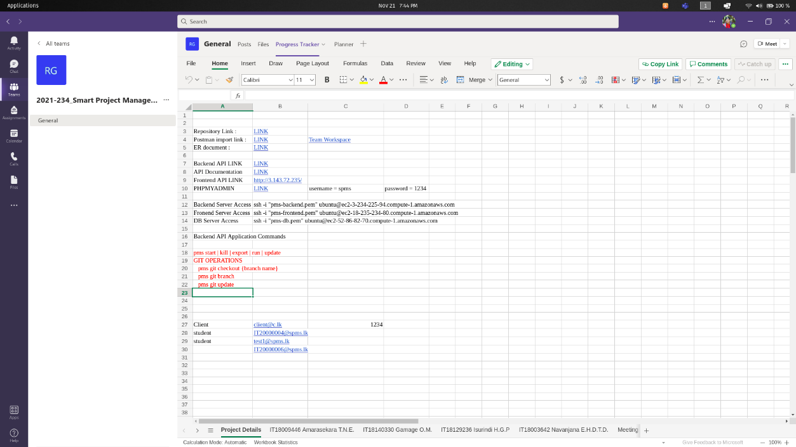

## Figure 1 – Useful information storage

We’ve used an excel sheet to keep track of server information and login credentials of the system, in order to make easier to give access information to the group members. This excel sheet contains,

* Backend server login command using ssh
* Frontend server login command using ssh
* Database server login command using ssh
* IP addresses of each server to access web interfaces.
* Custom unix commands to deploy and run backend server components.
* Login information of system users.

In addition to that, we’ve kept track of tasks in the excel sheet before we added planner to the teams group.

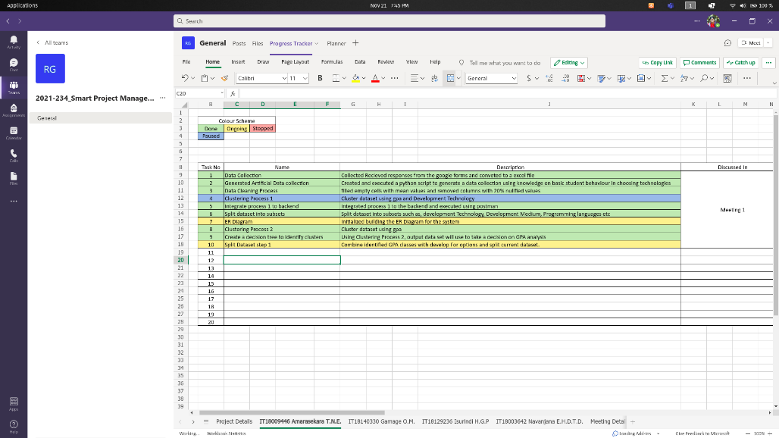

## Figure 2 – Tasks definer in the excel sheet

To provide further evidences, we’ve kept track of meetings with the supervisor and members in the team.

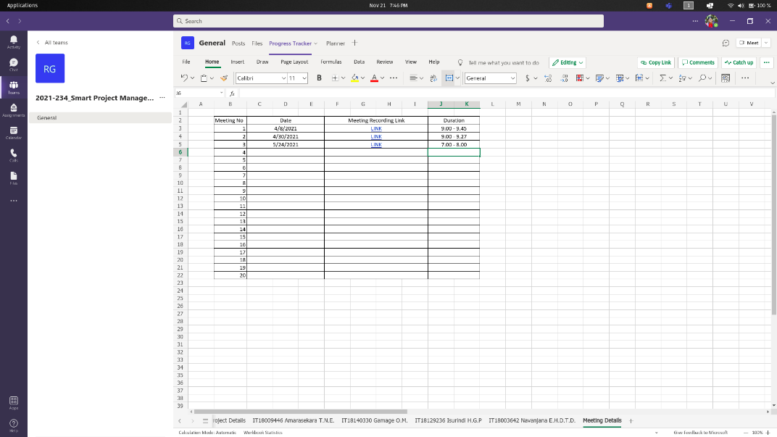

## Figure 3 – Meeting records with the meeting recording link

After we’ve created the planner tab, we’ve tracked the project progress using the MS planner. Before we start a task, we’ve created a task record in the MS planner. So that we can recheck the previous tasks that we’ve completed.

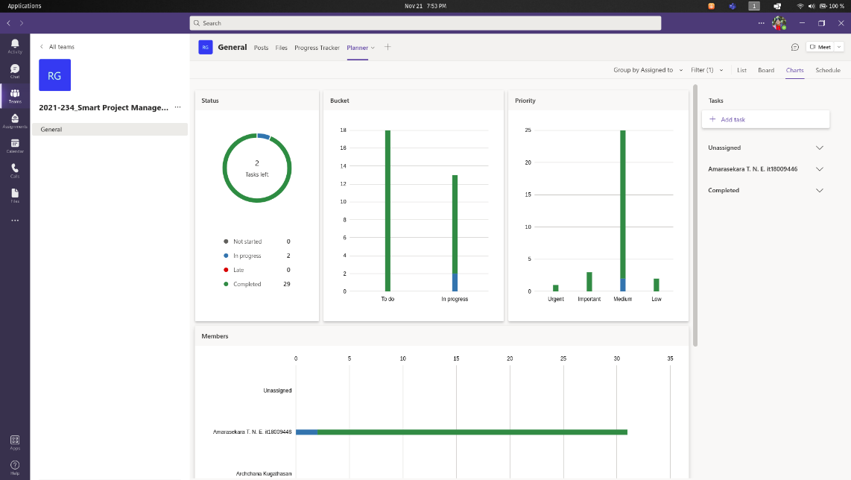

## Figure 4 – Tasks overview of completed and in progress task records in the system.

Green colored column segments indicate the completed tasks and blue column segments indicate in progress tasks.

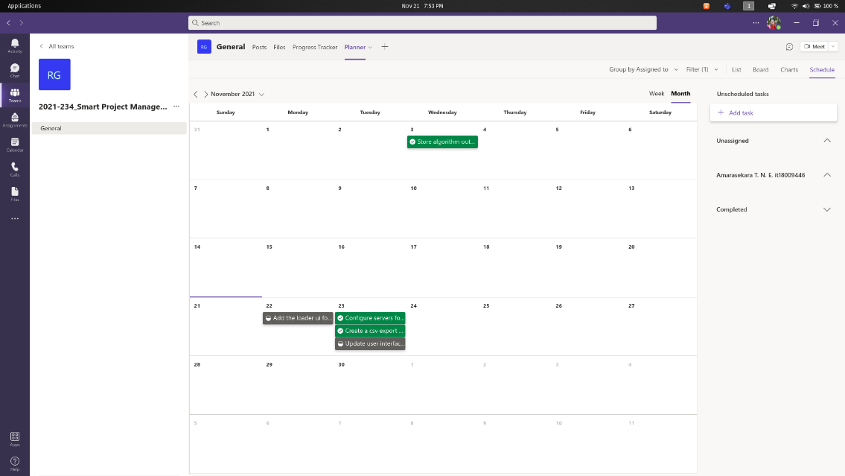

## Figure 5 – Calendar overview of completed tasks and in progress tasks

Schedule tab in the planner gives us the overview of tasks that we’ve completed and the tasks that need to be implemented in the system. Let’s take a look at the tasks that I’ve completed between April and November.

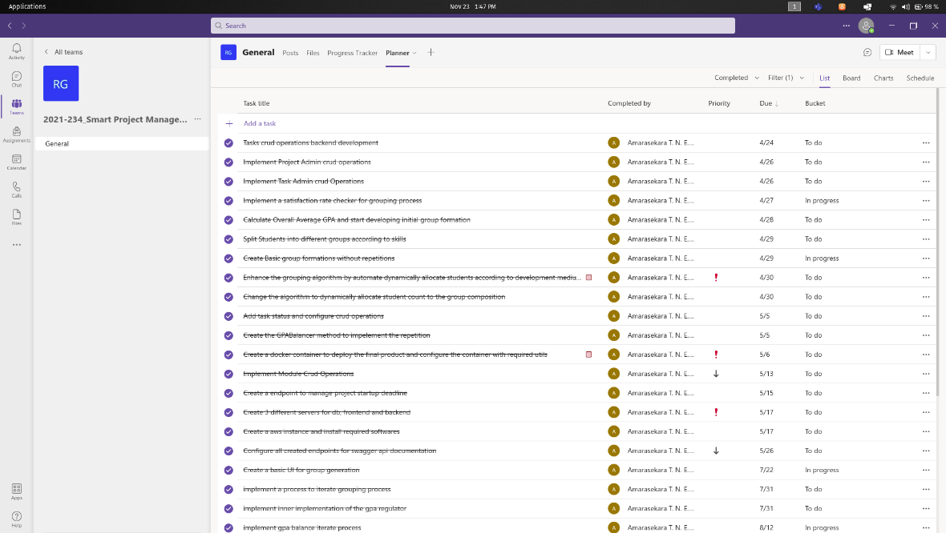

## Figure 6 – Completed tasks list 1

In the priority column, we can see “!” and the Down arrow mark. Red explanation mark indicates the High priority tasks and the Down arrow mark indicates the task is low prioritized. By defining a task such way, we can give the priority for that tasks in the implementations. It also a reminder that, the task is a high priority task and it need to be completed before the due date.

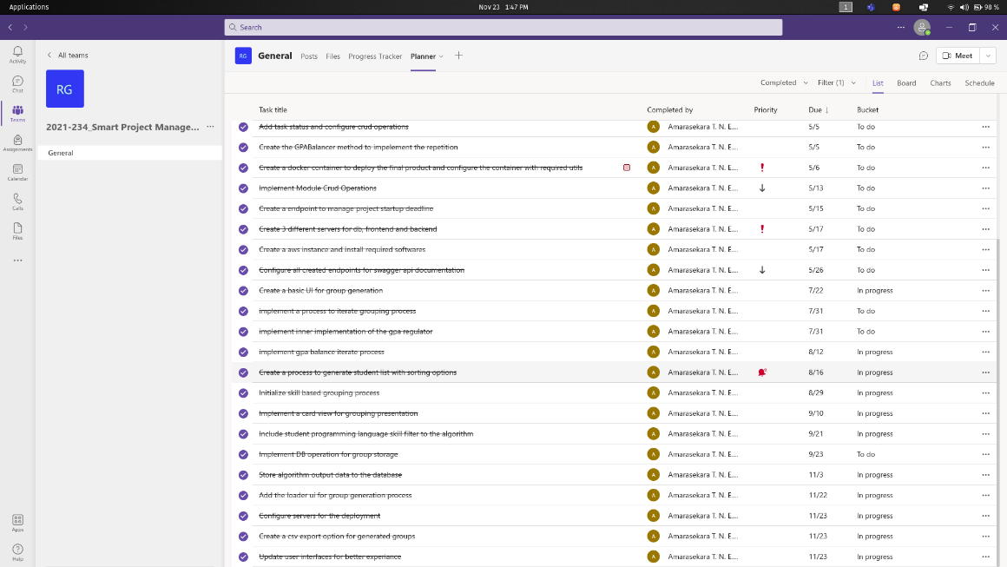

## Figure 7 – Completed tasks list 2

# 2. MS Teams Meeting Screenshots.

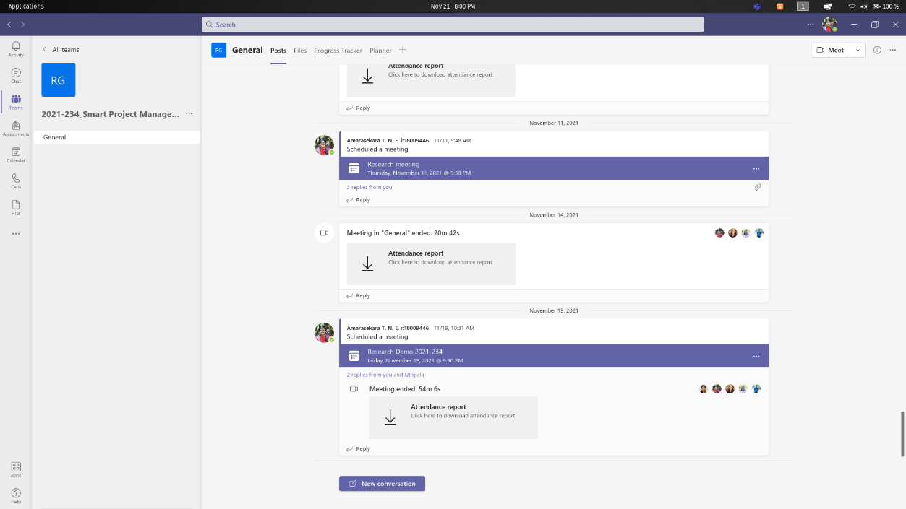

## Figure 8 – Meeting history

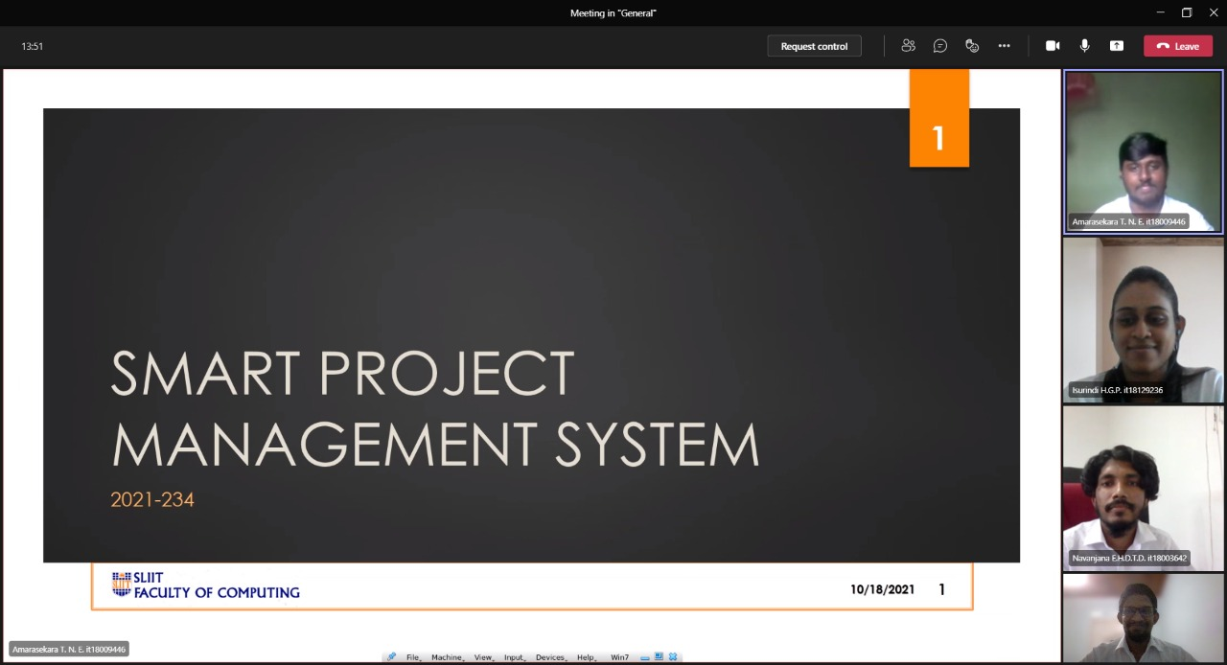

## Figure 9 – Progress Presentation 2

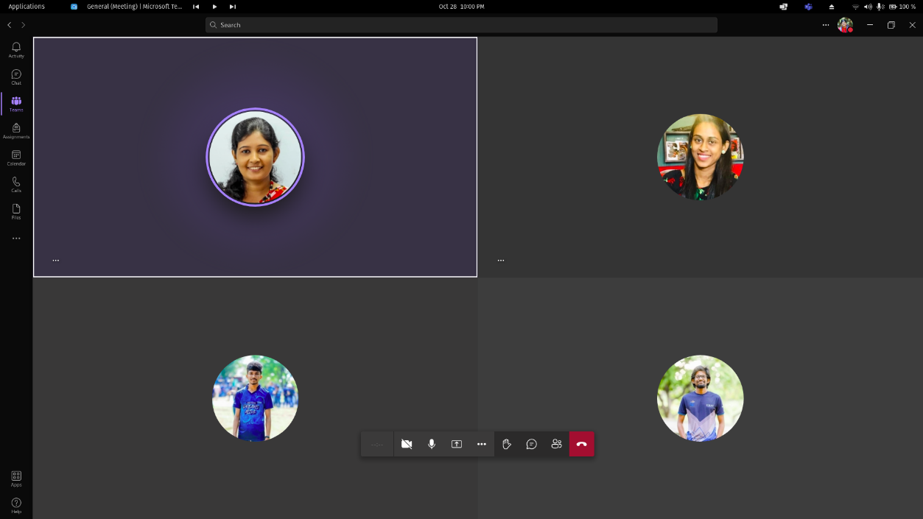

## Figure 10 – Meeting screenshot 1

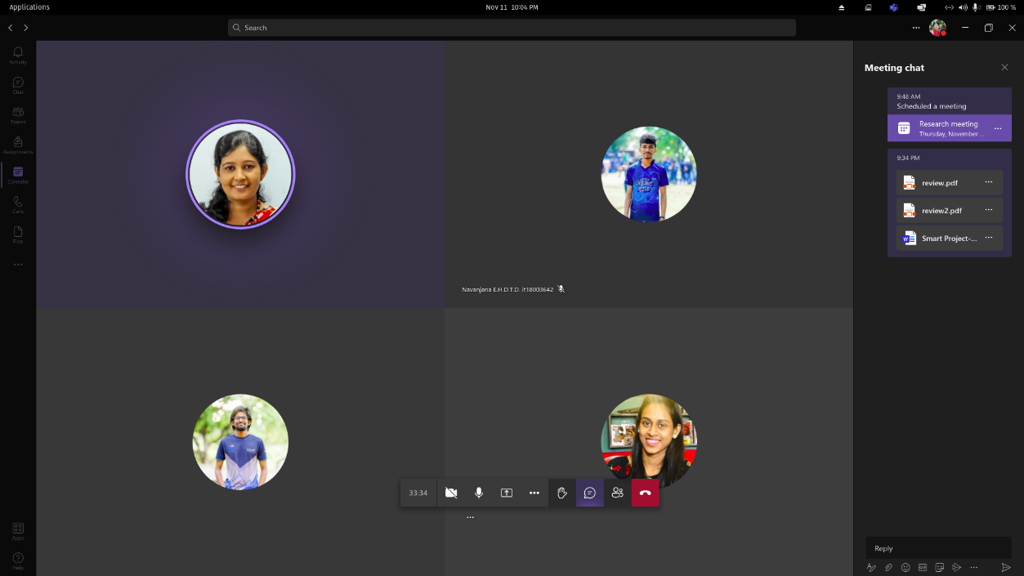

## Figure 11 – Meeting screenshot 2 (Conference blind review results discussion)

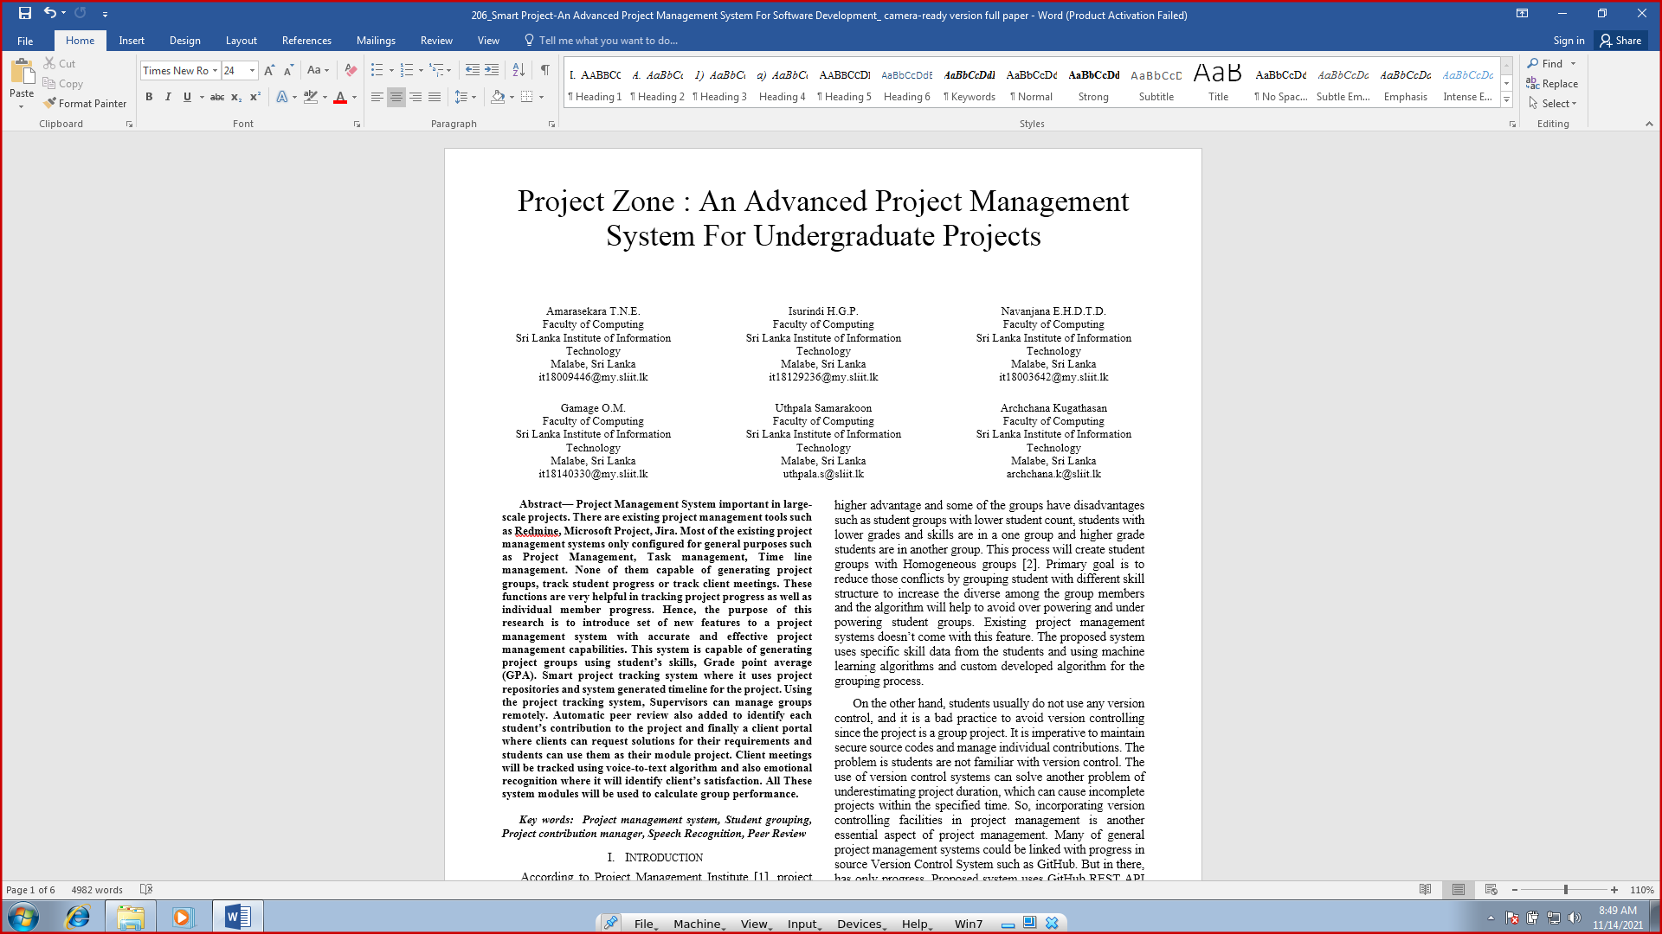

## Figure 12 – Blind review discussion of the research paper

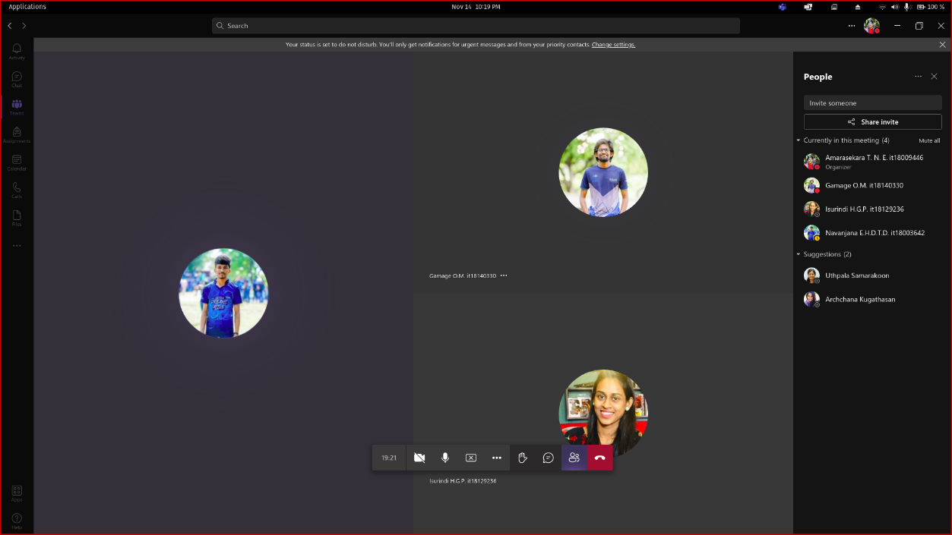

## Figure 13 – Meeting screenshot 4 (Demo testing meeting)

# 3. GitLab Reports

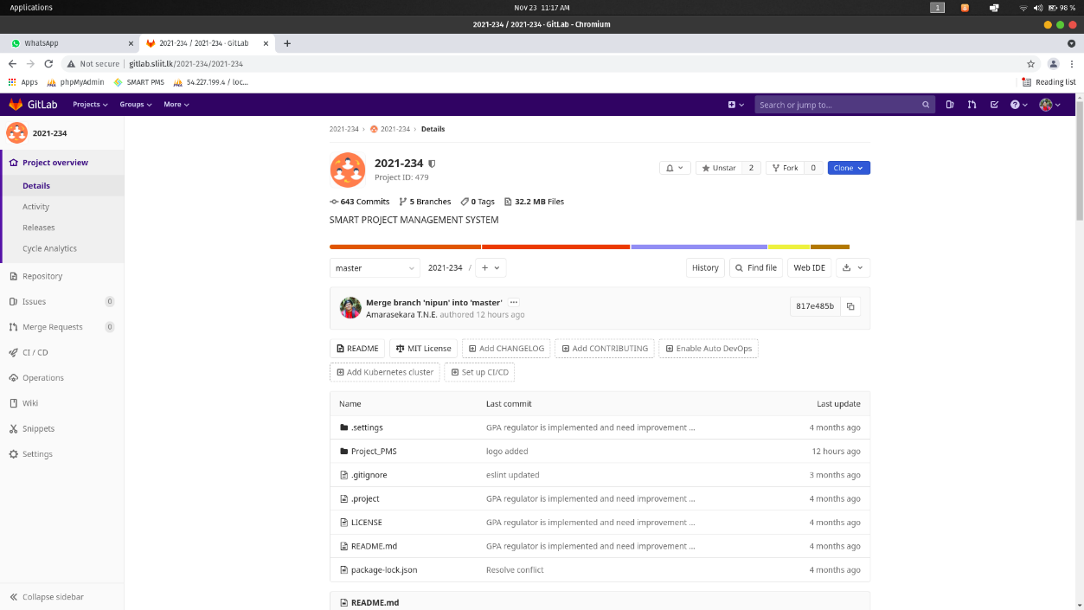

## Figure 14 - Repository

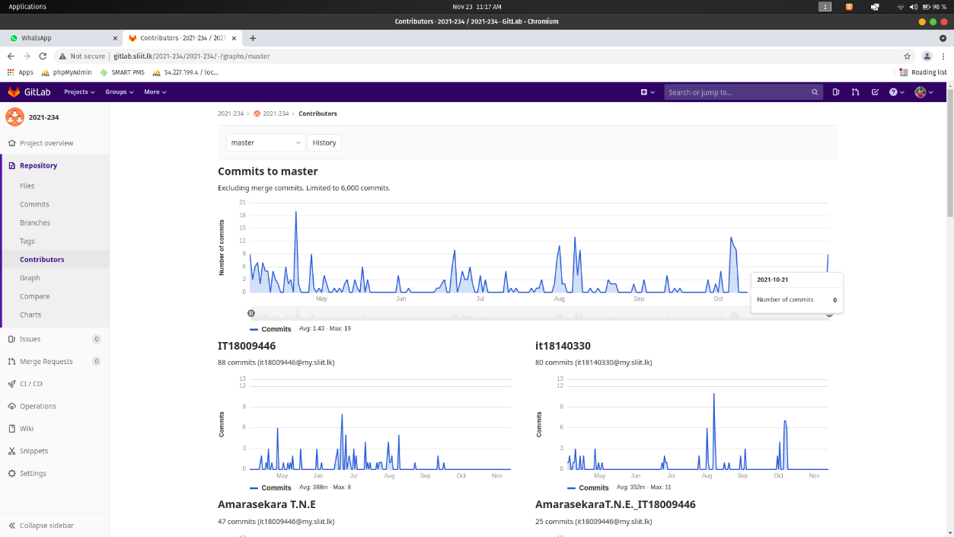

## Figure 15 – Contribution

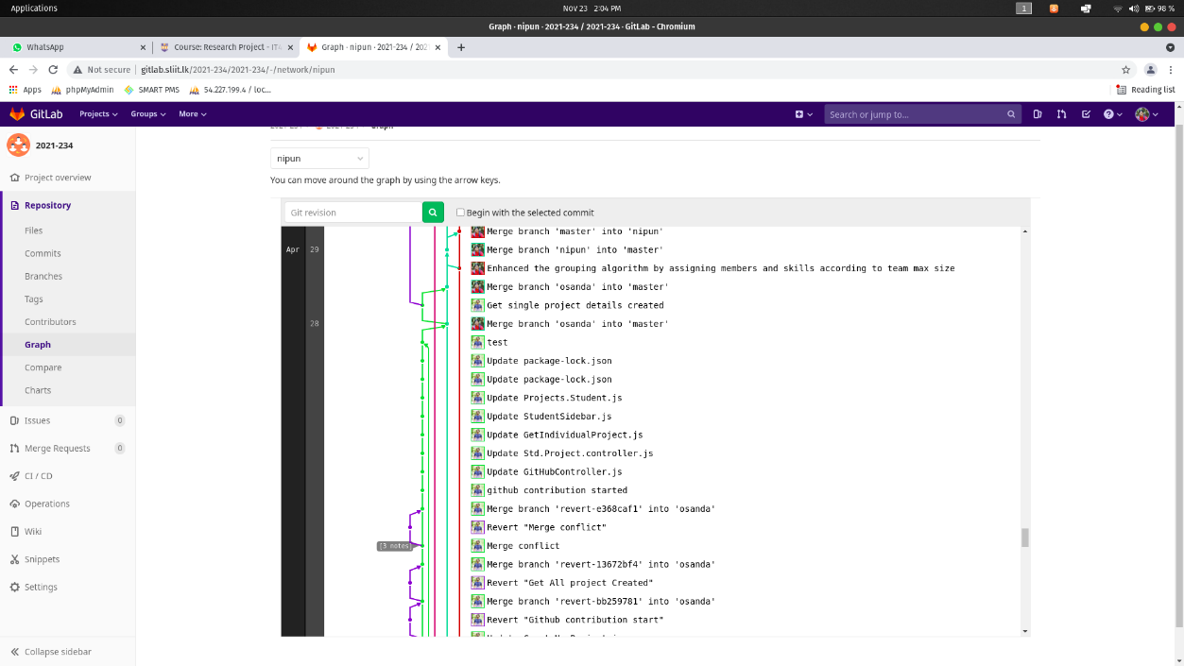

## Figure 16 – April GitLab Contribution graph

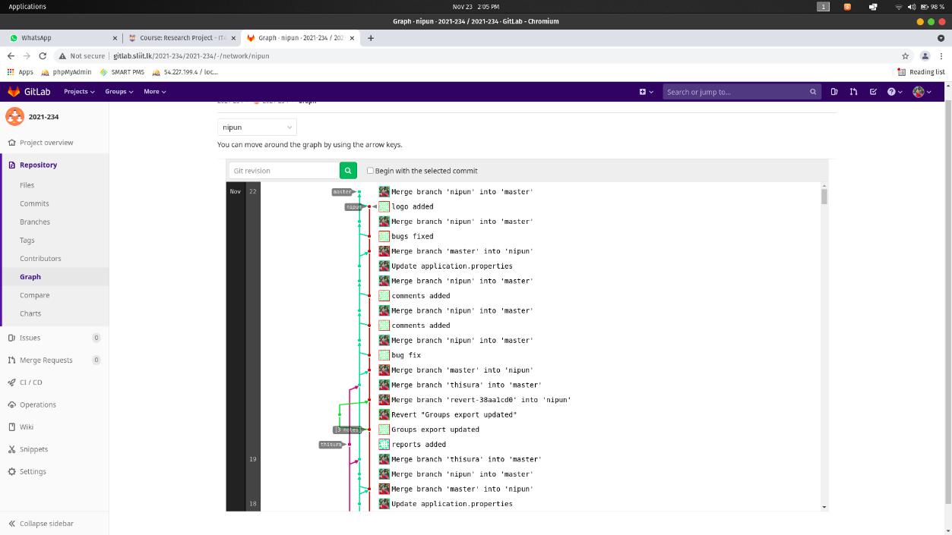

## Figure 17 – November GitLab Contribution graph

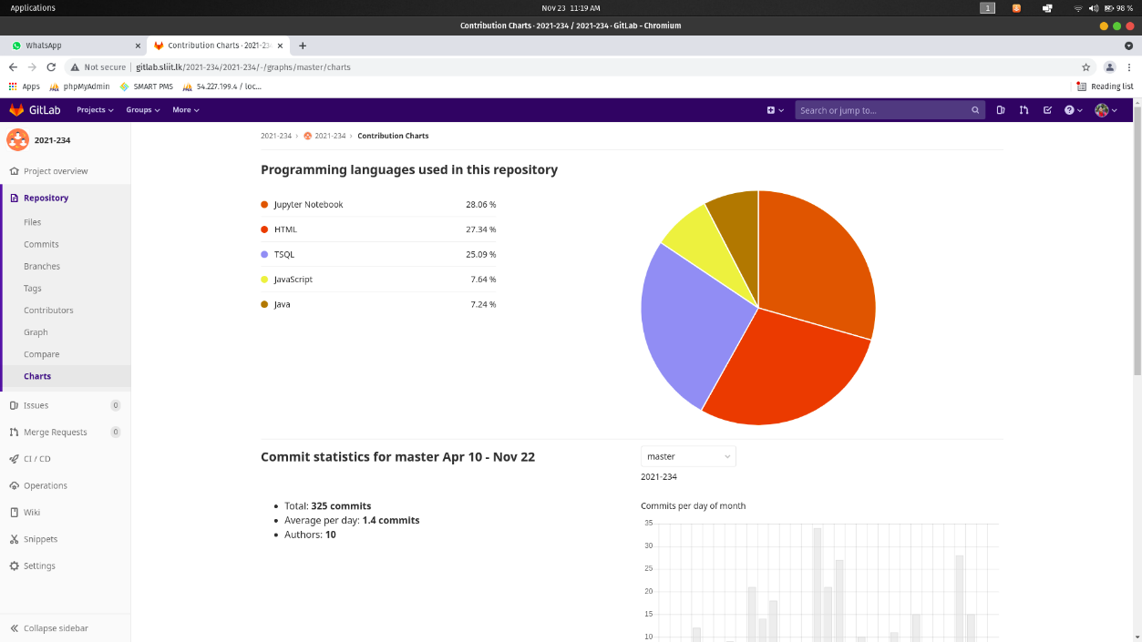

## Figure 18 – Programming Languages Chart

# 3. AWS EC2 instances for Servers

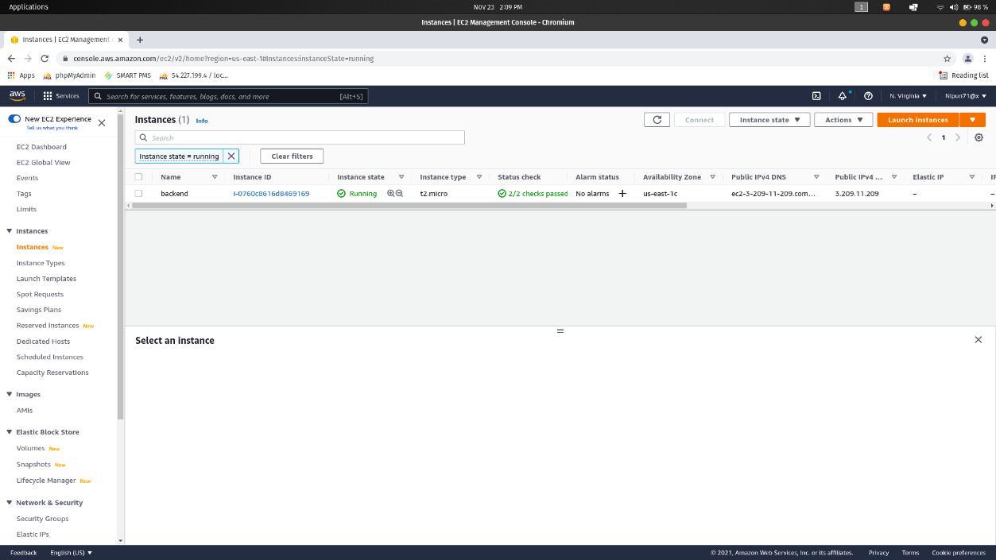

## Figure 19 – Backend Server EC2 instance

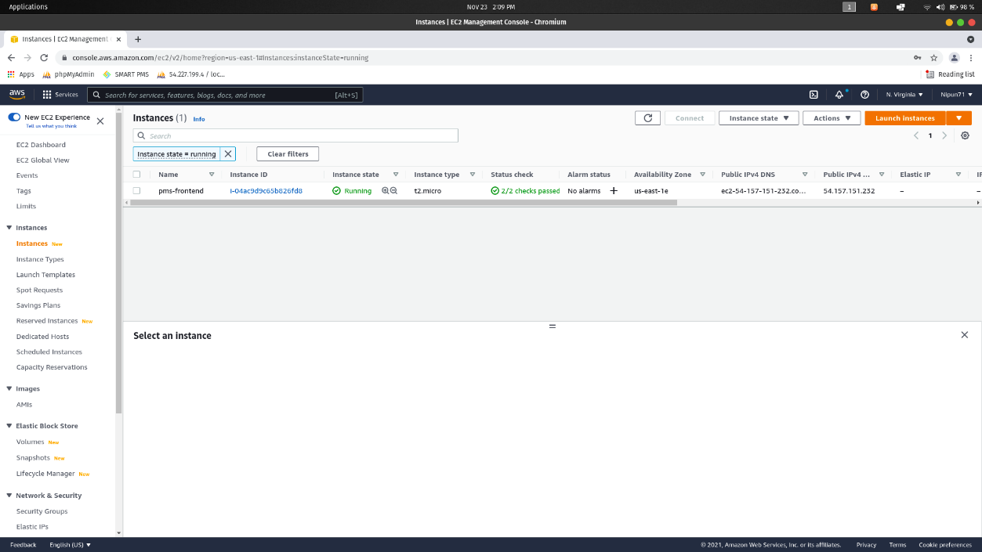

## Figure 20 – Frontend Server EC2 instance

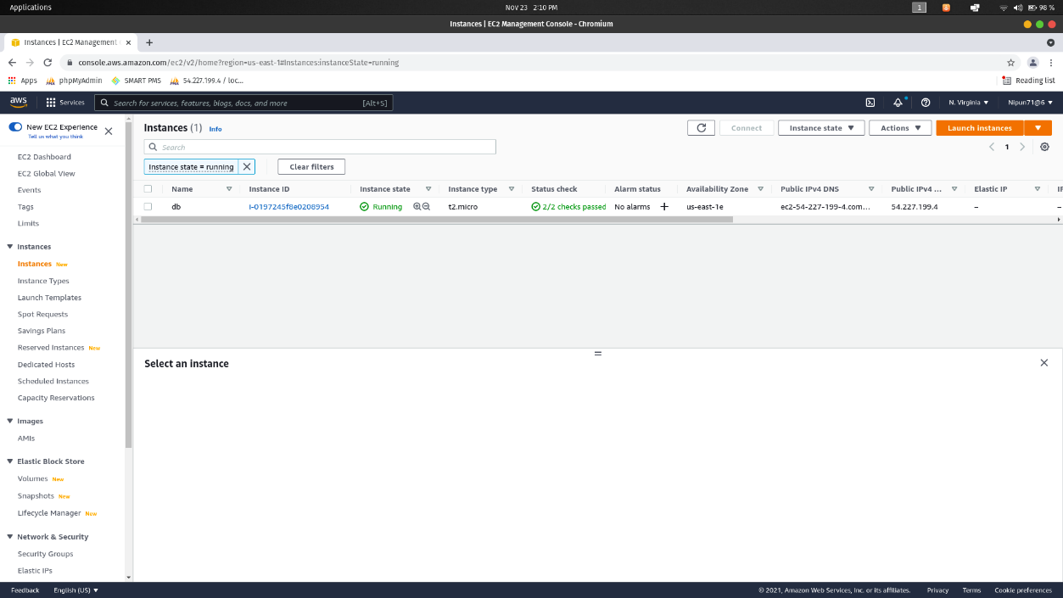

## Figure 21 – Database Server EC2 instance