**SMART PROJECT MANAGEMENT SYSTEM**

**2021-234**

**s**

Project Proposal Report

Isurindi H.G.P.

B.Sc. (Hons) Degree in Information Technology

Department of Information Technology

Sri Lanka Institute of Information Technology

Sri Lanka

February 2021

**SMART PROJECT MANAGEMENT SYSTEM**

**2021-234**

Project Proposal Report

B.Sc. (Hons) Degree in Information Technology

Department of Information Technology

Sri Lanka Institute of Information Technology

Sri Lanka

February 2021

**Declaration page of the candidates & supervisor**

We declare that this is our own work and this proposal does not incorporate without acknowledgement any material previously submitted for a degree or diploma in any other university or Institute of higher learning and to the best of our knowledge and belief it does not contain any material previously published or written by another person except where the acknowledgement is made in the text.

|  |  |  |
| --- | --- | --- |
| Name | Student ID | Signature |
| Isurindi H.G.P | IT18129236 |  |
|  |  |  |
|  |  |  |
|  |  |  |

The supervisor/s should certify the proposal report with the following declaration.

The above candidates are carrying out research for the undergraduate Dissertation under my supervision.

Signature of the supervisor: Date :

**Abstract**

Today, human beings are able to communicate their feelings, ideas, conversations in a variety of ways, either by writing or by waving, but speech is considering to be the easiest form of communication. From ancient times the people used a specific language for communication. With the gradual development of the social order and the new awakening of technology, new modes of communication came among us.

In our research, Project Management System is required for students when doing large-scale projects. But there is no any other proper system to generate project groups, track student progress or track meetings with clients. Since existing project management systems only configured for general purpose, it will not be enough for university purpose. Above mentioned facilities are not provided by any other project management solution. In My part focus the Client meetings will have held via video and audio. According to our research, we found voice to text concept and emotional recognition. So we introduce Client meeting to text format and emotional recognition feature to our system. It includes features such as a voice-to-text converter, a facial recognition system, a client meetings platform, and a task suggested to address above mention project failure causes. The client meetings platform supports arranging meetings easily using third-party apps. Then, at the end of the meeting, a report is generated using the voice-to-text converter. If the client turns on his/her camera during the meeting, the client satisfaction rate can also be calculated using the emotional recognition system.

**Keywords:** Speech Recognition, Emotional Recognition, Smart PMS

**Table of Contents**

LIST OF FIGURES v

LIST OF TABLES v

LIST OF APPENDICES v

1 INTRODUCTION 1

1.1 Background & Literature survey 1

1.2 Research Gap 3

1.3 Research Problem 4

2 OBJECTIVES 6

2.1 Main Objectives 6

2.2 Specific Objectives 6

3 METHODOLOGY 8

3.1 Architecture 8

3.2 Research Area 11

3.3 Requirement Gathering and Analysis 12

3.4 Design 12

3.5 Tools and Technologies 13

3.6 Implementation 14

3.7 Testing 14

3.8 Deployment 15

4 DESCRIPTION OF PERSONAL AND FACILITIES 16

5 REFERENCE LIST 17

6 APPENDIX 19

# LIST OF FIGURES

Figure 1.1.1: A framework for face recognition system. 2

Figure 1.3.1: Feature Comparison with the existing solutions and proposed system 4

Figure 3.1.1: Interaction among stockholders 8

Figure 3.1.2: System Overview 9

# LIST OF TABLES

Table 4.1: Description of personal and facilities………………………………….15

# LIST OF APPENDICES

Appendix Description Page

Appendix – A Sample questionnaire………………………………………………………..18

Appendix – B Sample questionnaire response…………………………………………19

# 1 INTRODUCTION

# 1.1 Background & Literature survey

Project Management is quite simple with current technology and most of the time Project Manager has the technology to manage most of the management process automatically using existing solutions. For the industry, existing project management tools are powerful enough to reduce the workload for the manager. However, when it comes to the Undergraduate Project Management, most of the management tools are more advanced and also some of the required features are not available with common management solutions. Therefore, we’ve decided to develop a Project Management System where we define our own features and also included with common features.

Speech recognition is a technology that enable the recognition and translation of spoken language into text. It is also known as Automatic Speech Recognition (ASR) or Speech to Text. Speech recognition is based on the voice as the research object. Speech recognition allows the machine to turn the speech signal into text or commands through the process of identification and understanding, and also makes the function of natural voice communication. [1]

The recognition of a person by them voice is one of the forms of biometric authentication, which makes it possible to identify a person by a combination of unique voice characteristics and refers to dynamic methods of biometrics. The most popular recognition models are Vector Quantization (VQ), Dynamic Time Warping (DTW) and Artificial Neural Network (ANN). [2] However we are going to use an algorithm for the problem of personality identification by voice using machine learning.

Emotional recognition is a technology capable of matching a human face from a digital image or a video frame against database of faces. This is one of the few biometric methods that possess the metrics of both high accuracy and low intrusiveness. It has the accuracy of a physiological approach without being intrusive. [3] So we need to configure emotional recognition has drawn the attention of researchers in fields from security, psychology and image processing to computer vision.

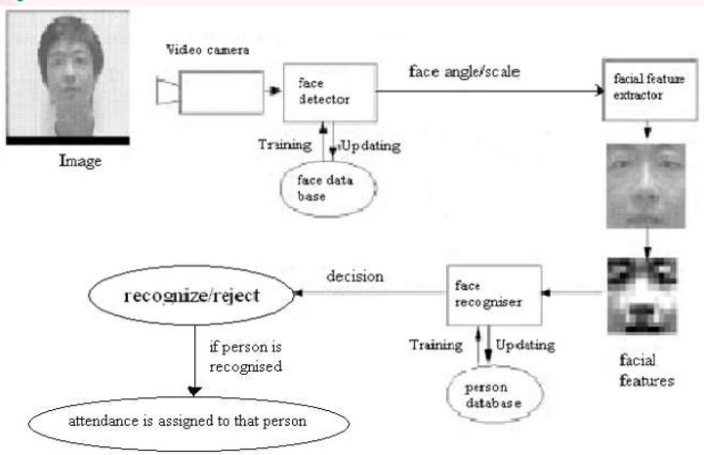

Figure 1.1.1: A framework for face recognition system. [3]

Today most of employees work in different stages and different environments. So they can communicate their ideas in virtual environment. So Clients meeting will have held via video and audio. According to my part we found the voice to text concept and facial recognition. So this introduce client meeting to text format and emotional recognition feature this is introduce the undergraduate students in the universities. That will help to identify the hole client requirements without any issues. Students doesn’t usually take notes in a meeting and it is not necessary if student able to remember all the details and plans that made with client.

As a result of our research, we are going to develop speech to text feature when doing client meetings. So the students don’t need to take notes or other things. Clients will propose the projects. There is a publicly access interface which can be used by clients as a project marketplace -And also client can track the project with coordination. Finally, client meeting tracking using voice to text conversion and emotional recognition use to calculate the client satisfaction rate and the auto generated report from the client requirements.

# 1.2 Research Gap

In my research part, there are several existing systems related to Speech Recognition [1][4][5][6] and Emotional Recognition [7][8][9] [10]. Above mentioned research solutions and systems are modern and configured systems. The problem is what is the research part that is different from other emotional and speech recognitions. Those existing systems are outputting only a result that related to face or speech. That means when we consider about the emotional recognition, system gives a result related to face expressions. From the Speech recognition, system give some texts related to his or her voice.

In our system, we are going to develop that using those two recognition systems. We get the output same as above mention research solution for those recognition systems and generate a report. Report will include speech recognition system’s text report and the Emotional recognition system’s client satisfaction rate. We are going to use Machine Learning to develop those two algorithm and to generate the Final report form the client meetings. Those two models can configure using existing systems. But we have to develop those models also.

However, we have to develop the client publicity access interface too. When the client publishes a project, student can start bidding. After that client can refer students’ profiles or group profiles. Then the client can start communicating with them. When the client communicates with the students or students group, Emotional Recognition and the Speech Recognition part will start. Finally, when the student finished their client meetings, they can get a report about client requirements and client’s satisfaction rate. So the student can get an idea about client is happy or not. Also they don’t need to worry about take down notes in client requirements.

# 1.3 Research Problem

Undergraduate project management is challenging when it comes to group projects. Even though there are many existing project management systems such as Microsoft project, Jira, and Redmine, most of them were developed for general purpose. Hence, some important specific features which are useful when managing student projects such as automatic group formation, project tracking and notification generation on project progress are not available in those systems.

When the project is for a specific client, it is important to trach the progress of the project by client and give feedback. Also, even if there is a client connected to the project, project coordinators cannot track their meeting details and what they communicated with the client. Students also get into trouble in this situation. Students doesn’t usually take notes in a meeting and it is not necessary if student able to remember all the details and plans that made with client. But they are not. After few days they don’t even know what they are doing. It is better to have any solution to auto generate a report of the meeting and the content. With current systems we have not found any solutions to this matter. Client also find difficulty to track project progress and clients may also blame for the project coordinators for any failures.

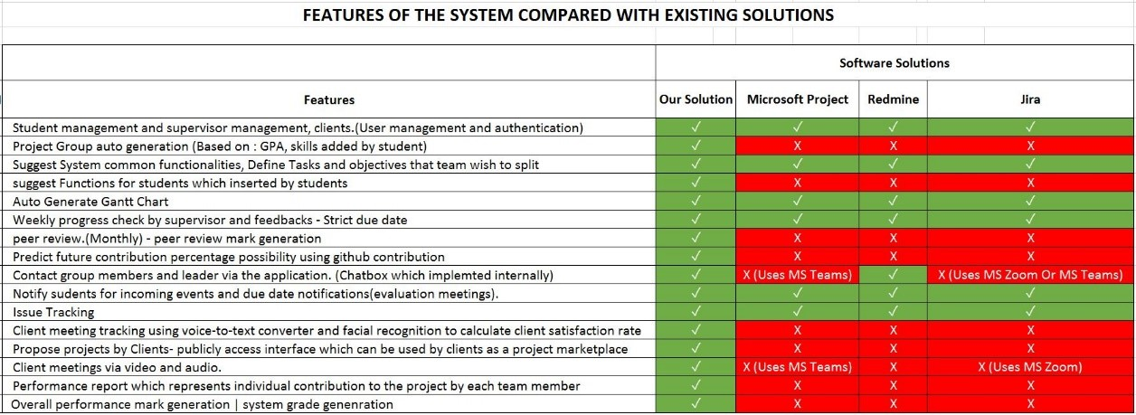

Figure 1.3.1: Feature Comparison with the existing solutions and proposed system

Figure 1.3.1 shows a table that we created by finding functionalities in the existing project management systems. The red colored cells show the functionality is not implemented in the system and green colored cells shows the functionality is implemented in the system. As you can see the Client meeting tracking using voice-to-text converter and facial recognition to calculate client satisfaction rate, Propose projects by Clients- publicly access interface which can be used by clients as a project marketplace, Client meetings via video and audio and suggest Functions for students which inserted by students are not implemented in neither software solutions and it is a major requirement for any university to improve effectiveness and efficiency of university projects.

# 2 OBJECTIVES

# 2.1 Main Objectives

The main objective of this research part is emotional and speech recognition into auto generated report and a satisfaction rate. There is same model in the emotional and speech recognition that are developed in the existing systems. The algorithm is very important for generate a report with client requirements and satisfaction rate.

# 2.2 Specific Objectives

Client meeting tracking using voice-to-text converter and emotional recognition to calculate client satisfaction rate.

* This facility is given to the students to track client meetings. Advantage of using this solution is student can check the meeting logs anytime. If they missed or forgot anything, they can check the meeting log. System will generate a log by converting voice to text method. Also if the camera turned on by the client, System will recognize facial expressions and it will give an output about client’s overall satisfaction during the meeting.

Client meetings platform

* This platform will provide facilities to arrange meetings and host meetings with clients instead of using a third party application.

Client portal which provide facility to propose projects

* publicly access interface which can be used by clients as a project marketplace. These portal will give access to external clients for project suggestions that can be used for students. Students can access the system and look for available projects.

suggest Functions for students which inserted by students

* This facility will split user given tasks to most suitable team mate. For example, if a student in the team is interested in frontend development and if the student knows multiple frontend frameworks and technologies, Suitable frontend tasks will be suggested for the student. Student can decide what to choose. This facility will use student profiles to calculate suitable tasks.

# 3 METHODOLOGY

# 3.1 Architecture

Our overall research is Project Management System. There are four main types of parties involved in this system. Student and the lecturer are the main users and others are supervisors and clients. In this part mainly focus the client and student.

This is a web application and the component of the application are handle by the system.

Here is the System overview and other architectures.

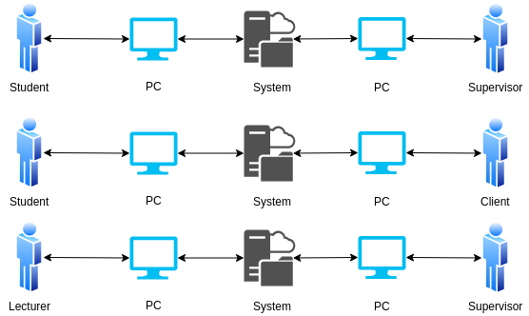

Figure 3.1.1: Interaction among stockholders

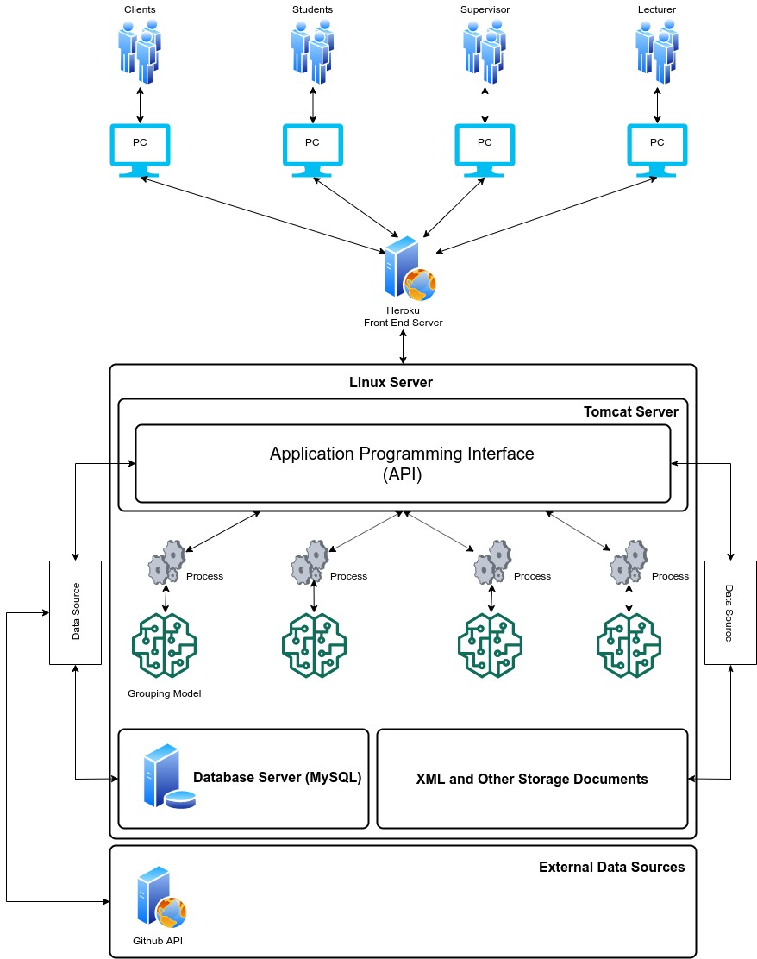

Figure 2.1.2: System Overview

According to the system diagram as shown in Figure 3.1, We’re hosting the backend server in a Linux environment and inside the Linux server there are 4 components.

* API running on Apache Tomcat Server
* MySQL Server
* Trained Models for decision Makings
* XML and Other Storage Documents

Heroku Server used to deploy the Frontend solution to interact with users. Frontend solution will be communicating with the users and the API.

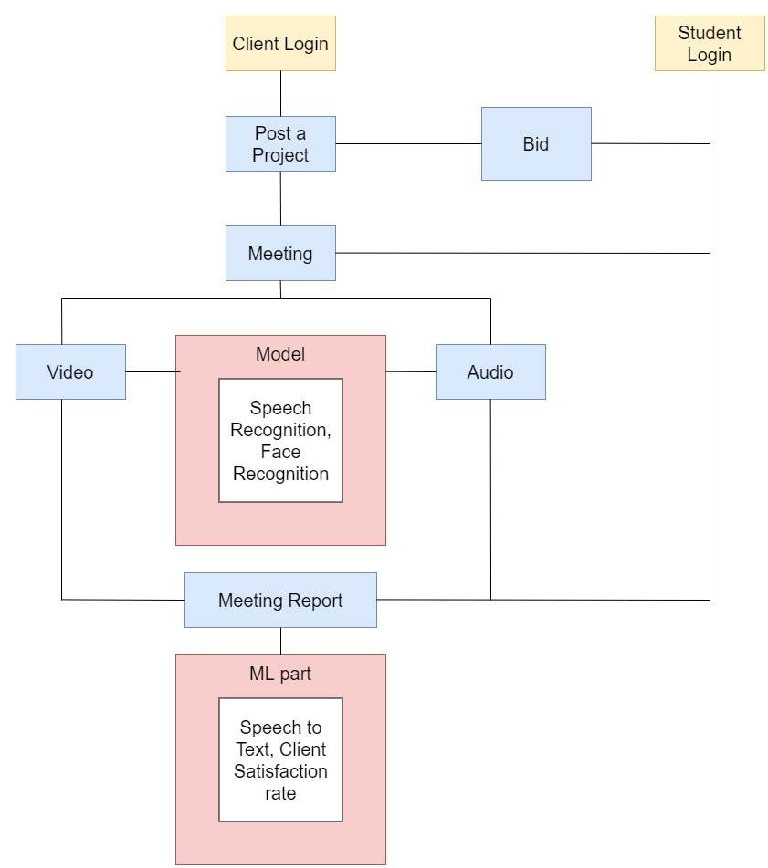

Figure 3: Client-student overall process

# 3.2 Research Area

Research part of this part is Client meeting tracking using voice-to-text converter and emotional recognition to calculate client satisfaction rate. This facility is given to the students to track client meetings. Advantage of using this solution is student can check the meeting logs anytime. If they missed or forgot anything, they can check the meeting log. System will generate a log by converting voice to text method. I need to follow some Models regarding to Emotional and Speech Recognitions.

Client meetings will have held via video and audio. According to our research, we found voice to text concept and Emotional recognition. So we introduce Client meeting to text format and Emotional recognition feature to our system. That will help to identify client requirements without any trouble. Because students have the all client’s requirements. Students doesn’t usually take notes in a meeting and it is not necessary if student able to remember all the details and plans that made with client. But they are not. After few days they don’t even know what they are doing. It is better to have any solution to auto generate a report of the meeting and the content. As a result of our research, we are going to develop speech to text feature when doing client meetings. So the students don’t need to take notes or other things. Clients will propose the projects. There is a publicly access interface which can be used by clients as a project marketplace and also client can track the project with coordination. Finally, client meeting tracking using voice to text conversion and emotional recognition use to calculate the client satisfaction rate.

# 3.3 Requirement Gathering and Analysis

Requirement gathering is very important. Because I need requirements to develop my part. Especially I must concern about the gathered information because it should be important to my research pat. I gathered my requirements by using,

* Research papers related to my part.
* Emotional and Speech recognition systems currently running.
* Survey Results

# 3.4 Design

I need a design before starting to development. That is very important to have that, because the hardware, software and system requirements to identify the architecture. So I can manage tools and technologies that I am going to use in my part. We can consider about two parts in design section. That are Frontend and Backend Design. We are going to use draw.io platform to design wireframe in frontend.

# 3.5 Tools and Technologies

Tools

* Visual Studio Code
* Apache Server
* Eclipse IDE
* Maven
* Postman
* Ngrok

Server Side

* Java – JAX-RS Rest API
* Python
* Redux

Client Side

* HTML, CSS, JS (jQuery, React JS)

Database

* MySQL

Communication

* REST, AJAX, JSONs

# 3.6 Implementation

Implementation stage divides the part into several sections. Such as Client meeting platform, Emotional recognition system, Speech recognition system, checking and generating overall recognition report, classify client satisfaction rate, Client portal which provide facility to propose projects, suggest Functions for students which inserted by students.

For the frontend part I am going to use React JS and for the backend part going to use python API. For the database we use MySQL and some java parts. Visual Studio code and the Eclipse will be out tools to develop our system.

# 3.7 Testing

We are going to use both functional and non-functional testing types to test our system. Because testing is the most important part in software life circle. Testing will be begun from the beginning of the system development and will be proceeded until the last endpoint of the system development. All these testing will be done so as to check whether the sections have been completed related to client requirements. Those two type of testing will be done to verify the development will have finished related to client requirements.

And also we are going to use Postman to test the API endpoints. Postman is a collaboration platform for API development. Postman's features simplify each step of building an API and streamline collaboration so the user can create better APIs faster [11]

# 3.8 Deployment

* + **AWS**

AWS has significantly more services, and more features within those services, than any other cloud provider–from infrastructure technologies like compute, storage, and databases–to emerging technologies, such as machine learning and artificial intelligence, data lakes and analytics, and Internet of Things. This makes it faster, easier, and more cost effective [12].

* + **Ngrok**

For the demonstration purposes we sometimes need to use other API implementations for the frontend implementations. To do that we can use Ngrok to temporary host the localhost and access the API anywhere. But the free version is only providing 2hr of online period. After that period ngrok needed to be restarted with a new URL. But for the temporary testing, ngrok is best solution for the temporary global hosting.

# 4 DESCRIPTION OF PERSONAL AND FACILITIES

|  |  |  |
| --- | --- | --- |
| Member | Component | Task |
| IT18129236  Isurindi H.G.P. | * Tracking using voice-to-text converter and Emotional recognition to calculate client satisfaction rate * Client meetings platform * Suggest Functions for students * Client portal which provide facility to propose projects | * Develop voice-to-text converter which generates a report. * Develop client satisfaction rate calculator using Emotional recognition. * Develop client meetings platform * Develop suitable function suggested to the students. |

Table 4.1 : Description of personal and facilities

# 5 REFERENCE LIST

[1] IEEE, “Overview of the Speech Recognition Technology”, 2012 fourth International Conference on Computational and Informational Science. Available at <https://ieeexplore.ieee.org/abstract/document/6300437/keywords#keywords>

[2] Orken Mamyrbayew, Nurbapa Mekebayev, Mussa Turdalyuly, Nurzhamal Oshanova, Tolga Ishsan Medeni and Aigerim Yessentay, “Voice Identification Using Classification Algorithms”, 2019, Available at <https://www.intechopen.com/books/intelligent-system-and-computing/voice-identification-using-classification-algorithms>

[3] Shang-Hung Lin, “An Introduction to Face Recognition Technology”, 2000, Available at <http://inform.nu/Articles/Vol3/v3n1p01-07.pdf>

[4] Lowerre B.T. , “The Happy Speech Recognition System”, Ph.D. Thesis Carnegie-Mellon University, Pittsburgh, PA, Available at <https://ui.adsabs.harvard.edu/abs/1976PhDT........81L/abstract>

[5] “The Kaldi Speech Recognition Toolkit”, 2011, Available at <https://infoscience.epfl.ch/record/192584>

[6] “The BBN Continues Speech Recognition System”, IEEE , Available at <https://ieeexplore.ieee.org/abstract/document/1169748?casa_token=udzxGegb80kAAAAA:sKUjnCH5hOxNdm41rEZy-Q1U2BmTYOkL823BleuGkMy0IoLMJyPH7Brlpb3yGAV6Esgrlzw2X1UIwQ>

[7] “Face recognition system using local autocorrelations and multiscale integration”, IEEE, Available at <https://ieeexplore.ieee.org/abstract/document/541411?casa_token=jHku6a2pdlYAAAAA:keWsgEazEIPkF5-HcUOjZhYWDKR7GbpQptw4rHHCOzumsm1_cRenFPaH68vRTRfeVpl287ioznI_3Q>

[8] “Face recognition methods and applications” , Cornell University, 2014, Available at <https://arxiv.org/abs/1403.0485>

[9] “A new LDA-Based face recognition system which can solve the small sample size problem”, Science Direct, 2000, available at <https://www.sciencedirect.com/science/article/abs/pii/S0031320399001399>

[10] “Hidden Makov models for face recognition”, IEEE, available at <https://ieeexplore.ieee.org/abstract/document/678085/authors#authors>

[11] Postman. (2021). The Collaboration Platform for API Development. [online]. Available: <https://www.postman.com/>. [Accessed: 21-Feb-2021]

[12] Amazon Web Services. (2021). Cloud computing with AWS. [online]. Available: <https://aws.amazon.com/what-is-aws/?nc1=f_cc>. [Accessed: 21-Feb-2021]

# 6 APPENDIX

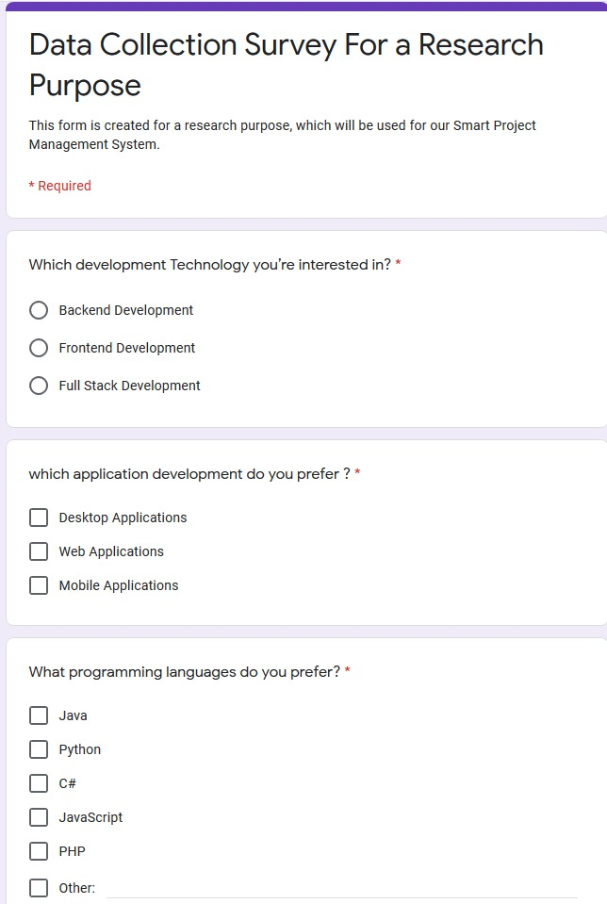Appendix – A: Sample questionnaire

# Appendix – B: Sample questionnaire response

