**SMART PROJECT MANAGEMENT SYSTEM**

**TEMP-21-027**

Project Proposal Report

Navanjana E.H.D.T.D.

B.Sc. (Hons) Degree in Information Technology

Department of Information Technology

Sri Lanka Institute of Information Technology

Sri Lanka

February 2021

**SMART PROJECT MANAGEMENT SYSTEM**

**TEMP-21-027**

Project Proposal Report

B.Sc. (Hons) Degree in Information Technology

Department of Information Technology

Sri Lanka Institute of Information Technology

Sri Lanka

February 2021

**Declaration page of the candidates & supervisor**

We declare that this is our own work and this proposal does not incorporate without acknowledgement any material previously submitted for a degree or diploma in any other university or Institute of higher learning and to the best of our knowledge and belief it does not contain any material previously published or written by another person except where the acknowledgement is made in the text.

|  |  |  |
| --- | --- | --- |
| Name | Student ID | Signature |
| Navanjana E.H.D.T.D. | IT18003642 |  |
|  |  |  |
|  |  |  |
|  |  |  |

The supervisor/s should certify the proposal report with the following declaration.

The above candidates are carrying out research for the undergraduate Dissertation under my supervision.

Signature of the supervisor: Date :

**Abstract**

Universities use different kinds of approaches for managing their undergraduate projects which will be expected to help them to improve their collaborative learning skills associated with cooperative learning[30][31]. Collaborative learning is a method of teaching and learning in which undergraduate groups together to study a given assignment or create a meaningful project. A group of undergraduates discussing a lecture or undergraduates from different universities working together over the Internet on a shared assignment are both examples of collaborative learning. Cooperative learning is a specific kind of collaborative learning. In cooperative learning, undergraduates work together in small groups on structured assignments. They are individually accountable for their work, and the work of the group as a whole is also assessed. Cooperative groups work face-to-face and learn to work as a team.

But there are some major issues with undergraduate project module structures that affect these collaborative learning environments which universities trying to maintain. one of those issues is the free-riding effect[28] among undergraduates. Most of the time the free-riding effect is based on unbalanced work breakdown among undergraduates project timelines. Without monitoring unbalanced work breakdown they are becoming passive observers rather than active participants in the project's early stages. In this smart project management solution, we are addressing those issues. We are designing a work breakdown structure to reduce those unbalanced work breakdowns among the timeline and we are adding a lockdown feature to discourage free-riding. This structure comes with pre-defined milestones and customizable tasks between those milestones which undergraduates need to update and get approved by their supervisors. one of that milestone is peer-reviewing their team members to help supervisors to detect weak points of the undergraduates' collaborative skillsets and help to improve those which is the ultimate result of this research study.

**Table of Contents**

Declaration………………………………………………………………………........ i

Abstract…………………………………………………………………………….... ii

Table of Contents..………………………………………………………………….. iii

List of Figures…………………………………………………………………...…...iv

List of abbreviations………………………………………………………………… v

List of Appendices………………………………………………………………….. vi

1 Introduction……………………………………………………………………...1

1.1 Background & Literature Survey……………………………………………. 3

1.2 Research Gap…………………………………………………………………5

1.3 Research Problem…………………………………………………………….7

2 Objectives……………………………………………………………………….9

2.1 Main Objectives……………………………………………………………... 9

2.2 Specific Objectives…………………………………………………………...9

3 Methodology…………………………………………………………………..11

3.1 System Architecture....……………………………………………………... 13

3.1.1 Software Solution………………………………………………………14

4 Description of Personal and Facilities…………………………………………21

4.1 Other Functions…………………………………………………………….. 22

5 References………………………………………………………………….......22

**List of Figures**

Figure 1.Five phases of project management………………………,………………..1

Figure 1.2.Sentiment analysis classification …………………………,……...………5

Figure 1.3.Feature Comparison with the existing solutions and proposed system…...8

Figure 2.1.Aspect Based Sentiment analysis……………………...………………….9

Figure 3.1.Overall Workflow of the Proposed ABSA process………………,….....11

Figure 3.2.ABSA method and techniques……………………………….…………..12

Figure 3.1.1.System Architecture Diagram………………………...……………….13

Figure 3.1.1.1.SDLC Life Cycle…………………………………………………….14

Figure 3.2: Sample Quarkus architecture with microservices………………………18

Figure 3.3: Ngrok Frontend demonstration…………………………………………20

Figure 3.4: Overall ABSA workflow………………………………………………..21

**LIST OF ABBREVIATION**

|  |  |
| --- | --- |
| Abbreviation | Description |
| PMI | Project Management Institute |
| PMBOK | Project Management Body of Knowledge |
| WBS | Work Breakdown Structure |
| ABSA | Aspect-Based Sentiment Analysis |
| CRF | Conditional Random Fields |
| HMM | Hidden Markov Model |
| LDA | Latent Dirichlet Allocation |
| PLSI | Probabilistic Latent Semantic Indexing |
| CNN | Convolutional neural network |
| RNN | Recurrent neural network |
| LSTM | Long Short-Term Memory |
| GRU | Gated Recurrent Unit |
| AWS | Amazon Web Services |
| ITP | Information Technology Project |
| JDBC | Java Database Connectivity |
| SLIIT | Sri Lanka Institute of Information Technology |
| XML | Extensible Markup Language |
| JS | JavaScript |
| UI | User Interface |
| UX | User Experience |
| API | Application Programming Interface |

**1. INTRODUCTION**

According to Project Management Institute[1], project management is the application of knowledge, skills, tools, and techniques to a broad range of activities to meet the requirements of a particular project. Project Management Body of Knowledge (PMBOK Guide)[1] divides the project management process into five essential steps. They can be identified as project initiation, project planning, project execution, project performance/monitoring, and project closure. The project monitoring phase has a sub-phase call performance which associates with project health. Project health measure by information which includes team performance associate with deadlines. we implement this project management process phase's with suitable modifications to undergraduate group projects.

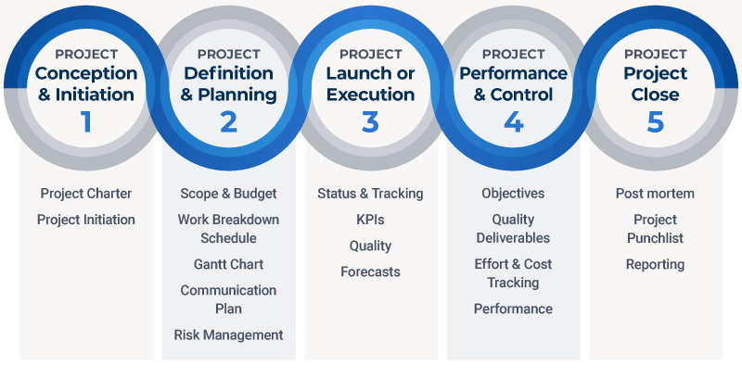

Figure 1 Five phases of project management

We are using a timeline associated with the work breakdown structure (WBS) [2] [3] from the project planning phase to the project performance phase and onwards. A WBS, as defined in the PMBOK Guide—Third Edition is a deliverable-oriented hierarchical decomposition of the work to be executed by the project team to accomplish the project objectives and create the required deliverables. It organizes and defines the total scope of the project. There will be a WBS-associated timeline for each group member and also the group itself. It will help to visualize more information about the project's health. The timeline comes with the predefined milestones which are critical tasks include in the project. It will also have the functionality to lock down the tasks after their deadlines. We are using this lockdown functionality in the timeline to reduce the free-riding problem and passive observance among the undergraduates[4].

In the project execution phase project, the manager/ supervisor goes through timelines and status reports to stay tuned-in with the team. We modify the status report with a peer review assessment functionality in the execution phase for undergraduates.it will collect their opinions and feedbacks about team members and their related work with the project. Currently, undergraduates project modules don’t have peer review reports to help supervisors. Peer review will be aspect-based which is supervisor can get an idea about the area of the project with a mentioned team member is struggling or the skill set team member is lacking.

So with these replacements with work breakdown structure-based timelines and aspect-based peer review assessment reports we are trying to reduce the major disadvantages like the free-riding problem, passive observance, unbalance work breakdown workflows in the current project management process for the undergraduates.[5]

**1.1 Background & Literature survey**

Project management systems don’t offer peer review assessments and reports for ongoing projects. Most of the project management systems barely collect feedbacks and reviews even after the projects because they focus on project planning, resource allocation, and scheduling, not project execution or project monitoring. Project management systems do have timelines in which we can define tasks based on different methodologies. But they don’t have a facility to lockdown those defined tasks according to deadlines because their approaches to project management in the industry are different than university project environments. Most of the project management systems made for industrial environments and are commercial applications with subscriptions and different editions based on developers' requirements. So with an open-source project management system for undergraduates will fill that void and give them the expected experience about the project management process.

Sentiment analysis is a trending topic in the researches of natural language processing when it comes to analyzing reviews and feedbacks. Most sentiment analysis studies mainly focus on sentiment classification, which is trying to define the sentimental polarity of a text which is negative or positive. In the past years of researches, sentiment classification methodologies have been applied in different datasets, including product reviews [6, 8, 9, 11, 12, 13, 14], tweets [10, 14, 15, 18], news articles [16], movie reviews [9, 13, 17, 18]. The approaches used for sentiment classification can be divided into lexicon-based approaches [13, 19] or machine learning-based approaches [6, 14, 17, 18], the neural network models [9, 10, 12, 14, 15, 18], have proven significant performance. Based on our knowledge, sentiment classification techniques have not been applied in the aspects of peer reviews for undergraduate project management processes.

Few research studies have tried to automate the prediction of peer reviews’ effectiveness and enhance the quality of peer review assessments. In these research studies, the peer review assessments are not limited to peer reviews for research papers but include peer reviews for students’ work. For example, [7] presented machine learning methods applied for classifying peer review comments in writing, and the support vector machine has proven a significant performance. [20] proposed a system for generating automatic assessments of reviewing performance depends on problem localization at the reviewer-level, and shown the possibility of detecting reviewers who have minor problem localization in their reviewing. [21] further showed that the utility of generic features in predicting review effectiveness depends on different review types. [22] used effective data preprocessing techniques with latent semantic analysis and cosine similarity to determine the tone, quality, and review comments count. [23] proposed to use a decision-tree-based classifier to detect the review’s quality. These tasks are related to this research study but different from the sentiment analysis tasks focus on this research study which is aspect-based sentiment analysis based on undergraduates peer-review assessments.

**1.2 Research Gap**

There are several approaches for sentiment classification techniques. They can be categorized as the lexicon-based approach, machine learning approach, and Hybrid method approach.

The machine learning approach applies the popular machine learning algorithms and uses linguistic features. The Lexicon-based approach is based on a sentiment lexicon, a collection of known and precompiled sentiment words. It is again divided into the dictionary-based approach and corpus-based approach which use statistical or semantic methods to detect sentiment polarity. The hybrid approach combines both approaches and is common with sentiment lexicons playing the main role in most methods.

These approaches and the most popular algorithms related to sentiment classification are illustrated in Figure 1.2. these approaches for text mining is about finding sentiments or subjectivity of text and classify their polarity,

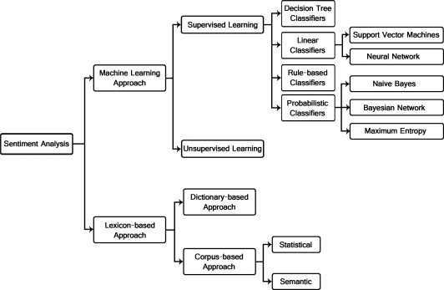

Figure 1.2. Sentiment analysis classification

In undergraduate projects, feedbacks or reviews about the project or project group comes after the project completion on document level or sentence level by their client or group supervisor. The objective of the document level is to determine the overall expression representing by the document. Sentiment analysis at the document level considers that each document represents its opinions on a single entity.

The objective of the sentence level is to decide if each sentence has represented an opinion. This level considers the objective sentences expressing factual information and subjective sentences expressing opinions. In this scenario, there are two steps, firstly detect if the sentence has represented or not an opinion, then move to the polarity of that opinion.

The existing research studies use these sentiment methods mentioned above with all three levels which are document level, sentence level, aspect level on different areas. But they never focus on undergraduate projects or use these methods to monitor undergraduate project group performance based on peer reviews.

There are mainly focusing on the economic and marketing approach of this sentiment analysis. In our research studies, we are using aspect-based sentiment analysis on peer reviews for ongoing projects to detect the weak points of each team member's skill sets in their undergraduate project group phases.

**1.3 Research Problem**

The umbrella term called collaborative learning refers to the different types of instructional practices that encourage undergraduates to work together as a team and apply their related course material to answer the given questions, solve problems, or create a product[24]. Research conducted with undergraduates indicates that participation in group projects promotes their academic achievement, persistence in university, and positive mindset about learning.[25]

To maintain participation undergraduates need to be active participants, not passive observers. Undergraduates need guidance to maintain the workflow.[26] In the current project management module, there are no utilities to maintain undergraduates' workflow. He will become a passive observer with a lack of information and guidance with the current project management module structure.

Undergraduates are more likely to expect positive outcomes from group experiences when supervisors provide them with information and guidance about teamwork.[26] The current project management modules lack this factor which is the information and guidance given to undergraduates about their project.

The undergraduates were particularly frustrated when they believed that the supervisor had poor teamwork skills or a lack of responsibility for helping their groups.[27] The supervisor needs to stay tuned with his/her assigned project groups. Supervisors' help will be less effective if she doesn’t have sufficient information about the group and the group members to improve their project management skills.

Group members who shirk their obligations in the hopes of benefiting from the work of others are often referred to as social loafers or free riders.[28] A free-riding problem in group work happens when one or several members of a group low contribution to a group project that if the same grade is given to all members in the group, the grade would be misleading and unfair.

Peer-assessment can be used to empower undergraduates by giving them to have control over their marks by allowing them to justify and explain their work.

peer-assessment can reduce the possibility of the free-riding problem as the anticipation of receiving negative feedback can be enough for a student to modify his or her behavior.[29]

Currently, undergraduates' project modules don’t come up with Project management phases with WBS or peer-assessment utilities to assess undergraduates. As you can see in Figure 1.3 peer reviews not available in trending project management applications. The free-riding problem will remain with undergraduate project modules every year if there are no solutions to monitor it or discourage it.

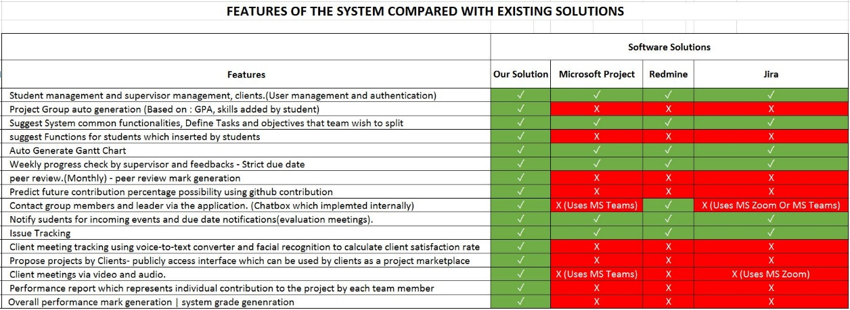

## Figure 1.3: Feature Comparison with the existing solutions and proposed system

# **2. OBJECTIVES**

**2.1 Main Objectives**

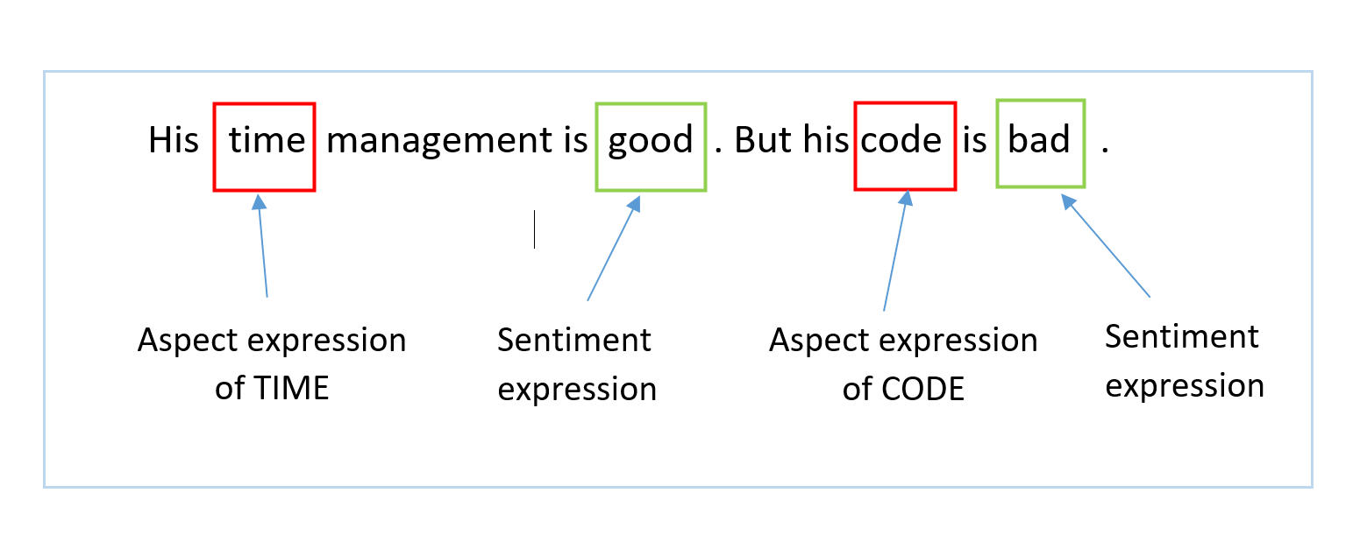In this research section our main objective to build and maintain a peer-assessment utility to assess each undergraduate student with their project team members and collect their opinions and feedbacks about them. After we get their opinions and feedbacks we put them through an aspect-based sentiment analysis process to extract the keywords and find polarity towards the opinions with them as demonstrated in the below figure 2.1.this procedure will detect the free-riders and weak skillsets among the undergraduate related to project management.

Figure 2.1 Aspect Based Sentiment analysis

After the peer-assessments process like figure 3.1 supervisor can work with his or her project group on mentioned aspects and help them to improve those weak points and keep maintain the best practices.

**2.2 Specific Objectives**

To achieve the main objective it binds with several specific objectives to be completed. They can be described as followed.

1.Data collection

Data collection is a required objective in this aspect-based sentiment analysis process. We need feedbacks and opinions data to move forward to the pre- processing stage of the aspect-based sentiment analysis process because we extract keywords for topics and sentiments from peer-reviews documents. Peer-review documents are milestones in the project management work breakdown structure with strict deadlines. We follow those practices to get peer-reviews from every team member on time.

2.Data Cleaning

This is the next function after data collection this aspect-based sentiment analysis process, in this objective we have clean the dataset for our next functions and remove all the unwanted data parts from the collection and generate new data collection for the next functions to use because when we collect all the feedback and opinions in the given period there will be huge raw data sets to be maintained before put it through the data cleaning process.

3.Data Extraction

After the clean data set, we have essential data set for our data extraction. in the data extraction, we will extract the keywords for our targeted topics and aspects related to group project skill sets. After the data extraction, we can move to map them and analyze them to generate human-readable information. Then we can visualize them with reports and user interfaces for the respective people.

# **3. METHODOLOGY**

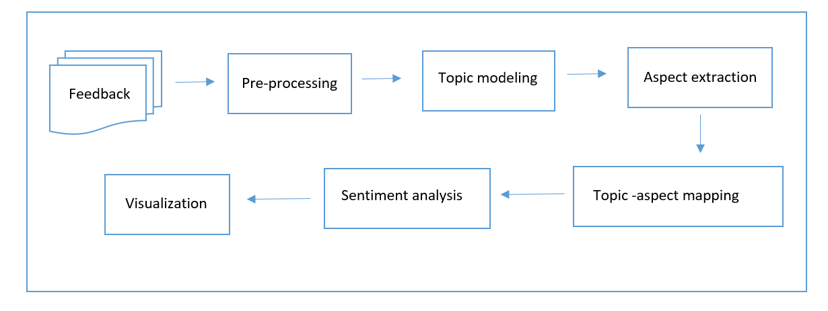

Figure 3.1. Overall Workflow of the ABSA process

We are considering using the Naive Bayes classifier for our sentiment classification. After the data collection and data pre-processing, we will be using it for Data classification. The overall workflow of the proposed approach is demonstrated in Figure 3.1.

Data Pre-processing is performed for converting raw text documents into a well-defined sequence of linguistically meaningful units. This is a required section of this sentiment analysis process, as the words, characters, symbols, and sentences identified at this stage are the basic elements passed to all other processing stages. The words such as the, but, and, and other punctuation and hyperlinks are removed from the feedbacks and opinion documents.

In our Aspect based sentimental analysis, we will be using Latent Dirichlet Allocation(LDA) on top of those clean data sets to find each feedback document's topic distribution and the probability of the content towards the topic. In peer-revies we focus on finding out what skill sets should the undergraduates be maintaining and improve based on feedback and opinions.

After the LDA process data set will be a move to the next process which takes the peer-review corpus as the process input, and the process output will be sentenced with specific aspects. LDA is performed on the pre-processed corpus to do topic modeling and topics are extracted from clean data sets. Each topic is then mapped to a respective aspect, and for each aspect, this topic modeling process will be scan pre-processed corpus to find a match with keywords to extract aspect-specific sentences. The aspect-specific sentences will be written in a text document.

 In the case of thousands of feedback documents from this dataset, topic modeling will be a good approach to understand those archive content without reading every feedback document and this will help extract aspects from the feedback documents.

ABSA process takes the text document containing aspect-specific sentences as the process input, and it determines the polarity score for each aspect-specific sentence. The polarity score shows the sentiment of the sentence. If the polarity score of an aspect-specific sentence is greater than zero, the sentiment considers as positive sentiment, and if the polarity score is less than zero, then the sentiment considers as a negative sentiment. If the polarity score is equal to zero, then, the sentiment toward the particular sentence is considered to be a neutral sentiment.

The sentiment deciding process takes the total polarity score of aspect-specific sentences as the process input, and it representing the sentiment on that respective aspect. If the total positive polarity score is higher than the negative and neutral polarity score, then the sentiment toward the particular aspect is consider positive. Likewise, if the total negative polarity score is higher than the positive and neutral polarity score, then the sentiment toward a particular aspect is consider negative. If the total neutral score is higher than the positive and negative polarity score, then the sentiment toward the particular aspect is considered neutral.

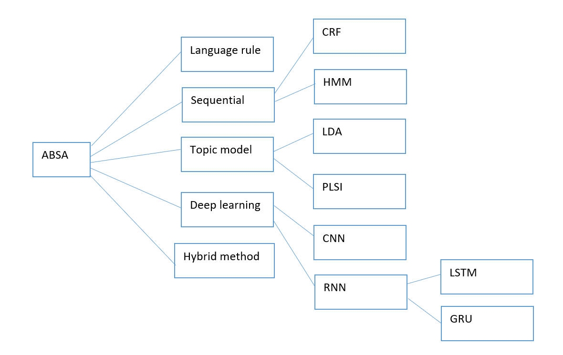

Figure 3.2. ABSA method and techniques

**3.1 System Architecture**

The system architecture is shown in figure 3.1.

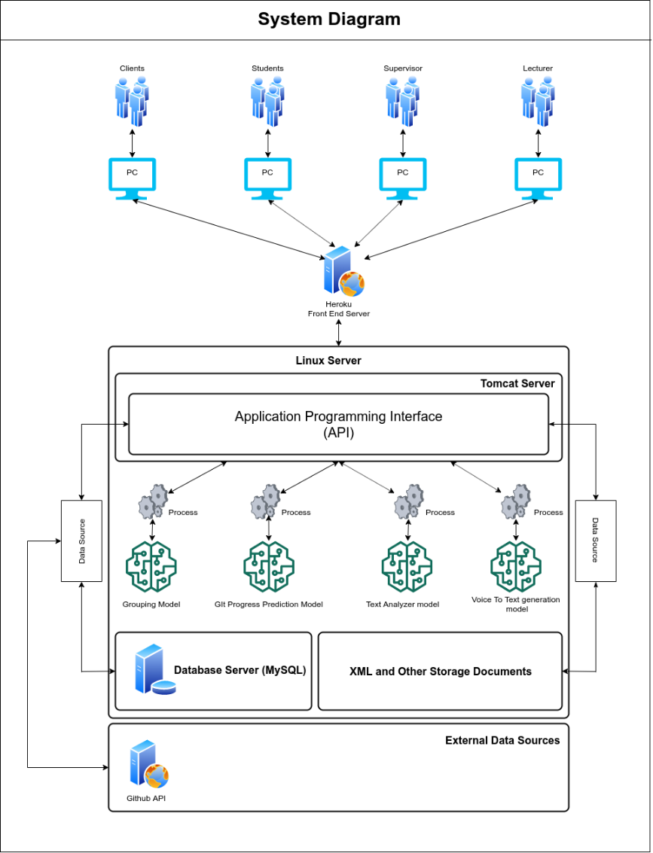

## Figure 3.1.1 – System Architecture Diagram

According to this system diagram as shown in Figure 3.1, We’re hosting the backend server in a Linux environment and inside the Linux server, there are 4 components.

* API running on Apache Tomcat Server
* MySQL Server
* Module related to research components
* XML and Other Storage Documents

Heroku Server is used to deploy the Frontend section to interact with users. The frontend section will be communicating with the users and the API.

**3.1.1 Software Solution**

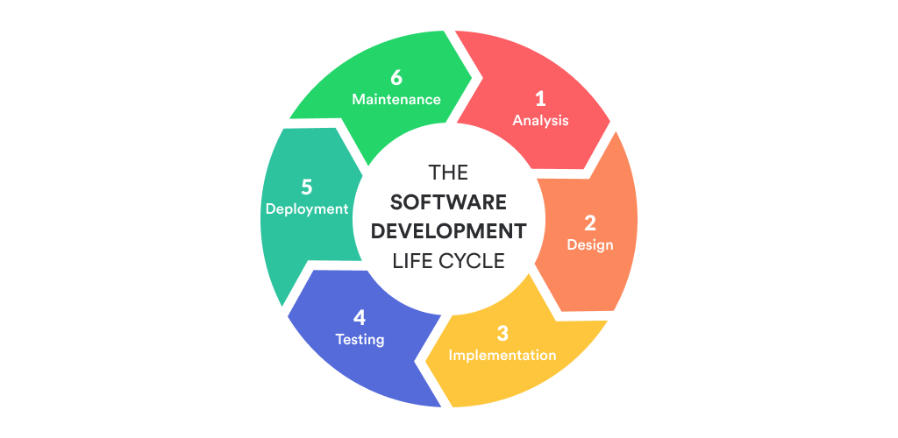

## Figure 3.1.1.1 SDLC Life Cycle

For our research studies and developments, we will be following agile methodology. With our Overall Workflow of the Proposed Approach for Aspect-Based Sentiment Analysis demonstrate in Figure 4 it needed this agile methodology for product development.

* **Requirement Gathering and Analysis**

The initial phase in the SDLC is the requirement gathering and analysis process. In the process, we’ve gathered existing issues with the project management process in the SLIIT University ITP module. Our research group contacted the lecture in charge of the ITP module to collect important facts related to this module and the existing issues currently involve with the project management process.

* + Survey Results

One of the major issues was the free-riding problem from the early stages of the module. In the early stages of the project module there not many developments involve rather than documentation about the project because the supervisor does not much have an idea about group status with the project. Also, the group is unbalanced due to the group creating methods so free-riding is a usual complaint and a trending topic when it comes to these project modules.

* **Feasibility Study**

**Schedule feasibility**

The proposed solution has a sufficient period to finish within the given timeline and the research scope of the group members, we think with enough effort we can finish this research solution in its period. we can arrange a period after completion of the solution for testing before the demonstrations.

**Economy feasibility**

With a complete solution deployed in a virtual environment, there will be server cost need to be considered. We think using education tier AWS instant will be sufficient for the solution, if our solution requirement exceeds the education tier we have to manage the cost for the additional server hosting.

**Technical Feasibility**

* + - Sentiment analysis knowledge and practice

To implement those mentioned algorithms related to sentiment analysis, we need to have a high-level understanding of sentiment analysis knowledge and practice to develop and use those mentioned algorithms and the logical and mathematical content within those research areas.

* + - Knowledge in APIs and MySQL Server

Need to have basic knowledge in API implementations because we have to integrate algorithm with our front end development environment. Since the API will be developed using java, we need to have basic knowledge of java. We also have to master python to interact with machine learning libraries and algorithms.

* + - UI and UX

Need to have considerable knowledge in Frontend Frameworks since we’re using React JS as the frontend development.

* **Design**

For the design phase, we’re focusing on 2 sides.

Frontend Design

Our team will be using mock flow or draw.io to design wireframes for the proposed system and high fidelity design demonstrations for animations and transitions need to be decided using a tool to test and explore new features for the proposed system.

Backend Design

For the backend of our team running an API, we need to design pathways for the endpoints for the API. It needs dedicated documentation to be maintained with the API source.

* **Implementation**

In the implementation phase, the below steps will be completed to finish the implementations.

* + Implement a WBS to monitor project management phases.
  + Implement lockdown function associate with WBS deadlines.
  + Implement an interface to collect peer-reviews associate with WBS.
  + Implement the Database associate with peer-review collection
  + Implement ABSA component.
  + Implement an interface for supervisors to interact with ABSA reports.

After implementing the above-mentioned sections of the development process, we’re can be providing a web application to interact with the WBS and ABSA components.

**Web Application Development**

The final product of the project will be a web application that has a detailed WBS with lockdown functionality according to deadlines and collecting peer-revies from undergraduates to help supervisors improve their related group undergraduates' skill sets with ABSA reports. We’ll be using React JS for web application development. React is a JavaScript library for building user interfaces.

**API development**

In the API development section, we’re using Quarkus. Quarkus is a Cloud Native, (Linux) Container First framework for writing Java applications. It has several features which help our development process.

* **Container First**: this feature supports minimal footprint for Java applications to running in containers.
* **Cloud-Native**: this feature embraces [twelve-factor architecture](https://12factor.net/) in environments such as Kubernetes.
* **Unify imperative and reactive**: This feature brings under one programming model with non-blocking and imperative styles of development.
* **Standards-based**: this feature is based on the standards and frameworks we need and we use REST Easy and JAX-RS, Hibernate ORM and JPA, Netty, Eclipse Vert.x, Eclipse Micro Profile, Apache Camel...
* **Microservice First**: this feature brings lightning-fast startup time and code turn around to Java application.

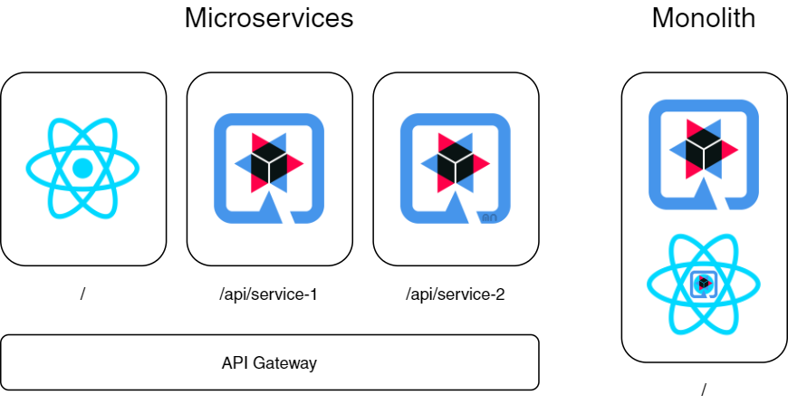

## Figure 3.2: Sample Quarkus architecture with microservices

**Database Handling**

We are considering using The java JDBC driver to manage the MySQL database with the API. JDBC Driver is a software component related to the Java application which communicates with the database. For the database querying and constructing database template, we’ll be using MySQL workbench. This database template will contain Tables, Procedures, and functions to reduce code repetition and improve code quality.

**Model Training**

We are considering using theGoogle Collaboratory, or Colab for short is a Google Research product, which allows developers to write and execute Python code through our browser. Google Colab is an excellent tool for our research component tasks. It is a hosted Jupyter notebook that requires no setup and has a free version which is helpful for us, which gives free access to Google computing resources such as GPUs.

* **Testing**
  + **Postman**

For our API testing, we’re considering using the Postman application. Postman is a collaboration platform for API development. Postman's features simplify each step of building an API and streamline collaboration so the developer can create better APIs with much efficiency.

* **Deployment**
  + **AWS**

AWS is a secure cloud service platform, has more features related to cloud services, than any other cloud provider–from infrastructure technologies like computing power, database storage, content delivery, and other functionality to help businesses scale and grow.

* + **Ngrok**

For demonstrations, we have to use other API implementations for the frontend implementations. We will be using Ngrok to host our localhost and access the API as an outsider Its free version is limited to two hours timeslot.

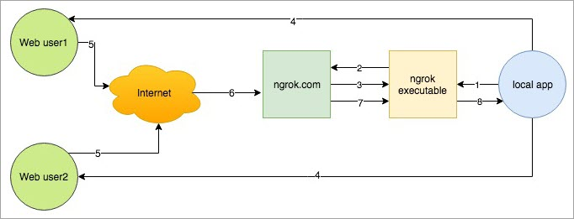

## Figure 3.3: Ngrok Frontend demonstration

# **4.DESCRIPTION OF PERSONAL AND FACILITIES**

Peer-review collecting will depend on the deadlines which short amount of time. It will be a mandatory task in the WBS flag as one of the milestones in the project management process. But peer-review assessment which is associate with the ABSA component will depend on its training time and accuracy. Before start the project management process there will be requirements to be satisfied.

* All the undergraduates should require to create their individual and group WBS related to the project management phase and get approval from their supervisor before the deadline passes. After the deadline, the system will automatically lock the WBS.
* Supervisors need to check their related groups' WBS and review them before acceptance.



Response

Requests

Project Group

Supervisor



Web

Application

API

Calls

ABSA

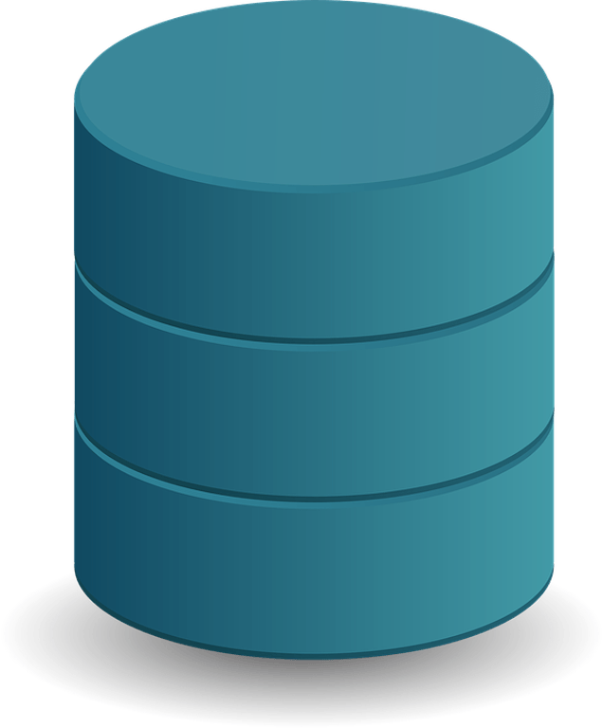

MySQL

Database

Apache Tomcat Server (API)



Undergraduates

## Figure 3.4: Overall ABSA workflow

# **5. REFERENCES**

[1] Project Management Institute 2008. A Guide to the Project Management Body of Knowledge (PMBOK Guide) (4rd ed.). Project Management Institute.

[2] "Glossary of Defense Acquisition Acronyms and Terms: Contract Work Breakdown Structure (CWBS)". Defense Acquisition University. Retrieved 19 September 2017.

[3] Brotherton, S. A., Fried, R. T., & Norman, E. S. (2008). Applying the work breakdown structure to the project management lifecycle. Paper presented at PMI® Global Congress 2008—North America, Denver, CO. Newtown Square, PA: Project Management Institute.

[4] Hall, David & Buzwell, Simone. (2013). The problem of free-riding in group projects: Looking beyond social loafing as reason for non-contribution. Active Learning in Higher Education. 14. 37-49. 10.1177/1469787412467123.

[5] Peter Levin (2003) Running group projects: dealing with the free-rider problem, Planet, 9:1, 7-8, DOI: 10.11120/plan.2003.00090007

[6] John Blitzer, Mark Dredze, and Fernando Pereira. 2007. Biographies, Bollywood, Boom-boxes and Blenders: Domain Adaptation for Sentiment Classification.. In ACL. 187–205.

[7] Kwangsu Cho. 2008. Machine Classification of Peer Comments in Physics. In Educational Data Mining 2008, the International Conference on Educational Data Mining, Montreal, QuÃľbec, Canada, June 20-21, 2008. Proceedings. 192–196.

[8] Kushal Dave, David M. Pennock, and David M. Pennock. 2003. Mining the peanut gallery: opinion extraction and semantic classification of product reviews. In International Conference on World Wide Web. 519–528.

[9] Yoon Kim. 2014. Convolutional Neural Networks for Sentence Classification. Eprint Arxiv (2014).

[10] Jan Deriu, Aurelien Lucchi, Valeria De Luca, Aliaksei Severyn, Simon Müller, Mark Cieliebak, Thomas Hofmann, and Martin Jaggi. 2017. Leveraging Large Amounts of Weakly Supervised Data for Multi-Language Sentiment Classification (WWW ’17). Republic and Canton of Geneva, Switzerland, 1045–1052. https: //doi.org/10.1145/3038912.3052611

[11] Nana Li, Shuangfei Zhai, Zhongfei Zhang, and Boying Liu. 2016. Structural Correspondence Learning for Cross-lingual Sentiment Classification with Oneto-many Mappings. national conference on artificial intelligence (2016), 3490–3496.

[12] Duyu Tang, Bing Qin, and Ting Liu. 2015. Learning Semantic Representations of Users and Products for Document Level Sentiment Classification. In Meeting of the Association for Computational Linguistics and the International Joint Conference on Natural Language Processing. 1014–1023.

[13] Peter D. Turney. 2002. Thumbs up or thumbs down?: semantic orientation applied to unsupervised classification of reviews. In ACL. 417–424.

[14] Xinjie Zhou, Xiaojun Wan, and Jianguo Xiao. 2016. Attention-based LSTM Network for Cross-Lingual Sentiment Classification. In EMNLP. 247–256.

[15] Y Ren, Y Zhang, M Zhang, and D Ji. 2016. Context-sensitive twitter sentiment classification using neural network. (01 2016), 215–221.

[16] Namrata Godbole, Manjunath Srinivasaiah, and Steven Skiena. 2007. Large-Scale Sentiment Analysis for News and Blogs. In International Conference on Weblogs and Social Media.

[17] Bo Pang, Lillian Lee, and Shivakumar Vaithyanathan. 2002. Thumbs up? Sentiment Classification using Machine Learning Techniques. empirical methods in natural language processing (2002), 79–86.

[18] Richard Socher, Alex Perelygin, Jean Y Wu, Jason Chuang, Christopher D Manning, Andrew Y Ng, and Christopher Potts. 2013. Recursive Deep Models for Semantic Compositionality Over a Sentiment Treebank. (2013), 1631–1642.

[19] Maite Taboada, Julian Brooke, Milan Tofiloski, Kimberly Voll, and Manfred Stede. 2011. Lexicon-based methods for sentiment analysis. Computational Linguistics 37, 2 (2011), 267–307.

[20] Wenting Xiong, Diane J. Litman, and Christian D. Schunn. 2010. Assessing Reviewers ’ Performance Based on Mining Problem Localization in Peer-Review Data. In Educational Data Mining 2010, the International Conference on Educational Data Mining, Pittsburgh, Pa, Usa, June 11-13, 2010. Proceedings. 211–220.

[21] Wenting Xiong and Diane Litman. 2011. Automatically predicting peer-review helpfulness. In Meeting of the Association for Computational Linguistics: Human Language Technologies: Short Papers. 502–507.

[22] Lakshmi Ramachandran and Edward F. Gehringer. 2011. Automated Assessment of Review Quality Using Latent Semantic Analysis. In IEEE International Conference on Advanced Learning Technologies. 136–138.

[23] Ravi Yadav and Edward F. Gehringer. 2016. Automated Metareviewing: A Classifier Approach to Assess the Quality of Reviews. In Workshop and Tutorial Proceedings of the 9th International Conference on Educational Data Mining, Raleigh, NC, USA, June 29, 2016.

[24] Smith, B. L., & MacGregor, J. T. (1992). What is collaborative learning? In A. Goodsell, M. Maher, V. Tinto, B. L. Smith, & J. T. MacGregor (Eds.), Collaborative learning: A sourcebook for higher education. University Park, PA: National Center on Postsecondary Teaching, Learning & Assessment, The Pennsylvania State University.

[25] Springer, L., Stanne, M. E., & Donovan, S. (1997). Effects of small-group learning on undergraduates in science, mathematics, engineering, and technology: A meta-analysis. Paper presented at the annual meeting of the Association for the Study of Higher Education. Albuquerque, NM, November, 1997.

[26] Bosworth, K., & Hamilton, J. (1994). Collaborative learning: Underlying processes and effective techniques. New Directions for Teaching and Learning, No. 59. San Francisco: Jossey-Bass

[27] Fiechtner, S. B., & Davis, E. A. (1984-85). Why some groups fail: A survey of students' experiences with learning groups. Organizational Behavior Teaching Review, 9, 58-71.

[28] Dommeyer, C. J. (2007). Using the diary method to deal with social loafers on the group project: Its effects on peer evaluations, group behavior, and attitudes. Journal of Marketing Education, 29, 175-188

[29] Aggarwal P and O’Brien CL (2008) Social loafing on group projects: Structural antecedents and effect on

student satisfaction. Journal of Marketing Education 30(3): 255–64

[30] Saunders, N. G., & Batson, T. (1999, October). Cooperative learning strategies in graduate education. Paper presented at the Annual Meeting of the Mid-Western Educational Research Association, Chicago, IL.

[31] Magney, J. R. (1996, December). Using cooperative learning in the technical classroom. Paper presented at the American Vocational Association Convention, Cincinnati, OH.