**SMART PROJECT MANAGEMENT SYSTEM**

**TEMP-21-027**

Project Proposal Report

Gamage O.M.

B.Sc. (Hons) Degree in Information Technology

Department of Software Engineering

Sri Lanka Institute of Information Technology

Sri Lanka

February 2021

**SMART PROJECT MANAGEMENT SYSTEM**

**TEMP-21-027**

Project Proposal Report

B.Sc. (Hons) Degree in Information Technology

Department of Software Engineering

Sri Lanka Institute of Information Technology

Sri Lanka

February 2021

**Declaration page of the candidates & supervisor**

We declare that this is our own work and this proposal does not incorporate without acknowledgement any material previously submitted for a degree or diploma in any other university or Institute of higher learning and to the best of our knowledge and belief it does not contain any material previously published or written by another person except where the acknowledgement is made in the text.

|  |  |  |
| --- | --- | --- |
| Name | Student ID | Signature |
| Gamage O.M. | IT18140330 |  |
|  |  |  |
|  |  |  |
|  |  |  |

The supervisor/s should certify the proposal report with the following declaration.

The above candidates are carrying out research for the undergraduate Dissertation under my supervision.

Signature of the supervisor: Date :

**Abstract**

Project Management Systems are the most important systems in the university time period. Most of the universities uses different project managing platform or systems which includes various functionalities. But when we consider about international industrial project management systems, their requirements don’t come with a common solution for managing projects. Because international project management systems are different by one to another. Therefor we decide to develop a common project management system which includes all facilities in existing systems and some special parts that are not include in the existing systems.

The Smart Project Management System include Predict future contribution percentage possibility using GitHub contribution part which is a one of the special part that we are going to include to our system. Using GitHub REST API [7], we generate a progress report using student group project repositories [5] and give them a grade. So the student can get an idea about their marks before getting viva or presentation. That is how are we going to predict future contribution possibility using GitHub. Notify students for incoming events and due date notifications, Performance report which represents individual contribution to the project by each team member and Issue tracking are the other sections of this research part.

The end of the solution, we provide a web based application to manage projects with highly customized functionalities. Application will be an open source solution for the universities.

**Keywords:** GitHub API, Smart PMS, Algorithm

**TABLE OF CONTENTS**

LIST OF FIGURES iv

LIST OF TABLES iv

LIST OF APPENDICES iv

1 INTRODUCTION 1

1.1 Background & Literature survey 1

1.2 Research Gap 4

1.3 Research Problem 5

2 OBJECTIVES 7

2.1 Main Objectives 7

2.2 Specific Objectives 7

3 METHODOLOGY 9

3.1 Architecture 9

3.2 Research Area 12

3.3 Requirement Gathering and Analysis 13

3.4 Design 13

3.5 Tools and Technologies 14

3.6 Implementation 15

3.7 Testing 16

3.8 Deployment 17

4 DESCRIPTION OF PERSONAL AND FACILITIES 18

5 Reference List 19

6 APPENDIX 20

# LIST OF FIGURES

Figure 1.1.1: Percent increase in open source project creation per active user compared to previous year 1

Figure 1.1.2: Geographical distribution of active users 2020 2

Figure 1.1.3: Top languages over the years 2

Figure 1.2.1: Architecture of the GHTorrent data-on-demand service 4

Figure 1.3.1: Feature Comparison with the existing solutions and proposed system 6

Figure 3.1.1: Interaction among Stakeholders 9

Figure 3.1.2: System overview 10

# LIST OF TABLES

Table 4.1: Description of personal and facilities………………………………..….17

# LIST OF APPENDICES

Appendix Description Page

Appendix – A Sample questionnaire 19

Appendix – B Sample questionnaire response 20

# 1 INTRODUCTION

# 1.1 Background & Literature survey

Project Management is quite simple with current technology and most of the time Project Manager has the technology to manage most of the management process automatically using existing solutions. For the industry, existing project management tools are powerful enough to reduce the workload for the manager. However, when it comes to the Undergraduate Project Management, most of the management tools are more advanced and also some of the required features are not available with common management solutions. Therefore, we’ve decided to develop a Project Management System where we define our own features and also included with common features.

GitHub offers a tremendous research potential. For instance, it is a flagship for current open source development, a place for developers to showcase their expertise to peers or potential recruiters, and the platform where social coding features or pull requests emerged. [1]

There are 56M total developers on GitHub. There 60M+ new repositories created in the 2020 and there are 1.9B contributions added in the last year. [8]

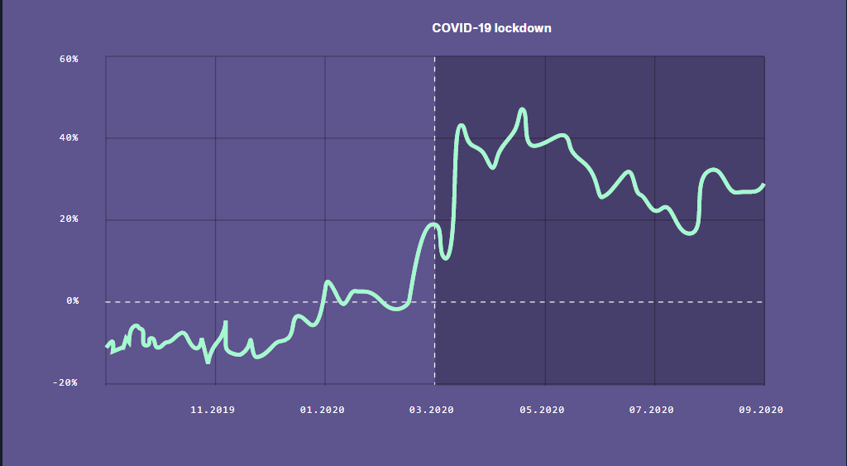

Figure 1.1.1: Percent increase in open source project creation per active user compared to previous year [8]

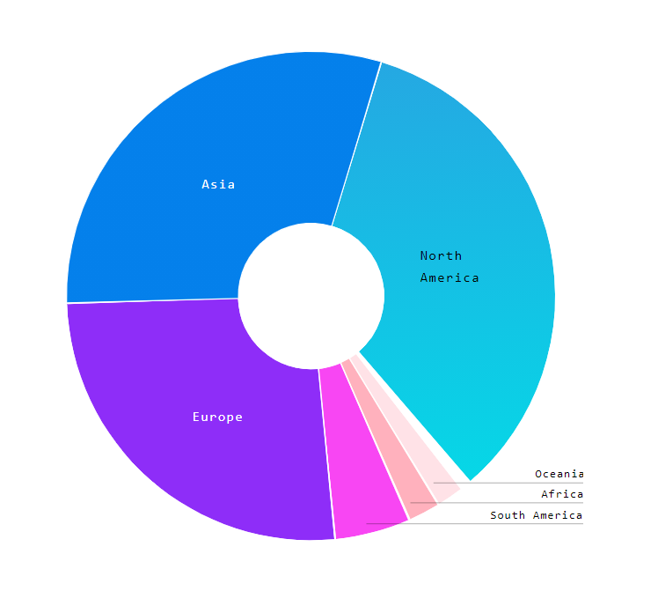

Figure 1.1.2: Geographical distribution of active users 2020 [8]

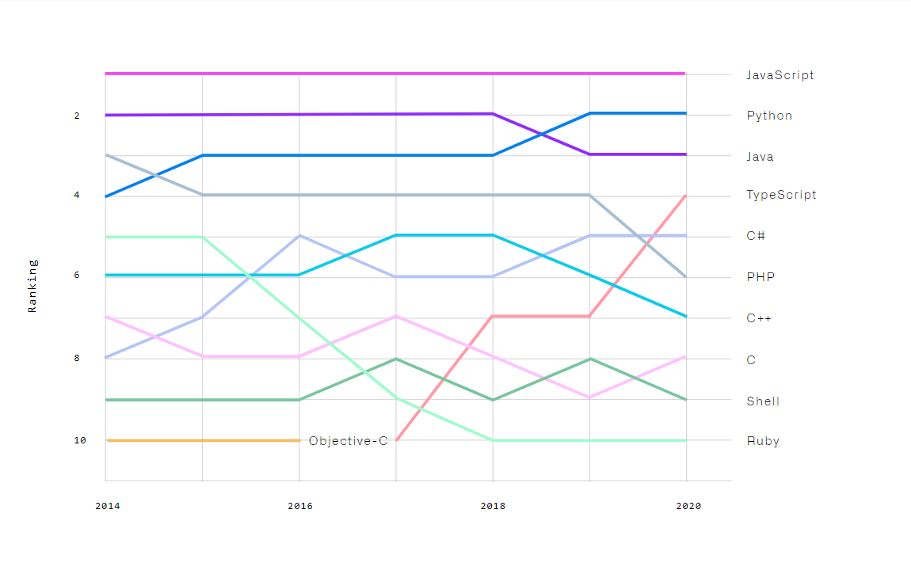

Figure 1.1.3: Top languages over the years [8]

Predict future contributions with percentages and possibilities using GitHub contribution is one of the important part for universities. Because using a version control system is mandatory to doing current group projects. However, there are several version control systems. But GitHub is the most popular version control system in project management part. Most of the students in universities are using GitHub. Our goal is to develop a system, to predict future contribution with percentage and possibilities using GitHub contribution. There are some systems to predict popularity of repositories [2], predict ecosystem health in GitHub [3], predict issues lifetime in GitHub projects [4]. But there isn’t a system to predict future contribution. Our goal is to predict student’s future contribution in a group projects.

To achieve this goal, we planned to use GitHub API to manage student’s group projects. We can collect data and analyze the GitHub repositories [5] and Users [6] from the GitHub API. We are going to track the code, commits, user contribution, task completion and we planned to calculate a mark using volume of code, overall commits, user contribution, quality of the code and task completion. That’s we planned to predict each student future contribution for a group project. All we have to do is pass the project Repository URL with the credentials [7].

However, GitHub data is, to date, largely underexplored. To facilitate studies of GitHub, we have created GHTorrent, a scalable, queriable, offline mirror of the data offered through the GitHub REST API. [1]

Students adding their project GitHub URL to the system, supervisors and team members can get a rough idea about the project progress and speed of their project work. We are introducing this feature to identify each student do their work by themselves. Not the same person doing the entire group project. That will track using commit progress. There is a doubt. Yes, we have GitHub and we can use that to predict this problem. But in our system, we create a group first. Then assign a lecturer or a supervisor. After that supervisor will assign task to complete the project or give them a Topic and the team leader has to create a repository in GitHub and add the GitHub repository link to the system. So the system will predict the progress and generate the progress evaluation.

# 1.2 Research Gap

Regarding to above mentioned research solutions, we found a way to develop “Predict Future Contribution on GitHub” part using GitHub REST API. The problem is to configure volume of code, quality of code and user contribution to the project. For those first two parts, we have to develop another part to calculate the volume and the quality. There are some existing systems to measure and analysis both volume and the quality of the code [9]. So we don’t need to add new features or modify current options. We can directly use that technology. We need this part to generate a grade to the final result.

From the GitHub REST API, we can track overall commits for each student, the target is to use GitHub REST API and configure future prediction. Since all above mentioned existing systems are made for a single task [1].

Some of the solutions are complex to be develop and some them are not enough to configure and satisfy our requirements [2][3][4]. According to the existing system, there are two loosely coupled parts. A web server that handles data requests from users and the GHTorrent server that performs the data extraction. The two servers communicate via messaging queues [1]

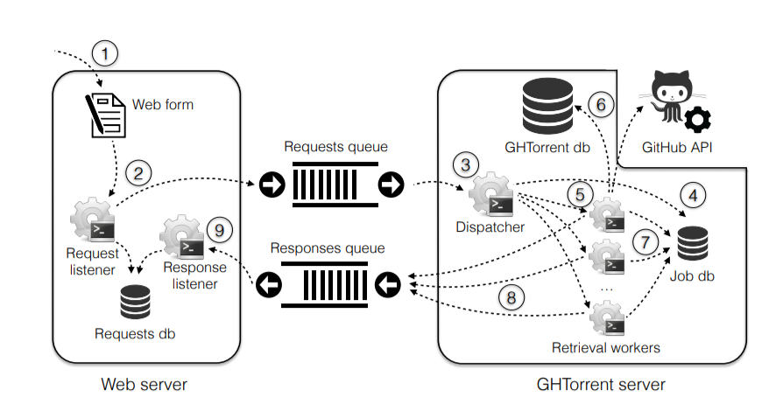

Figure 1.2.1: Architecture of the GHTorrent data-on-demand service [1]

As you can see their Architecture. They use GitHub REST API to data dumps for any collection of GitHub repositories. In our system we planned to develop our system to predict future contribution, that means, we will get the repository data from the GitHub REST API. And then we will give students about progress regarding to overall commit progress, user contribution to the project, quality of the code progress and a grade regarding to overall project version control contribution to get an idea about their project overall evaluation before getting the actual marks. It means from the above mention commit progress, user contribution, quality of the code used to generate a grade. So the student can get an idea about the future contribution related to the group project. It means, he or she done the group project well or not before get the final result from the lecturer. That is the research gap from the existing systems and the what I am going to develop.

# 1.3 Research Problem

Undergraduate project management is challenging when it comes to group projects. Even though there are many existing project management systems such as Microsoft project, Jira, and Redmine, most of them were developed for general purpose. Hence, some important specific features which are useful when managing student projects such as automatic group formation, project tracking and notification generation on project progress are not available in those systems.

One of the major problem was tracking the project progress. There is no project tracking system and it leads to project failures. In the other hand, students usually do not use any version controlling and it is a bad practice to avoid version controlling since the project is a group project. Version control systems (VCSs) are used to store and reconstruct past versions of program source code. In industry almost all the IT companies use version controlling systems to update their systems and also to carry out their projects and source codes. It is very important to maintain secure source codes and manage individual contributions.

Problem is students are not familiar with version controlling. Use of version controlling systems can solve another problem of underestimating project duration which can cause incomplete projects within the specified time. So, incorporating version controlling facility in project management is another important aspect in project management.

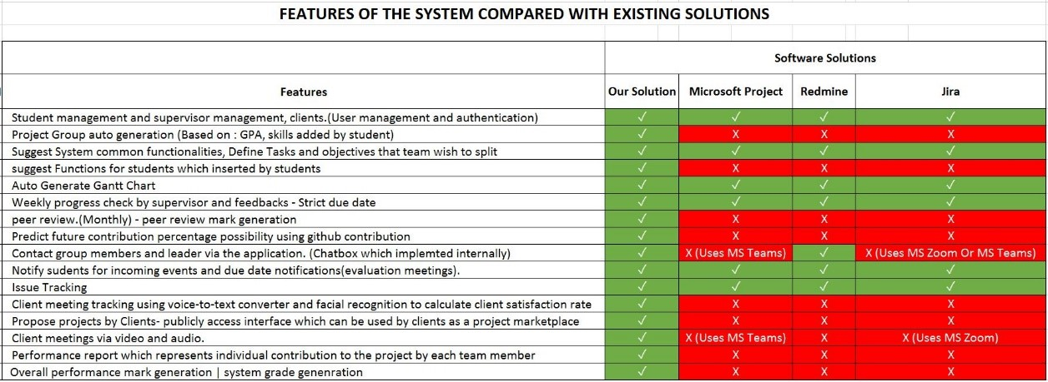

Figure 1.3.1: Feature Comparison with the existing solutions and proposed system

Figure 1.3.1 shows a table that we created by finding functionalities in the existing project management systems. The red colored cells show the functionality is not implemented in the system and green colored cells shows the functionality is implemented in the system. As you can see the Predict future contribution percentage possibility using GitHub contribution is not implemented in neither software solutions and it is a major requirement for any university to improve effectiveness and efficiency of university projects.

# 2 OBJECTIVES

# 2.1 Main Objectives

The main objective of the Predict Future Contribution percentage possibility using GitHub contribution, is track the user code form the repository and generate a progress related to key frames (Overall commits, user engagements, quality of the code etc.). Application is ready to get the GitHub repository URL to identify each student group projects. The algorithm is very important for generate a mark using above key frames.

# 2.2 Specific Objectives

Track the project progress using GitHub REST API.

* The students can track their work and the lecturer can check each of the student are working with the project. Using GitHub contribution percentage, system will predict the future contribution to the project. This process will be applied to each student. This uses commits, project tasks and timeline created in the start to track the project progress and using extracted data, system will generate prediction about future contributions by each student. Using this facility system can identify if there is a risk of leading to an incomplete project or not.

Issue Tracking similar as stack overflow

* Different groups have different skilled students. Some of the students may have not known enough to solve an issue that might risk of stuck in workload. This solution is created to get inside help in the project. Team member can post issues that he came up with and team members can help to solve the issue. This solution is implement to improve team working skills.

Notify students for incoming events and due date notifications.

* This facility is a notification system to inform due dates of current tasks and events. Such as evaluations and group assignments which interacts with project. Most university students having this issue. Most of the time they do not check course web and they miss some of important due date. This system is implemented to reduce that risk.

Performance report which represents individual contribution to the project by each team member

* This facility is to generate an individual mark for their overall performance. This will be helpful to show as evidence in interviews. Experience is the key for everything, and most of the time students fail to show that because there are no visible evidences. Only repositories of their projects. This marking system also can be used to evaluate individual student performance in final evaluation meetings.

# 3 METHODOLOGY

# 3.1 Architecture

Our overall research is a Project Management System. There are four users in this system. Student and the lecturer are the main users and others are supervisors and clients. In this part there are two users. Students and Lecturer. After creating groups (this is the main part of the overall research) Lecturer will be assign to the relevant groups. Each group has a group environment.

This is a web application and the components of the application are handle by the system. Specially the algorithm and models.

Mainly we can identify 3 sections in the system architecture

* Interaction Among Stakeholders
* System Overview

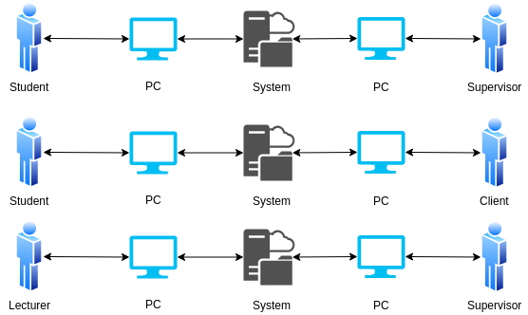

Figure 3.1.1: Interaction among Stakeholders

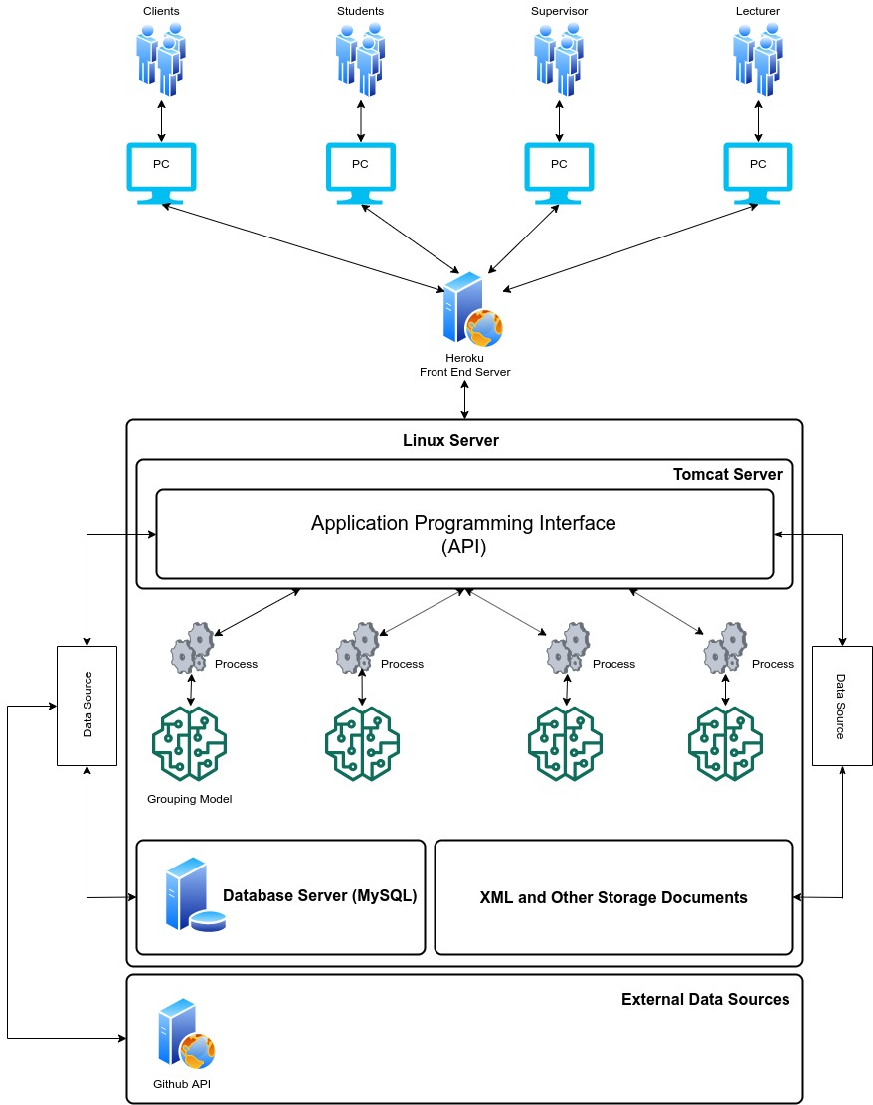

Figure 3.1.2: System overview

According to the system diagram as shown in Figure 3.1, We’re hosting the backend server in a Linux environment and inside the Linux server there are 4 components.

* API running on Apache Tomcat Server
* MySQL Server
* Trained Models for decision Makings
* XML and Other Storage Documents

Heroku Server used to deploy the Frontend solution to interact with users. Frontend solution will be communicating with the users and the API.

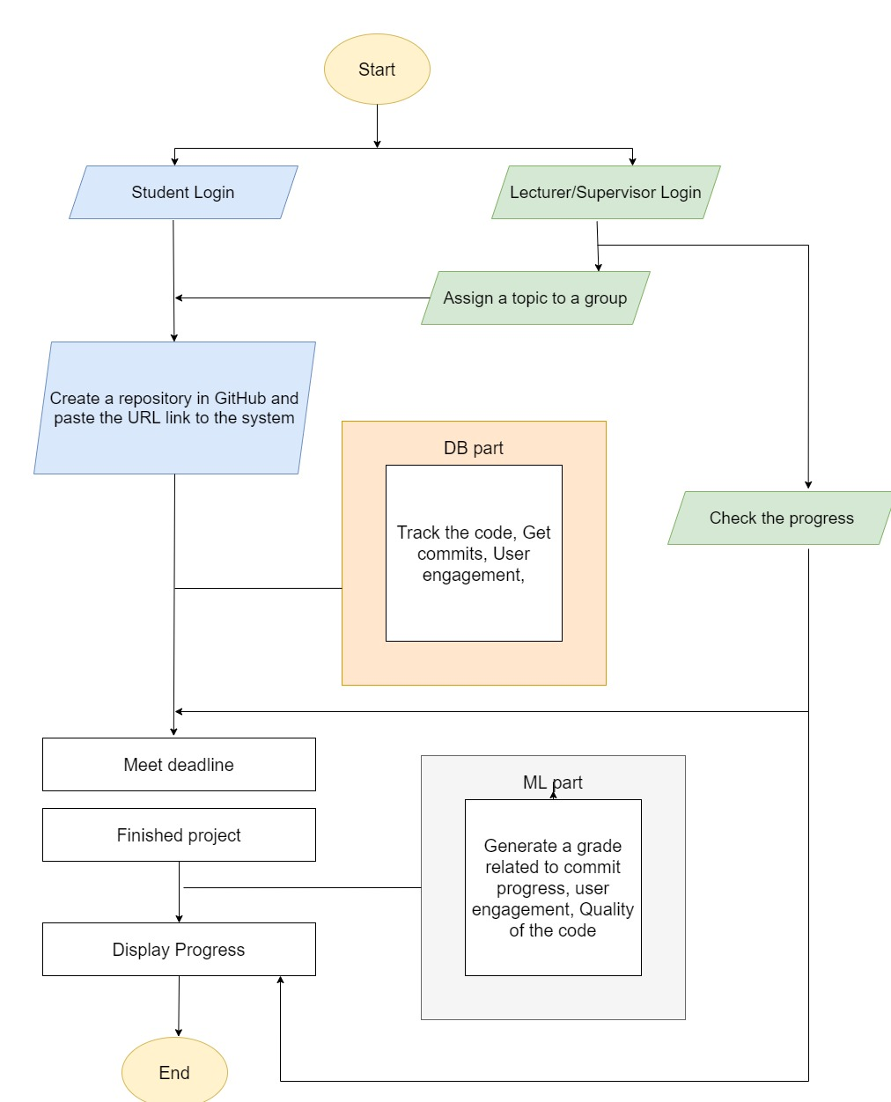

Figure 4: Predict future contribution using GitHub

# 3.2 Research Area

Research part of this part is Predict Future Contribution of the student group project using GitHub REST API. Using that API, we track each student code, commits, user contribution, quality of the code, enragements. Finally generate a progress. So as to configure this research part, I have need to follow GitHub REST API documentation and the Machine Learning technology.

The system will predict future contributions with percentages and possibilities using GitHub contribution. So we are going to use GitHub API to collect data and analysis GitHub Repositories.and user’sAPI can track the code, commits, User contribution, task completion for the relevant project. All we have to do is, pass the project Repository URL with the credentials. So supervisors and team members can get a rough idea about the project progress and speed of their project work. We are introducing this feature to identify each student do their work by themselves. Not the same person doing the entire project. That will track using commit progress.

There is a doubt. Yes, we have GitHub and we can use that to predict this problem. But in our system, we create a group first. Then assign a lecturer or a supervisor. After that supervisor will assign task to complete the project and the team leader has to create a repository in GitHub and add the GitHub repository link to the system. So the system will predict the progress and generate the progress evaluation. Our system will do the entire solution. That is the solution proposed to track the project part. Finally, it will generate a mark using GitHub progress and it will get implemented on system grade for the project.

# 3.3 Requirement Gathering and Analysis

This part is the most important part in my research part. Because I have to gather requirements and analysis them to develop my part. Especially I must concern about the gathered information because it should be important to my research part. Before starting to development, requirement gathering is most important to give the right solutions.

* Read research papers related to my research part.
* Refer GitHub Documentation to analysis how to configure GitHub REST API
* Survey Results

# 3.4 Design

After I gathered requirements, I analysis those requirements to create a design. Design will help me to specify what are the hardware, software and system requirements to identify the architecture. So I can manage the tools and technologies that I am going to use to develop my research part. The architecture depends on my design and the software and hardware that I am going to use. So I can start this process immediately.

# 3.5 Tools and Technologies

Tools

* Visual Studio Code
* Apache Server
* Eclipse IDE
* Maven
* Postman
* Ngrok

Server Side

* Java – JAX-RS Rest API
* Python
* Redux

Client Side

* HTML, CSS, JS (jQuery, React JS)

Database

* MySQL

Communication

* REST, AJAX, JSONs

# 3.6 Implementation

This section start using my design, it will be converting the design into a working program. Implementation stage divides the part into several sections. Such as assigning Task or a Topic (That will be doing by the lecturer or supervisor. After created student groups, there is a lecturer will assign to the relevant group. Then the lecture will assign a task or a topic), Team leader has to publish the GitHub project URL to our system, get each contributions credentials (API needs repository contributions’ credentials to configure), checking the code, commits and all other engagements related to each repository, analysis the evaluation of the repository (Commit charts, engagement charts, user engagements, some results related to code complexity and the quality of the code), Generating a mark.

After each section is completed it transfer to testing to verify and validation. I am going to use React JS technology to develop the frontend part and Redux to store token in localhost (When some user log into the system there is a token to identify each uses. Redux will helps to store the token) and for the backend part we are going to use a python API that will develop by us. MySQL will be our database and we will use little java parts. Visual Studio Code and Eclipse IDE are the tools for relevant technologies.

In shortly, we can consider about following parts in Implementation process.

* Web Application Development
* API Development
* Database Handling

# 3.7 Testing

In the software life circle, Testing is a most important part. Because of according to Guru99 testing is a method check whether the actual software product matches expected requirements and to ensure that software product is defect free. There are two parts that we consider in testing part. That is Functional and non-functional.

Testing will be begun from the beginning of the system development and will be proceeded until the last endpoint of the system development. All these testing will be done so as to check whether the sections have been completed related to client requirements. For the functional testing we are going to use Sanity and User Acceptance testing. Testing will be proceeded until all the parts are tested completely. For the non-functional testing we are going to use all the non-functional testing types. That will be done to verify the development will have finished related to client requirements.

# 3.8 Deployment

* AWS

AWS has significantly more services, and more features within those services, than any other cloud provider–from infrastructure technologies like compute, storage, and databases–to emerging technologies, such as machine learning and artificial intelligence, data lakes and analytics, and Internet of Things. This makes it faster, and more cost effective [10].

* Ngrok

For the demonstration purposes we sometimes need to use other API implementations for the frontend implementations. To do that we can use Ngrok to temporary host the localhost and access the API anywhere. But the free version is only providing 2hr of online period. After that period ngrok needed to be restarted with a new URL. But for the temporary testing, ngrok is best solution for the temporary global hosting.

# 4 DESCRIPTION OF PERSONAL AND FACILITIES

|  |  |  |
| --- | --- | --- |
| Member | Component | Task |
| Gamage O.M. | Predict future contribution percentage possibility using GitHub contribution. | * Assign task or a topic by a lecturer or supervisor part * Track the GitHub project progress * Generate a report related to project progress * Generate a grade related to project progress * Lecturer or a supervisor review or a comment related to the project progress * Issue tracking * Send Notification about incoming events and due dates |

Table 4.1 : Description of personal and facilities

After Google form is published, the next step is waiting until form gathered considerable amount of responses. We can check the responses that recorded by the google form after the data collection is performed. Google form records each response separately and outputs a summary of answers for each question. Google forms provide a feature to export responses to an excel or as a CSV file. Using this feature, we can directly use the csv file or the excel file for next steps which is training and testing phases in the model training.

# 5 Reference List

[1] Georgios Gousios, Bogdan Vasilescu, Alexander Serebrnik and Andy Zaidman, “Lean GHTorrent: GitHub data on demand”, MSR2014, Available at <https://dl.acm.org/doi/abs/10.1145/2597073.2597126>

[2] Hudson Borges, Andre Hora and Macro Tulio Valente, “Predicting the Popularity of GitHub Repositories”, PROMISE 2016

[3] Zhuang Liao, Mengjie Yi, Yan Wang, Shengzong Liu, Hui Liu and Yan Zhang, “Healthy or Not: A Way to predict ecosystem health in GitHub”, 28 January 2019

[4] IEEE, “Using Dynamic and Contextual Features to Predict Issue Lifetime in GitHub Projects”, 2016 IEEE/ACM 13th working Conference on MSR.

[5] GitHub Documentation Guide, ”Repositories”, Available at <https://docs.github.com/en/rest/reference/repos>

[6] GitHub Documentation Guide, “ Users “ , Available at <https://docs.github.com/en/rest/reference/users>

[7] GitHub User insight using GitHub API – Data Collection and Analysis, Available at <https://towardsdatascience.com/github-user-insights-using-github-api-data-collection-and-analysis-5b7dca1ab214>

[8] The 2020 state of the OCTO-VERSE, Available at <https://octoverse.github.com>

[9] IEEE, “Comparison of static Code Analysis Tools”, 2009 third International Conference of Emergency Security Information, Systems and Technologies

[10] Amazon Web Services. (2021). Cloud computing with AWS. [online]. Available: <https://aws.amazon.com/what-is-aws/?nc1=f_cc>. [Accessed: 21-Feb-2021]

# 6 APPENDIX

# Appendix – A: Sample questionnaire

# 

# Appendix – B: Sample questionnaire response

