

**Sri Lanka Institute of Information Technology Sri Lanka**

**SMART PROJECT MANAGEMENT SYSTEM**

**Predict future Contribution and Progress Tracking using GitHub REST API**

**2021-234**

**Project Status Document**

Group Number: 2021_234

Member: GAMAGE O.M. (IT18140330)

November 2021

# Table of Content

1. MS Teams Management iii

2. MS Teams Meeting Screenshots. v

3. Work Breakdown Structure x

4. Gantt chart x

5. GitLab Reports xi

Figure 14 - Repository xi

Figure 15 – Contribution xi

Figure 16 – April GitLab Contribution graph xii

Figure 17 – October GitLab Contribution graph xii

Figure 18 – Programming Languages Chart xiii

# Table of Figures

Figure 1: Useful information storage iii

Figure 2: Tasks definer in the excel sheet iii

Figure 3: Tasks overview of completed and in progress task records in the system iv

Figure 4: Calendar overview of completed tasks and in progress tasks iv

Figure 5: Call history from November 16 2020 v

Figure 6: meeting with co supervisor v

Figure 7: keep tracking the meetings vi

Figure 8: keep tracking meeting in June and August in 2021 vi

Figure 9: meetings in october and novemner in 2021 vii

Figure 10: Progress Presentation 2 vii

Figure 11: Meeting screenshot 1 viii

Figure 12: Meeting screenshot 2 (Conference blind review results discussion) viii

Figure 13: Blind review discussion of the research paper ix

Figure 14: Meeting screenshot 4 (Demo testing meeting) ix

Figure 15: work breakdown structure x

Figure 16:Gantt chart x

# 1. MS Teams Management

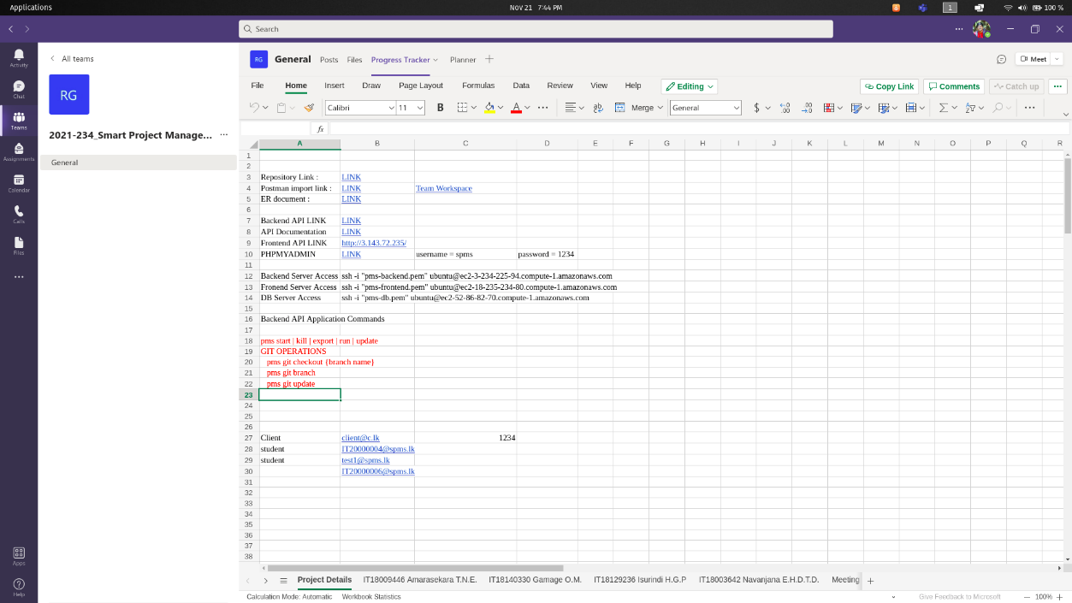

Figure : Useful information storage

.

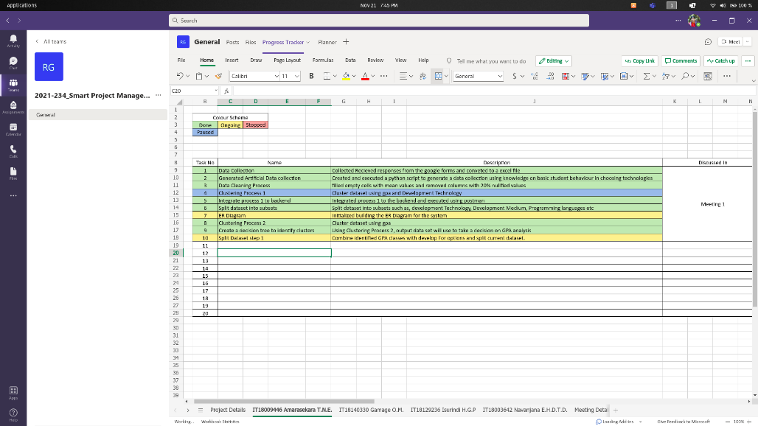

Figure : Tasks definer in the excel sheet

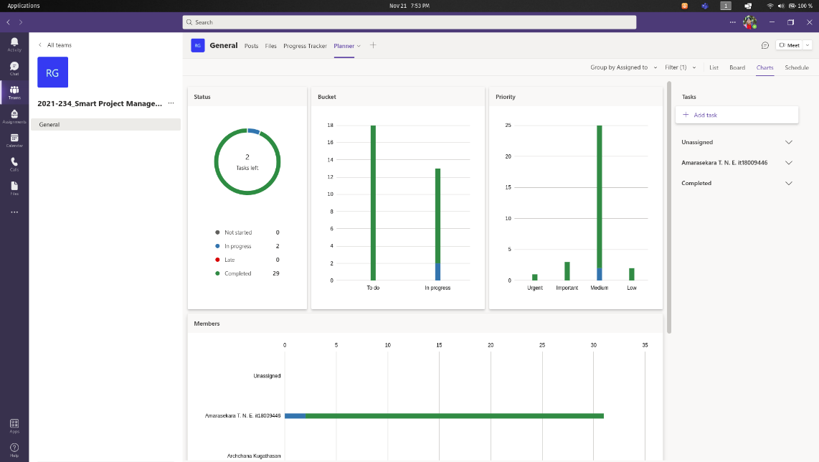

Figure : Tasks overview of completed and in progress task records in the system

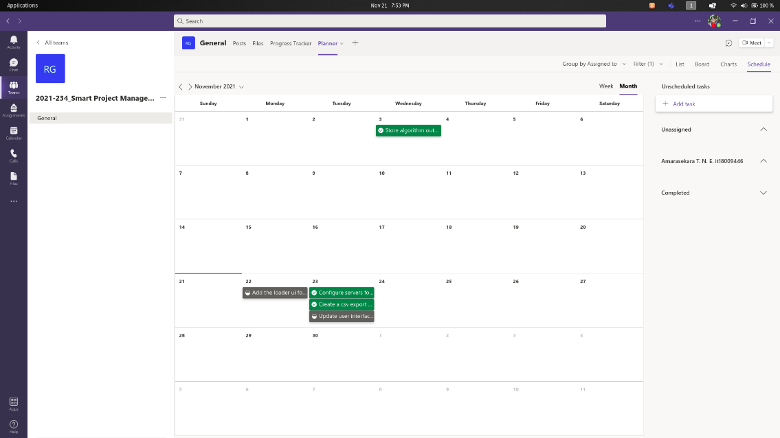

Figure : Calendar overview of completed tasks and in progress tasks

# 2. MS Teams Meeting Screenshots.

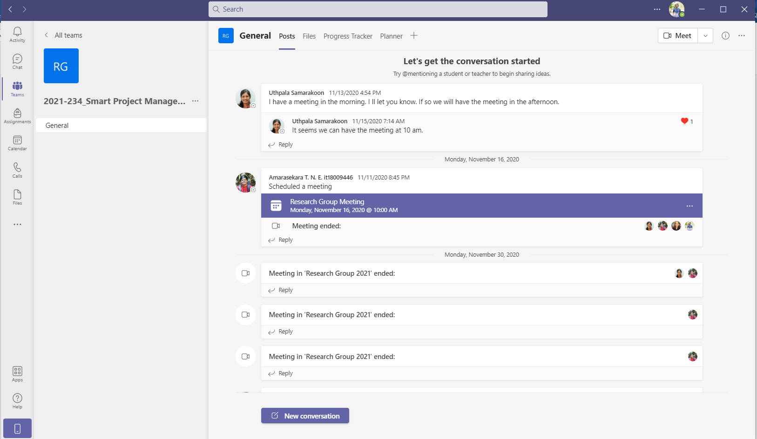

Figure : Call history from November 16 2020

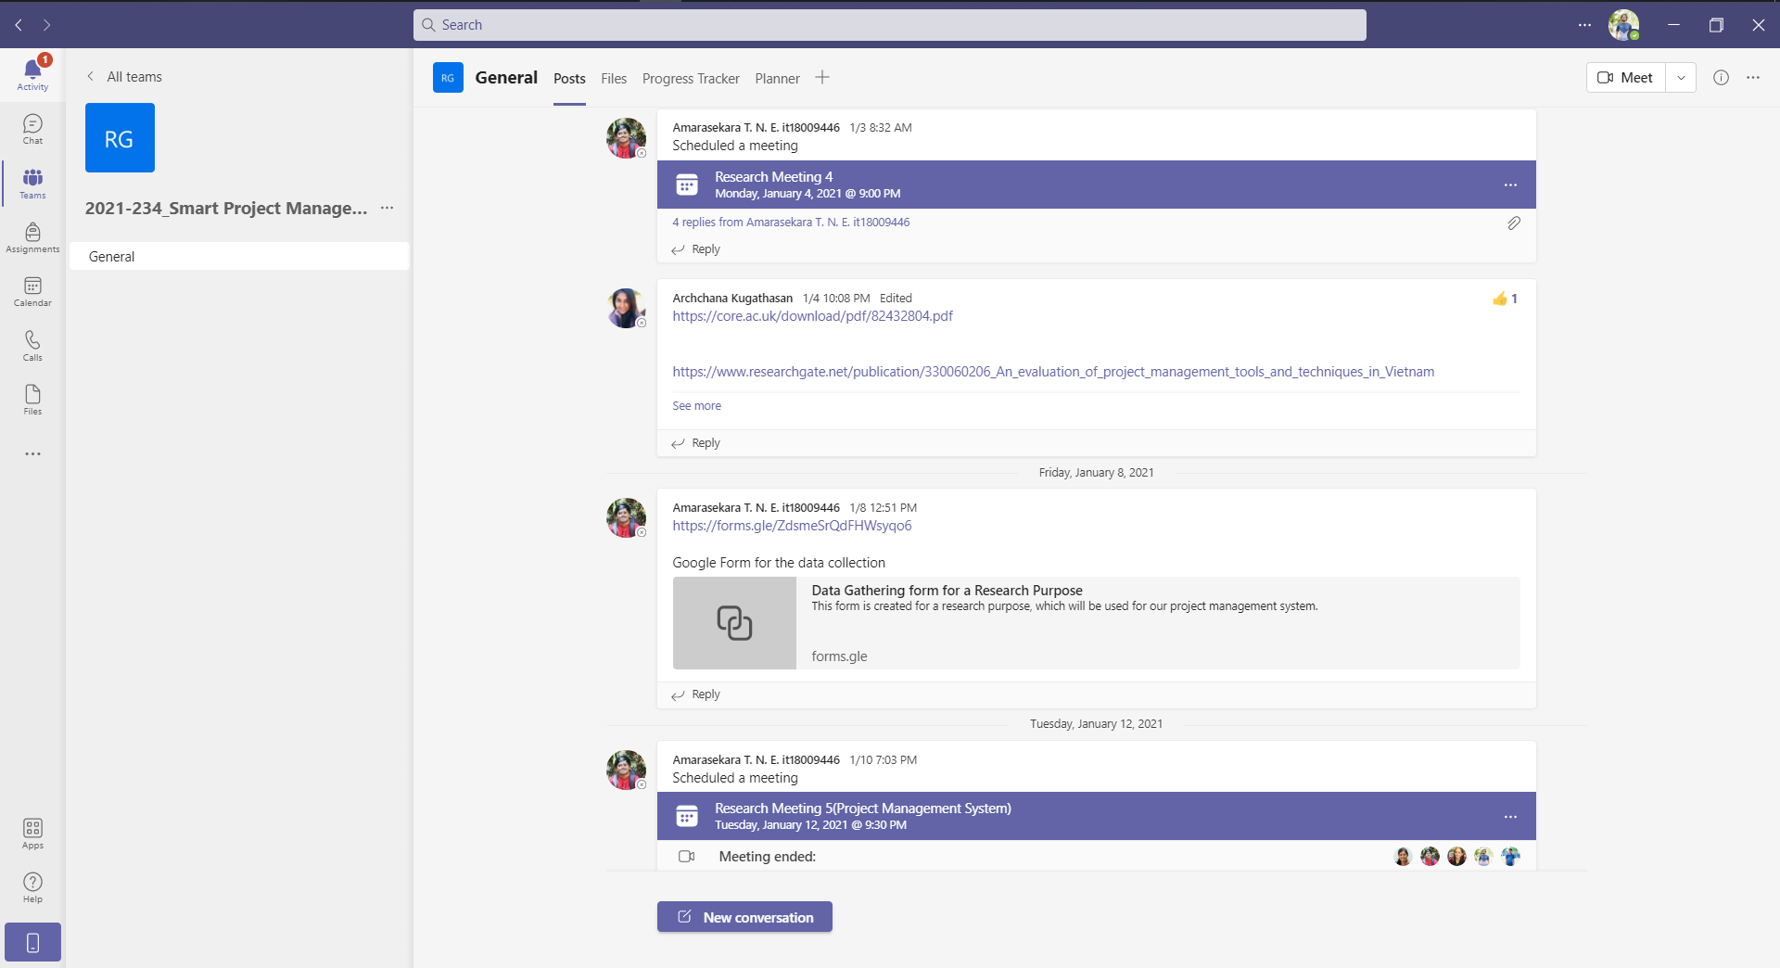

Figure : meeting with co supervisor

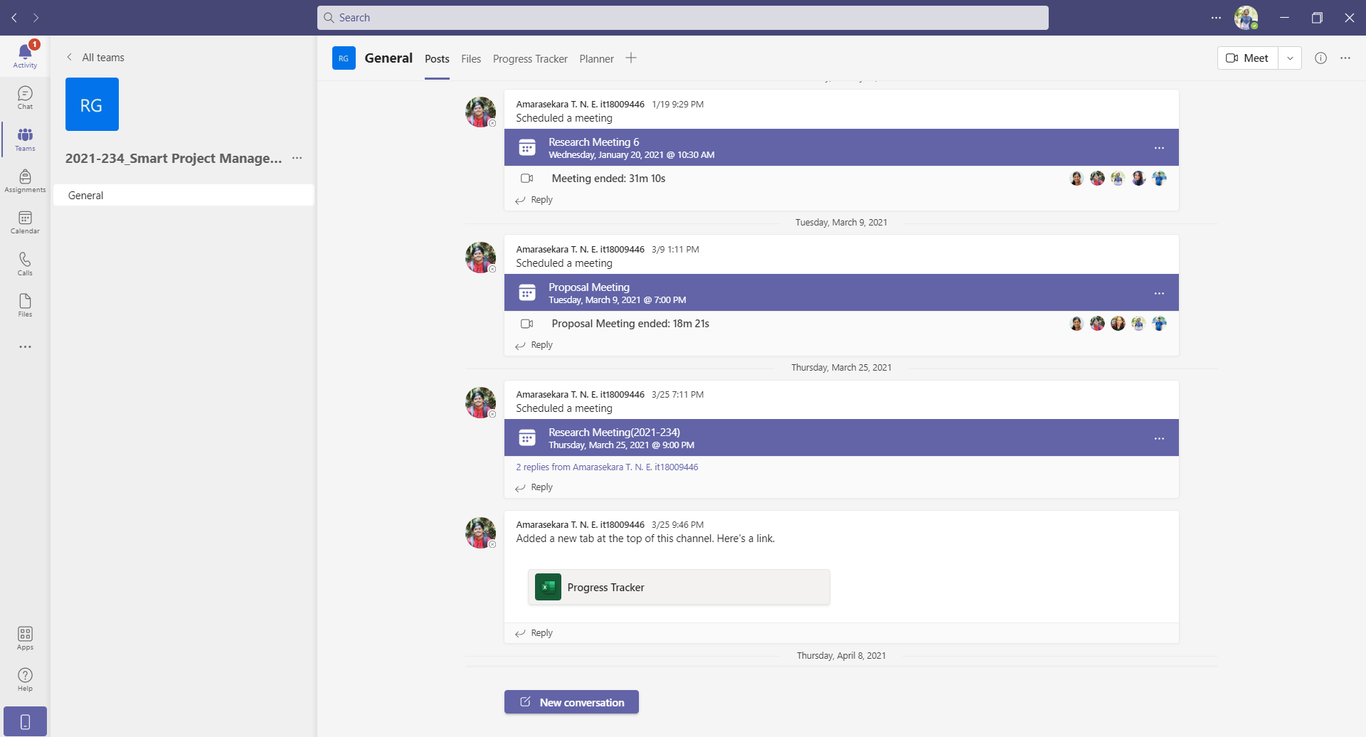

Figure : keep tracking the meetings

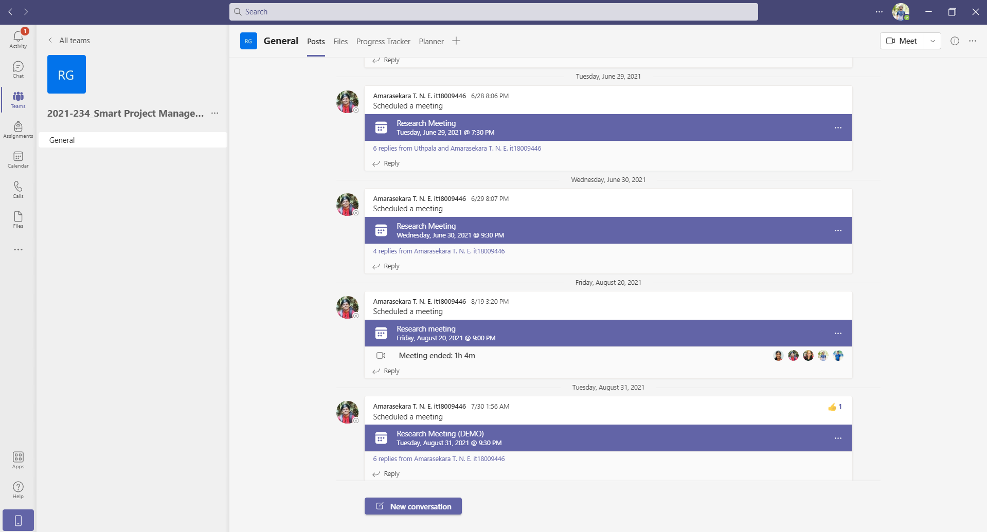

Figure : keep tracking meeting in June and August in 2021

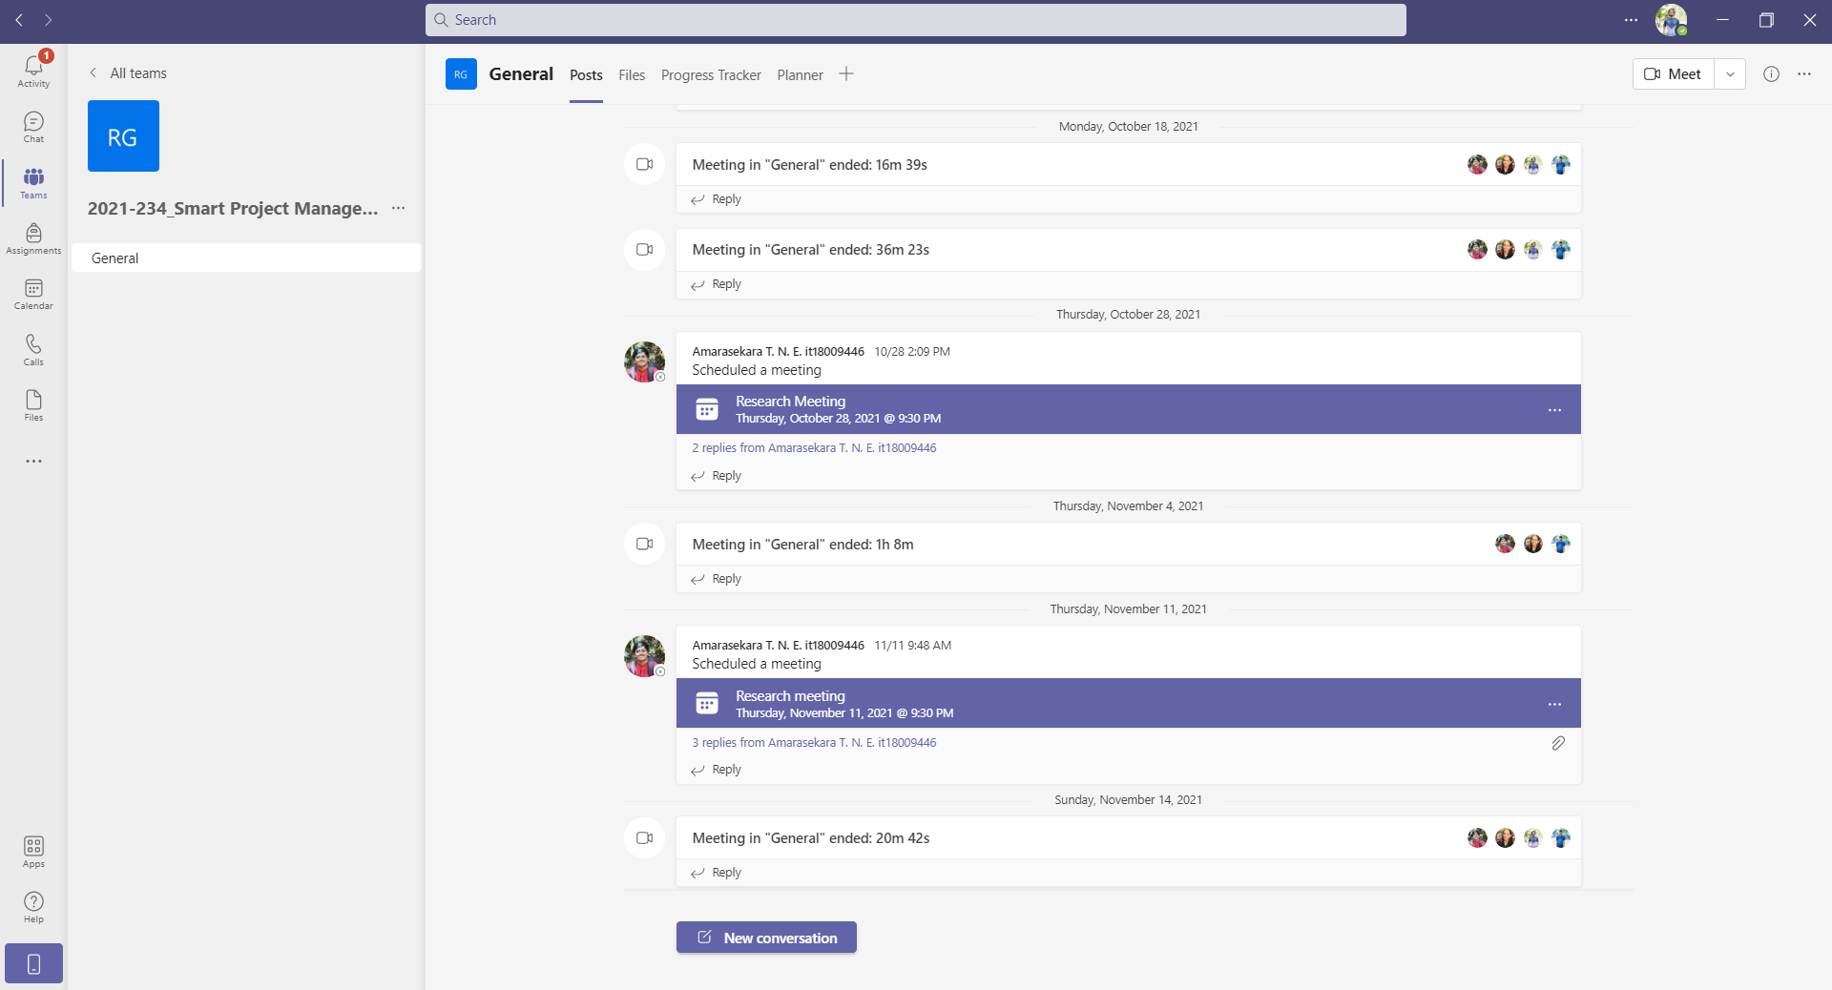

Figure : meetings in october and novemner in 2021

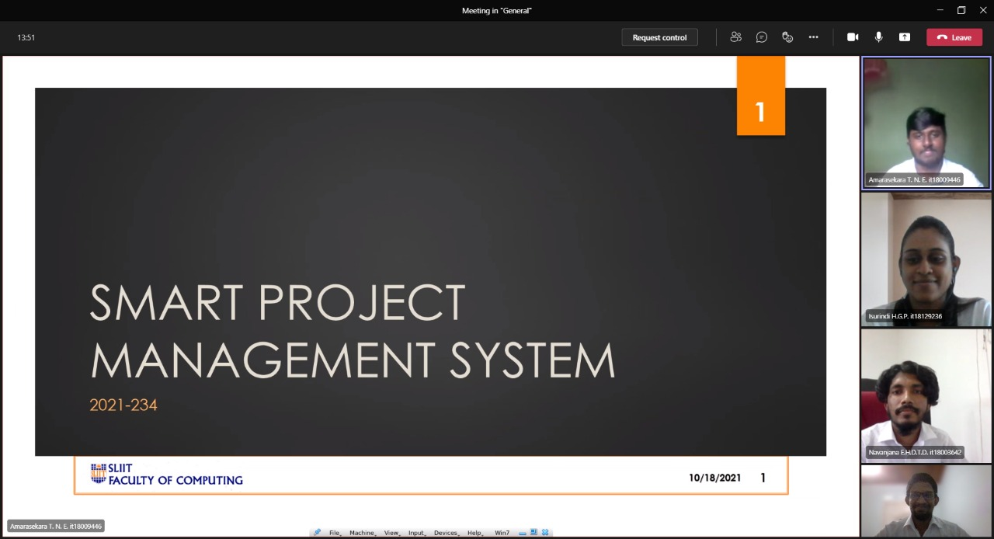

Figure : Progress Presentation 2

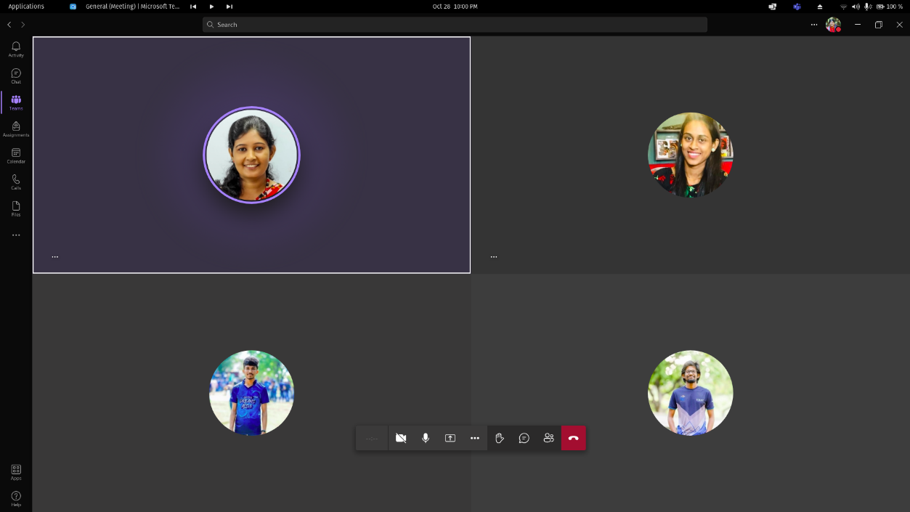

Figure : Meeting screenshot 1

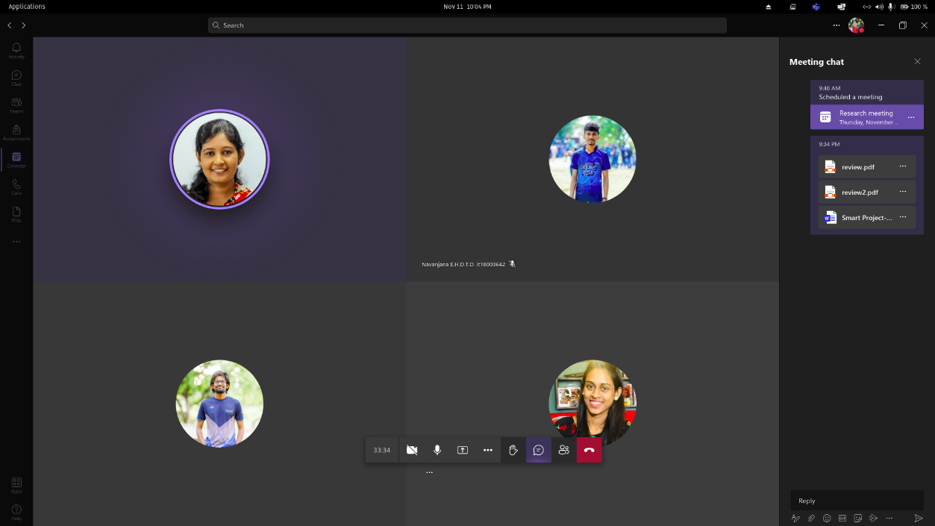

Figure : Meeting screenshot 2 (Conference blind review results discussion)

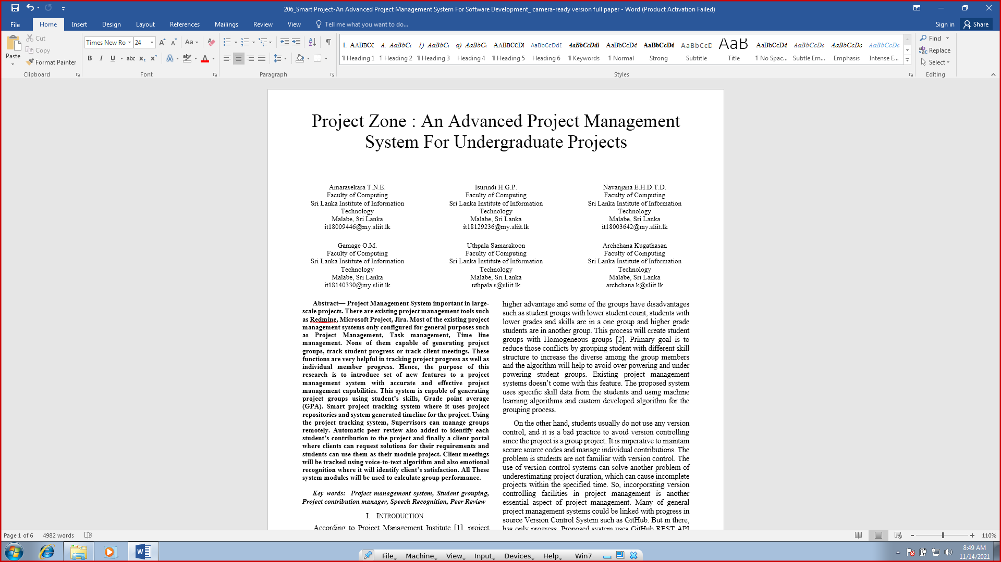

Figure : Blind review discussion of the research paper

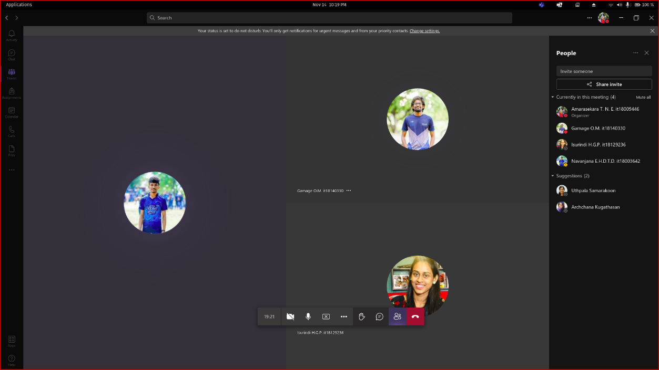

Figure : Meeting screenshot 4 (Demo testing meeting)

# 3. Work Breakdown Structure

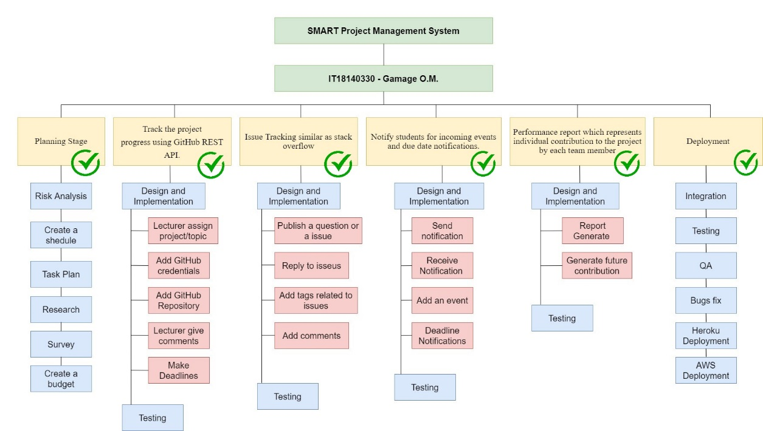

Figure : work breakdown structure

# 4. Gantt chart

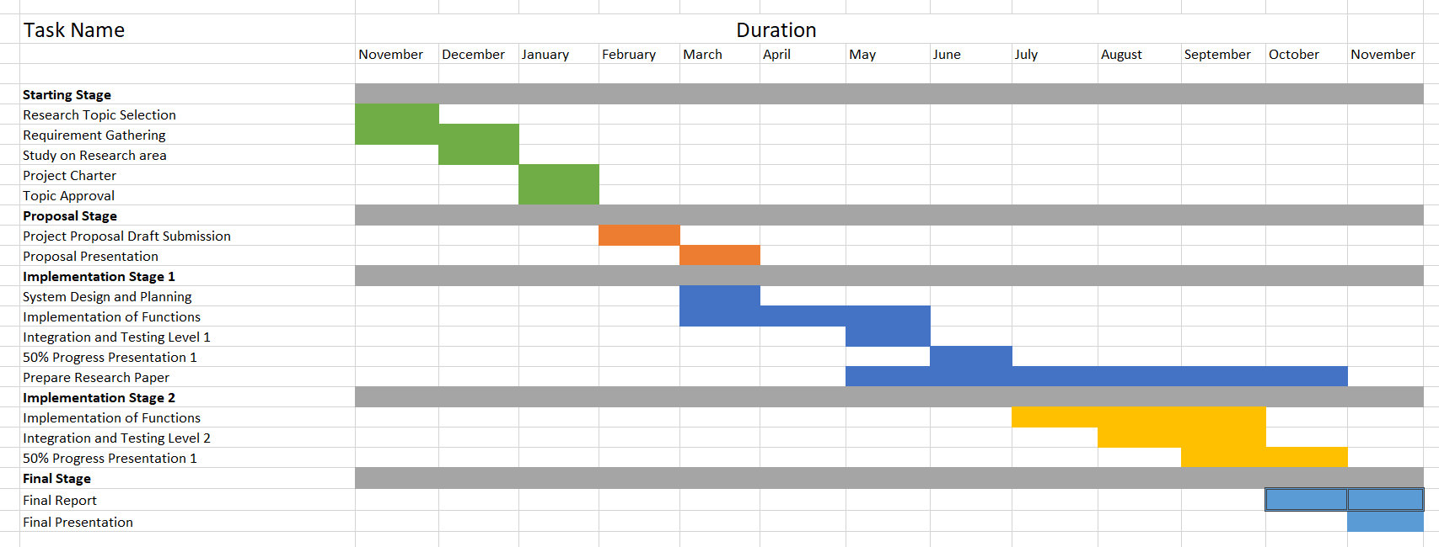

Figure :Gantt chart

# 5. GitLab Reports

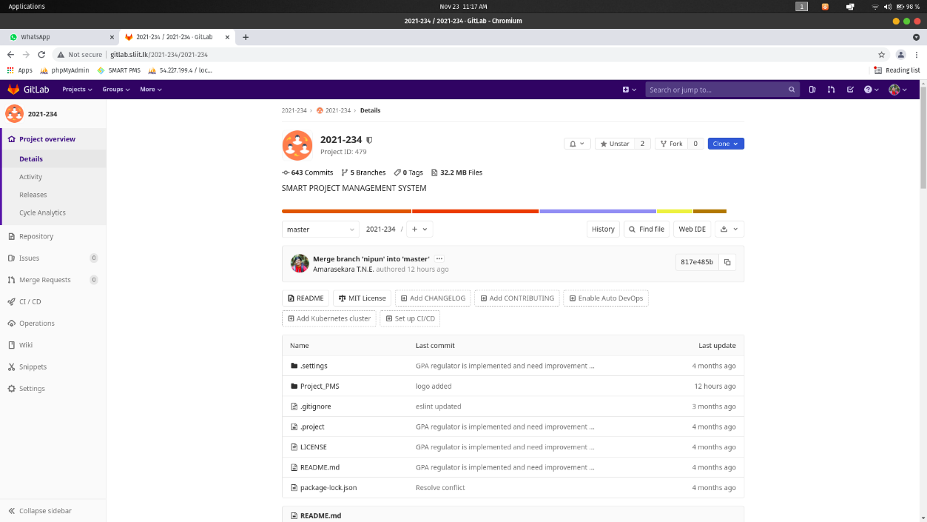

## Figure 14 - Repository

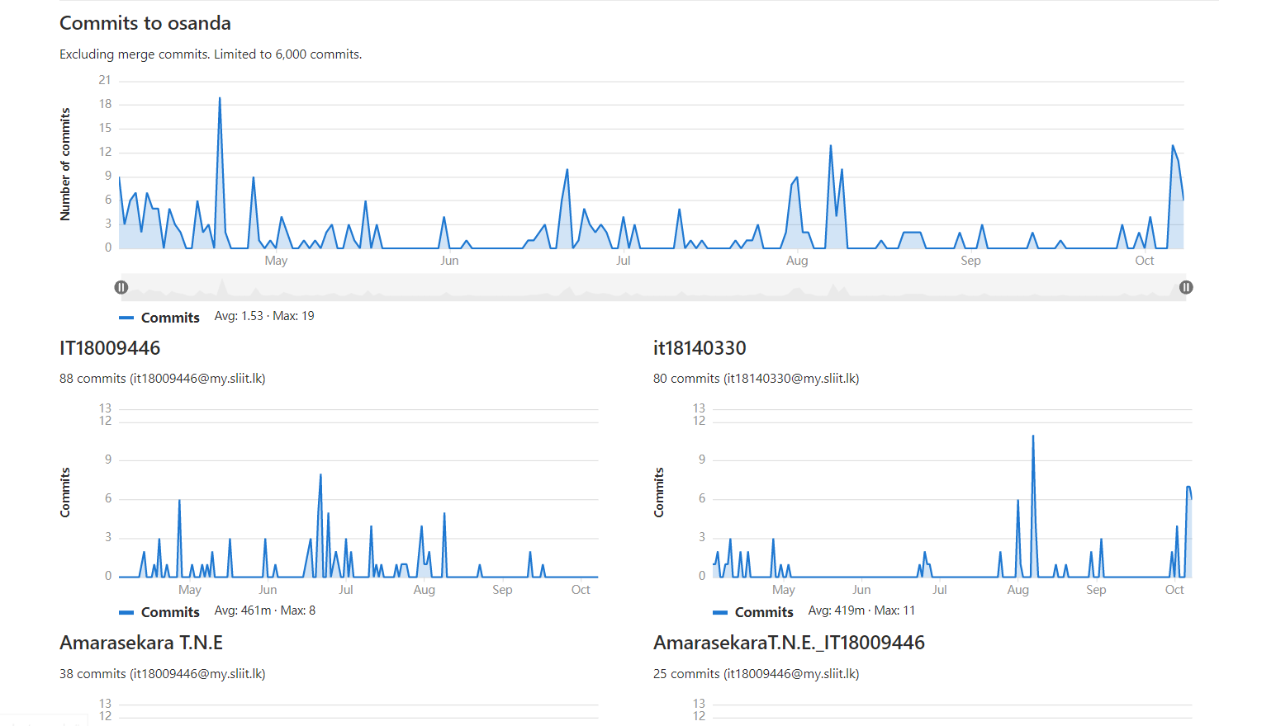

## Figure 15 – Contribution

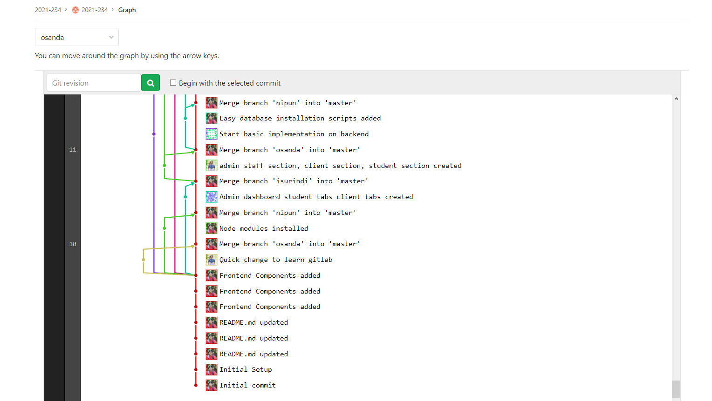

## Figure 16 – April GitLab Contribution graph

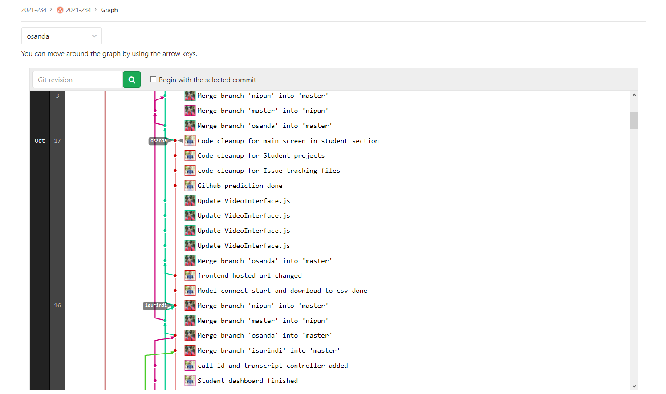

## Figure 17 – October GitLab Contribution graph

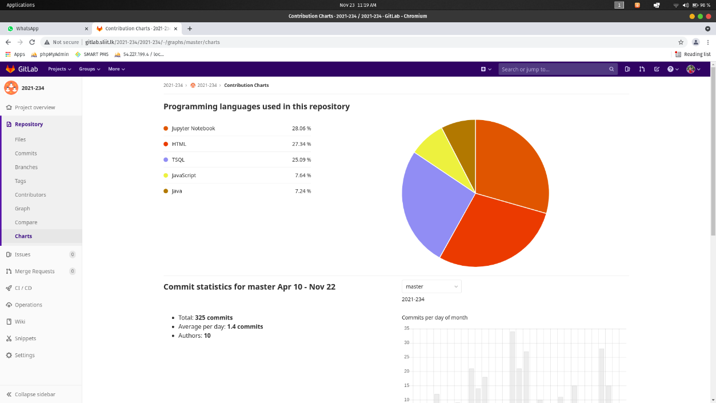

## Figure 18 – Programming Languages Chart