**SMART PROJECT MANAGEMENT SYSTEM**

**2021-234**

Project Status Document 2

**Nipun Eranda Amarasekara**

**IT18009446**

BSc (Hons) in Information Technology

Specializing in Information Technology

Department of Information Technology

Sri Lanka Institute of Information Technology

Sri Lanka

November 2021

Table of Contents

1. Microsoft Teams chats & Meetings i

Figure 1.1 – Meeting history i

Figure 1.2 – Progress Presentation 2 i

Figure 1.3 – Meeting screenshot 1 ii

Figure 1.4 – Meeting screenshot 2 (Conference blind review results discussion) ii

Figure 1.5 – Meeting screenshot 3 (Conference blind review results discussion) iii

Figure 1.6 – Meeting screenshot 4 (Demo testing meeting) iii

2. Microsoft Teams project planner iv

Figure 2.1 – MS Project planner screenshot 1 iv

Figure 2.2 – MS Project planner screenshot 2 iv

3. GitLab Reports v

Figure 3.1 - Repository v

Figure 3.2 – Contribution v

Figure 3.3 – Contribution graph vi

Figure 3.4 – Programming Languages Chart vi

4. Work Breakdown Structure vii

Figure 3.1 – Updated Work Breakdown Chart vii

5. Gantt Chart vii

Figure 4.1 – Gantt chart vii

# 1. Microsoft Teams chats & Meetings

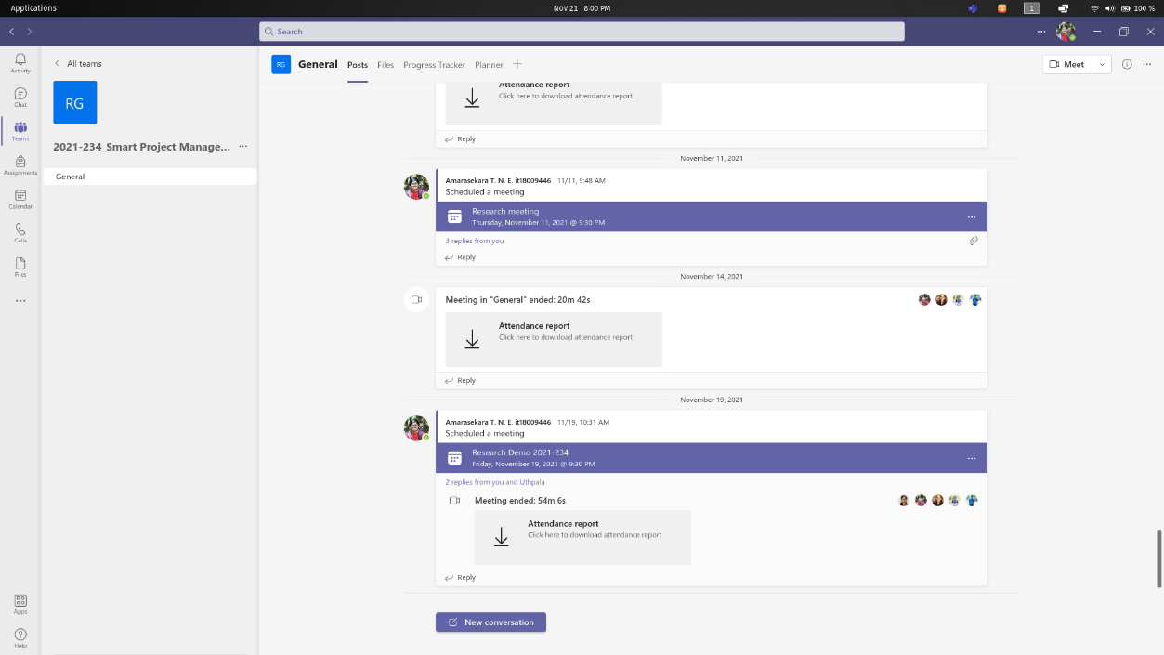

## Figure 1.1 – Meeting history

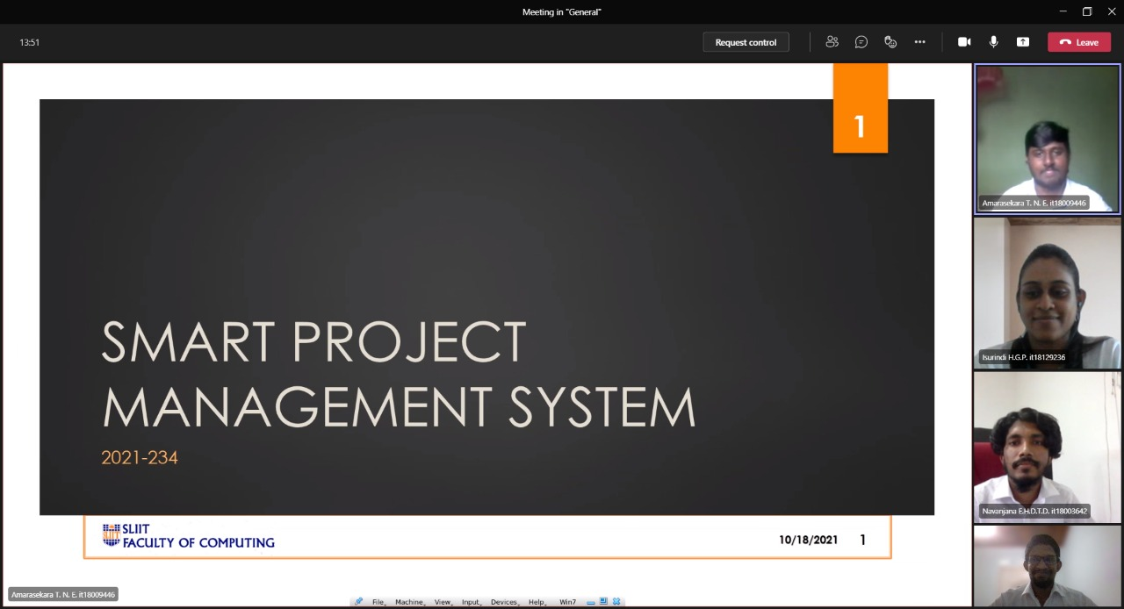

## Figure 1.2 – Progress Presentation 2

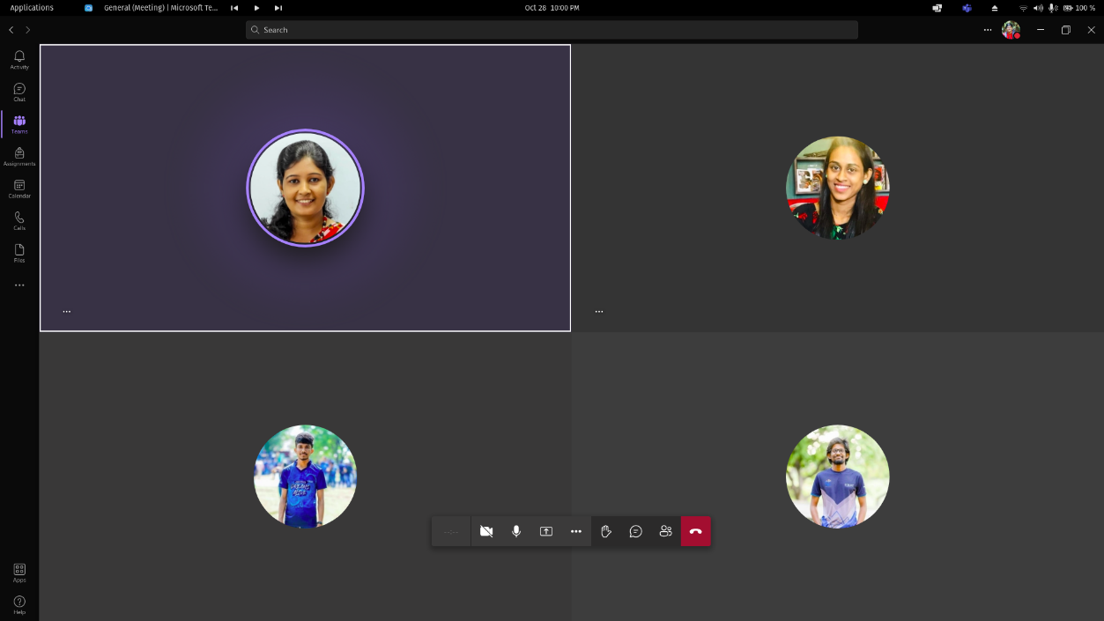

## Figure 1.3 – Meeting screenshot 1

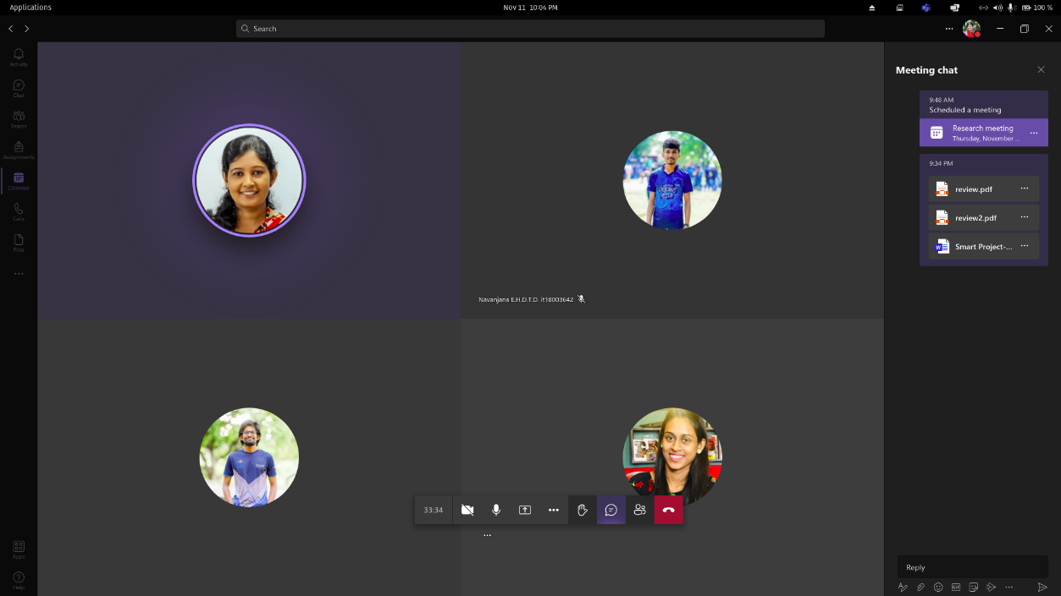

## Figure 1.4 – Meeting screenshot 2 (Conference blind review results discussion)

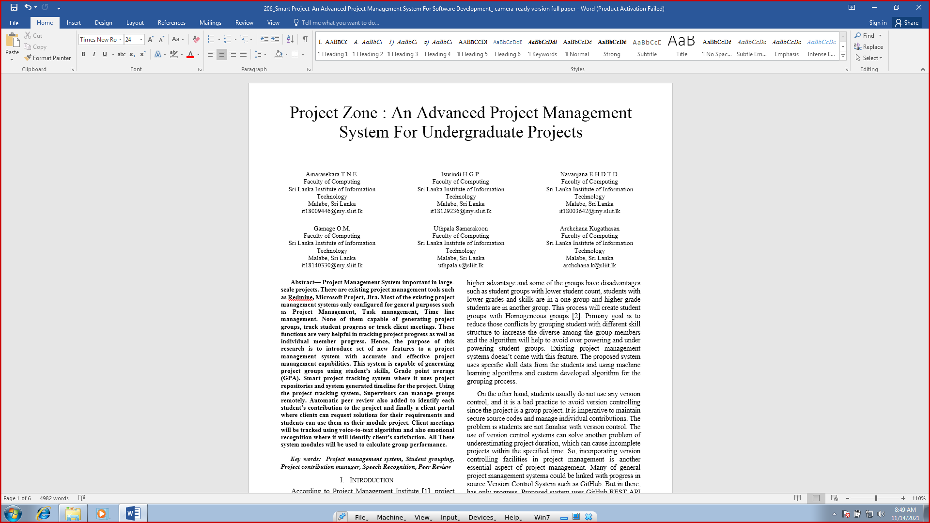

Figure 1.5 – Meeting screenshot 3 (Conference blind review results discussion)

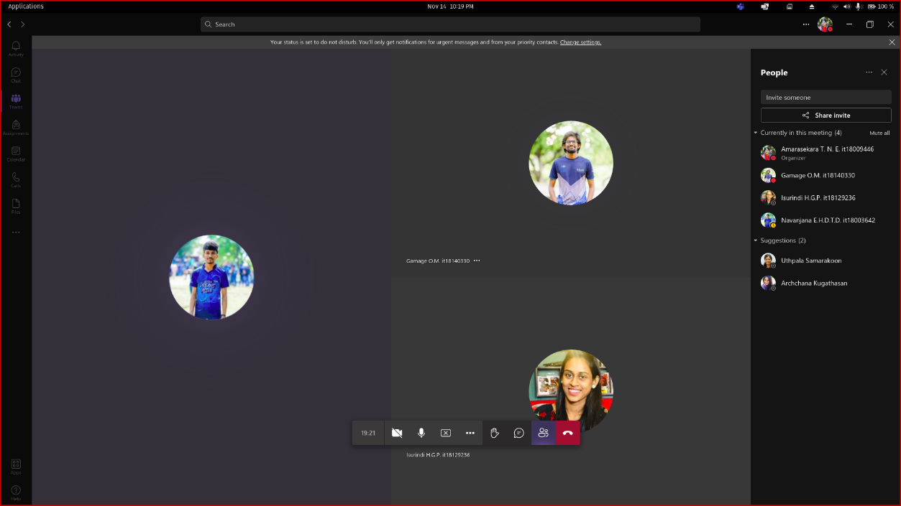

Figure 1.6 – Meeting screenshot 4 (Demo testing meeting)

# 2. Microsoft Teams project planner

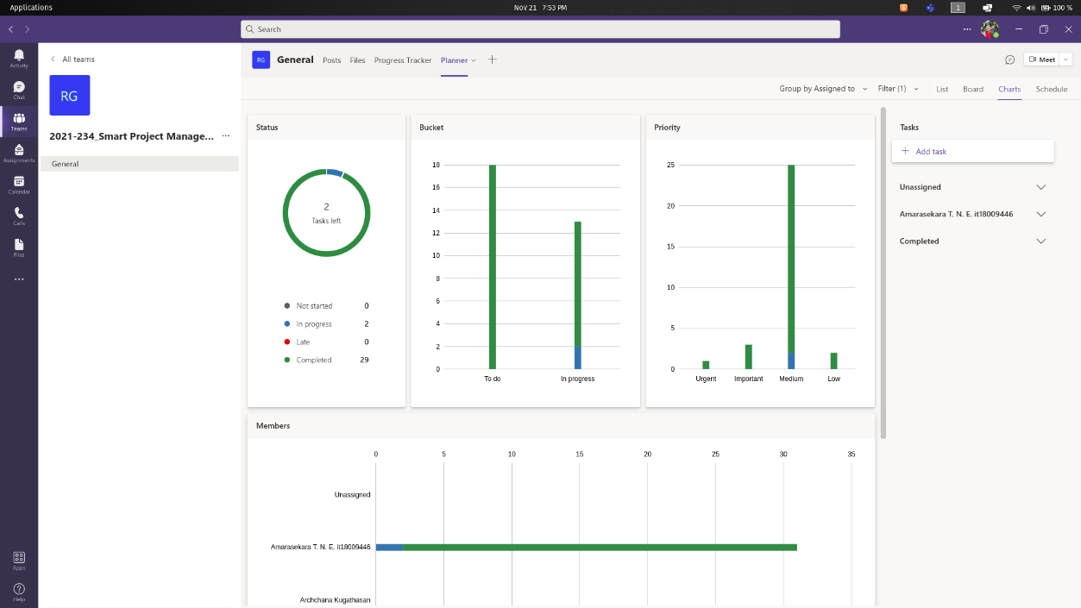

## Figure 2.1 – MS Project planner screenshot 1

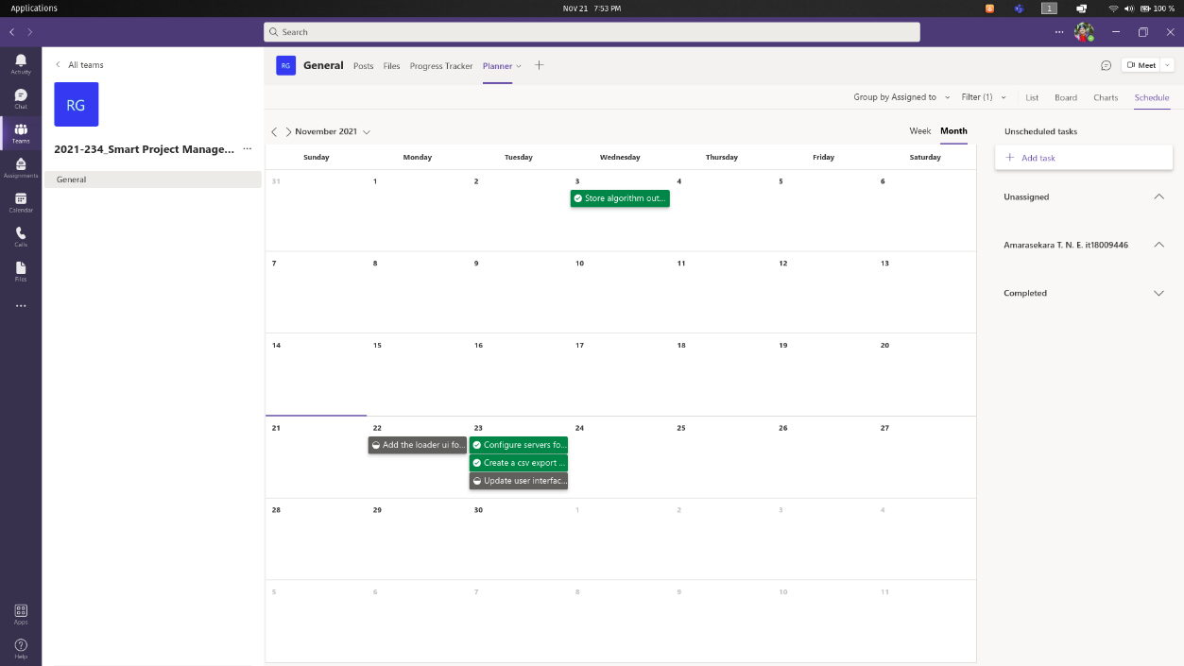

## Figure 2.2 – MS Project planner screenshot 2

# 3. GitLab Reports

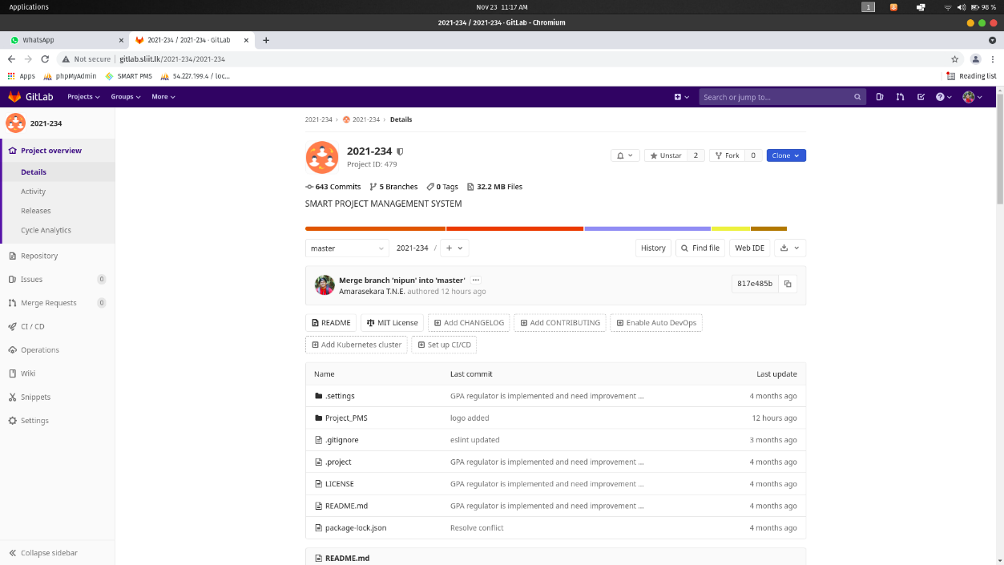

## Figure 3.1 - Repository

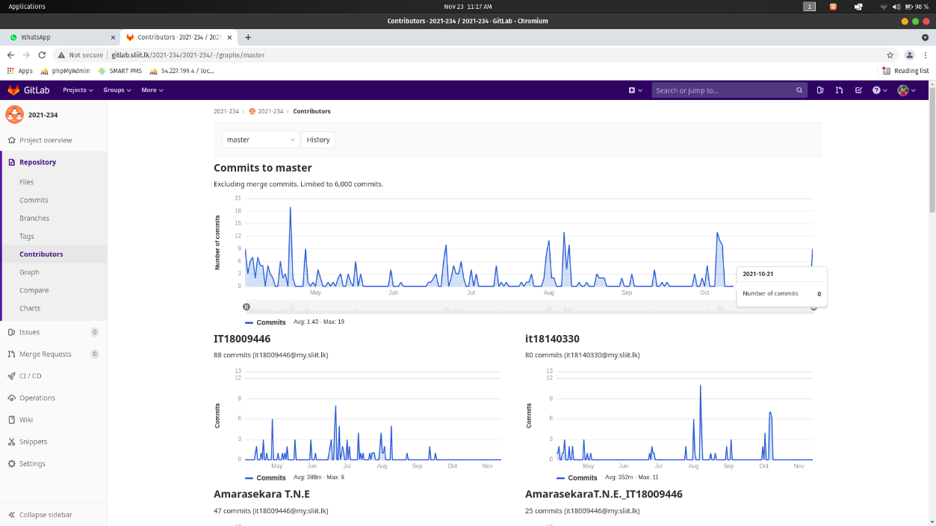

## Figure 3.2 – Contribution

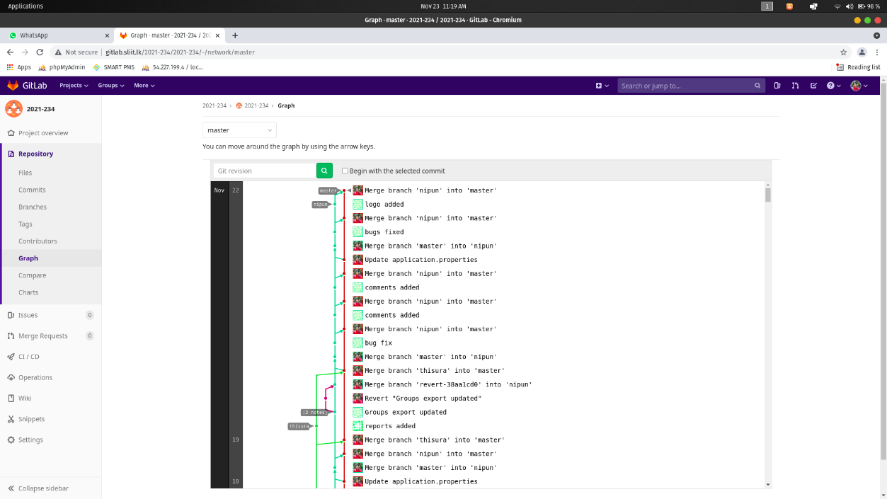

## Figure 3.3 – Contribution graph

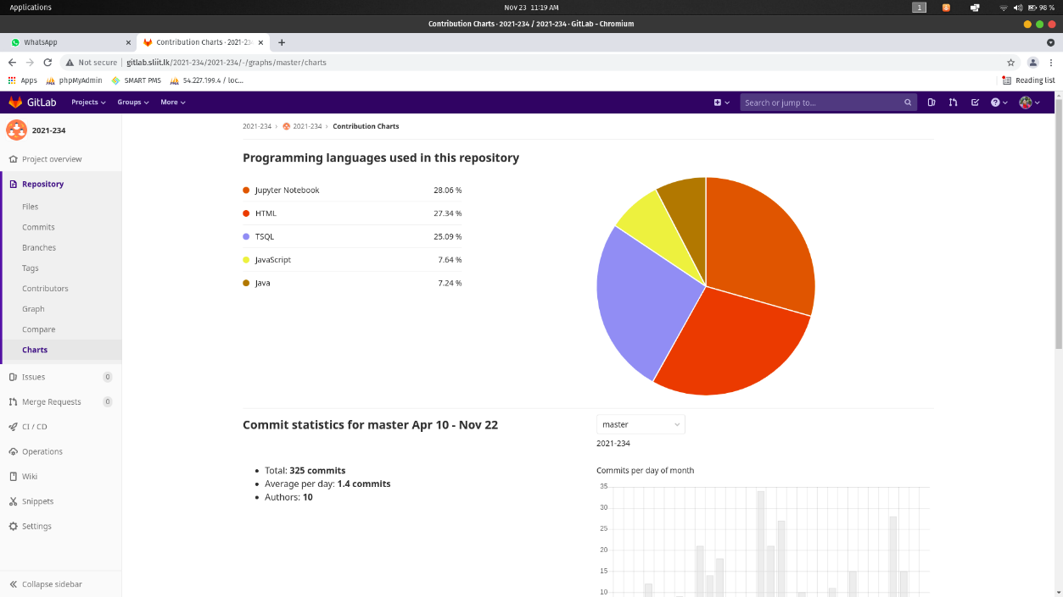

## Figure 3.4 – Programming Languages Chart

# 4. Work Breakdown Structure

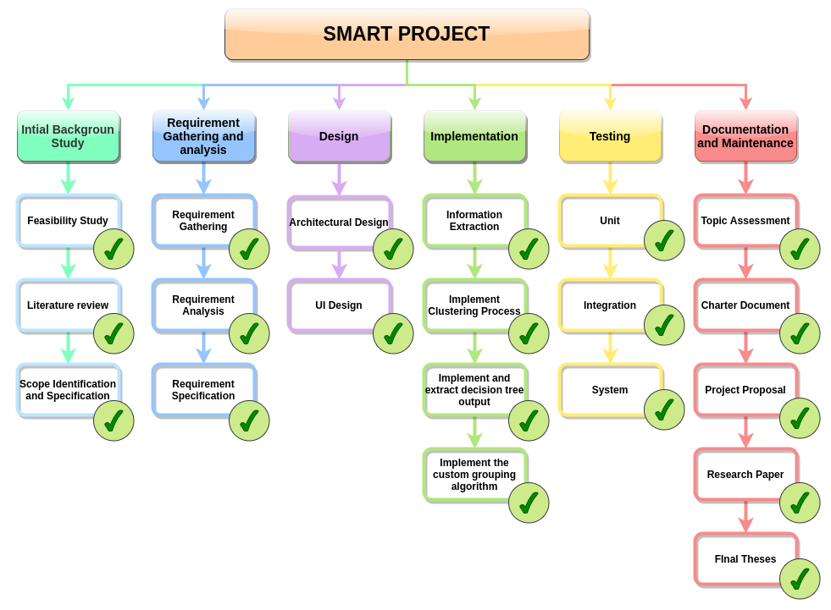

## Figure 3.1 – Updated Work Breakdown Chart

# 5. Gantt Chart

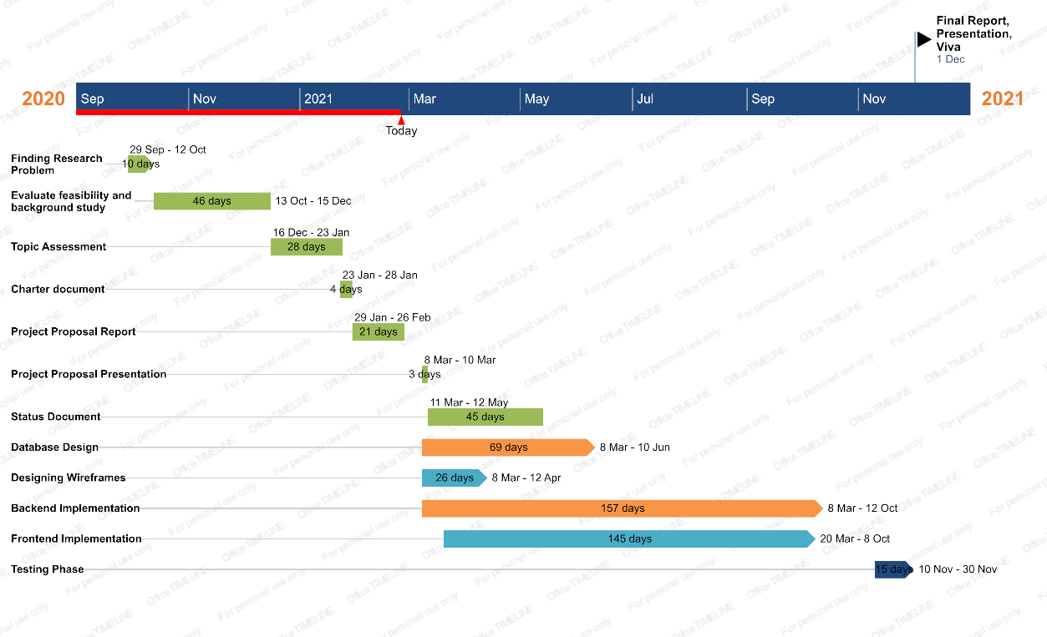

18 Nov – 23 Nov

18 Nov – 23 Nov

## Figure 4.1 – Gantt chart

As we planned, we were able to finish the implementations and testing phases between 10th November and 30th November. We’re now at the final stage, which is the Final presentations and Viva sessions. Backend and Frontend implementations took more time than we expected. But we were able to finish the implementations before the final phase.