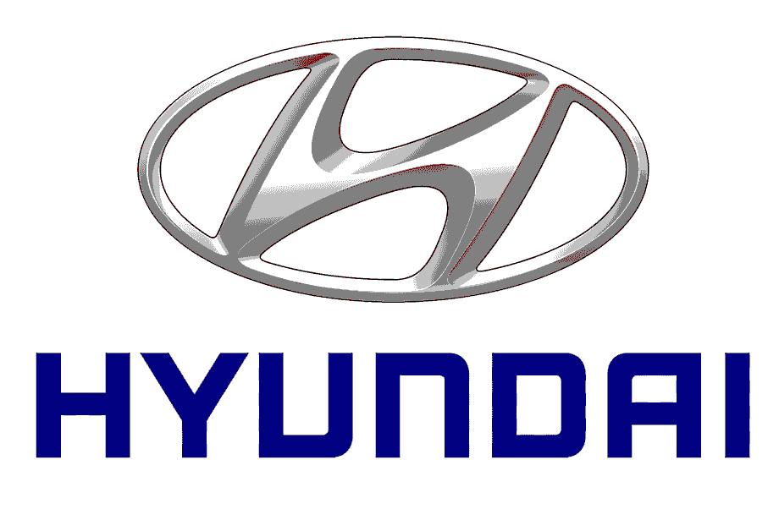

**Internship Report**

**Data Analysis Project at Hyundai Motors India**

Presented by **Nipun Kumar**

**Signature of the incharge**

**Introduction**

This report summarizes my internship as a Data Analyst at Hyundai Motors India. During the internship, I gained practical experience in data analysis and expanded my knowledge in the field of automotive data analytics.

**Internship Details**

* Duration: 5th June 2023 to June 21st 2023
* Organization: Hyundai Motors India, Sriperumbudur
* Department: Digital ME
* Role: Data Analyst

**Methodology**

I employed various tools and techniques for data analysis in excel and used various python libraries to analyse the data. These tools enabled efficient data manipulation, statistical analysis , and data visualization.

**Project Overview**

The project focused on analysing sales data of ABC Pharma to address the challenge of a lower growth rate compared to competitors. The objectives were to identify inconsistencies, determine factors contributing to the lower growth rate, and provide recommendations for improvement.

**Data Analysis and Findings**

Through data preparation, exploration, statistical analysis, and data visualization, I discovered key insights:

* Disparities in growth rates among states, with some performing below expectations.
* Revenue distribution analysis revealed areas for investment and revenue optimization.
* Clustering analysis identified distinct market segments for targeted strategies.
* Classification tree analysis helped filter out unprofitable states and formulate improvement measures.

**Recommendations**

Based on the analysis, the following recommendations are proposed:

* Increase investment in states with untapped growth potential.
* Refocus marketing and sales strategies in states with below-average growth rates.
* Develop customized marketing campaigns targeting specific market segments.
* Implement performance tracking mechanisms to monitor interventions.
* Continuously review and refine data analysis processes.

**Skills and Knowledge Acquired**

During my internship, I developed skills and knowledge in:

* Python for data analysis with Pandas, NumPy, and scikit-learn.
* Data Analysis with Excel.
* Statistical analysis.
* Data visualization using matplotlib.

**Lessons Learned**

The internship provided opportunities for skill development, including proficiency in Python for data analysis, machine learning algorithms, statistical analysis, and data visualization using tools such as Excel and Matplotlib. It also emphasized the importance of effective communication, collaboration, and continuous learning.

**Conclusion**

The internship at Hyundai Motors India as a Data Analyst was a valuable experience that allowed me to apply my knowledge in a practical setting. I am grateful for the opportunity to contribute to Hyundai's data analytics initiatives and the skills I gained will benefit me in future endeavours.

**Nipun Kumar**

+91-8106675500

 linkedin.com/in/nipun-kumar-411aa288

 github.com/NipunKumar44

nipunkr2003@gmail.com