AI-Driven Tea Quality and Production Improvements in Mid-Country Sri Lanka
25-26J-133

Project Proposal Report

Abeysekara A.M.N

B.Sc. (Hons) Degree in Information Technology Specializing in
Data Science

Department of Data Science

Sri Lanka Institute of Information and Technology
Sri Lanka
2025 August
AI-Driven Tea Quality and Production Improvements in Mid-Country Sri Lanka

Project ID: 25-26J-133

Project Proposal Report

Abeysekara A.M.N
Supervised by – Ms. Wishalya Tissera
Co – Supervisor – Ms. Ishara Weerathunga

B.Sc. (Hons) Degree in Information Technology Specializing in
Data Science

Department of Data Science

Sri Lanka Institute of Information Technology
Sri Lanka
August 2025

Abbreviation | Description
AI | Artificial Intelligence
CNN | Convolutional Neural Network
R-CNN | Region-Based Convolutional Neural Network
Mask R-CNN | Mask Region-Based Convolutional Neural Network
YOLO | You Only Look Once (real-time object detection model)
DB | Database
GUI | Graphical User Interface
UAT | User Acceptance Testing
WBS | Work Breakdown Structure
GPU | Graphics Processing Unit
API | Application Programming Interface
ML | Machine Learning
DL | Deep Learning
SLIIT | Sri Lanka Institute of Information Technology
SCRUM | Agile project management framework
UI | User Interface
PNG | Portable Network Graphics
JPEG | Joint Photographic Experts Group (image format)
AWS | Amazon Web Services
GCP | Google Cloud Platform


Declaration

Abstraction
Tea leaves undergo visible physical and color changes as they lose freshness, directly impacting tea quality and market value. This research proposes a system that automates the evaluation of tea leaf freshness and tea type identification using image-based analysis. In the proposed two-tier architecture, a mobile application is used to capture images of plucked leaves in the field, which are then analyzed on a cloud-hosted web platform. In the first stage, tea leaves are spread on a flat surface and photographed under controlled conditions. Image processing and machine learning techniques are then applied to analyze color, texture, and shape features. Based on these features, the system determines the freshness percentage of the sample and highlights the freshest leaves within the image. If the freshness level falls below a defined threshold, the system provides recommendations to maintain quality. In the second stage, the same image is used to classify the tea type (e.g., green, black, oolong) by comparing extracted features against a trained dataset. By integrating freshness detection with tea type recognition across mobile and web platforms, this research aims to provide a practical, low-cost tool for tea growers, manufacturers, and consumers to maintain quality control, reduce wastage, and improve decision-making in tea production.

Contents
List of Figures vi
List of Tables vii
01.Introduction 1
1.1 Background & Literature survey 3
1.2 Research Gap 6
1.3 Research Problem 8
2.Objectives 8
2.1 Main Objectives 8
2.2 Specific Objectives 9
3.Methodology 13
3.1 Project Overview 13
3.2 System Overview Diagram 14
14
3.3 System Overview 15
3.3.1 App and Web Integration 16
3.4 Software Development Process 17
3.4.1 Requirements Gathering and Analysis 19
3.4.2 Feasibility Study 20
3.4.3 Dataset 23
3.4.4 Implementation 25
3.4.5 Testing 27
3.4.6 Work Breakdown Structure 28
3.4.7 Gannt Chart 29
4. Project Requirements 30
4.1 Functional Requirements 30
4.2 Non-Functional Requirements 31
4.3 User Requirements 32
4.4 Software Requirements 32
4.5 Expected Test Cases 33
5. Budget and Budget Justification 36
7.Commercialization 37
7.1 Domestic Commercial Rollout 37
7.2 Strategic Industry Partnerships 38
7.3 Regional and Global Expansion Potential 39
7.4 Revenue Streams 40
7.5 Long-Term Impact and Differentiation 41
References 42

List of Figures
Figure 1.1: The Ceylon Tea production process – from leaf plucking to cup
Figure 2.1:photo taken by phone camera for dataset
Figure 2.3:Tea types
Figure 3.1:System Overview Diagram
Figure 3.2:Component Over view
Figure 3.3:Application and Web
Figure 3.4:Software Development Life Cycle
Figure 3.5:Types of tea
Figure 4.4:Work Breakdown Structure
Figure 4.5:Gantt Chart
Figure 7.1:logo

List of Tables
Table 4.1:User case 01
Table 4.2:User case 02
Table 4.3:User case 03

01.Introduction
Tea (Camellia sinensis) is one of the world’s most widely consumed non-alcoholic beverages, with the quality of its leaves directly influencing flavor, aroma, and market value. As a major tea exporter, Sri Lanka depends heavily on maintaining high standards to ensure its products remain competitive in global markets. Traditionally, tea leaf evaluation relies on skilled graders who inspect leaves visually for freshness, maturity, and disease. While this method has been the standard for decades, it is time-consuming, subjective, and often inconsistent across different evaluators [1].
The unique characteristics of Sri Lankan tea are affected by a combination of environmental and agricultural factors, including climate, elevation, soil type, and the precision of workers during the plucking process [4]. Maintaining uniform quality across large-scale production, however, remains a persistent challenge.
Recent advances in computer vision and deep learning have created opportunities to automate quality assessment in agriculture. For instance, Zhang et al. applied convolutional neural networks (CNNs) to detect diseases in tea leaves, achieving high accuracy in distinguishing healthy leaves from infected ones [2]. Similarly, Li et al. employed Mask R-CNN to segment tea buds and leaves, facilitating more efficient harvesting [3]. Comparable AI-based systems have also been successfully used in crops such as grapes, apples, and rice, demonstrating the potential of machine vision to modernize traditional farming practices and improve consistency [1], [3].
Building on these innovations, this study proposes using region-based convolutional neural networks (R-CNNs) to automatically evaluate tea leaf freshness and quality. In the proposed approach, leaves are arranged on a flat surface and photographed under controlled lighting conditions. The model then identifies and classifies leaves into categories such as fresh, mature, diseased, stems, or other extraneous matter [2], [3]. By calculating the proportion of fresh leaves, the system generates a quality score for the harvest, providing an objective measure to guide plucking practices and support fair evaluation [1], [2].
This work aims to improve the reliability and scalability of tea leaf grading while reducing human subjectivity. Moreover, it lays the groundwork for integrating AI-driven solutions into the tea supply chain, benefiting both farmers and the broader tea industry by enhancing quality and operational efficiency [1], [3].
To operationalize the proposed grading approach, this study adopts a two-tier architecture in which a mobile application performs field image capture while a cloud-based web platform executes AI inference and presents results to users.

Background & Literature survey
Tea (Camellia sinensis) is one of the most widely consumed beverages worldwide, and its taste and quality are strongly determined by the freshness, maturity, and chemical content of the leaf. Previous research has demonstrated that bioactive components in tea contribute significantly to flavor, aroma, and health benefits [1]. For tea-exporting countries such as Sri Lanka, maintaining high quality is essential for competitiveness, since poor grading practices can diminish both market value and global reputation. Traditionally, grading has relied on skilled human assessors who visually inspect leaves for freshness, disease, and maturity. However, this method is slow, subjective, and inconsistent across evaluators [2].
The uniqueness of Sri Lankan tea arises from ecological and production factors such as elevation, soil type, and climate, much like the terroir effect in wine [3]. Among these, the plucking stage is most critical, as improper plucking introduces a mix of tender, mature, and coarse leaves, thereby lowering overall quality. To overcome these challenges, automated, objective grading systems are necessary.
Recent advances in computer vision and deep learning have transformed image classification and object detection tasks. LeCun et al. pioneered backpropagation for character recognition [4], followed by Krizhevsky et al.’s breakthrough with AlexNet [5]. Simonyan and Zisserman developed VGGNet [6], while Szegedy et al. proposed the Inception architecture [7], [8]. He et al. introduced ResNet to address vanishing gradients in deep networks [9], and Hu et al. proposed Squeeze-and-Excitation Networks (SENet) for channel-wise attention [10]. Building on these, He et al. extended Faster R-CNN into Mask R-CNN, enabling both detection and segmentation with high accuracy [11].
These models have been applied to agriculture and tea research. Zhang et al. achieved 95.3% recognition accuracy for fresh tea leaves using CNNs [12]. Gao et al. designed a CNN-based computer-aided sorting system [13], while Chang applied neural networks for intelligent tea size sorting [14]. Wang [15] and Ji et al. [16] explored stalk detection and automated grading systems. Qian et al. used Inception-V3 with transfer learning to classify fresh tea leaves into categories such as buds and leaves, achieving up to 98% accuracy [17].
In Sri Lanka, Sivalingam et al. introduced tAssessee, a CNN and Mask R-CNN–based automated grading platform that classified freshness, diseases, and pest damage with 87–98% accuracy on single-leaf images and 91–100% accuracy on bulk images [18]. This system demonstrated factory-level grading feasibility, though challenges remain regarding dataset diversity, environmental variation, and generalization across tea varieties.
Figure 2.1: The Ceylon Tea production process – from leaf plucking to cup
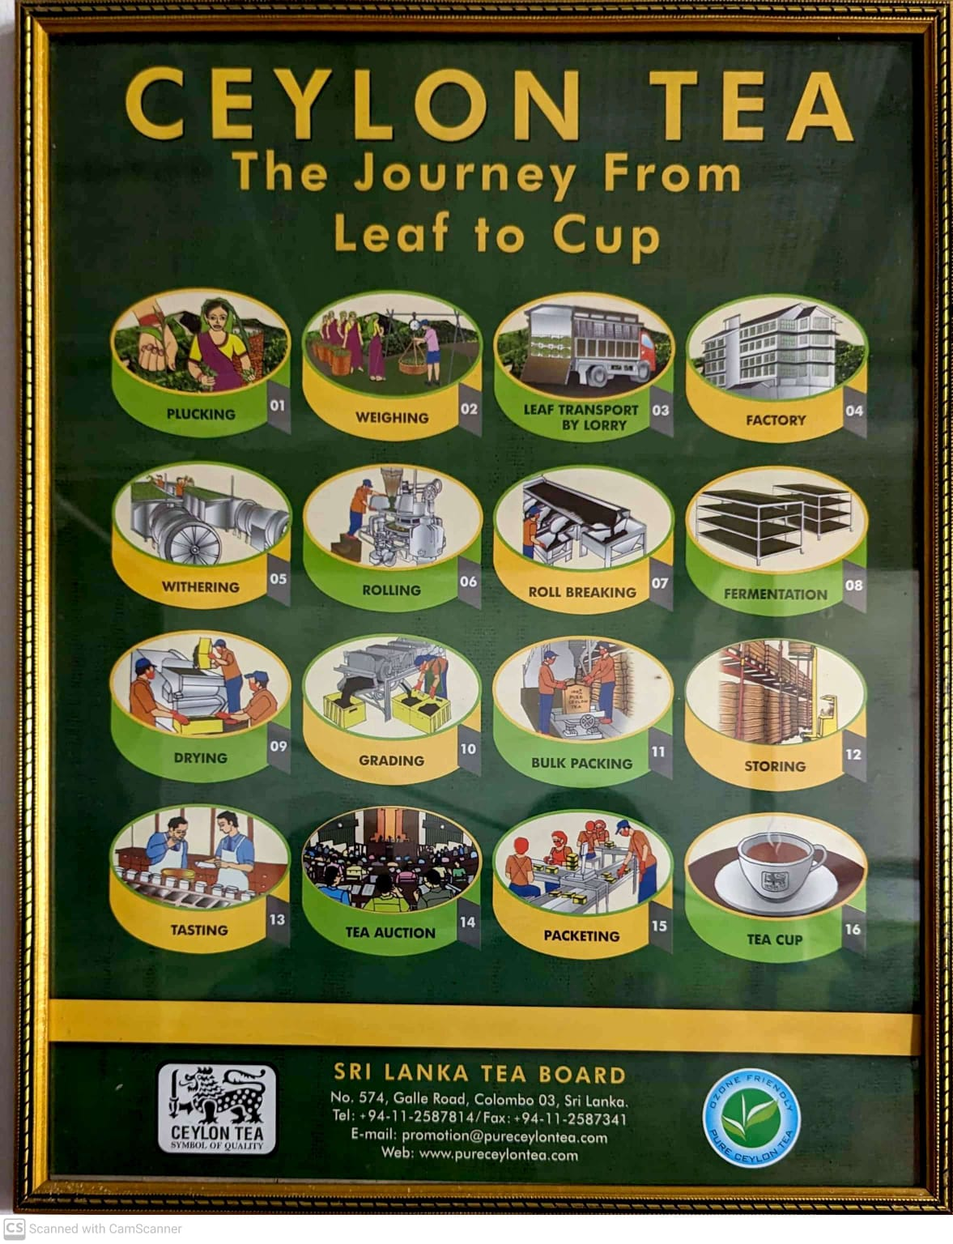

The tea production process in Sri Lanka follows a standardized sequence, beginning with plucking and weighing, and continuing through withering, rolling, fermentation, grading, and finally packaging and consumption. Among these stages, plucking plays the most critical role, as the freshness and maturity of leaves directly influence both flavor and market value [2], [4]. However, improper plucking often results in mixed batches of tender, mature, and coarse leaves, thereby reducing consistency and overall product quality [13], [14].

This research primarily supports the plucking and weighing stages by integrating freshness detection and tea type classification methods. Similar approaches using CNNs and deep learning have already demonstrated promising results in tea leaf sorting, disease detection, and automated assessment [13]–[16], [19], [20]. By applying these techniques at the point of collection, the system ensures that higher-quality leaves are selected at the source, allowing farmers and collectors to maintain tighter control of leaf quality before the leaves are delivered to factories. Consequently, this strengthens the entire supply chain and contributes to consistent quality in Sri Lankan tea production [17]–[19], [21].
Building on this literature, the present work emphasizes a pragmatic deployment pattern for Sri Lankan estates by separating field capture from centralized analysis. Images are captured on mobile devices in the field and later processed on a web dashboard hosting CNN/Mask‑R‑CNN models, thereby coupling practical data acquisition with robust, cloud‑level inference.

Research Gap
While previous studies have successfully applied computer vision and deep learning techniques such as CNNs and Mask R-CNNs to detect tea leaf diseases, classify leaf types, and evaluate freshness, there remain several limitations:
- Limited Focus on Practical Farm-Level Evaluation: Most prior work focuses either on disease detection or on factory-level bulk grading of leaves. There is a lack of systems that allow farmers to immediately evaluate the freshness and quality of leaves at the plucking stage, which is crucial for ensuring consistent tea quality.
- Controlled Environment Dependency: Many AI-based grading systems perform well under highly controlled imaging conditions, but they are less reliable under variable field conditions such as different lighting, angles, and leaf arrangements.
- Insufficient Integration of Freshness and Type Identification: Existing solutions often evaluate freshness or type separately. A combined approach that simultaneously identifies leaf type (e.g., green, black, oolong) and measures freshness percentage has not been extensively implemented for practical decision-making by farmers.
- Generalization Challenges Across Varieties: AI models trained on specific tea varieties or datasets show reduced accuracy when applied to different tea cultivars or environmental conditions, limiting their applicability across diverse Sri Lankan tea plantations.
- Lack of Actionable Feedback: While previous systems can classify and grade leaves, they rarely provide recommendations or corrective advice to farmers when the freshness is below acceptable thresholds.

Gap No. | Identified Research Gap | Explanation / Limitation
1 | Limited Focus on Practical Farm-Level Evaluation | Most prior work emphasizes disease detection or factory-level grading, with little attention to farm-level freshness evaluation during plucking.
2 | Controlled Environment Dependency | Existing AI models perform well in controlled lab settings but show reduced reliability in field conditions with varying lighting, angles, and arrangements.
3 | Insufficient Integration of Freshness and Type Identification | Current systems often handle freshness detection and tea type classification separately, lacking a combined solution for farmers’ decision-making.
4 | Generalization Challenges Across Varieties | Models trained on specific datasets or cultivars struggle to generalize to different tea varieties and plantation conditions in Sri Lanka.
5 | Lack of Actionable Feedback | Many systems stop at classification/grading and do not provide corrective advice or actionable insights to farmers when leaf quality is poor.

Conclusion: There is a clear need for a low-cost, user-friendly system that integrates tea leaf freshness evaluation and type recognition, provides immediate, actionable insights for farmers, and works under practical field conditions to ensure consistent quality and reduce wastage.

Research Problem
In the tea industry, maintaining consistent and transparent quality evaluation at the estate level remains a significant challenge. Although factories assess leaf quality after collection, there is no standardized mechanism to evaluate and record quality at the point of harvest. As a result, variations in freshness, maturity, and leaf composition can reduce overall product quality by the time leaves reach factories.
The absence of a real-time evaluation process at the estate prevents systematic feedback to pluckers about freshness and composition, limiting continuous improvement and traceability.
To address these challenges, this study proposes a two‑stage system that enables estates to evaluate tea‑leaf quality at the point of harvest through a mobile application, while performing AI‑driven freshness and classification analysis on a connected web platform. The mobile app functions as the capture interface for pluckers, and the website serves as the analytical dashboard that executes CNN/Mask R‑CNN models and presents graded results. This approach ensures reliable, transparent, and accessible quality evaluation across different stages of tea production [11], [17], [18],[22].

2.Objectives

2.1 Main Objectives
The main objective of this research is to develop a Region-Based Convolutional Neural Network (RCNN) model that can analyze bulk photographs of tea leaves to automatically assess freshness and quality. This system will help identify fresh leaves, matured leaves, and foreign objects (e.g., stems, stones), thereby supporting tea industry pluckers and farmers by ensuring fair evaluation of their harvests and reducing losses caused by enabling consistent, transparent estate-level quality evaluation at the point of harvest

2.2 Specific Objectives

- Dataset Collection
  - Gather or create a dataset of bulk tea leaf images under controlled conditions (plucked leaves spread on a cloth/tray).
  - Ensure dataset diversity with samples of different tea types (white, green, oolong, black) and leaf standards (buds, fresh leaves, matured leaves, coarse leaves, stems, foreign particle
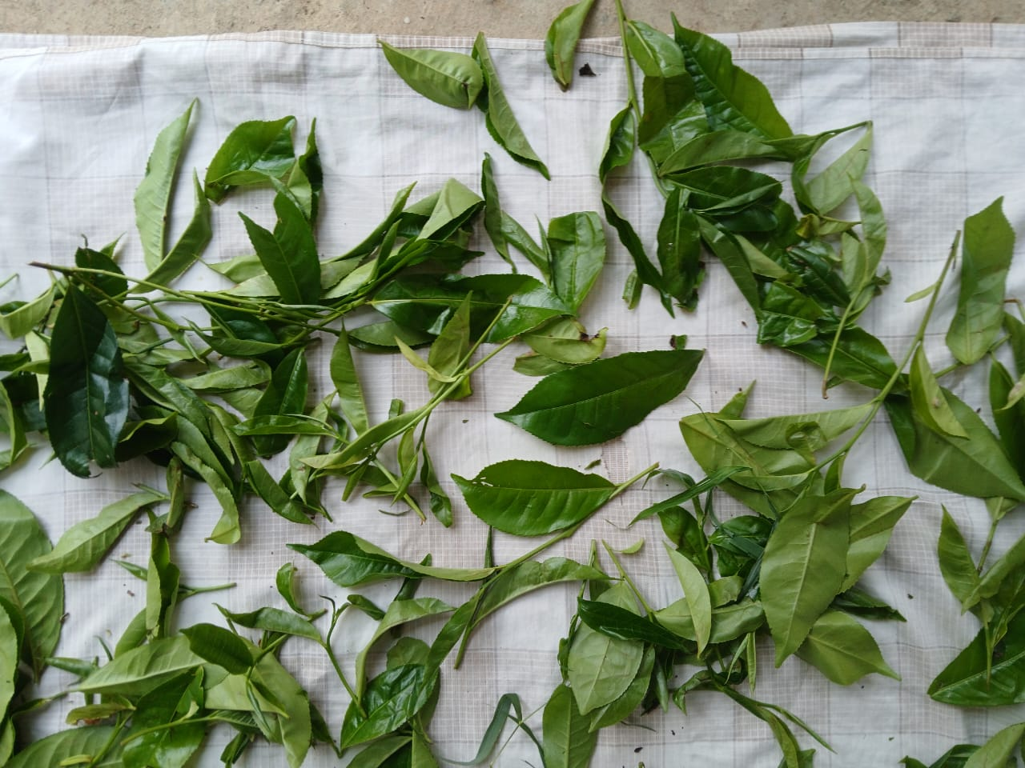
Figure 2.1:photo taken by phone camera for dataset

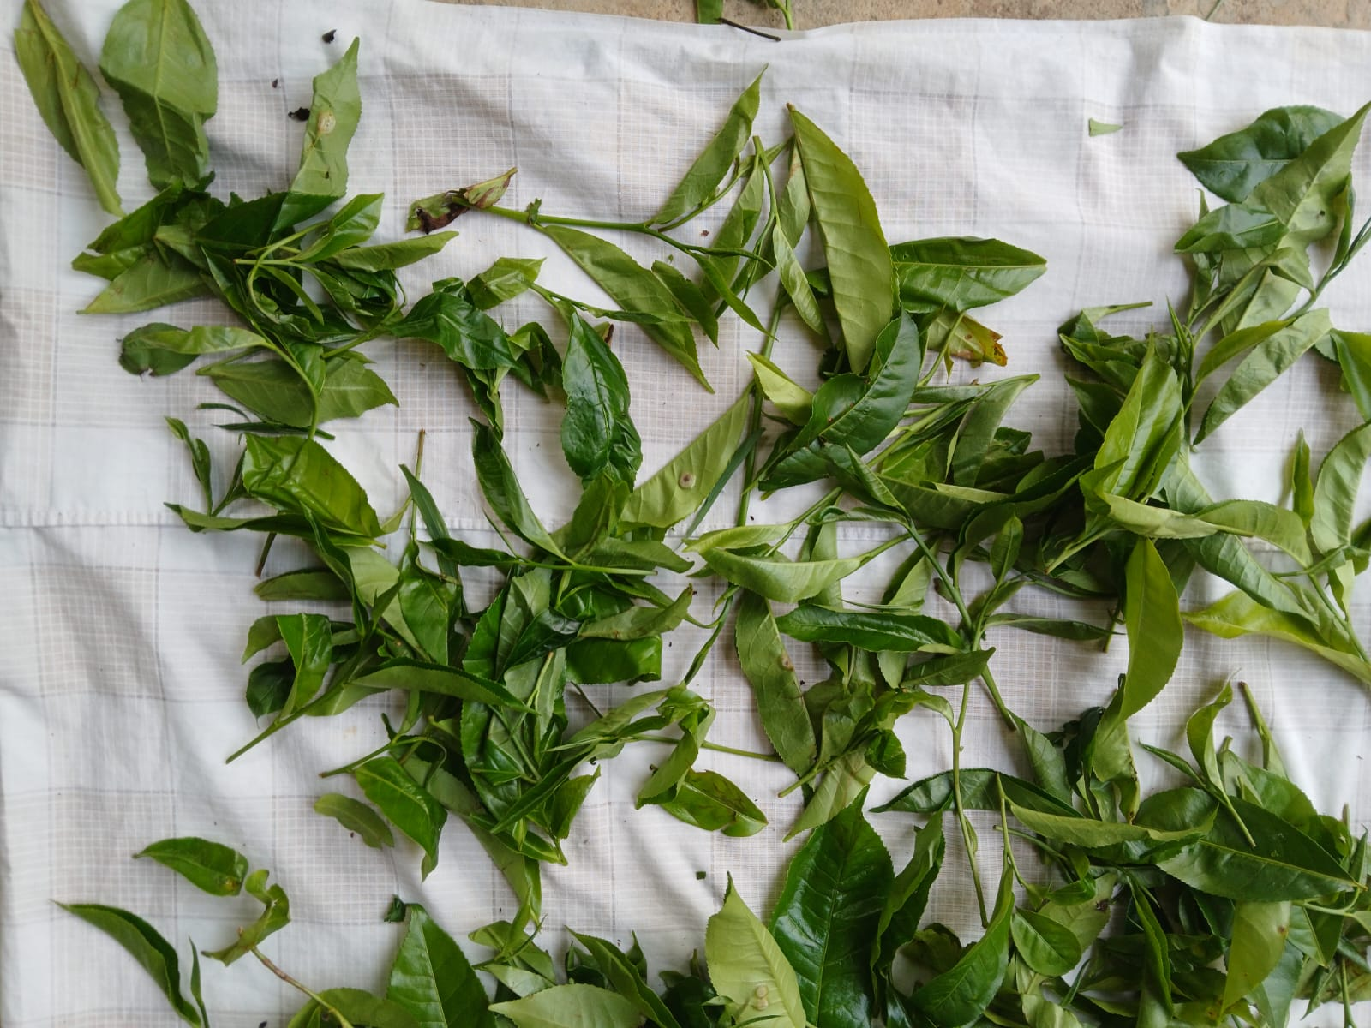
Figure 2.2:photo taken by phone camera for dataset

- Tea Type Identification (Model 1)
  - Use a classification model to identify the type of tea (white, green, oolong, black) from a bulk photo or single photo.
Figure 2.3:Tea types
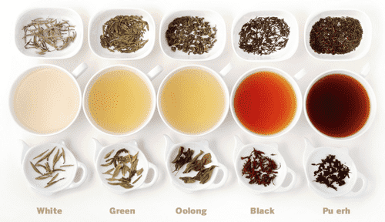
- Leaf Freshness and Quality Classification (Model 2)
  - Apply an object detection model (e.g., RCNN, YOLO) to classify leaves in bulk into fresh leaves, matured leaves, coarse leaves, stems, and foreign objects.
- Freshness Analysis
  - Quantify the percentage of fresh vs. non-fresh material in each bulk photo.
  - Provide grading outputs (premium, medium, low quality) for each tea type.

- Farmer Decision Support
  - Translate model results into actionable feedback (e.g., “Your harvest is 65% fresh buds suitable for premium green tea, but 25% coarse leaves reduce quality”).
  - Highlight the economic benefits of improving plucking practices, helping farmers increase profit while ensuring fairness at collection points.
  - Provide grading outputs (premium, medium, low quality) for each tea type.
- App–Web Architecture
- implement a two-tier workflow in which a mobile app captures tea-leaf images and a web platform performs centralized AI analysis, grading, and reporting.

3.Methodology

3.1 Project Overview

This project focuses on developing an automated system that can assess the freshness and quality of tea leaves using image-based machine learning techniques. Farmers will spread freshly plucked tea leaves on a flat surface, and a photograph will be captured under controlled conditions. The image is then processed in two stages:
Tea Type Identification – A classification model determines whether the sample belongs to green tea, black tea, oolong, or white tea.
Freshness and Quality Assessment – A region-based convolutional neural network (R-CNN) or YOLO model detects and classifies individual items within the bulk image into fresh leaves, matured leaves, coarse leaves, stems, or foreign particles.
The system calculates the percentage of fresh leaves and generates a farmer quality score, which reflects the overall quality of the harvest. Based on this score, farmers receive decision-support feedback, such as highlighting high-quality practices or identifying issues that reduce market value.
The project aims to improve fairness at collection points, reduce fraudulent practices, and help factories maintain consistent quality standards. Ultimately, it provides a low-cost, scalable solution for tea growers, buyers, and manufacturers by integrating modern computer vision with traditional tea production workflows.
In the deployed workflow, images are captured via a mobile application in the field and subsequently uploaded on the web dashboard, where AI inference and visualization are performed.

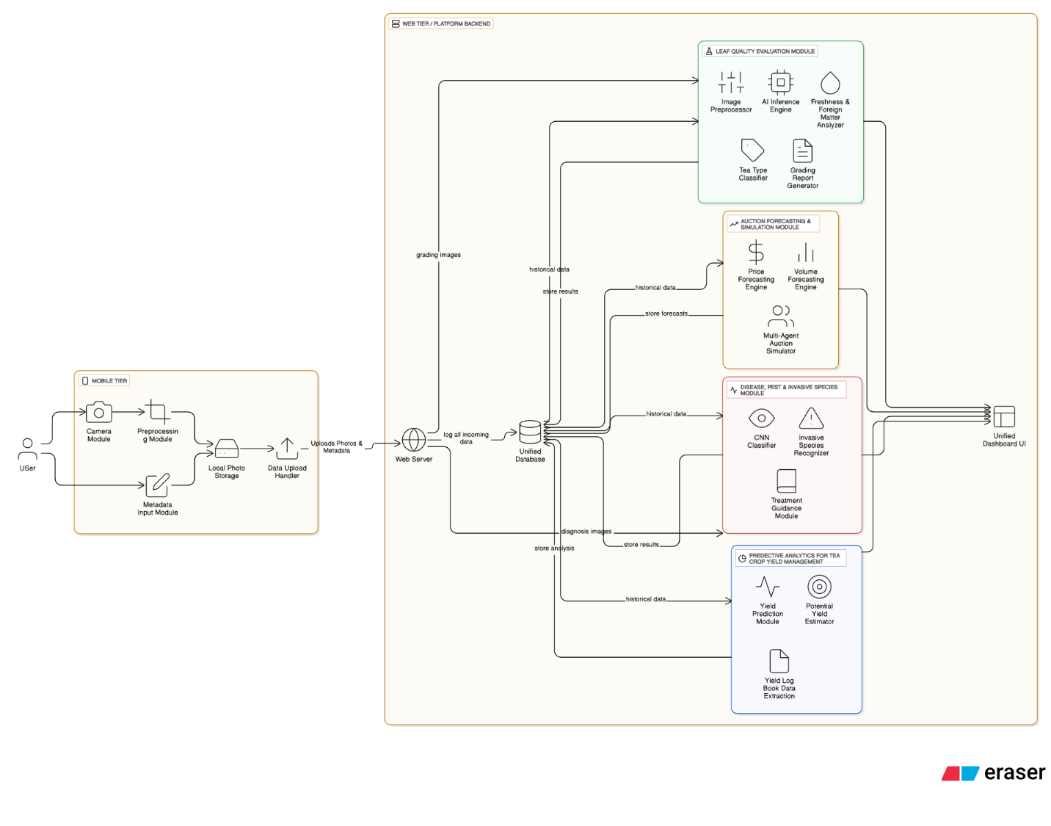
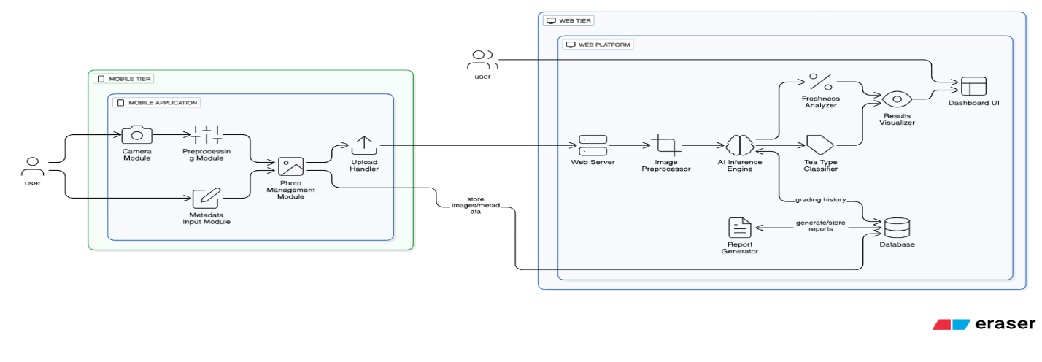
3.2 System Overview Diagram
Figure 3.1:System Overview Diagram

Figure 3.2:Component Diagram

3.3 System Overview
The proposed system integrates multiple artificial intelligence–driven modules to modernize and streamline the tea supply chain, from leaf plucking to market forecasting. At its highest level (second diagram), the architecture brings together four main components:
Automated Tea Leaf Grading & Inspection – machine vision models classify leaf quality and freshness.
AI-Based Detection of Tea Plant Diseases – deep learning systems identify signs of pest attacks or disease from leaf imagery.
Predictive Analytics for Crop Yield – historical and environmental data feed ML models to forecast production outcomes.
Tea Market Demand Prediction & Auction Planning – time-series forecasting of auction/market data informs smarter supply planning.
All outputs feed into a unified dashboard that provides actionable insights grading data, disease alerts, yield forecasts, and demand predictions for stakeholders including farmers, factories, and industry experts.

3.3.1 App and Web Integration
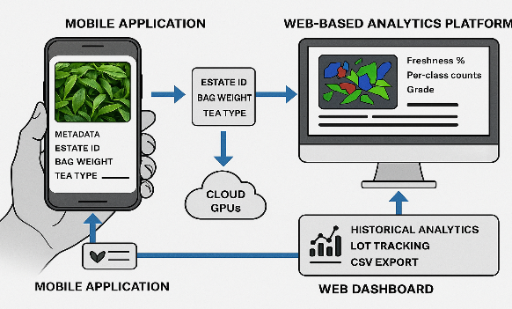
To ensure practical deployment, the system combines a mobile application for data capture and a web-based analytics platform for machine-learning inference. The mobile app guides pluckers to capture standardized photographs of bulk tea leaves, attach metadata (estate, plucker ID, bag weight, tea type), and upload data when connectivity allows. The web dashboard hosts the CNN/Mask R-CNN pipeline, executing image preprocessing, segmentation, and quality scoring on cloud GPUs. Inference results freshness %, per-class counts, and grade are displayed on both the dashboard and the phone app. The website further provides historical analytics, lot tracking, and CSV export for supervisors. This architecture leverages ubiquitous mobile hardware and centralizes computationally expensive tasks, ensuring accessibility and scalability across Sri Lankan estates [11], [17], [18], [22].
Figure 3.3:Application and Web

3.4 Software Development Process

The software development process for the proposed AI-driven tea leaf freshness and quality detection system is structured into manageable stages, following the principles of the Agile methodology. Agile is considered the most appropriate approach for this project due to its iterative nature, flexibility, and ability to adapt to evolving requirements—an essential factor when dealing with real-time image analysis, machine learning model refinement, and integration with end-user applications.
Agile promotes continuous development and improvement, ensuring that each iteration delivers a functional component of the system. This allows early validation, user feedback, and incremental enhancements to system performance. The development process will progress through six core stages of the Agile cycle: requirements gathering, analysis, design, coding, testing, and maintenance. After each cycle, a working prototype will be produced and refined in subsequent iterations until the final system is fully optimized.
To effectively manage the Agile process, the project will emphasize collaboration, adaptability, and regular communication within the development team. Short iterative development cycles, daily meetings, progress reviews, and reflection sessions will help the team quickly address challenges, respond to new insights from testing, and continuously improve both the machine learning models and the system’s usability.
The use of Agile in this project supports efficient task management and encourages close collaboration between developers, researchers, and potential end-users such as farmers and tea industry stakeholders. Given the system’s complexity and the likelihood of evolving requirements, Agile provides the ideal strategy to maintain flexibility, ensure scalability, and ultimately deliver a robust solution that meets user expectations for accuracy, performance, and ease of use.
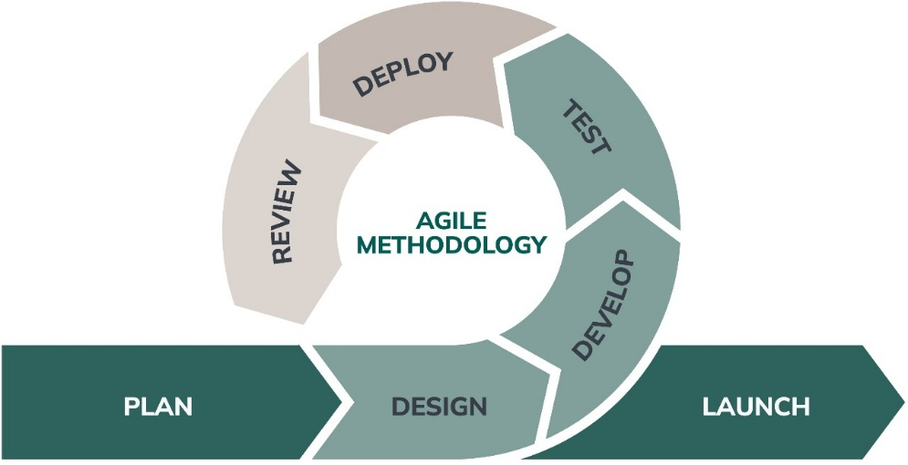

Figure 3.4 Software Development Life Cycle

3.4.1 Requirements Gathering and Analysis
In each sprint, the team will refine and prioritize a subset of the product backlog the master list of all project requirements. This iterative approach is crucial for an AI system, as the full scope of requirements is rarely known at the outset. Initial requirements will be broad, focusing on the core system functionality. For example, an early sprint might focus on basic classification of "fresh" vs. "not fresh" leaves.
As the project progresses, data analysis and stakeholder feedback will inform the refinement and addition of more granular requirements. This allows for a flexible and adaptive approach to defining and evolving the system's capabilities. Later sprints can, for instance, introduce the need for more granular categories such as "matured leaves," "stems," and "foreign particles." The requirements gathering process will be continuous and collaborative, involving input from:
Farmers and Pluckers: To understand real-world plucking techniques, common impurities, and the type of feedback most valuable to them.
Factory Personnel and Quality Graders: To capture the precise criteria they use for manual grading and to identify critical quality metrics.
Domain Experts: For scientific knowledge about tea leaf composition and the factors influencing quality.
This continuous analysis of user needs and project findings ensures that the final product directly addresses the core problems of quality assessment, making the system both accurate and practical for its end-users.

3.4.2 Feasibility Study
The proposed automated tea leaf freshness and type identification system has been evaluated for technical, operational, economic, and legal feasibility, with particular attention to its deployment within the Sri Lankan tea industry. The feasibility assessment is conducted iteratively within the Agile development framework, ensuring that technical refinements, stakeholder input, and cost–benefit considerations are addressed continuously throughout the project’s lifecycle.
Technical Feasibility
The system builds on well-established technologies in image processing and machine learning. On the hardware side, farmers and collectors require only smartphones equipped with standard cameras (8MP or higher), which are already widely available in the field, while model training and intensive processing can be carried out using GPUs such as the NVIDIA RTX 3080 in labs or cloud platforms like AWS or Google Cloud. Software requirements are met through open-source frameworks including TensorFlow, PyTorch, and OpenCV, supported by tools like Roboflow for dataset annotation. For modeling, R-CNN (e.g., Mask R-CNN) is selected for its accuracy in object detection and segmentation, with YOLO explored as a faster real-time alternative. Transfer learning with pre-trained models such as ResNet and Inception-V3 further reduces data and training requirements.
Freshness detection relies on extracting visual and morphological features from images. Color helps identify whether leaves are fresh, matured, or stale, while texture measures smoothness or roughness as an indicator of aging. Shape and size features distinguish tender young leaves from matured ones, and morphological analysis is applied to detect impurities such as stems or stones. A diverse dataset of over 5,000 images collected from Sri Lankan estates, supplemented by public sources, ensures model robustness. Augmentation techniques such as rotation, flipping, and brightness adjustments mitigate the challenges of environmental variation. Preprocessing methods like brightness normalization and background segmentation further improve consistency, while cloud deployment ensures scalability to multiple users.
Operational Feasibility
The system is designed for easy integration into existing workflows. Farmers can capture and upload images through a simple smartphone requiring minimal training, while factory supervisors access results through dashboards aligned with current quality control practices. The system functions reliably in both field and factory environments, provided leaves are spread on flat cloths under consistent lighting. Regular input from farmers, graders, and tea board officials during development ensures practical usability, and user acceptance testing during each sprint validates performance under real conditions. Maintenance is simplified through cloud deployment, with updates and monitoring carried out continuously based on user feedback.
Economic Feasibility
The project balances initial investment with long-term benefits. Development costs are estimated at $32,000, including hardware, software, personnel, and data collection. For end-users, operational costs remain minimal since smartphones are already owned, with ongoing cloud hosting fees between $100 and $200 per month. Economic benefits are substantial: early impurity detection prevents processing of low-quality batches, while farmers gain fairer evaluations that can improve earnings by focusing on higher-quality produce. Scalability further ensures that widespread adoption does not significantly increase costs. Funding opportunities may be sourced from tea boards, agricultural grants, and agrotech partnerships to offset the initial outlay.
Legal and Ethical Feasibility
Data collected from farmers, including images and quality scores, is securely encrypted and stored in compliance with Sri Lankan data protection regulations and international standards such as GDPR. Intellectual property rights can be safeguarded by patenting the dual-model approach, while all open-source components are used under appropriate licenses. Ethically, the system promotes fairness and transparency by rewarding genuine farmers, penalizing fraudulent practices, and ensuring equitable treatment across the supply chain.
Risks and Alternatives
Key risks include potential inaccuracies in model performance across diverse tea types, variability in environmental conditions, dataset bias if samples are too narrow, and possible resistance to adoption among farmers. These are mitigated through diverse data collection, robust preprocessing, user training, and iterative system refinement. Should R-CNN prove computationally demanding, alternatives such as YOLOv5 or YOLOv8 can deliver faster inference, while local server deployment may replace cloud solutions in areas with poor connectivity.
Continuous Evaluation and Conclusion
Feasibility is not assessed once but revisited in every sprint, covering technical updates, operational usability trials, economic cost–benefit analysis, and ethical/legal compliance. This iterative approach ensures the system remains adaptable and aligned with stakeholder expectations.
In conclusion, the study confirms that the proposed solution is technically feasible, operationally practical, economically justifiable, and legally and ethically sound. By leveraging accessible technologies and maintaining a cycle of continuous evaluation, the system offers a sustainable and impactful innovation for the Sri Lankan tea industry.

3.4.3 Dataset
The dataset will primarily consist of images of tea leaves collected under controlled conditions. Farmers or pluckers will spread freshly plucked tea leaves on a flat cloth, and Images will be captured using the mobile application under controlled conditions using smartphones in common formats such as JPEG or PNG.
The dataset will support two main objectives:
1. Freshness Detection
- Images will be labeled to reflect different freshness levels:
- Fresh leaves – young, soft green leaves.
- Matured leaves – harder, dark green leaves.
- Yellowish/brown leaves – indicating reduced freshness.
- Foreign matter – stems, rocks, or other non-leaf materials.
2. Tea Classification
The dataset will also include images of leaves from different Sri Lankan tea varieties to enable classification. Key categories include:
- Ceylon Black Tea – Assamica-based, strong flavor.
- Ceylon Green Tea – minimally oxidized, bright green.
- Ceylon White Tea (Silver Tips) – delicate, minimally processed buds.
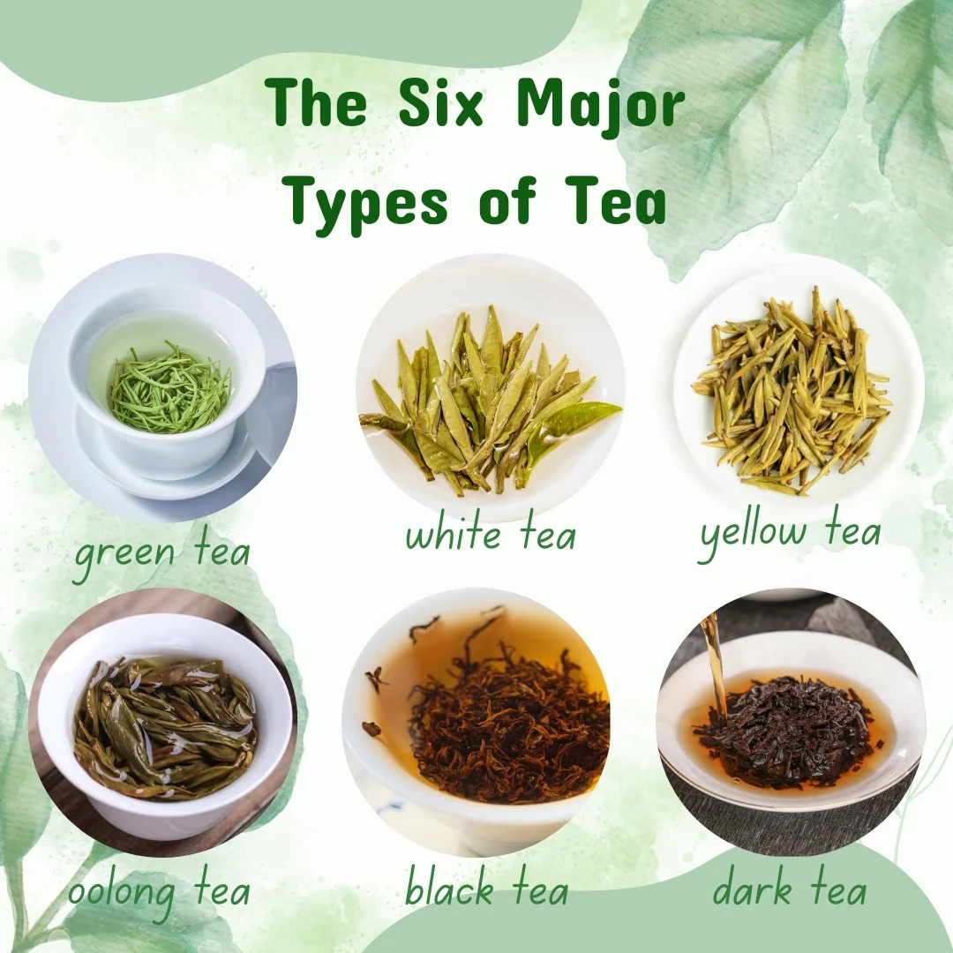
- Ceylon Oolong Tea – partially oxidized, intermediate characteristics.

Figure 3.5 Types of tea

Dataset Characteristics
Diversity: Images will be captured under varying lighting conditions (natural sunlight, shade, artificial light) and backgrounds (different cloths or trays).
Annotation: Each image will be manually labeled for both freshness and tea type categories.
Splitting: The dataset will be divided into training (70%), validation (15%), and testing (15%) subsets to ensure balanced model development.
Integration with Existing Data: Where feasible, publicly available datasets or tea industry image archives will be incorporated to strengthen model accuracy.

3.4.4 Implementation
The system will be implemented using a combination of image processing techniques and deep learning models. The key implementation steps are as follows:

1. Data Acquisition and Preprocessing
- Capture tea leaf images under controlled conditions using smartphones or digital cameras.
- Apply preprocessing methods such as:
  - Image resizing and normalization for consistent input size.
  - Noise removal and contrast adjustment for clarity.
  - Background segmentation to isolate leaves from the cloth/tray.

2. Feature Extraction
- Use color features (green, yellow, brown tones) for freshness detection.
- Extract texture and shape features to differentiate tea types.
- Employ Convolutional Neural Networks (CNN) to learn feature representations automatically.

3. Model Training
- Train a Region-based Convolutional Neural Network (RCNN) model for object detection and classification.
- The RCNN will perform:
  - Freshness classification → fresh, matured, yellowish, or foreign matter.
  - Tea type classification → Ceylon Black, Green, White, or Oolong.
- Use the training dataset (70%) for model learning, validation dataset (15%) for hyperparameter tuning, and testing dataset (15%) for evaluation.

4. Evaluation Metrics
Model performance will be evaluated using:
- Accuracy – overall correctness of classifications.
- Precision, Recall, and F1-score – to assess classification performance in each category.
- Confusion Matrix – to visualize misclassifications.

5. System Deployment
- Develop a mobile app for capturing tea leaf images in the field and a web interface for uploading, analyzing, and displaying results to users.
- The system will:
  - Automatically detect leaf freshness.
  - Identify the tea type.
  - Provide instant feedback and suggestions to support decision-making in tea processing.

3.4.5 Testing
The testing phase ensures that the Tea Freshness and Classification System functions correctly and meets all functional and non-functional requirements. The goal is to verify that the system accurately detects freshness levels and classifies tea leaves, providing reliable outputs for farmers, pluckers, and industry stakeholders. The user interface, backend integration, and machine learning models are tested for correctness, usability, and performance.
Unit Testing:
Test individual components of the system, such as image preprocessing, feature extraction modules, and the RCNN classification model, to ensure each performs as expected. Tools like Pytest and Unit test (for backend) will be used to validate modules independently.
Integration Testing:
Validate the integration of system components, including the backend, frontend, image processing pipeline, and the classification model. Ensure smooth communication between modules and seamless data flow from image capture to classification results.
User Acceptance Testing (UAT):
Conduct testing sessions with tea farmers, pluckers, and quality controllers to collect feedback. Assess usability, accuracy of freshness detection, and classification of tea types. This ensures the system aligns with user expectations and provides practical support for decision-making.
System Testing:
Perform end-to-end testing of the complete system under different scenarios (e.g., bulk images, varied lighting conditions). Validate that all features work cohesively to deliver consistent and reliable results.
Performance Testing:
Evaluate the system’s efficiency by measuring processing time for image uploads, classification speed, and scalability when handling bulk images. This ensures the system performs well under real-world conditions.
Security Testing:
Verify that the system is secure when storing or transmitting data. If cloud storage or online platforms are used, test login functionalities, authentication mechanisms, and data encryption to ensure user data is protected.

3.4.6 Work Breakdown Structure
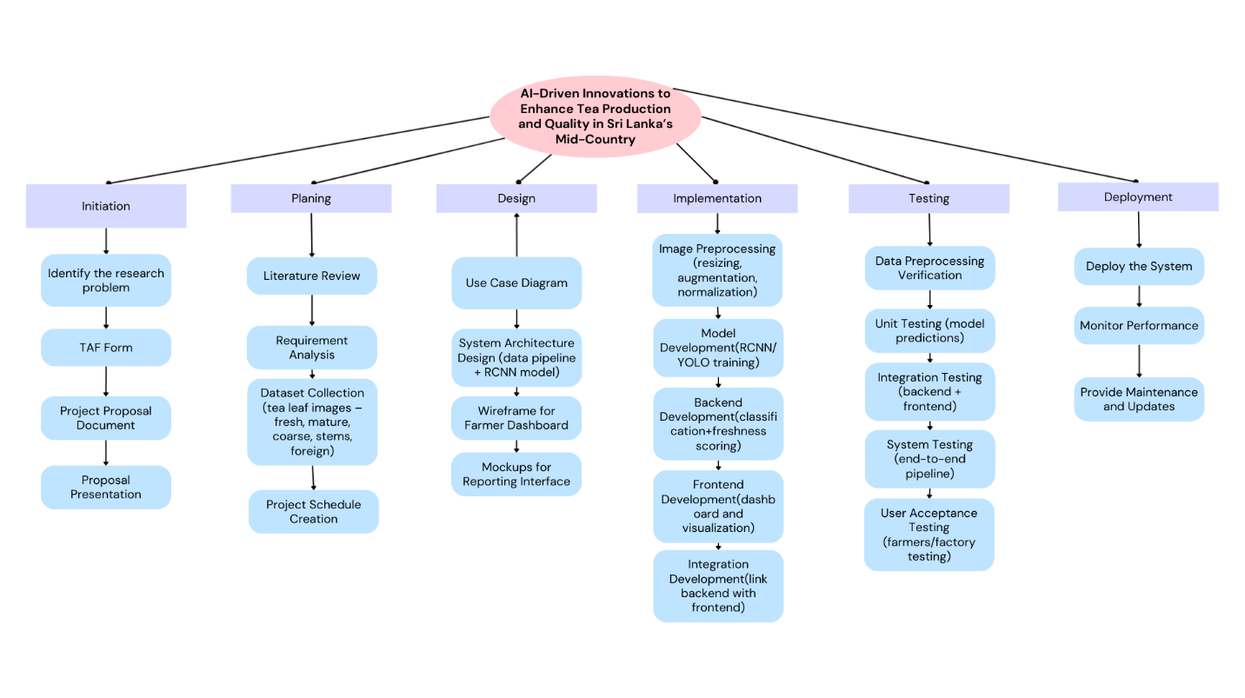
Figure 3.4:Work Breakdown Structure


3.4.7 Gannt Chart
Figure 3.5:Gantt Chart

4. Project Requirements

4.1 Functional Requirements
- Image Acquisition
- The system should allow users (farmers/pluckers) to capture or upload bulk tea leaf images placed on a rectangular cloth/surface.
- It should support multiple input formats (e.g., JPEG, PNG).
- Preprocessing
- The system should automatically adjust brightness, contrast, and remove noise to ensure consistency in image quality.
- Background segmentation should be applied to separate leaves from the cloth/background.
- Feature Extraction
- The system should analyze color (green/yellow/brown tones), texture, and shape of each leaf.
- Extracted features should be passed into the trained RCNN model.
- Object Detection & Classification
- The system should detect each individual leaf (or object like stem/rock) in the bulk image.
- Each detected object should be classified into categories:
  - Fresh Leaves (tender/yellow-green)
  - Mature Leaves (hard green)
  - Foreign Particles (stems, stones, impurities)
- Freshness Scoring
- The system should calculate the percentage of fresh vs matured leaves in the image.
- A freshness index (0–100%) should be displayed.
- Result Visualization
- The system should output the image with bounding boxes and color-coded labels (e.g., yellow for fresh, green for matured, red for foreign).
- A summary table should show the count of each class and overall freshness score.
- Data Storage & Reporting
- The system should store analyzed results in a database for future reference.
- Farmers should be able to generate simple reports of freshness trends across batches.
- User Interaction
- The system should provide a simple dashboard where farmers can upload photos, view results, and download reports.
- Results should be displayed in an easy-to-understand manner, even for non-technical users.

4.2 Non-Functional Requirements
- Accuracy: Minimum classification accuracy of 90% for single leaves and 95% for bulk leaves.
- Performance: Image upload and analysis results must be provided within 5–10 seconds.
- Scalability: The system must handle large volumes of images from multiple farmers simultaneously.
- Usability: The interface must be simple, mobile-friendly, and suitable for field use.
- Reliability: The system must work consistently under varying lighting conditions and image qualities.
- Security: Farmer data and results must be stored securely with restricted access.

4.3 User Requirements
- Farmers should be able to easily capture and upload photos of tea leaves using a smartphone.
- Factory supervisors should be able to view automated grading results.
- The system should provide decision-support feedback in simple, understandable language for farmers.
- Users should be able to compare current results with past assessments.
4.4 Software Requirements
- Frontend: React.js / Vue.js (mobile-friendly interface).
- Backend: Python (Flask/Django) for model integration.
- Machine Learning Frameworks: TensorFlow / PyTorch for CNN and R-CNN models.
- Database: MySQL / PostgreSQL for storing farmer data and results.
- Deployment: Cloud-based (AWS/GCP/Azure) or local server depending on availability.
- Tools: OpenCV for preprocessing, LabelImg/Roboflow for annotation, Jupyter for prototyping.

4.5 Expected Test Cases

Table 4.1:User case 1
Test case ID: SID_Test_01 |  |  | Test designed by: Abeysekara A.M.N
Test title: Tea Leaf Capture & Upload |  |  | Test designed day: 2025/8/28
Test priority (High/Medium/Low): High |  |  | Test executed by: Abeysekara A.M.N
Module name: Mobile App – Camera & Upload |  |  | Test executed day: 2024/12/28
Description : Verify that the mobile app captures a photo of tea leaves, attaches metadata, and uploads it to the server
Pre-conditions: Mobile device with app installed and user logged in.
Testing steps:
- Open app
- Capture photo
- Enter metadata (tea type, estate, plucker ID)
- Upload photo
Test ID | Test Inputs | Expected Output | Actual Output | Result (Pass/Fail) | Comments
A_Test_01 | Fresh leaf photo with metadata | Image saved and sent to web | Image successfully uploaded | Pass | Works as expected

Table 4.2:User case 2
Test case ID: WEB_Test_01 |  |  | Test designed by: Abeysekara A.M.N
Test title:Tea Type Identification |  |  | Test designed day: 2025/8/29
Test priority (High/Medium/Low): High |  |  | Test executed by: Abeysekara A.M.N
Module name: Classification (Model 1) |  |  | Test executed day: 2024/12/29
Description: Verify that the system correctly classifies the tea type (Green, Black, White, Oolong) from uploaded image.
Pre-conditions: Image available on server, user logged inUser logged in; model trained; dataset labeled.
Testing steps:
- Login to dashboard
- Select uploaded image
- Run "Classify Tea Type"
- View result
Test ID | Test Inputs | Expected Output | Actual Output | Result (Pass/Fail) | Comments
W_Test_01 | Bulk image of green tea leaves | Output: Green tea | Output: Green tea | Pass | Matches

Table 4.3: User case 3
Test case ID: WEB_Test_02 |  |  | Test designed by: Abeysekara A.M.N
Test title: Freshness Scoring and Leaf Grading |  |  | Test designed day: 2025/8/30
Test priority (High/Medium/Low): High |  |  | Test executed by: Abeysekara A.M.N
Module name: Detection (Model 2) |  |  | Test executed day: 2024/12/30
Description: Verify that the system detects fresh, matured, coarse leaves and calculates freshness % and quality grade.
Pre-conditions: User logged in, model trained and deployed
Testing steps:
- Upload image
- Run freshness detection
- View bounding boxes and % freshness
- See assigned grade
Test ID | Test Inputs | Expected Output | Actual Output | Result (Pass/Fail) | Comments
W_Test_02 | Image: 80% fresh, 15% matured, 5% stems | Output: Premium grade | Output: Premium grade | Pass | Good inference

5. Budget and Budget Justification

The following table presents the estimated monthly budget required to maintain and operate the proposed system. This monthly cost will remain approximately constant throughout the project duration.
Item | Monthly Cost (LKR) | Justification
GPU-enabled Cloud Access (AWS/GCP/Colab Pro) | 6,000 | Required for model training, evaluation, and deployment of CNN/R-CNN/YOLO models.
Dataset Storage (Cloud/Drive) | 1,000 | For storing annotated images, trained models, and reports.
Web Hosting / Server Deployment | 3,000 | For hosting the web-based dashboard and backend system.
Field Visit / Data Collection Allowance | 5,000 | Covers travel and related expenses for dataset updates or field verification.
Miscellaneous (Stationery, Documentation, Internet, etc.) | 2,000 | Monthly operational and reporting costs.
Total Estimated Monthly Cost = 17,000 LKR

Justification Summary
- The monthly recurring cost is 17,000 LKR, covering computing, storage, hosting, dataset upkeep, and reporting.
- One-time hardware (e.g., smartphone/camera) is excluded here and accounted separately at project initiation.
- Over a 12-month project, the cumulative cost will be 17,000 × 12= 204,000 LKR, in addition to one-time hardware expenses.

7.Commercialization

The proposed T-AI (Tea-AI) system a smart tea leaf freshness and grading detection solution powered by AI holds strong commercial potential within Sri Lanka’s tea ecosystem and beyond. By leveraging real-time image analysis and predictive modeling, the system directly addresses core inefficiencies in tea leaf quality assessment, grading inconsistencies, and post-harvest loss.

7.1 Domestic Commercial Rollout

At the national level, the system can be deployed in three major operational environments:

At Estate Collection Centers: Integrated into smart weighing stations to instantly evaluate and grade tea leaves upon arrival. This reduces human bias in grading and improves transaction transparency.

For Individual Farmers: Offered as a mobile app (compatible with Android devices) that allows pluckers and smallholders to capture leaf images, receive instant freshness grading, and optimize harvest batches before sending to collection.

At Factories: Used in pre-processing stages to sort batches by grade and quality, reducing time, energy, and chemical usage during drying and processing stages.

The service can follow a tiered subscription model:

Free/Pilot Tier: Basic leaf capture and classification (for smallholders).

Standard Tier: Factory dashboards, batch analytics, and report generation.

Enterprise Tier: API integrations, role-based access, training support, and cloud backup.

Additionally, hardware bundling (e.g., AI camera modules for weighing stations or factory intake belts) offers an upsell opportunity and enhances adoption.

7.2 Strategic Industry Partnerships

To ensure successful commercialization, the following partnerships are critical:

Sri Lanka Tea Board: For endorsement, policy alignment, and large-scale deployment across registered estates.

SLTFOA (Sri Lanka Tea Factory Owners’ Association): For direct rollout into factory operations and testing.

Agri-tech Startups and Local Device Integrators: For mobile phone bundling, last-mile agent training, and localized technical support.

Microfinance Institutions & NGOs: For financing solutions to help smallholders and rural pluckers adopt the app.

Through early pilot programs across select mid-country factories and estates in Central Province (e.g., Nawalapitiya, Hatale, Embilmeegama), adoption pathways and ROI metrics can be validated before nationwide scaling.

7.3 Regional and Global Expansion Potential

Beyond Sri Lanka, the same AI-powered grading framework can be customized and exported to other major tea-producing nations:

India: Especially Assam and Darjeeling, where manual plucking and auction-based selling dominate.

Kenya: One of the largest black tea exporters, facing grading fraud and large-scale post-harvest losses.

China and Vietnam: Where green and oolong varieties are sensitive to freshness degradation.

The core image detection algorithm can be retrained on localized datasets, enabling rapid customization across geographies. Strategic licensing to regional agricultural tech companies or inclusion into government agricultural digitization initiatives provides a scalable business model.

7.4 Revenue Streams

Stream Description
Subscription SaaS | Cloud-based platform access (per estate, per factory, or per broker account).
Pay-per-Analysis | Per image or batch processed fee for smallholder farmers.
Hardware Bundling | Integrated edge-AI devices with monthly maintenance packages.
Data-as-a-Service | Selling anonymized grading/quality analytics to research orgs or exporters.
Consulting & Training | Enterprise support, dashboard customization, and staff upskilling.

7.5 Long-Term Impact and Differentiation

Brand Differentiation: Certified use of T-AI grading technology can become a "Quality Stamp" for estates exporting to EU, US, or Japanese markets.

Sustainability Impact: By reducing coarse or damaged leaf processing, factories reduce energy and water use, aligning with ESG and carbon reduction goals.


Farmer Empowerment: Creates a trustworthy, decentralized evaluation mechanism for pluckers, ensuring fair pay and reducing disputes at weighing centers.

Figure 7.1:logo

References

[1] Z. Lin, H. Lu, and Z. Sheng, “The chemical and pharmacological effects of active ingredients in tea,” China Tea, vol. 40, no. 11, pp. 1–6, 2018. [Online]. Available: https://m.fx361.com/news/2018/1122/14853148.html
[2] Y. Wang, “Research on the application of neural network technology in tea classification,” Fujian Tea, vol. 38, no. 6, pp. 15–16, 2016. [Online]. Available: https://www.cnki.net
[3] S. Ahmed et al., “Environmental factors variably impact tea secondary metabolites in the context of climate change,” Frontiers in Plant Science, vol. 10, p. 939, 2019. DOI: 10.3389/fpls.2019.00939.
[4] Y. LeCun et al., “Backpropagation applied to handwritten zip code recognition,” Neural Computation, vol. 1, no. 4, pp. 541–551, 1989. DOI: 10.1162/neco.1989.1.4.541.
[5] A. Krizhevsky, I. Sutskever, and G. Hinton, “ImageNet classification with deep convolutional neural networks,” in Advances in Neural Information Processing Systems (NeurIPS 2012), pp. 1097–1105. Available: https://papers.nips.cc/paper/2012/file/c399862d3b9d6b76c8436e924a68c45b-Abstract.html
[6] K. Simonyan and A. Zisserman, “Very deep convolutional networks for large-scale image recognition,” arXiv preprint, arXiv:1409.1556, 2014. Available: https://arxiv.org/abs/1409.1556
[7] C. Szegedy et al., “Going deeper with convolutions,” in Proc. IEEE Conf. Computer Vision and Pattern Recognition (CVPR), 2015, pp. 1–9. DOI: 10.1109/CVPR.2015.7298594.
[8] C. Szegedy et al., “Rethinking the Inception architecture for computer vision,” in Proc. IEEE Conf. Computer Vision and Pattern Recognition (CVPR), 2016, pp. 2818–2826. DOI: 10.1109/CVPR.2016.308.
[9] K. He et al., “Deep residual learning for image recognition,” in Proc. IEEE Conf. Computer Vision and Pattern Recognition (CVPR), 2016, pp. 770–778. DOI: 10.1109/CVPR.2016.90.
[10] J. Hu, L. Shen, and G. Sun, “Squeeze-and-excitation networks,” IEEE Transactions on Pattern Analysis and Machine Intelligence, vol. 42, no. 8, pp. 2011–2023, 2020. DOI: 10.1109/TPAMI.2019.2913372.
[11] K. He et al., “Mask R-CNN,” in Proc. IEEE Int. Conf. Computer Vision (ICCV), 2017, pp. 2961–2969. Available: https://openaccess.thecvf.com/content_ICCV_2017/papers/He_Mask_R-CNN_ICCV_2017_paper.pdf
[12] Z. Yanyan, F. Maosheng, and S. Yun, “Study on sorting technology of fresh tea leaves based on CNN,” in Proc. IEEE Int. Conf. Electronic Measurement & Instruments (ICEMI), 2019, pp. 614–617. DOI: 10.1109/ICEMI46757.2019.9101900.
[13] Z. Gao et al., “Intelligent fresh-tea-leaves sorting system research based on CNN,” Transactions of the Chinese Society of Agricultural Machinery, vol. 48, no. 7, pp. 53–58, 2017. Available: https://www.nyjxxb.net/index.php/journal/article/view/481(in Chinese)
[14] C. Chang, “Intelligent fresh tea sorting machine based on neural network image analysis,” Chinese Journal of Agricultural Machinery Chemistry, vol. 34, no. 1, pp. 137–141, 2013. [Online]. Available: http://www.j-csam.org
[15] K. Wang and D. Liu, “Intelligent identification for tea state based on deep learning,” Journal of Chongqing University of Technology (Natural Science), vol. 29, no. 12, pp. 120–126, 2015. [Online]. Available: http://clgzk.qks.cqut.edu.cn
[16] S. Ji, L. Wang, S. Xiong, et al., “Technique for on-line tea-stalk distinction and its application,” Transactions of the Chinese Society of Agricultural Machinery, vol. 26, no. 1, pp. 56–60, 1995. [Online]. Available: https://www.nyjxxb.net
[17] Y. Qian et al., “Fresh tea leaves classification using Inception-V3,” in Proc. IEEE Int. Conf. on Intelligent Computing and Signal Processing (ICICSP), 2019, pp. 415–419. Available: https://ieeexplore.ieee.org/document/8958529
[18] J. Sivalingam et al., “tAssessee: Automatically assessing quality of tea leaves using image processing techniques,” in Proc. IEEE Int. Conf. on Advances in ICT for Emerging Regions (ICTer), 2022, pp. 160–165. DOI: 10.1109/ICTer58063.2022.10024078.
[19] S. Bhowmik, A. Talukdar, and K. Sarma, “Detection of disease in tea leaves using CNN,” in Proc. IEEE Int. Conf. (venue TBD), 2020, pp. xx–xx. (No DOI available)
[20] R. Latha et al., “Automatic detection of tea leaf diseases using deep CNN,” in Proc. IEEE Int. Conf. (venue TBD), 2021, Available:https://ieeexplore.ieee.org/document/9402225
[21] P. Rajan, B. Radhakrishnan, and L. Suresh, “Detection and classification of pests from crop images using SVM,” in Proc. IEEE Int. Conf. on Emerging Trends in Technology (ICETT), 2016. DOI: 10.1109/ICETT.2016.7873750.
[22] M. Loganathan, J. Sivakumaran, and S. Sivachandrabose, “Hybrid Mobile–Cloud Framework for Smart Agriculture: Design and Deployment Challenges,” IEEE Access, vol. 10, pp. 14597–14610, 2022. [Online]. Available: https://ieeexplore.ieee.org/document/9690291

