

Sri Lanka Institute of Information Technology

Faculty of Computing

## Data Warehousing and Business Intelligence (IT3021)

## Assignment 2

Submitted By:

## Pallepitiya N.D.

## IT19005386

Y3S1.15(DS-Weekday)

**Table of Content**

1. Data Set Source…………………………………………………….………...1
2. SSAS Cube Implementation………………………………………………....3
3. OLAP Operations…………………………………………………………....9
4. SSRS Reports……………………………………………………………....15

# Data Source

# DonorsChoose was Founded in 2000 by a highschool teacher in Bronx, DonorsChoose empowers school teachers to request needed school materials for their students. There are more than thousand

# -ds teacher requests that people can donate to. Teachers posts Projects to relevant topics and donors

# Donate. The organization has gained the trust of the society due to the efficiency and clarity.

# The ER diagram of the DonorsChoose dataset is attached below

ER Diagram

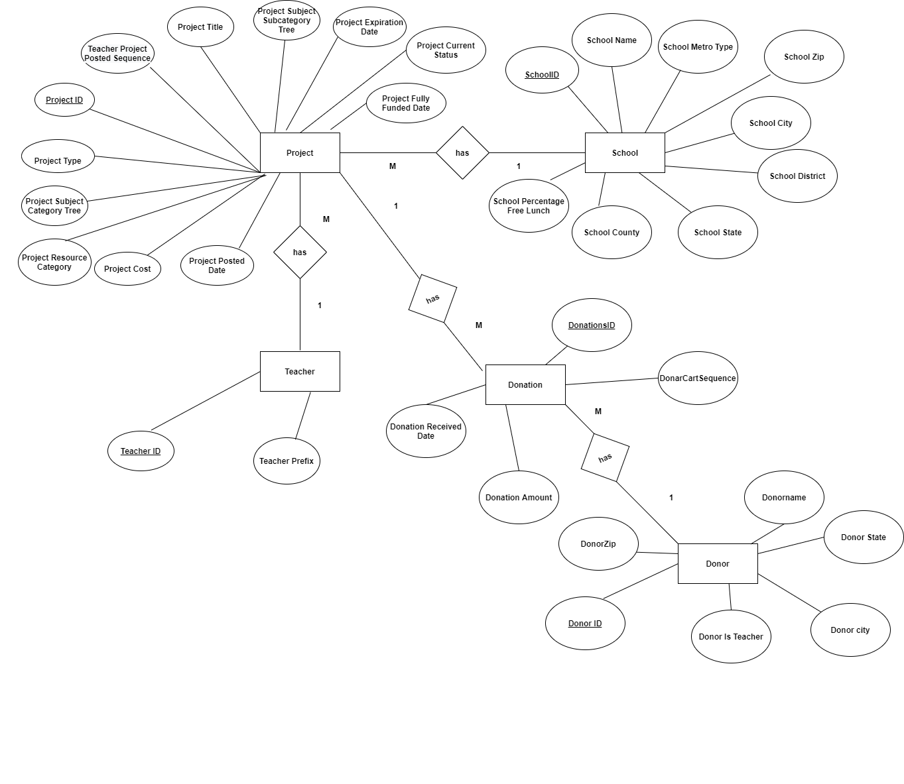

The dataset used for this assignment is based on the first assignment. The datawarehouse created

in the first assignment was used to deploy the analysis service cube and other reports.

There are five dimensions and one fact table in the datawarehouse namely

1. FactDonations

2. DimProject

3. DimDonor

4. DimTeacher

5. DimSchool

6. DimDate

The Star Schema of the datawarehouse is attached below.

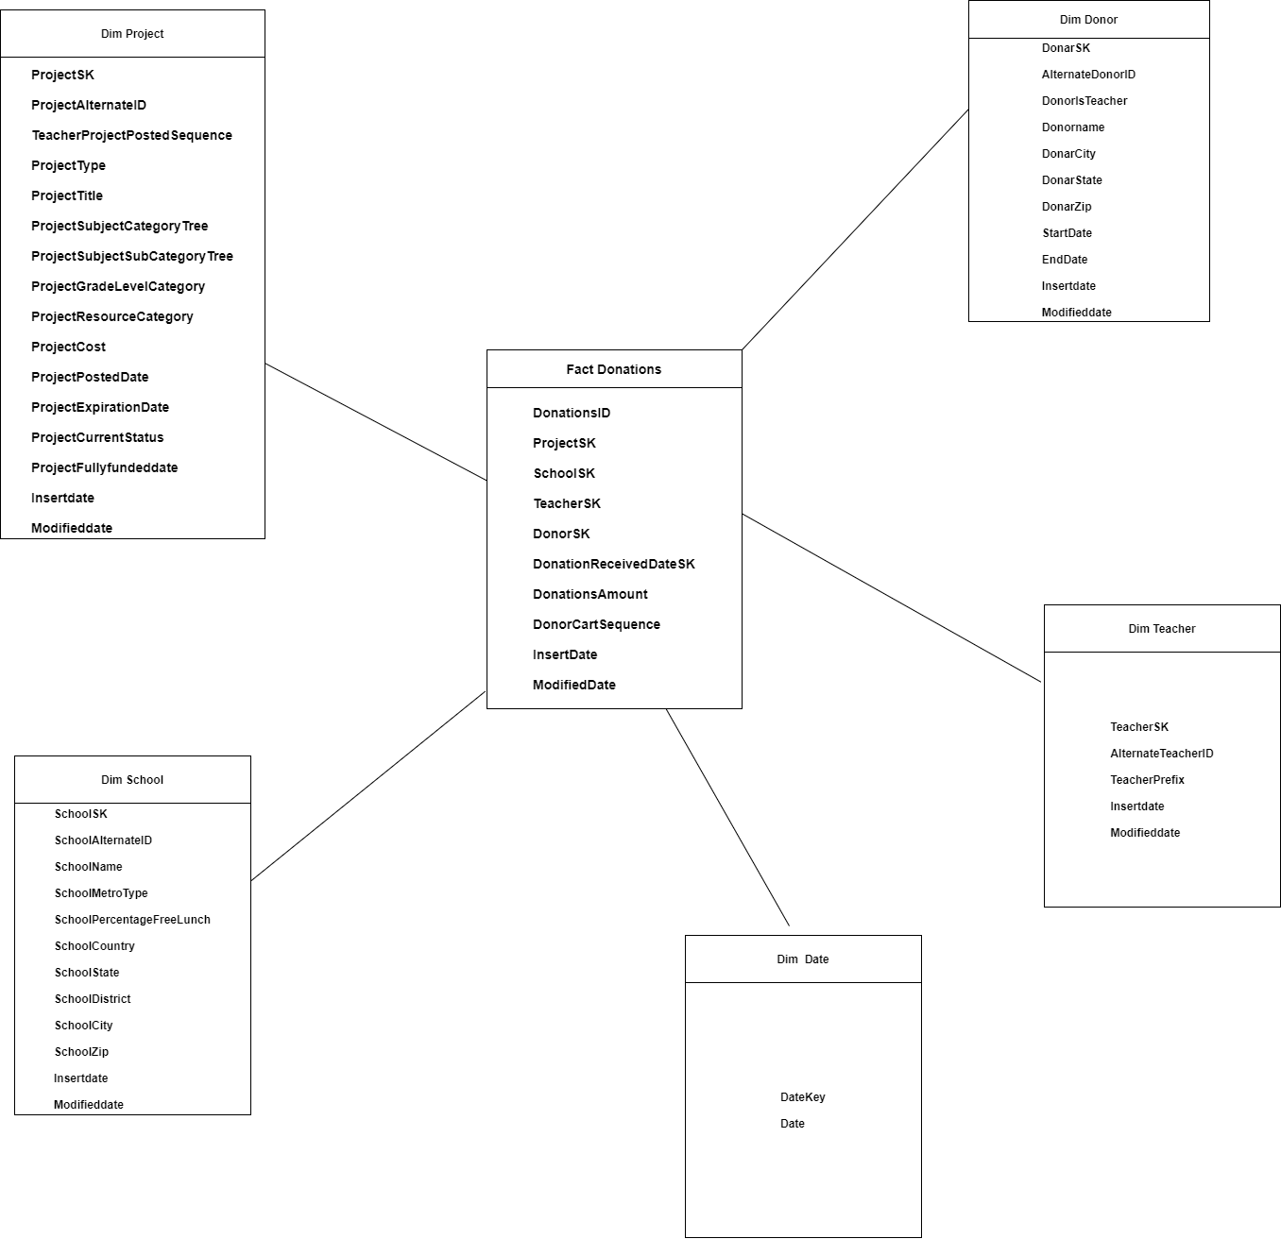

1. **SSAS Cube Implementation**

* Cube was implemented using SQL server data tools and deployed in SQL Server Management Studio
* Initially the Datawarehouse which was implemented in the Assignment1 was used as the

Datasource and a connection was made to it.

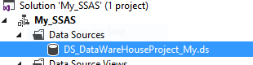

* Then a datasource view was created

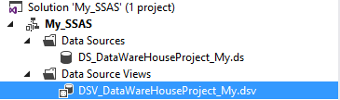

* Then the links with the fact tables and dimension tables were created. The links were as follows

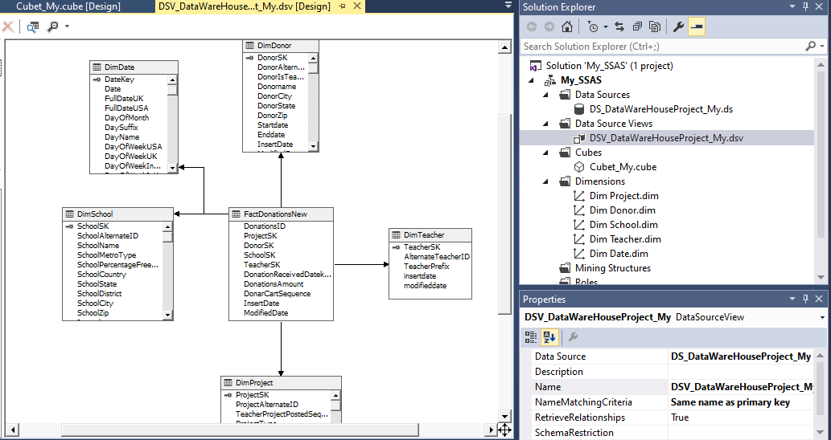

* Then in the cube wizard, FactDonationsNew was selected as the measurable group table and the cube was created.

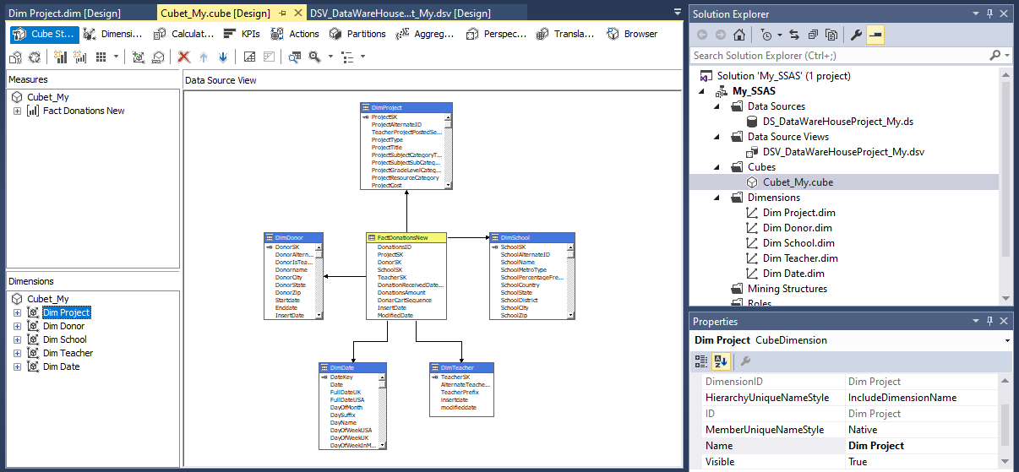

* Next the primary keys for all the dimensions along with the relationships were created.
* Next the Hierarchies were defined

1)Date Hierarchy

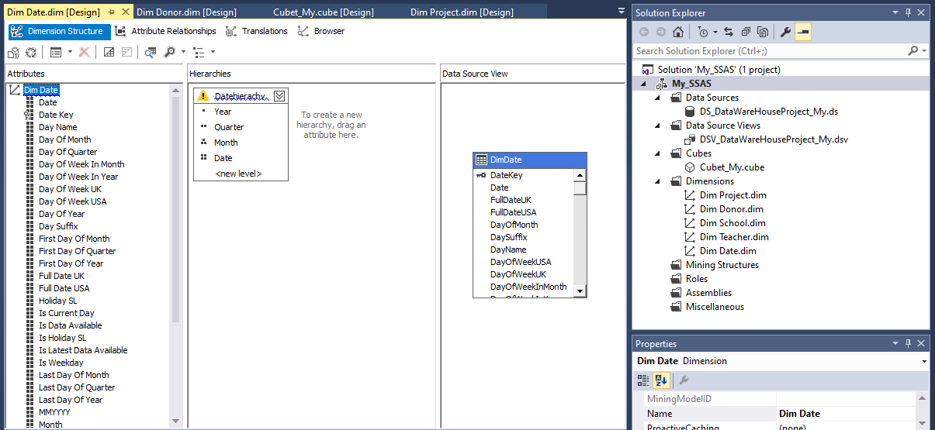

2)DonorAddress Hierarchy

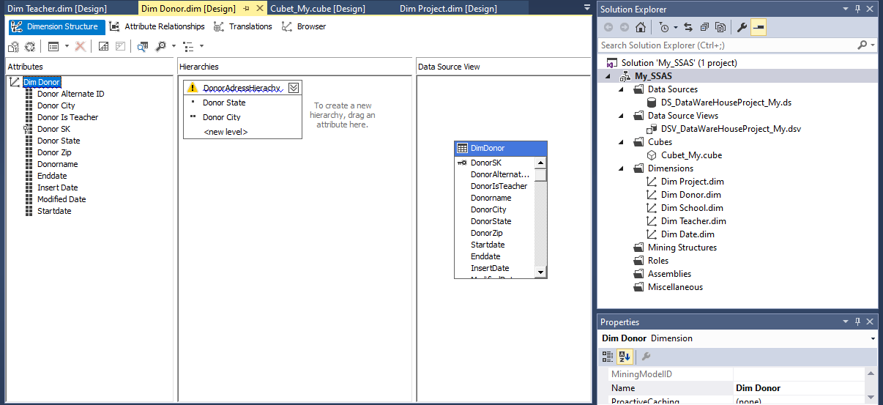

3)SchoolAddress Hierarchy

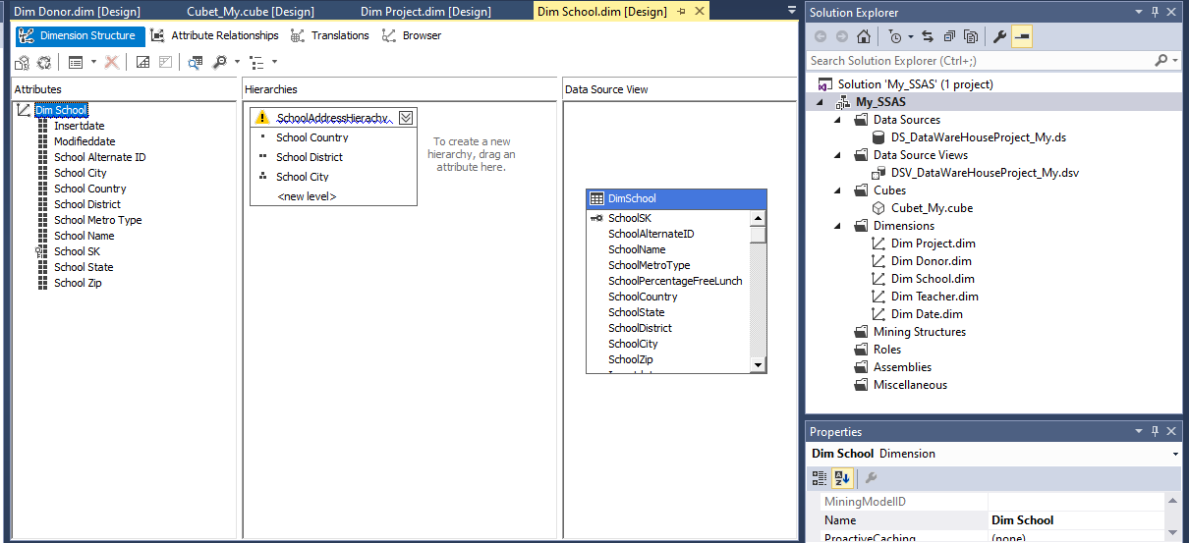

4)Project Hierarchy

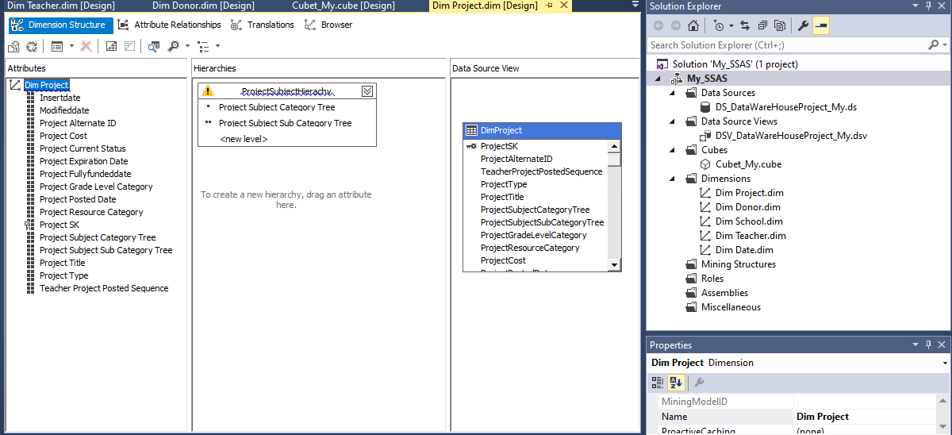

* Then a KPI was created for the donations amount

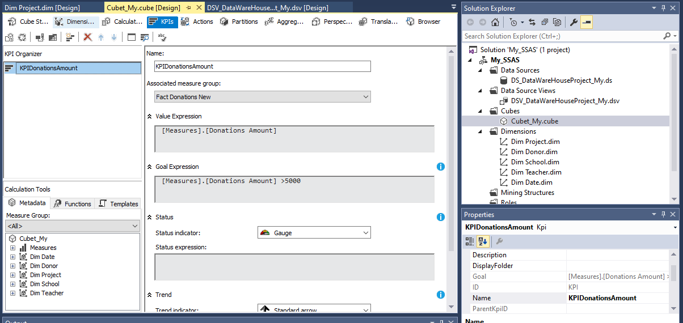

* Then finally the cube was deployed

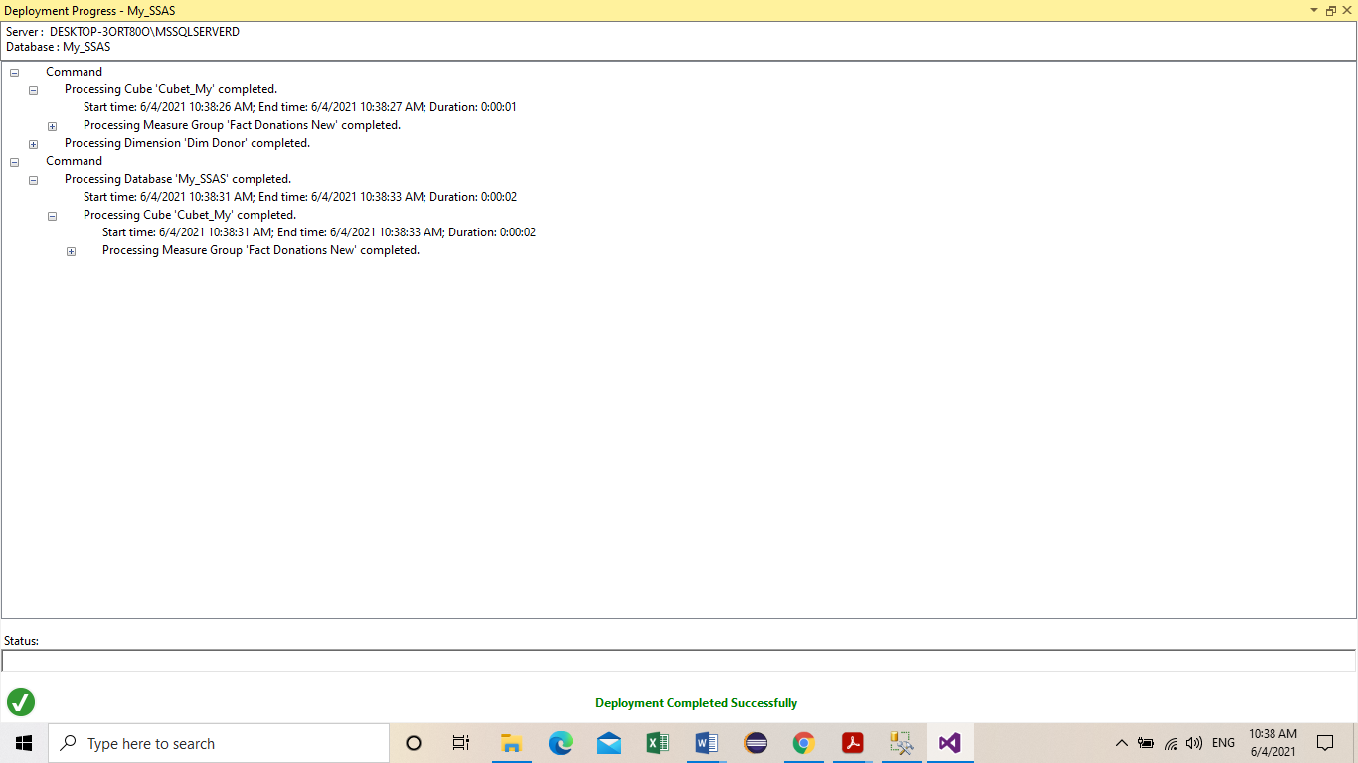

* Deployment in SSMS

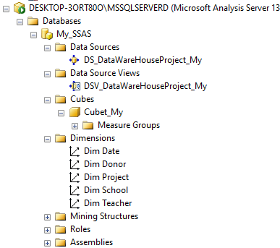

* Browsing the cube

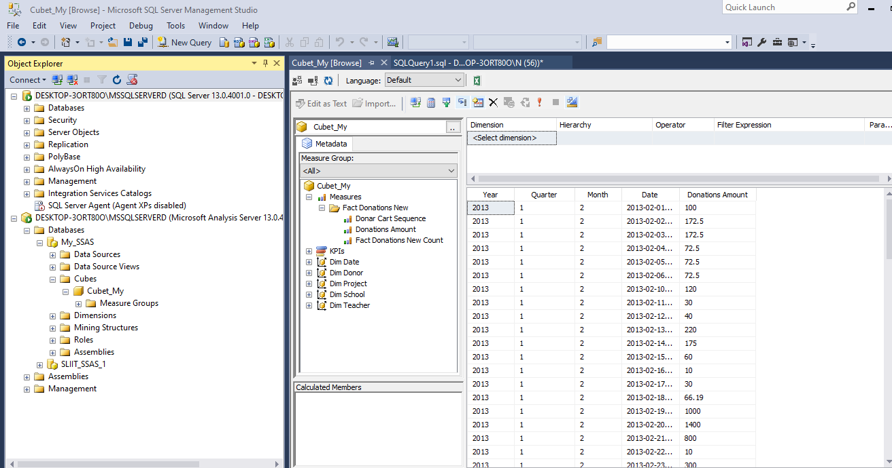

1. **OLAP Operations**

The Excel workbooks were connected with the analysis services through the Data tab.

1. Roll-up

The Roll up operation is presented using the Subject Category hierarchy of the

project dimension with the sum of the donations amount.

Project Subject SubCategory tree

Project Subject Category tree

Project Grade Level Category

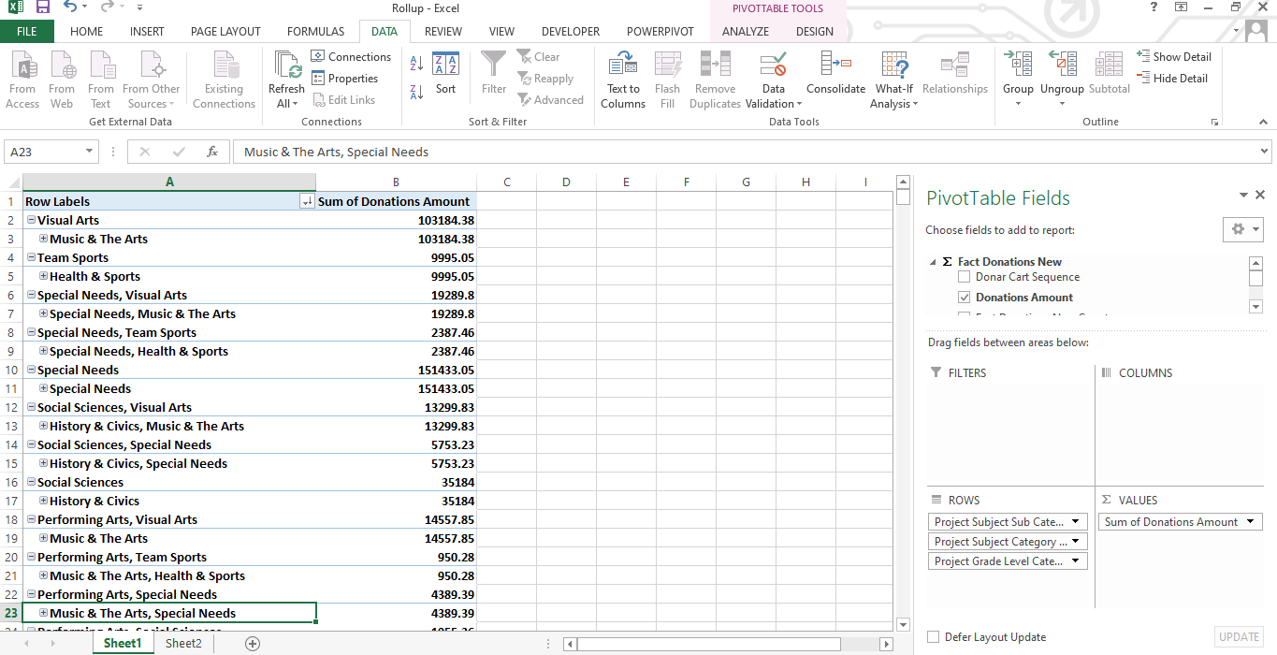

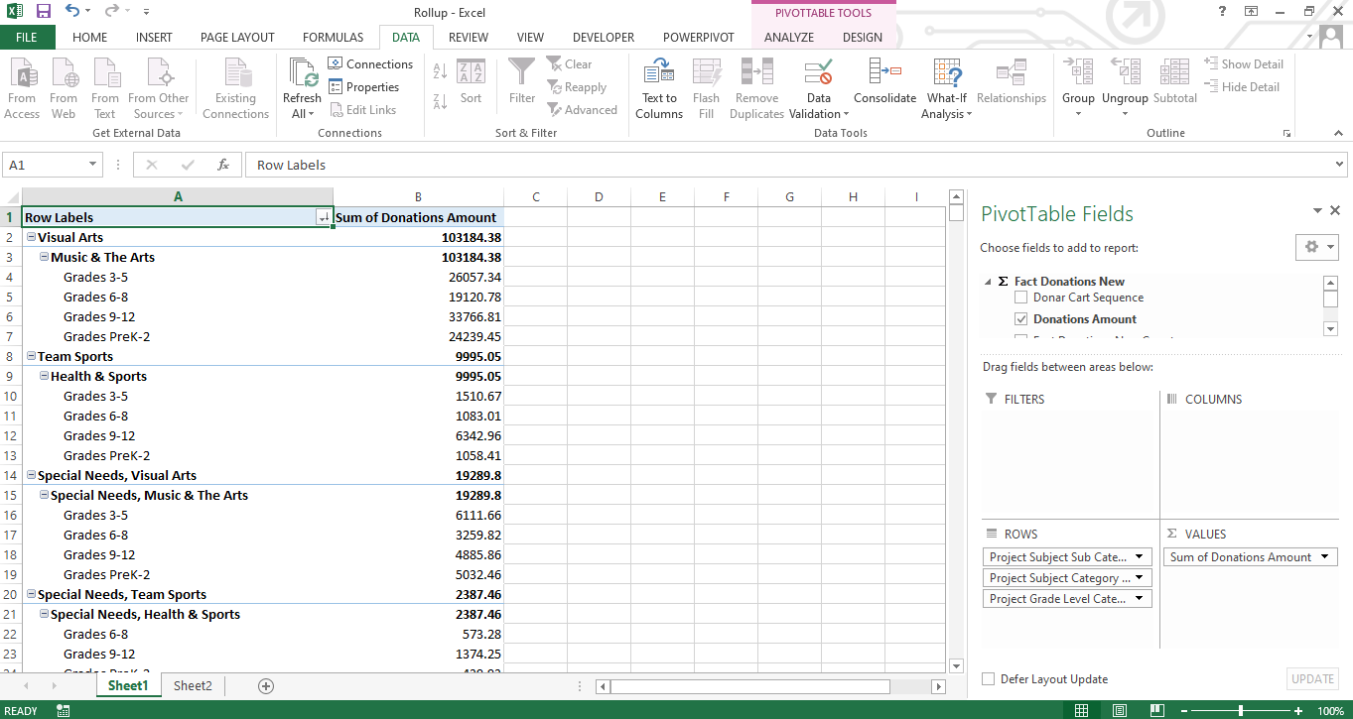

1. Drill-down

The Dill down operation is presented using the School Address hierarchy of the

school dimension with the sum of the donations amount and Goal of the KPI of the donations amount.

School Country

School District

School City

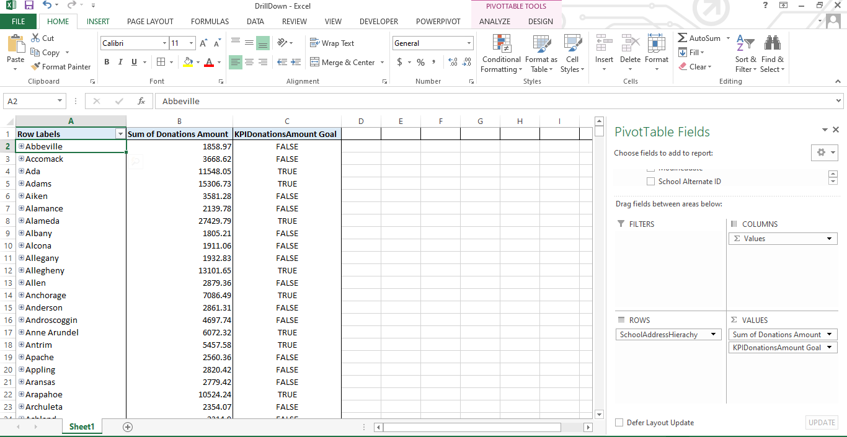

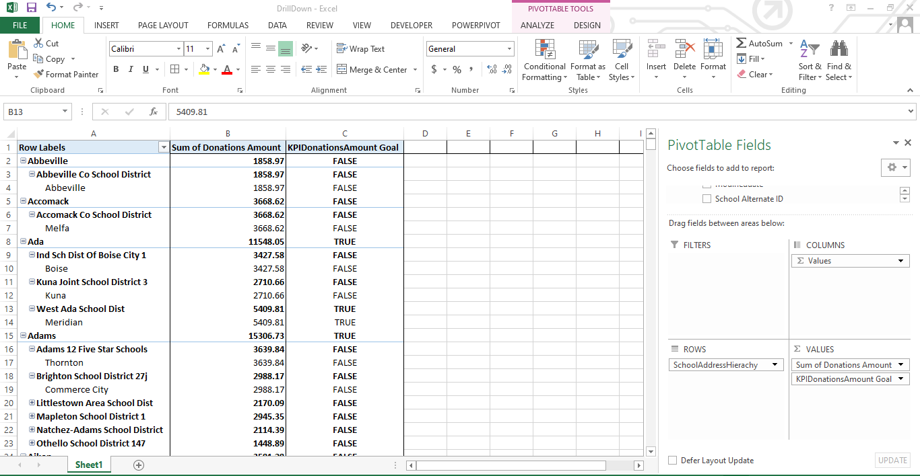

1. Slice

The Slice operation is presented using the Quarter 4 of the Date Dimension and Project Grade

level category and Project Resource level category of the Project dimension with the sum

of the donations amount

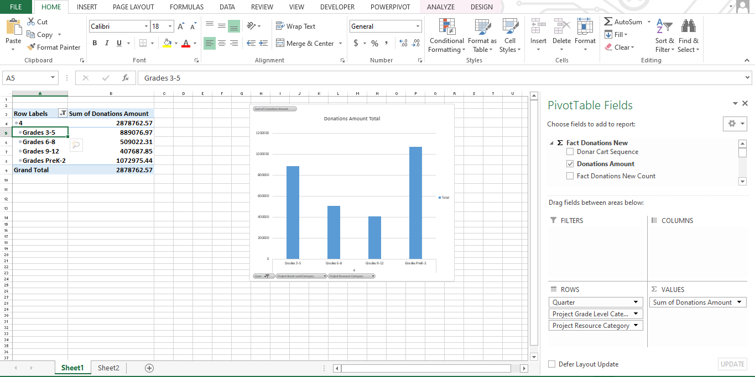

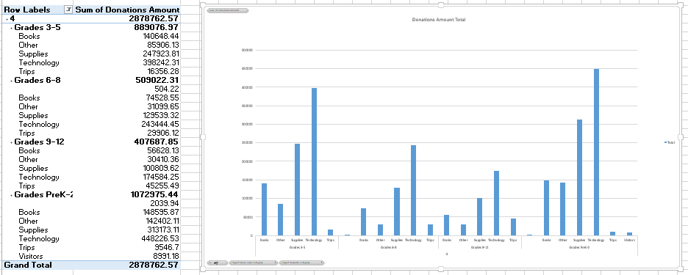

1. Dice

The Dice operation is presented using the Quarter 3 and 4 of the Date Dimension , seven donor states were selected namely California, New Hampshire, Ohio ,Pennsylvania ,Texas ,Washington

From Donor Dimension and Books and Technology were selected from Project Resource category

of Project Dimension.

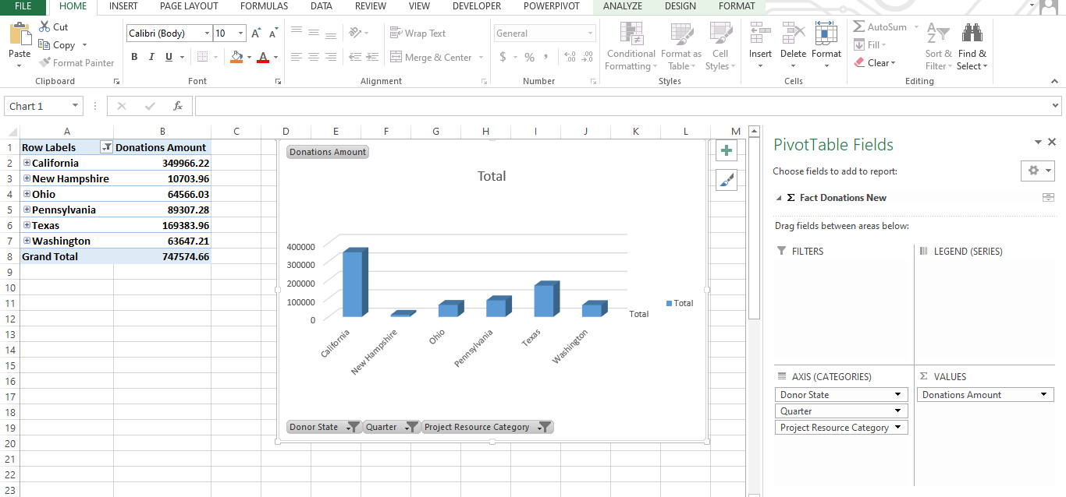

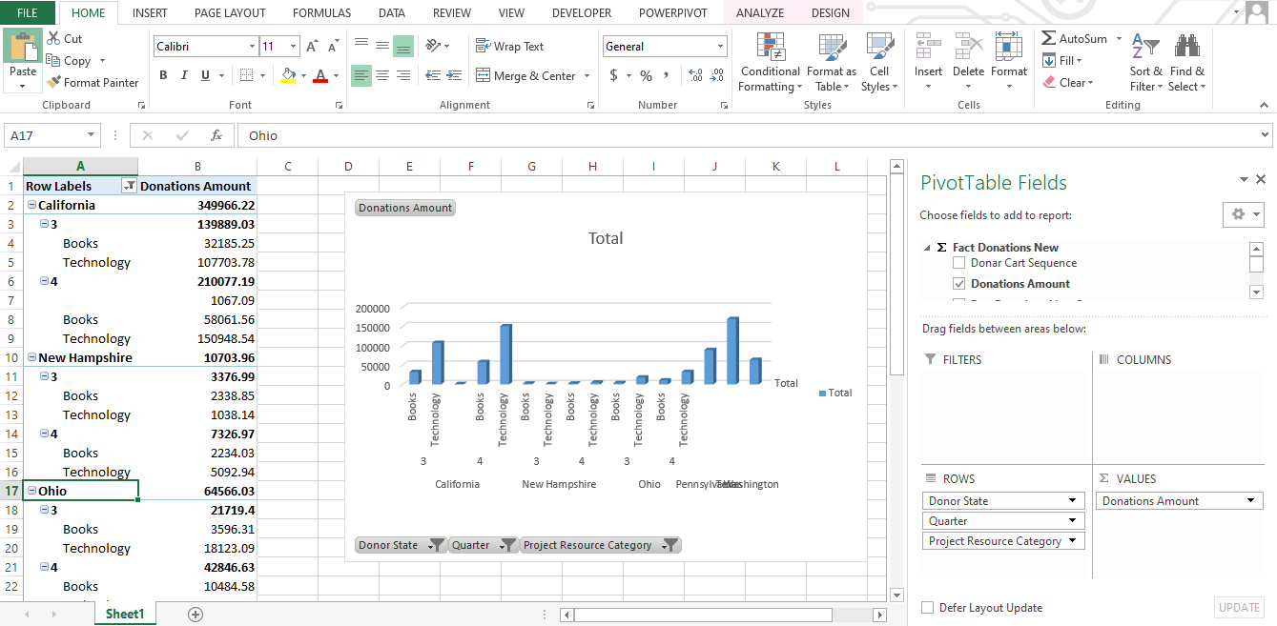

1. Pivot

Pivot operation rotates the data axes to provide an alternative presentation by swapping

the rows and columns.

The Project Grade Level category of Project Dimension was used as the column and

School Metro Type of School Dimension was used as the row along with the sum

of the donations amount in the first pivot table.

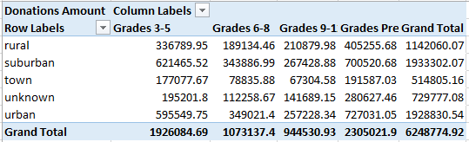

The Project Grade Level category of Project Dimension was used as the row and

School Metro Type of School Dimension was used as the column along with the sum

of the donations amount in the second pivot table.

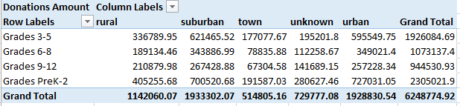

A Bar chart is also used to visualize the data

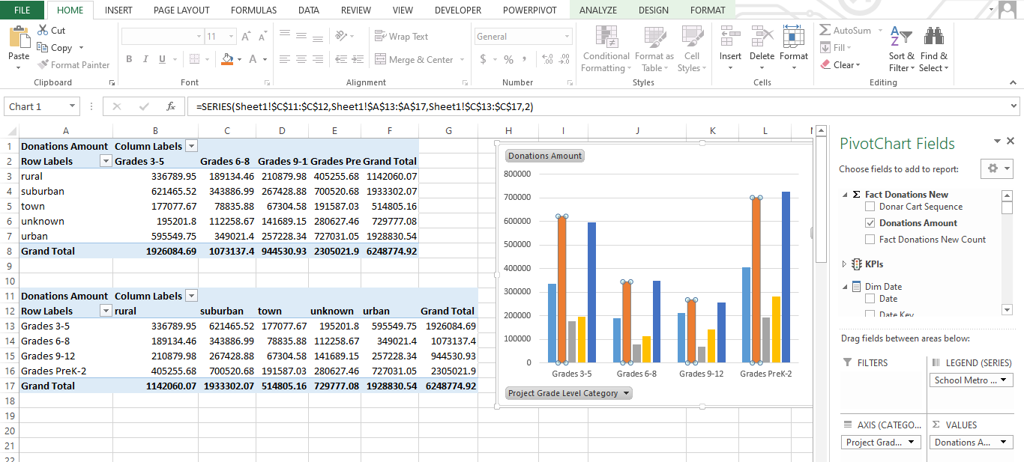

1. **SSRS Reports**

Report Builder was used to create the paginated reports using the datawarehouse. They were

Published in the SSRS web portal and users can view reports and interact through it. There were

4 types of reports generated from Report Builder and published in SSRS web portal.

**Report 1 : Report with a Matrix**

Report For monthly donations Amount for year 2013 on Project Grade Level Category

Initially a connection for the datasource was created.

Then a dataset was created. The below mentioned query was used to execute the dataset.

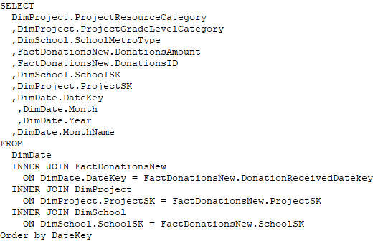

Then Row Groups were selected Based on ProjectGradeLevelCategory and SchoolMetroType and Column Groups were based on the month names and the sum of the donations amount were calculated within all those categories.

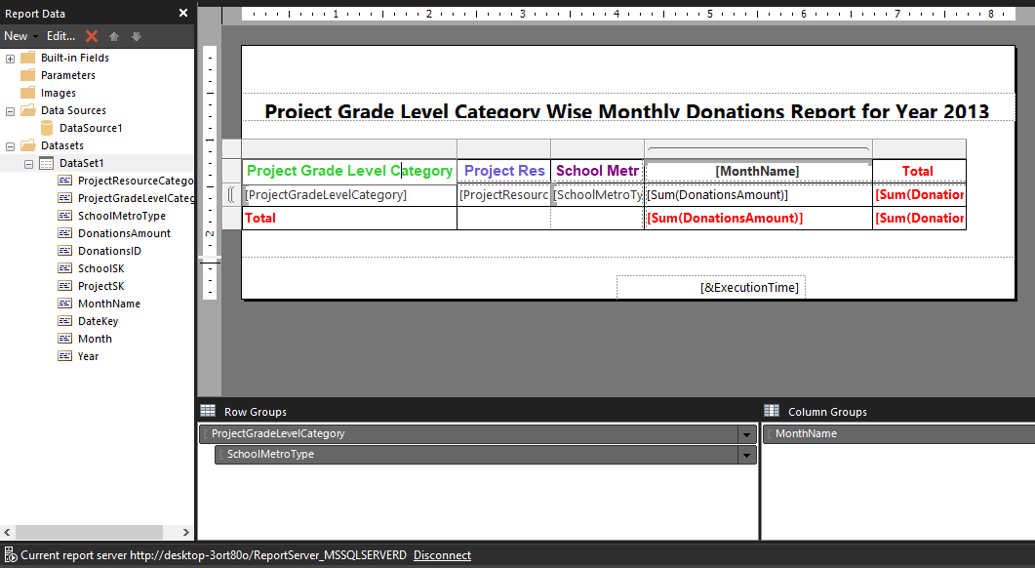

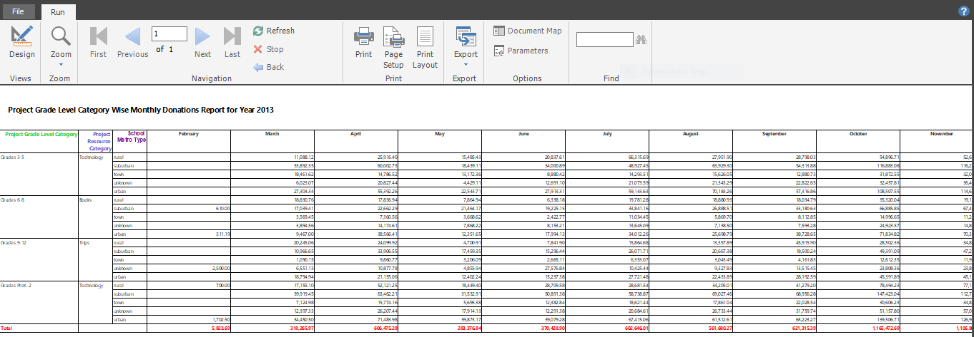

Report Published in the SSRS Web-Portal

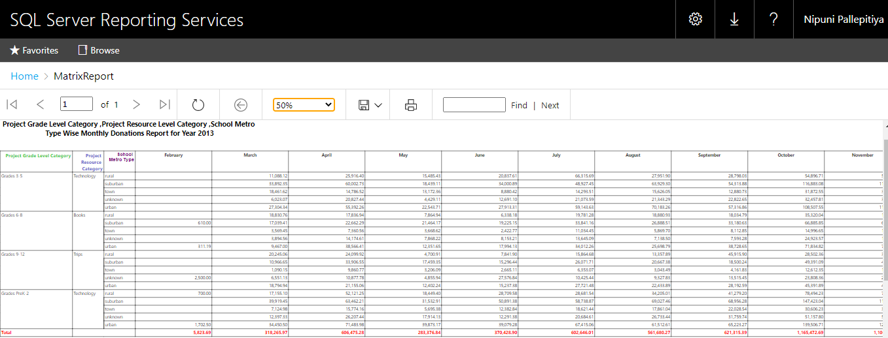

**Report 2 : Report with Multiple Parameters**

Report For monthly donations Amount for year 2013 based Donor State and Donor City

Initially a connection for the datasource was created.

Then a dataset was created. The below mentioned query was used to execute the dataset.

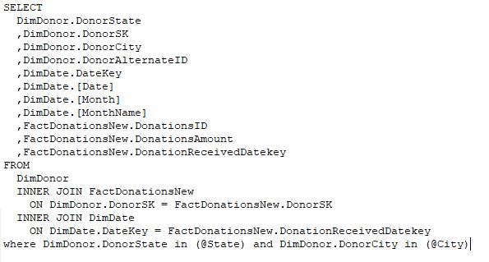

2 parameters were created namely state and city.According to the state or states selected by the

user the cities are loaded. For both State and City parameters multiple values were allowed.

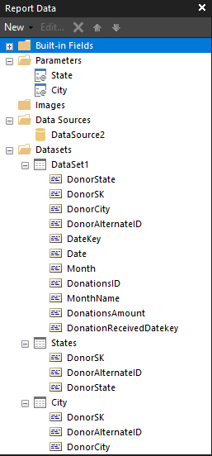

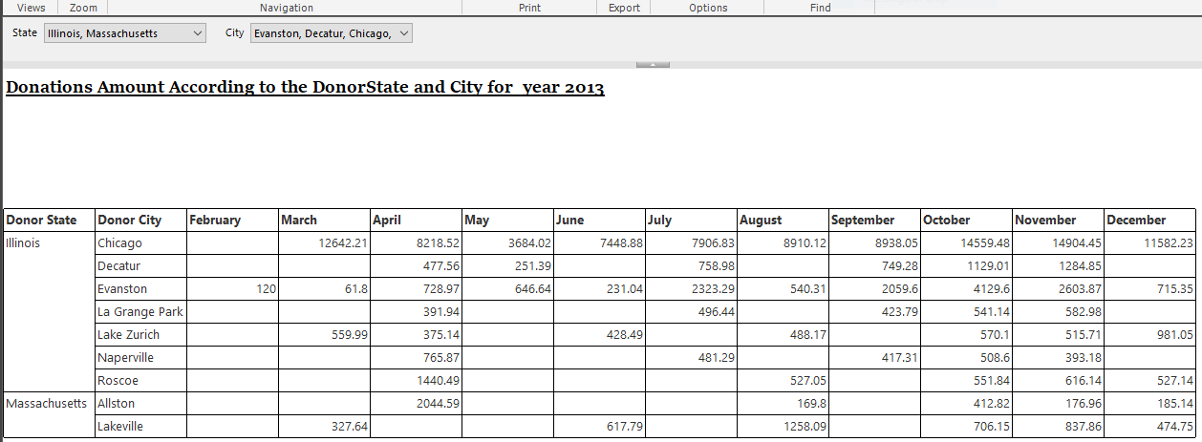

Report Published in the SSRS Web-Portal

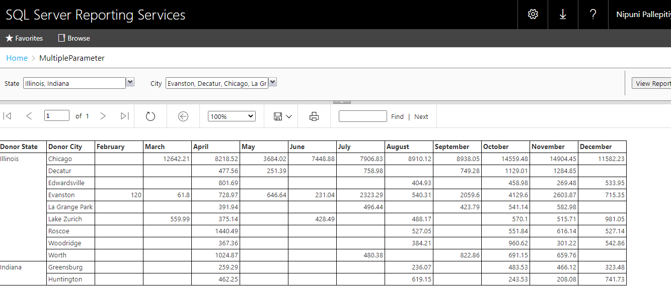

Report Published in SSRS Web- Portal using a bar chart

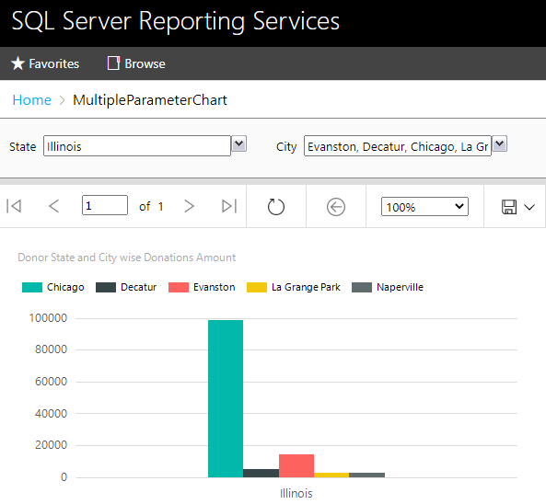

**Report 3 : Drilldown Report**

Report For Quarter Wise Monthly Donations Amount Acccording to Project Grade Level category

Initially a connection for the datasource was created

Then a dataset was created. The below mentioned query was used to execute the dataset

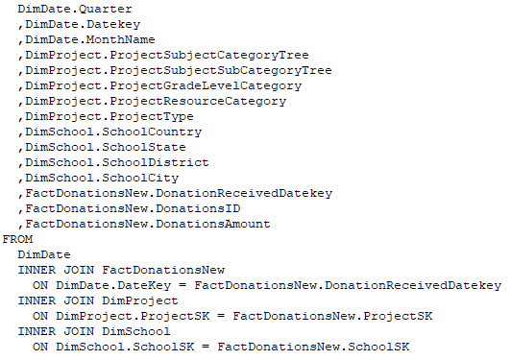

A drill down created according to the quarter wise monthly donations amount received for the project grade Level categories in year 2013.Futher more Row Groups were Quarter,Month Name and Column groups were Project Grade Level category

# D:\Year3My\DWBI\screenshots\report3Reportbuilder.PNG

# Report published in SSRS web portal

# D:\Year3My\DWBI\screenshots\Report3Webportal.PNG

**Report 4 : DrillThrough Report**

Report for Project Grade level wise Project cost and Donations Amount

Initially a connection for the datasource was created

Then a dataset was created. The below mentioned query was used to execute the dataset

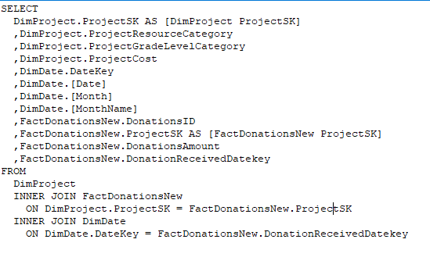

Here when the user clicks on the project grade level category of a chart it redirects to another chart where it shows the project Resource category wise sum of project costs and donations amount.

Project Grade level wise project cost in drill through report1

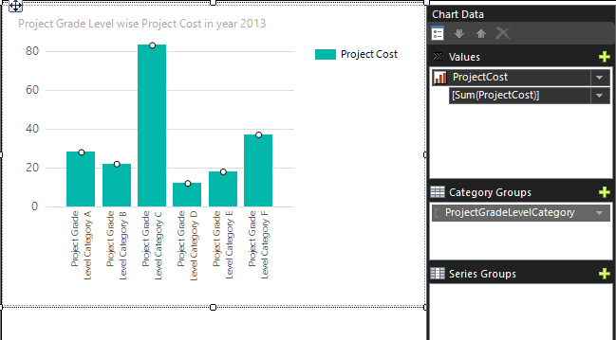

Project Grade Level wise donations amount in drill through report1

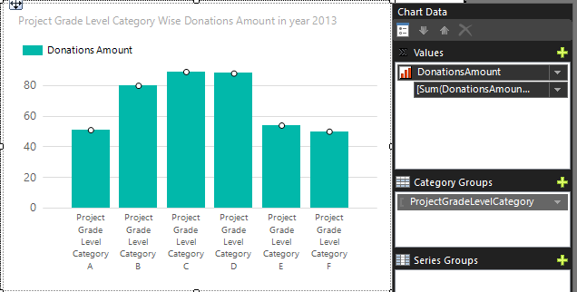

When user clicks the bars the report is redirected to another chart which shows the project resource level category according to the selected project grade level category

Project Resource Level wise sum of project costs in drill through report2

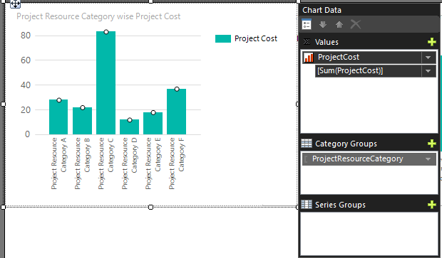

Project Resource Level wise sum of donations amount in drill through report2

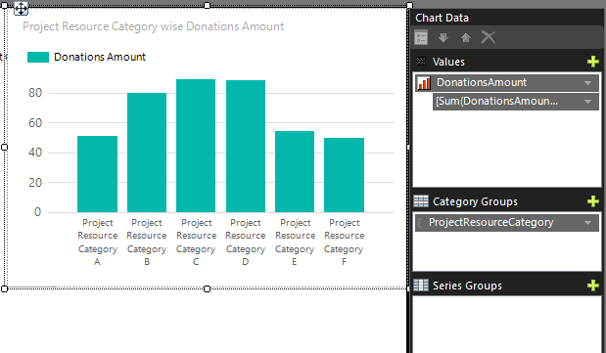

Using the drill through1 report when the user clicks on a bar as an action its passed to the drillthough report 2. The parameter value passed is the project Grade level category.In the drillthrough report2 the resource level category is based on the project grade level category that is passed.

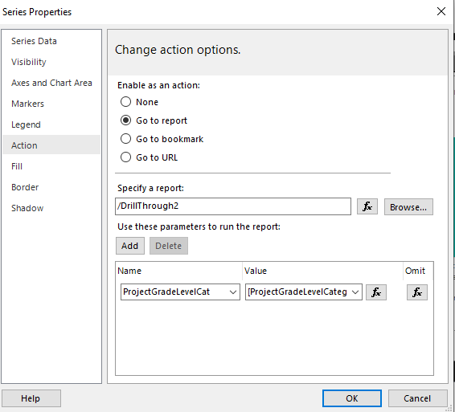

# Report Published in the SSRS web portal

# D:\Year3My\DWBI\screenshots\report4newone11.PNG

# When user clicks its redirected to the Project Resource Level category wise report

# D:\Year3My\DWBI\screenshots\report4newtwo22.PNG