INDIAN INSTITUTE OF TECHNOLOGY (ISM) DHANBAD
Career Development Centre (CDC)

PROPOSAL
CDC CONCLAVE 2026
An Industry-Academia Engagement Initiative

Venue: IIT (ISM) Dhanbad Campus
Dates: 21st- 22nd August 2026
Expected Industry Delegates: 10 (approx.)
Expected Student Participation: 500-600 students
Organized by: Career Development Centre (CDC), IIT (ISM) Dhanbad

Document Date: July 2026

1. Executive Summary
The Career Development Centre (CDC), IIT (ISM) Dhanbad proposes to organize CDC Conclave 2026, a two-day industry engagement event scheduled for 21st- 22nd August 2026 on campus. The Conclave is envisioned as a structured platform that brings senior industry leaders and organizations face-to-face with students, faculty, and the institute's placement ecosystem. Unlike a placement drive, the Conclave is designed purely as a knowledge-sharing and employer-branding initiative, through which participating companies deliver keynote addresses and company spotlight sessions covering industry trends, emerging technologies, and career pathways for engineering graduates.
The event will host approximately 10 industry delegates across two days: Core Industries on Day 1, and Corporate, Technology & Consulting on Day 2 - with an estimated student turnout of 500-600 across both days. The total estimated budget for the Conclave is ₹3,00,000, covering travel, merchandise, guest mementos, branding, and documentation.

2. Objectives
- Strengthen long-term industry-academia relations between IIT (ISM) Dhanbad and leading organizations across core, technology, and consulting sectors.
- Provide students with direct, informal access to senior industry leaders beyond the structured format of campus placements.
- Create awareness among students about current industry trends, evolving skill requirements, and the impact of AI and digital transformation across sectors.
- Offer participating companies a dedicated platform for employer branding and visibility on campus.
- Build a sustainable, annual industry-engagement calendar event for the institute, distinct from recruitment activities.

3. Expected Outcomes
- Enhanced visibility and goodwill for participating companies among the student community.
- Improved student awareness of industry expectations, which is likely to translate into better placement readiness in subsequent cycles.
- A stronger, documented industry network for CDC to draw upon for future recruitment drives, internships, and guest lectures.
- A reusable event framework (keynote + spotlight format) that can be scaled in future editions.
- A post-event report and company information booklet that can be used for institutional records and future sponsorship outreach.

4. Benefits to Students
- Interaction with senior industry professionals in an informal, non-evaluative setting.
- Clarity on the skills, tools, and mindset expected by top recruiters, ahead of the placement season.
- Exposure to a broader set of career pathways including core, consulting and technology roles that students may not otherwise encounter.
- Opportunity to build professional connections that may assist in internship and job search efforts.

5. Benefits to Companies
- A low-pressure platform to build brand recall among students well ahead of the placement season.
- Opportunity to showcase organizational culture, technology stack, and career pathways to a large, relevant student audience.
- Direct feedback and interaction with a talent pool, without the logistical overhead of a placement drive.
- Institutional recognition and goodwill from association with IIT (ISM) Dhanbad.

6. Why Companies Should Participate

Organizations seeking to engage with high-calibre, future-ready talent

Connect with IIT Guwahati's exceptional student pool

Organizations interested in fostering long-term institutional partnerships

Build valuable, collaborative relationships with leading academic institutions

Organizations exploring collaborative opportunities across talent, research, and innovation

Open new avenues for joint ventures, research projects, and innovation ecosystems

Organizations looking to participate in thoughtful, peer-level industry dialogue

Engage in strategic discussions with top-tier industry leaders and thought pioneers6. 9. Event Flow & Tentative Schedule
9.1 Schedule – Format A (Panel Discussion Model)
Day 1 – 21st August 2026 (Core Industries)
Time | Session Details
09:30 – 10:00 | Registration & Welcome  Venue: Penman Auditorium
10:00 – 10:15 | Inaugural Address  Director / Dean (CDC), IIT (ISM) Dhanbad  Venue: Penman Auditorium
10:15 – 12:15 | Panel Discussion 1  Circuital Core Industries: Transformation, Automation & Future Workforce Readiness  Panelists:  • Delegate 1 – Senior Representative, Company A  • Delegate 2 – Senior Representative, Company B  • Delegate 3 – Senior Representative, Company C  • Moderator – CDC Coordinator  Venue: Penman Auditorium
12:15 – 13:15 | Lunch Break
13:15 – 15:15 | Panel Discussion 2  Non-Circuital Core Industries: Building India's Infrastructure  Panelists:  • Delegate 4 – Senior Representative, Company D (Steel / Mining)  • Delegate 5 – Senior Representative, Company E (Manufacturing / Construction)  • Moderator – CDC Coordinator  Venue: Penman Auditorium
15:15 – 15:45 | Networking Tea & Closing Remarks – Day 1
15:45-17:00 | Break
17:00-18:00 | Campus Tour ( i2H, iRH, Texmin, Library, Final Photoshoot at Heritage, and Department)

Day 2 – 22nd August 2026 (Technology & Consulting)
Time | Session Details
09:30 – 10:00 | Registration & Welcome  Venue: Penman Auditorium
10:00 – 10:15 | Opening Remarks  Director/Dean Inaugural Address  Venue: Penman Auditorium
10:15 – 12:15 | Panel Discussion 1  Technology & Innovation: Building the Future  Panelists:  • Delegate 6 – Senior Representative, Company F  • Delegate 7 – Senior Representative, Company G  • Delegate 8 – Senior Representative, Company H  • Moderator – CDC Coordinator  Venue: Penman Auditorium
12:15 – 14:00 | Lunch Break
14:00-16:00 | Panel Discussion 2  Consulting & Strategy: Solving Tomorrow's Business Problems  Panelists:  • Delegate 9 – Senior Representative, Company I (Management Consulting)  • Delegate 10 – Senior Representative, Company J (Strategy / Risk Advisory)  • Moderator – CDC Coordinator  Venue: Penman Auditorium
16:00– 16:30 | Valedictory Session, Vote of Thanks & Certificate Distribution  Venue: Penman Auditorium
16:30-17:30 | Break
17:30-16:30 | Campus Tour ( i2H, iRH, Texmin, Library, Final Photoshoot at Heritage)

9.2 Schedule – Format B (Individual Company Sessions Model)
Day 1 – 21st August 2026 (Core Industries)
Time | Session Details
09:00 – 09:30 | Registration & Welcome  Venue: Penman Auditorium
09:30 – 09:45 | Inaugural Address  Director / Dean (CDC), IIT (ISM) Dhanbad  Venue: Penman Auditorium
09:45 – 10:45 | Company 1 Session – Circuital Core  Industry Keynote (30–35 min) + Company Spotlight (20–25 min)  Venue: Penman Auditorium
10:45 – 11:45 | Company 2 Session – Circuital Core  Industry Keynote + Company Spotlight  Venue: Penman Auditorium
11:45 – 14:00 | Lunch Break
14:00 – 15:00 | Company 3 Session – Non Circuital Core  Industry Keynote + Company Spotlight  Venue: Penman Auditorium
15:00 – 16:00 | Company 4 Session – Non-Circuital Core  Industry Keynote + Company Spotlight  Venue: Penman Auditorium
16:00 – 16:30 | Closing Remarks – Day 1 Valedictory Session, Vote of Thanks & Certificate Distribution
16:30 – 17:00 | Break
17:00-18:00 | Campus Tour

Day 2 – 22nd August 2026 (Technology & Consulting)
Time | Session Details
09:00 – 09:30 | Registration & Welcome  Venue: Penman Auditorium
09:30 – 09:45 | Inaugural Address  Director / Dean (CDC), IIT (ISM) Dhanbad  Venue: Penman Auditorium
09:45 – 10:45 | Company 1 Session – Consulting  Industry Keynote (30–35 min) + Company Spotlight (20–25 min)  Venue: Penman Auditorium
10:45 – 11:45 | Company 2 Session – Consulting  Industry Keynote + Company Spotlight  Venue: Penman Auditorium
11:45 – 14:00 | Lunch Break
14:00 – 15:00 | Company 3 Session – Tech  Industry Keynote + Company Spotlight  Venue: Penman Auditorium
15:00 – 16:00 | Company 4 Session – Tech  Industry Keynote + Company Spotlight  Venue: Penman Auditorium
16:00 – 16:30 | Closing Remarks – Day 2, Valedictory Session, Vote of Thanks & Certificate Distribution
16:30 – 17:00 | Break
17:00-18:00 | Campus Tour

Note: Timings are tentative and subject to final confirmation based on the number, availability, and panel preference of participating delegates.

10. Roles of the Career Development Centre (CDC)
- Identify, invite, and confirm participation of industry delegates across both days.
- Coordinate travel, accommodation, and hospitality arrangements for all delegates.
- Manage end-to-end event logistics, including venue booking, audio-visual setup, and seating.
- Oversee student registration, attendance tracking, and audience coordination for each session.
- Prepare and distribute a company information booklet ahead of the event.
- Coordinate with student volunteers for registration desk, delegate escort, and on-ground support.
- Handle branding, signage, and printing requirements in coordination with the institute's design resources.
- Collect structured feedback from students and delegates for a post-event report.
- Issue certificates of appreciation to delegates.

11. Expected Deliverables
- A successfully executed two-day Conclave with 10 confirmed industry delegates.
- A company information booklet documenting all participating organizations.
- Photography and video documentation of all sessions.
- Consolidated feedback report from students and delegates.
- A post-event report summarizing outcomes, attendance, and recommendations for future editions.
- Certificates of appreciation for delegates.

12. Budget Estimate
The following budget has been prepared on the basis of 10 industry delegates over two event days, with hospitality routed through the IIT (ISM) Guest House. All figures are estimates and may vary marginally based on final vendor quotations.
Item | Quantity | Est. Unit Cost | Total Cost
Travel (Domestic, to & fro) | 10 delegates | ₹20000 | ₹200,000
Merchandise – Welcome Kits, Notebooks, Pens, Folders, Badges | 10 kits | ₹1,000/kit | ₹10,000
Guest Gifts (Wooden plaque / Institute memento) | 10 delegates | ₹1,800/piece | ₹18,000
Printing & Branding (Banners, Standees, Name Plates, Certificates, Signage) | 1 event set | Lump sum | ₹15,000
Team Merch | 30 | 700/piece | ₹21,000
Subtotal |  |  | ₹2,64,000
Contingency / Miscellaneous (~10%) | — | — | ₹36,000
GRAND TOTAL (Estimated) |  |  | ₹3,00,000

13. Assumptions
- All 10 delegates travel by domestic means (train/flight to nearest airport/station plus local transfer); average reimbursement capped at ₹20,000 per delegate.
- Merchandise and guest gifts are kept modest and institutionally appropriate, sourced through existing institute vendors where possible.
- Printing and branding costs are based on a single reusable set of banners/standees and per-day signage and certificates.
- Photography and videography are engaged on a per-day basis through a local vendor or institute media cell.
- A contingency of 36,000 is added to absorb minor cost variations.

14. Organizing Team

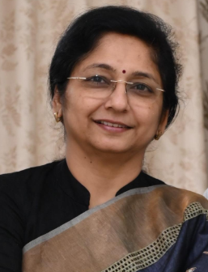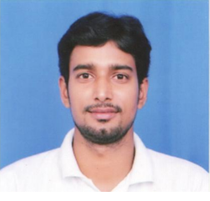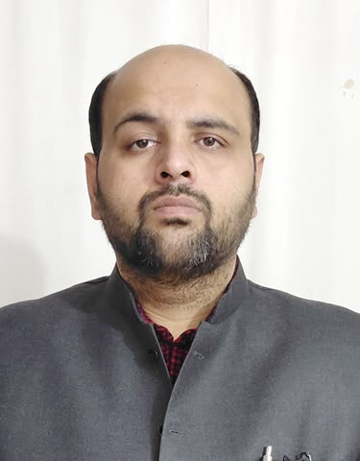
Prof. Saumya Singh Prof. Abhishek Kumar Singh Shri. Munish Sharma
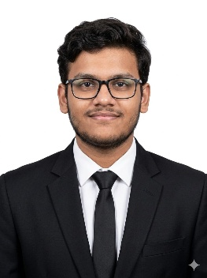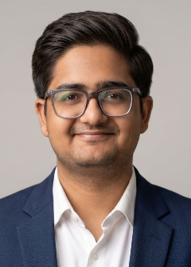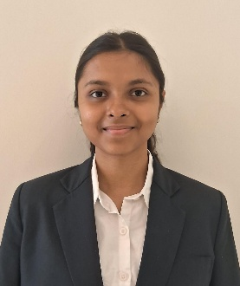
Nipun Shekhar Nehmeet Patel Tanya Yadav

15. Tentative List of Companies to be invited:

BNY

Nokia

Cadence

Bain and Co

McKinsey and Co

Apple

Blackrock

American Exp

Mastercard

SAP Labs

Dell

Orica

BCG

Barclays

HCL Tech

Graviton Consulting

Adobe

AMD

Deloitte

Erikson

Quadeye

NK Securities

HUL

ITC

P&G

SRK Consulting

Intel

NXP Semiconductors

Baker Hughes

Rystad Energy

Shell

Qualcomm

Micron

IBM

15. Conclusion
CDC Conclave 2026 offers IIT (ISM) Dhanbad a structured, cost-effective opportunity to deepen its engagement with industry beyond the placement cycle. With a modest budget of ₹3,00,000 and a clearly defined two-day format, the Conclave is designed to be realistic and implementation-ready, while creating lasting value for students, participating companies, and the institute's long-term industry relationships. The Career Development Centre seeks the administration's approval to proceed with delegate outreach and detailed logistical planning.

Submitted by:
Career Development Centre (CDC) IIT (ISM) Dhanbad

