DATA STRUCTURES & ALGORITHMS
23CSE203
LAB MANUAL
Submitted By
Name | Y.Nipun
Roll No. | AV.SC.U4CSE25054
Year/Sem/Section | 2nd year /Sem-3/CSE-A
Credits | 05

Submitted To
Name | Dr.Rajkumar Batchu
Designation | Asst. Professor
Department | School Of Computing

INDEX
S.No. | Title | Page No.
1) | Week-1:  1A)Rocket launch systems display the countdown of before launch instead of using a loop implement the countdown using the recursion write a recursion Python program to display the countdown from n to 1 followed by launch.  1B)Banks calculate the growth of an investment using compound interest. The formula requires calculating powers, which can be implemented recursively. Write a recursive Python program to calculate P^n (power), where P = Principal growth factor, n = number of years.  1C)An HR department stores employee IDs in a list. Develop a recursive program to search for a given employee ID. Write a recursive function to search for an employee ID in a list.  1D)In a logistics company, the number of possible ways to arrange n different parcels is calculated using the factorial formula. Develop a recursive program to calculate the factorial of a given number.  1E)Write a recursive Python program to print the first n terms of a Fibonacci series. | 4-13
2) | 2A)Write a python program to perform linear search on the given input.  2B) Write a python program to perform binary search on the given input.Verify by taking sorted array and unsorted array as input. | 14-17
3) | 3A)Write a python program to sort the elements using a selection sort technique.Take an input elements from the user.  3B)Write a python program to sort the elements using a insertion sort technique.Take an input elements from the user.  3C)Write a python program to sort the elements using a bubble sort technique.Take an input elements from the user.  3D)Write a python program to sort the elements using a merge sort technique.Take an input elements from the user.  3E)Write a python program to sort the elements using a quick sort technique.Take an input elements from the user. | 18-27
4) | 4A)Write a Python program to implement singly linked list  which could perform the below operations by taking  the input from the user:  1. Create a linked list  2. Insert at beginning  3. Insert at end  4. Insert at a specific index  5. Delete by value  6. Delete first node  7. Delete last node  8. Count number of nodes  9. Display / Traverse  10. Exit

WEEK-1

1A)Aim: Rocket launch systems display the countdown of before launch instead of using a loop implement the countdown using the recursion write a recursion Python program to display the countdown from n to 1 followed by launch.

Program:

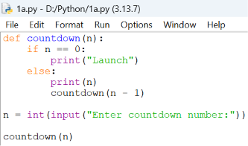
Output:
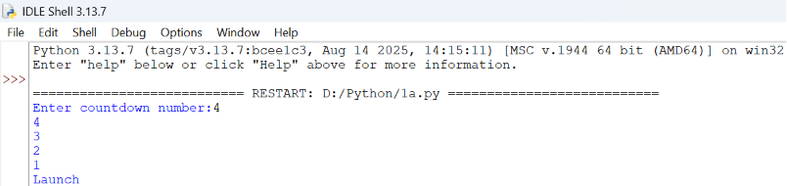

Explanation:
- def defines the countdown() function.
- input() accepts the countdown value from the user.
- int() converts the input into an integer.
- countdown() starts the recursive countdown process.
- if checks the base case (n == 0).
- else executes when the condition is False.
- print(n) displays the current countdown number.
- countdown(n - 1) recursively calls the function with the value decreased by 1.
- print("Launch!") displays the launch message when the countdown reaches 0.
- The program demonstrates the use of functions, recursion, conditional statements, input, and output to perform the countdown.
Error Table:
S.No. | Errors Observed | Rectification
1) | Invalid (non-numeric) input entered by the user. | Enter a valid integer as input.
2) | Missing base case (if n == 0) causing infinite recursion. | Include the base case to stop recursion .l
3) | incorrect indentation leading to an Indentation Error | Maintain proper Python indentation.
4) | Missing colon (:) after def, if, or else. | Add the required colon (:) after statements.
5) | Calling countdown(n) instead of countdown(n - 1), causing infinite recursion. | Decrease the value by 1 in each recursive call using countdown(n - 1).

1B)Aim: Banks calculate the growth of an investment using compound interest. The formula requires calculating powers, which can be implemented recursively. Write a recursive Python program to calculate P^n (power), where P = Principal growth factor, n = number of years.
Program:

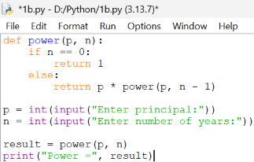

Output:

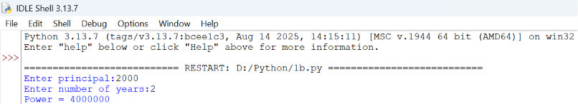

Explanation:
- power() is the recursive function that computes P raised to n.
- The base case is n == 0, which returns 1 (any number to the power 0 is 1).
- The recursive case multiplies p with power(p, n - 1), reducing n by 1 on each call.
- float() allows the principal growth factor to be a decimal value.
- input() collects the values of P and n from the user.
- Each recursive call is stacked until the base case is reached, then the results are multiplied back up the call stack.
- print() displays the final computed value of P^n.
Error Table:
S.No. | Errors Observed | Rectification
1) | Missing base case (n == 0) causing infinite recursion. | Include the base case to stop recursion.
2) | Entering a negative value for n causes the recursion to never reach 0. | Restrict input to non-negative integers or handle negative n separately.
3) | Using int() for P truncates decimal growth factors. | Use float() to accept decimal values for P.
4) | Incorrect indentation leading to an IndentationError. | Maintain proper Python indentation.
5) | Calling power(p, n) instead of power(p, n - 1), causing infinite recursion. | Decrease n by 1 in each recursive call using power(p, n - 1).

1C) Aim:An HR department stores employee IDs in a list. Develop a recursive program to search for a given employee ID. Write a recursive function to search for an employee ID in a list.
Program:
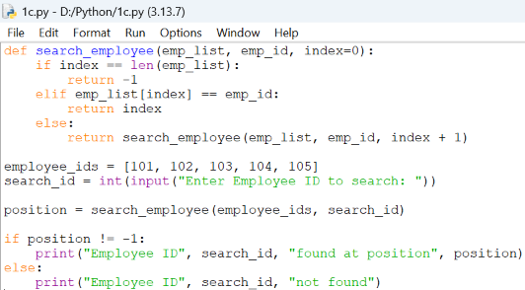
Output:
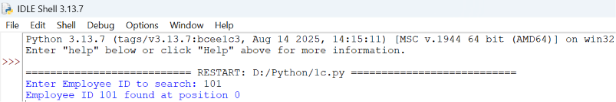

Explanation:
- search_employee() is the recursive function that searches the list one index at a time.
- The base case index == len(emp_list) means every element was checked and the ID was not found, so it returns -1.
- The second condition checks if the current element matches the employee ID being searched.
- If not matched, the function calls itself with index + 1, moving to the next employee in the list.
- employee_ids is the list of employee IDs stored by the HR department.
- input() and int() collect the employee ID to search for from the user.
- The if-else block reports whether the employee ID was found and at which position.
Error Table:
S.No. | Errors Observed | Rectification
1) | Missing base case (index == len(emp_list)) causing infinite recursion. | Include the base case to stop recursion when the list is exhausted.
2) | Invalid (non-numeric) input entered by the user. | Enter a valid integer as input.
3) | Calling search_employee(emp_list, emp_id, index) without incrementing index, causing infinite recursion. | Increase index by 1 in each recursive call using index + 1.
4) | Incorrect indentation leading to an IndentationError. | Maintain proper Python indentation.
5) | Searching an empty list without handling it, giving a confusing result. | Add a check for an empty list before searching.
1D) Aim:In a logistics company, the number of possible ways to arrange n different parcels is calculated using the factorial formula. Develop a recursive program to calculate the factorial of a given number.
Program:
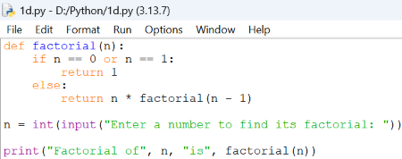
Output:
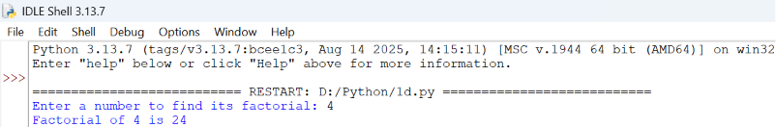
Explanation:
- factorial() is the recursive function that computes n! (n factorial).
- The base case is n == 0 or n == 1, both of which return 1.
- The recursive case multiplies n with factorial(n - 1), reducing n by 1 on each call.
- input() and int() collect the number whose factorial is to be found.
- Each recursive call is stacked until the base case is reached, then the results are multiplied back up the call stack.
- print() displays the number of possible arrangements (the factorial value).

Error Table:
S.No. | Errors Observed | Rectification
1) | Missing base case (n == 0 or n == 1) causing infinite recursion. | Include the base case to stop recursion.
2) | Entering a negative number, for which factorial is undefined. | Restrict input to non-negative integers.
3) | Invalid (non-numeric) input entered by the user. | Enter a valid integer as input.
4) | Incorrect indentation leading to an IndentationError. | Maintain proper Python indentation.
5) | Calling factorial(n) instead of factorial(n - 1), causing infinite recursion. | Decrease n by 1 in each recursive call using factorial(n - 1).

1E) Aim:Write a recursive Python program to print the first n terms of a Fibonacci series.

Program:
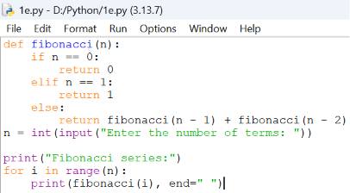
Output:
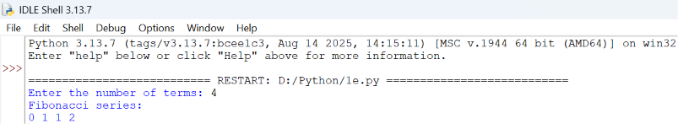
Explanation:
- fibonacci() is the recursive function that returns the nth Fibonacci term.
- The base cases are n == 0 (returns 0) and n == 1 (returns 1).
- The recursive case adds fibonacci(n - 1) and fibonacci(n - 2), following the Fibonacci rule.
- input() and int() collect the number of terms to be printed.
- The for loop calls fibonacci(i) for each index from 0 to n - 1.
- print(..., end=" ") displays each term on the same line, separated by a space.

Error Table:
S.No. | Errors Observed | Rectification
1) | Missing base cases (n == 0 and n == 1) causing infinite recursion. | Include both base cases to stop recursion.
2) | Entering a negative number of terms. | Restrict input to non-negative integers.
3) | Invalid (non-numeric) input entered by the user. | Enter a valid integer as input.
4) | Incorrect indentation leading to an IndentationError. | Maintain proper Python indentation.
5) | Using fibonacci(n - 1) - fibonacci(n - 2) instead of addition, giving wrong terms. | Use addition, fibonacci(n - 1) + fibonacci(n - 2), as per the Fibonacci rule.

WEEK-2

2A) Aim: Write a python program to perform linear search on the given input.
Program:

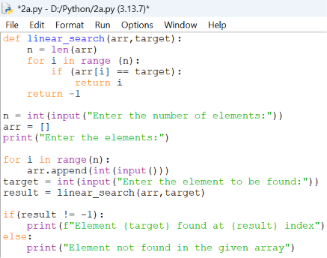
Output:

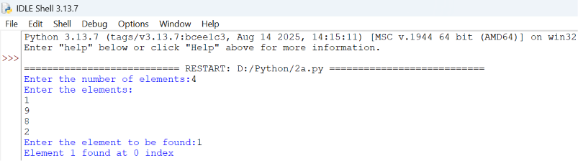

Explanation:
- linear_search(arr, target) sequentially iterates through arr to check each element against target.
- for i in range(n): iterates through array indices from 0 to n-1 sequentially.
- if arr[i] == target: checks for a match and returns index i if found.
- return -1 executes when the target element is absent from the array.
- arr.append(int(input())) converts user input to integers and builds the array.
- if (result != -1): displays the index where the element is found or prints a "not found" message.
Error Table:
S.No. | Errors Observed | Rectification
1) | Invalid (non-numeric) input entered by the user. | Entered a valid integer as input.
2) | Incorrect indentation leading to an Indentation Error | Maintained proper Python indentation.
3) | Missing colon (:) after def, for, if, or else. | Added the required colon (:) after statements.
4) | ValueError when passing non-integer strings to int(input()). | Ensure user input consists of valid integer characters.
5) | IndexError caused by accessing an array index out of bounds. | Ensure loop bounds do not exceed len(arr) - 1.

2B) Aim: Write a python program to perform binary search on the given input.Verify by taking sorted array and unsorted array as input.
Program:
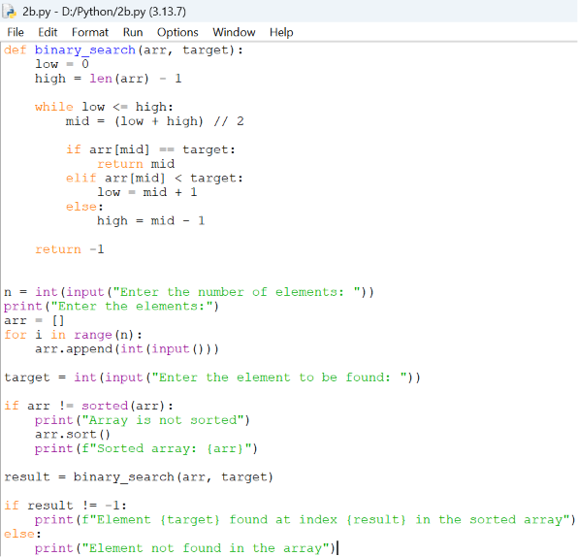
Output:
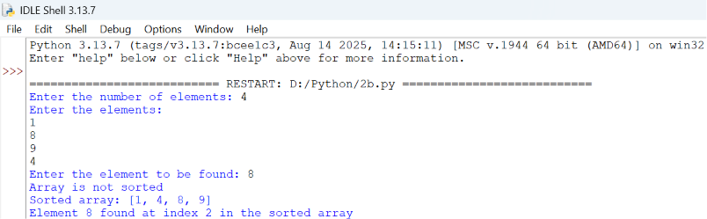
Explanation:
- binary_search(arr, target) uses a divide-and-conquer strategy on a sorted array.
- while low <= high: runs as long as the search boundary contains valid elements.
- mid = (low + high) // 2 computes the middle index using integer division.
- if arr[mid] == target: returns mid if the target is found at the middle index.
- elif arr[mid] < target: updates low = mid + 1, otherwise sets high = mid - 1.
- arr.sort() ensures the input array is sorted before executing binary search.
Error Table:
S.No. | Errors Observed | Rectification
1) | Performing binary search on an unsorted array leading to incorrect results. | Sort the array using arr.sort() before applying binary search.
2) | Using floating-point division / instead of integer division // for calculating mid, causing a TypeError. | Use mid = (low + high) // 2 for integer index calculation.
3) | Incorrect loop condition (low < high instead of low <= high), missing target when low == high. | Change the condition to while low <= high:.
4) | Incorrectly updating pointers like low = mid or high = mid causing an infinite loop. | Use low = mid + 1 and high = mid - 1.
5) | Invalid (non-numeric) input entered by the user. | Enter a valid integer as input.

WEEK-3
3A) Aim:Write a python program to sort the elements using a selection sort technique.Take an input elements from the user.
Program:
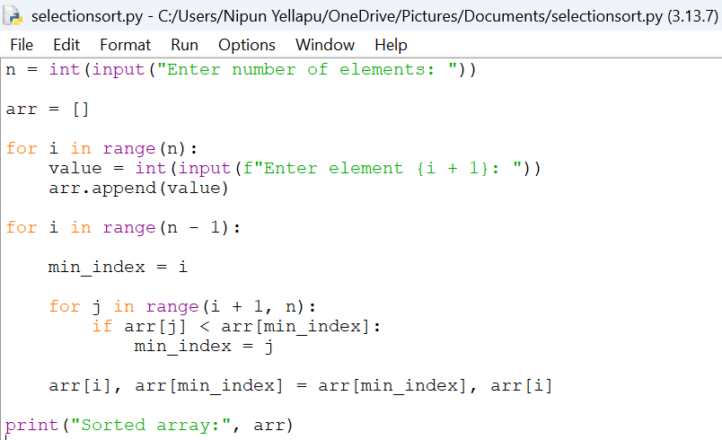
Output:
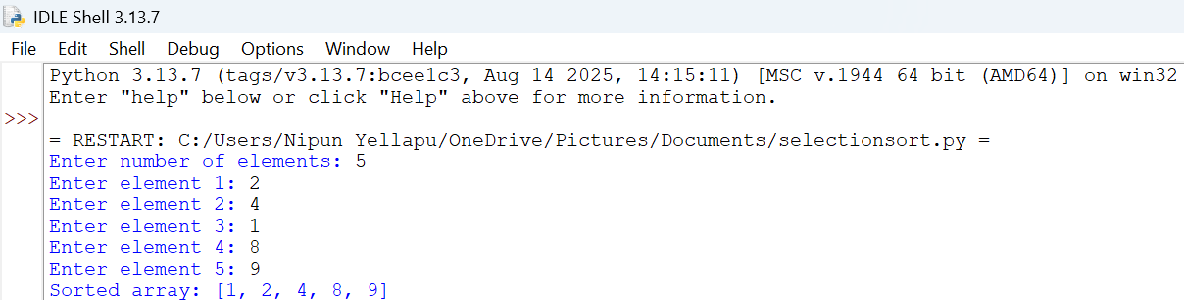

Explanation:
Took the number of elements from the user.
- Created an empty list arr.
- Used a for loop to take each element individually.
- min_index stores the position of the smallest element.
- The inner loop searches for the smallest element in the unsorted portion.
- Swapped the smallest element with the first unsorted element.
- Repeated this until the array was sorted
Error Table:
S.No. | Errors Observed | Rectification
1) | Incorrect initialization of min_index, causing the minimum element to be identified incorrectly. | Initialize min_index = i before searching for the minimum element.
2) | Starting the inner loop from 0, causing already sorted elements to be checked again. | Start the inner loop from i + 1.
3) | Forgetting to update min_index when a smaller element is found. | Use min_index = j inside the if condition.
4) | Incorrect swapping of elements, resulting in an unsorted array. | Use arr[i], arr[min_index] = arr[min_index], arr[i].
5) | Invalid (non-numeric) input entered by the user. | Enter a valid integer for each array element.
6) | Incorrect indentation causing an IndentationError. | Maintain proper indentation inside for loops and if statements.

3B) Aim: Write a python program to sort the elements using a insertion sort technique.Take an input elements from the user.
Program:
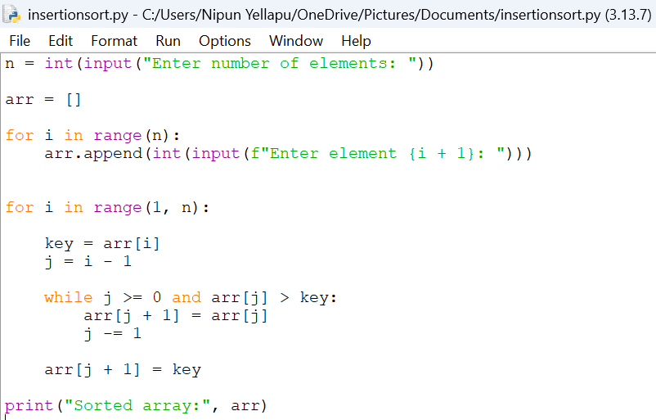
Output:
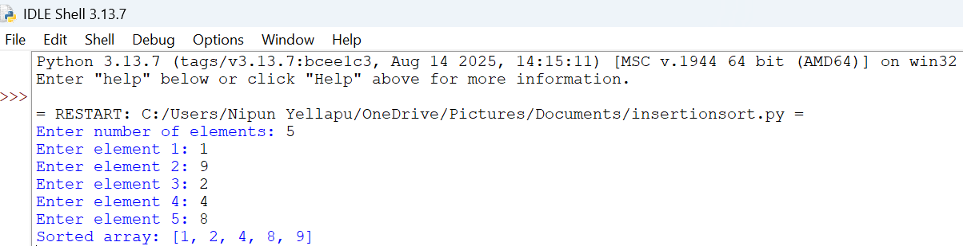

Explanation:
- Took the number of elements from the user.
- Used a loop to input every element.
- Started sorting from index 1.
- Stored the current element in key.
- Compared key with the elements before it.
- Shifted larger elements one position to the right.
- Inserted key into its correct position.
- Repeated until the array was sorted.
Error Table:
S.No. | Errors Observed | Rectification
1) | Starting the outer loop from 0, unnecessarily processing the first element. | Start the loop from 1 because the first element is already considered sorted.
2) | Forgetting to store the current element in key. | Use key = arr[i] before shifting elements.
3) | Forgetting j -= 1, causing the while loop to run indefinitely. | Decrease j by using j -= 1 after shifting an element.
4) | Placing the key at arr[j] instead of arr[j + 1]. | Insert the key using arr[j + 1] = key.
5) | Incorrect condition in the while loop. | Use j >= 0 and arr[j] > key to shift larger elements.

3C) Aim: Write a python program to sort the elements using a bubble sort technique.Take an input elements from the user.
Program:
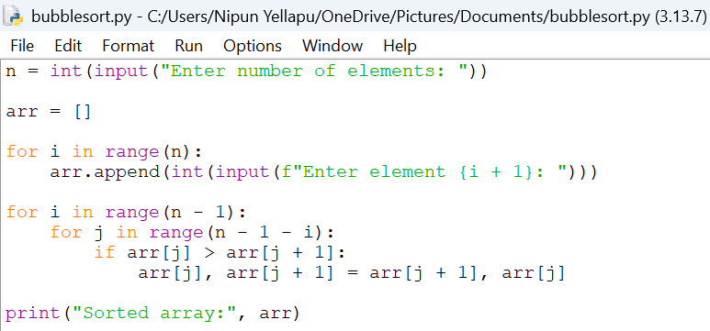
Output:
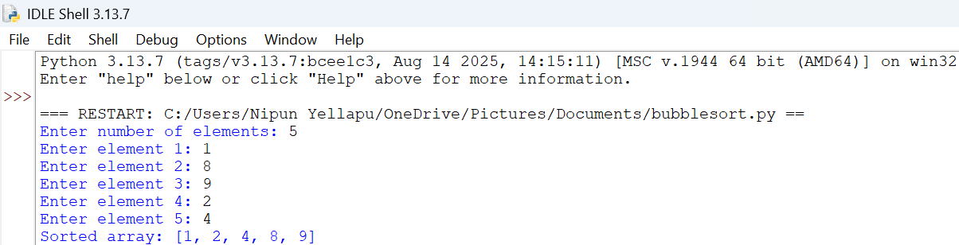

Explanation:
- Took the number of elements.
- Input each element using a loop.
- Compared two adjacent elements.
- If the left element was greater, we swapped them.
- After every pass, the largest remaining element moved to the end.
- Reduced the comparison range after every pass.
- Repeated until the array became sorted.
Error Table:
S.No. | Errors Observed | Rectification
1) | Comparing non-adjacent elements instead of neighboring elements. | Compare arr[j] with arr[j + 1].
2) | Using an incorrect inner loop range. | Use range(n - 1 - i) so that already sorted elements are not checked
3) | Forgetting to swap elements when they are in the wrong order. | Use arr[j], arr[j + 1] = arr[j + 1], arr[j].
4) | Using < instead of > for ascending order. | Use if arr[j] >arr[j + 1] for ascending sorting.
5) | Using an incorrect outer loop range. | Use range(n - 1) to perform the required passes.
6) | Entering non-numeric values as array elements. | Enter valid integer values using int(input()).

3D) Aim: Write a python program to sort the elements using a merge sort technique.Take an input elements from the user.
Program:
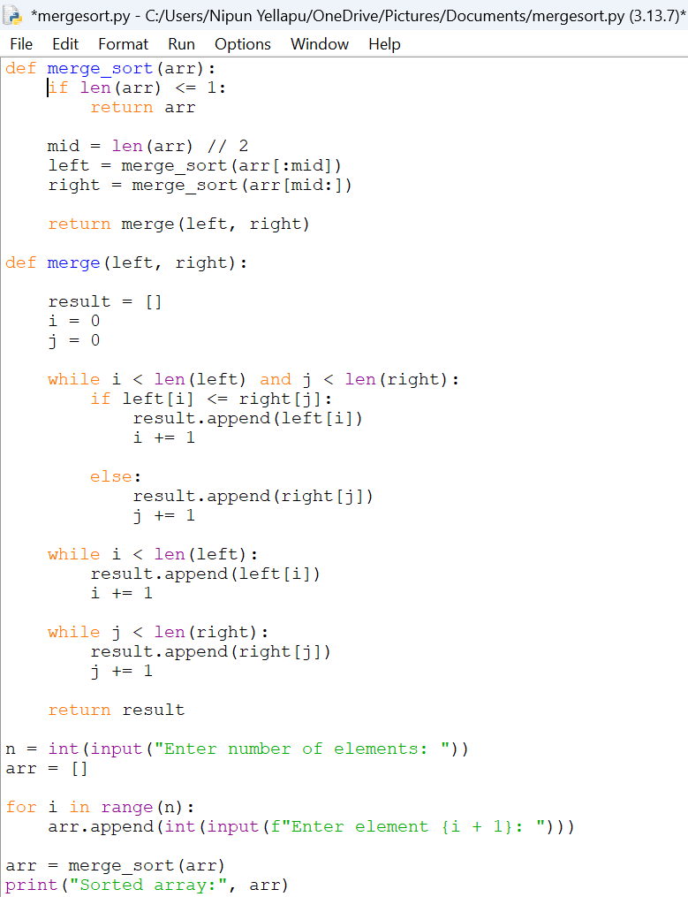
Output:
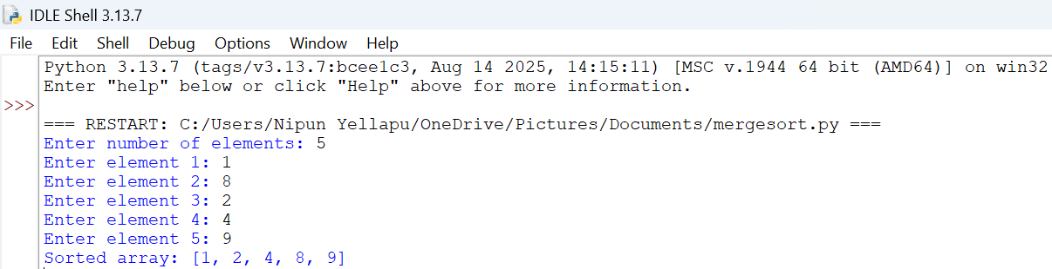
Explanation:
- Took the number of elements from the user.
- Used a loop to input the array.
- Used recursion to divide the array.
- Divided the array into two halves.
- Continued dividing until each part contained one element.
- Used the merge() function to combine the smaller arrays.
- Compared elements from the left and right halves.
- Added the smaller element to result.
- Added remaining elements.
- Returned the sorted array.
Error Table:
S.No. | Errors Observed | Rectification
1) | Missing base case causing infinite recursion. | Include if len(arr) <= 1: return arr to stop recursion.
2) | Incorrect calculation of the middle position. | Use mid = len(arr) // 2 to divide the array correctly.
3) | Incorrectly dividing the array into left and right parts. | Use arr[:mid] for the left half and arr[mid:] for the right half.
4) | Forgetting to increment i or j while merging. | Increment the corresponding index after adding an element to result.
5) | Forgetting to add the remaining elements from either half. | Add the remaining elements using result.extend(left[i:]) and result.extend(right[j:]).

3E) Aim: Write a python program to sort the elements using a quick sort technique.Take an input elements from the user.
Program:
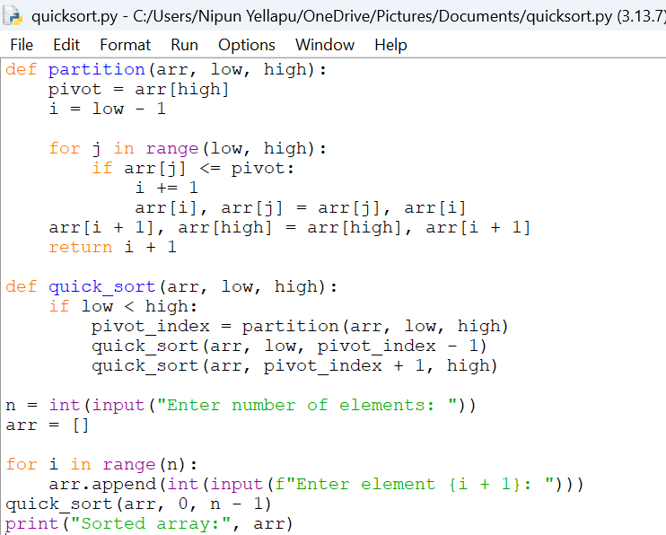
Output:
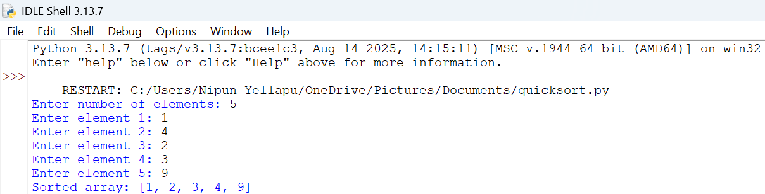

Explanation:
- Took the number of elements.
- Used a loop to input every element.
- Selected the last element as the pivot.
- Compared every element with the pivot.
- Elements smaller than or equal to the pivot were moved to the left.
- Elements greater than the pivot remained on the right.
- Placed the pivot in its correct position.
- Recursively sorted the left and right portions.
- Continued until the entire array was sorted.
Error Table:
S.No. | Errors Observed | Rectification
1) | Missing base condition causing infinite recursion. | Use if low < high: to continue recursion only when elements remain to be sorted.
2) | Incorrectly selecting or accessing the pivot element. | Select the last element using pivot = arr[high].
3) | Forgetting to return the pivot index from the partition function. | Use returni + 1 after placing the pivot.
4) | Incorrect recursive boundaries causing the pivot to be processed again. | Use quick_sort(arr, low, pivot_index - 1) and quick_sort(arr, pivot_index + 1, high).
5) | Incorrect initial function call. | Call quick_sort(arr, 0, n - 1) to sort the complete array.
6) | Incorrect partition condition resulting in improper ordering. | Use if arr[j] <= pivot for ascending order.

WEEK-4
4A)Aim: Write a Python program to implement singly linked list
which could perform the below operations by taking
the input from the user:
1. Create a linked list
2. Insert at beginning
3. Insert at end
4. Insert at a specific index
5. Delete by value
6. Delete first node
7. Delete last node
8. Count number of nodes
9. Display / Traverse
10. Exit
Program:

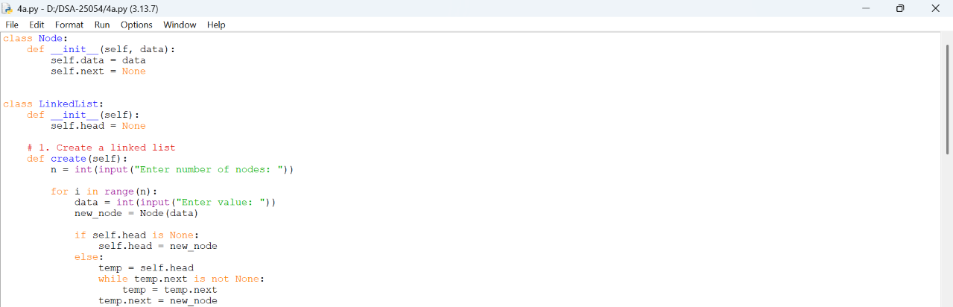
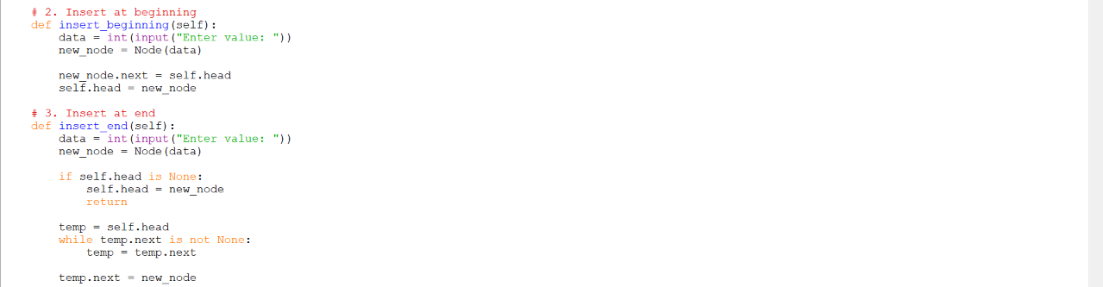
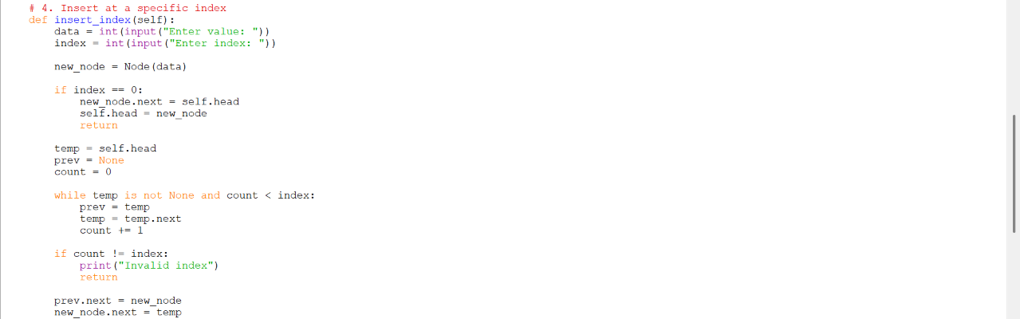
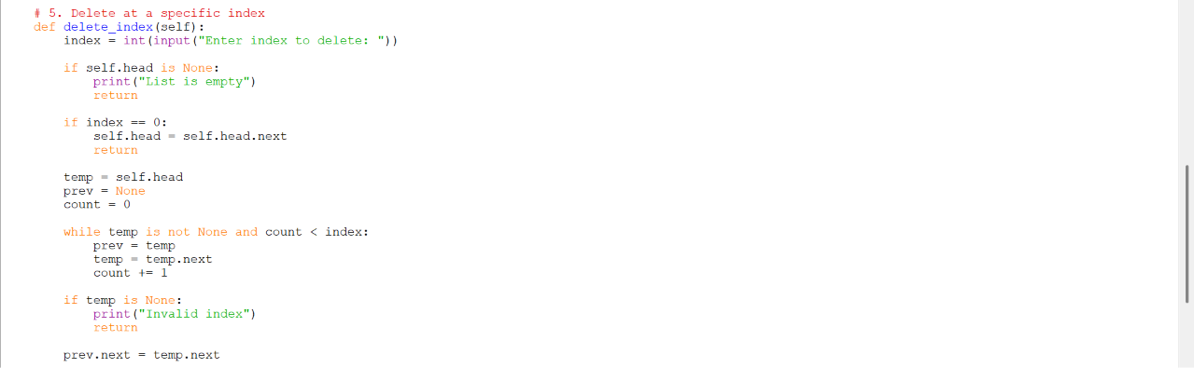
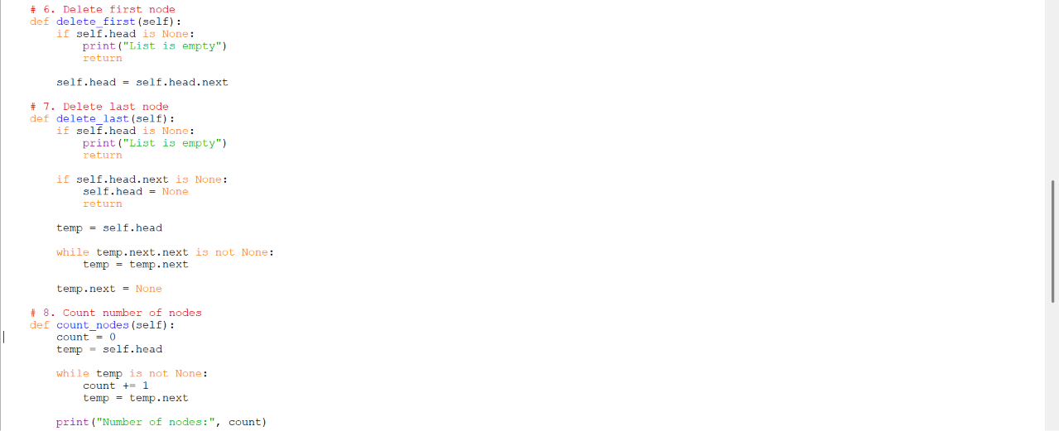
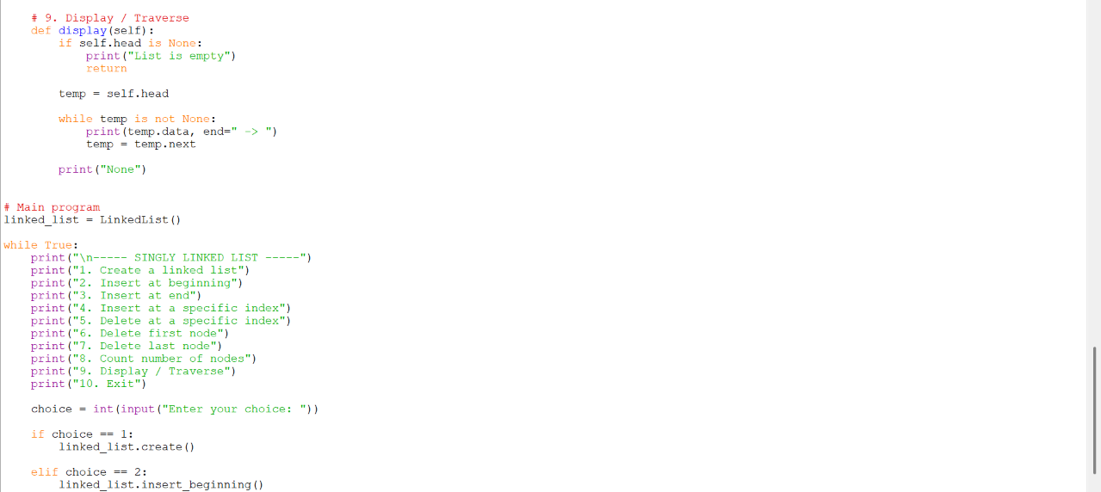
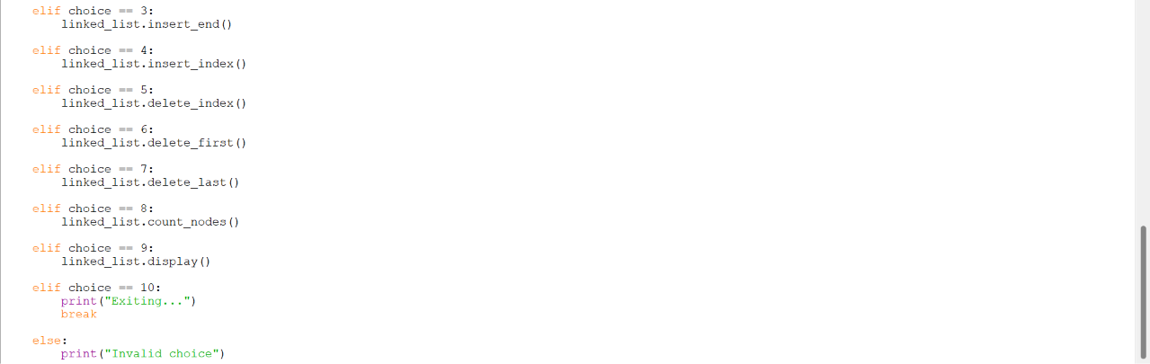
Output:
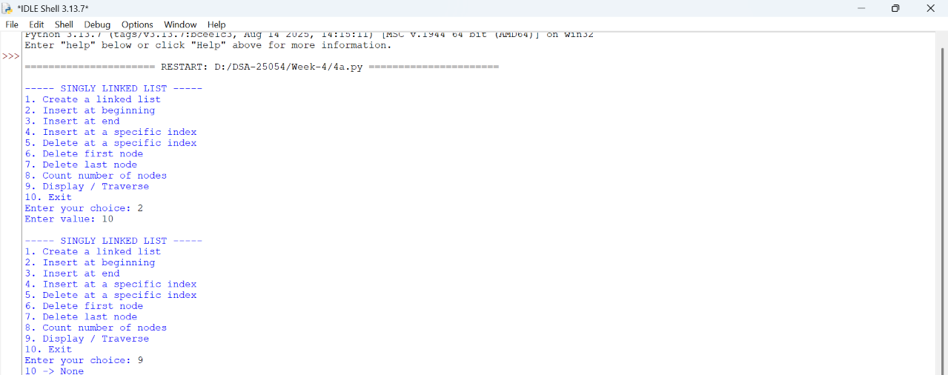

Explanation:
1. Node Class:
• Created a Node to store data and the next node's address.
• Initialized next as None.
2. LinkedList Class:
• Created the linked list using the head pointer.
• Initially, head is set to None.
3. Create a Linked List:
• Took the number of nodes and their values from the user.
• Created and connected each node to the list.
4. Insert at Beginning:
• Created a new node with the given value.
• Connected it to the current head and made it the new head.
5. Insert at End:
• Created a new node.
• Traversed to the last node and connected the new node.
6. Insert at Specific Index:
• Took the value and 0-based index from the user.
• Traversed to the required position and inserted the new node.
7. Delete by Value:
• Searched for the given value in the list.
• Changed the links to remove the matching node.

8. Delete First Node:
• Moved the head to the next node.
• This removes the first node.
9. Delete Last Node:
• Traversed to the second-last node.
• Set its next pointer to None.
10. Count Nodes:
• Traversed through the list.
• Increased the counter for each node and displayed the count.
11. Display / Traverse:
• Started from the head and visited every node.
• Printed each node's data until None was reached.
12. Main Program:
• Displayed a menu for all operations.
• Executed the selected operation until the user chose Exit.

