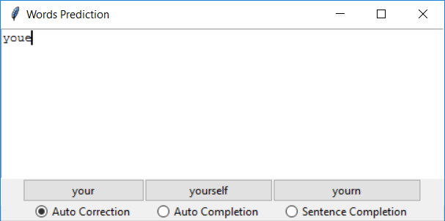

Autocorrection for your, youe is typed instead of your, it is based on rankings of vicinity characters in keyboard

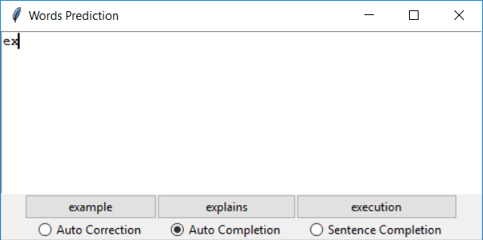

Autocompletion results for words starting with ‘ex’ based on ranking/number of words are saved

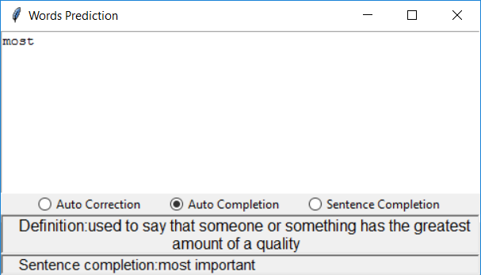

Definition and sentence completion results for most word

Sentence completion is based on ranking generated from ngram algorithm