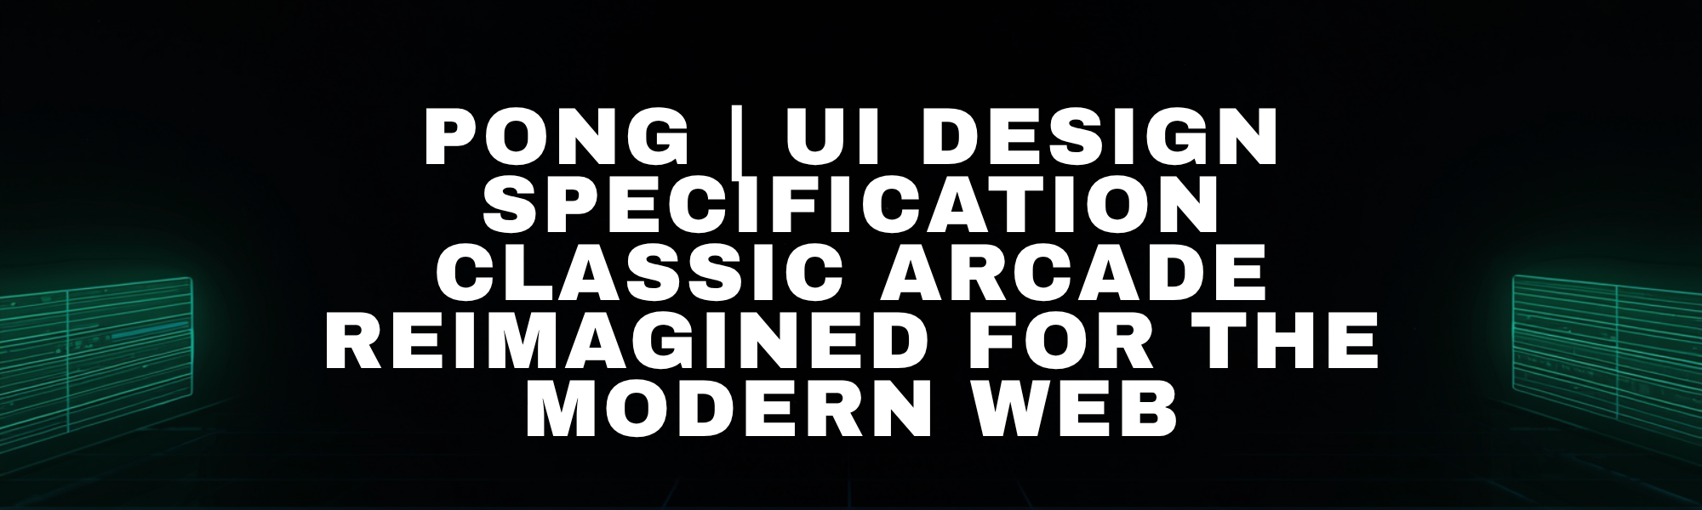
PONG | UI Design Specification
Classic Arcade Reimagined for the Modern Web

Pong is a two-player table tennis arcade game that blends 1980s minimalist design with a modern fullscreen browser presentation. The interface is neon-on-black, pixel-perfect, and intentionally uncluttered so the court reads instantly at a glance. The experience is pure skill-based gameplay—reflexes, positioning, and shot control—without power-ups, terrain, or distractions.

🎛️ Design Principles
Neon Minimalism — Pure black background with vibrant neon elements.
Pixel Precision — Sharp rendering with no anti-aliasing.
Arena First — The game court is the entire interface.
Instant Feedback — Every collision produces immediate visual response.
Pure Skill — No power-ups or distractions, only reflexes and positioning.

🎨 Color Palette
Role | Hex Code | Usage | Notes
Base Black | #000000 | Universal background | Primary canvas for neon contrast
Pure White | #FFFFFF | Paddles, ball, center line, primary text | Keep edges crisp for pixel readability
Neon Green | #00FF00 | Success states, start button, Player 1 accent | Use for primary CTA and positive feedback
Neon Cyan | #00FFFF | Info states, Player 2 accent, UI highlights | Default “system neon” for highlights and focus
Warning Red | #FF0000 | Pause state, error feedback | Short-duration emphasis; avoid persistent red UI
Grid Gray | #111111 | Subtle court boundaries | Dividers, frames, faint grid accents
Secondary Gray | #888888 | Labels and metadata | Non-critical copy and helper text

🔤 Typography System
Primary UI Font: Google Pixelify Sans loaded with the following embed code:
<link rel="preconnect" href="https://fonts.googleapis.com">
<link rel="preconnect" href="https://fonts.gstatic.com" crossorigin>
<link href="https://fonts.googleapis.com/css2?family=Pixelify+Sans:wght@400..700&display=swap" rel="stylesheet">

Pixelify Sans should be the default typeface for overlay headings, title treatment, button labels, and primary interface copy. Monospace fallbacks may remain only as backup if the Google font fails to load.
Title Text: 48–64px for the game title.
Score Display: 32–48px monospace for score counters.
UI Labels: 12–14px uppercase for controls and buttons.
Status Messages: 24–32px for PAUSED, GAME OVER, etc.
Small Print: 10px for footer and metadata.

🕹️ Court Layout & Components
Playing Field
Parameter | Value / Description
Canvas width | 680px
Canvas height | 400px
Background | Solid black (#000000)
Center line | Dashed white vertical line (x = 340)

Paddles
Spec | Value / Description
Width | 12px
Height | 80px
Color | Pure white (#FFFFFF)
Movement speed | 5px / frame
Position constraints | Clamped to top and bottom edges; no overscroll

Ball
Spec | Value / Description
Size | 10×10px
Color | Pure white (#FFFFFF)
Initial speed | 4px / frame horizontal (serve toward conceding player)
Speed cap | 12px / frame (horizontal)

🧩 Game States & UI Overlays
State | Visual Treatment | Interactive Elements
Idle | Title overlay centered on court; PRESS START prompt; subtle neon glow accents (#00FF00 / #00FFFF) | Start action; control hints visible
Active Play | Clean court with score displays; minimal HUD; center dash line remains visible | Player movement; pause available
Paused | Semi-transparent overlay; PAUSED text in high-contrast; optional red accent (#FF0000) for state clarity | Resume prompt (Spacebar); optional Resume button
Game Over | Winner announcement overlay; background court remains visible behind the result | PLAY AGAIN button; restart via keyboard

⌨️ Controls & Input
Role | Input Mapping
Player 1 (Left) | W (up), S (down)
Player 2 (Right) | Arrow Up (up), Arrow Down (down)
Universal | Spacebar (pause / resume)

✨ Visual Effects
Scanline Overlay: Subtle horizontal lines at ~10% opacity; must not reduce score readability.
Neon Glow: 4–6px blur glow on paddles and ball; keep glow restrained to preserve crisp edges.
Collision Flash: Brief white flash on paddle hits for instant feedback.
Score Pulse: Quick scale or brightness pulse on the scoring player’s counter.
Trail Effect: Optional subtle motion blur on the ball; disable in reduced-motion mode.

📱 Responsive Behavior
Breakpoint | Width | Layout Adjustments
Desktop | ≥1280px | Fullscreen court centered; score counters at top of each half; overlays sized for comfortable reading
Tablet | 768–1279px | Scale canvas proportionally; increase UI label size slightly; ensure touch-safe overlay buttons (≥48px targets)
Mobile | <768px | Prefer landscape prompt; keep overlays compact; reduce glow intensity; preserve score legibility and input responsiveness

♿ Accessibility Standards
High contrast mode support: Maintain readable neon-on-black with WCAG AA contrast for all text.
Keyboard-only navigation: All menus/overlays operable via keyboard; clear focus indicators in neon cyan (#00FFFF).
Screen reader labels for scores: Expose Player 1 / Player 2 scores and state text via accessible labels/live regions.
Reduced motion mode: Respect prefers-reduced-motion; disable scanlines, pulses, flashes, and trails.
Colorblind-friendly alternatives: Provide optional palette adjustments while preserving Player 1/2 differentiation.

✅ Implementation Checklist
Render the court as a fixed 680×400 canvas with a dashed center line and top score counters.
Implement crisp pixel rendering (no blur) and validate at common device pixel ratios.
Apply the color palette consistently (Base Black, Pure White, Neon Green #00FF00, Neon Cyan #00FFFF).
Build state overlays (Idle, Paused, Game Over) as centered in-arena cards with clear prompts.
Implement keyboard input mapping (W/S, Arrow Up/Down, Spacebar) with reliable keydown/keyup handling.
Add collision feedback (flash + sound hook) and score pulse animation with snappy timing (100–200ms).
Implement responsive scaling to fullscreen while preserving aspect ratio and score legibility.
Add accessibility hooks (focus rings, screen reader labels/live regions for scores and state).
Support reduced motion mode by disabling scanlines, glow pulses, collision flashes, and trails.
Optimize for 60 FPS using requestAnimationFrame and avoid layout thrash during gameplay.

