תרגיל 4

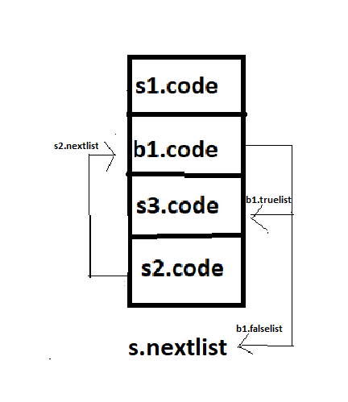

א.

ב.

S→ for (S1; M1 B1; S2 N2) M2 S3

{

backpatch(N2.nextlist, M1.quad);

backpatch(B1.truelist, M2.quad);

S.nextlist = B1.falselist;

}