IDL Project 2 Report
Nir Ellor Waizner

- Autoencoder:
We defined a convolutional autoencoder with 3 convolutional layers in the encoder, each followed by BatchNorm and LeakyReLU, reducing the input to a flattened latent vector of any chosen dimension via a linear layer. The decoder mirrors this with a linear layer projecting back to the conv feature map shape, followed by 3 transposed convolutions and LeakyReLU (Tanh at the end).
The structure in short:
Encoder: Input (1×28×28) → Conv2D → BN → LeakyReLU → Conv2D → BN → LeakyReLU → Conv2D → BN → LeakyReLU → Flatten → Linear → z (latent dim)
Decoder: z (latent dim) → Linear → Unflatten → ConvTranspose2D → LeakyReLU → ConvTranspose2D → LeakyReLU → ConvTranspose2D → Tanh → Output (1×28×28)
  - The architecture is flexible to support any latent dimension and customizable channel sizes, since we made the architecture flexible by decoupling the latent dimensionality from the convolutional layers. The encoder uses a dynamic dummy forward pass to compute the flattened output size based on the chosen channels. This allows mapping to any latent dimension using a fully connected layer. The decoder mirrors this by reshaping it from any latent size and using transposed convolutions to reconstruct the image.

  - The two following plots in the next page are input vs. reconstructed images in a network with a small number of channels (4 →8 →16), where on the left the latent dim = 4 and on the right it's 16. Moreover, in each plot (also the next two), in each row, every pair of consecutive images shows an input and its reconstruction: the left image is the original input, and the right image is the reconstruction produced by the autoencoder.
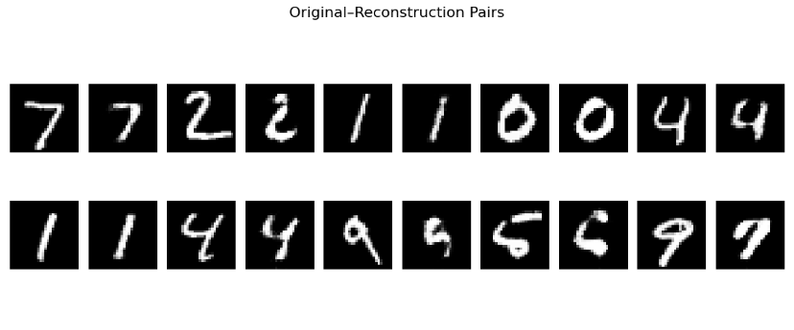
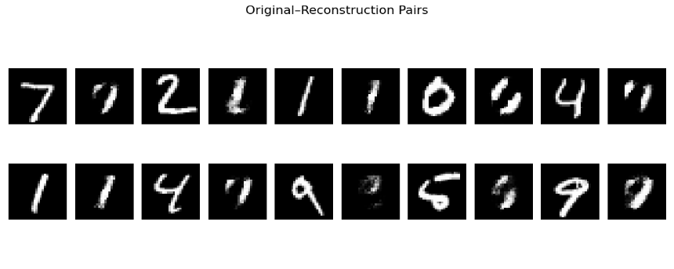
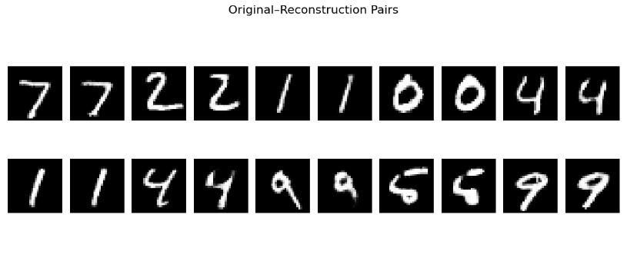
And the next two plots are input vs. reconstructed images in a network with a large number of channels (16 →32 →64), where on the left the latent dim = 4 and on the right it's 16.
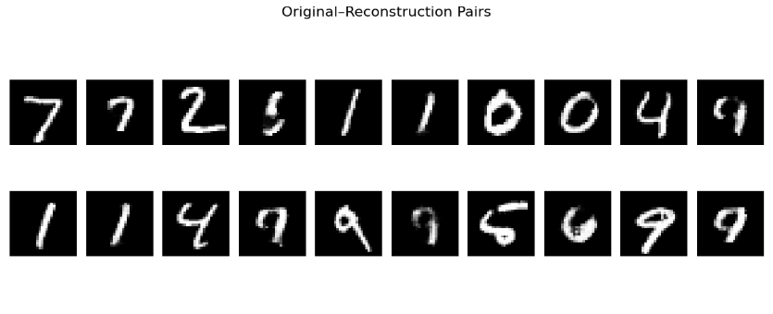

  - Denote that "small" refers to the network with channels (4 →8 →16). and large refers to the network with channels (16 →32 →64),
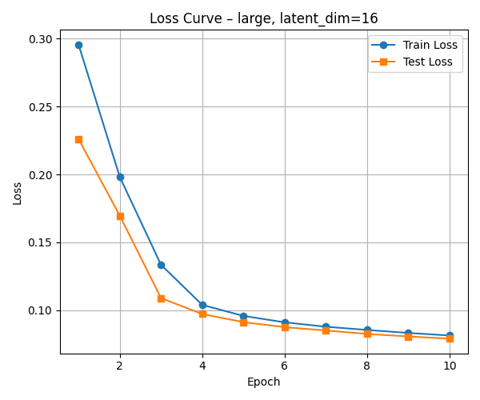
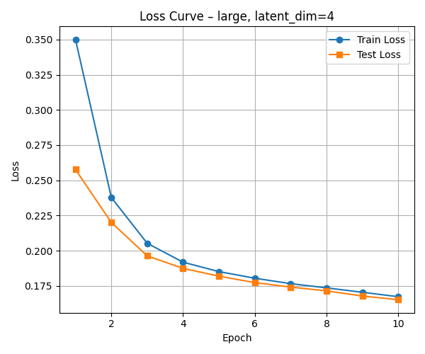
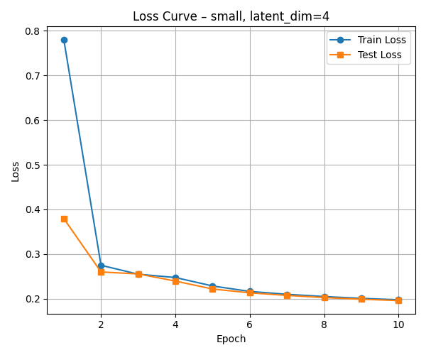
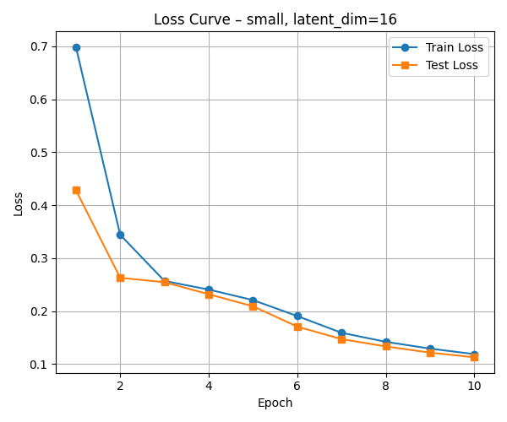

1. Small model (4 → 8 → 16), latent dim = 4
- The loss drops sharply in the first few epochs, indicating that even a small model with a low-dimensional latent space can quickly learn a rough reconstruction.
- After epoch 3, both train and test losses converge and stabilize around ~0.20, showing no signs of overfitting but also limited capacity for improvement due to the restricted latent space and fewer parameters.
2. Small model (4 → 8 → 16), latent dim = 16
- The model shows significantly better learning compared to latent dim=4, with a lower final loss.
- Both train and test loss curves continue to improve throughout the epochs, suggesting the model benefits from the increased latent dimensionality while still being capacity-limited by its small architecture.
3. Large model (16 → 32 → 64), latent dim = 4
- Despite the limited latent space, the larger model achieves better performance than the small model with the same latent size.
- The greater number of parameters helps the model compensate for the low-dimensional bottleneck, achieving smooth and consistent convergence.
4. Large model (16 → 32 → 64), latent dim = 16
- This configuration yields the best overall performance, with rapid convergence and the lowest final loss.
- The architecture has sufficient capacity (channels) and representational power (latent space) to capture fine-grained details, making it ideal for high-fidelity reconstruction.
  - We designed a convolutional autoencoder with 3 convolutional layers in both the encoder and decoder.
Each layer uses filter size = 3 with stride pattern 2 → 2 → 1 in the encoder and 1 → 2 → 2 in the decoder to compress and then upsample.
The number of filters increases in the encoder (e.g., 4 → 8 → 16 or 16 → 32 → 64) and decreases symmetrically in the decoder.
We apply LeakyReLU activations after every layer except the decoder’s last, which uses Tanh for normalized outputs.
This architecture captures image structure efficiently while preserving flexibility for different latent sizes.
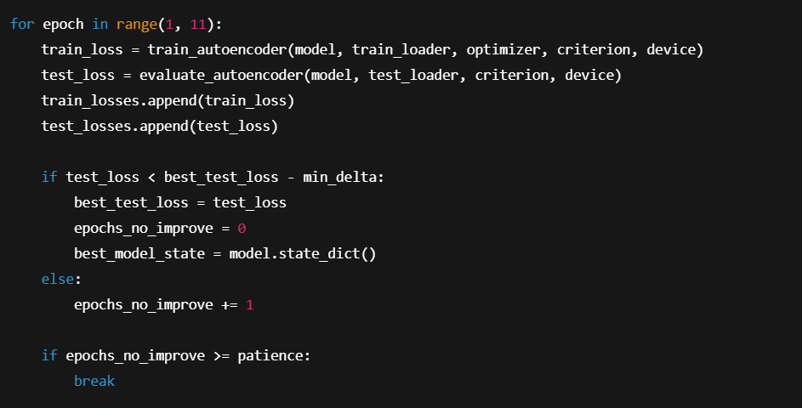
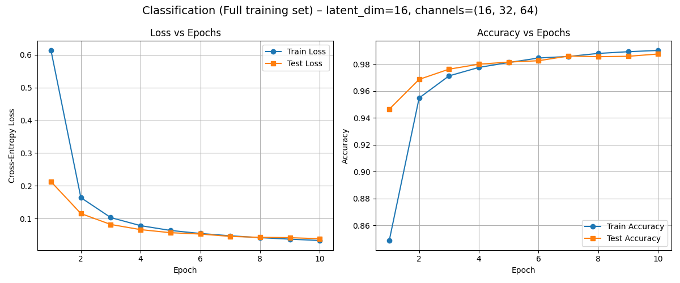
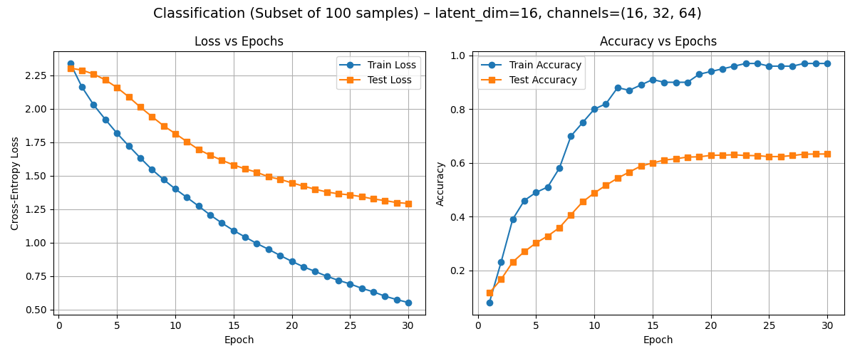
- Classifier:
Above are the plots for the two scenarios.
Plot 1 (Full training set):
The loss decreases steadily, and the accuracy quickly converges to >98%, showing the model generalizes well with sufficient data.
The gap between train and test curves is minimal, indicating no significant overfitting.
Plot 2 (Subset of 100 samples):
The model overfits the small training set, with train accuracy nearing 100% but test accuracy saturating around 65%.
The growing gap between training and test performance highlights poor generalization due to limited data.
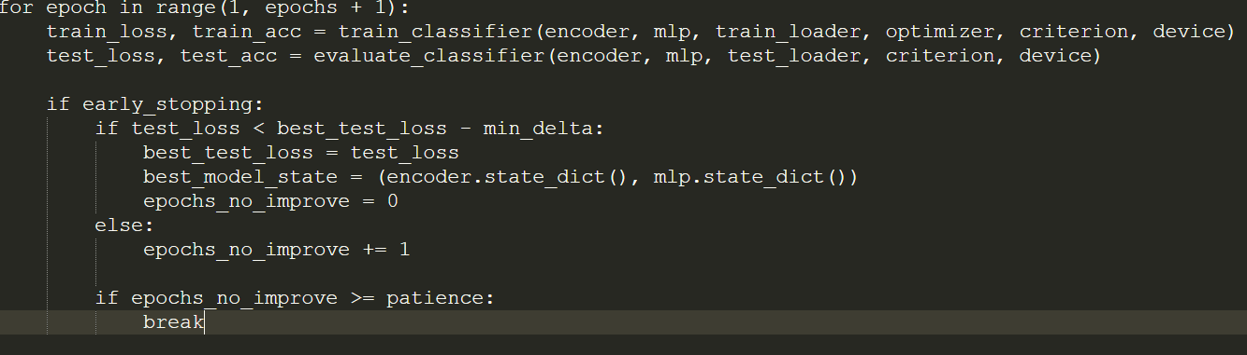

- Pre-trained Representation:
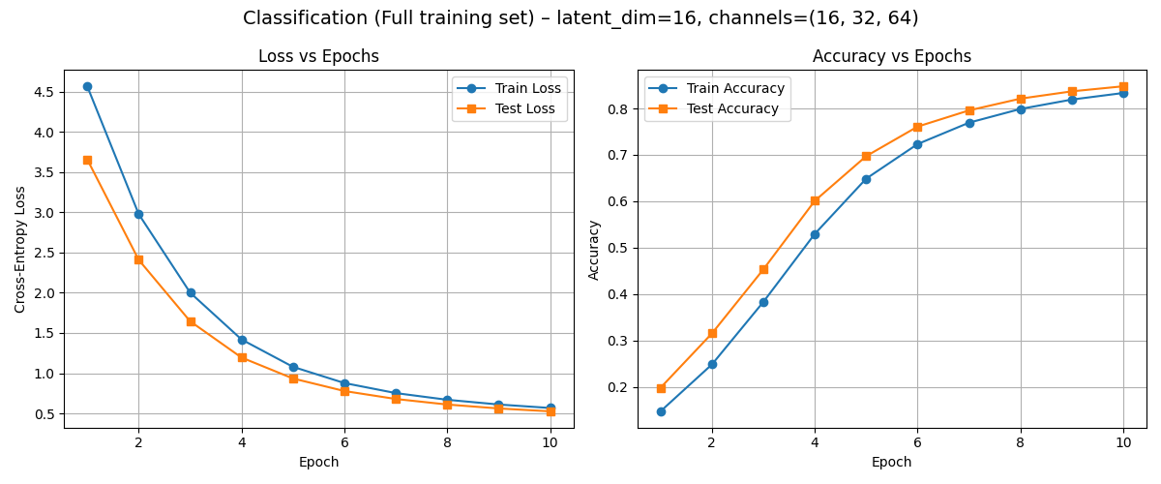
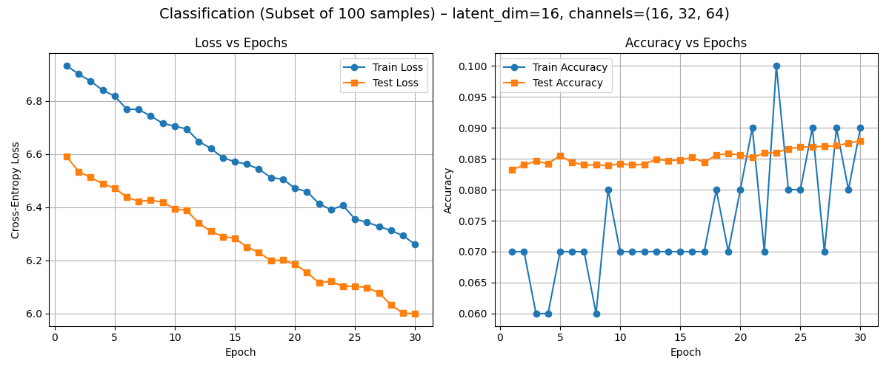

Analysis - Full Dataset
- Q2 (Trained from Scratch): Achieved ~98.7% accuracy, with fast convergence and smooth learning. The encoder could learn task-specific features.
- Q3 (Frozen Pretrained Encoder): Reached only ~84.5% accuracy. While loss and accuracy improved steadily, performance saturated early and was significantly worse than Q2.
- Insight: Without the ability to fine-tune, the frozen encoder limits the MLP's capacity to adapt to the classification task.

Analysis - 100-Sample Subset
- Q2 (Trained from Scratch): Achieved ~63% test accuracy, showing that even with limited data, learning both encoder and MLP is feasible.
- Q3 (Frozen Pretrained Encoder): Accuracy stagnated at ~9%, near random guessing. The training accuracy also showed instability, with spikes and fluctuations — a sign of optimization difficulties when only the classifier is trained.
- Insight: The frozen encoder lacks flexibility, especially with few samples. The MLP can't extract discriminative information from static latent representations.
In conclusion, pretrained unsupervised encoders provide a good starting point, particularly when data is abundant. However, fine-tuning is crucial. Without it, even high-quality latent representations may fail to align with the downstream task. On small datasets, end-to-end training is essential to adapt the feature extractor to the task-specific signal. Overall, unsupervised pretraining seems to help only when paired with sufficient data and flexibility to fine-tune.

The training loop is the same as in Q1, but with function "init_models" which use a pre-trained encoder:
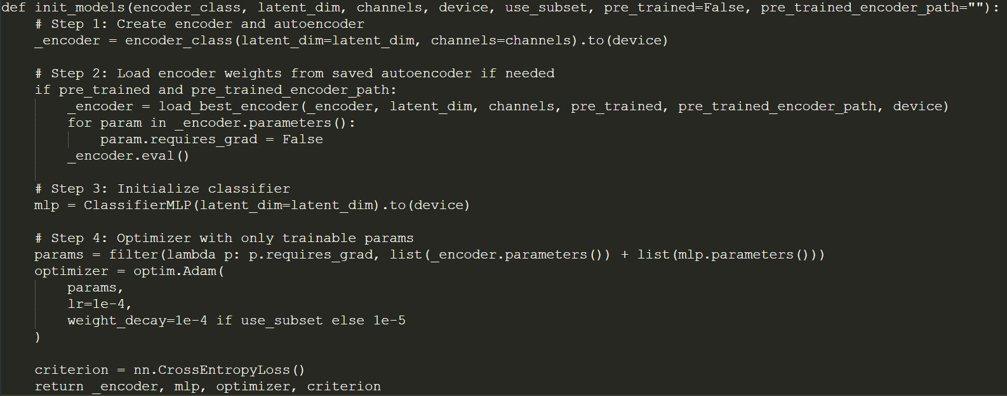
- Task Specific Encoding:
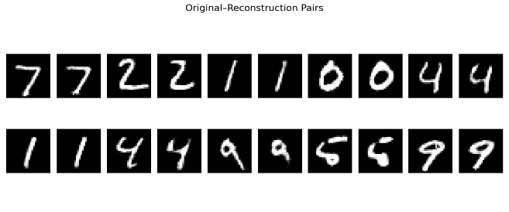
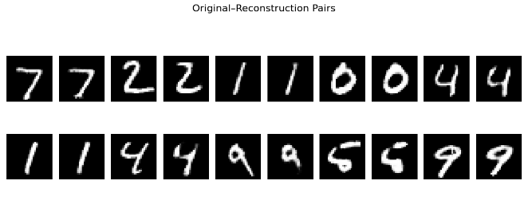
  - On the left is the losses plots + input vs reconstruction with pre-trained encoder and on the right with trained encoder:
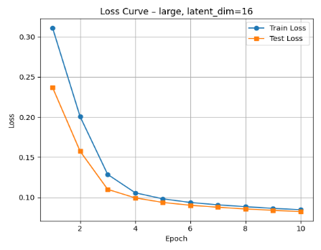
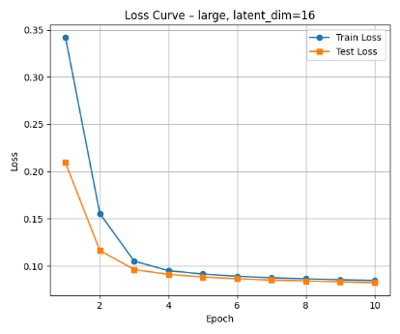

The model from Q1 (where the encoder and decoder are trained jointly from scratch) achieves slightly lower reconstruction error, both on the training and test sets. The encoder in Q1 is optimized specifically for the reconstruction task, so it learns latent representations that preserve all the necessary pixel-level details for accurate decoding.
In contrast, the encoder in Q4 was trained for classification, so it only retains information relevant for distinguishing digit classes — not for precise pixel recovery.
  - Q1 reconstructions are slightly sharper, with clearer digit contours and finer details — especially noticeable on digits like 4 and 9. Q4 reconstructions are also high quality, but show minor smoothing and blurring in some strokes, likely due to the encoder being trained to preserve class-discriminate features rather than for reconstruction. This reflects how classification-trained encoders capture semantic identity well, but not necessarily pixel-perfect information.
  - Below are input vs reconstruction with trained encoder for each digit:
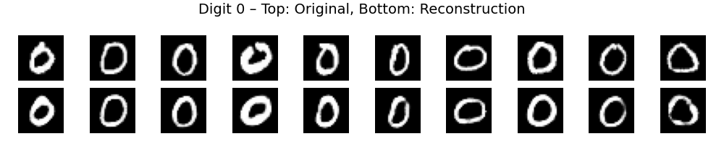
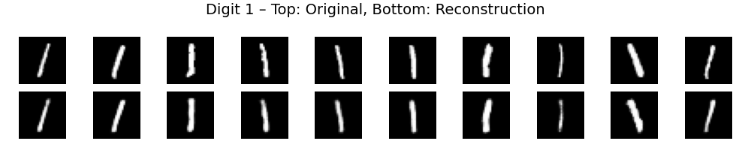
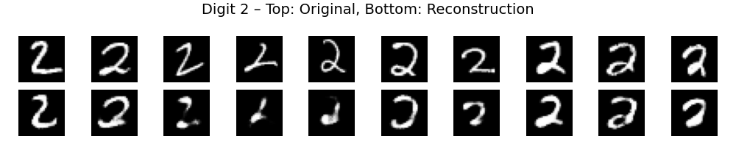
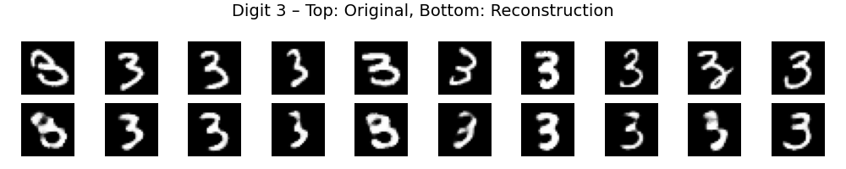
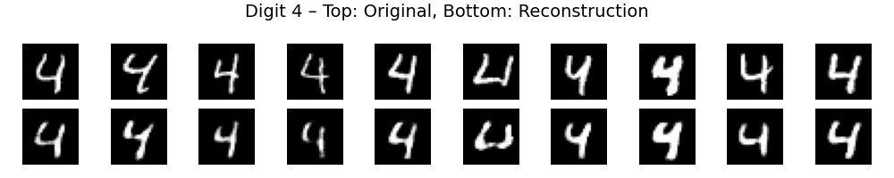
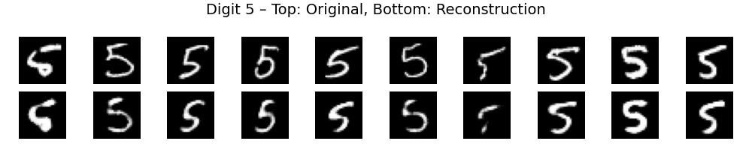
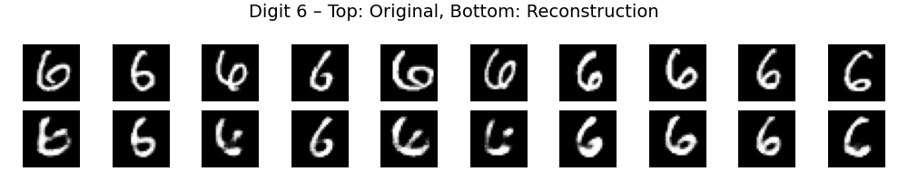
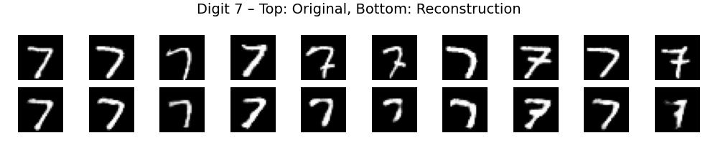
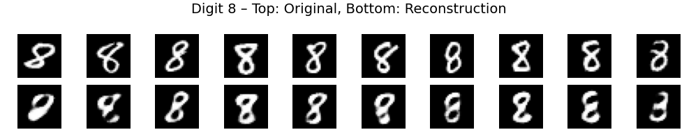
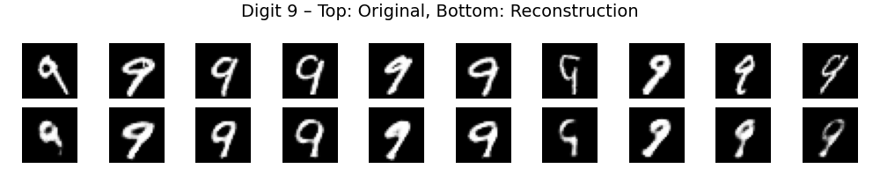

And with pre-trained encoder for each digit:
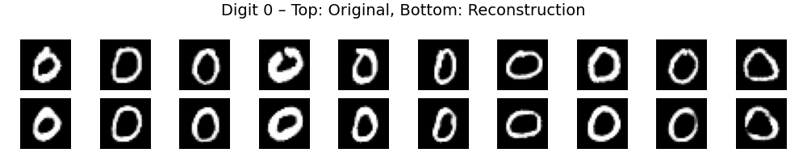
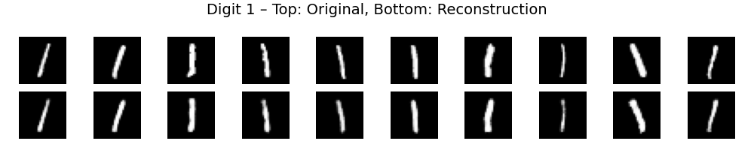
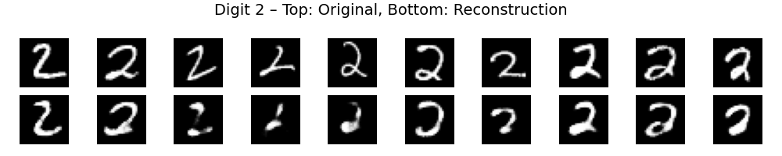
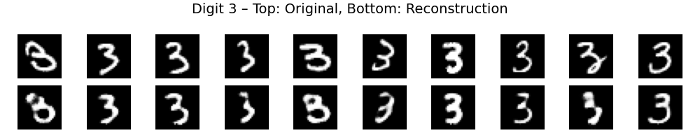
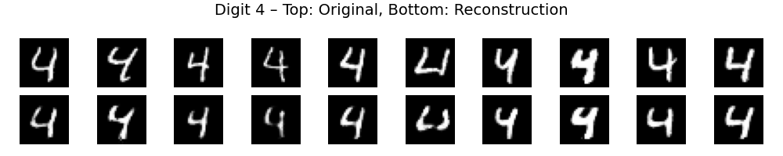
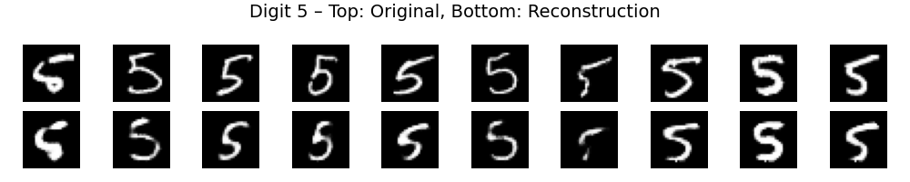
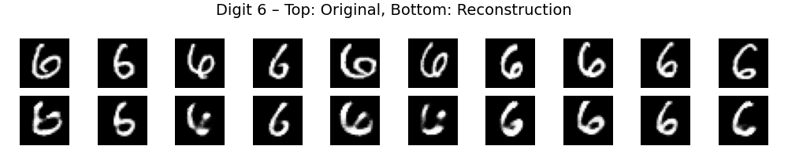
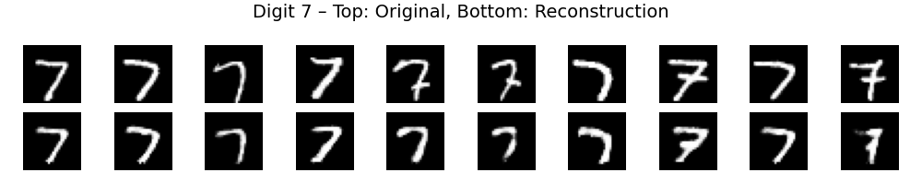
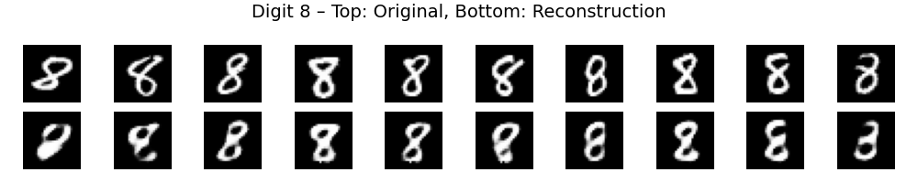
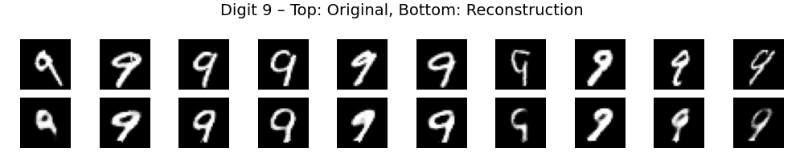
In Q1, reconstructions show higher intra-class variability — each digit instance retains its individual characteristics (e.g., slant, loop size, stroke).
In Q4, the reconstructions tend to “average out” digit variations, leading to lower variability between instances of the same digit.
  - Below are plots shows the separation between digit clusters – Q1 on the left and Q4 on the right:
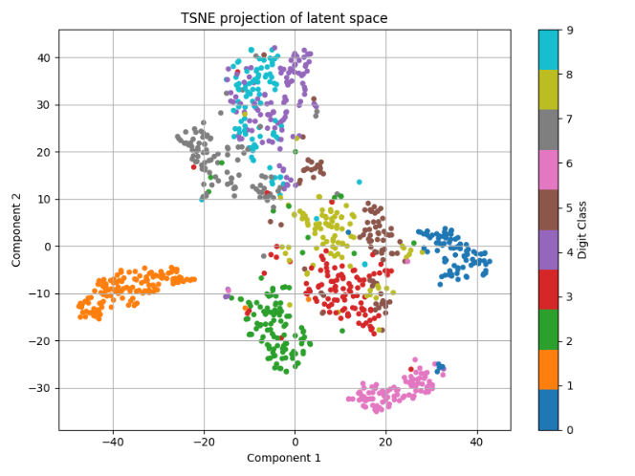
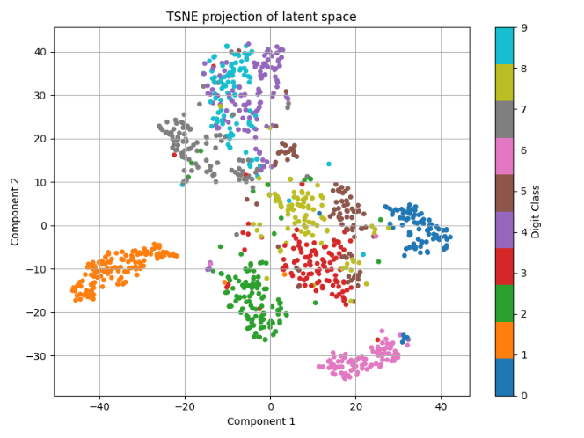
The Q4 encoder, trained for classification, exhibits stronger inter-class separation. In its t-SNE plot, each digit cluster is more distinct and compact, there is less overlap between neighboring digit classes (e.g., 3 and 5, 4 and 9).
In contrast, the Q1 encoder, trained only to reconstruct inputs, produces a latent space where digits are still clustered but with more blurring at the boundaries and classes such as 3 and 8, or 4 and 9, are closer and less clearly separated. The results are supported by the fact that Q4’s encoder was optimized to discriminate between digit classes, while Q1’s encoder was optimized only for reconstruction fidelity, not class separation.
The training loop is the same as in Q1, but with these lines of code before:
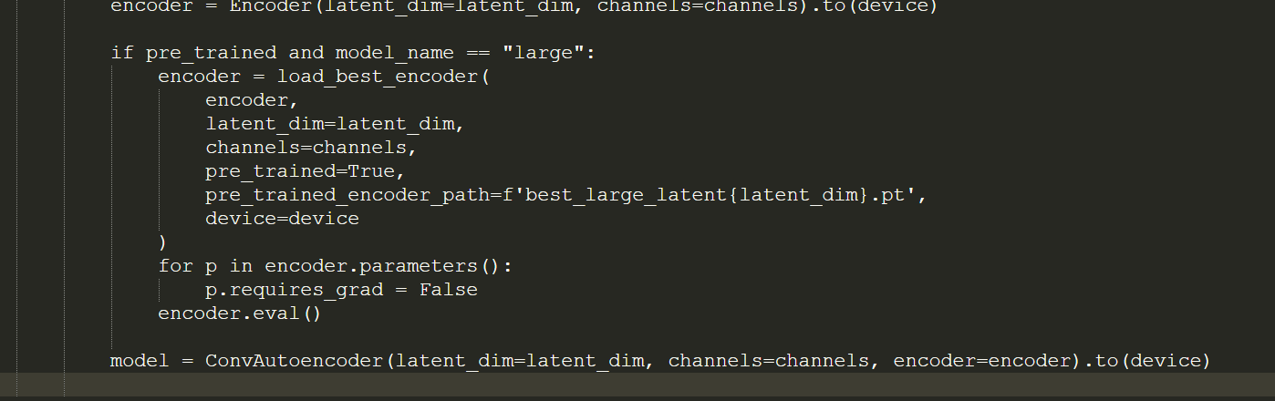
Theoretical Questions:
