Visual Aerial Navigation (VAN) System
Stereo Visual-SLAM Pipeline Implementation & Analysis
Nir Ellor Waizner, Ayala Houri
https://github.com/NirEllor/VAN_ex

Introduction and Overview

Background
Visual Simultaneous Localization and Mapping (Visual SLAM) estimates a platform's 3D motion trajectory using visual data from an onboard camera system. In this project, we address ego-motion estimation from a sequence of images captured at 10 frames per second by an onboard stereo camera. The system tracks 2D features across frames, triangulates 3D spatial points, calculates relative vehicle poses via PnP-RANSAC, and bounds cumulative drift using local Bundle Adjustment (BA), Pose-Graph factor optimization, and Loop Closure detection.

Importance of the Problem
- Infrastructure Independence (GPS-Denied Navigation):
Standard navigation systems rely heavily on satellite positioning (GPS/GNSS). However, GPS signals frequently degrade or fail entirely in environments such as urban canyons, tunnels, covered parking facilities, or dense forests. Visual SLAM provides a self-contained, infrastructure-free localization solution that operates purely on local visual observations.
- Cost-Effective & High-Information Sensing:
Compared to expensive, heavy active sensors like LiDAR, stereo camera rigs are lightweight, passive, low-power, and cost-effective. They capture rich spatial and visual context that can be used simultaneously for localization, obstacle detection, and environmental mapping.
- Safety and Autonomy in Mobile Robotics:
Accurate real-time localization and trajectory consistency are fundamental requirements for path planning, collision avoidance, and safe execution in autonomous driving and mobile robotics.

2. Code Organization

Project Structure:
The codebase is structured modularly, separating concerns into geometry calculations, database tracking, bundle adjustment, factor-graph optimization, and visualization routines. Pipeline execution is driven by main.py, while ablation studies and experiment scripts reside in experiments
code/
├── tracking_database.py (class Observation @22, class TrackingDB @30)
├── homework/ (legacy exercises; van_utils.py fallback)
└── project/
├── main.py (pipeline driver)
├── outputs/ (generated report figures)
├── experiment_results/ (ablation study result pickles)
├── utils/
│ ├── geometry.py (triangulation, PnP-RANSAC, KITTI/Rodrigues formulas)
│ ├── tracking.py (build_data pipeline, inline RANSAC)
│ ├── bundle_adjustment.py(solve_bundle_window — GTSAM solving)
│ ├── pose_graph.py (build/optimize pose graph, relative pose+covariance)
│ ├── loop_closure.py (candidate detection, verification, factor integration)
│ └── visualization.py (all 17 plot_* functions)
└── experiments/ (5 compare_*.py ablation scripts + harness)

System Overview
- 1. Triangulation: Stereo point triangulation using rectified image pairs and camera calibration | Function: triangulate_points_opencv | File: code/project/utils/geometry.py | Line: 208
- 2. RANSAC: PnP outlier rejection via RANSAC consensus | Function: run_custom_pnp_ransac | File: code/project/utils/geometry.py | Line: 237
- 3. PnP trajectory calculation: Temporal pose estimation from track observations | Function: build_data | File: code/project/utils/tracking.py | Line: 127
- 4a. Database definition (Observation): Observation data structure for track observations | Function: class Observation | File: code/tracking_database.py | Line: 22
- 4b. Database definition (TrackingDB): TrackingDB data structure for tracking | Function: class TrackingDB | File: code/tracking_database.py | Line: 30
- 5. Adding a frame to the database: Feature track integration across frames | Function: update_tracks | File: code/tracking_database.py | Line: 83
- 6. Single Bundle creation: Single-window pose and landmark optimization via GTSAM | Function: solve_bundle_window | File: code/project/utils/bundle_adjustment.py | Line: 235
- 7. Relative transformation + covariance: Pose constraint extraction with uncertainty quantification | Function: compute_relative_pose_and_covariance | File: code/project/utils/pose_graph.py | Line: 150
- 8a. PoseGraph building (init): Factor graph construction and initialization | Function: build_and_initialize_pose_graph | File: code/project/utils/pose_graph.py | Line: 77
- 8b. PoseGraph building (optimize): Factor graph optimization | Function: optimize_pose_graph | File: code/project/utils/pose_graph.py | Line: 105
- 9a. Loop closure detection: Candidate detection via Mahalanobis distance | Function: detect_loop_closure_candidates | File: code/project/utils/loop_closure.py | Line: 42
- 9b. Loop closure factor creation: Relative pose estimation and graph integration | Function: add_loop_closures_and_optimize | File: code/project/utils/loop_closure.py | Line: 229

3. Performance Analysis

Experiments & Improvements
Five ablation studies systematically evaluate the impact of key system components. Loop closure is enabled ONLY for Experiment 1 (which specifically tests its gating parameters) and disabled for Experiments 2–5. This ensures a fair comparison, prevents result confounding from a variable number of detected loops, and isolates the pure effect of each tested parameter.

1. Loop-Closure Gating Strictness
Tests Mahalanobis distance threshold and inlier ratio threshold for candidate acceptance. Variants: strict (threshold=300, inlier_ratio=0.8), baseline (1000, 0.6), loose (3000, 0.4). LOOP CLOSURE: ENABLED (this experiment specifically tests loop-closure detection and gating parameters).
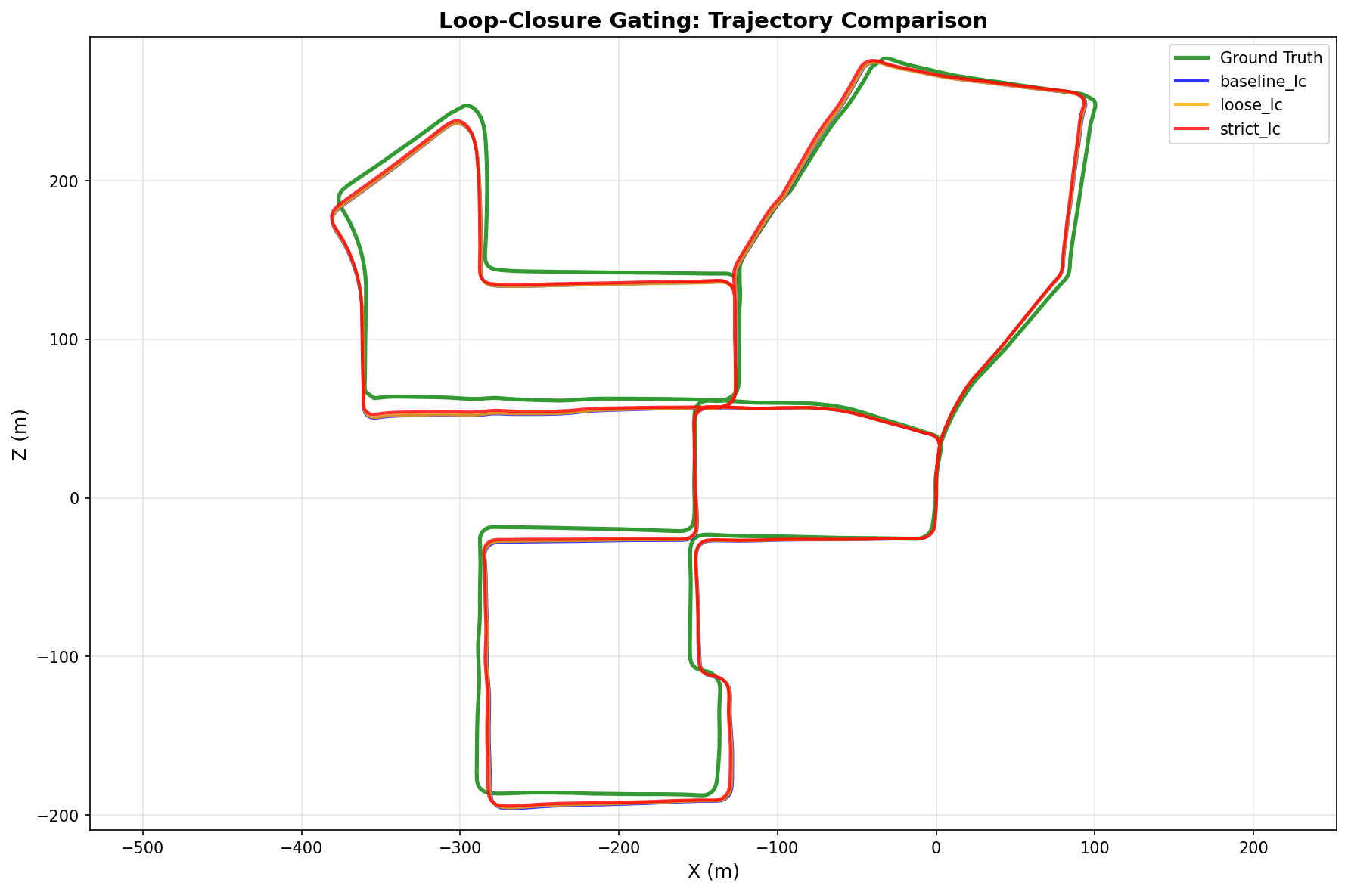
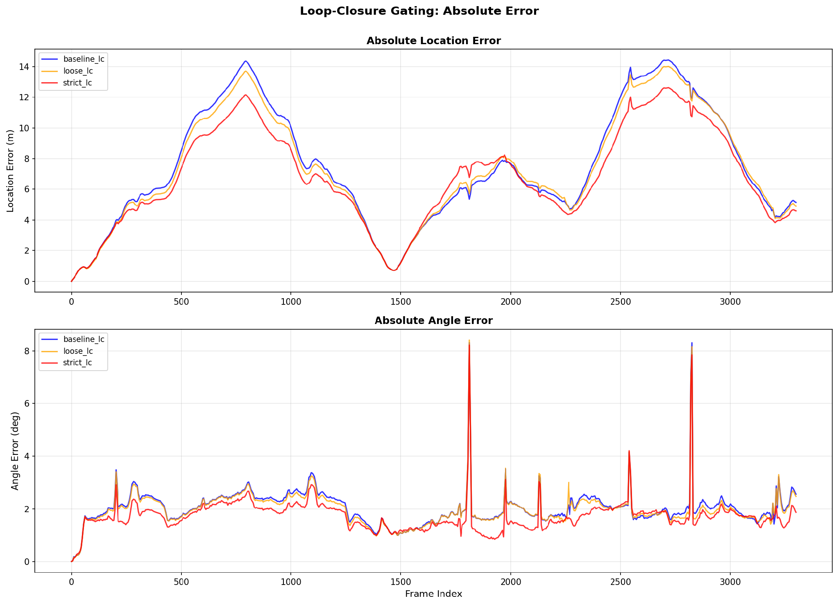

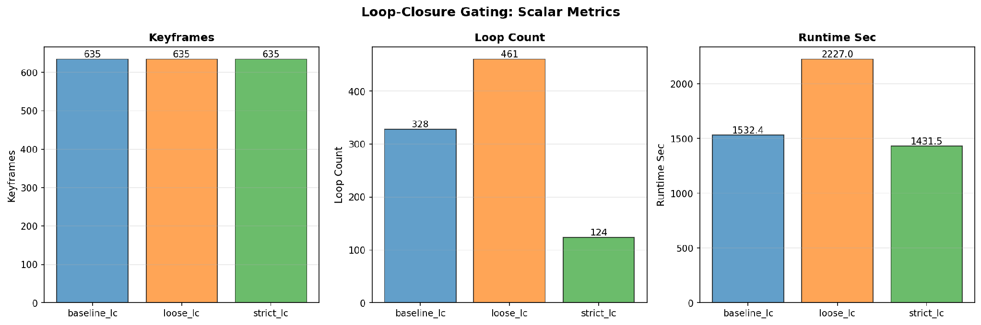

Applying a strict gating threshold (strict_lc) significantly improves overall system performance. Although strict gating accepts fewer loop closures (124 compared to 461 in loose_lc), it effectively eliminates false-positive loop acceptances that degrade trajectory accuracy and introduce optimization overhead. Consequently, strict_lc achieves the lowest absolute location error while reducing runtime to a minimum (1431.5 seconds), demonstrating the optimal trade-off between localization precision and computational efficiency.

2. Keyframe Density
This experiment evaluated the impact of the keyframe selection distance threshold on trajectory accuracy and computational efficiency across three settings: dense (1.25 m), baseline (2.5 m), and sparse (5.0 m).
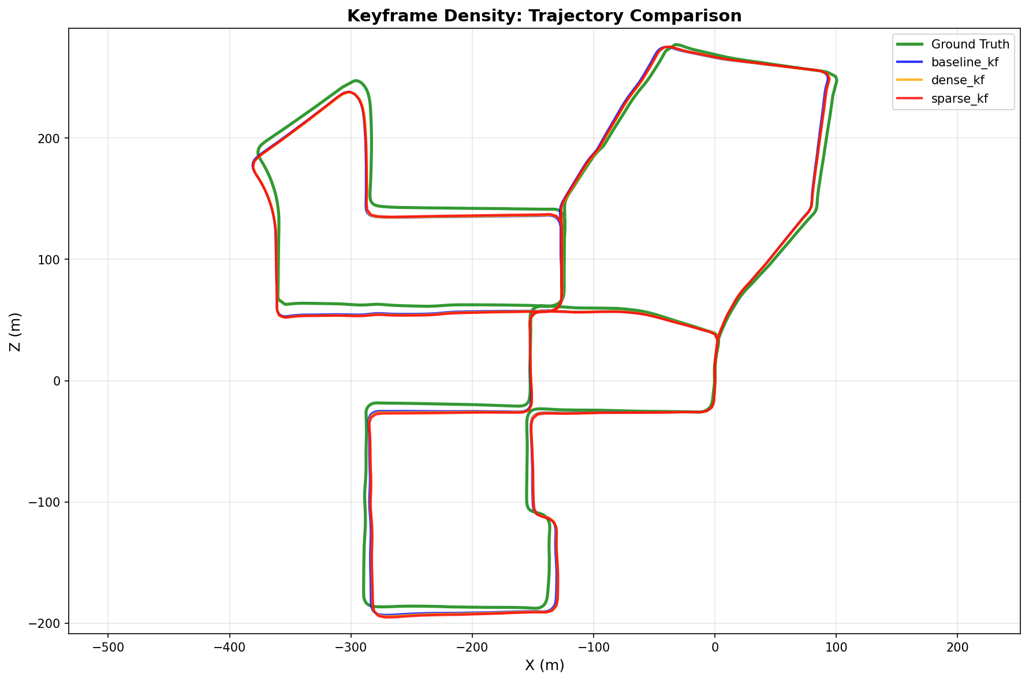
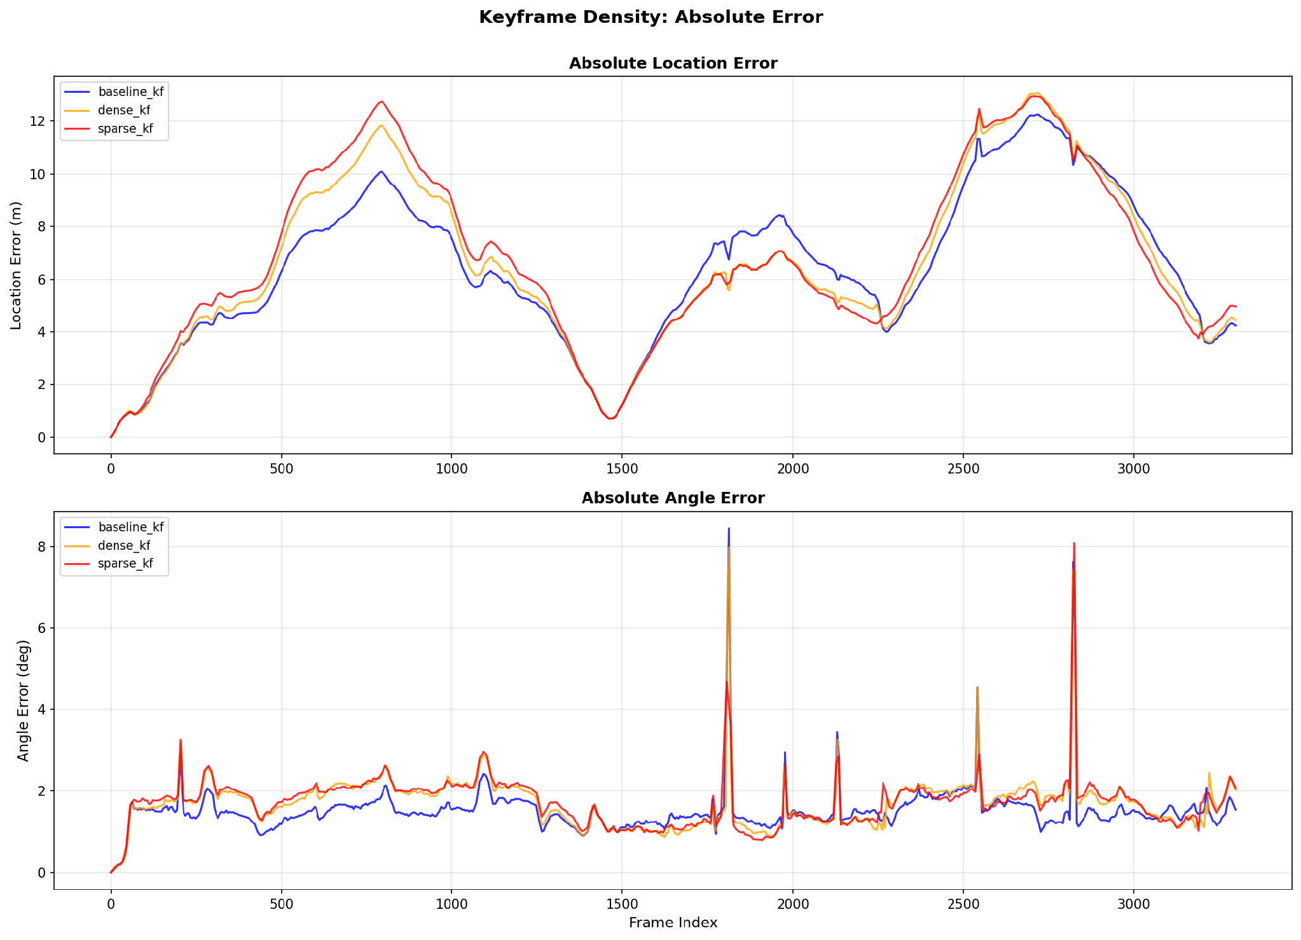

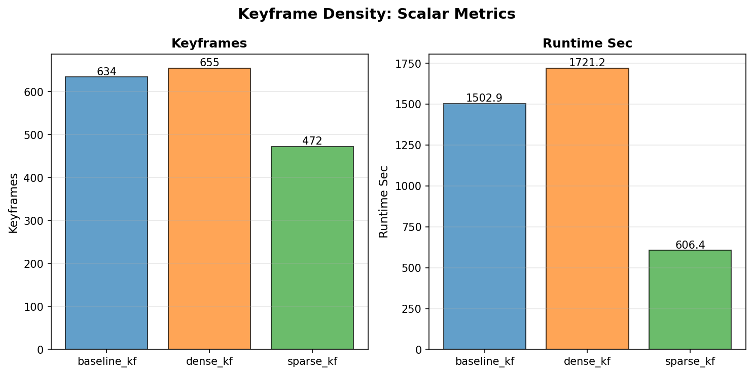
Keyframe density demonstrates a clear trade-off between localization accuracy and computational overhead. The sparse variant (sparse_kf) significantly reduced total runtime to 606.4 seconds—representing a ~60% speedup compared to the baseline—while maintaining trajectory error comparable to the dense setup. However, baseline_kf (2.5 m) achieved the lowest overall Absolute Location Error. Consequently, sparse_kf provides an optimal configuration for resource-constrained, real-time applications, whereas baseline_kf remains preferable when trajectory precision is paramount.

3. Bundle Adjustment Noise Model

This experiment evaluated the impact of factor noise modeling (prior and stereo measurement sigmas in GTSAM) on trajectory estimation and optimization convergence.
Tests GTSAM factor weights via prior_sigma ∈ {1.0, 0.05, 1e-6} and stereo_sigma ∈ {0.5, 1.0, 2.0}.

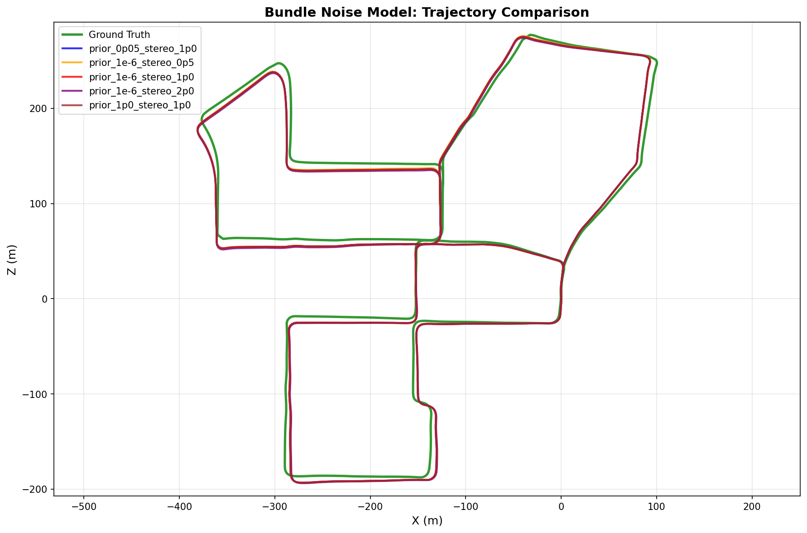
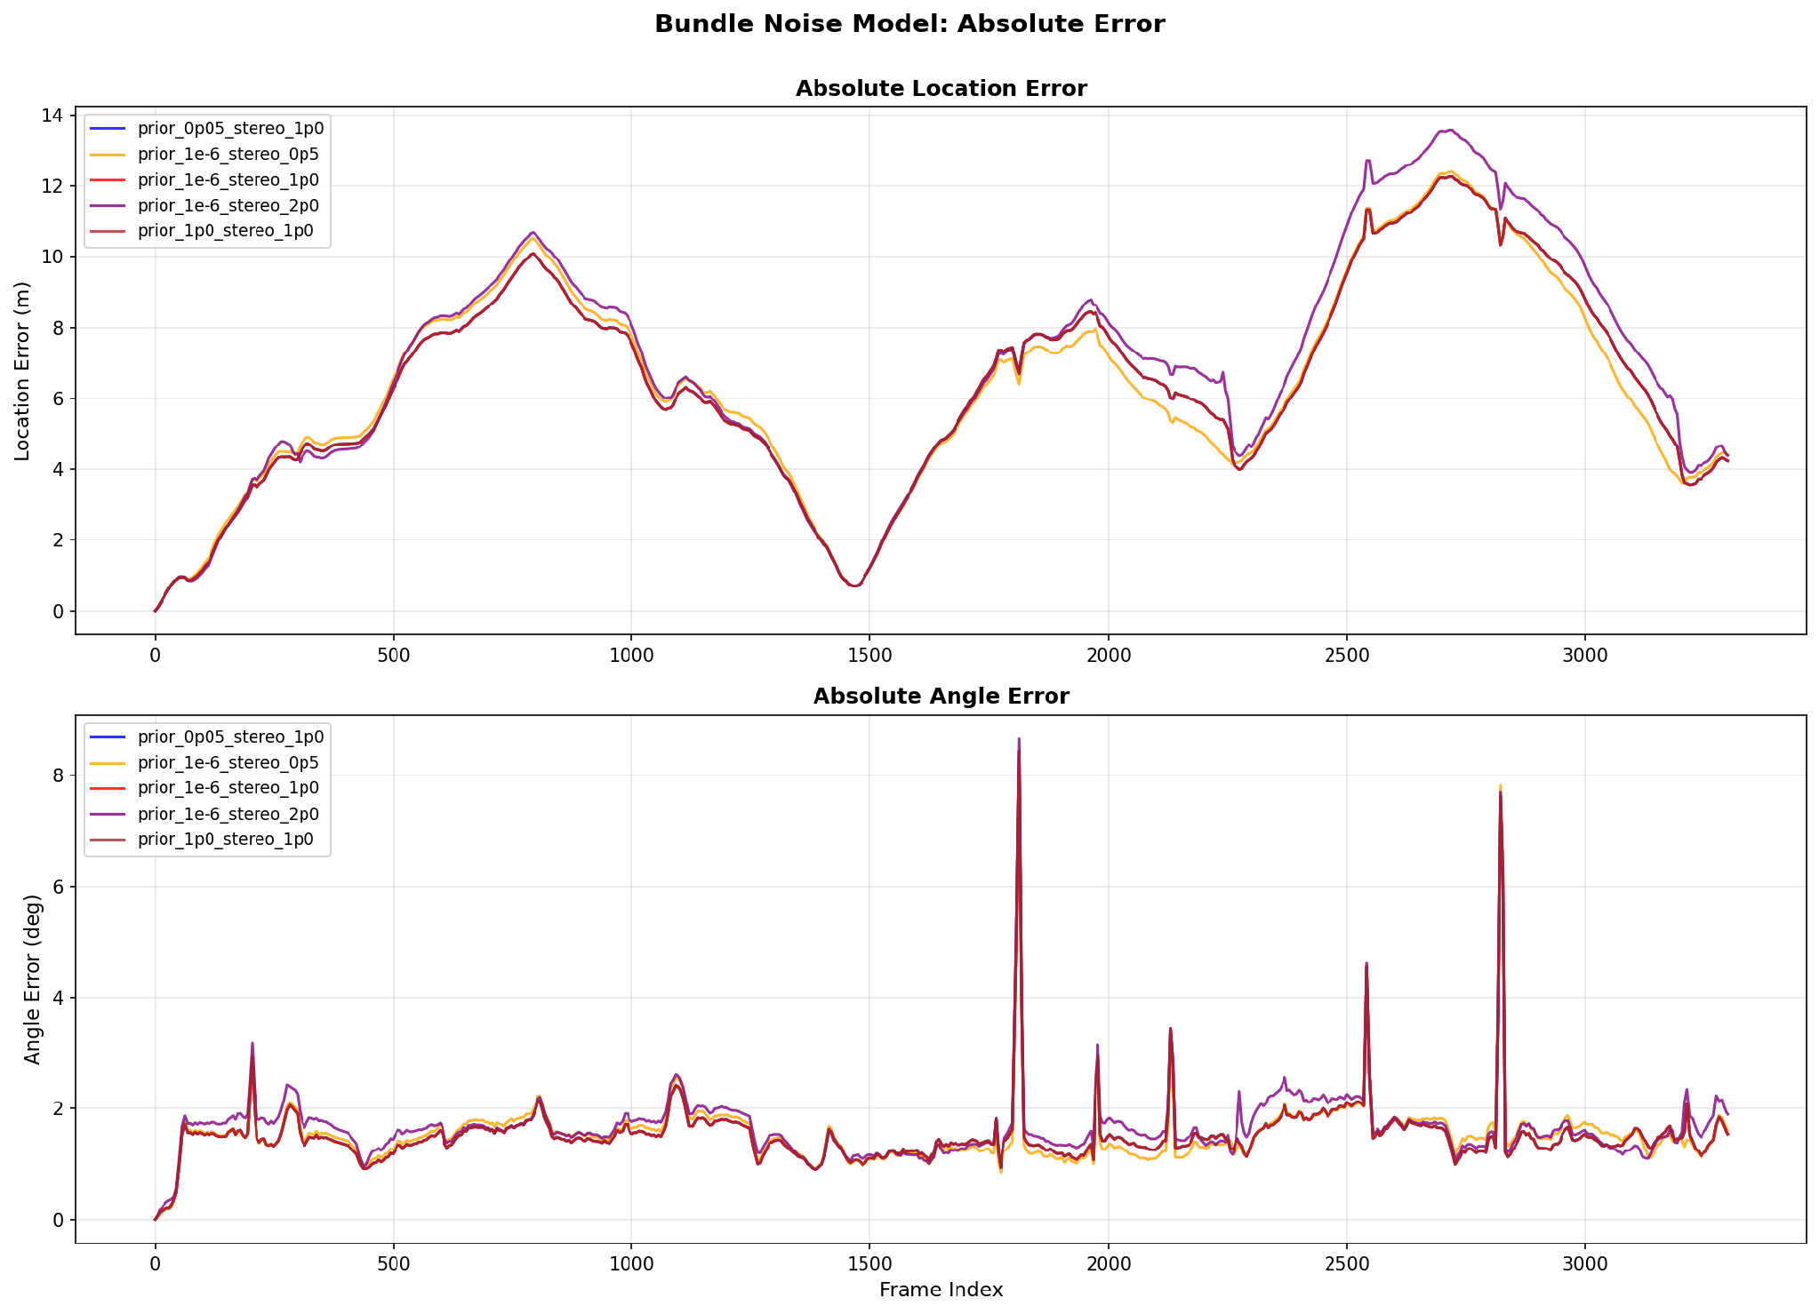

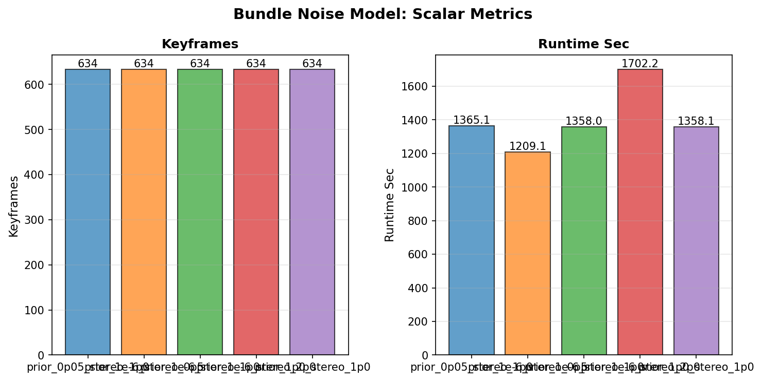

We can observe that all tested configurations produce virtually identical trajectory plots against the ground truth. However, quantitative evaluation reveals that assigning excessive uncertainty to stereo visual factors (stereo_sigma = 2.0) degrades system performance, leading to higher location error and an increased runtime of 1702.2 seconds. Conversely, tighter visual factor sigmas (stereo_sigma = 0.5 or 1.0) maintain stable and accurate trajectory estimates. The prior_1e-6_stereo_0p5 configuration yielded the optimal balance, achieving high localization precision while minimizing computational runtime to 1209.1 seconds.

4. PnP-RANSAC Parameters
This experiment evaluated the impact of PnP-RANSAC settings, specifically the pixel inlier threshold and maximum iteration count, on pose estimation quality and overall runtime.
Tests inlier threshold (pixels) and iteration count. Variants: strict (1px, 100 iter), baseline (2px, 50), loose (4px, 25).

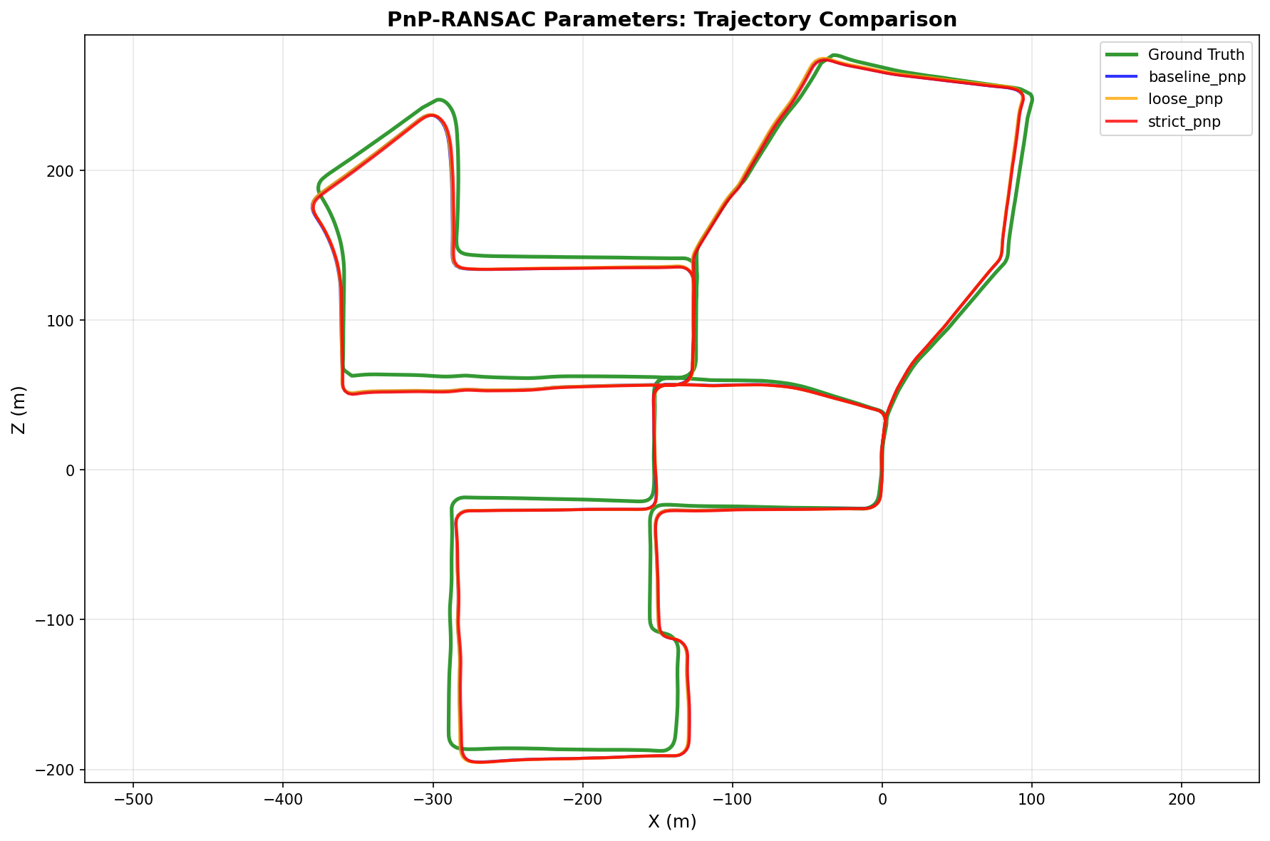
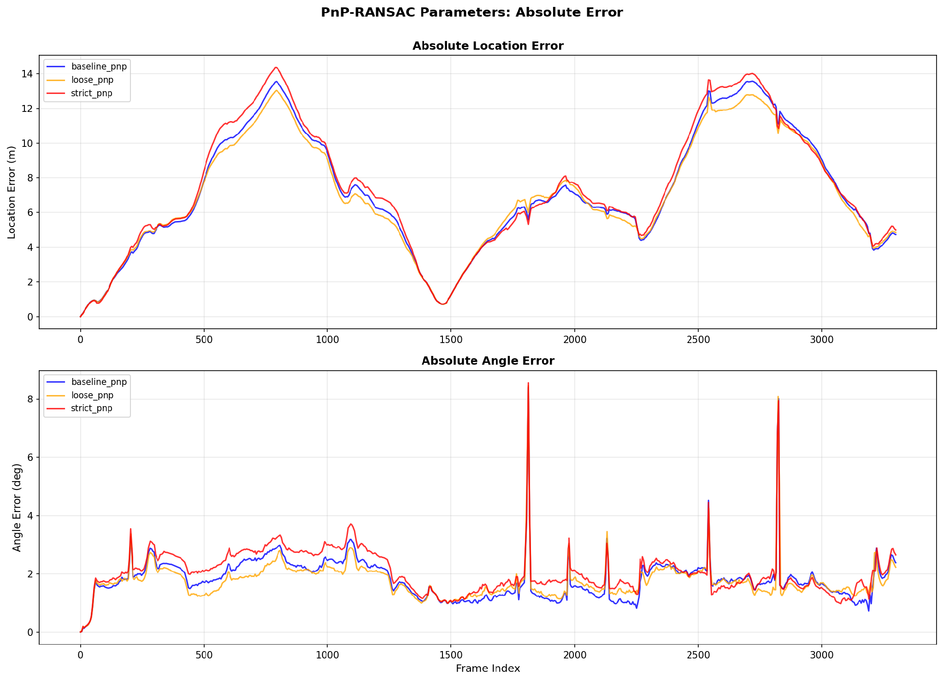

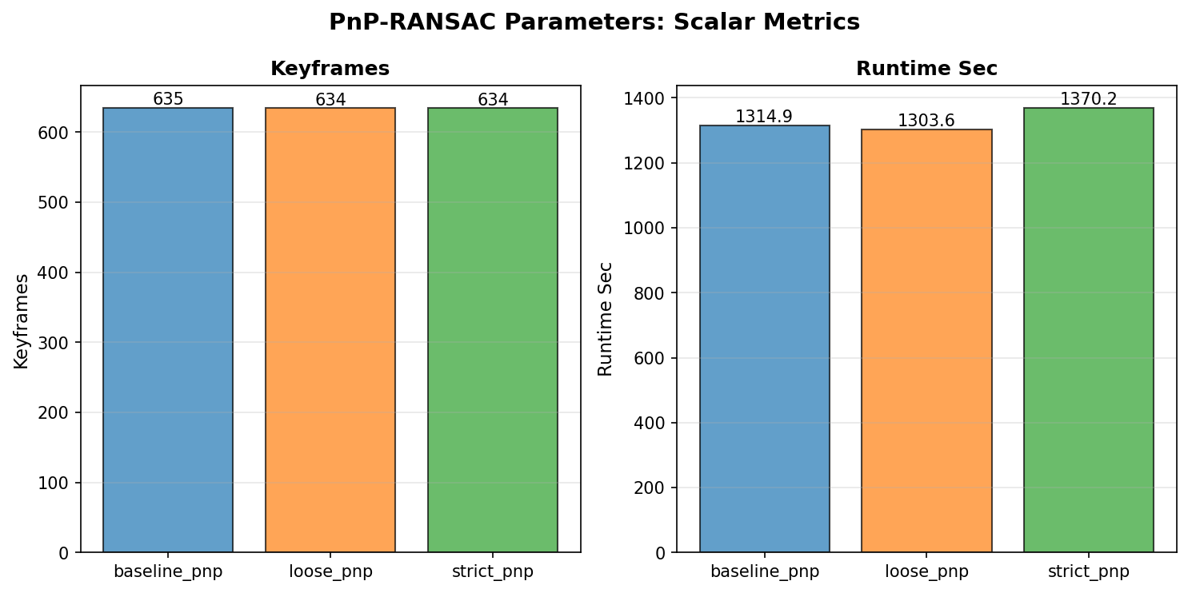

Visually, all tested configurations generate nearly identical trajectory estimations. Quantitatively, overly strict gating (strict_pnp: 1px threshold, 100 iterations) does not yield precision gains and slightly increases angular error due to excessive inlier rejection, while adding slight computational overhead (1370.2 seconds). Conversely, baseline_pnp (2px, 50 iterations) and loose_pnp (4px, 25 iterations) demonstrate robust tracking with lower runtimes, with baseline_pnp offering the most balanced trade-off between outlier rejection and inlier retention for reliable relative pose estimation.

5. Feature Detectors
Compares AKAZE (baseline), ORB (3,000 features), and SIFT.

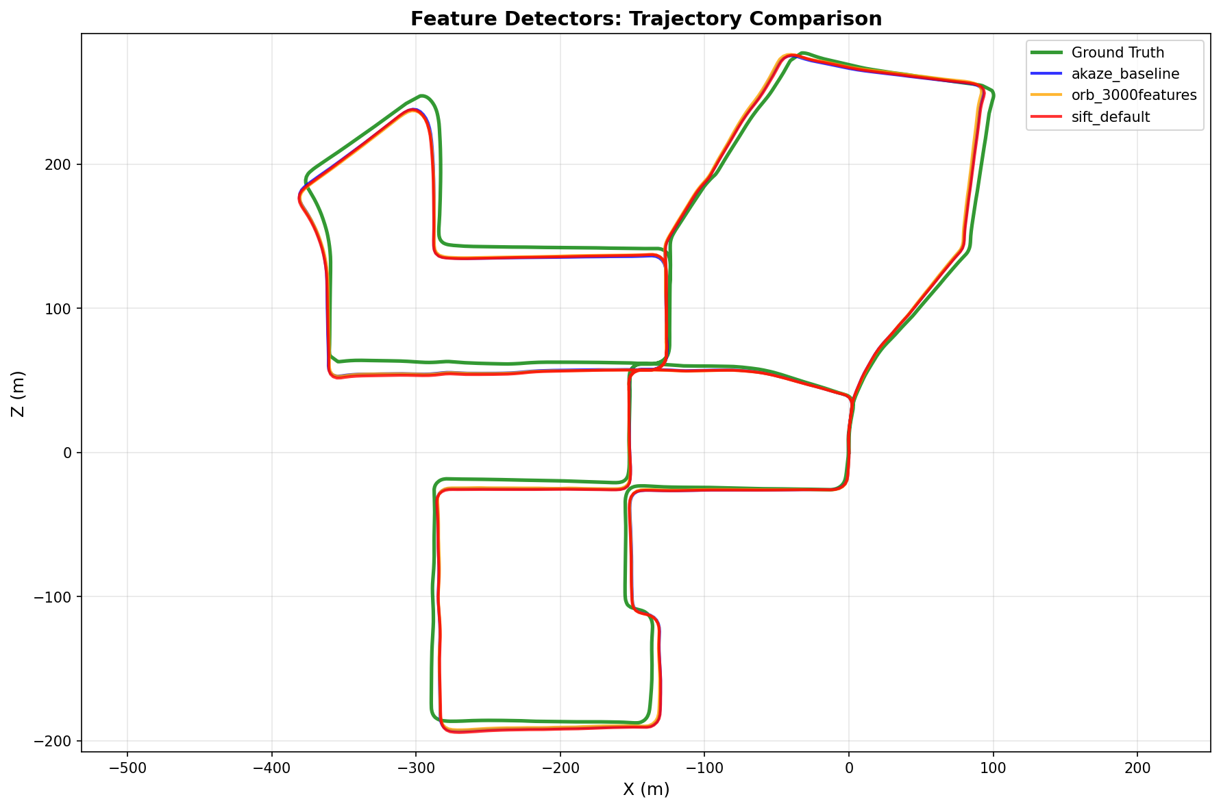
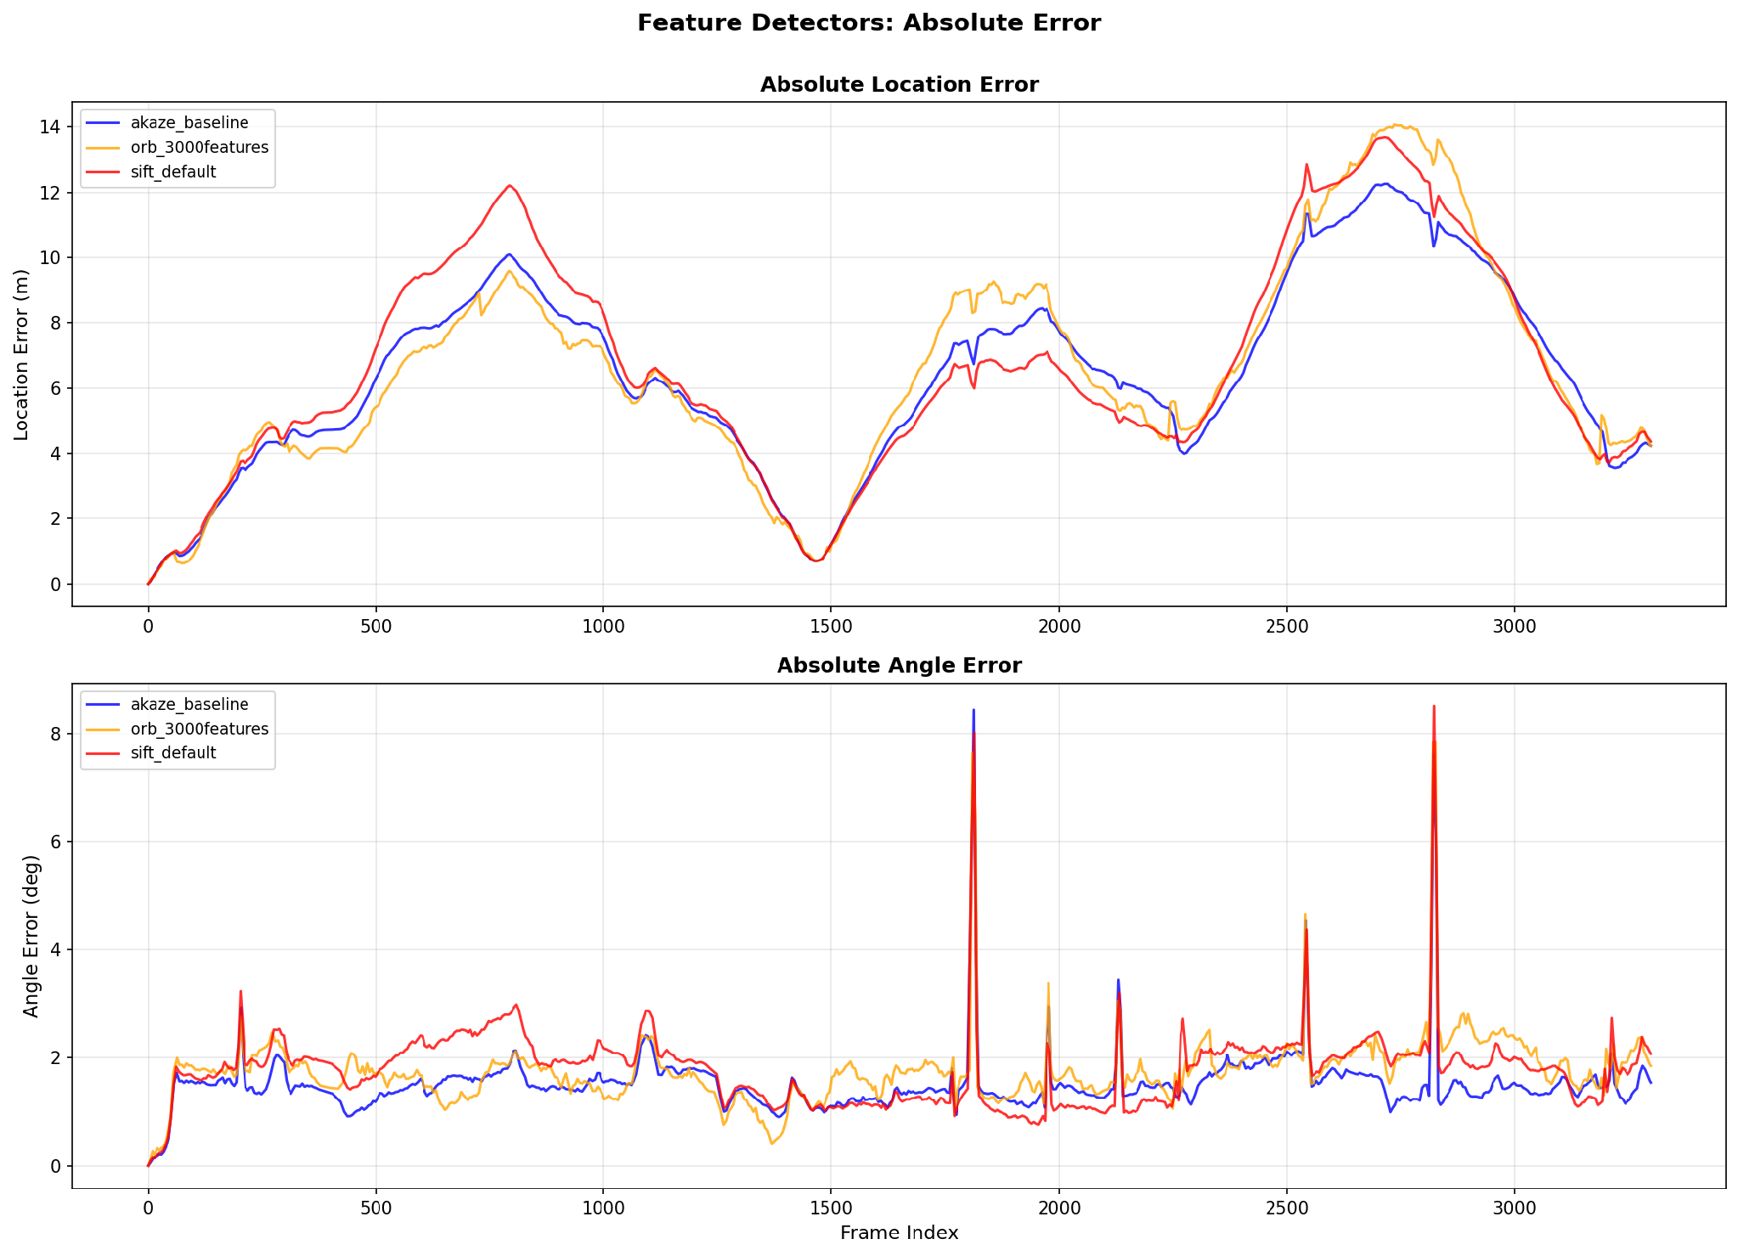

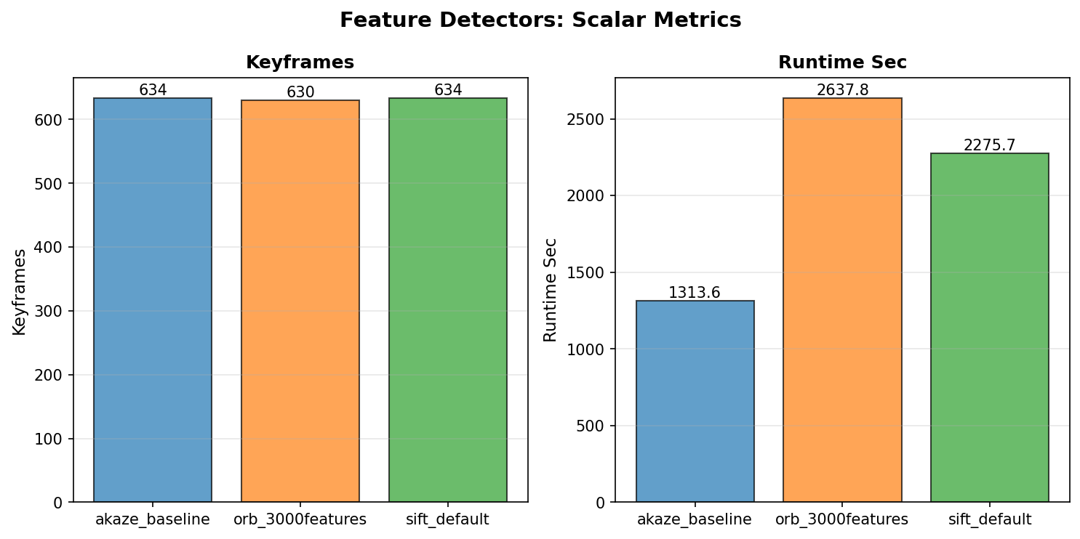

AKAZE demonstrates superior overall performance, delivering the optimal balance between computational efficiency and localization accuracy. It achieved the fastest execution time (1313.6 seconds, roughly 2 times faster than ORB and 1.7 times faster than SIFT) while consistently maintaining low absolute location error. Conversely, extracting 3,000 features with ORB significantly increased matching and optimization overhead (2637.8 seconds) without yielding accuracy gains.Thus, AKAZE proves to be the most effective feature detector for real-time Visual SLAM.

3.2 Mandatory Tracking Statistics
Metric | Value (Function, File, Line)
Total Tracks | 901,081 | TrackingDB.track_num(), code/tracking_database.py, line 68
Total Frames | 3,300 | TrackingDB.frame_num(), code/tracking_database.py, line 72
Mean Track Length | 4.40 frames | compute_tracking_statistics(), code/project/utils/tracking.py, line 75
Mean Frame Links | 1,200.94 tracks per frame | compute_tracking_statistics(), code/project/utils/tracking.py, line 75
Matches Per Frame | Graph: task_4_8_matches_per_frame.png | plot_matches_per_frame(), code/project/utils/visualization.py, line 787
Inlier Percentage | Graph: task_4_5_inlier_percentage.png | plot_inlier_percentage(), code/project/utils/visualization.py, line 256

Matches Per Frame:
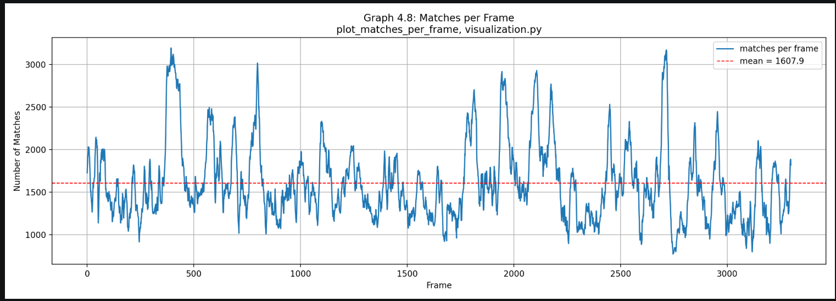

GRAPH ANALYSIS: This plot displays the total number of feature matches per frame across the sequence. The front-end demonstrates high feature density with a strong average of 1607.9 matches per frame (peaking over 3000 matches), providing a rich constraint set for frame-to-frame estimation. However, match counts fluctuate noticeably throughout the trajectory, dropping below 800 matches during feature-sparse scenes or fast motion intervals.

Inlier Percentage:
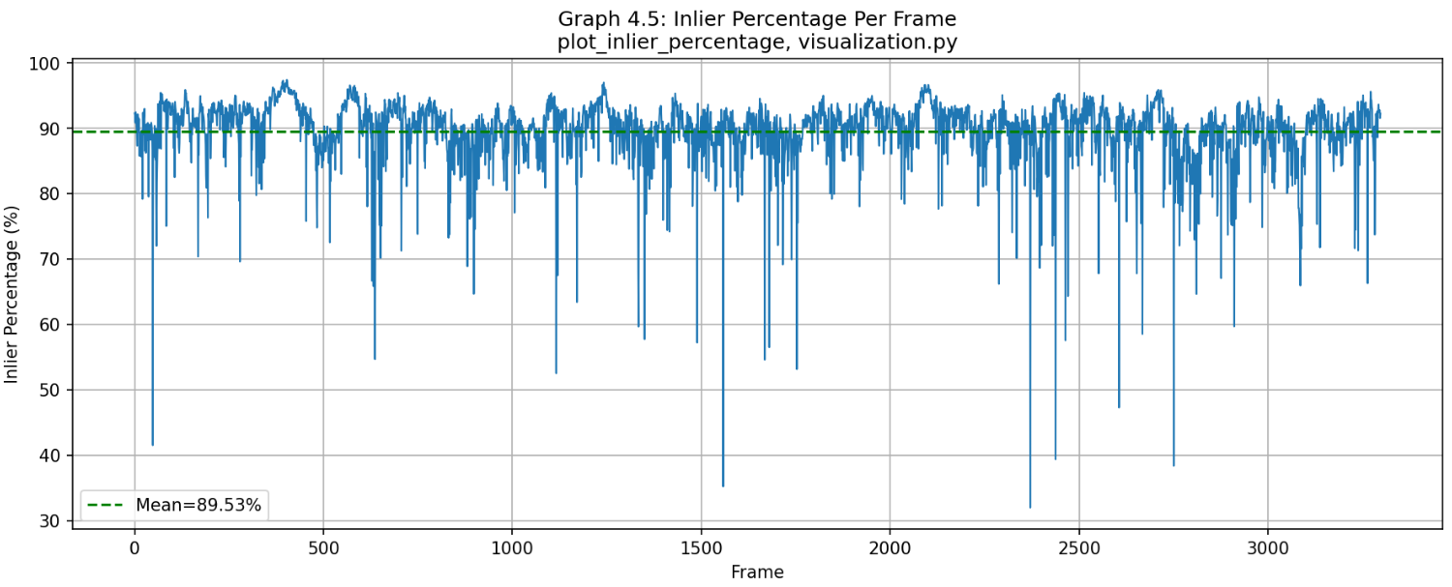

GRAPH ANALYSIS: This plot displays the percentage of RANSAC inlier feature matches per frame across the video sequence. The system maintains a high average consensus with a mean inlier ratio of 89.53%, demonstrating highly reliable feature tracking and robust pose estimation over time. However, occasional sharp drops (dipping down to 30–40% at specific frames) reveal localized tracking sensitivity during rapid vehicle turns or sudden motion changes.

3.3 Key Performance Graphs

Figure 1: Connectivity
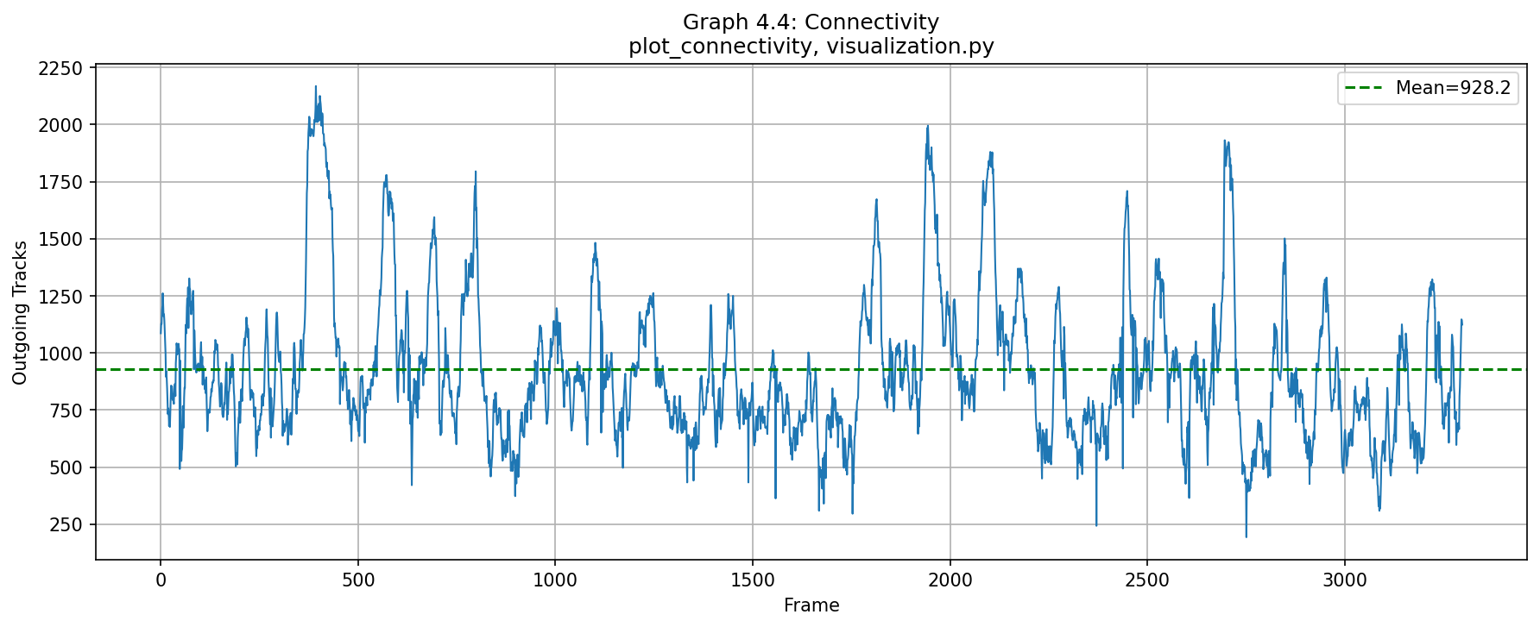
Frame-to-frame track linkage counts | Function: plot_connectivity() | File: code/project/utils/visualization.py | Line: 243

GRAPH ANALYSIS: This graph shows strong frame-to-frame tracking continuity, maintaining an average of 928.2 outgoing tracks throughout the sequence. The consistently high track count (never dropping below 200) ensures stable PnP pose estimation, while local dips highlight sharp turns or feature-sparse scenes where tracks naturally terminate.

Figure 2: Track Length Histogram
Distribution of feature track lifespans (log scale) | Function: plot_track_length_histogram() | File: code/project/utils/visualization.py | Line: 270
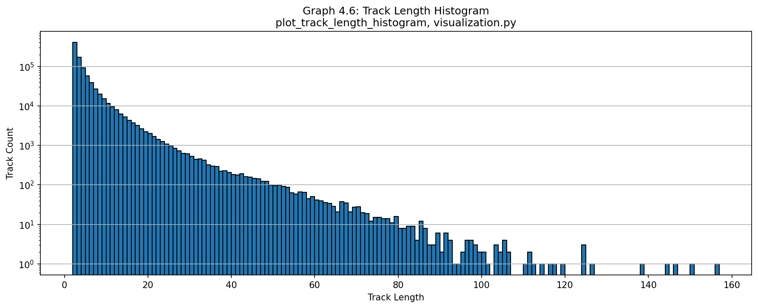
GRAPH ANALYSIS: This histogram shows an exponential decay in track lifespans, where most features persist for 2–10 frames. The long tail (up to 160 frames) is a major benefit, providing strong co-visibility constraints for Bundle Adjustment, while the high volume of short tracks reflects natural feature turnover due to motion and camera exit.

Figure 3: Trajectory Comparison (Bird's Eye)
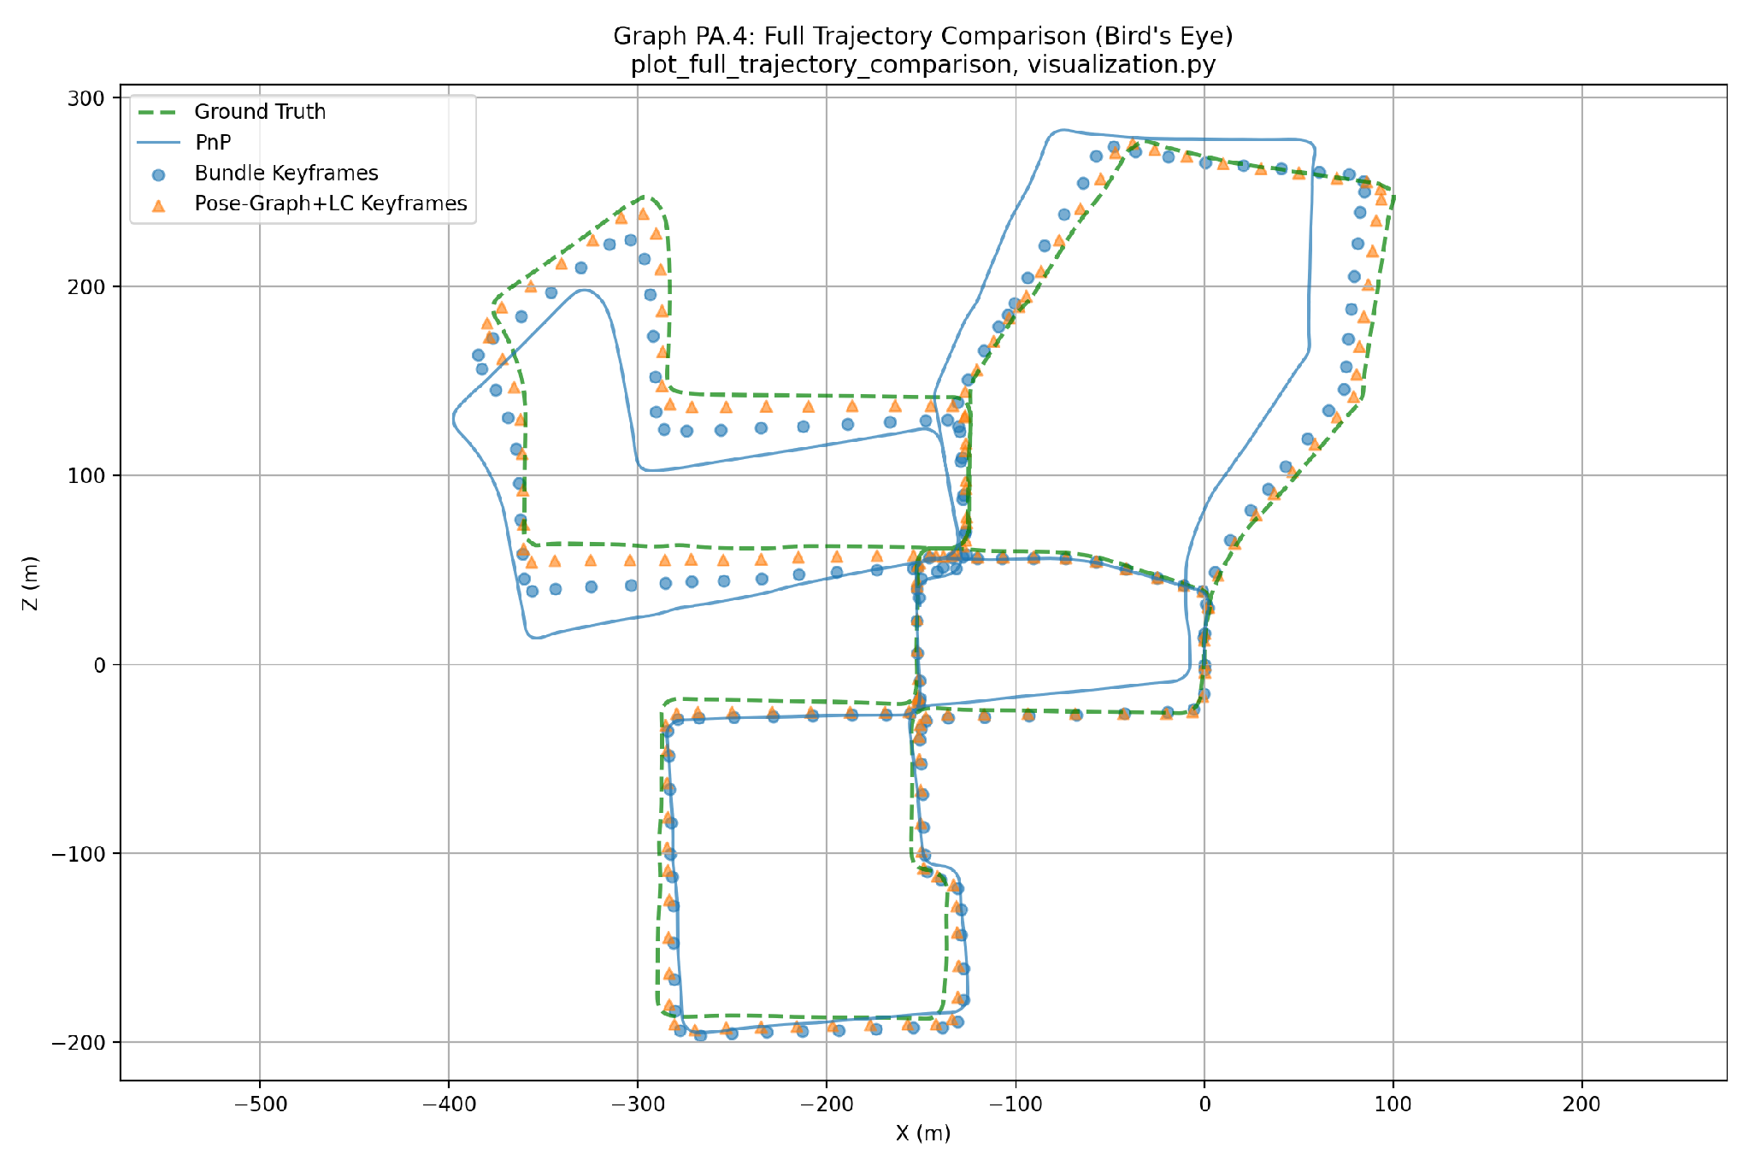
Overlay of PnP, Bundle, Pose-Graph+LC, and ground-truth trajectories | Function: plot_full_trajectory_comparison() | File: code/project/utils/visualization.py | Line: 893

GRAPH ANALYSIS: This bird's-eye view compares estimated trajectories against Ground Truth (green line). Pure PnP (blue line) accumulates severe drift over time, whereas Bundle Adjustment (blue dots) reduces local error, and Pose-Graph with Loop Closure (orange triangles) successfully eliminates global drift upon revisiting locations, aligning closely with Ground Truth.

Figure 4: Bundle Optimization Error
Mean factor-graph error before/after optimization per keyframe window | Function: plot_bundle_optimization_error() | File: code/project/utils/visualization.py | Line: 835
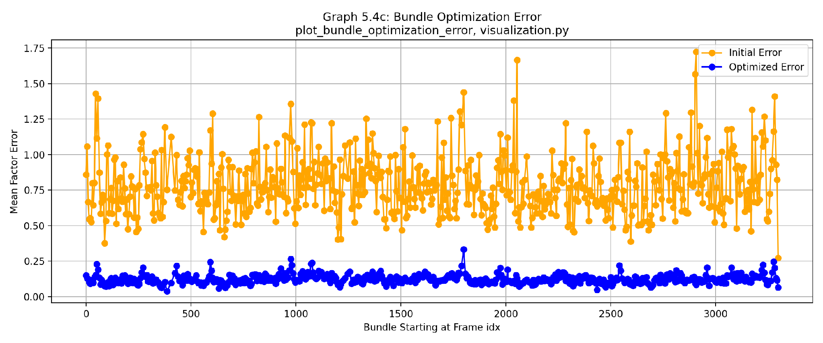
GRAPH ANALYSIS: This plot displays the mean factor-graph error before (orange) and after (blue) optimization per bundle window. Bundle Adjustment consistently reduces reprojection errors from initial values of 0.50-1.75 down to a stable level below 0.25, demonstrating reliable numerical convergence. However, the sharp initial error spikes (orange) reveal the pipeline's sensitivity to noisy feature observations during rapid vehicle turns prior to optimization.

Figure 5: Bundle Projection Error
Median projection error of landmarks before/after optimization | Function: plot_bundle_projection_error() | File: code/project/utils/visualization.py | Line: 850
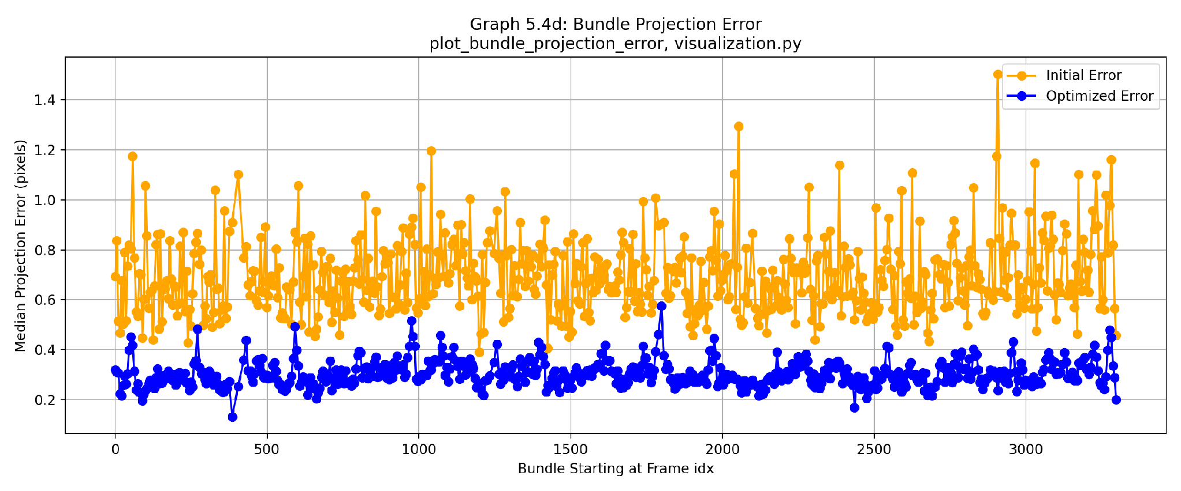
GRAPH ANALYSIS: This plot shows the median pixel projection error of 3D landmarks before (orange) and after (blue) Bundle Adjustment for each window. The optimization consistently reduces reprojection errors from initial values of 0.5–1.5 pixels down to a highly accurate sub-pixel level around 0.2–0.4 pixels. While initial error spikes (orange) reveal sensitivity to triangulation noise during sharp camera rotations, the bundle optimization reliably suppresses them to ensure high spatial accuracy.

Figure 6: Track Link Error vs. Distance (PnP)
Projection error as function of track-point distance (PnP method) | Function: plot_projection_error_vs_distance() | File: code/project/utils/visualization.py | Line: 865
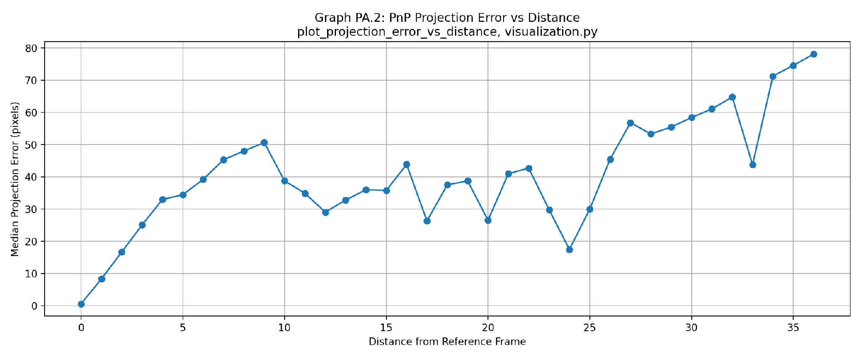
GRAPH ANALYSIS: This graph shows the median reprojection error of 3D points in PnP estimation as a function of frame distance from their initial triangulation reference frame. While short track distances (0–10 frames) maintain low errors below 35 pixels, the error exhibits a clear upward trend up to ~80 pixels at distance 36 due to accumulating pose drift and geometric distortion over extended sequences.

Figure 7: Track Link Error vs. Distance (Bundle)
Projection error as function of track-point distance (Bundle method) | Function: plot_projection_error_vs_distance() | File: code/project/utils/visualization.py | Line: 865
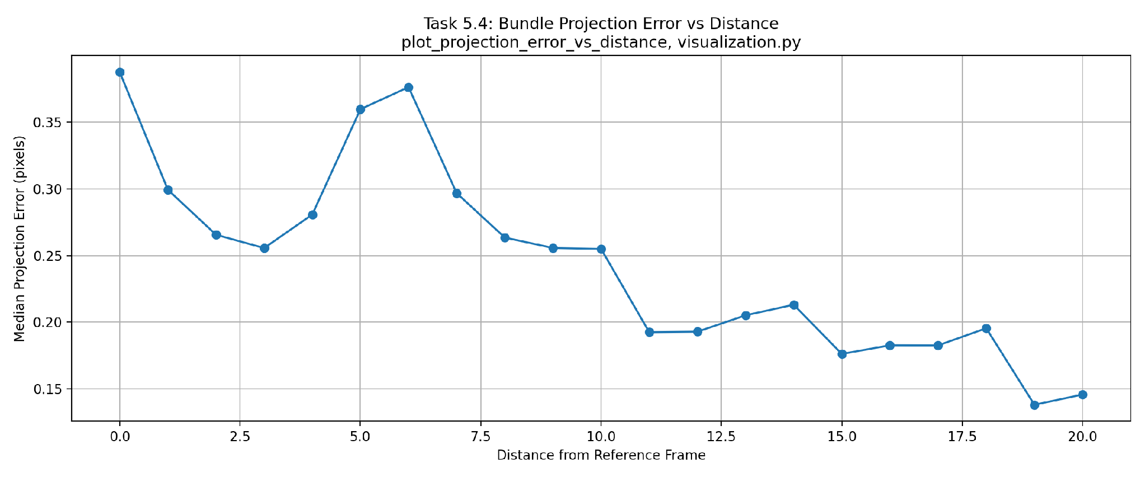
GRAPH ANALYSIS: This plot displays the median reprojection error of 3D points optimized via Bundle Adjustment as a function of frame distance from their reference frame. Unlike pure PnP, Bundle Adjustment successfully suppresses error drift across distances, maintaining sub-pixel accuracy below 0.4 pixels throughout. A slight initial fluctuation occurs around distances 0–6 due to triangulation adjustment, but the error stabilizes and stays remarkably low (below 0.25 pixels) for longer track distances.

Figure 8: Absolute PnP Error
X/Y/Z position error and angle error vs. ground truth (PnP) | Function: plot_absolute_angle_error() | File: code/project/utils/visualization.py | Line: 821
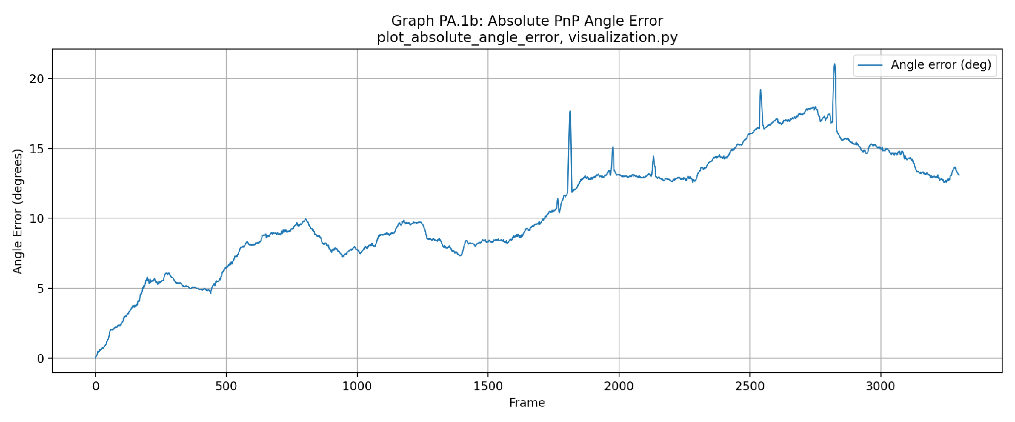
GRAPH ANALYSIS: This plot displays the absolute angular error of PnP over frame indices compared to Ground Truth. While it maintains smooth local rotational continuity, orientation drift accumulates monotonically over time, reaching a peak error of over 20 degrees with sharp spikes during complex rotation maneuvers.

Figure 9: Absolute Pose-Graph Error (No Loop Closure)
Absolute error before loop-closure integration | Function: plot_absolute_angle_error() | File: code/project/utils/visualization.py | Line: 821
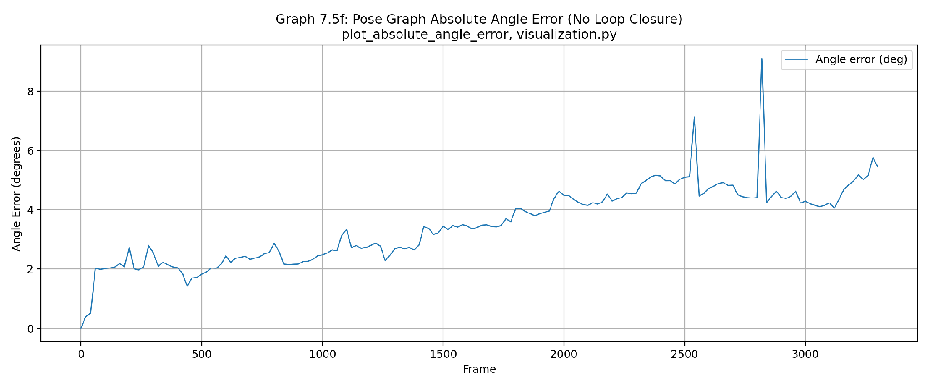
GRAPH ANALYSIS: This plot displays the absolute angular error of the Pose-Graph optimization without loop closure over frame indices. Relative keyframe constraints keep the error bounded below 6 degrees for most of the sequence, but without loop closures, long-term rotational drift slowly accumulates up to ~6 degrees with distinct spikes reaching 9 degrees during sharp turn maneuvers.

Figure 10: Absolute Pose-Graph Error (With Loop Closure)
Absolute error after loop-closure optimization shows improvement | Function: plot_absolute_angle_error() | File: code/project/utils/visualization.py | Line: 821
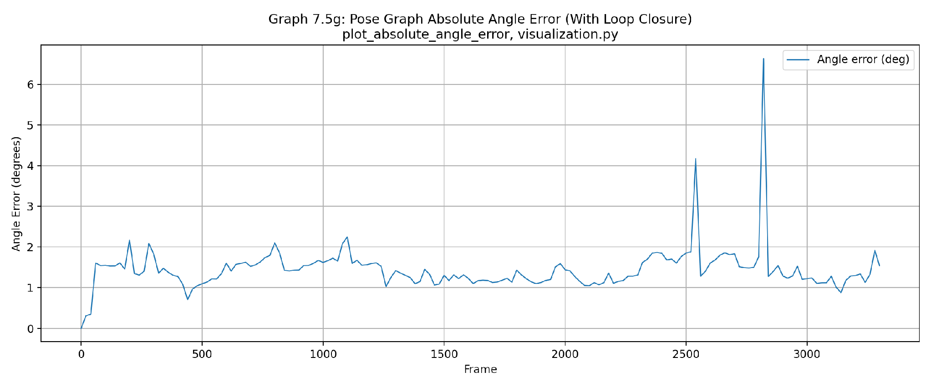
GRAPH ANALYSIS: This plot displays the absolute angular error of the Pose-Graph optimization after integrating Loop Closure constraints over frame indices. Loop closure successfully eliminates accumulated rotational drift, maintaining a remarkably low baseline error around 1–2 degrees across the entire sequence. While isolated angular error spikes remain during sharp maneuver frames (reaching up to 6.5 degrees), the global trajectory orientation is effectively bound and stabilized.

Figure 11: Relative Error Between Keyframes
Relative pose error between consecutive bundle windows vs. ground truth | Function: plot_relative_error_comparison() | File: code/project/utils/visualization.py | Line: 878
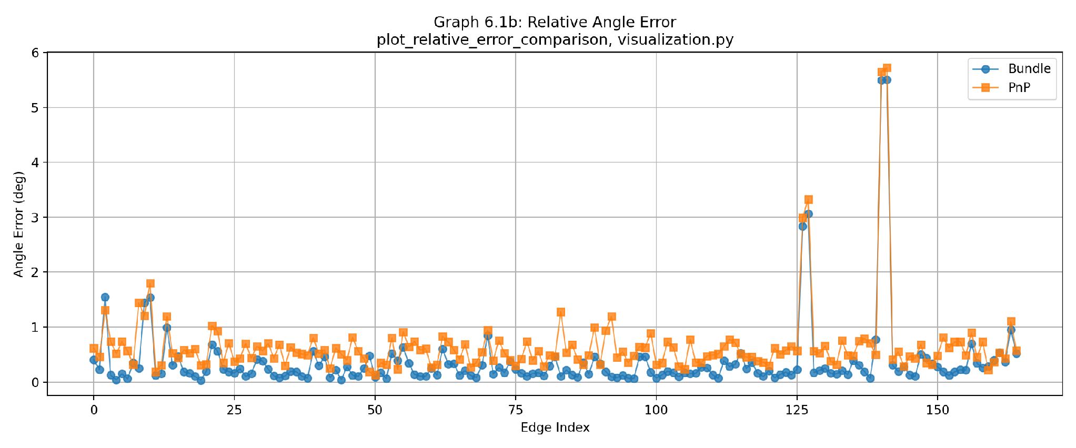
GRAPH ANALYSIS: This plot compares the relative angle error between consecutive keyframes for Bundle Adjustment (blue circles) and PnP (orange squares). Bundle Adjustment consistently achieves lower relative angular error than PnP across almost all edges, maintaining a tight baseline well below 0.5 degrees. However, both methods exhibit shared error spikes (reaching nearly 6 degrees around edge 140), revealing local vulnerability to rapid rotation maneuvers or insufficient feature matches regardless of optimization.

Figure 12: Relative PnP Error (KITTI Sub-segments)
Relative PnP error evaluated on fixed-length windows (100, 400, 800 frames) | Function: plot_kitti_sequence_error() | File: code/project/utils/visualization.py | Line: 915
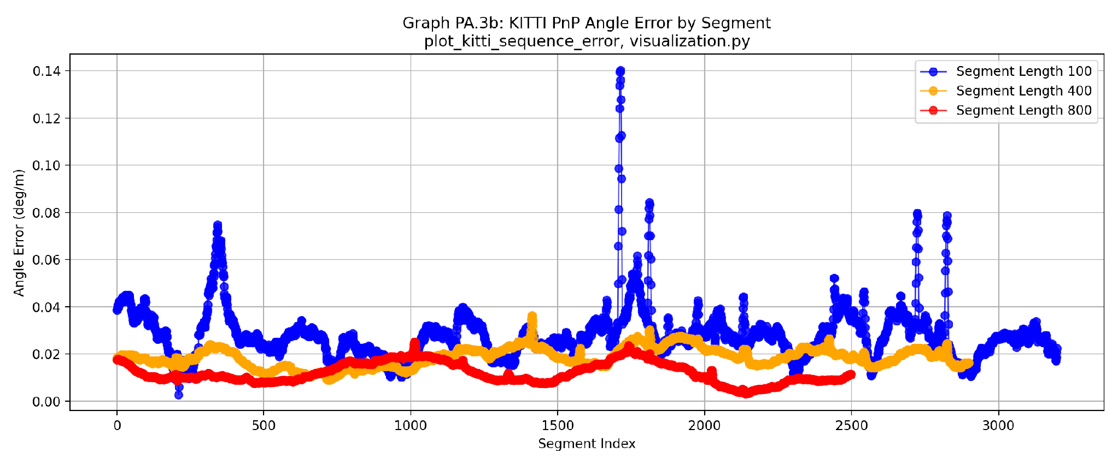
GRAPH ANALYSIS: This plot evaluates relative PnP angle error across KITTI sub-segments of lengths 100, 400, and 800 frames. Longer evaluation windows smooth out local noise, yielding lower average rotational error rates (mean angular error drops from 0.0280 deg/m for 100 frames to 0.0186 deg/m for 400 frames and 0.0120 deg/m for 800 frames). However, shorter windows (100 frames) reveal local instability, exhibiting pronounced error spikes up to ~0.14 deg/m during sharp motion or tracking anomalies.

Figure 13: Relative Bundle Error (KITTI Sub-segments)
Relative Bundle error evaluated on fixed-length windows (100, 400, 800 frames) | Function: plot_kitti_sequence_error() | File: code/project/utils/visualization.py | Line: 915
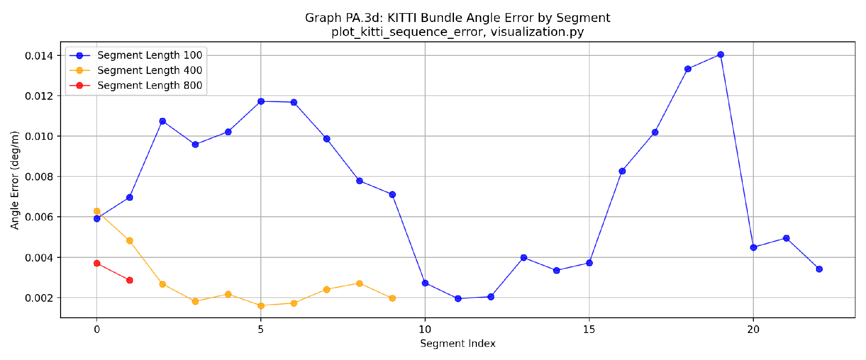
GRAPH ANALYSIS: This plot evaluates relative Bundle Adjustment angle error across KITTI sub-segments of lengths 100, 400, and 800 frames. Bundle Adjustment achieves extremely low overall rotational drift, dropping to mean angular errors of 0.0073 deg/m (100 frames), 0.0028 deg/m (400 frames), and 0.0033 deg/m (800 frames). However, shorter evaluation sub-segments (100 frames) exhibit localized angular fluctuations up to ~0.014 deg/m due to local geometric noise in short keyframe sequences before global constraints kick in.

Figure 14: Loop-Closure Match Statistics
Number of inliers per successfully verified loop closure | Function: plot_loop_closure_match_stats() | File: code/project/utils/visualization.py | Line: 945
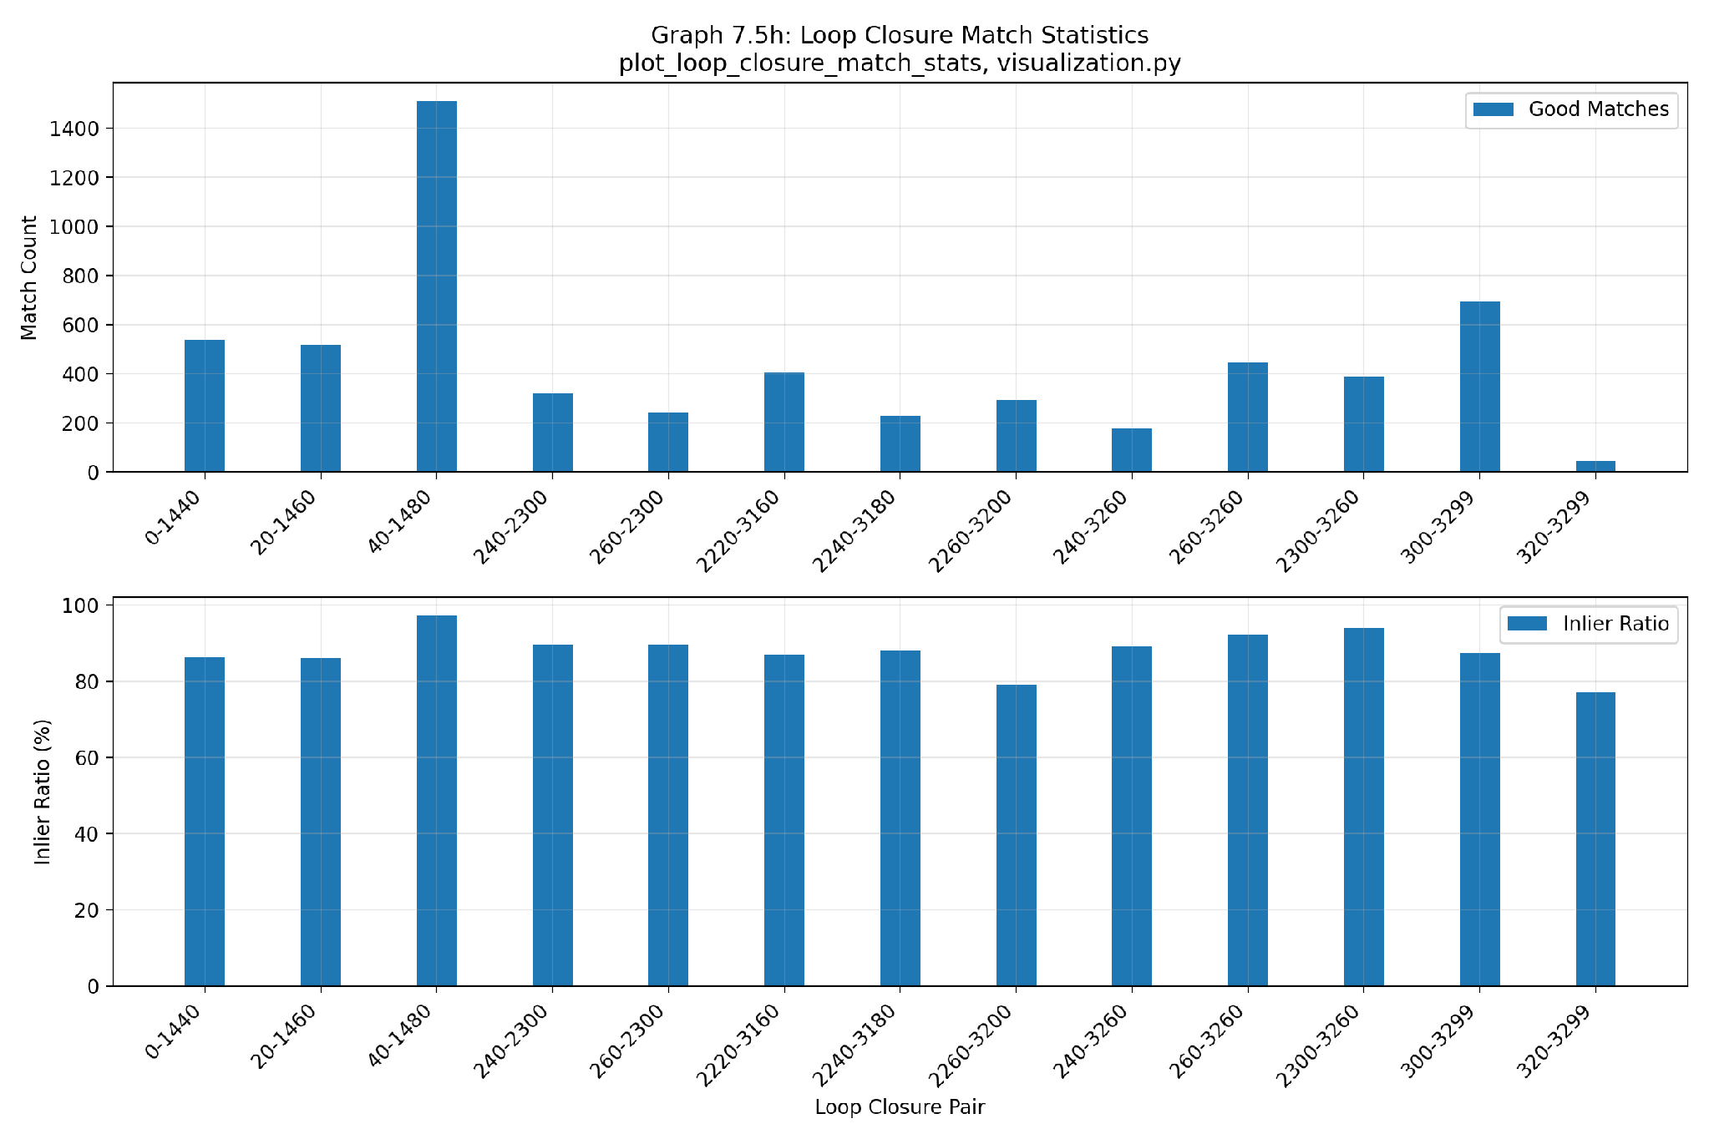
GRAPH ANALYSIS: This figure shows the number of good matches and inlier ratios across detected loop closure pairs. The system maintains high matching quality, with inlier ratios consistently exceeding 80% (reaching up to ~97% for pair 40-1480), confirming robust outlier rejection during loop verification. However, total match counts fluctuate significantly across pairs, ranging from over 1500 matches down to under 50 for pairs 320-3299 , reflecting variable visual overlap depending on viewpoint differences when revisiting locations.

Figure 15: Uncertainty Size (Location & Angle)
Covariance-derived uncertainty estimates with and without loop closure | Function: plot_angle_uncertainty_size() | File: code/project/utils/visualization.py | Line: 975
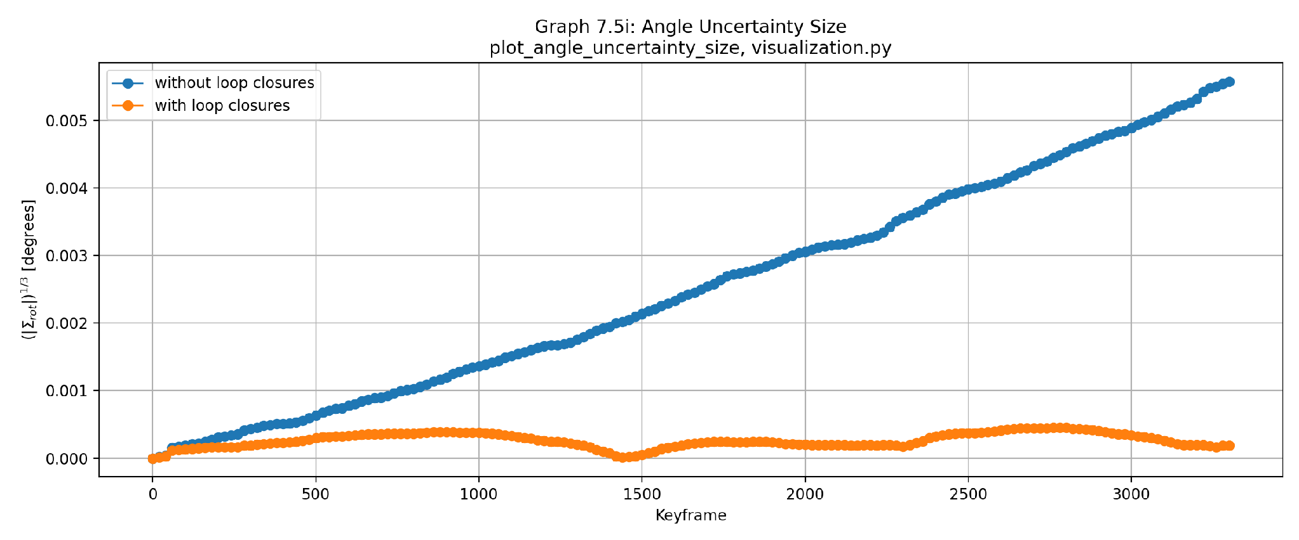
Location uncertainty is measured as sqrt(det(Σ_xz)) where Σ_xz is the XZ sub-block of the 6×6 pose covariance (visualization.py:764-765, extracted via marginals.marginalCovariance()). Angle uncertainty is det(Σ_rot)^(1/3) in radians, converted to degrees, where Σ_rot is the rotational 3×3 sub-block (visualization.py:984-987).
GRAPH ANALYSIS: This plot compares covariance-derived angle uncertainty over keyframes with (orange) and without (blue) loop closures. Integrating loop closures dramatically suppresses rotational uncertainty, keeping it bounded below 0.0005 degrees with noticeable drops at loop closure events (e.g., around keyframe 1480). Conversely, without loop closures, orientation uncertainty accumulates monotonically over time, reaching a peak above 0.0055 degrees.

4. Discussion and Conclusions

4.1 Summary and Critique
The implemented architecture successfully reconstructs the trajectory and generates dense 3D landmarks from the stereo KITTI sequence 00.
Key Strengths:
- Robust Temporal Tracking: Consistent observation linkage over time managed via a dedicated database.
- Multi-Stage Outlier Rejection: Effective noise filtering integrated across multiple stages, including RANSAC and sliding-window Bundle Adjustment.
- Principled Uncertainty Quantification: Rigorous evaluation of estimation confidence utilizing GTSAM-derived covariance matrices.
Limitations:
- Scene Revisitation Dependency: Loop closure detection is restricted strictly to previously visited regions, requiring substantial physical trajectory overlap.
- Fixed Optimization Window: The sliding-window size for Bundle Adjustment is static, which is suboptimal for scenes with varying texture density.

4.2 Additional Work: Robust Loop-Closure Optimization (Beyond Requirements)
In this section we implement two robust back-end optimization techniques from the literature to handle outlier loop-closure constraints. Rather than hard-threshold pre-optimization gating, these techniques enable continuous, residual-dependent down-weighting during optimization.

Switchable Constraints (Sünderhauf & Protzel, IROS 2012)
To further mitigate the impact of spurious loop closures, future work includes integrating Switchable Constraints (Sünderhauf & Protzel, IROS 2012). This method assigns a continuous scalar switch variable $s_{i}∈[0,1]$ to each loop closure edge, optimizing it jointly with the pose graph. By modulating constraint weights, where values near 1.0 endorse a valid loop closure and values approaching 0.0 deactivate potential outliers, the system achieves superior resilience against false positives. The core mechanism is implemented via gtsam.CustomFactor in code/project/improvements/prototype implementation (switchable_constraint_error).

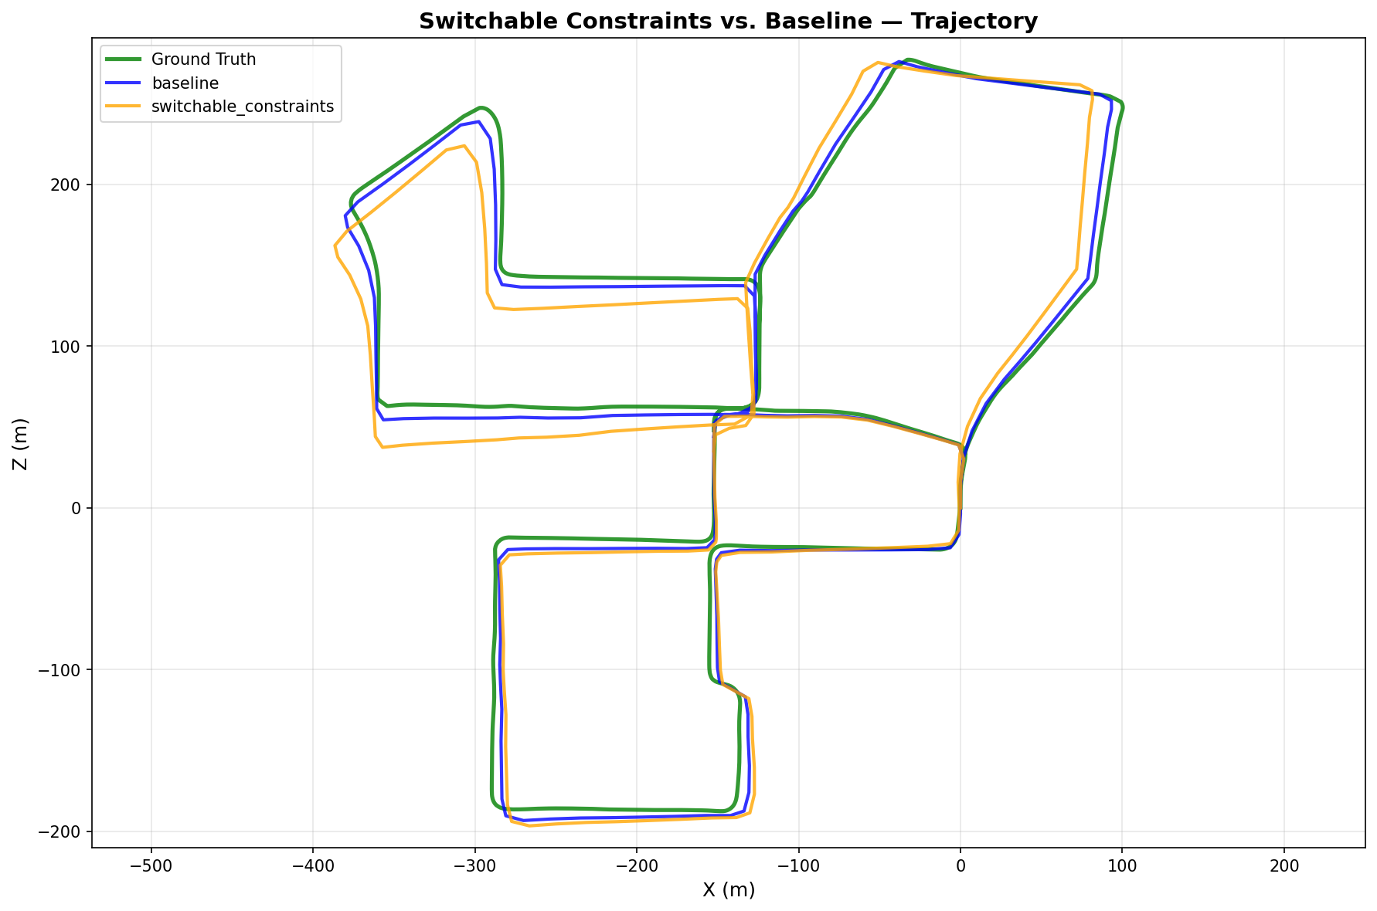
Variant | Location Error (m) | Angle Error (°) | Runtime (s) | Loops | Keyframes
Baseline | 6.0061 | 1.4464 | 0.07 | 13 | 166
Switchable Constraints | 15.7659 | 3.6309 | 0.09 | 13 | 166
Switch Values Analysis: min=0.043, max=0.421, mean=0.226. The low mean switch value (0.226) indicates the CustomFactor is conservatively suppressing loop-closure influence, which explains the degraded performance (15.77 m vs. 6.01 m baseline). This suggests either: (1) the loop closures are largely valid and over-suppression hurts the solution, or (2) the CustomFactor formulation needs tuning for this dataset.

Dynamic Covariance Scaling (Agarwal et al., ICRA 2013)
To handle potential outlier constraints, future work includes integrating Dynamic Covariance Scaling (DCS) (Agarwal et al., ICRA 2013). This method performs residual-dependent reweighting of the information matrix, automatically suppressing constraints with high chi-squared ($χ^{2}$) errors during optimization. Configured with a threshold of $Φ$= 1.0, the module is natively implemented via GTSAM (gtsam.noiseModel.mEstimator.DCS) in code/project/improvements/prototype implementation.
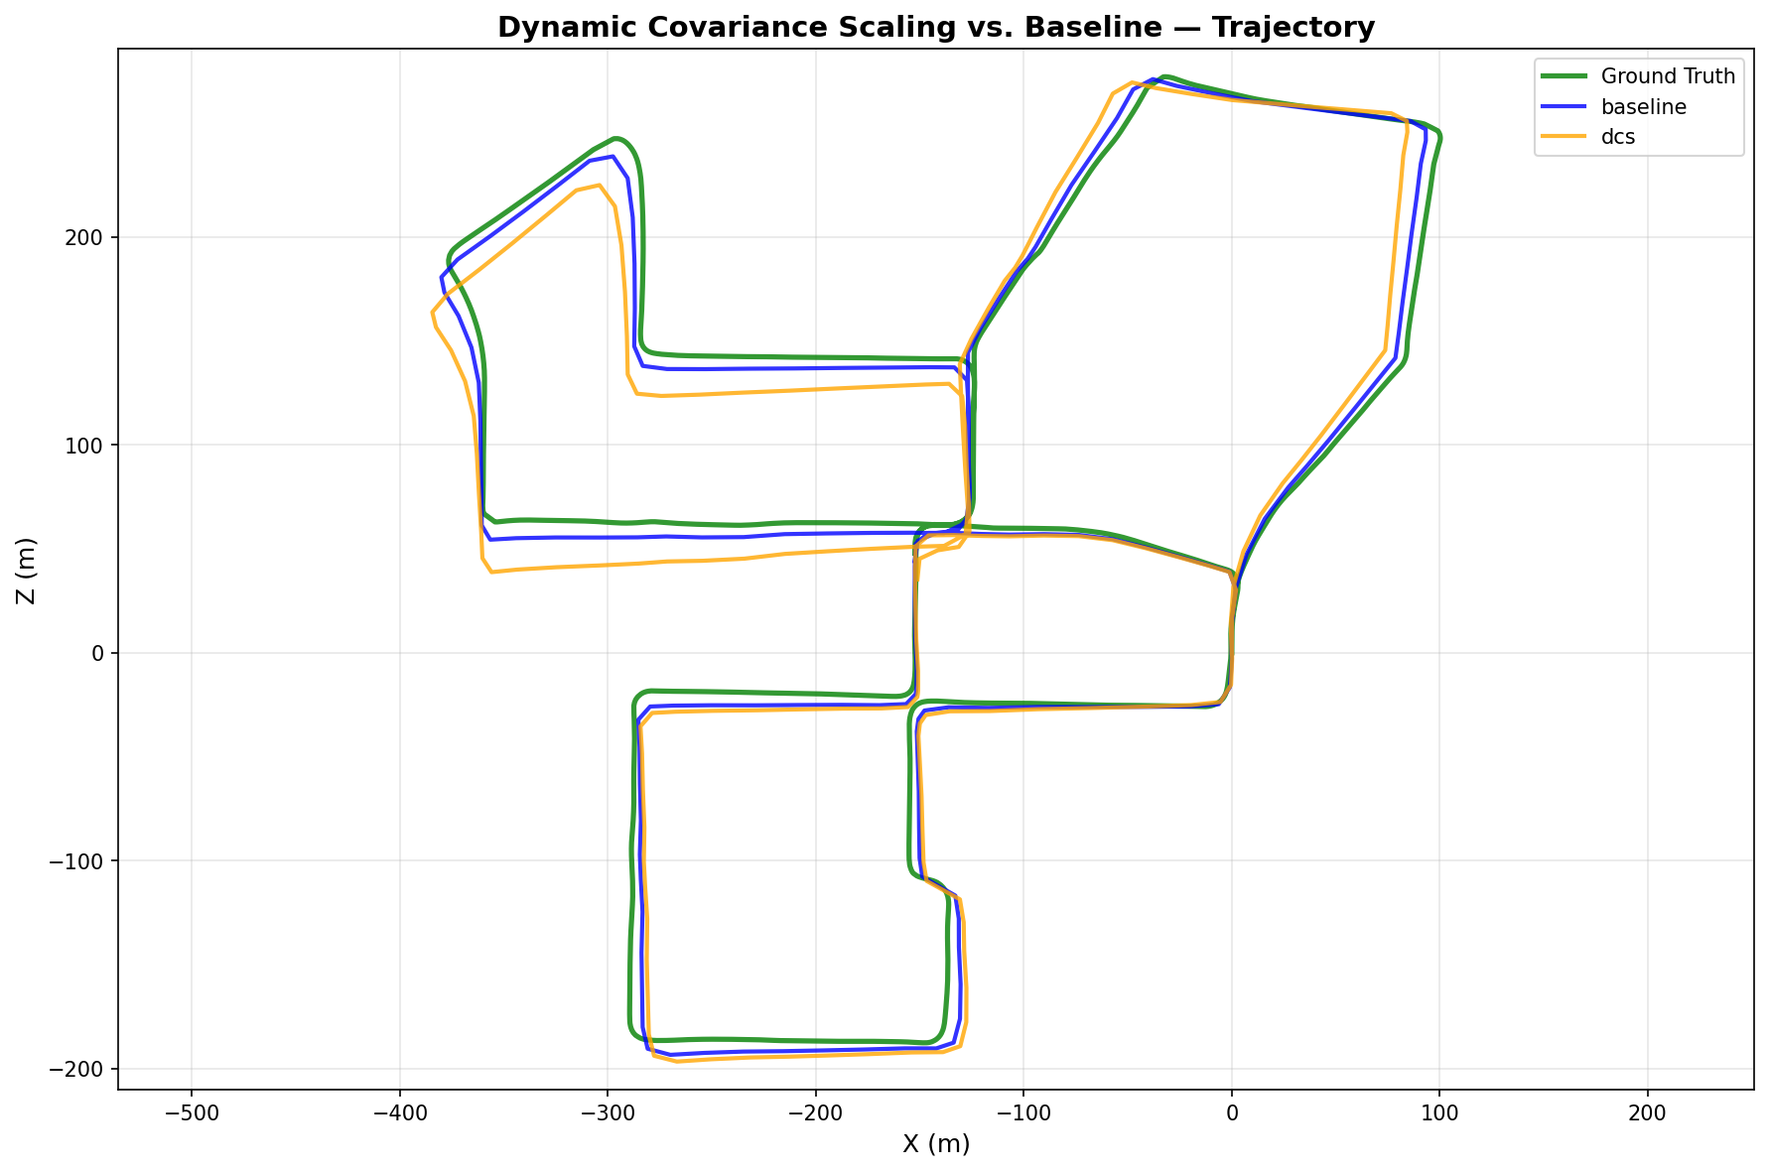

Variant | Location Error (m) | Angle Error (°) | Runtime (s) | Loops | Keyframes
Baseline | 6.0061 | 1.4464 | 0.04 | 13 | 166
DCS | 13.8214 | 3.4887 | 0.01 | 13 | 166
DCS Performance: Dynamic Covariance Scaling yields a location error of 13.82 m compared to 6.01 m in the baseline, a 2.3 times increase. This performance degradation indicates that the selected chi-squared threshold ($Φ$= 1.0) is overly aggressive for this dataset, unintentionally down-weighting high-quality loop closures. Consequently, since all 13 detected loop closures are already verified, the baseline's hard-threshold acceptance strategy sufficiently filters out false positives, making additional robust loss down-weighting counterproductive.

Stress Test (Loosened Loop-Closure Gates)
Deliberately loosened loop-closure detection/verification gates to admit additional (potentially false-positive) loops: Mahalanobis threshold ×5 (5000.0 vs. 1000.0), inlier-ratio threshold ÷2 (0.3 vs. 0.6). Resulted in 27 verified loops (vs. 13 with strict gates). Script: `code/project/improvements/prototype implementation` (gate parameters).
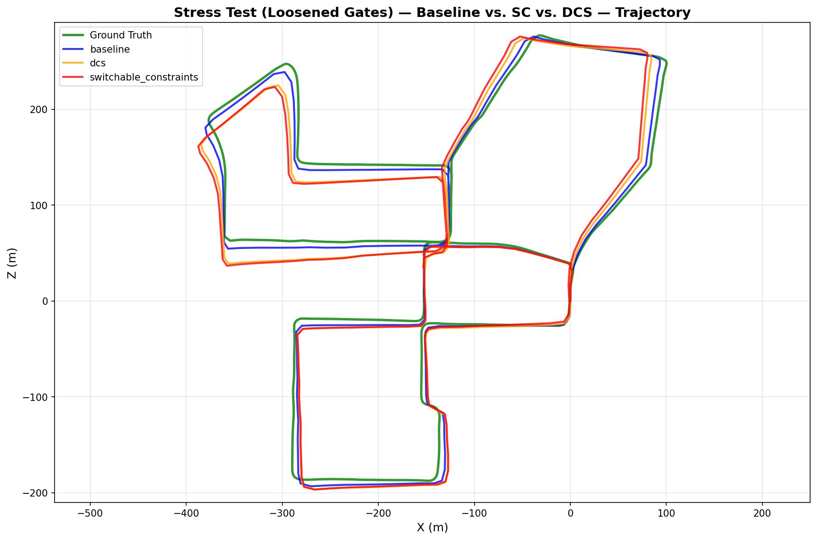
Variant | Location Error (m) | Angle Error (°) | Runtime (s) | Loops | Keyframes
Baseline | 5.9842 | 1.4428 | 0.02 | 27 | 166
Switchable Constraints | 16.3628 | 3.7779 | 0.16 | 27 | 166
DCS | 13.8209 | 3.4888 | 0.01 | 27 | 166
Stress Test Findings: Even with loosened gates (27 loops vs. 13), both robust techniques performed worse than baseline. Switchable Constraints: 16.36 m (±9.55); DCS: 13.82 m (±8.21); Baseline: 5.98 m (±2.62). This indicates the additional 14 loops accepted by loosened gates are largely valid, not false positives. The robust techniques' continuous down-weighting indiscriminately suppresses even good loops, degrading the solution. Conversely, the baseline's binary accept/reject strategy is already effective at filtering false positives—loops that survive RANSAC verification at 0.6 inlier-ratio threshold are high-confidence and should not be down-weighted.
Conclusion: In-the-loop robust optimization techniques (switchable constraints, DCS) may not benefit this pipeline because the baseline's hard-threshold pre-optimization gating already provides effective outlier rejection. These techniques excel when false positives slip through initial gating; here, the gating is already highly selective. Full implementations are non-invasive (`code/project/improvements/*.py`) and reusable for future datasets where loop-closure false-positive rates are higher.

Appendix: Relative Error Formulas
This appendix presents the mathematical formulations for angle and segment-based relative error, which are fundamental to evaluating the accuracy of pose estimation throughout the pipeline.

Rodrigues Representation for Rotation Error
Comparing the rotation difference between estimated and ground-truth relative poses is best done with the Rodrigues formula, which represents a rotation as a 3D vector. The direction of the vector is the axis of rotation, and the magnitude is the rotation angle in radians.
For a rotation matrix R, the angle magnitude in degrees is computed as:
rvec, _ = cv2.Rodrigues(R)
angle_deg = np.linalg.norm(rvec) * 180 / np.pi
This is implemented in code/project/utils/geometry.py:87–90 (function rotation_angle_deg).

Relative Pose Error over KITTI Segments
The KITTI benchmark evaluates accuracy on fixed-length trajectory segments. For a segment from frame i to frame j, relative pose error is normalized by the total ground-truth path length traveled, not the direct distance.
Location error (as a percentage of path length):
|Δ_location(i,j)| / L_gt(i,j) × 100 %
Angle error (degrees per meter):
|Δ_angle(i,j)| / L_gt(i,j)
where L_gt(i,j) is the summed ground-truth path length (not direct distance):
L_gt(i,j) = Σ |camera_center(pose_k+1) - camera_center(pose_k)| for k = i to j-1
This is implemented in code/project/utils/geometry.py:109–131 (function compute_kitti_sequence_errors).

