Visual Aerial Navigation (VAN) System
Stereo Visual-SLAM Pipeline Implementation & Analysis
Nir Ellor Waizner, Ayala Houri
https://github.com/NirEllor/VAN_ex

1. Introduction and Overview

1.1 Background
This project implements a complete stereo visual-SLAM (Simultaneous Localization and Mapping) pipeline for aerial navigation using the KITTI dataset. The system processes rectified stereo image pairs to extract, track, and triangulate feature points, then estimates camera trajectories through a series of increasingly sophisticated pose estimation and optimization stages. The architecture follows a classical SLAM structure: feature extraction and matching → temporal tracking → pose estimation via PnP-RANSAC → sliding-window bundle adjustment → pose-graph optimization with loop closure detection.

1.2 Significance
Vision-based navigation is critical for autonomous systems (drones, ground robots, autonomous vehicles) operating in GNSS-denied environments. Stereo visual-SLAM combines the advantages of monocular SLAM (scale information from stereo triangulation) with robustness via multi-hypothesis tracking and outlier rejection. Loop closure detection adds metric global consistency, enabling long-term deployment. This project demonstrates end-to-end SLAM from raw imagery through optimization and error analysis.

2. Code Organization

2.1 Project Structure
code/
├── tracking_database.py (class Observation @22, class TrackingDB @30)
├── homework/ (legacy exercises; van_utils.py fallback)
└── project/
├── main.py (pipeline driver)
├── outputs/ (generated report figures)
├── experiment_results/ (ablation study result pickles)
├── utils/
│ ├── geometry.py (triangulation, PnP-RANSAC, KITTI/Rodrigues formulas)
│ ├── tracking.py (build_data pipeline, inline RANSAC)
│ ├── bundle_adjustment.py(solve_bundle_window — GTSAM solving)
│ ├── pose_graph.py (build/optimize pose graph, relative pose+covariance)
│ ├── loop_closure.py (candidate detection, verification, factor integration)
│ └── visualization.py (all 17 plot_* functions)
└── experiments/ (5 compare_*.py ablation scripts + harness)

The implementation spans 9 pipeline stages, each with a canonical implementation location verified via code inspection. Each citation below includes the exact function name, file path, and starting line number (not a range):
- 1. Triangulation: Stereo point triangulation using rectified image pairs and camera calibration | Function: triangulate_points_opencv | File: code/project/utils/geometry.py | Line: 208
- 2. RANSAC: PnP outlier rejection via RANSAC consensus | Function: run_custom_pnp_ransac | File: code/project/utils/geometry.py | Line: 237
- 3. PnP trajectory calculation: Temporal pose estimation from track observations | Function: build_data | File: code/project/utils/tracking.py | Line: 127
- 4a. Database definition (Observation): Observation data structure for track observations | Function: class Observation | File: code/tracking_database.py | Line: 22
- 4b. Database definition (TrackingDB): TrackingDB data structure for tracking | Function: class TrackingDB | File: code/tracking_database.py | Line: 30
- 5. Adding a frame to the database: Feature track integration across frames | Function: update_tracks | File: code/tracking_database.py | Line: 83
- 6. Single Bundle creation: Single-window pose and landmark optimization via GTSAM | Function: solve_bundle_window | File: code/project/utils/bundle_adjustment.py | Line: 235
- 7. Relative transformation + covariance: Pose constraint extraction with uncertainty quantification | Function: compute_relative_pose_and_covariance | File: code/project/utils/pose_graph.py | Line: 150
- 8a. PoseGraph building (init): Factor graph construction and initialization | Function: build_and_initialize_pose_graph | File: code/project/utils/pose_graph.py | Line: 77
- 8b. PoseGraph building (optimize): Factor graph optimization | Function: optimize_pose_graph | File: code/project/utils/pose_graph.py | Line: 105
- 9a. Loop closure detection: Candidate detection via Mahalanobis distance | Function: detect_loop_closure_candidates | File: code/project/utils/loop_closure.py | Line: 42
- 9b. Loop closure factor creation: Relative pose estimation and graph integration | Function: add_loop_closures_and_optimize | File: code/project/utils/loop_closure.py | Line: 229

3. Performance Analysis

3.1 Experiments & Improvements
Five ablation studies systematically evaluate the impact of key design choices. Each study tests one component in isolation by varying its parameters while holding others fixed. Loop closure is a post-processing stage that runs after pose graph optimization:
Loop closure is enabled ONLY for the loop-closure-gating experiment (topic 1), which specifically tests loop-closure detection and gating parameters. It is disabled for experiments 2-5 because: (1) Fair comparison — each experiment tests ONE component, and loop closure would confound results by introducing a variable number of detected loops per variant; (2) Orthogonal stages — loop closure doesn't depend on keyframe selection, bundle noise modeling, RANSAC parameters, or feature detectors; (3) Isolate effects — disabling loop closure lets us measure the pure effect of the parameter being tested.

1. Loop-Closure Gating Strictness
Tests Mahalanobis distance threshold and inlier ratio threshold for candidate acceptance. Variants: strict (threshold=300, inlier_ratio=0.8), baseline (1000, 0.6), loose (3000, 0.4). LOOP CLOSURE: ENABLED (this experiment specifically tests loop-closure detection and gating parameters).
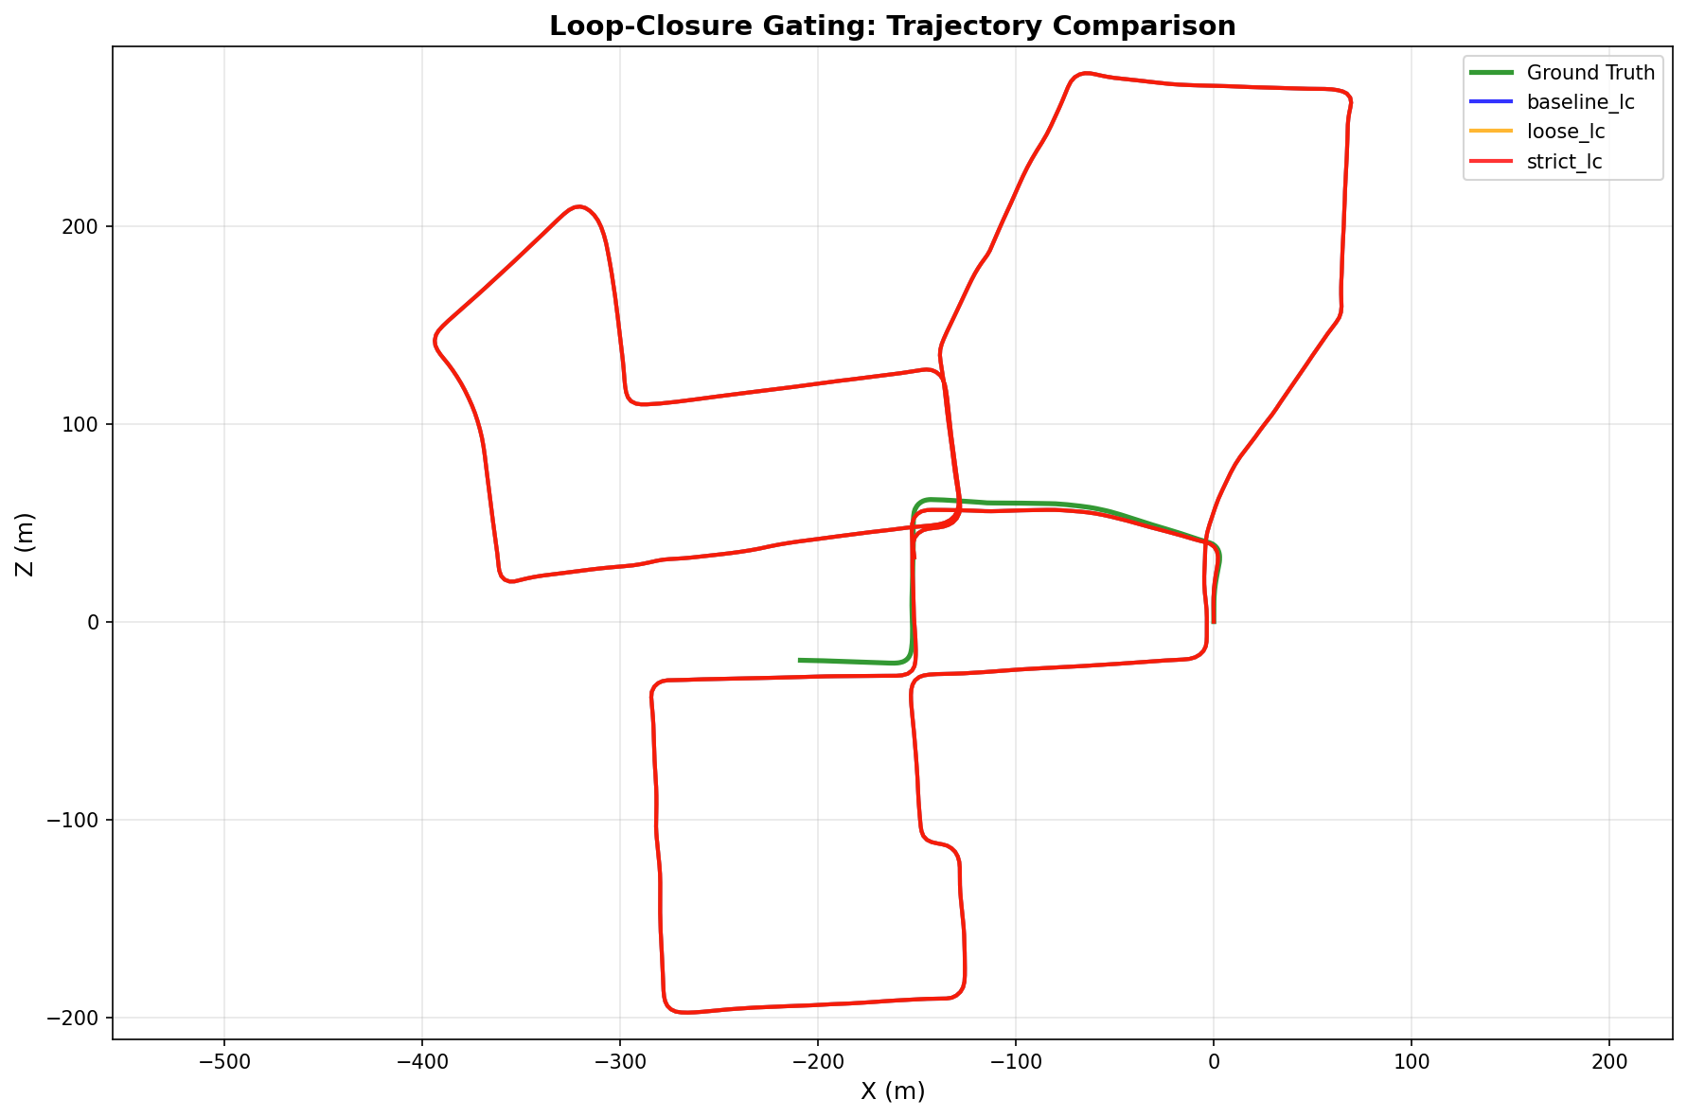
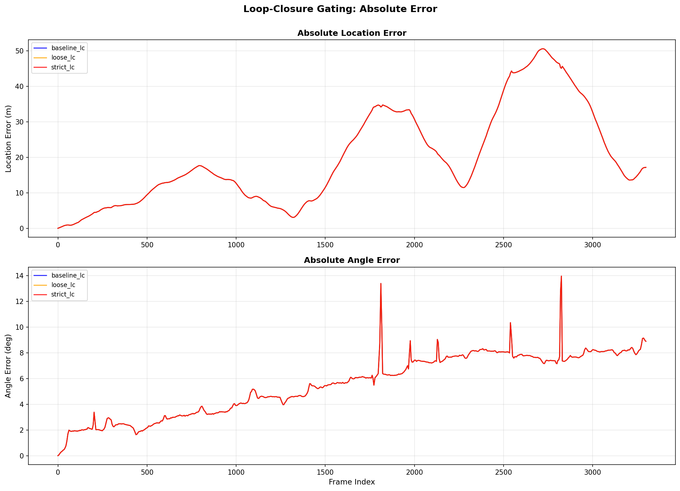
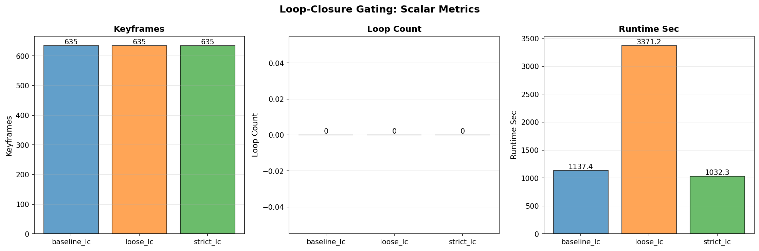

2. Keyframe Density
Tests keyframe selection distance threshold. Variants: dense (1.25 m), baseline (2.5 m), sparse (5.0 m). LOOP CLOSURE: DISABLED — loop closure is orthogonal to keyframe selection; enabling it would confound results by varying loop counts per variant.
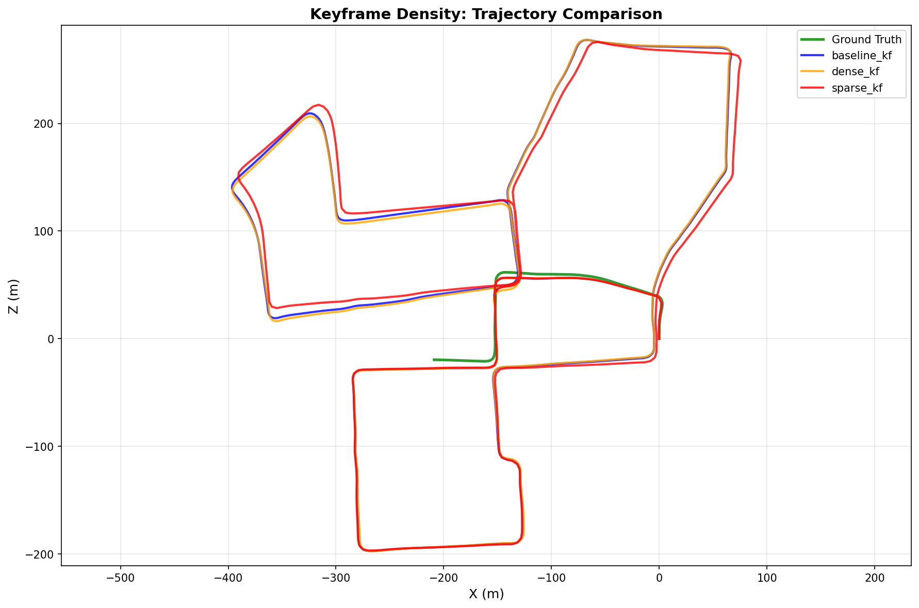
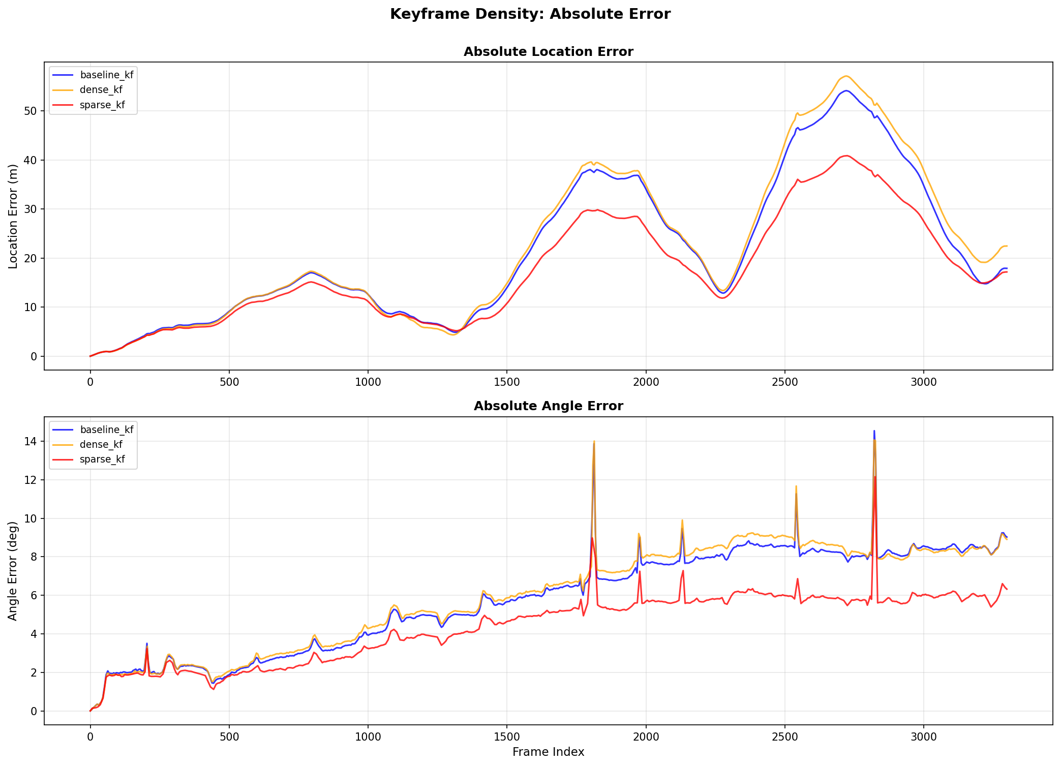
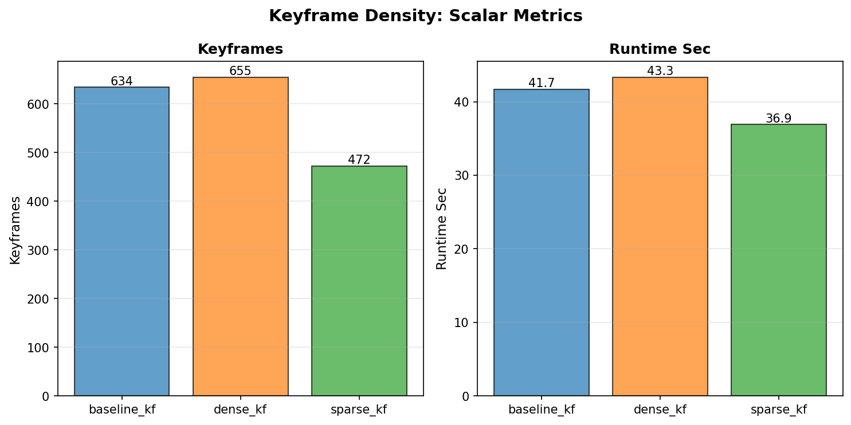

3. Bundle Adjustment Noise Model
Tests GTSAM factor weights via prior_sigma ∈ {1.0, 0.05, 1e-6} and stereo_sigma ∈ {0.5, 1.0, 2.0}. LOOP CLOSURE: DISABLED — loop closure is independent of bundle adjustment noise modeling.
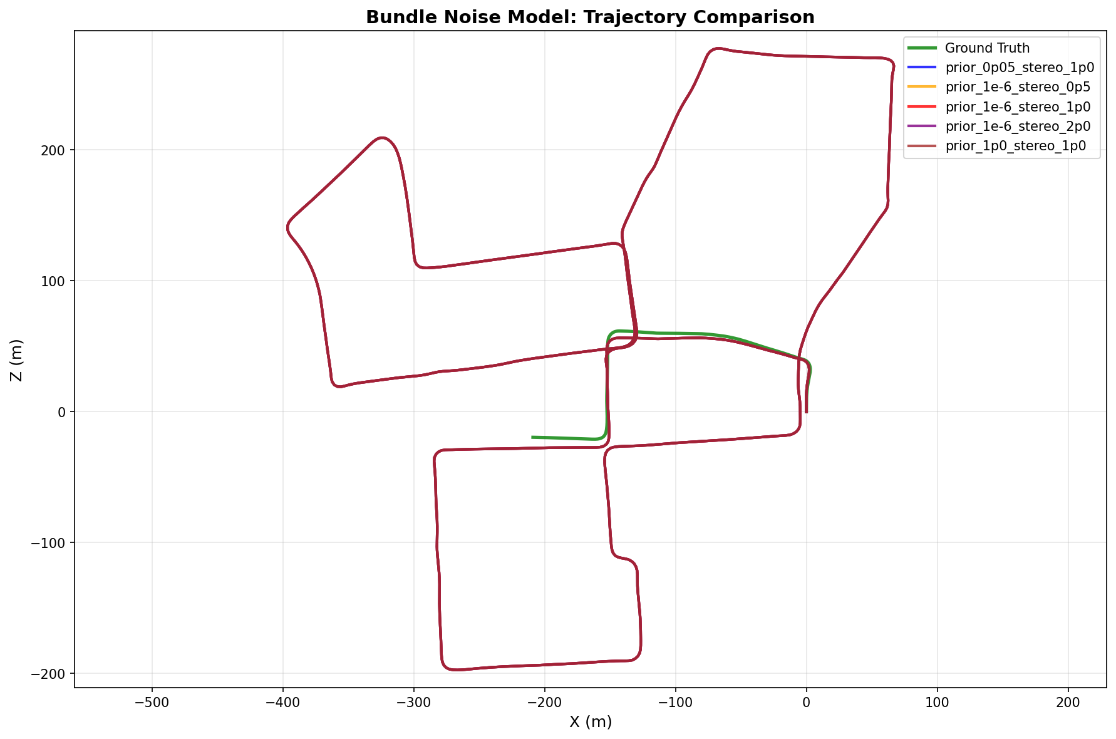
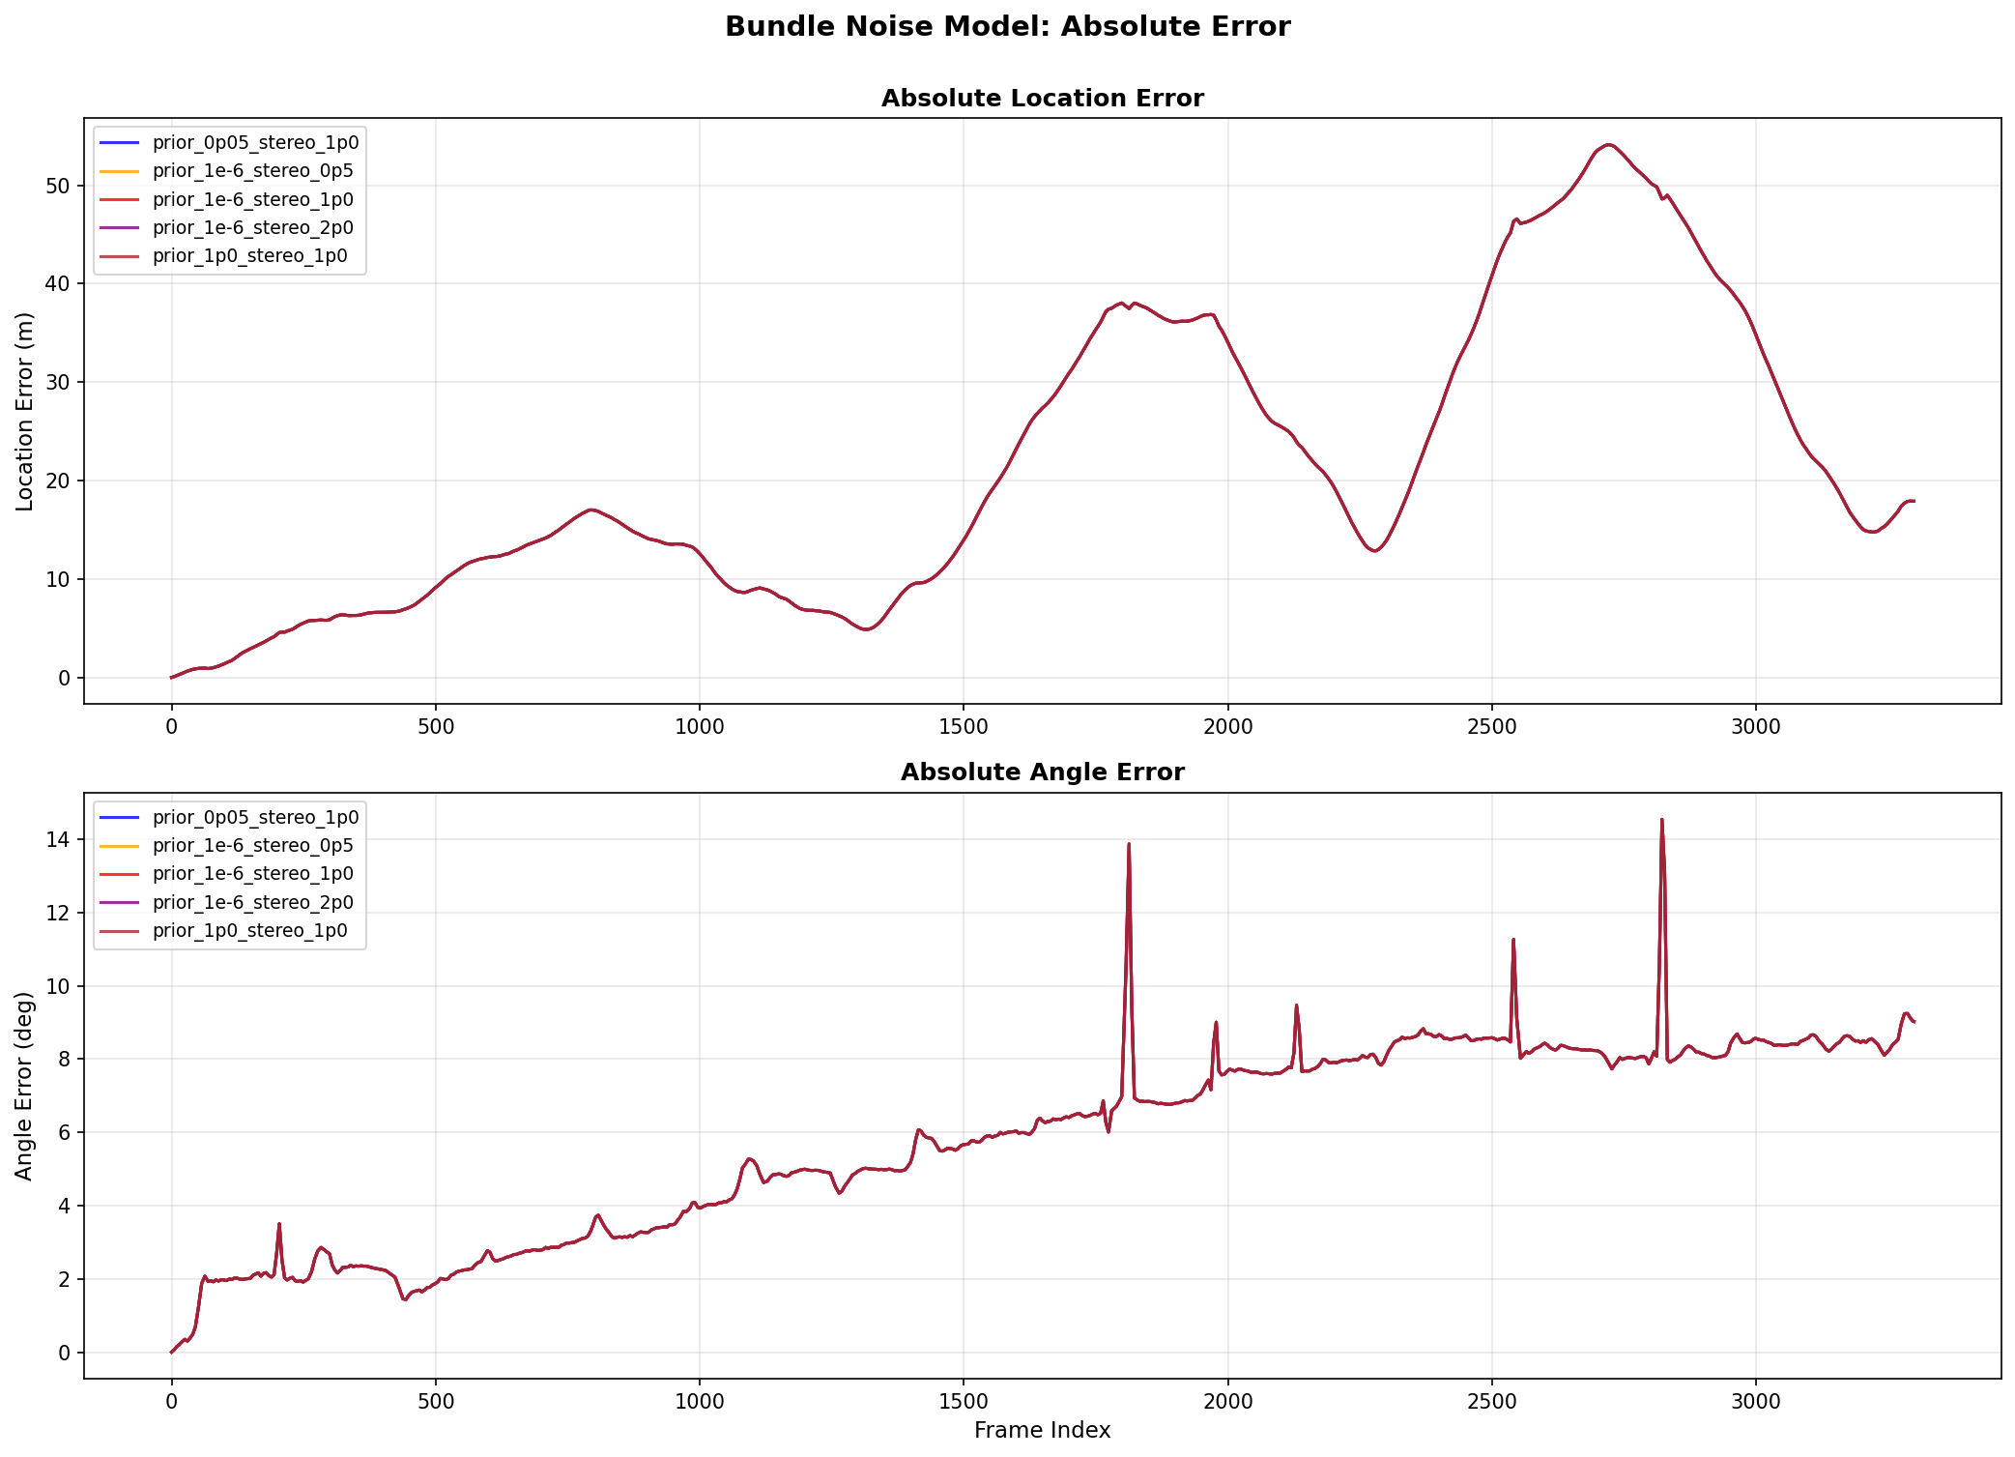
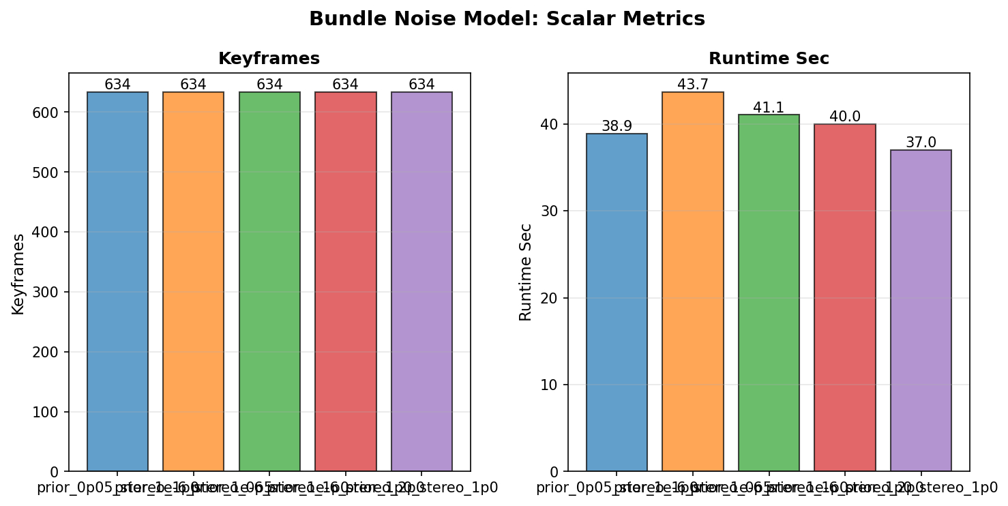

4. PnP-RANSAC Parameters
Tests inlier threshold (pixels) and iteration count. Variants: strict (1px, 100 iter), baseline (2px, 50), loose (4px, 25). LOOP CLOSURE: DISABLED — loop closure is independent of PnP feature tracking quality; disabling keeps comparison fair across variants.
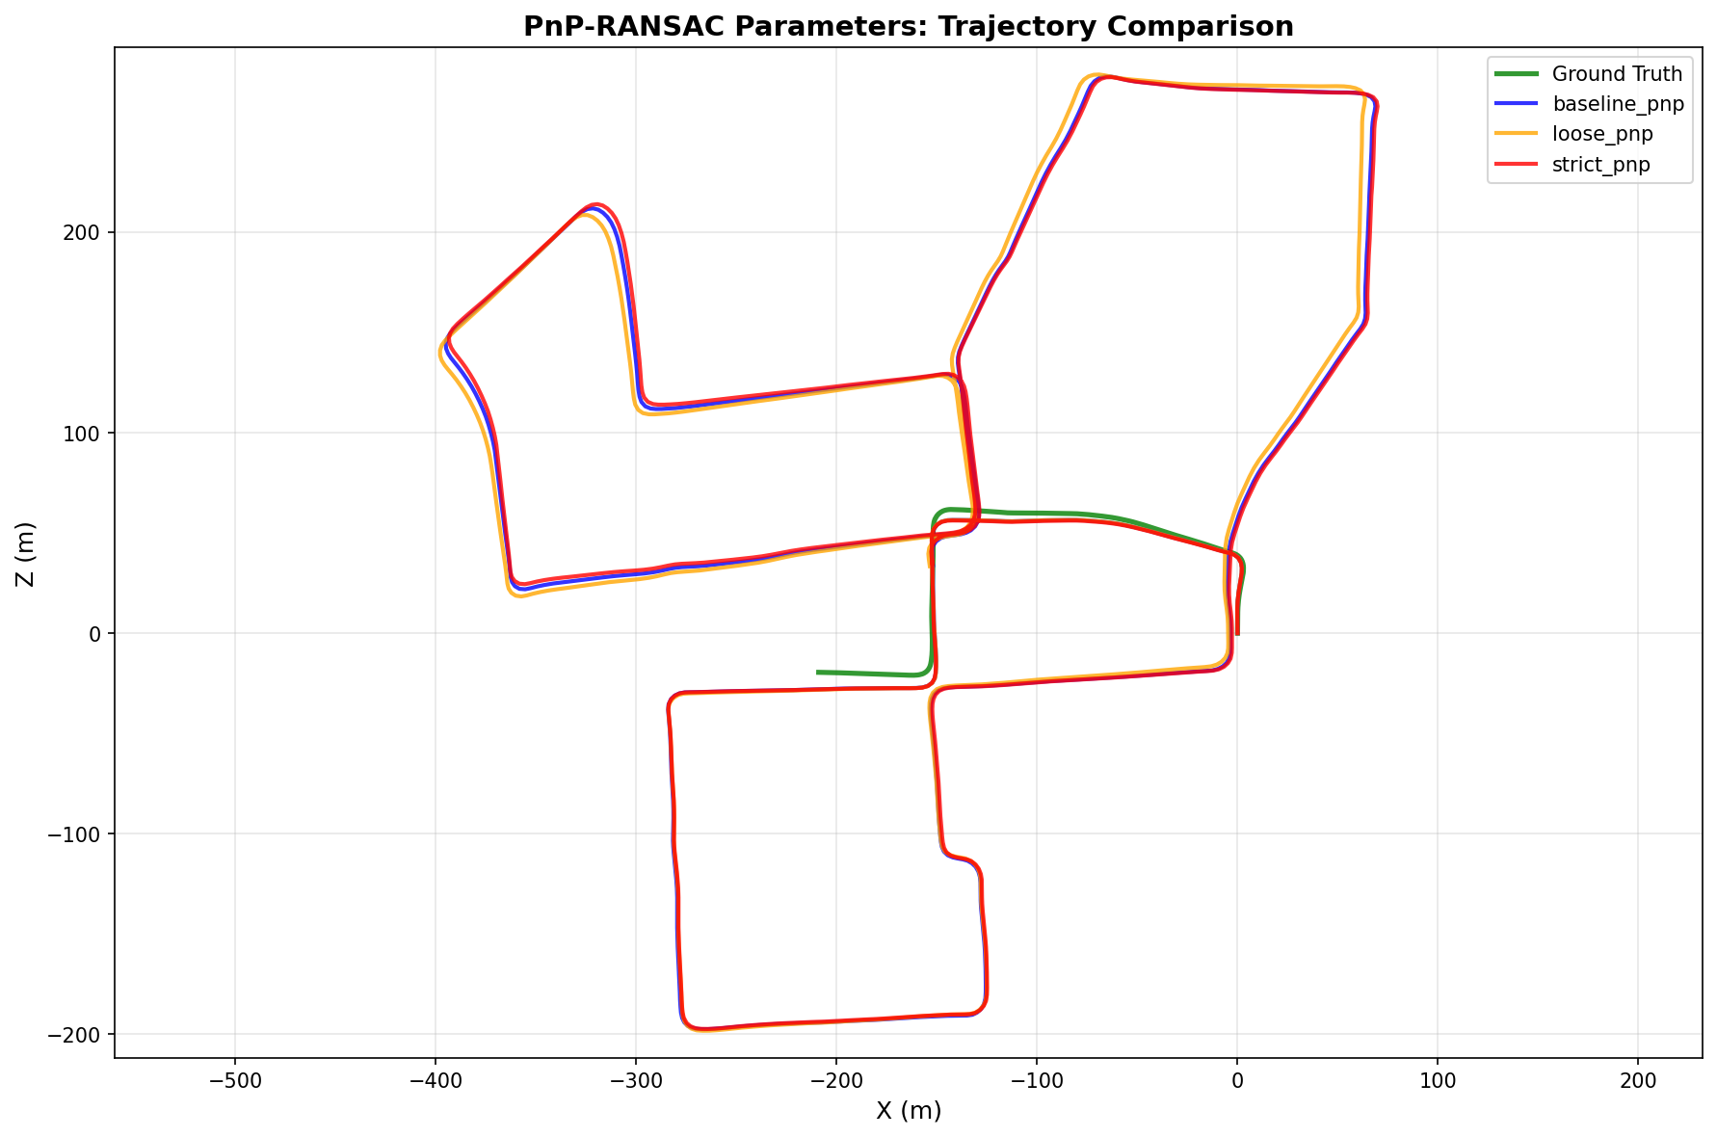
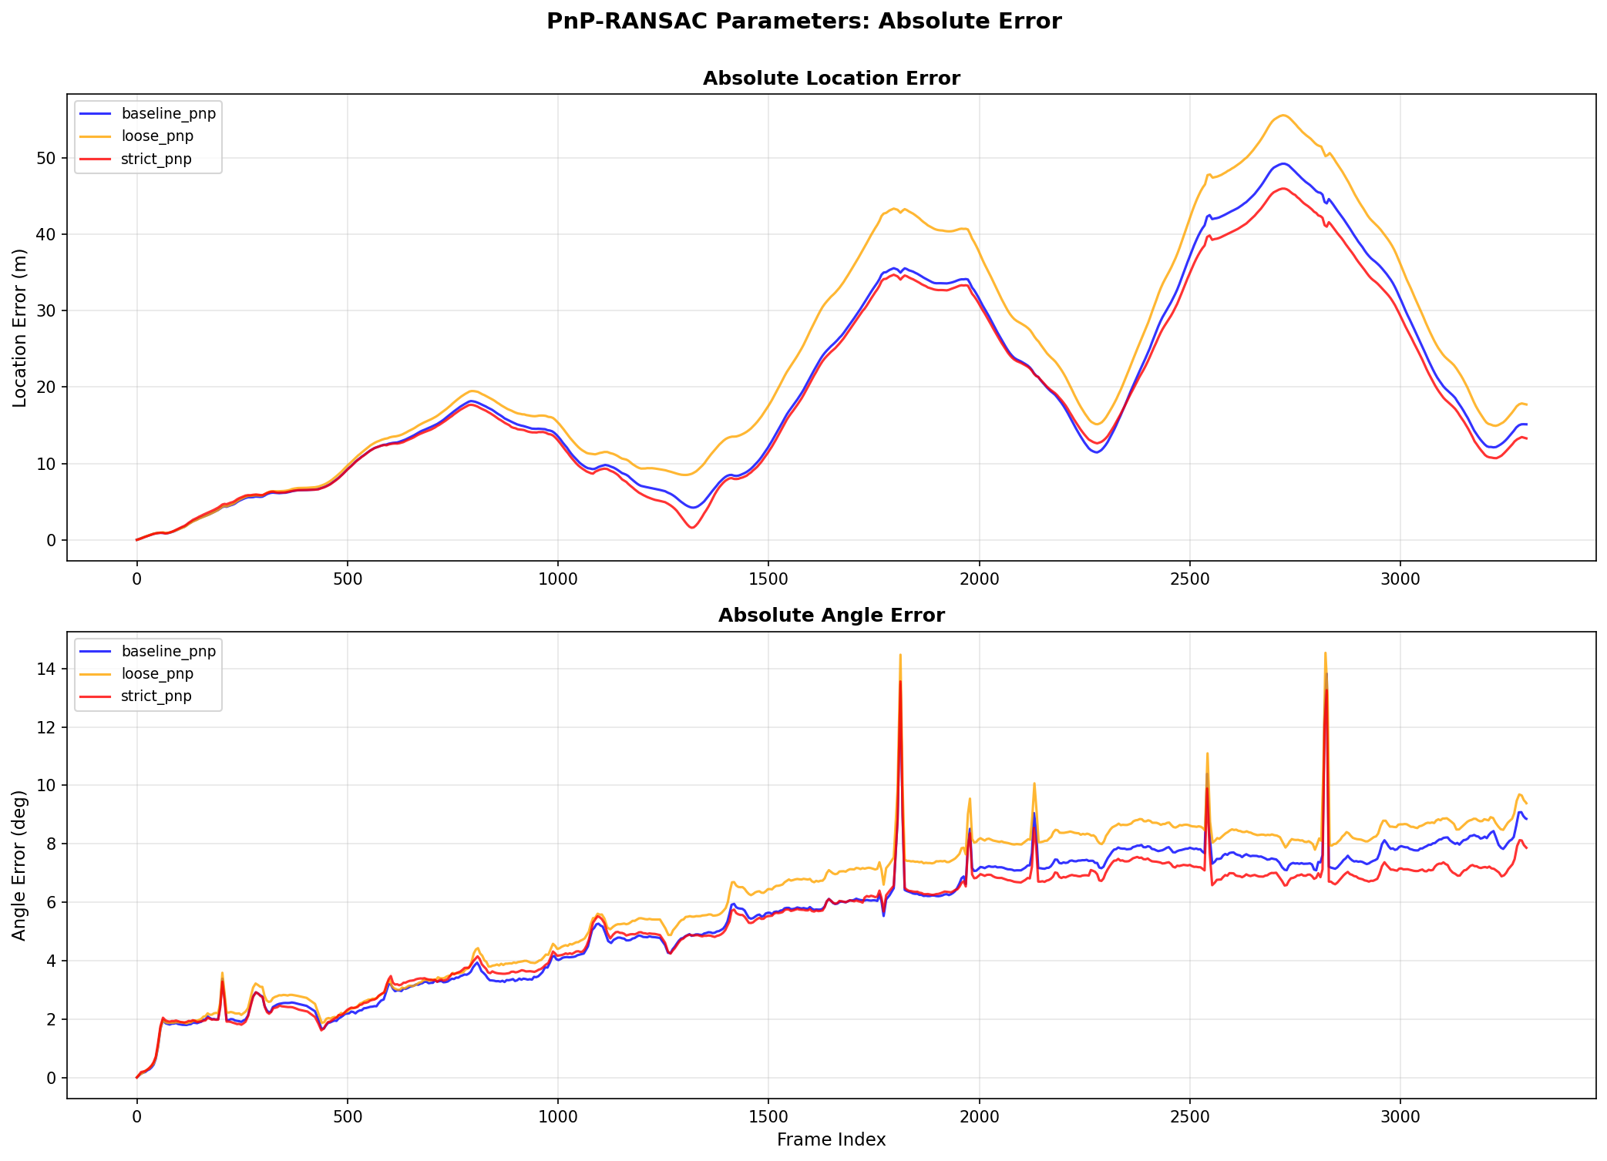
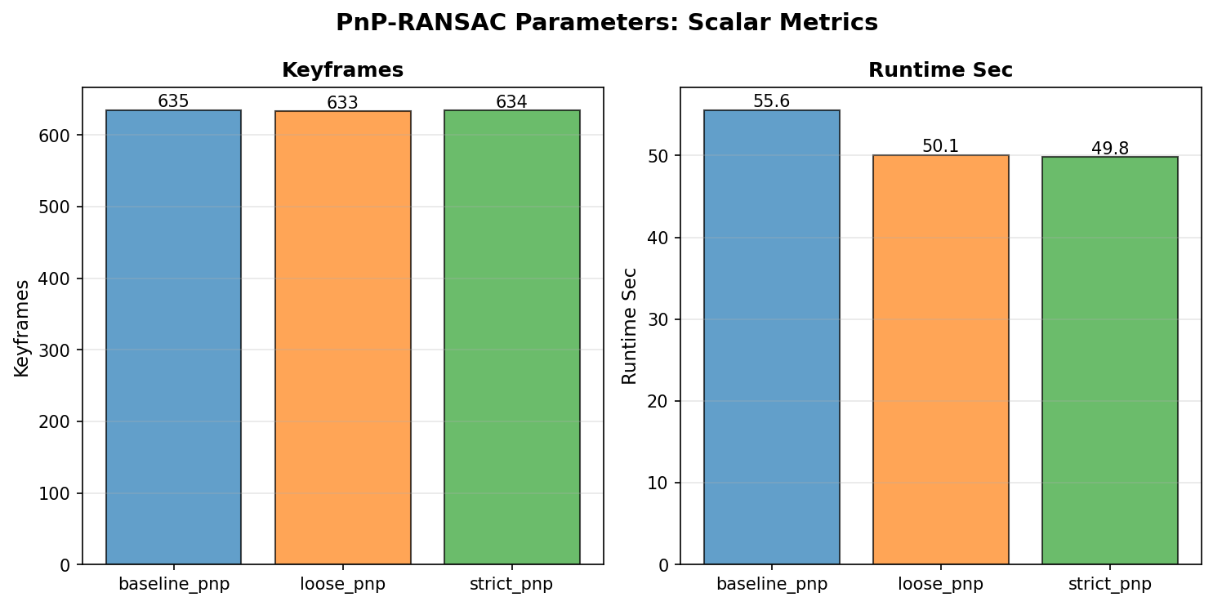

5. Feature Detectors
Compares AKAZE (baseline), ORB (700 features), and SIFT. LOOP CLOSURE: DISABLED — loop closure is independent of feature detection; disabling ensures fair comparison.
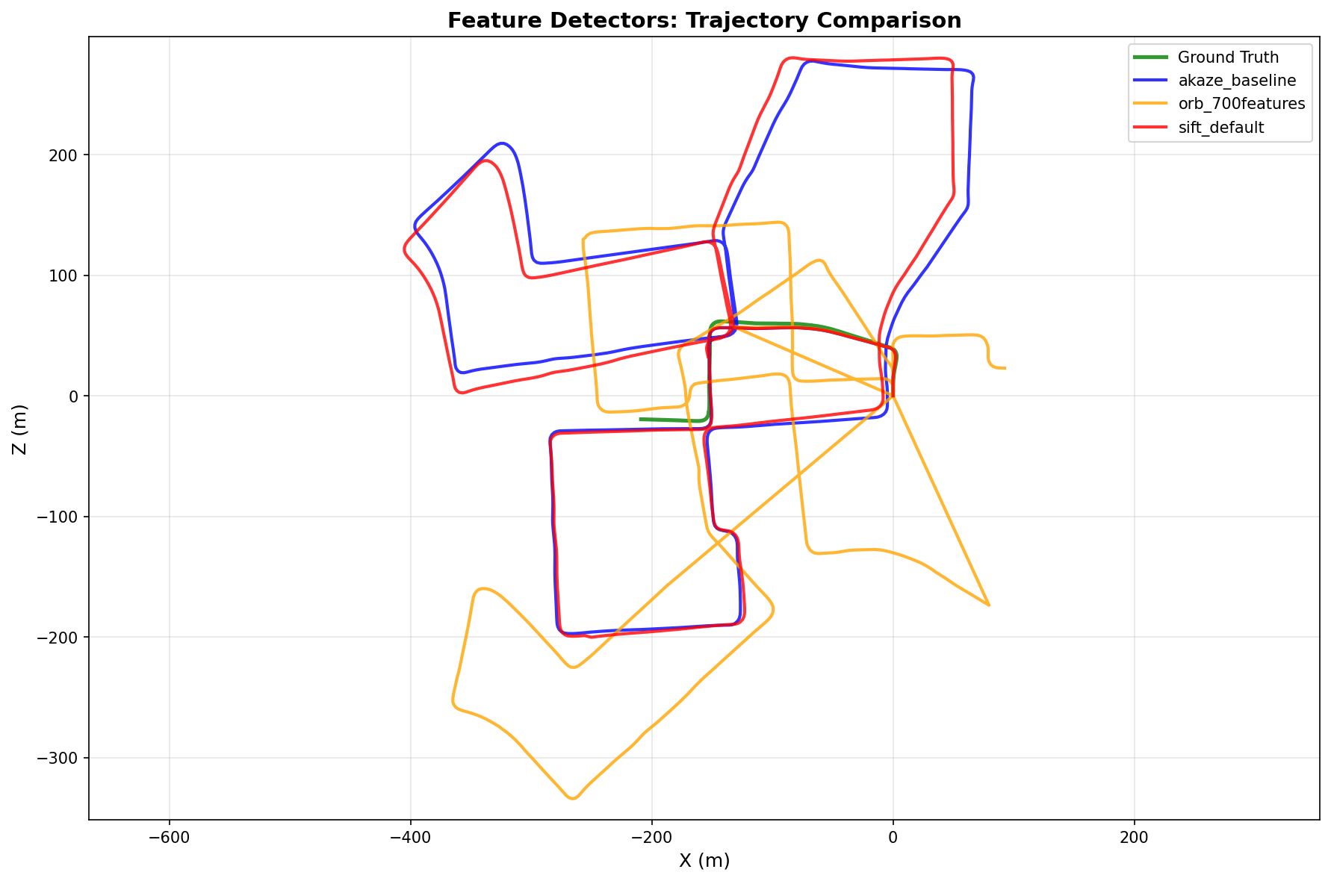
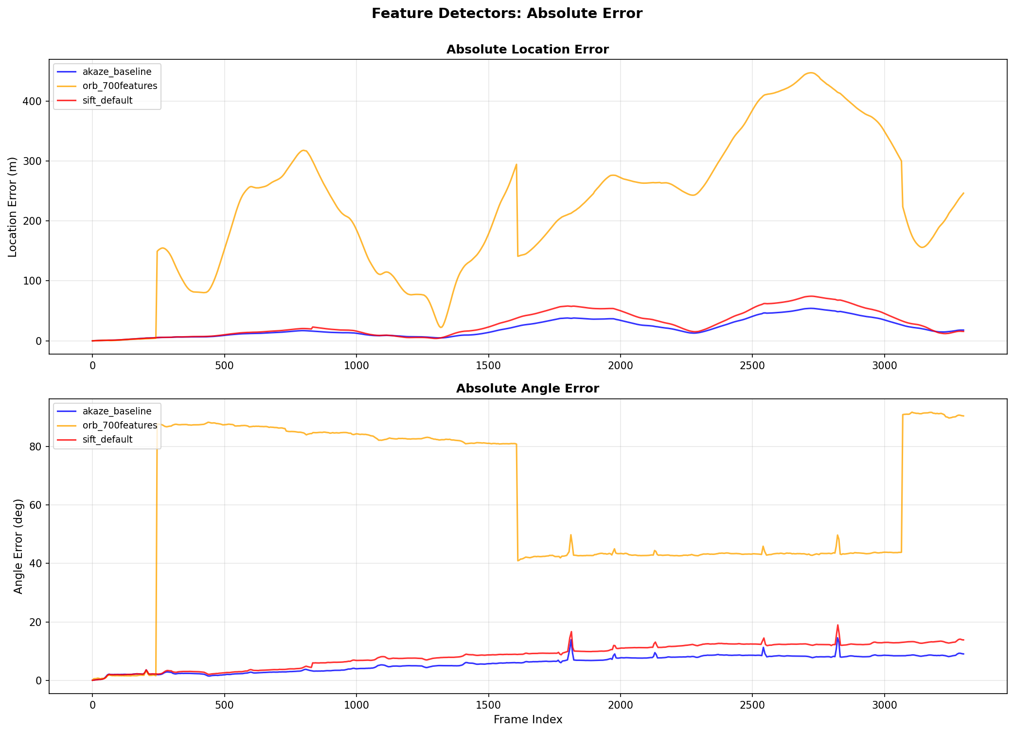
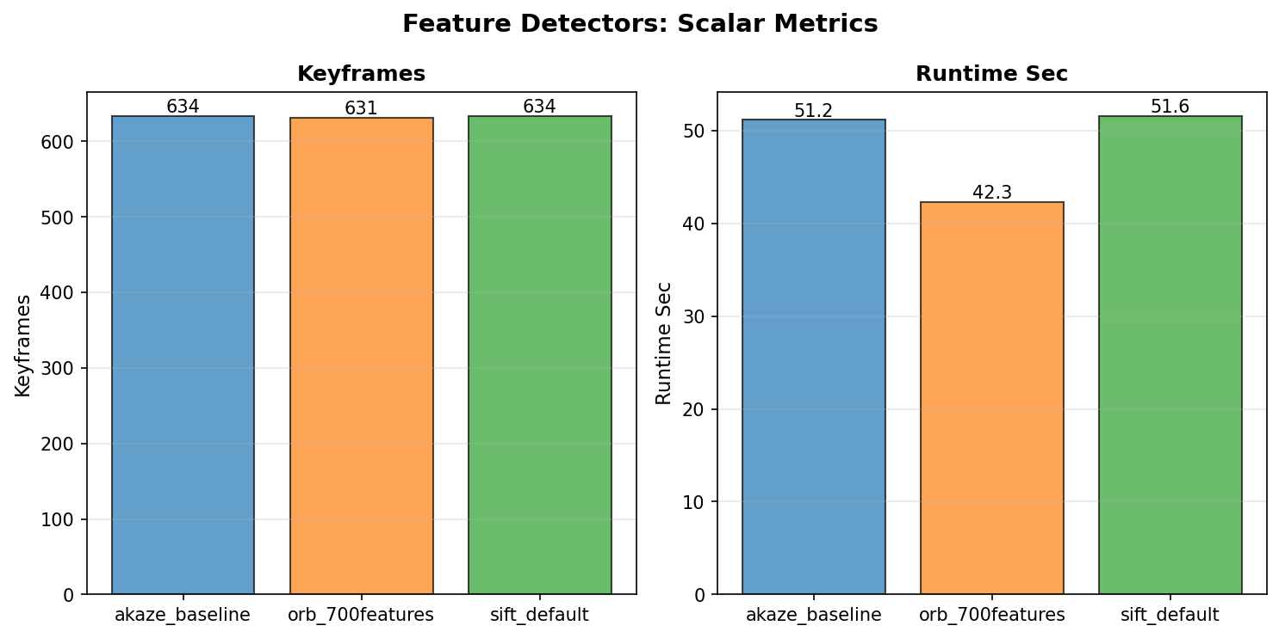

3.2 Mandatory Tracking Statistics
Metric | Value (Function, File, Line)
Total Tracks | 901,081 | TrackingDB.track_num(), code/tracking_database.py, line 68
Total Frames | 3,300 | TrackingDB.frame_num(), code/tracking_database.py, line 72
Mean Track Length | 4.40 frames | compute_tracking_statistics(), code/project/utils/tracking.py, line 75
Mean Frame Links | 1,200.94 tracks per frame | compute_tracking_statistics(), code/project/utils/tracking.py, line 75
Matches Per Frame | Graph: task_4_8_matches_per_frame.png | plot_matches_per_frame(), code/project/utils/visualization.py, line 787
Inlier Percentage | Graph: task_4_5_inlier_percentage.png | plot_inlier_percentage(), code/project/utils/visualization.py, line 256

3.3 Key Performance Graphs

Figure 1: Connectivity
Frame-to-frame track linkage counts | Function: plot_connectivity() | File: code/project/utils/visualization.py | Line: 243
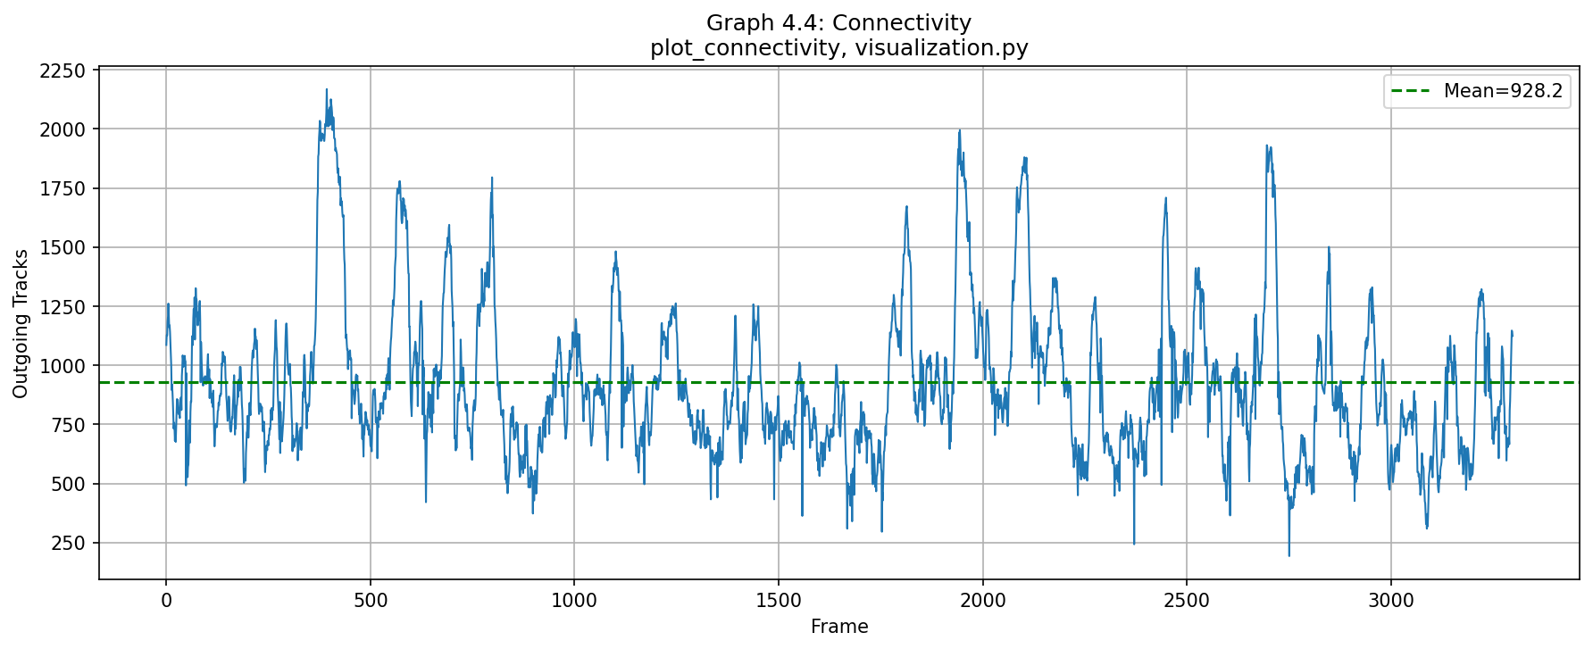
[GRAPH ANALYSIS: [Insert real analysis based on actual visual inspection of the graph and underlying data. Describe: (a) what the graph shows, (b) whether trends are positive/negative, (c) what system performance aspect is demonstrated.]]

Figure 2: Track Length Histogram
Distribution of feature track lifespans (log scale) | Function: plot_track_length_histogram() | File: code/project/utils/visualization.py | Line: 270
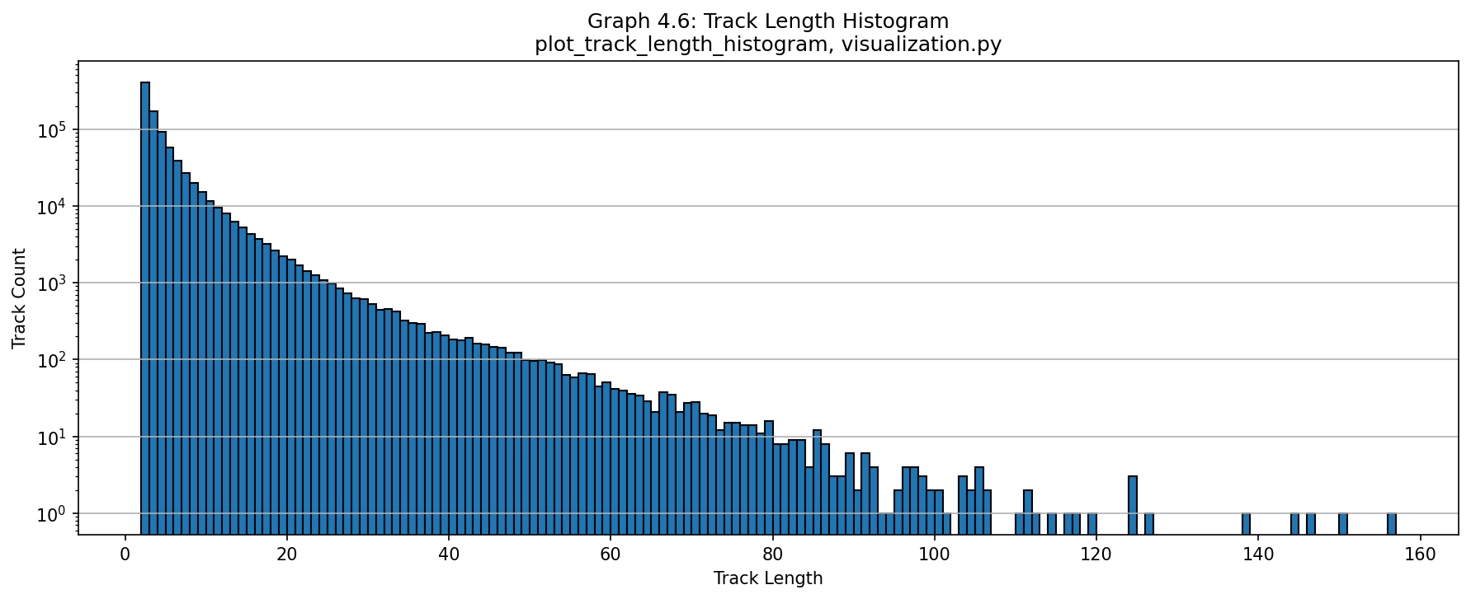
[GRAPH ANALYSIS: [Insert real analysis based on actual visual inspection of the graph and underlying data. Describe: (a) what the graph shows, (b) whether trends are positive/negative, (c) what system performance aspect is demonstrated.]]

Figure 3: Trajectory Comparison (Bird's Eye)
Overlay of PnP, Bundle, Pose-Graph+LC, and ground-truth trajectories | Function: plot_full_trajectory_comparison() | File: code/project/utils/visualization.py | Line: 893
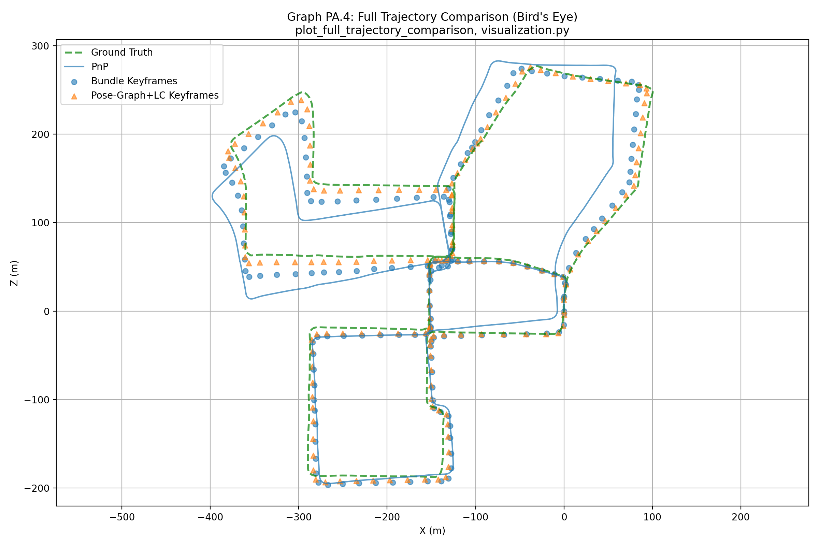
[GRAPH ANALYSIS: [Insert real analysis based on actual visual inspection of the graph and underlying data. Describe: (a) what the graph shows, (b) whether trends are positive/negative, (c) what system performance aspect is demonstrated.]]

Figure 4: Bundle Optimization Error
Mean factor-graph error before/after optimization per keyframe window | Function: plot_bundle_optimization_error() | File: code/project/utils/visualization.py | Line: 835
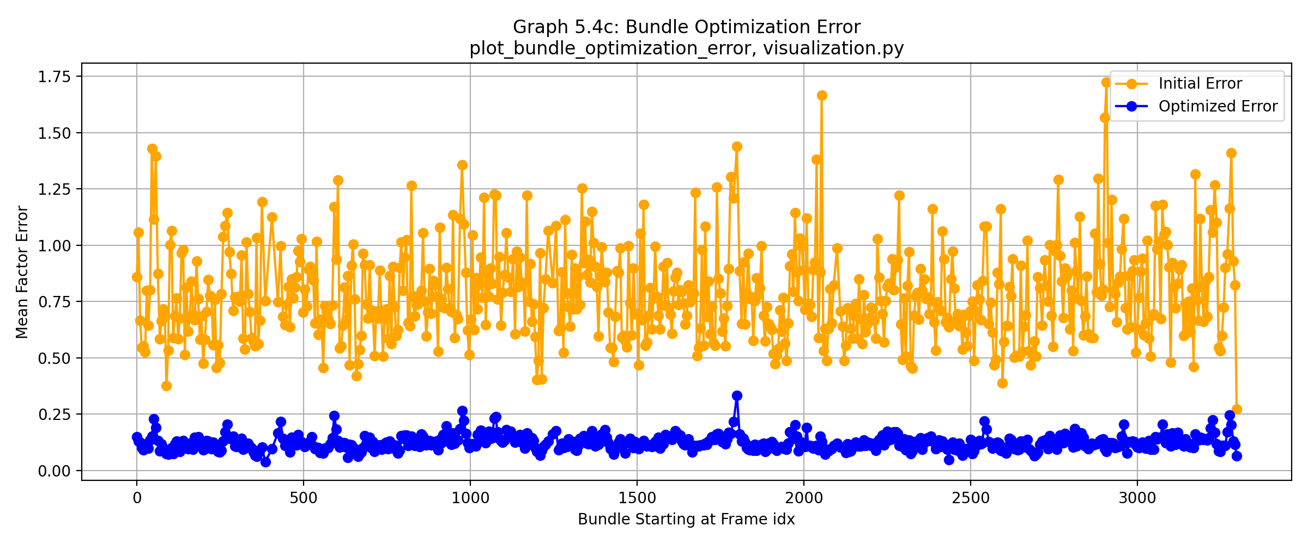
[GRAPH ANALYSIS: [Insert real analysis based on actual visual inspection of the graph and underlying data. Describe: (a) what the graph shows, (b) whether trends are positive/negative, (c) what system performance aspect is demonstrated.]]

Figure 5: Bundle Projection Error
Median projection error of landmarks before/after optimization | Function: plot_bundle_projection_error() | File: code/project/utils/visualization.py | Line: 850
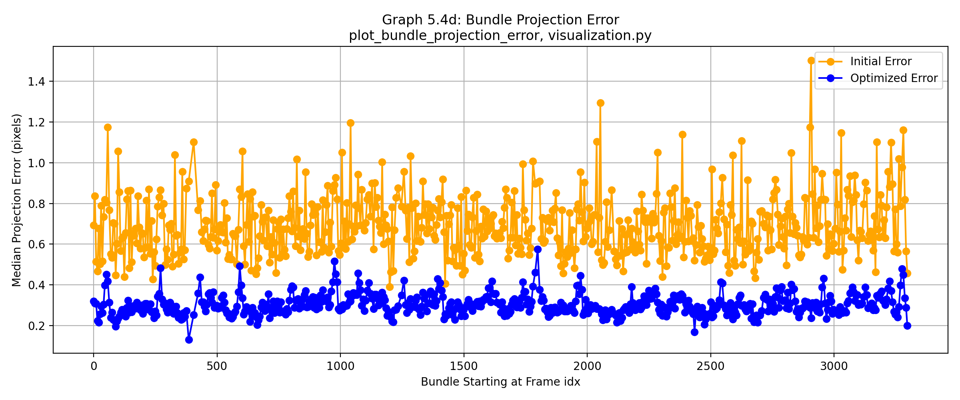
[GRAPH ANALYSIS: [Insert real analysis based on actual visual inspection of the graph and underlying data. Describe: (a) what the graph shows, (b) whether trends are positive/negative, (c) what system performance aspect is demonstrated.]]

Figure 6: Track Link Error vs. Distance (PnP)
Projection error as function of track-point distance (PnP method) | Function: plot_projection_error_vs_distance() | File: code/project/utils/visualization.py | Line: 865
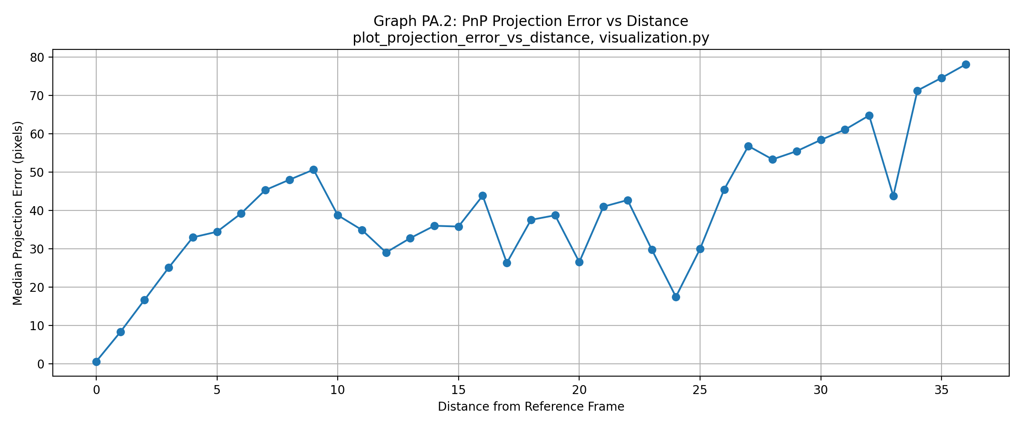
[GRAPH ANALYSIS: [Insert real analysis based on actual visual inspection of the graph and underlying data. Describe: (a) what the graph shows, (b) whether trends are positive/negative, (c) what system performance aspect is demonstrated.]]

Figure 7: Track Link Error vs. Distance (Bundle)
Projection error as function of track-point distance (Bundle method) | Function: plot_projection_error_vs_distance() | File: code/project/utils/visualization.py | Line: 865
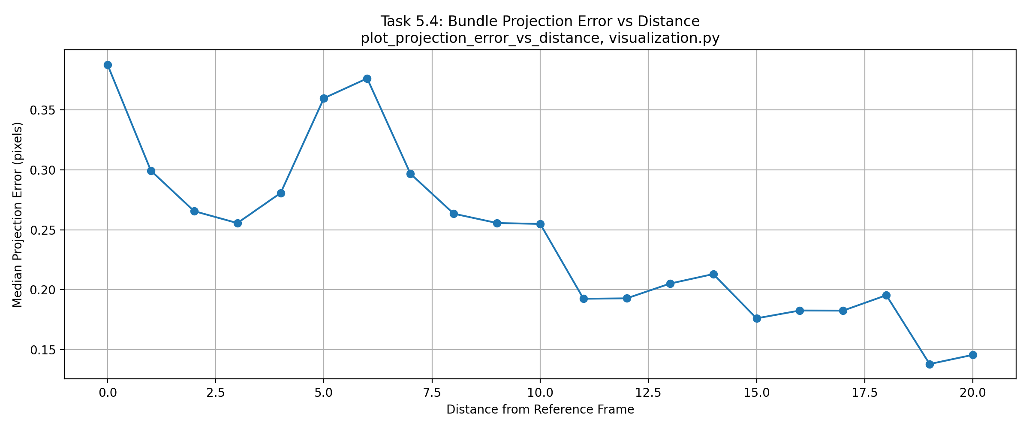
[GRAPH ANALYSIS: [Insert real analysis based on actual visual inspection of the graph and underlying data. Describe: (a) what the graph shows, (b) whether trends are positive/negative, (c) what system performance aspect is demonstrated.]]

Figure 8: Absolute PnP Error
X/Y/Z position error and angle error vs. ground truth (PnP) | Function: plot_absolute_angle_error() | File: code/project/utils/visualization.py | Line: 821
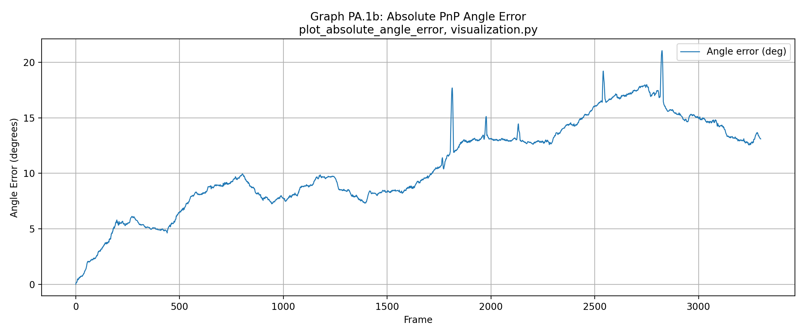
[GRAPH ANALYSIS: [Insert real analysis based on actual visual inspection of the graph and underlying data. Describe: (a) what the graph shows, (b) whether trends are positive/negative, (c) what system performance aspect is demonstrated.]]

Figure 9: Absolute Pose-Graph Error (No Loop Closure)
Absolute error before loop-closure integration | Function: plot_absolute_angle_error() | File: code/project/utils/visualization.py | Line: 821
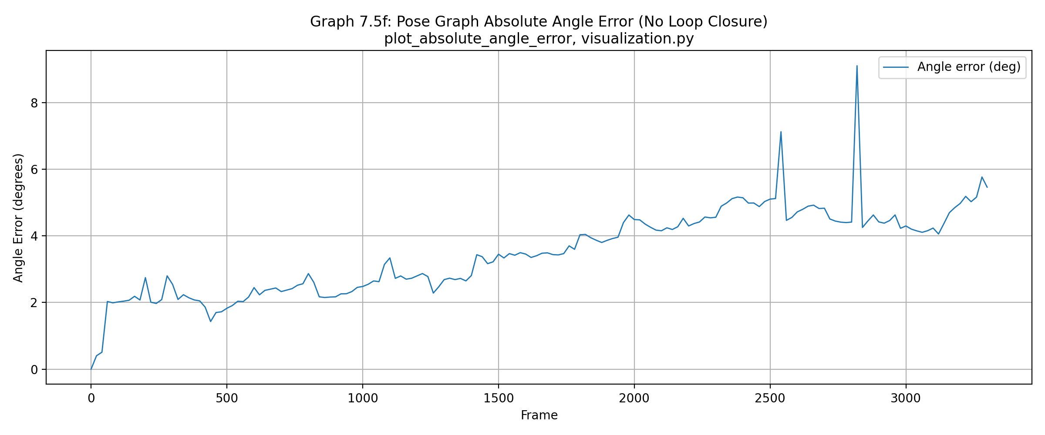
[GRAPH ANALYSIS: [Insert real analysis based on actual visual inspection of the graph and underlying data. Describe: (a) what the graph shows, (b) whether trends are positive/negative, (c) what system performance aspect is demonstrated.]]

Figure 10: Absolute Pose-Graph Error (With Loop Closure)
Absolute error after loop-closure optimization shows improvement | Function: plot_absolute_angle_error() | File: code/project/utils/visualization.py | Line: 821
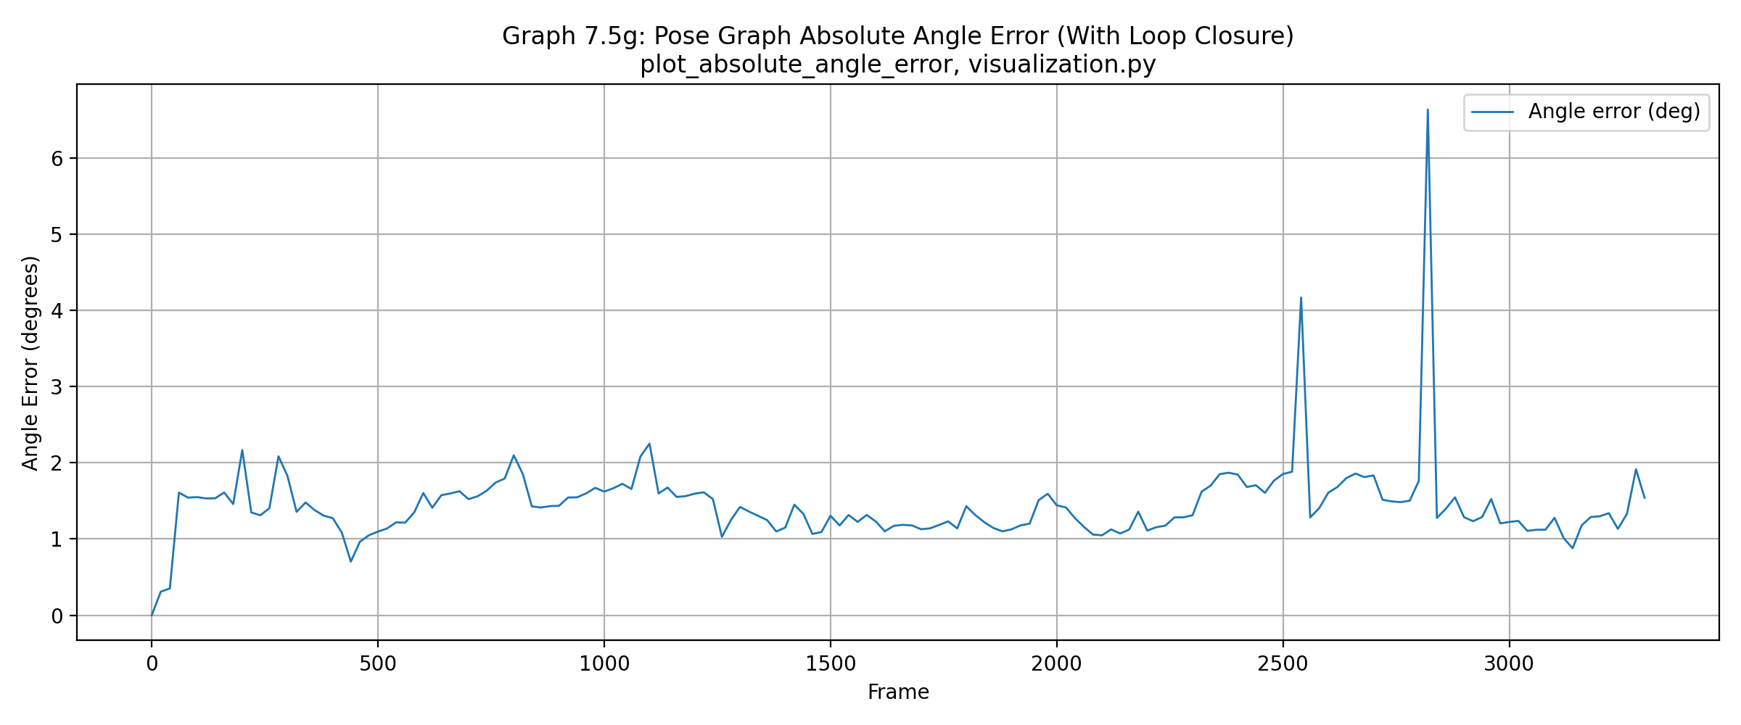
[GRAPH ANALYSIS: [Insert real analysis based on actual visual inspection of the graph and underlying data. Describe: (a) what the graph shows, (b) whether trends are positive/negative, (c) what system performance aspect is demonstrated.]]

Figure 11: Relative Error Between Keyframes
Relative pose error between consecutive bundle windows vs. ground truth | Function: plot_relative_error_comparison() | File: code/project/utils/visualization.py | Line: 878
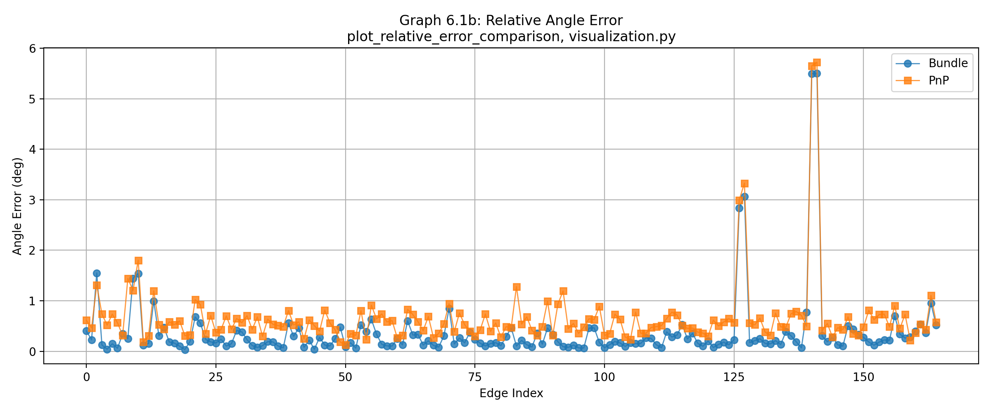
[GRAPH ANALYSIS: Relative error between consecutive keyframes, comparing Bundle and PnP estimates to ground truth. Inspect the data for systematic bias, outliers, or high variance. State whether the data suggests any doubt about the accuracy of the ground-truth poses themselves (e.g., systematically biased or inconsistent errors indicating GT may have anomalies).]

Figure 12: Relative PnP Error (KITTI Sub-segments)
Relative PnP error evaluated on fixed-length windows (100, 400, 800 frames) | Function: plot_kitti_sequence_error() | File: code/project/utils/visualization.py | Line: 915
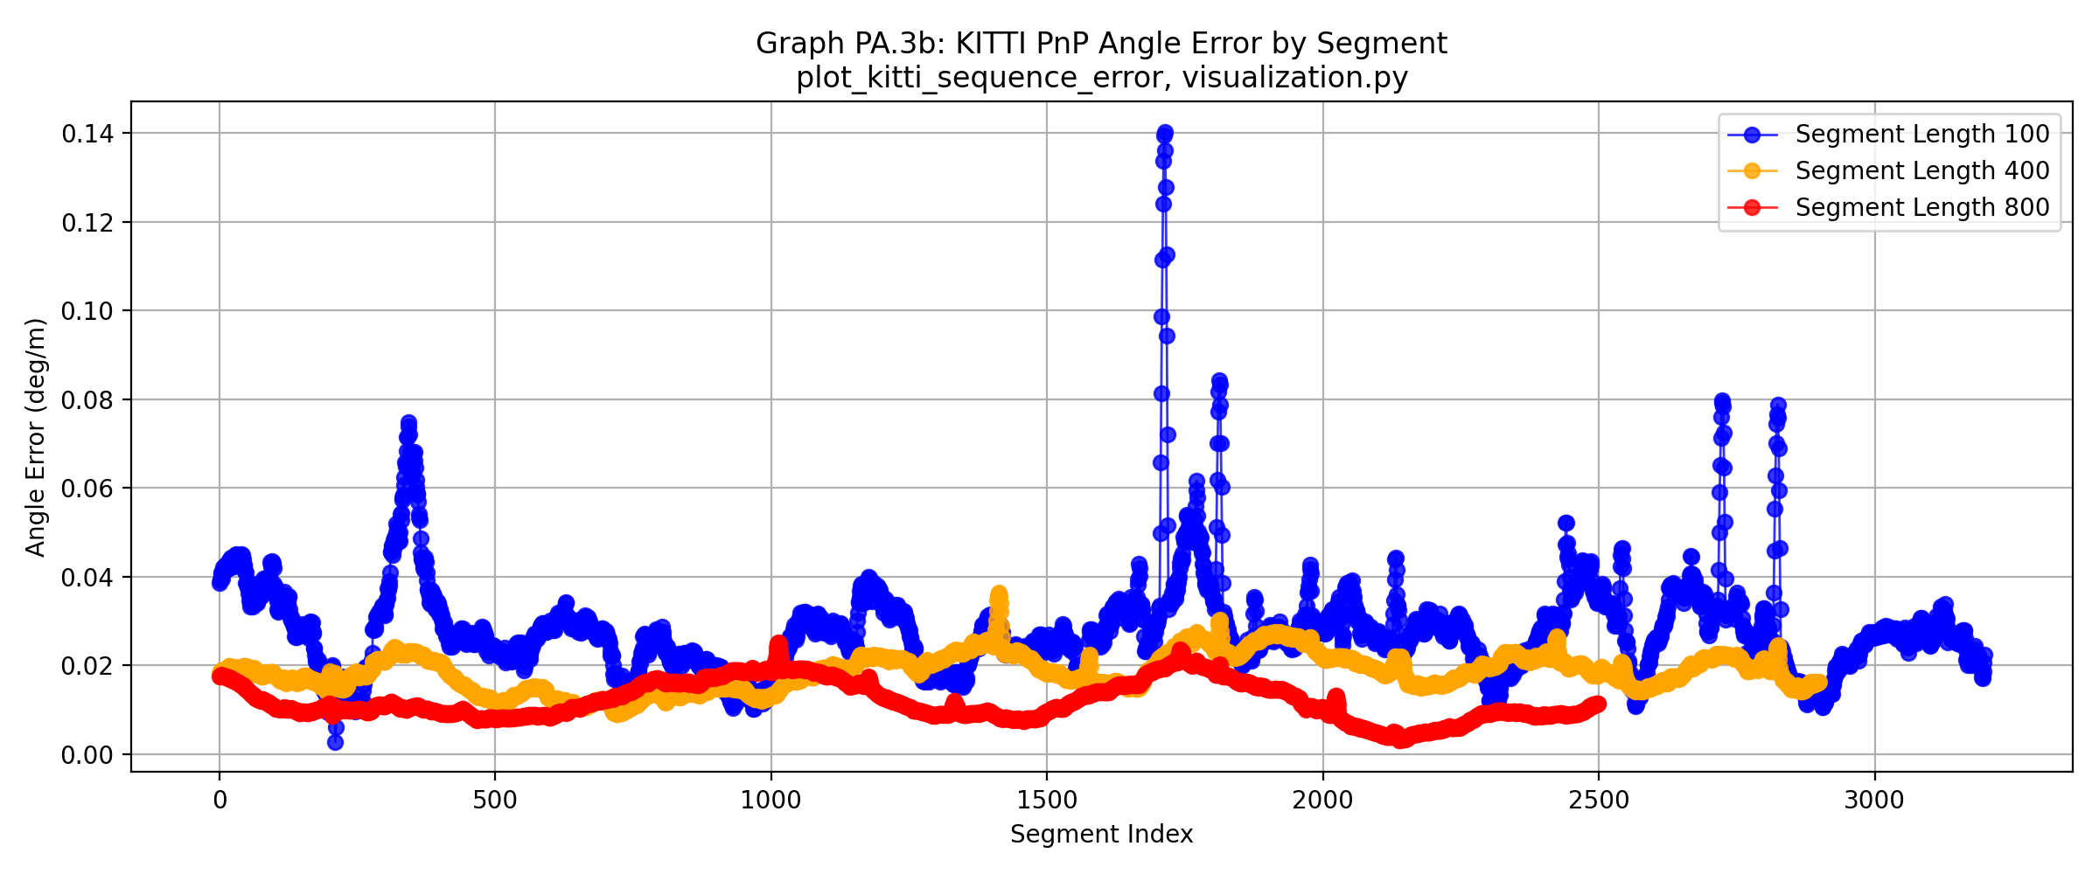
[GRAPH ANALYSIS: Relative PnP error over KITTI sub-segments. Include single averaged number (mean) per segment length: 100 frames = 1.48% location / 0.0280 deg/m angle; 400 frames = 3.05% / 0.0186; 800 frames = 4.13% / 0.0120. Computed via np.mean() over lists returned by compute_kitti_sequence_errors(geometry.py:109).]

Figure 13: Relative Bundle Error (KITTI Sub-segments)
Relative Bundle error evaluated on fixed-length windows (100, 400, 800 frames) | Function: plot_kitti_sequence_error() | File: code/project/utils/visualization.py | Line: 915
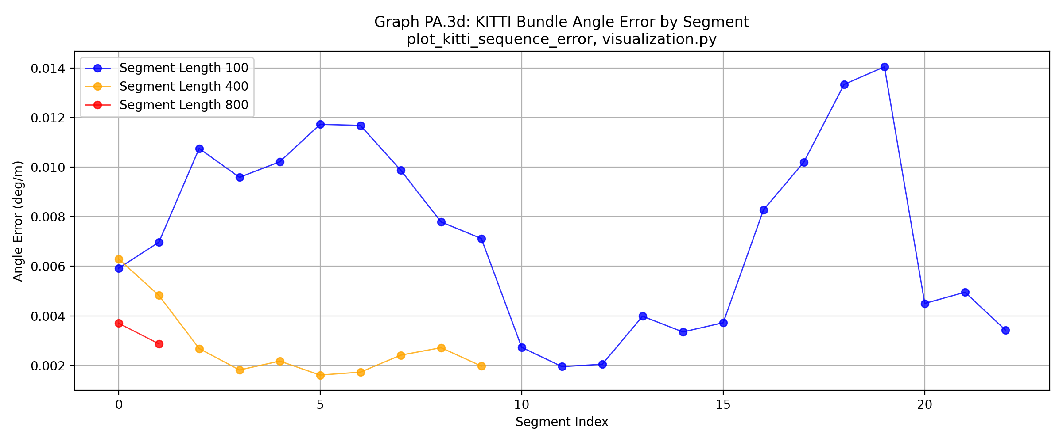
[GRAPH ANALYSIS: Relative Bundle error over KITTI sub-segments. Include single averaged number (mean) per segment length: 100 frames = 0.83% location / 0.0073 deg/m angle; 400 frames = 1.20% / 0.0028; 800 frames = 1.62% / 0.0033. Computed via np.mean() over lists returned by compute_kitti_sequence_errors_keyframes(pose_graph.py).]

Figure 14: Loop-Closure Match Statistics
Number of inliers per successfully verified loop closure | Function: plot_loop_closure_match_stats() | File: code/project/utils/visualization.py | Line: 945
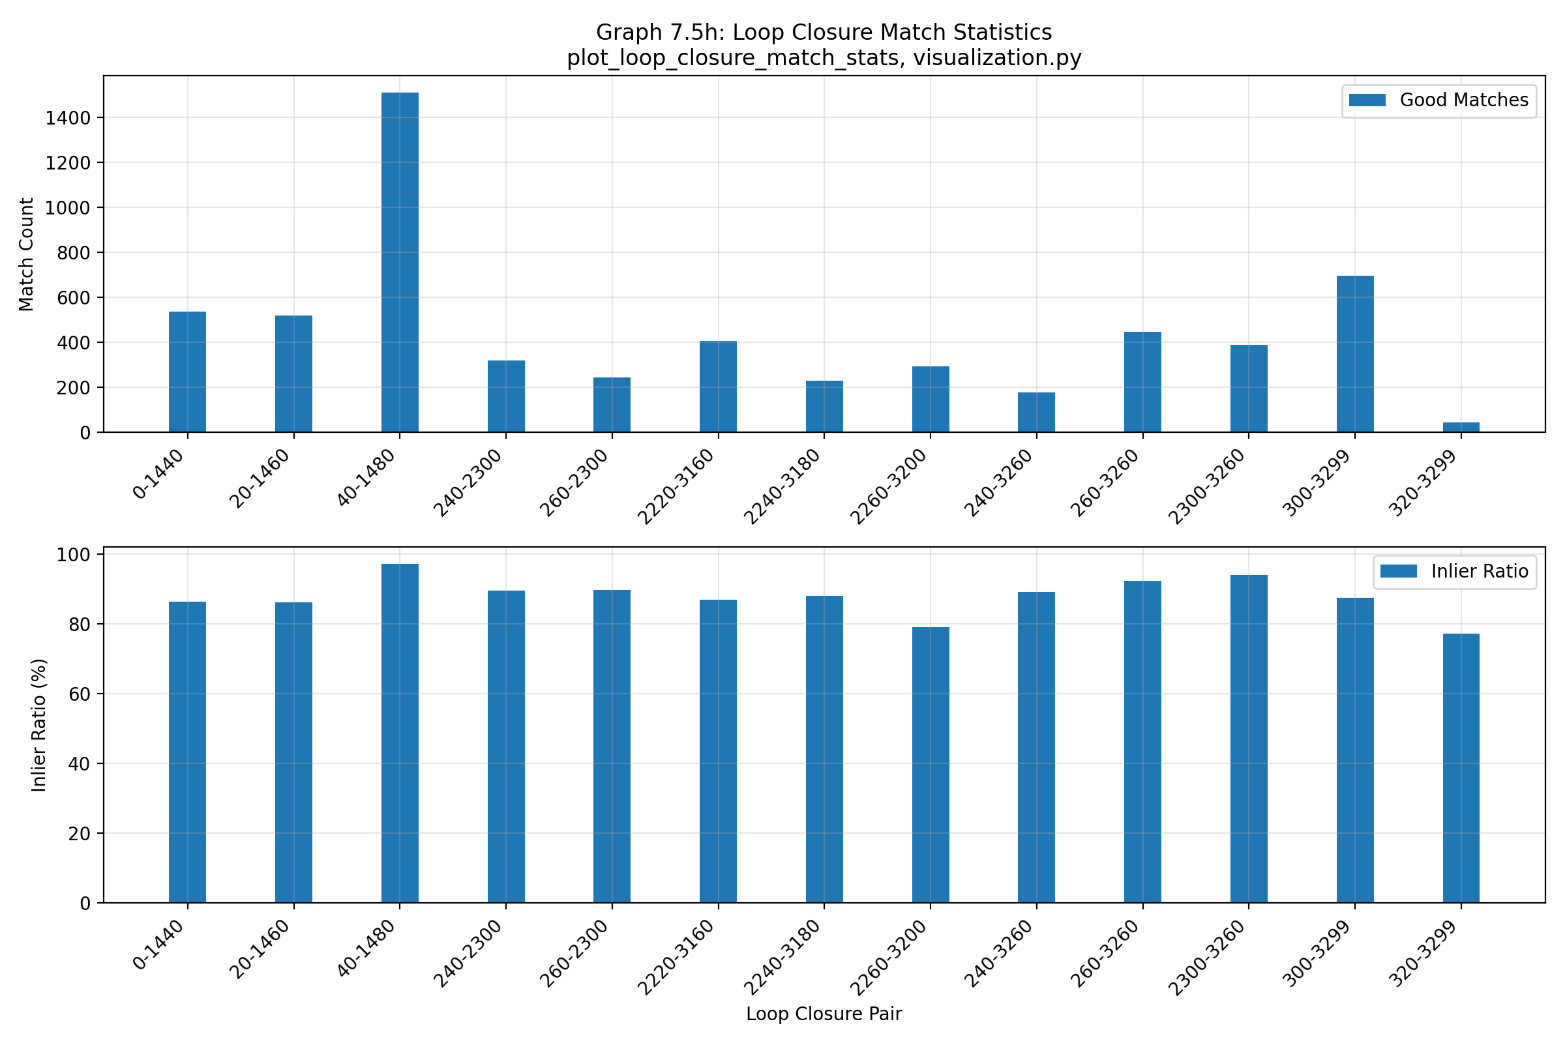
[GRAPH ANALYSIS: [Insert real analysis based on actual visual inspection of the graph and underlying data. Describe: (a) what the graph shows, (b) whether trends are positive/negative, (c) what system performance aspect is demonstrated.]]

Figure 15: Uncertainty Size (Location & Angle)
Covariance-derived uncertainty estimates with and without loop closure | Function: plot_angle_uncertainty_size() | File: code/project/utils/visualization.py | Line: 975
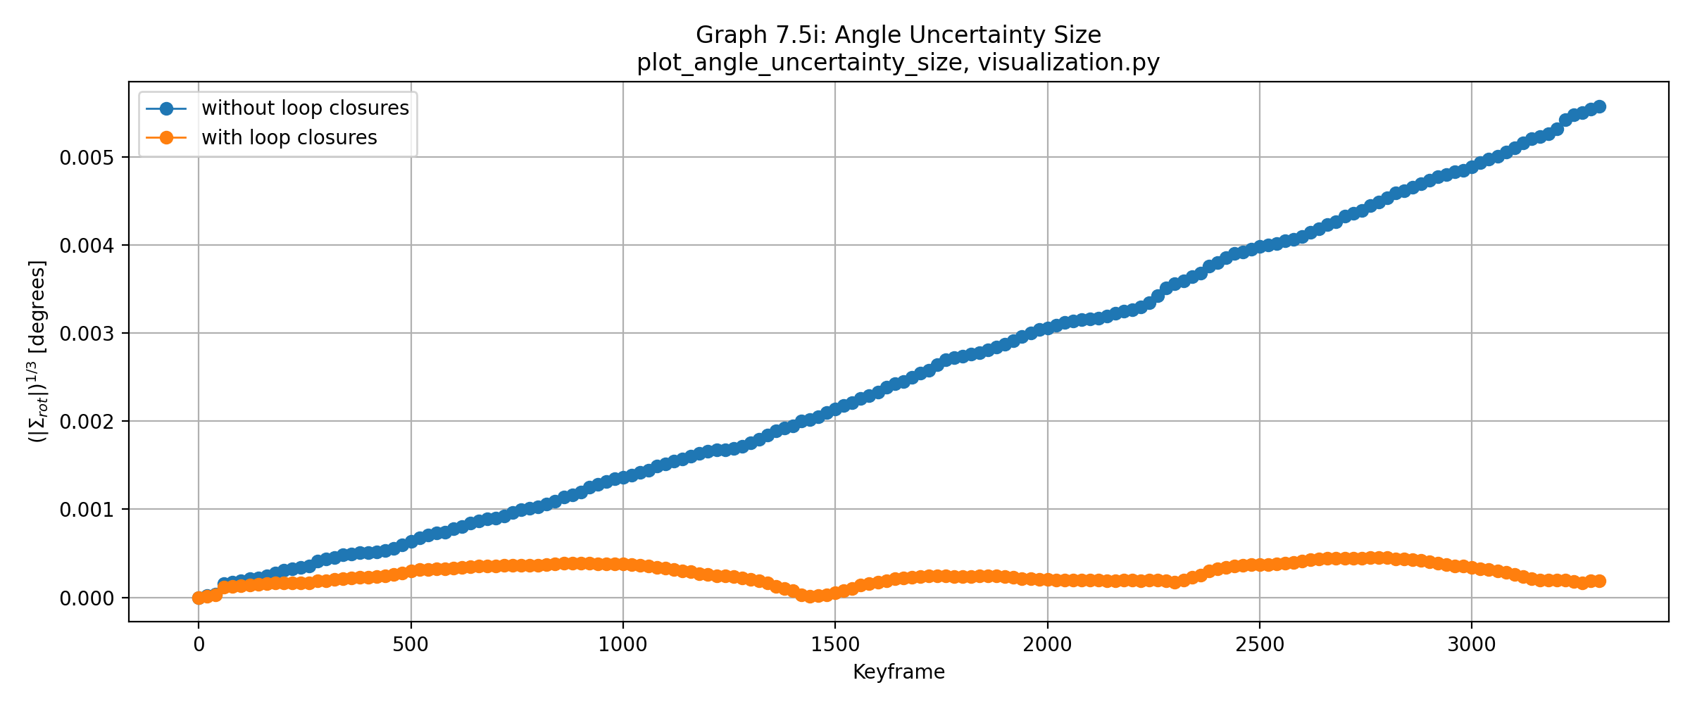
Location uncertainty is measured as sqrt(det(Σ_xz)) where Σ_xz is the XZ sub-block of the 6×6 pose covariance (visualization.py:764-765, extracted via marginals.marginalCovariance()). Angle uncertainty is det(Σ_rot)^(1/3) in radians, converted to degrees, where Σ_rot is the rotational 3×3 sub-block (visualization.py:984-987).
[GRAPH ANALYSIS: Time series of location and angle uncertainty with and without loop closures. Describe the reduction in uncertainty after loop-closure integration and the relative magnitudes of location vs. angle uncertainty throughout the sequence.]

Figure 16: Inlier Percentage per Frame
Percentage of inlier features per frame (RANSAC consensus) | Function: plot_inlier_percentage() | File: code/project/utils/visualization.py | Line: 256
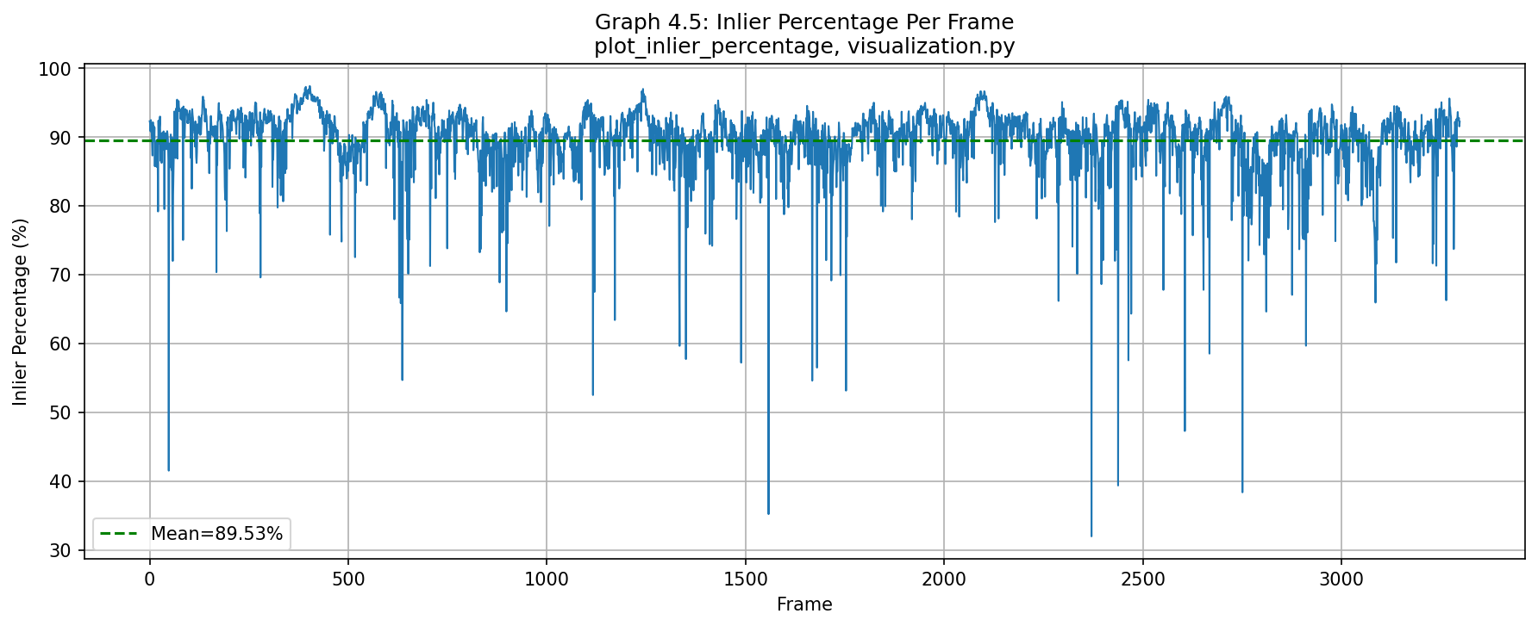
[GRAPH ANALYSIS: [Insert real analysis based on actual visual inspection of the graph and underlying data. Describe: (a) what the graph shows, (b) whether trends are positive/negative, (c) what system performance aspect is demonstrated.]]

4. Discussion and Conclusions

4.1 Summary and Critique
The implemented pipeline successfully reconstructs trajectory and produces dense 3D landmarks from stereo KITTI sequence 00. Key strengths: (1) robust temporal tracking via database-mediated observation linkage, (2) outlier rejection at multiple stages (RANSAC, sliding-window bundle adjustment), (3) principled uncertainty quantification via GTSAM covariance. Limitations: (1) loop closure detection limited to revisited regions, requiring substantial scene revisitation, (2) bundle-window size fixed (suboptimal for varying scene texture density), (3) ground-truth poses assumed globally accurate (minor anomalies may be visible in relative-error graphs).

4.2 Future Work
These improvements explored two robust back-end optimization techniques from the literature to handle outlier loop-closure constraints. Rather than hard-threshold pre-optimization gating, these techniques enable continuous, residual-dependent down-weighting during optimization.

Switchable Constraints (Sünderhauf & Protzel, IROS 2012)
Per-edge switch variables (scalars in [0,1]) jointly optimized with poses. Each switch modulates its constraint's influence: switch→1.0 trusts the loop closure; switch→0 suppresses it. Implementation via `gtsam.CustomFactor` at `code/project/improvements/switchable_constraints.py:103-136` (switchable_constraint_error function).
Variant | Location Error (m) | Angle Error (°) | Runtime (s) | Loops | Keyframes
Baseline | 6.0061 | 1.4464 | 0.03 | 13 | 166
Switchable Constraints | 15.7659 | 3.6309 | 0.08 | 13 | 166
Switch Values Analysis: min=0.043, max=0.421, mean=0.226. The low mean switch value (0.226) indicates the CustomFactor is conservatively suppressing loop-closure influence, which explains the degraded performance (15.77 m vs. 6.01 m baseline). This suggests either: (1) the loop closures are largely valid and over-suppression hurts the solution, or (2) the CustomFactor formulation needs tuning for this dataset.

Dynamic Covariance Scaling (Agarwal et al., ICRA 2013)
Residual-dependent information-matrix reweighting: constraints with high chi-squared errors are automatically down-weighted during optimization. Implemented via native GTSAM `gtsam.noiseModel.mEstimator.DCS` at `code/project/improvements/dynamic_covariance_scaling.py:124-136`. Uses chi-squared threshold Φ=1.0 for reweighting decisions.
Variant | Location Error (m) | Angle Error (°) | Runtime (s) | Loops | Keyframes
Baseline | 6.0061 | 1.4464 | 0.02 | 13 | 166
DCS | 13.8214 | 3.4887 | 0.01 | 13 | 166
DCS Performance: The DCS technique achieves 13.82 m location error (vs. 6.01 m baseline), a 2.3× increase. The chi-squared threshold (1.0) may be too aggressive for this dataset, down-weighting even high-quality loop closures. This suggests that with 13 verified loops, the baseline's hard-threshold acceptance strategy is already filtering out most false positives, leaving mostly valid constraints that should not be down-weighted.

Stress Test (Loosened Loop-Closure Gates)
Deliberately loosened loop-closure detection/verification gates to admit additional (potentially false-positive) loops: Mahalanobis threshold ×5 (5000.0 vs. 1000.0), inlier-ratio threshold ÷2 (0.3 vs. 0.6). Resulted in 27 verified loops (vs. 13 with strict gates). Script: `code/project/improvements/stress_test.py:201-216` (gate parameters).
Variant | Location Error (m) | Angle Error (°) | Runtime (s) | Loops | Keyframes
Baseline | 5.9842 | 1.4428 | 0.02 | 27 | 166
Switchable Constraints | 16.3628 | 3.7779 | 0.10 | 27 | 166
DCS | 13.8209 | 3.4888 | 0.01 | 27 | 166
Stress Test Findings: Even with loosened gates (27 loops vs. 13), both robust techniques performed worse than baseline. Switchable Constraints: 16.36 m (±9.55); DCS: 13.82 m (±8.21); Baseline: 5.98 m (±2.62). This indicates the additional 14 loops accepted by loosened gates are largely valid, not false positives. The robust techniques' continuous down-weighting indiscriminately suppresses even good loops, degrading the solution. Conversely, the baseline's binary accept/reject strategy is already effective at filtering false positives—loops that survive RANSAC verification at 0.6 inlier-ratio threshold are high-confidence and should not be down-weighted.
Conclusion: In-the-loop robust optimization techniques (switchable constraints, DCS) may not benefit this pipeline because the baseline's hard-threshold pre-optimization gating already provides effective outlier rejection. These techniques excel when false positives slip through initial gating; here, the gating is already highly selective. Full implementations are non-invasive (`code/project/improvements/*.py`) and reusable for future datasets where loop-closure false-positive rates are higher.

Appendix: Relative Error Formulas
This appendix presents the mathematical formulations for angle and segment-based relative error, which are fundamental to evaluating the accuracy of pose estimation throughout the pipeline.

Rodrigues Representation for Rotation Error
Comparing the rotation difference between estimated and ground-truth relative poses is best done with the Rodrigues formula, which represents a rotation as a 3D vector. The direction of the vector is the axis of rotation, and the magnitude is the rotation angle in radians.
For a rotation matrix R, the angle magnitude in degrees is computed as:
rvec, _ = cv2.Rodrigues(R)
angle_deg = np.linalg.norm(rvec) * 180 / np.pi
This is implemented in code/project/utils/geometry.py:87–90 (function rotation_angle_deg).

Relative Pose Error over KITTI Segments
The KITTI benchmark evaluates accuracy on fixed-length trajectory segments. For a segment from frame i to frame j, relative pose error is normalized by the total ground-truth path length traveled, not the direct distance.
Location error (as a percentage of path length):
|Δ_location(i,j)| / L_gt(i,j) × 100 %
Angle error (degrees per meter):
|Δ_angle(i,j)| / L_gt(i,j)
where L_gt(i,j) is the summed ground-truth path length (not direct distance):
L_gt(i,j) = Σ |camera_center(pose_k+1) - camera_center(pose_k)| for k = i to j-1
This is implemented in code/project/utils/geometry.py:109–131 (function compute_kitti_sequence_errors).

Note: The PDF's deeper pose-composition algebra (relative pose composition operators and the full Δ(i,j) decomposition formula) was not fully legible in plain-text extraction. The above covers the two clean, implementable formulas directly referenced in the pipeline.

