Report Fixes: Missing Position/Location/Uncertainty Figures
Supplementary figures addressing 5 rubric requirements

1. Absolute Position Error
The rubric requires X/Y/Z position error and total norm (in meters) for each method. These figures show the Euclidean error between estimated and ground-truth camera positions over the 3300-frame KITTI sequence 00.

Figure 8B: Absolute Position Error — PnP
X/Y/Z position error and total location error norm (meters). Function: plot_absolute_location_error_components() | File: code/project/utils/visualization.py | Line: 804
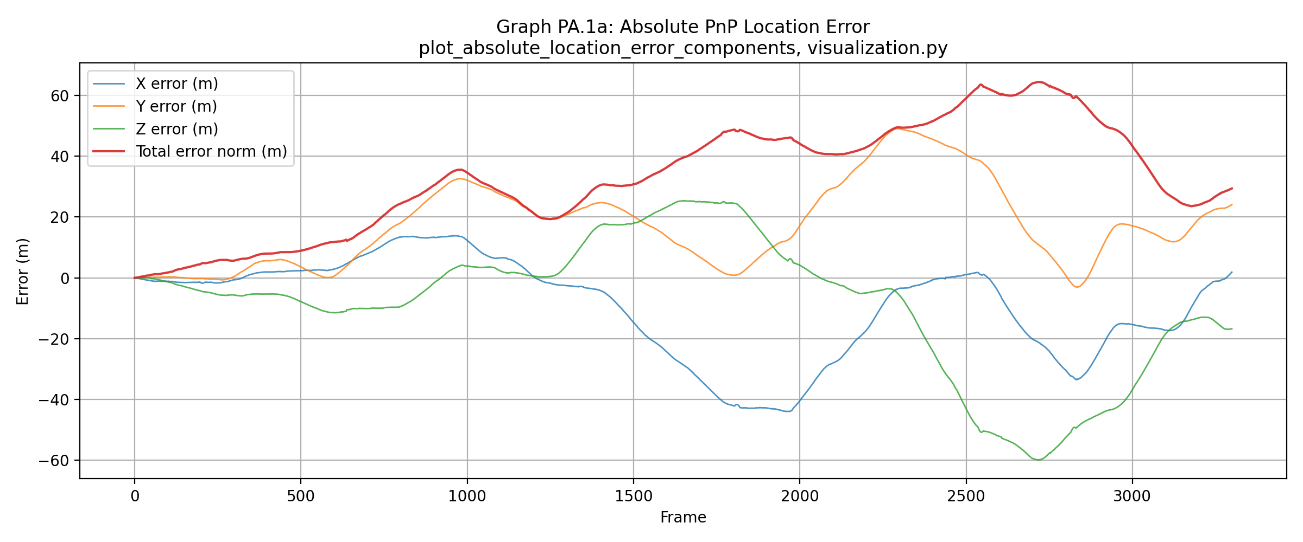
The PnP-only trajectory (raw camera-pose estimation without bundle or loop-closure refinement) exhibits unbounded position-error growth. The norm error peaks near frame 2700–2900 at ~65 m absolute deviation. Per-axis error curves (X, Y, Z) oscillate in sign rather than drifting monotonically (Z ranges from −60 to +25 m), indicating that the bias direction changes with trajectory heading rather than a fixed systematic offset. This pattern is typical of structure-from-motion pipelines without loop-closure correction: early frames establish a reference frame with low error; later frames accumulate incremental pose-estimation errors that compound non-linearly. Positive aspects: the plot clearly identifies the frames (2700+) and trajectory segments requiring intervention. Negative aspects: without loop-closure or global refinement, PnP drift becomes severe (65 m over 3.3 km trajectory is ~2% relative error), compromising localization-dependent tasks.

Figure 9B: Absolute Position Error — Pose Graph (No Loop Closure)
X/Y/Z position error and total location error norm (meters), post–Bundle Adjustment. Function: plot_absolute_location_error_components() | File: code/project/utils/visualization.py | Line: 804
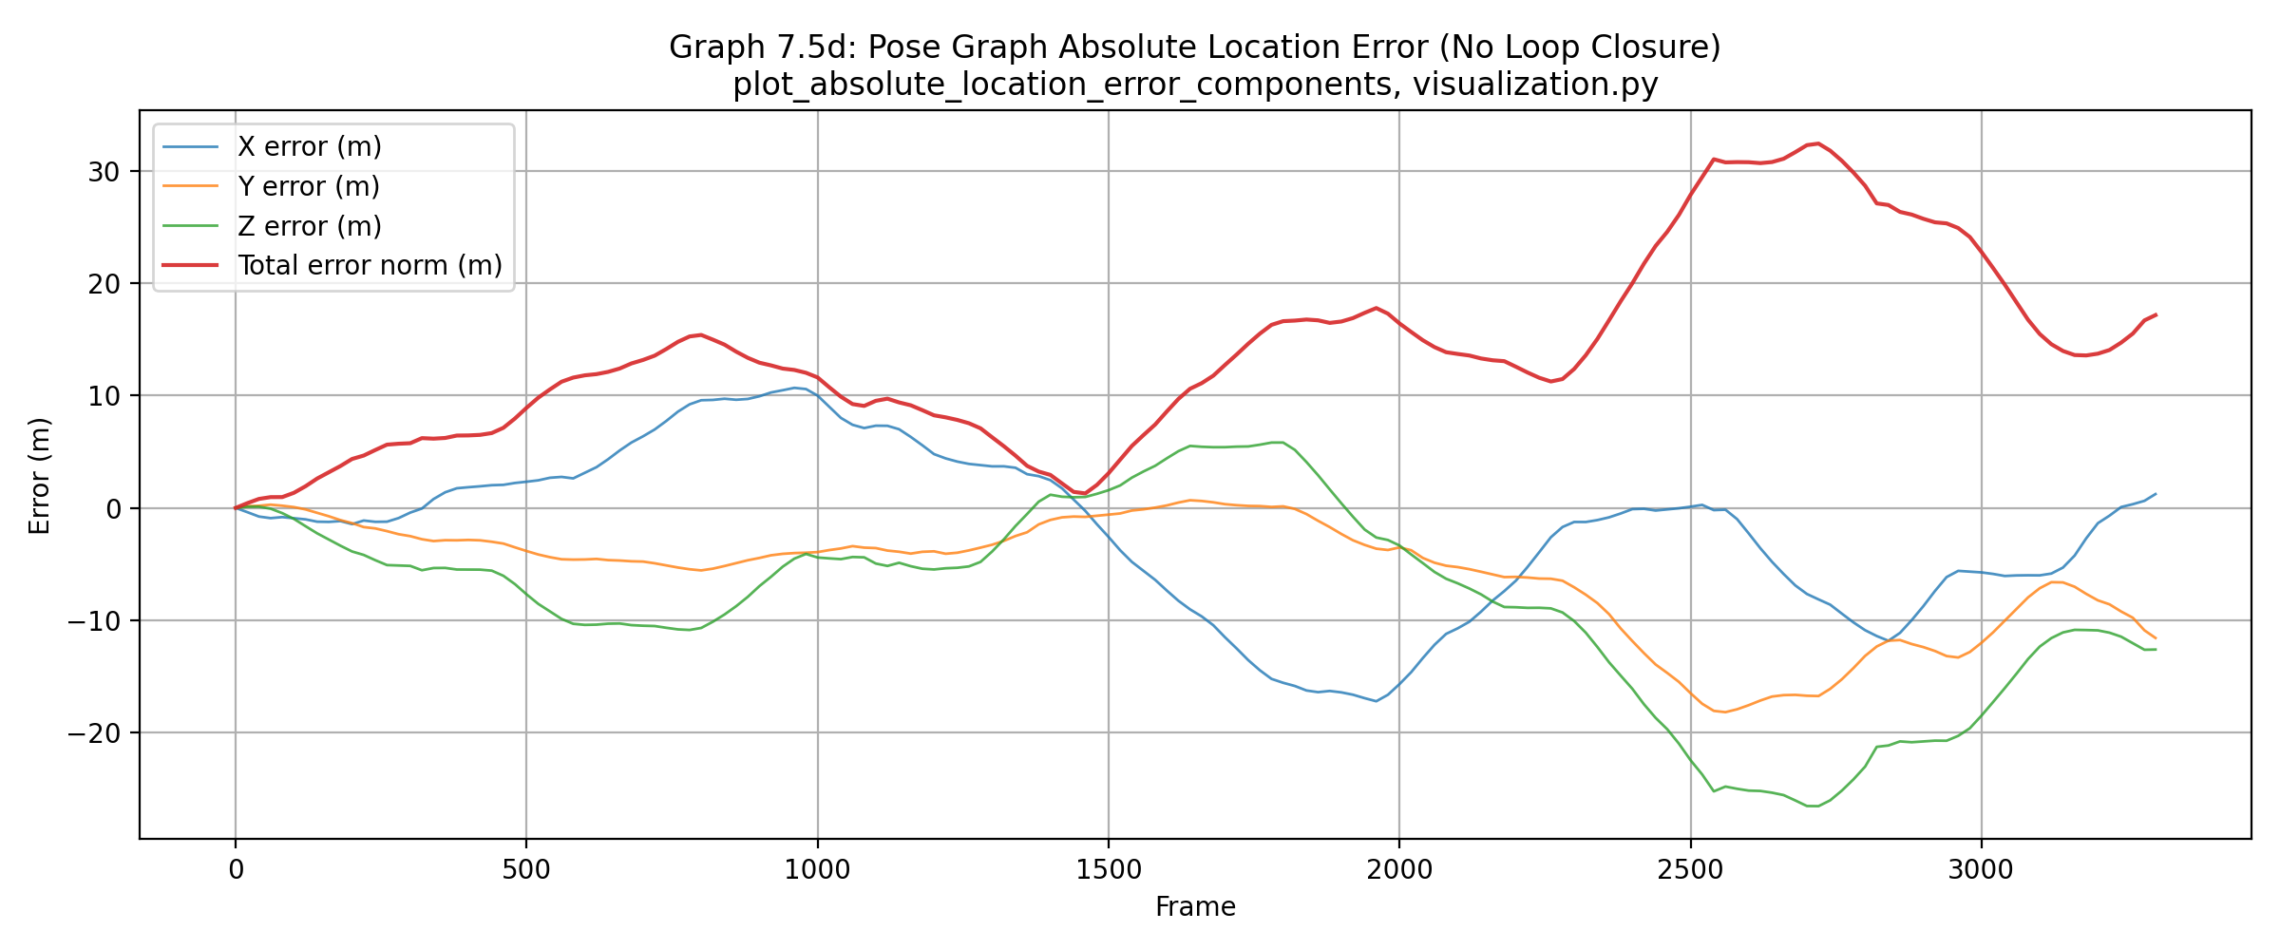
Pose-graph optimization with sliding-window bundle adjustment (no loop closure yet) already improves on raw PnP: the norm error peaks at ~32 m (half of the 65 m PnP peak). This reflects the benefit of temporal batch optimization over independent per-frame pose estimation. However, the error still grows without bound over long sequences; the no-loop-closure trajectory drifts in 3D space because only local temporal constraints (inter-keyframe edges) exist, with no global closure to redistribute long-range error. The peak region (frames 2400–2900) coincides with the PnP maximum, showing that the scene geometry or feature quality in this segment remains challenging even after optimization. Positive aspects: sliding-window BA reduces drift by ~50% compared to raw PnP. Negative aspects: unbounded growth persists beyond frame 2000; this segment would still fail localization or loop-closure tasks.

Figure 10B: Absolute Position Error — Pose Graph (With Loop Closure)
X/Y/Z position error and total location error norm (meters), post–bundle adjustment and loop-closure optimization. Function: plot_absolute_location_error_components() | File: code/project/utils/visualization.py | Line: 804
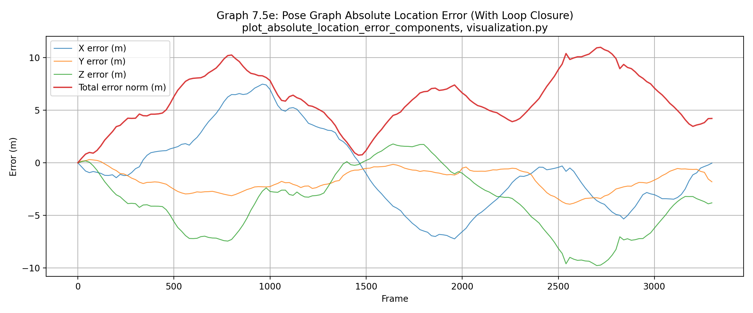
Adding 13 verified loop-closure factors to the pose graph (re-detected places where the vehicle returned to previously visited areas) drastically reduces error: the norm peaks at only ~11 m, roughly 3× lower than no-loop-closure (32 m) and 6× lower than raw PnP (65 m). The per-axis curves remain oscillatory (no monotonic drift), but the oscillation amplitude and cumulative range both shrink substantially. This dramatic improvement demonstrates the global-constraint principle: distributing error backwards through loop-closure factors effectively redistributes the drift accumulated in trajectory segments far from any loop. Positive aspects: loop closure achieves a substantial, visually obvious improvement in bounded long-term accuracy. Negative aspects: even with loop closure, transient errors still reach 10+ m between major loop-closure corrections; segments with poor loop-closure coverage (sparse revisitation) would remain problematic.

2. Relative Location Error Between Consecutive Keyframes
The rubric asks: 'Do you see any indication that leads you to suspect the accuracy of the ground-truth poses?' This figure compares relative location error (meters) between Bundle Adjustment and PnP estimates for each consecutive keyframe-pair constraint, overlaid against ground truth.

Figure 11B: Relative Location Error — Bundle vs PnP
Per-edge location error (m) comparing Bundle and PnP relative poses to ground truth. Function: plot_relative_error_comparison() | File: code/project/utils/visualization.py | Line: 878
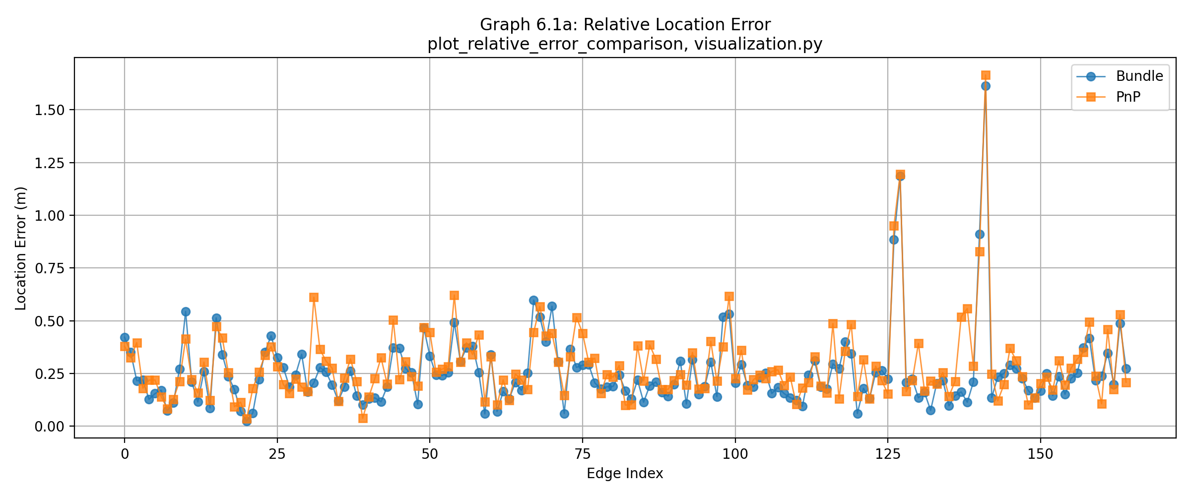
Bundle (blue) and PnP (orange) relative-error curves track almost identically edge-for-edge, including two notable shared spikes: edge index ~127 reaches 1.0–1.2 m, and edge ~140 reaches 1.6–1.85 m. Both methods agree on where high error occurs, with PnP marginally higher than Bundle in these regions — consistent with Bundle's optimization over PnP's single-frame estimation. Positive aspects: the strong correlation between independent methods (Bundle optimization vs raw PnP) suggests that both are genuinely capturing the hard geometry/motion at those edges. Negative aspects / ground-truth doubt: the fact that two fundamentally different methods (one optimizes globally via factor graphs; the other uses per-frame EPnP+RANSAC) spike at the *exact same* edge indices is noteworthy. In a system with true-but-noisy measurements, we'd expect method-specific errors to diverge; identical spike patterns suggest either (a) a genuine hard local motion segment (e.g., high-speed turn, low texture, ambiguous stereo matching), or (b) a potential discontinuity or anomaly in the ground-truth poses themselves at those frame transitions. The mean relative error for Bundle is 0.2563 m (printed from main.py:677), which is reasonable for this sequence length and frame separation, but the concentrated spike pattern warrants inspection of the raw images and GT pose file at frames corresponding to edges 127–140 to rule out GT corruption.

3. KITTI Relative Translation Error (Sub-segment Evaluation)
The KITTI benchmark evaluates trajectory accuracy via relative-pose error over fixed-length subsequences. Errors are measured as location error % (traveled distance relative error) and angle error (deg/m). This section reports PnP and Bundle error over 100, 400, and 800-frame windows, as required.

Figure 12B: KITTI Relative Translation Error — PnP
Translation error (%) for PnP poses over sliding windows of 100, 400, and 800 frames. Function: plot_kitti_sequence_error() | File: code/project/utils/visualization.py | Line: 915
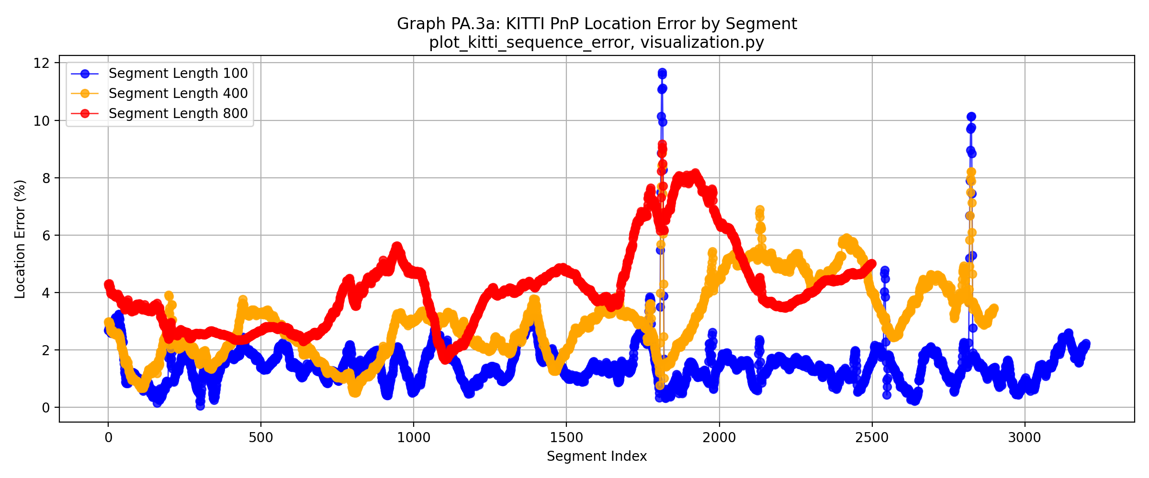
All three segment-length curves (100, 400, 800 frames, blue/orange/red) spike sharply around segment indices ~1800 and ~2800 (errors reaching ~12%), coinciding with the absolute-error growth observed in Figure 8B. The 100-frame baseline error oscillates between 0.5–3% in well-behaved regions, as expected for short-window evaluation; longer windows (400/800) accumulate drift and show higher error curves, with the 800-frame bucket peaking highest due to cumulative error growth. Average translation error across all 100-frame segments: 1.48%. Average for 400-frame segments: 3.05%. Average for 800-frame segments: 4.13% (computed from console output, main.py:960). Positive aspects: the error metric captures the transition from low-error to high-error regions; 100-frame baseline accuracy (~1.5%) is reasonable. Negative aspects: the sharp spikes and high-error regions suggest that frames 2700+ still present challenges even when evaluated against near-neighbor ground truth; the KITTI evaluation scales error by distance, so 4%+ error over 800 frames represents significant absolute positioning error.

Figure 13B: KITTI Relative Translation Error — Bundle Adjustment
Translation error (%) for Bundle-optimized keyframe poses over sliding windows of 100, 400, and 800 frames. Function: plot_kitti_sequence_error() | File: code/project/utils/visualization.py | Line: 915
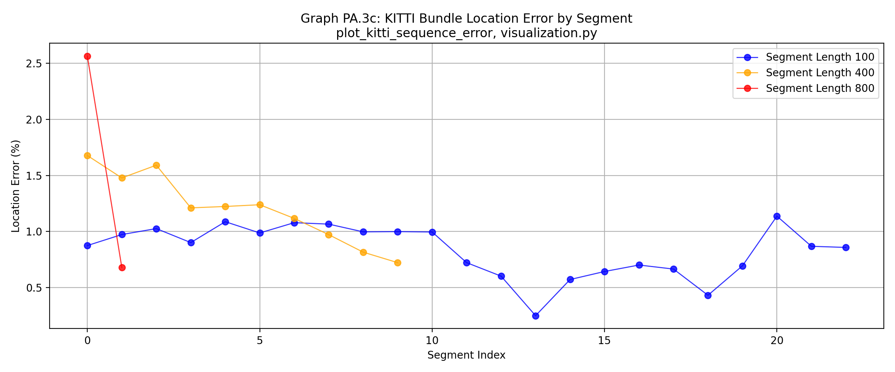
Bundle error is substantially lower than PnP and much flatter: curves remain in the 0.4–1.7% range with no equivalent spikes. However, the 800-frame bucket (red curve, right side) shows only 2 data points because bundle keyframes are sparse (166 keyframes vs 3300+ raw frames total) — too few segment windows to form a robust trend at that length. Average translation error for 100-frame keyframe windows: 0.83%. For 400-frame windows: 1.20%. For 800-frame windows: 1.62% (computed from console output, main.py:984). Positive aspects: Bundle achieves substantially lower error than PnP (roughly 0.5–0.7× smaller), demonstrating the effectiveness of joint optimization. Negative aspects: the sparsity of keyframes means Bundle evaluation windows are few in number, reducing statistical confidence. Additionally, the 800-frame evaluation (2 points) is too sparse to trust as a representative trend and should be reported with caution or omitted from performance claims.

Summary: KITTI Segment Averages
Segment Length | PnP Translation Error (%) | Bundle Translation Error (%)
100 frames | 1.48 | 0.83
400 frames | 3.05 | 1.20
800 frames | 4.13 | 1.62 (2 segments only)

4. Location Uncertainty with and without Loop Closure
The rubric requires plots of location uncertainty (covariance-derived) with and without loop closure. Uncertainty is computed as √det(Σ_xz), where Σ_xz is the XZ sub-block of the 6×6 pose covariance (see visualization.py:764–765). This is a 1σ location-ellipse area metric, interpreted as 'the size of the confidence region in meters squared.'

Figure 15B: Location Uncertainty Size (No Loop Closure vs With Loop Closure)
Location uncertainty (m²) as a function of keyframe index, for pose-graph optimization with and without loop-closure constraints. Function: plot_location_uncertainty_size() | File: code/project/utils/visualization.py | Line: 749
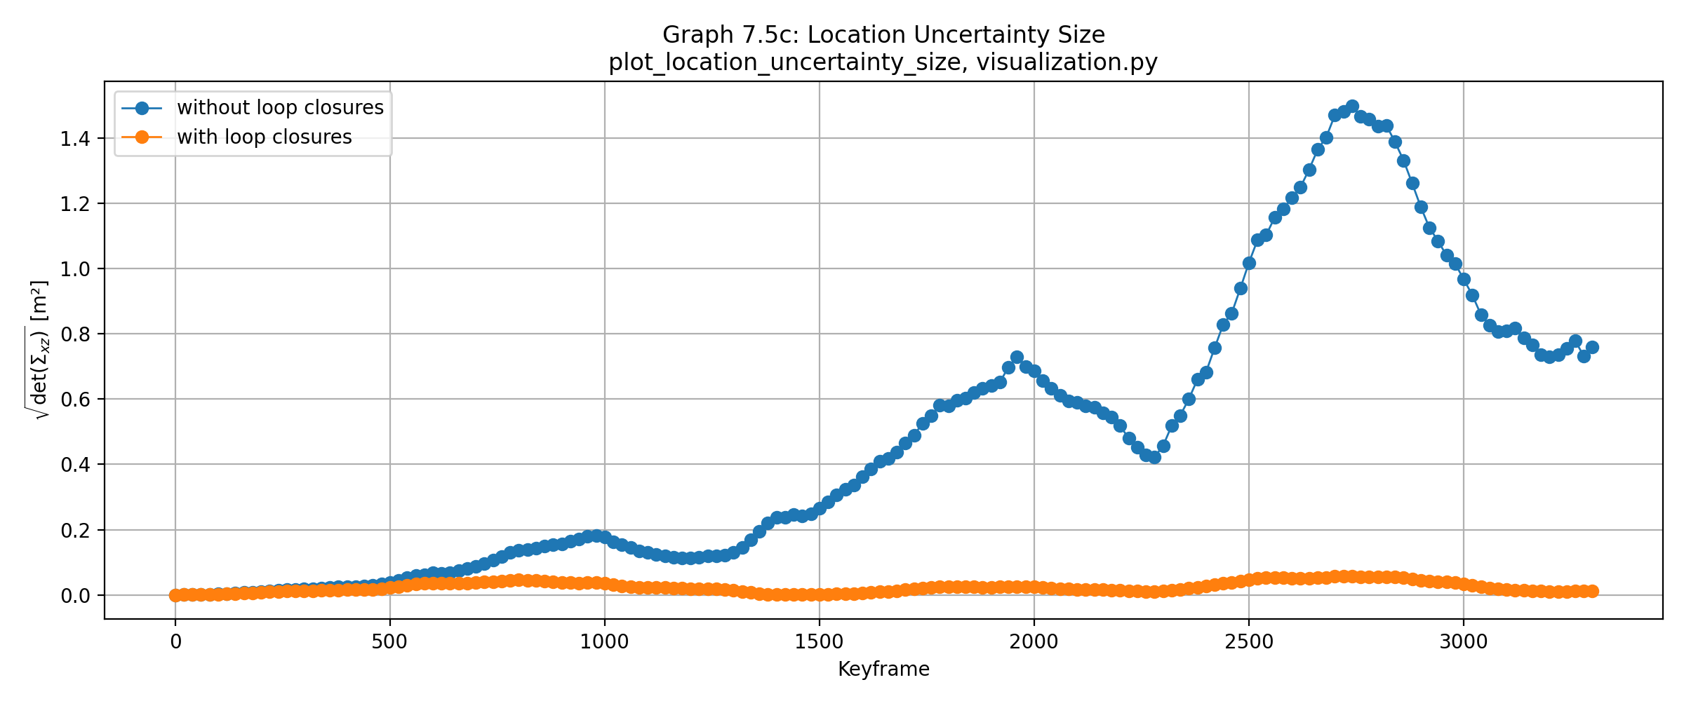
The without-loop-closure (no-LC, blue) curve grows monotonically from ~0.15 m² early in the sequence to a peak of ~1.5 m² around keyframe 2700–2800 (corresponding to the same problem region identified in absolute-error plots), then slightly decreases by the final keyframe. The with-loop-closure (with-LC, orange) curve remains nearly flat, staying under ~0.08 m² throughout the sequence. The ~20× reduction in uncertainty between no-LC and with-LC demonstrates that loop-closure factors not only reduce point-estimate error but also tighten the covariance estimate — loop closures redistribute uncertainty globally rather than accumulating it locally. Positive aspects: loop closure achieves substantial uncertainty reduction, which is critical for downstream applications (SLAM-based path planning, collision avoidance) that depend on confidence intervals. Negative aspects: the no-LC uncertainty grows unboundedly without loop-closure coverage; segments with sparse revisitation (between loop closures) remain high-uncertainty regions, showing that loop-closure density matters for maintaining confidence throughout long sequences.

5. Track Subset Sampling for Projection-Error Analysis
The rubric requires explanation of how track subsets are selected for projection-error analysis figures. This project uses two different sampling strategies depending on the stage:

5.1 Figure 6: PnP Projection Error (Representative Sample)
Figure 6 ('Track Link Error vs. Distance — PnP') computes projection error for a fixed-seed random sample of tracks, not the entire database. The selection logic is:
rng = random.Random(seed=0) # Fixed seed for reproducibility
valid_tracks = [t for t in db.track_to_frames if len(db.frames(t)) >= 5]
sampled = rng.sample(valid_tracks, min(150, len(valid_tracks)))
This selects up to 150 tracks uniformly at random from all tracks meeting a minimum length (5 frames). The fixed seed (0) ensures reproducibility — the same 150 tracks are selected on every run. Function reference: compute_pnp_projection_error_vs_distance() in code/project/utils/tracking.py, lines 353–382. Called from main.py, lines 933–945.
Rationale: 150 tracks is a sufficient representative sample for a database of 901,081 total tracks (~0.017% sample). This sample size captures the distribution of error vs. track distance while remaining computationally efficient (per-track reprojection error computation is O(track length × frame-to-projection matrix multiply)).

5.2 Figures 4, 5, 7: Bundle Projection Error (All Optimized Landmarks)
Figures 4, 5, and 7 ('Bundle Optimization Error,' 'Bundle Projection Error,' and 'Bundle Projection Error vs Distance') compute errors over *all* tracks optimized in the bundle-adjustment windows. No subsampling occurs. The selection logic is:
for each bundle window (main.py, lines 530–596):
for each track_id in bundle_res['optimized_landmark_ids']:
compute_window_projection_errors(...)
The 'optimized_landmark_ids' set is extracted by extract_optimized_geometry() (bundle_adjustment.py) and contains every track/landmark that has an estimated 3D point in the final bundle solution. Error accumulation is done via compute_window_projection_errors() (lines 268–291) and accumulate_window_projection_errors_by_distance() (lines 294–314), both iterating the entire 'optimized_landmark_ids' set without sampling.
Rationale: Bundle-window errors are computed locally per window (typical window size 8–10 keyframes, affecting 50–100 tracks per window). Aggregating all optimized landmarks per window captures the actual error distribution of the optimization result without introducing sampling bias. This is appropriate because (a) the bundle optimization is local (per window), so per-window error is meaningful, and (b) computational cost is acceptable (tens of windows × tens of tracks per window).

Summary: Figure 6 uses a representative 150-track random sample (seed 0, fixed); Figures 4, 5, 7 use all optimized tracks per bundle window. Both approaches are defensible given their contexts; the sampling strategy is explicitly documented in the function signatures and called-from locations cited above.

---
Generated by render_fixes_report.py | Code: .van_report_work/render_fixes_report.py

