Software Requirements Specification (SRS)
Product (working title): Creator Trips and AI Trip Planner Platform Version: 1.1 (draft) Date: 17 October 2026 Prepared by: Niraj Alone (tech co-founder)

1. Introduction

1.1 Purpose
This document specifies the requirements for a web platform where (a) travel content creators publish shareable trip pages with a full itinerary, cost breakdown and bookable slots, (b) travellers request a slot from the creator (through WhatsApp at first, later through in-platform booking, payments and trip groups), and (c) travellers use an AI trip planner that proposes three itineraries, lets them pick or mix, and saves the result as a personal trip guide.

1.2 Scope
Release 1 (MVP) has two parts. Creators publish a shareable trip page with the itinerary, cost breakdown and slots. Each page has a “Book my slot” button that opens the creator’s WhatsApp chat with a ready-made booking message. Confirmation, payment and traveller communication stay between the creator and the traveller on WhatsApp. Travellers can also use an AI trip planner that proposes three itineraries, and save their choice as a personal trip guide. Release 2 adds in-platform slot booking with deposit payments, trip groups and a full creator dashboard. Release 3 adds creator profile pages and community features. Release 4 covers offline guides, reviews, coupons, WhatsApp automation, more languages and mobile apps.

1.3 Definitions
Term | Meaning
Creator (Host) | A travel content creator who publishes and leads group trips
Traveller | A user who books a slot or uses the AI planner
Trip | A creator-led group trip with dates, price and a limited number of slots
Slot | One bookable seat on a trip
Itinerary | A day-by-day plan made of stops
Trip Guide | A traveller's saved itinerary with map, costs and notes
Operator | A vetted local company that delivers the trip logistics
MVP | Minimum viable product

1.4 References
Internal product discussions; payment gateway documentation; applicable Indian laws on travel services, payments and data protection (to be confirmed by a legal advisor).

2. Overall Description

2.1 Product perspective
A new, standalone web application with a public website, authenticated dashboards and a backend API. It integrates with a payment gateway, a maps/places service, an LLM provider, and email/WhatsApp messaging.

2.2 User classes
User | Description | Key needs
Visitor | Unregistered person opening a shared trip link | See itinerary, price, slots quickly; trust the page
Traveller | Person who requests a slot or plans a trip (an account is needed only to save trip guides) | Book slots, plan trips with AI, keep a trip guide
Creator | Registered and approved host | Publish trips, track bookings and payments
Operator | Vetted logistics partner | View trip requirements and confirmed headcount (Release 2)
Admin | Platform staff | Approve creators, moderate, handle refunds and disputes

2.3 Operating environment
Modern browsers on mobile and desktop (mobile-first design). Cloud-hosted backend and PostgreSQL database.

2.4 Constraints
- From Release 2, payments must go through a licensed payment gateway; card data is never stored by the platform. In Release 1 the platform takes no payments and creators handle money themselves.
- Tour-operator registration, GST and refund rules must be confirmed with a legal advisor before accepting real money.
- AI output may be inaccurate and must be validated before display.

2.5 Assumptions and dependencies
- Creators have an existing audience, share trip links on social media and use WhatsApp to talk to travellers.
- At least one vetted operator is available per launch destination.
- Third-party APIs (payments, maps, LLM) remain available and affordable.

3. System Features (Functional Requirements)
Priority shows the release that delivers the requirement: R1 = Release 1 (MVP), R2 = Release 2, R3 = Release 3, R4 = Release 4 or later (see section 9).

3.1 Authentication and accounts
ID | Requirement | Priority
FR-AUTH-1 | Users shall register and log in with email/password or Google sign-in | R1
FR-AUTH-2 | Users shall verify their email address; phone verification by OTP is added in Release 2 | R1
FR-AUTH-3 | Users shall have a role: traveller, creator or admin | R1
FR-AUTH-4 | Users shall be able to reset their password | R1
FR-AUTH-5 | Visitors shall be able to view trip pages and request a slot on WhatsApp without creating an account | R1
FR-AUTH-6 | Travellers shall be able to create an account (needed to save trip guides), edit their profile and delete their account | R1

3.2 Creator onboarding
ID | Requirement | Priority
FR-CRE-1 | A user shall be able to apply to become a creator, providing profile, social links, follower count and the WhatsApp number travellers should contact | R1
FR-CRE-2 | Admin shall approve or reject creator applications | R1
FR-CRE-3 | Creators shall provide payout details, verified by the payment provider | R2
FR-CRE-4 | Creators shall have a public profile page listing their trips | R3

3.3 Trip page builder (creator)
ID | Requirement | Priority
FR-TRIP-1 | Creators shall create a trip with title, destination, dates, description, cover image and gallery | R1
FR-TRIP-2 | Creators shall add a day-by-day itinerary with stops (name, location, time, notes) | R1
FR-TRIP-3 | Creators shall add a cost breakdown (stay, transport, food, activities, total per person) | R1
FR-TRIP-4 | Creators shall set total slots, price per slot and booking deadline, and update the slots left by hand | R1
FR-TRIP-5 | Creators shall define inclusions, exclusions, difficulty, fitness level, safety notes and their own booking and cancellation terms | R1
FR-TRIP-6 | Creators shall save a trip as draft, preview it, and publish it | R1
FR-TRIP-7 | Creators shall close a trip, mark it sold out or duplicate it | R1
FR-TRIP-8 | Creators shall set a deposit amount per slot and a platform fee line in the cost breakdown | R2
FR-TRIP-9 | Creators shall assign a verified operator to a trip | R2
FR-TRIP-10 | Creators shall cancel a trip, which triggers refunds to booked travellers | R2

3.3.1 Public trip page and sharing
ID | Requirement | Priority
FR-PAGE-1 | Each published trip shall have a unique public URL | R1
FR-PAGE-2 | The page shall show itinerary, cost breakdown, creator profile, slots left (as set by the creator) and the creator’s booking and cancellation terms | R1
FR-PAGE-3 | The page shall generate rich link previews (title, image, price) for social apps and WhatsApp | R1
FR-PAGE-4 | The page shall show a prominent “Book my slot” button, or a “Sold out” label when slots left is zero | R1
FR-PAGE-5 | The page shall load fast on mobile networks | R1
FR-PAGE-6 | Visitors shall be able to join a waitlist when slots are sold out | R2

3.3.2 WhatsApp booking request (Release 1)
In Release 1 the “Book my slot” button does not book anything on the platform. It hands the visitor to the creator on WhatsApp, and the creator confirms the slot and takes payment there.
ID | Requirement | Priority
FR-WA-1 | Tapping “Book my slot” shall open a WhatsApp chat with the creator’s number, using a click-to-chat link (wa.me) on mobile and WhatsApp Web on desktop | R1
FR-WA-2 | The chat shall open with a ready-to-send message, for example: “Hi, I’d like to confirm my booking slot for [trip name], [dates]. Slots needed: 1.” | R1
FR-WA-3 | The message shall include the trip name, dates and the trip page link so the creator knows which trip it is about | R1
FR-WA-4 | The visitor shall be able to edit the message before sending it; the platform neither sees nor sends the message | R1
FR-WA-5 | Before redirecting, the page shall tell the visitor they are leaving the platform to talk to the creator directly, and that the creator handles confirmation and payment | R1
FR-WA-6 | The creator’s WhatsApp number shall be stored securely and used only to build the link | R1
FR-WA-7 | The system shall count page views and button clicks per trip and show them to the creator | R1
FR-WA-8 | When the creator sets slots left to zero or closes the trip, the button shall be replaced by a “Sold out” label | R1

3.4 Slot booking and payments (Release 2)
ID | Requirement | Priority
FR-BOOK-1 | A traveller shall select the number of slots and enter traveller details (name, age, phone, emergency contact) | R2
FR-BOOK-2 | The system shall reserve slots for a limited time (for example 10 minutes) while the traveller pays | R2
FR-BOOK-3 | The system shall prevent overbooking, even for simultaneous bookings of the last slot | R2
FR-BOOK-4 | Travellers shall pay a deposit or the full amount through UPI, cards or net banking via the payment gateway | R2
FR-BOOK-5 | The system shall confirm a booking only after verified payment (server-side webhook) | R2
FR-BOOK-6 | The system shall send a confirmation with booking ID and trip details by email and WhatsApp link | R2
FR-BOOK-7 | Travellers shall be able to pay the remaining balance before a due date | R2
FR-BOOK-8 | Travellers shall be able to cancel; refunds follow the trip’s stated policy | R2
FR-BOOK-9 | The system shall release unpaid reservations automatically when they expire | R2
FR-BOOK-10 | The system shall support coupon codes | R4

3.5 Creator dashboard (simple version in Release 1, full version in Release 2)
ID | Requirement | Priority
FR-DASH-1 | Creators shall see their trips and each trip’s status (draft, published, sold out, closed) | R1
FR-DASH-2 | Creators shall see page views and “Book my slot” clicks per trip | R1
FR-DASH-3 | Creators shall see slots sold and revenue per trip | R2
FR-DASH-4 | Creators shall see the list of confirmed travellers and their details | R2
FR-DASH-5 | Creators shall message all travellers of a trip | R2
FR-DASH-6 | Creators shall view payout status and history | R2
FR-DASH-7 | Creators shall see conversion from page view to confirmed booking | R2

3.6 Trip group (community) (Release 2)
ID | Requirement | Priority
FR-COM-1 | Each trip shall have a group for confirmed travellers and the creator | R2
FR-COM-2 | The group shall provide announcements and a link to an external WhatsApp group | R2
FR-COM-3 | Travellers shall have a short public traveller profile (name, photo, interests) visible inside the group | R3
FR-COM-4 | Past travellers shall be notified of the creator’s next trip | R3
FR-COM-5 | Travellers shall be able to follow creators | R3

3.7 AI trip planner (traveller) (Release 1)
ID | Requirement | Priority
FR-AI-1 | A traveller shall enter destination, number of days or dates, budget, group type (solo, friends, family), pace and interests | R1
FR-AI-2 | The system shall generate three distinct itineraries (for example budget, balanced and comfort/offbeat) as structured data | R1
FR-AI-3 | Each itinerary shall show total estimated cost range, days, pace and highlights for comparison | R1
FR-AI-4 | The traveller shall be able to select one itinerary as is | R1
FR-AI-5 | The traveller shall be able to build a custom itinerary by taking days or stops from any of the three | R1
FR-AI-6 | The traveller shall be able to add, remove, reorder or replace stops and regenerate a single day | R1
FR-AI-7 | The system shall validate every generated place against a places/maps service and discard or flag unverified ones | R1
FR-AI-8 | The system shall calculate travel time and distance between consecutive stops | R1
FR-AI-9 | Costs shall be shown as estimates and ranges, with a note that prices may change | R1
FR-AI-10 | The results page shall suggest matching creator trips for the destination | R1
FR-AI-11 | The system shall rate-limit AI requests per user and cache common requests | R1

3.8 Trip guide (Release 1)
ID | Requirement | Priority
FR-GUIDE-1 | A logged-in traveller shall save a chosen or custom itinerary as “My Trip Guide” | R1
FR-GUIDE-2 | The guide shall show a day-by-day view with map, times, costs and personal notes | R1
FR-GUIDE-3 | The guide shall be shareable through a link, with the owner controlling visibility | R1
FR-GUIDE-4 | The guide shall be available offline | R4
FR-GUIDE-5 | A traveller shall be able to save a creator’s published itinerary to their guides | R1
FR-GUIDE-6 | Travellers shall be able to copy a creator’s itinerary and customise it | R1
FR-GUIDE-7 | A booked creator trip shall appear automatically in the traveller’s guides | R2

3.9 Notifications (Release 1 and 2)
ID | Requirement | Priority
FR-NOT-1 | The system shall email creators when their application or a trip is approved or rejected | R1
FR-NOT-2 | The system shall email travellers for booking confirmation, payment failure, reminders and cancellations | R2
FR-NOT-3 | The system shall send trip reminders before departure | R2
FR-NOT-4 | The system shall support WhatsApp or SMS messages | R4

3.10 Administration
ID | Requirement | Priority
FR-ADM-1 | Admin shall review and approve creators and trips before they go live | R1
FR-ADM-2 | Admin shall suspend users or trips and view an audit log | R1
FR-ADM-3 | Admin shall view all bookings, payments and refunds | R2
FR-ADM-4 | Admin shall issue refunds and resolve disputes | R2
FR-ADM-5 | Admin shall manage operator records | R2

3.11 Reviews (Release 4)
ID | Requirement | Priority
FR-REV-1 | Travellers who completed a trip shall be able to rate and review the trip, creator and operator | R4

4. External Interface Requirements

4.1 User interfaces
Mobile-first responsive web. Release 1 screens: home, trip page with the “Book my slot” button, sign-up and login, creator trip builder, simple creator dashboard (trips, views, clicks), AI planner form, itinerary comparison, itinerary editor, trip guide and admin console. Release 2 adds booking checkout, traveller dashboard, trip group and the full creator dashboard.

4.2 Third-party interfaces
Interface | Purpose
Payment gateway | Release 2: collect payments, refunds, webhooks, creator payouts
Maps and places API | Release 1: validate places, geocoding, distance and travel time
LLM provider API | Release 1: generate itineraries as structured JSON
Email service | Transactional emails
Messaging (WhatsApp/SMS) | Release 1: click-to-chat (wa.me) link for slot requests. Release 2: reminders and group links
Object storage and CDN | Images and static assets
Error monitoring | Track failures

4.3 Internal API (summary)
Method and path | Purpose | Release
POST /auth/register, /auth/login | Authentication | R1
POST /creators/apply | Creator application | R1
POST /trips, PUT /trips/:id, POST /trips/:id/publish | Trip management | R1
GET /trips/:slug | Public trip page | R1
POST /trips/:id/events | Record a page view or a WhatsApp button click | R1
POST /planner/generate | Generate three itineraries | R1
POST /planner/itineraries/:id/mix | Build a custom itinerary | R1
POST /guides | Save a trip guide | R1
GET /guides/:id | View a guide | R1
POST /trips/:id/reservations | Reserve slots (creates a hold) | R2
POST /bookings/:id/pay | Start payment | R2
POST /webhooks/payment | Payment gateway callback | R2
POST /bookings/:id/cancel | Cancel booking | R2

5. Data Flow Diagrams
Diagrams for this section are included below the text descriptions. The first two diagrams show the full system (Release 2). Sections 5.3 and 5.4 show the Release 1 flows.

5.1 Context (Level 0)
External entities: Visitor, Traveller, Creator, Operator, Admin, Payment Gateway, Maps/Places API, LLM Provider, Email/Messaging service.
The platform receives trip details from creators, booking and planner requests from travellers, and approvals from admin. It sends confirmations, reminders and booking lists, calls the payment gateway for payments and refunds, calls the maps API to validate places, and calls the LLM provider to generate itineraries.
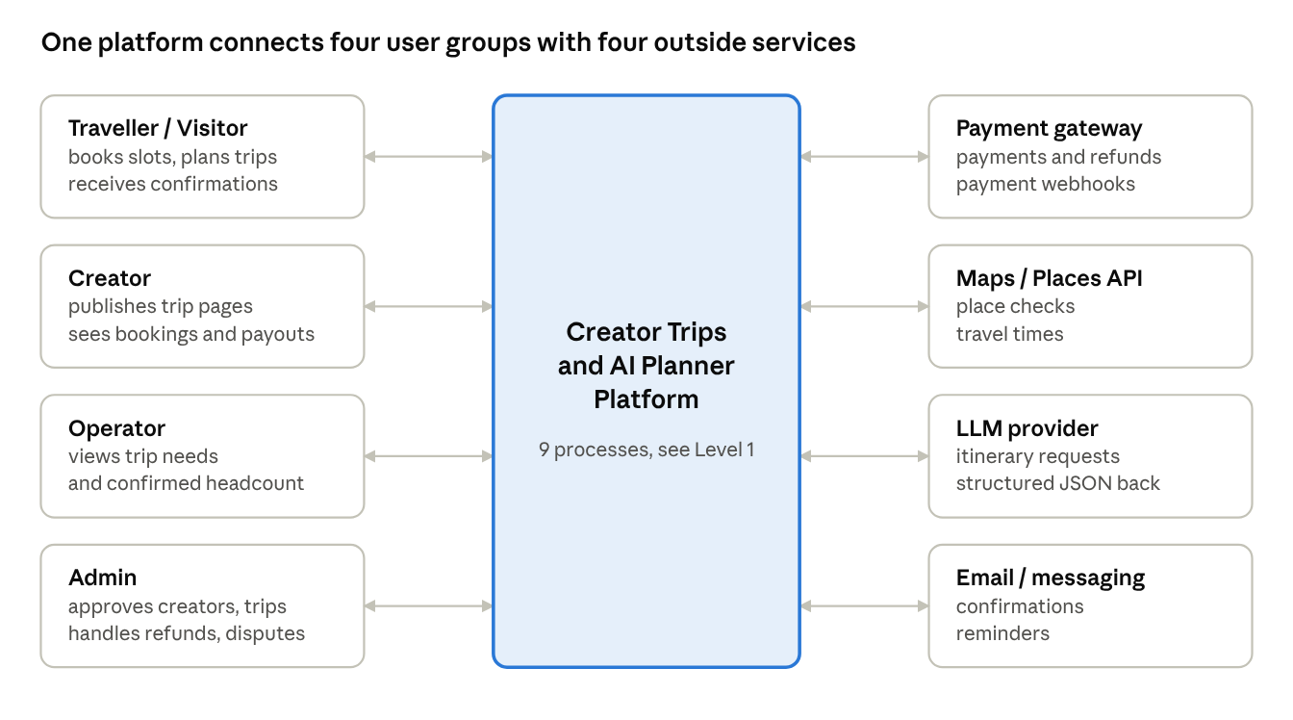
context diagram (Level 0) · 4 user groups, 4 outside services
Arrows run both ways: users send requests and receive results, and the outside services answer the platform’s calls.

5.2 Level 1 processes
No. | Process | Inputs | Outputs | Data stores
P1 | Manage accounts | Registration and login data | Sessions, profiles | Users
P2 | Manage trips | Trip, itinerary, costs, slots | Published trip pages | Trips, Itineraries, Slots
P3 | Handle bookings | Slot selection, traveller details | Reservation, booking | Bookings, Slots
P4 | Process payments | Payment request, gateway webhook | Payment status, refunds | Payments
P5 | Plan with AI | Preferences | Three itineraries | Itineraries, Place cache
P6 | Manage trip guides | Selected or mixed itinerary | Saved guide | Guides, Itineraries
P7 | Run trip groups | Confirmed bookings, messages | Group, announcements | Groups, Messages
P8 | Send notifications | Events from other processes | Emails and messages | Notifications
P9 | Administer platform | Approvals, disputes | Decisions, audit records | Audit log
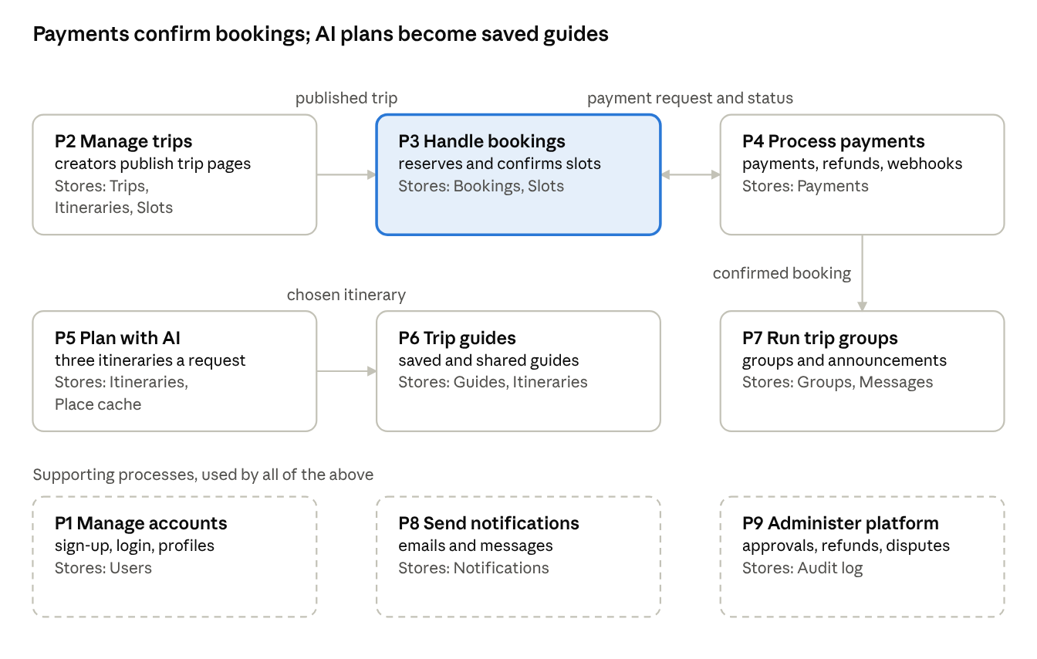
Level 1 data flow diagram · 9 processes and their data stores
A booking is confirmed only after the payment process verifies the gateway webhook; a confirmed booking then opens the trip group. In Release 1, P1, P2, P5, P6 and P9 run, with a few emails from P8; P3, P4 and P7 arrive in Release 2.

5.3 Release 1 flow (WhatsApp booking request)
For slot requests in Release 1, only the trip page and the click-to-chat handoff run on the platform. Confirmation, payment and the slot count are handled by the creator.
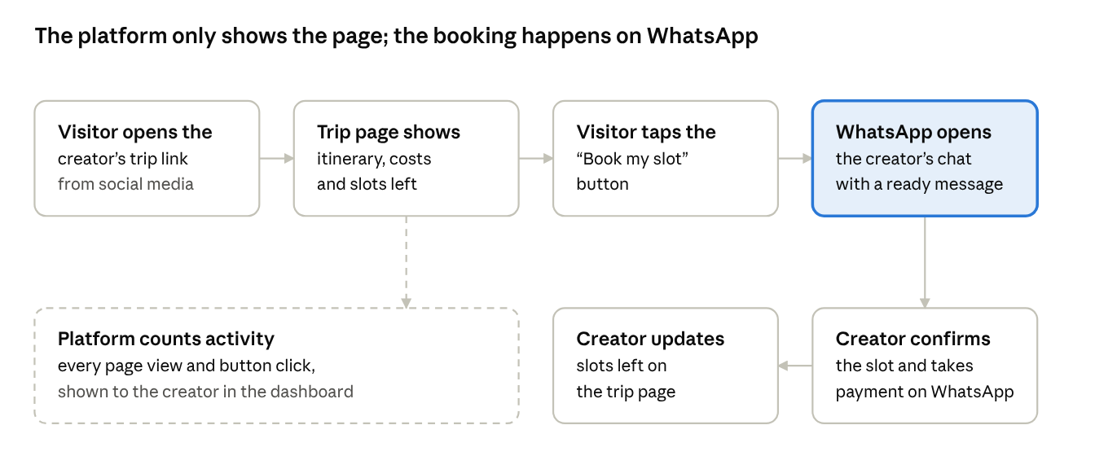
Release 1 flow · trip page to WhatsApp booking request
The dashed box is the only data the platform records about a booking request: a page view or a button click. It does not see the WhatsApp conversation.

5.4 Release 1 flow (AI trip planner and trip guide)
The planner is for travellers. It turns a few preferences into three different itineraries, lets the traveller pick one or mix them, and saves the result as a trip guide.
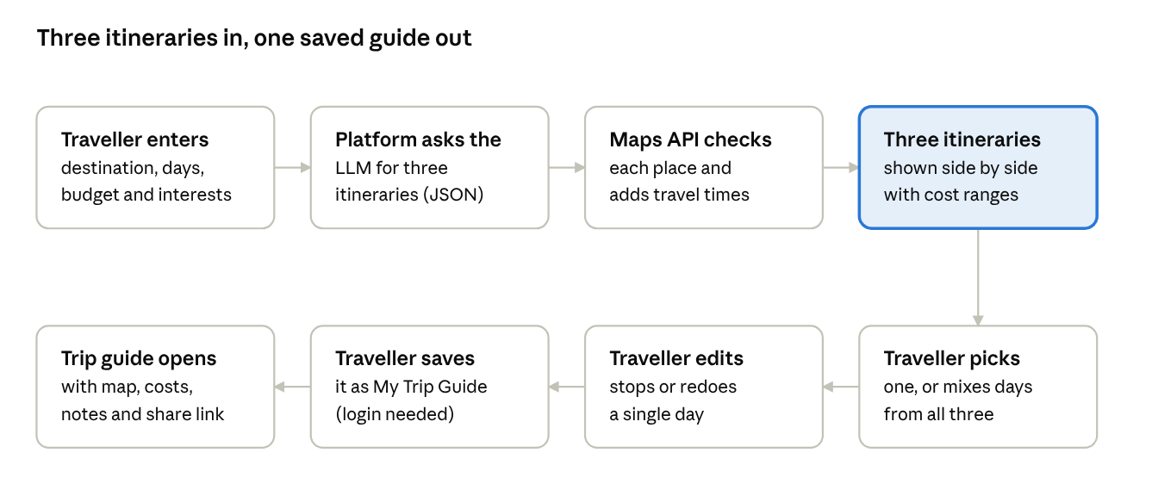
Release 1 flow · AI trip planner to saved trip guide
Every generated place is checked against the maps service before it is shown, and unverified places are dropped or flagged. Saving a guide requires a login; requesting a slot on WhatsApp does not.

6. Database Design

6.1 Entities and key attributes
Table | Key columns
users | id, name, email, phone, password_hash, role, email_verified, created_at
creator_profiles | id, user_id, handle, bio, social_links, whatsapp_number, followers, status, payout_account_ref
operators | id, name, contact, regions, verified
trips | id, creator_id, operator_id, slug, title, destination, start_date, end_date, description, price_per_slot, deposit_amount, total_slots, booking_deadline, cancellation_policy, status
trip_media | id, trip_id, url, type, position
trip_costs | id, trip_id, category, amount, notes
itineraries | id, owner_user_id, trip_id (nullable), source (ai, creator, custom), style, destination, days_count, total_cost_min, total_cost_max
itinerary_days | id, itinerary_id, day_number, title, notes
stops | id, day_id, place_id, name, lat, lng, start_time, duration_min, cost_estimate, notes, position
places | id, external_place_id, name, lat, lng, category, verified_at
reservations | id, trip_id, user_id, slots_count, expires_at, status
bookings | id, trip_id, user_id, slots_count, total_amount, amount_paid, status, created_at
booking_travellers | id, booking_id, name, age, phone, emergency_contact
payments | id, booking_id, gateway_ref, amount, type (deposit, balance, refund), status, created_at
trip_groups | id, trip_id, whatsapp_link
group_members | id, group_id, user_id, role
group_messages | id, group_id, user_id, body, created_at
guides | id, user_id, itinerary_id, title, visibility, share_token
planner_requests | id, user_id, preferences_json, status, created_at
notifications | id, user_id, type, channel, status, sent_at
audit_log | id, actor_id, action, entity, entity_id, created_at
Release 1 uses these tables: users, creator_profiles, trips, trip_media, trip_costs, itineraries, itinerary_days, stops, places, planner_requests, guides, audit_log and one small extra table, trip_events (id, trip_id, type: view or whatsapp_click, created_at), which counts page views and button clicks. The booking, payment and trip group tables arrive in Release 2.

6.2 Relationships
- A user has one optional creator profile.
- A creator has many trips; a trip belongs to one creator and optionally one operator.
- A trip has many media, cost items, reservations, bookings and one trip group.
- An itinerary has many days; a day has many stops; each stop may point to a place.
- A trip may reference one creator itinerary; a traveller's guide references one itinerary.
- A booking belongs to one trip and one user, has many travellers and many payments.
- A planner request produces three itineraries.
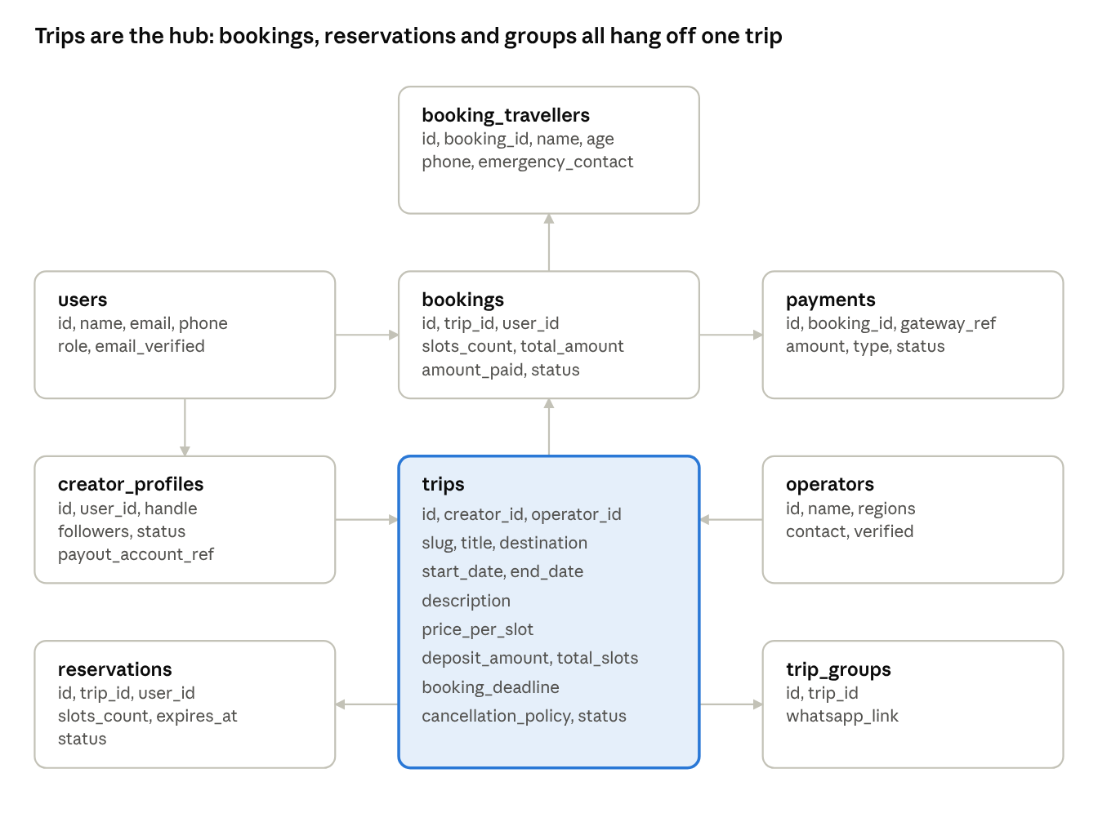
ER diagram 1 · trips, bookings and payments
Arrows run from a parent table to the table that holds its foreign key. Users also own reservations, which is not drawn.
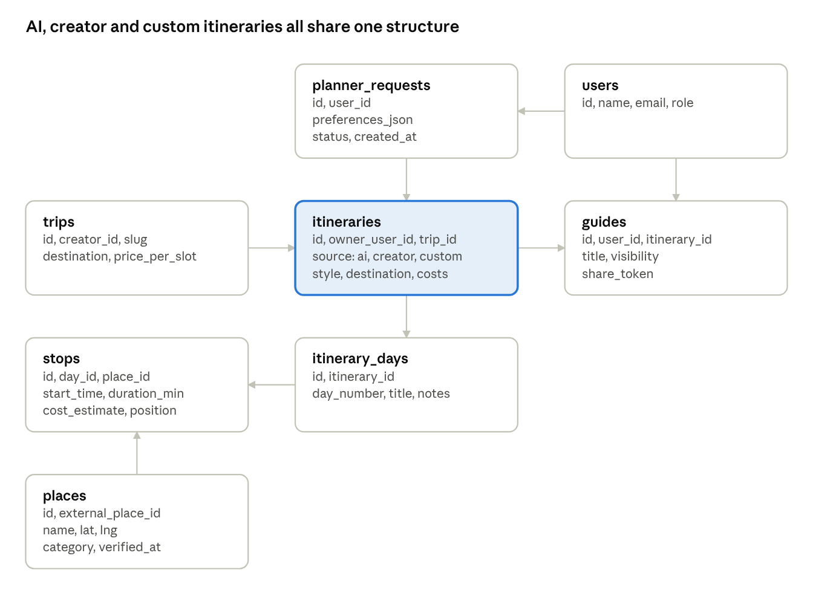
ER diagram 2 · itineraries, AI planner and guides
Each itinerary also records its owner in users, which is not drawn. A creator trip links to one itinerary through trip_id.

6.3 Booking concurrency rule (Release 2)
In Release 1 the creator sets slots left by hand. From Release 2, slots remaining equals total_slots minus confirmed bookings minus active reservations. Reservation creation runs in a database transaction that locks the trip row, rechecks availability and inserts the reservation. A scheduled job expires unpaid reservations.

6.4 Booking status lifecycle (Release 2)
A booking moves from Reserved to Pending payment, then to Partially paid (deposit received) or Fully paid. Those two paid states are the Confirmed states. An unpaid hold becomes Expired. A cancelled booking becomes Cancelled, then Refunded under the trip’s policy. A Fully paid booking becomes Completed after the trip.
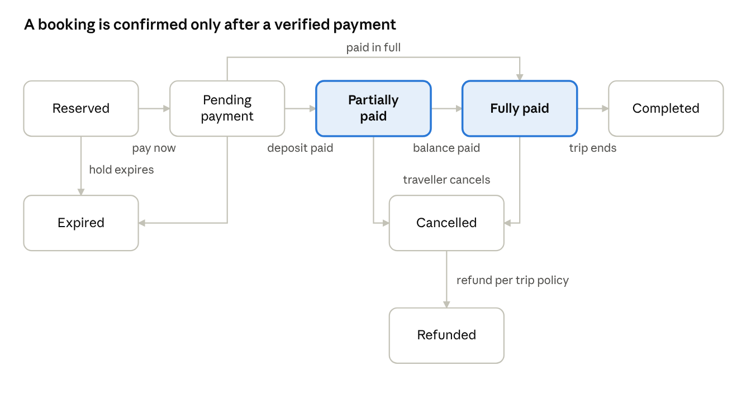
booking status lifecycle · 9 states
Filled boxes are confirmed bookings; every other state means no verified payment yet, or a booking that has ended.

7. Non-Functional Requirements
Category | Requirement
Performance | Public trip page loads in under 3 seconds on a 4G connection; AI planner shows the first itinerary within about 15 seconds
Scalability | Support at least 1,000 concurrent visitors during a creator's launch post without failing page loads or the WhatsApp redirect (and, from Release 2, bookings)
Availability | 99.5% uptime target for MVP
Security | HTTPS everywhere; hashed passwords; role-based access; server-side payment verification (Release 2); input validation; rate limiting
Privacy | Collect only needed personal data; creators agree that their WhatsApp number is visible to anyone who taps the booking button; consent and a privacy policy; compliance with applicable Indian data protection law (confirm with an advisor)
Reliability | From Release 2, payments are idempotent; daily database backups; no booking is lost if a webhook is delayed
Usability | Mobile-first; booking in no more than 4 steps; English first, Hindi and Marathi later
Accessibility | Readable contrast, keyboard navigation, alt text on images
Maintainability | Single repository, automated tests for booking and payments, a staging environment
AI safety | Validated JSON output, place verification, estimate labels, logging of prompts and outputs for review

8. Business Rules (to be finalised)
- In Release 1 the creator writes the booking and cancellation terms on the trip page and handles any refund directly. From Release 2, cancellation and refund tiers are set per trip and shown before payment.
- There is no platform fee in Release 1. From Release 2, the platform fee is a percentage of each booking; the exact rate is to be decided.
- From Release 2, creators are paid after the trip, or in agreed stages, never before the traveller's cancellation window closes. Final terms to be decided.
- Only approved creators can publish trips; admin approves each trip. In Release 1, “Book my slot” only opens a WhatsApp chat: the platform does not confirm bookings, hold money or guarantee a slot.
- From Release 2, every trip must have a vetted operator before the booking deadline.

9. Release Plan
Release | Scope
R1 (MVP) | Creator signup and approval, trip page builder, public trip page with share previews, “Book my slot” button that opens the creator’s WhatsApp with a ready message, simple creator dashboard (trips, slots left, page views, button clicks), admin console, approval emails, traveller accounts, AI planner with three itineraries (pick, mix and edit), and saved trip guides
R2 (after Release 1) | In-platform slot booking with deposit payments, trip groups, full creator dashboard (travellers, revenue, payouts), phone verification, notifications, balance payments, refunds, waitlist
R3 | Creator profile pages, community features (follow creators, past travellers)
R4 (later) | Offline guides, reviews, coupons, WhatsApp automation, Hindi and Marathi, mobile app

10. Risks
Risk | Mitigation
Release 1 is large: WhatsApp booking, AI planner, maps and saved guides together | Build in this order inside Release 1: trip page and WhatsApp button first, then the AI planner, then saved guides, and ship each part as soon as it works
Bookings and money move outside the platform in Release 1, so there is no record and no protection | Show a clear notice before the WhatsApp redirect, count clicks, and move to in-platform booking in Release 2
Traveller loses money because of a bad trip | Release 1: approve creators before they publish and state on the page that the creator is responsible. Release 2: vetted operators, insurance, clear refund rules, held payouts
AI invents places or costs | Place validation, estimate ranges, review of outputs
Higher AI costs | Caching, limits per user, cheaper models for simple steps
The creator’s WhatsApp number is visible to anyone who taps the button | Creators agree to this at signup and can use a separate business number
Creators reply slowly or forget to update slots left | Reminder emails, a one-tap sold-out toggle, and a “last updated” time on the page
Spam or fake enquiries to creators | Rate-limit the button and let creators report abusive visitors
Overbooking | Release 1: the creator tracks slots by hand. Release 2: transactional slot locking and reservation expiry
Too few creators | Start with 5 to 10 hand-picked creators in one niche
Regulatory issues | Legal review before taking real payments in Release 2

11. Open Issues
- Final product name and domain.
- Platform fee percentage and payout schedule (from Release 2).
- Legal registration requirements for selling tour packages.
- Which payment gateway and which LLM and maps providers to use.
- Whether travellers can book without creating an account in Release 2.
- The exact wording of the prefilled WhatsApp message, and whether each creator should use a separate WhatsApp Business number.

