Design Guide: Creator Trips (Release 1)
Version: 1.0 (draft) Status: a short starting point, not a full design system

1. Look and feel
Open, bright and adventurous, like the reference image: a lot of sky, white space, big calm headlines and one warm touch of yellow. The page should feel light and trustworthy, so travellers feel safe sending a WhatsApp message to a creator.
The photo in the reference is inspiration only. Use photos you have the right to use.

2. Colour palette
Three colours do the work: white, sky blue and a shade of yellow. Dark ink is used for text.
Name | Hex | Use
White | #FFFFFF | Main surfaces, cards, the page container
Sky 100 | #DCEEFB | Page background outside the white container
Sky 50 | #F2F9FF | Soft section backgrounds, table stripes
Sky 300 | #8CC4EE | Borders, tags, icons, chart fills
Sky 500 | #2F80C8 | Large graphics and big headings only
Sky 600 | #1F6AAE | Links and small blue text on white
Sun 400 | #F5A524 | The one accent: key button, highlights, “slots left” badge
Sun 100 | #FFF1D6 | Soft yellow background for notes and highlights
Ink | #0B1220 | Headings, body text, black buttons
Slate | #5B6B7F | Secondary text and captions
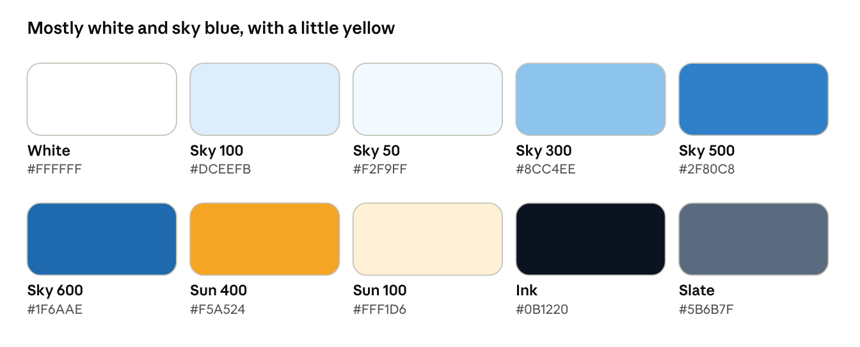
colour palette
Rules
- Roughly 60% white, 30% sky blue, 10% or less yellow. Yellow stays rare so it stands out.
- Never put yellow text on white; it is too faint. Put Ink text on yellow instead.
- Use Sky 600, not Sky 500, for blue text on white. My rough calculation puts Sky 500 under the 4.5:1 contrast needed for small text. Please check all pairs with a contrast checker before launch.

3. Typography
Role | Style
Font | Inter (free on Google Fonts), falling back to system sans-serif
Hero headline | 56 to 72 px on desktop, 36 px on mobile, regular weight, tight line spacing, Ink
Section heading | 28 to 32 px, medium weight
Body | 16 px, regular, line spacing 1.5
Labels and captions | 12 to 14 px, Slate
The big, light headline is what gives the reference its calm feel. Avoid heavy bold headings.

4. Shape and spacing
- Page background is Sky 100. Content sits in a large white container with 24 px rounded corners.
- Hero image has 32 px rounded corners. Cards use 20 to 24 px.
- Buttons and tags are fully rounded (pills). Icon buttons are circles.
- Use an 8 px spacing grid, with generous space between sections.
- Floating info cards may have one notched corner, as in the reference, but use this sparingly.

5. Components
Component | Design
Navigation bar | Logo on the left, centred links (Home, Destinations, Plan a trip, About), outline pill “Log in” and black pill “Sign up” on the right
Primary button | Black pill, white text
Secondary button | White pill with a thin Ink outline
Hero call to action | White pill with a black circle and an arrow, as in “Join with us”
Book my slot | Yellow pill, Ink text. The only yellow button, so the booking action stands out
Icon button | Outlined circle with an arrow; white outline on top of photos
Trip card | White card, large rounded photo, title, creator, dates, price, a yellow “N slots left” badge
Tags | Sky 100 pill with Sky 600 text (for example Trek, Solo, Budget)
Info card | White, rounded, floating over the bottom right of the hero image
Itinerary day | Sky 50 band with the day number in Sky 600 and stops listed below

6. Key screens (Release 1)
- Home: big headline (for example “Explore India with creators you trust”), a call to action to plan a trip, and a card with featured creator trips.
- Trip page: hero photo, title, creator, price per slot, slots left, day-by-day itinerary, cost breakdown, the creator’s terms, and the yellow Book my slot button. On mobile the button stays fixed at the bottom of the screen.
- AI planner: a short form, then three itinerary cards side by side (budget, balanced, comfort). Each shows the cost range and days. Selecting one opens the editor.
- Trip guide: a day-by-day list with a map and notes. Calm, mostly white, easy to read on the road.
- Creator dashboard: a simple table of trips with status, slots left, views and clicks. No decoration.
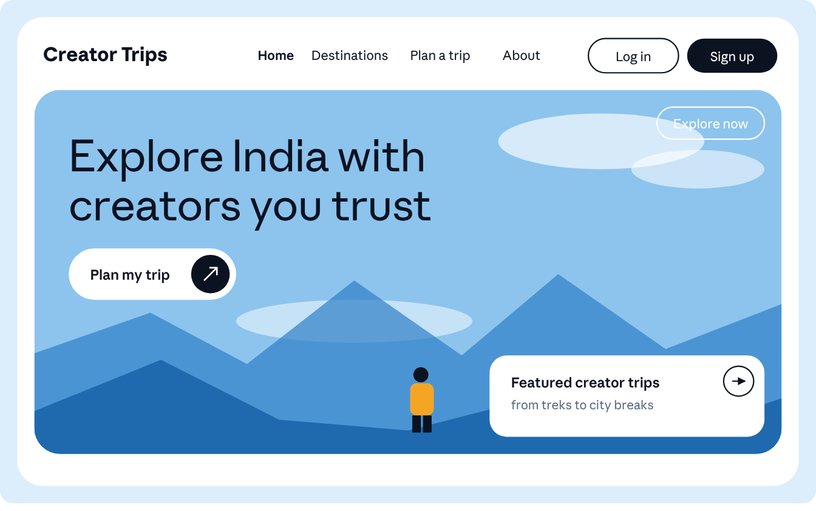
home screen sketch (layout and colour only, not final artwork)
The sketch shows the mood: pale sky page, white container, big light headline, pill buttons, one warm yellow detail and a floating white card.

7. Imagery
- Wide landscapes with a lot of sky (mountains, coasts, trails) and, where possible, a traveller in a warm yellow or orange jacket to echo the accent colour.
- Put headlines over calm, bright areas of the photo only. Keep text off busy detail.
- Compress images and give each one a text description for accessibility.

8. Accessibility basics
- Text contrast of at least 4.5:1 for body text and 3:1 for large text.
- Buttons and tap targets at least 44 px high.
- A clear 2 px Sky 600 focus ring on every interactive element.
- Do not rely on colour alone: the slots-left badge also says “Sold out” in words.

9. Open decisions
- Final product name and logo. The reference uses a small pin shape inside the logo text, which is a nice idea to reuse.
- Where the photos come from (own shoots, creators’ photos with permission, or a licensed library).
- Whether to add a dark mode later. Not needed for Release 1.

