# EDUCATION

## [Higher Secondery](https://milestonecollege.com/)

### [Milestone Collage/School of Science](https://milestonecollege.com/)

*01/2018 - 01/2021*,

## [Bachalor](https://www.ewubd.edu/)

### [East West University/B.Pharm](https://www.ewubd.edu/)

*03/2021 - Present*, [*mail:2021-3-70-096@std.ewubd.edu*](mailto:2021-3-70-096@std.ewubd.edu)

## [Current:](https://www.senecacollege.ca/home.html)

### [Seneca Collage/Biotechnology](https://www.senecacollege.ca/home.html)

*09/2023 - Present* [*mail:rimajumder@myseneca.ca*](mailto:rimajumder@myseneca.ca)

*Dhaka,Bangladesh,5.00*

*Dhaka,Bangladesh,2.65*

# SKILLS

Python

Javascript

Django

HTML5

#### 

CSS3

BootstrapStudio

Full Stack Web Development

Full Stack Web Application Development

Full Stack ML Based Web Application Development

Data Analysis

Pytorch

OpenCV

**WORK EXPERIENCE**

**Junior Web-Developer**

M.H Telecom

*01/2023 - 04/2023*,

*Achievements/Tasks*

Worked as a leader of a developer team several timmes Designed a subsequent part of backend using django

**PERSONAL PROJECTS**

[OCR STYLE TRANSFER (05/2023 - 05/2023)](https://rifatulislammajumder.me/base_ocr/)

Website to Convert Image Into Text & Text or Image Into Handwritten Pdf .

This project has been developed a web apps for my website

#### [Med-ﬁnder (06/2023 - 06/2023)](https://rifatulislammajumder.me/med_search/)

*Dhaka,Bangladesh*

# LANGUAGES

Bangla

*Native or Bilingual Proﬁciency*

Hindi

*Limited Working Proﬁciency*

# INTERESTS

Learning

Competitive Programing

Data Science

English

*Full Professional Proﬁciency*

Website to Get Subsequent Medicine With Diﬀetent Brand Name as well as with generic name. Database is only limited by the drugs of Bangladesh.

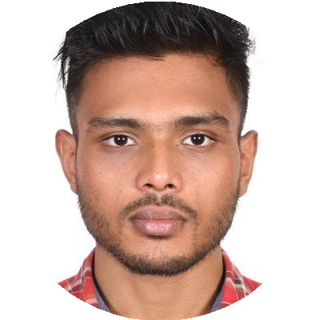

Rifatul Islam Majumder

FULL STACK WEB DEVELOPER

I've built each website and web app with care, starting from scratch and using the graceful combination of Django and JavaScript. I lean towards keeping away from heavy frameworks like WordPress, aiming to create smooth digital experiences.

[rimajumder@myseneca.ca](mailto:rimajumder@myseneca.ca)

BD:01732718066

Toronto, Canada

[rifatulislammajumder.me](http://rifatulislammajumder.me/)

[linkedin.com/in/rifatul-islam-majumder-02970a275](https://www.linkedin.com/in/rifatul-islam-majumder-02970a275/)

[github.com/Nirab123456](https://github.com/Nirab123456)

This project has been developed a web apps for my website

[CVD Prediction & BMI Calculator (06/2023 - 06/2023)](https://rifatulislammajumder.me/C_V_D_prediction/)

This project was result of a renowned dataset of kagle which is used to train model on PYTORCH which achived 92% ovorall prediction accuracy on test set & bmi calculation is a refactor of NHS BMI calculator.

This project has been also developed a web apps for my website

#### [Diery keeper (07/2023 - 07/2023)](https://rifatulislammajumder.me/personal_diary_input/)

This project is created a a base project for other two other projects. Where user can sore their day to day journal and edit anytime

This project has been also developed a web apps for my website

#### [Prescription Classification & Med Chatbot(07/2023 - 08/2023)](https://rifatulislammajumder.me/medicine_chatbot/)

This project was an extended project of MED FINDER .A model from hugging face is implimened answer the question of a user in natural language and to classify the same group of drugs

This project has been also developed a web apps for my website

#### [Mental Health Prediction(07/2023 - 08/2023)](https://rifatulislammajumder.me/predict_mental_health/)

This project was an extended project of personal diery.A model from hugging face is implimened to predict the emotional state of that journal into 28 different catagory from which a visual graph has been created in the website through JS

This project has been also developed a web apps for my website