**Disaster Recovery and Business Continuity Plan for On-Premises Virtual Machine on IBM Cloud Virtual Servers**

Phase 4: Development Part 2

Continuing with our "Disaster Recovery with IBM Cloud Virtual Servers" project, let's delve into feature engineering, model training, and evaluation using IBM Cloud services. This section assumes that we have already loaded and pre-processed the dataset on the IBM Cloud. Here's how to proceed:

Feature Engineering:

**1. Feature Selection:**

- Review the dataset and select the most relevant features for your disaster recovery analysis. This step is crucial for model efficiency and interpretability.

**2. Time-Based Features:**

- Create time-based features that are relevant to disaster recovery scenarios. For example, we can derive features like the time of day, day of the week, or the time since the last incident.

**3. Aggregate Metrics:**

- Compute summary statistics and aggregate metrics from the server data. Metrics such as average CPU usage, memory consumption, and network latency can be valuable features.

**4. Domain-Specific Features:**

- Introduce features specific to disaster recovery, such as the type of incident, previous recovery actions taken, and the duration of downtime.

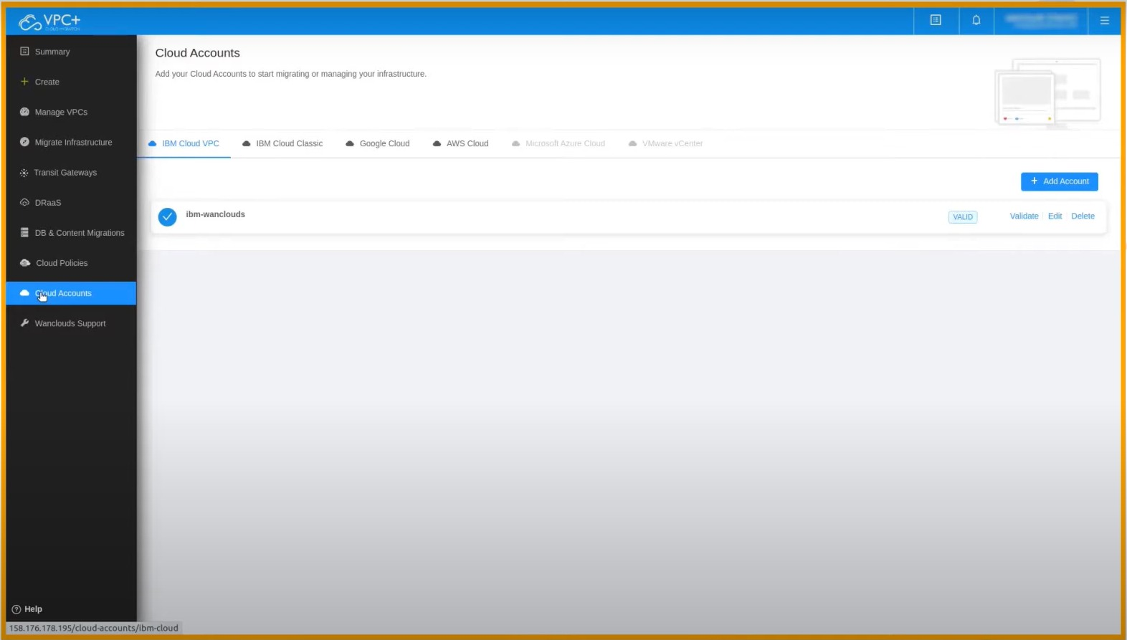

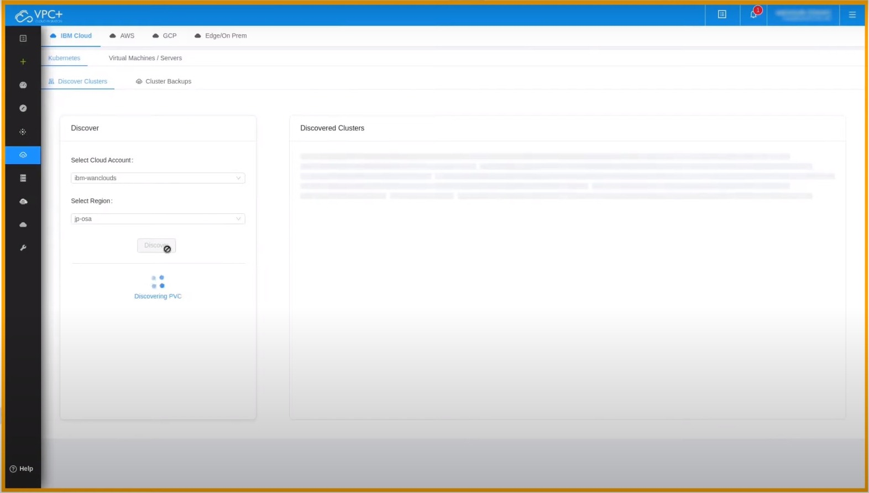

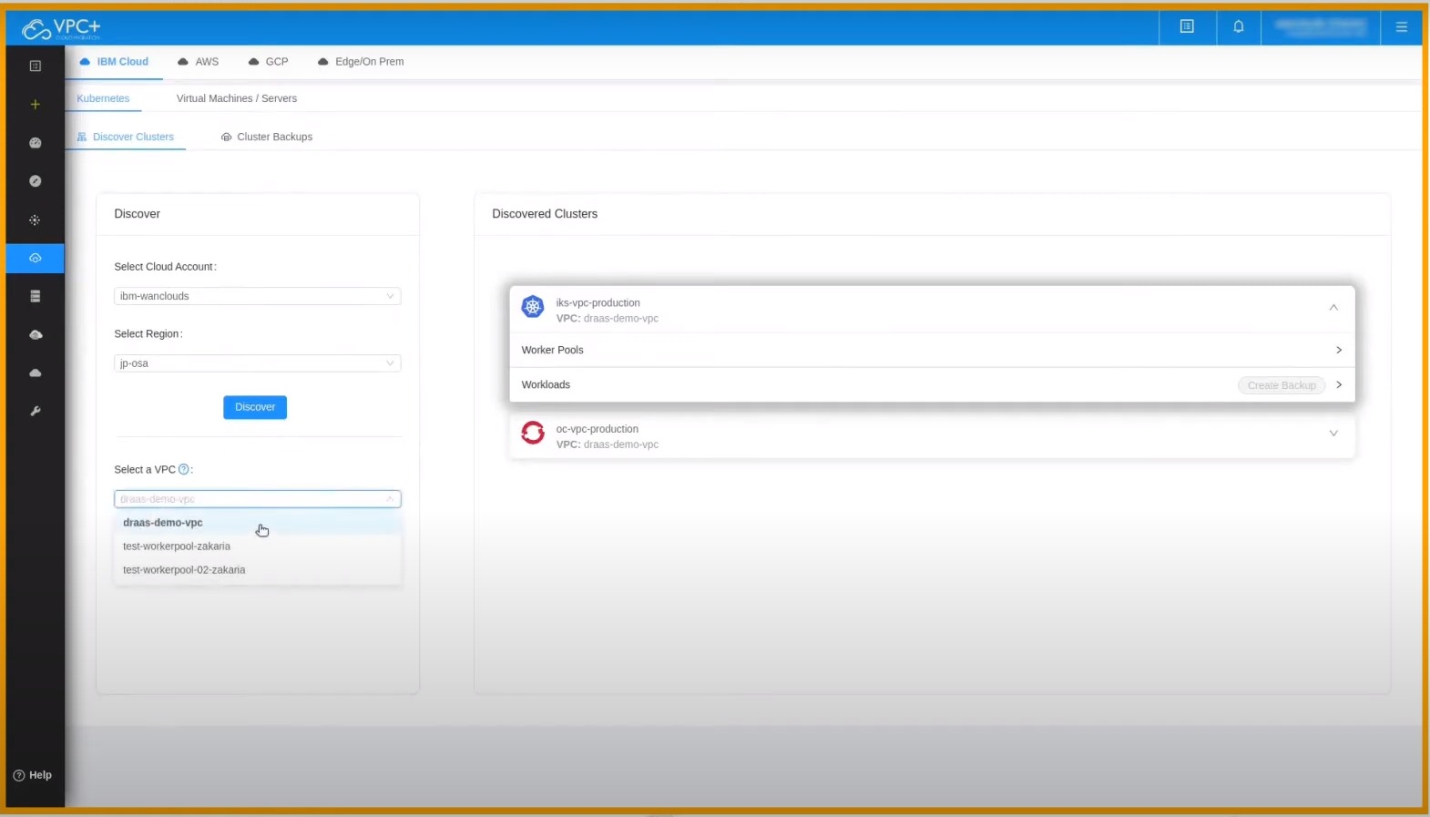

Model Training:

**1. IBM Cloud Machine Learning:**

- Utilize IBM Cloud's machine learning services and environments to develop our predictive model. IBM Watson Studio provides a collaborative environment for data scientists and developers.

**2. Select the Model:**

- Choose the appropriate machine learning algorithm for specific objectives. Common options include decision trees, random forests, support vector machines, or neural networks.

**3. Data Splitting:**

- Split the pre-processed data into training and testing sets to evaluate our model's performance.

**4. Model Training:**

- Train our selected model using the training dataset. Pass the relevant features as input and the desired outcomes (e.g., incident occurrence) as labels.

**5. Hyperparameter Tuning:**

- Optimize our model's hyperparameters to achieve better predictive performance. IBM Cloud may offer tools for hyperparameter tuning and optimization.

**6.** **Validation:**

- Evaluate our model on the testing dataset. Use relevant evaluation metrics, such as accuracy, precision, recall, F1-score, and ROC AUC, based on the specific goals of our disaster recovery model.

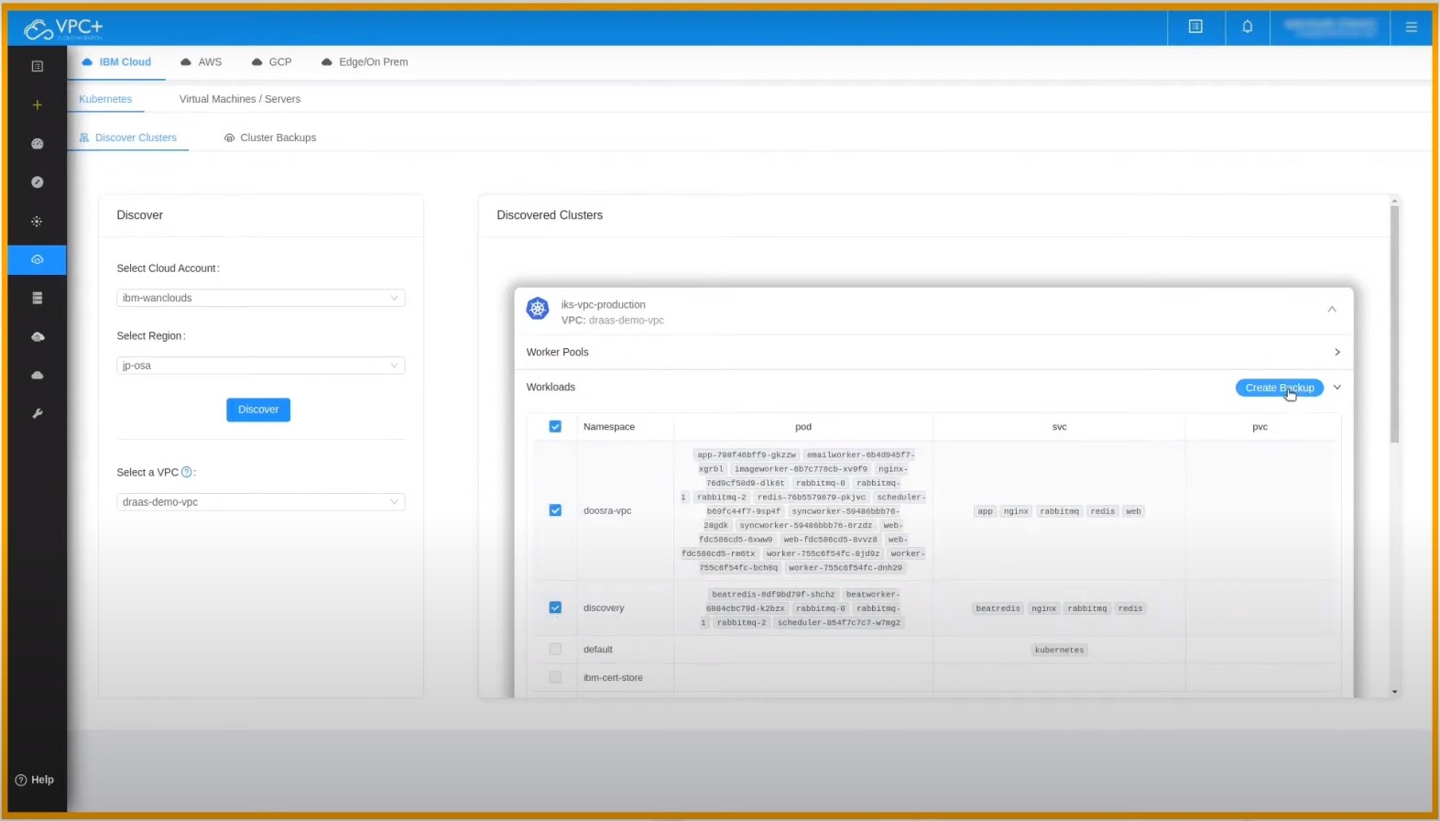

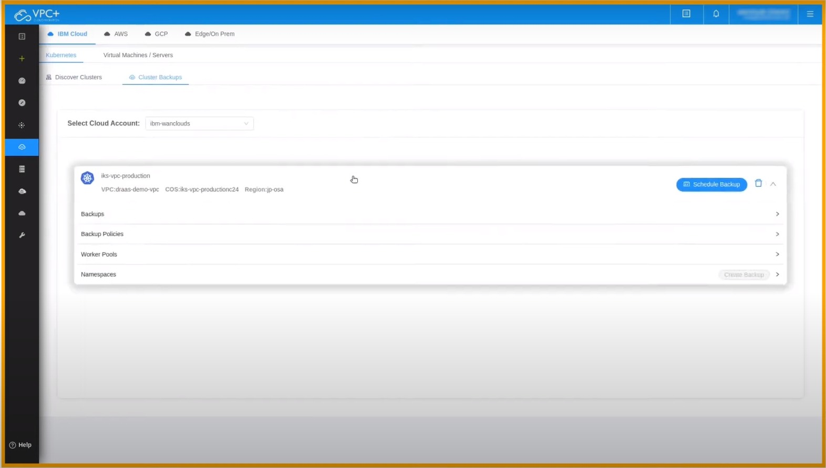

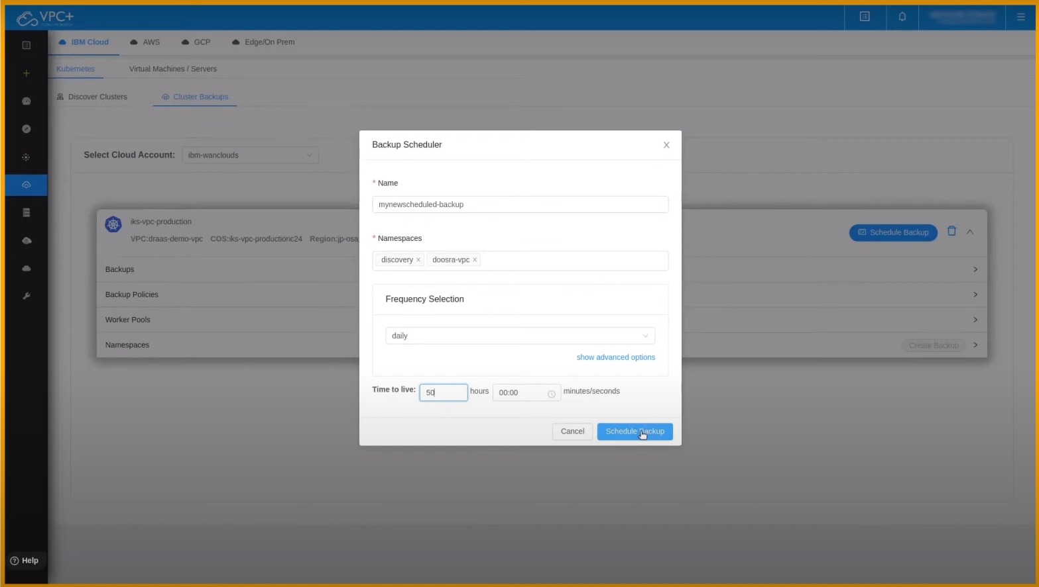

Model Evaluation:

**1. IBM Cloud Tools:**

- Leverage IBM Cloud's data visualization and analytics tools to visualize the model's predictions and performance metrics.

**2. Interpretability:**

- Ensure that our model is interpretable and provides actionable insights. This is crucial for making informed disaster recovery decisions.

**3. Deployment:**

- If our model performs well, consider deploying it within the IBM Cloud environment, so it can be used for real-time or automated decision-making.

**4. Monitoring and Maintenance:**

- Implement ongoing model monitoring to ensure it remains accurate and relevant. Continuously retrain our model as new data becomes available.

**5. Collaboration and Reporting:**

- Collaborate with our disaster recovery team, share insights, and create reports on the model's performance and recommendations.

**6. Security and Compliance:**

- Maintain strong security and compliance practices, ensuring that sensitive disaster recovery data is handled securely within the IBM Cloud environment.

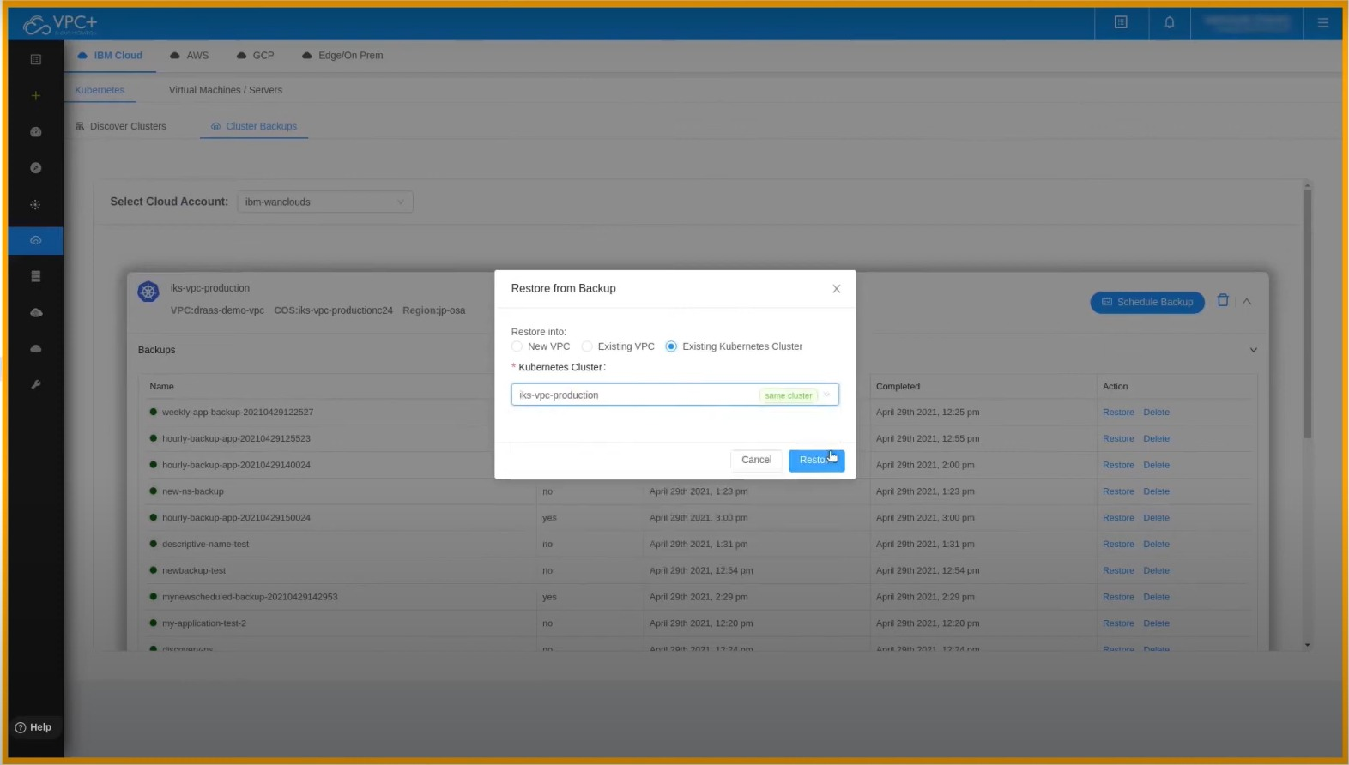

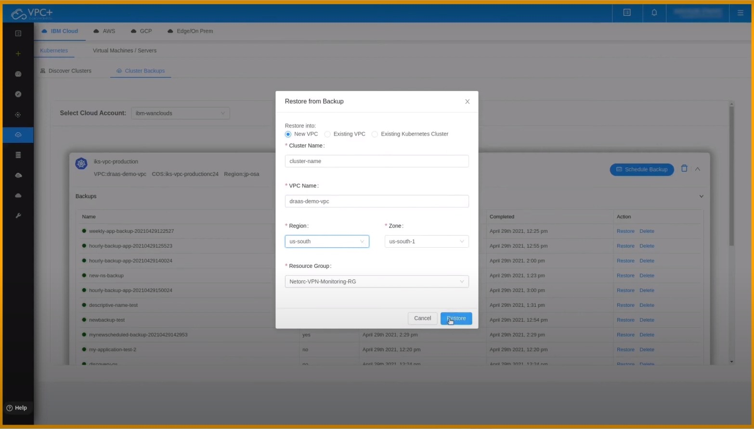

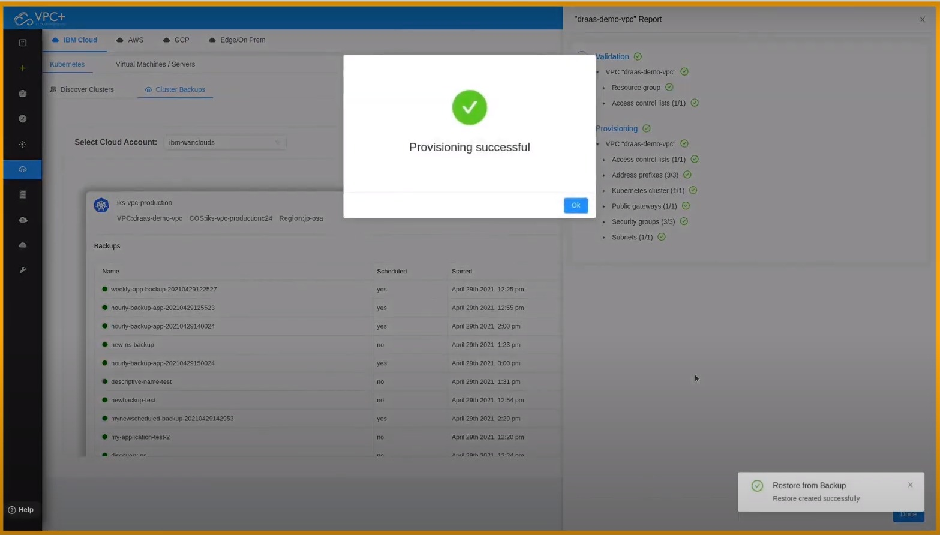

Remember that our disaster recovery model should be flexible and adaptive, as disaster scenarios can change over time. By incorporating regular data updates and model refinements into our project, we can continuously improve your disaster recovery capabilities using IBM Cloud Virtual Servers.