AttendX
Smart Classroom Attendance System

Group Members
- 25MCA018 – Niraj Kotadiya
- 25MCA006 – Savan Bhoraniya

1) Problem Statement / Introduction
Traditional classroom attendance relies on manual roll calls that consume five to ten minutes of every class, are vulnerable to proxy attendance, and produce paper records that are easy to lose or damage. Reviewing and analyzing attendance trends after the fact is slow and error-prone, and teachers lose valuable instructional time to administrative work.
AttendX is an IoT, AI, and cloud-computing platform that automatically recognizes students as they enter or sit in the classroom, marks their attendance in real time, stores every record securely in the cloud, and gives teachers and administrators live dashboards and analytics.
An ESP32-CAM module captures classroom images and streams them to an AWS-hosted face-recognition service, removing manual entry entirely.
Project Objectives
- Automated recognition: identify students using face recognition as soon as they enter the classroom.
- Zero manual entry: mark attendance without any manual intervention from the teacher.
- Secure cloud storage: store all attendance data securely in AWS (RDS and S3).
- Reporting and analytics: generate daily, weekly, monthly, and subject-wise attendance reports.
- Absence notifications: optionally alert students or parents through Amazon SNS.
- Speed: reduce attendance-taking time from minutes to a few seconds per class.

2) Proposed Solution with Concept Diagram

Proposed Solution
AttendX combines an ESP32-CAM classroom-scanning device, an AWS cloud backend, a face-recognition microservice, a cloud database, and role-based web dashboards for teachers, students, and admins.
The system works as follows:
- The teacher starts an attendance session from the dashboard.
- The ESP32-CAM captures multiple frames of the classroom over Wi-Fi.
- Images are uploaded to the backend API running on Amazon EC2.
- The face-recognition service (OpenCV and face_recognition) detects each face in the frame.
- Detected faces are matched against the registered face dataset stored in Amazon S3.
- Matched students are marked Present with a timestamp; unmatched faces are ignored or flagged Unknown.
- Attendance records are written to Amazon RDS (MySQL) and the dashboard updates live.
- Teachers, students, and admins access reports and analytics through their respective portals.

Concept Diagram
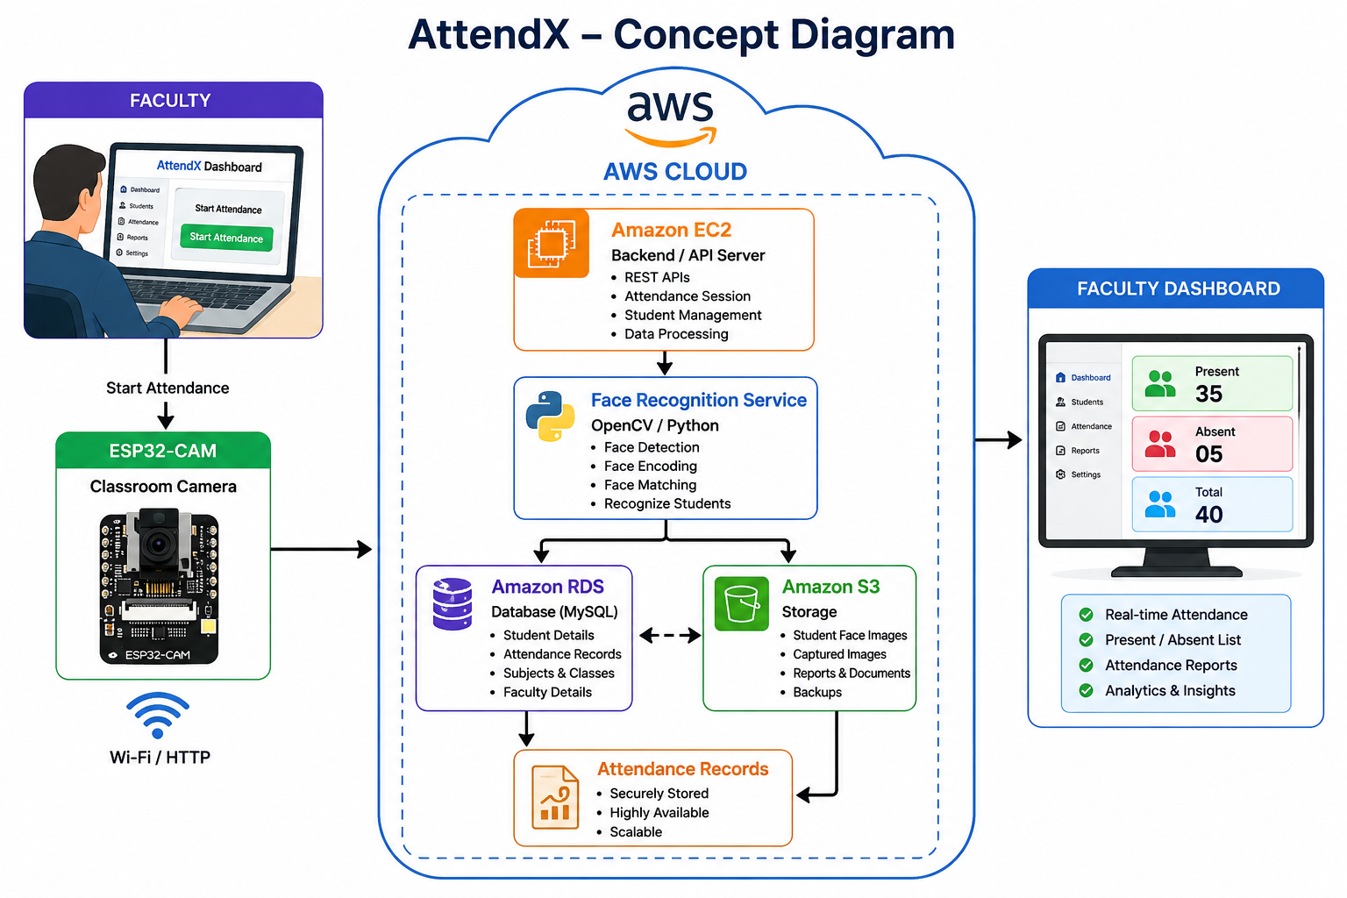

3) Scope of the Project
AttendX serves everyone involved in running a classroom or an academic department, spanning student enrollment, automated classroom scanning, attendance processing, and role-based reporting.
Student Registration
- Capture a student's name, roll number, department, semester, and section.
- Capture multiple face images for enrollment.
- Store enrollment data securely in the cloud.
Classroom Scan & Attendance Processing
- Teacher taps Start Attendance to begin a session.
- ESP32-CAM captures multiple frames and streams them to the backend.
- Each detected face is compared against registered faces.
- Matches are marked Present with a timestamp; unmatched faces are flagged Unknown.
Teacher Dashboard
- Live roll-number, name, status, and time-stamped attendance sheet for every session.
Student Portal
- View attendance percentage and full history.
- Download attendance reports.
Admin Portal
- Manage students, faculty, subjects, and timetables.
- Access historical attendance records and institution-wide analytics.
Benefits to Users
- For teachers: one dashboard for live attendance, zero paperwork, and no manual entry of scores.
- For students: instant visibility into attendance percentage and history, with downloadable reports.
- For admins: a single system to manage students, faculty, subjects, timetables, and institution-wide analytics.
- For institutions: a reusable, cloud-hosted platform that scales across classrooms, departments, and campuses.
Future Scope
- Liveness detection to prevent photo or video spoofing during recognition.
- QR code and RFID fallback as a backup marking method when recognition fails.
- Mobile app for native teacher and student access to dashboards and reports.
- Amazon Rekognition integration to offload recognition to a managed AWS AI service at scale.
- Cross-campus dashboard aggregating analytics across multiple institutions or campuses.
- Occupancy monitoring by extending the camera pipeline to track real-time classroom occupancy.

4) Tools and Technologies

a) Cloud Platform
Amazon Web Services (AWS)
AWS is the primary cloud platform because it provides scalable compute, managed databases, durable object storage, monitoring, and fine-grained access control needed to run AttendX reliably.
The proposed deployment runs the React/Node.js/Python stack on AWS, using Amazon RDS (MySQL) as the system of record, which keeps the architecture centered on core Cloud Computing concepts such as elastic compute, managed storage, and security.

b) Cloud Services
AWS Service | Role in the Deployment / Reason for Use
EC2 | Runs the backend API and the face-recognition service; the compute backbone of the platform.
RDS (MySQL) | Stores students, faculty, subjects, and attendance records as a managed relational database.
S3 | Stores the registered face-image dataset and system backups with durable object storage.
IAM | Secures access to every AWS resource with least-privilege roles instead of hard-coded credentials.
CloudWatch | Monitors EC2 instances and application logs to identify failures and performance issues.
SNS (optional) | Notifies parents or students of absences and low attendance.
Lambda (optional) | Generates scheduled daily and monthly reports without maintaining a server.

c) Third-Party APIs to Call
1. Notification / Email API (via Amazon SNS)
Used to send absence alerts and low-attendance notifications to students or parents.
Reason: Automates communication without requiring manual intervention from teachers or admins.
2. Amazon Rekognition — Optional AI API
Can be evaluated as a managed, cloud-based alternative to the locally hosted OpenCV/face_recognition service.
Reason: Demonstrates how a managed AI service can be integrated into a cloud architecture at scale.
The primary implementation uses OpenCV and face_recognition in Python, avoiding dependency on a paid external AI service.

d) Other Tools and Technologies
Hardware — ESP32-CAM
Purpose: capture classroom images and stream them to the cloud over Wi-Fi.
Reason: packages a camera and Wi-Fi on a single inexpensive board; used with an FTDI programmer for flashing and a stable power supply.
Programming Languages
Python — used for image processing, face detection, and face recognition (OpenCV, face_recognition).
Reason: Python provides mature computer vision and machine-learning libraries.
JavaScript — used across the frontend, backend, and API communication.
Backend — Node.js + Express
Used to create REST APIs, manage attendance sessions, and communicate with RDS and the face-recognition microservice.
Reason: lightweight, fast, and well suited for API-based web applications.
Frontend — React + Tailwind CSS
Used to build the teacher, student, and admin dashboards, attendance tables, and analytics views.
Reason: React supports reusable components and dynamic, real-time interfaces; Tailwind speeds up consistent styling.
Computer Vision — OpenCV + face_recognition
Used for image processing, face detection, face encoding, and face matching.
Reason: open-source libraries with extensive, well-tested image-processing and recognition functionality.
Database — MySQL
Used for structured student, faculty, subject, and attendance data (hosted on Amazon RDS).
Security & Authentication
- HTTPS for all communication between the ESP32-CAM, backend, and clients.
- JWT-based sessions and hashed passwords to protect user accounts.
- S3 bucket policies to restrict access to the face-image dataset and backups.
- IAM least-privilege roles to scope every AWS resource.
Development Tools
- Visual Studio Code
- Arduino IDE
- Git/GitHub
- Postman
- MySQL Workbench
- AWS Management Console

5) Project Timeline
The project can be completed in approximately 8 weeks.
Week | Activities
Week 1 | Requirement analysis, project objectives, AWS architecture and database design
Week 2 | ESP32-CAM hardware setup and Wi-Fi communication
Week 3 | Student registration module and face dataset collection
Week 4 | Face detection and recognition microservice (OpenCV / face_recognition)
Week 5 | Backend APIs (Node.js/Express) and Amazon RDS integration
Week 6 | AWS deployment: EC2, S3, IAM, CloudWatch, and optional SNS/Lambda
Week 7 | Teacher, student, and admin dashboards, reports and analytics
Week 8 | Security hardening, testing, debugging, documentation and final demonstration

Major Milestones
- Requirements & Architecture
- Hardware Setup (ESP32-CAM)
- Face Recognition Service
- Backend + Database
- AWS Deployment
- Dashboards & Portals
- Security & Testing
- Final Demonstration

6) Users

1. Admin
Admins manage the complete system across students, faculty, subjects, and timetables.
Responsibilities
- Register and manage students, faculty, and subjects.
- Manage timetables and classrooms.
- Register student face data during enrollment.
- View institution-wide attendance and analytics.
- Access historical attendance records and generate reports.

2. Teacher
Teachers use AttendX to run attendance sessions and monitor results live.
Responsibilities
- Login and select subject/class.
- Start an attendance session (Start Attendance).
- Monitor live recognition results as they arrive.
- View the roll-number, name, status, and time-stamped attendance sheet.
- Generate attendance reports for a session, subject, or date range.

3. Student
Students access their own attendance information through a dedicated portal.
Features
- View attendance percentage and full history.
- View subject-wise and date-wise records.
- Download attendance reports.

7) Main Functionality

1. Student Registration
Admins register:
- Roll Number
- Name
- Email
- Department
- Semester
- Section
- Multiple Face Images

2. Classroom Scan
A teacher taps Start Attendance; the ESP32-CAM captures multiple frames and streams them to the backend for recognition.

3. Attendance Processing
Each detected face is compared against registered faces; matches are marked Present with a timestamp, and unmatched faces are flagged Unknown.

4. Teacher Dashboard
Teachers see a live roll-number, name, status, and time-stamped attendance sheet for every session.

5. Student Portal
Students view their attendance percentage, full history, and can download reports.

6. Admin Portal
Admins manage students, faculty, subjects, timetables, and historical attendance records.

7. How the System Works — End to End
- The teacher starts an attendance session from the dashboard.
- The ESP32-CAM captures multiple frames of the classroom over Wi-Fi.
- Images are uploaded to the backend API running on Amazon EC2.
- The face-recognition service (OpenCV and face_recognition) detects each face in the frame.
- Detected faces are matched against the registered face dataset stored in Amazon S3.
- Matched students are marked Present with a timestamp; unmatched faces are ignored or flagged Unknown.
- Attendance records are written to Amazon RDS (MySQL) and the dashboard updates live.
- Teachers, students, and admins access reports and analytics through their respective portals.

8. Database Design
The core schema centers on four entities:
Table | Key Fields
Student | student_id, roll_no, name, email, semester, department, face_image_url
Attendance | attendance_id, student_id, subject, date, time, status
Faculty | faculty_id, name, email
Subject | subject_id, subject_name, faculty_id

9. Challenges and Solutions
Challenge | Solution
Poor lighting | Capture multiple frames and adjust exposure automatically.
Students wearing masks | Train the recognition model on masked images and weight upper facial features.
Multiple faces in frame | Detect and process each face in the frame individually.
Network interruptions | Queue images locally on the ESP32-CAM and retry uploads.
Duplicate detections | Record attendance only once per student per session.

10. Security
- Access control: IAM roles scope every AWS resource to least privilege.
- Transport security: all communication between the ESP32-CAM, backend, and clients uses HTTPS.
- Authentication: JWT-based sessions and hashed passwords protect user accounts.
- Storage security: S3 bucket policies restrict access to the face-image dataset and backups.

Conclusion
AttendX turns a slow, error-prone manual process into a fast, automated, and analyzable system by combining IoT capture, AI-based face recognition, and AWS cloud infrastructure.
Beyond saving classroom time, it gives teachers, students, and administrators transparent, real-time visibility into attendance, making it both a strong academic project and a practical, deployable platform.

