Hotel System Network Design

# Problem Statement

As a part of your end year networking project, you are required to design and implement Vic Modern Hotel network. The hotel has three floors; in the first floor there three departments (Reception, store and Logistics), in the second floor there are three departments (Finance, HR and Sales/Marketing), while the third floor hosts the IT and Admin. Therefore, the following are part of the considerations during the design and implementation;

* There should be three routers connecting each floor (all placed in the server room in IT department).
* All routers should be connected to each other using serial DCE cable.
* The network between the routers should be 10.10.10.0/30,10.10.10.4/30 and 10.10.10.8/30.
* Each floor is expected to have one switch (placed in the respective floor).
* Each floor is expected to have WIFI networks connected to laptops and phones.
* Each department is expected to have a printer.
* Each department is expected to be in different VLAN with the following details;  
  **1st Floor;**  
  - Reception- VLAN 80, Network of 192.168.8.0/24  
  - Store- VLAN 70, Network of 192.168.7.0/24  
  - Logistics- VLAN 60, Network of 192.168.6.0/24  
  **2nd Floor;**  
  - Finance- VLAN 50, Network of 192.168.5.0/24  
  - HR- VLAN 40, Network of 192.168.4.0/24  
  - Sales- VLAN 30, Network of 192.168.3.0/24  
  **3rd Floor;**  
  - Admin- VLAN 20, Network of 192.168.2.0/24  
  - IT- VLAN 10, Network of 192.168.1.0/24

* Use OSPF as the routing protocol to advertise routes.
* All devices in the network are expected to obtain IP address dynamically with their respective router configured as the DHCP server.
* All the devices in the network are expected to communicate with each other.
* Configure SSH in all the routers for remote login.
* In IT department, add PC called Test-PC to port fa0/1 and use it to test remote login.
* Configure port security to IT-dept switch to allow only Test-PC to access port fa0/1 (use sticky method to obtain mac-address with violation mode of shutdown.)

# Technologies Implemented

1. Creating a network topology using Cisco Packet Tracer.
2. Hierarchical Network Design.
3. Connecting Networking devices with Correct cabling.
4. Creating VLANs and assigning ports VLAN numbers.
5. Subnetting and IP Addressing.
6. Configuring Inter-VLAN Routing (Router on a stick).
7. Configuring DHCP Server (Router as the DHCP Server).
8. Configuring SSH for secure Remote access.
9. Configuring switchport security or Port-Security on the switches.
10. Configuring WLAN or wireless network (Cisco Access Point).
11. Host Device Configurations.
12. Test and Verifying Network Communication.

# COMPONENTS

**Router:** A router is a networking device that forwards data packets between computer networks. Routers perform the traffic directing functions on the Internet. For this project we are using **Cisco CISCO2911/K9** (revision 1.0) with 491520K/32768K bytes of memory.

**SWITCH:** A network switch (also called switching hub, bridging hub, and, by the IEEE, 1 MAC bridge) is networking hardware that connects devices on a computer network by using packet switching to receive and forward data to the destination device. Here we use 2 **Cisco WS-C2960-24TT** (RC32300) processor (revision C0) with 21039K bytes of memory.

**ACCESS POINT:** An access point (AP) is a device in a wireless local area network (WLAN) that allows wireless devices to connect to a wired network. It acts as a central hub, facilitating the connection between wireless devices, such as laptops, smartphones, or tablets, and the wired network infrastructure.

**END DEVICES**: End devices consists of pc, laptop, server, phone, tv , etc. Here we use 8 pc’s , 8 printers, 3 access points, 2 laptops, 2 smartphone

# NETWORK TOPOLOGY DIAGRAM

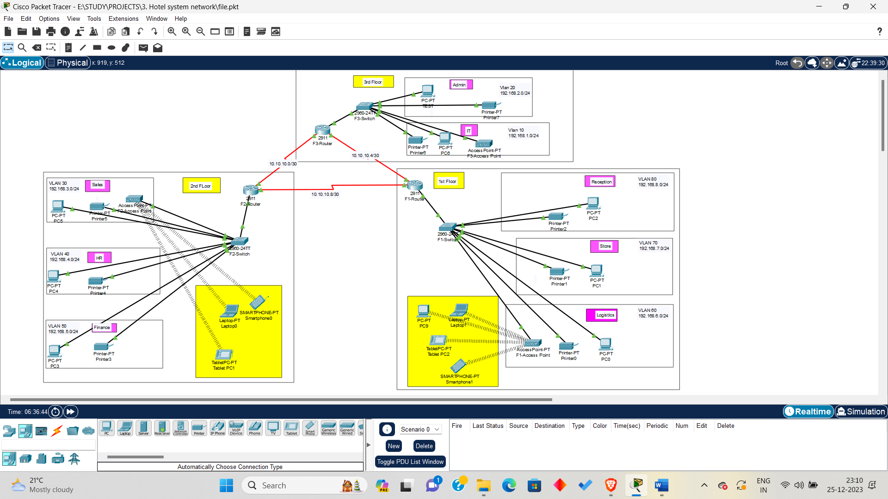

# **ROUTER CONFIGURATION**

* Since we are using Serial DCE cables so we need to set the clock rate on the router interface.
* For our project we are using 3 routers and between each pair there is a DCE (Data Circuit-terminating Equipment) and DTE (Data Terminal Equipment).
* So for each pair we must configure Clock rate for that interface in the router to establish a connection.

# F1-ROUTER

Interface se0/2/1(DCE)🡪 ip address 10.10.10.5 with a subnet mask of 255.255.255.252

Interface se0/2/0(DTE)🡪 ip address 10.10.10.9 with a subnet mask of 255.255.255.252

**DCE Configuration:**

* In router 1 global configuration mode enter “interface Se0/2/1”
* Enter “clock rate 64000”
* Enter “no shutdown”
* Enter “do wr” to save the running configuration to the startup configuration.
* By enter the above command we set the clock rate to be 64000 bits/sec and no shutdown ensures that the link is up and running.

**Creating Vlan for F1-switch:**

* In Switch-1 CLI go to global configuration mode by “config t”
* Enter “int range fa0/2-3” followed by “Switchport mode access” and “switchport mode access vlan 80”
* Similarly for vlan 70 enter “int range fa0/4-5” followed by “Switchport mode access” and “switchport mode access vlan 70”
* Similarly for vlan 60 enter “int range fa0/6-8” followed by “Switchport mode access” and “switchport mode access vlan 60”
* Finally to apply those configurations “do wr” end press enter.
* Since all Vlans will communicate with other Vlan via fa0/1 so it must a **trunk interface “int fa0/1**” , “switchport mode trunk” and “do wr”.
* **fa0/1** acts as the communication pathway between VLAN 60, VLAN 70, and VLAN 80, allowing traffic from these VLANs to be transmitted to other parts of the network. Without this trunk port, the VLANs would remain isolated from each other.

**InterVlan routing(by creating subInterfaces):**

1. **For Vlan 80(Reception)**
2. Int gig0/0.80
3. Encapsulation dot1Q 80
4. Ip address 192.168.8.1 255.255.255.0(This Ip acts as default gateway for this Vlan)
5. **For Vlan 70(Store)**

1.Int gig0/0.70

2.Encapsulation dot1Q 70

1. 3.Ip address 192.168.7.1 255.255.255.0(This Ip acts as default gateway for this Vlan)
2. **For Vlan 60(Logistics)**

1.Int gig0/0.60

2.Encapsulation dot1Q 60

1. 3.Ip address 192.168.6.1 255.255.255.0(This Ip acts as default gateway for this Vlan)

**DHCP POOL CONFIGURATION**

First we need to start the dhcp service by : *service dhcp* command

1. **Reception**

* ip dhcp pool reception
* network 192.168.8.0 255.255.255.0
* default-router 192.168.8.1
* dns-server 192.168.8.1

1. **Store**

* ip dhcp pool store
* network 192.168.7.0 255.255.255.0
* default-router 192.168.7.1
* dns-server 192.168.7.1

1. **Logistics**

* ip dhcp pool logistics
* network 192.168.6.0 255.255.255.0
* default-router 192.168.6.1
* dns-server 192.168.6.1

# F2-ROUTER

Interface se0/2/1(DCE)🡪 ip address 10.10.10.10 with a subnet mask of 255.255.255.252

Interface se0/2/0(DTE)🡪 ip address 10.10.10.1 with a subnet mask of 255.255.255.252

**DCE Configuration:**

* In router 2 global configuration mode enter “interface Se0/2/1”
* Enter “clock rate 64000”
* Enter “no shutdown”
* Enter “do wr” to save the running configuration to the startup configuration.
* By enter the above command we set the clock rate to be 64000 bits/sec and no shutdown ensures that the link is up and running.

**Creating Vlan for F2-switch:**

* In Switch-2 CLI go to global configuration mode by “config t”
* Enter “int range fa0/2-3” followed by “Switchport mode access” and “switchport mode access vlan 50”
* Similarly for vlan 40 enter “int range fa0/4-5” followed by “Switchport mode access” and “switchport mode access vlan 40”
* Similarly for vlan 30 enter “int range fa0/6-8” followed by “Switchport mode access” and “switchport mode access vlan 30”
* Finally to apply those configurations “do wr” end press enter.
* Since all Vlans will communicate with other Vlan via fa0/1 so it must a **trunk interface “int fa0/1**” , “switchport mode trunk” and “do wr”.
* **fa0/1** acts as the communication pathway between VLAN 30, VLAN 40, and VLAN 50, allowing traffic from these VLANs to be transmitted to other parts of the network. Without this trunk port, the VLANs would remain isolated from each other.

**InterVlan routing(by creating subInterfaces):**

1. **For Vlan 30(Sales)**
2. Int gig0/0.30
3. Encapsulation dot1Q 30
4. Ip address 192.168.3.1 255.255.255.0
5. **For Vlan 40(HR)**

1.Int gig0/0.40

2.Encapsulation dot1Q 40

3.Ip address 192.168.4.1 255.255.255.0

1. **For Vlan 50(Finance)**

1.Int gig0/0.50

2.Encapsulation dot1Q 50

3.Ip address 192.168.5.1 255.255.255.0

**DHCP POOL CONFIGURATION**

First we need to start the dhcp service by : *service dhcp* command

1. **Sales**

* ip dhcp pool sales
* network 192.168.3.0 255.255.255.0
* default-router 192.168.3.1
* dns-server 192.168.3.1

1. **HR**

* ip dhcp pool HR
* network 192.168.4.0 255.255.255.0
* default-router 192.168.4.1
* dns-server 192.168.4.1

1. **Finance**

* ip dhcp pool Finance
* network 192.168.5.0 255.255.255.0
* default-router 192.168.5.1
* dns-server 192.168.5.1

# F3-ROUTER

Interface se0/2/1(DTE)🡪 ip address 10.10.10.6 with a subnet mask of 255.255.255.252

Interface se0/2/0(DCE)🡪 ip address 10.10.10.2 with a subnet mask of 255.255.255.252

**DCE Configuration:**

* In router 1 global configuration mode enter “interface Se0/2/0”
* Enter “clock rate 64000”
* Enter “no shutdown”
* Enter “do wr” to save the running configuration to the startup configuration.
* By enter the above command we set the clock rate to be 64000 bits/sec and no shutdown ensures that the link is up and running.

**Creating Vlan for F3-switch:**

* In Switch-3 CLI go to global configuration mode by “config t”
* Enter “int range fa0/2-3” followed by “Switchport mode access” and “switchport mode access vlan 20”
* Similarly for vlan 10 enter “int range fa0/4-6” followed by “Switchport mode access” and “switchport mode access vlan 10”
* Finally to apply those configurations “do wr” end press enter.
* Since all Vlans will communicate with other Vlan via fa0/1 so it must a **trunk interface “int fa0/1**” , “switchport mode trunk” and “do wr”.
* **fa0/1** acts as the communication pathway between VLAN 10 and VLAN 20, allowing traffic from these VLANs to be transmitted to other parts of the network. Without this trunk port, the VLANs would remain isolated from each other.

**InterVlan routing(by creating subInterfaces):**

1. **For Vlan 10(IT)**
2. Int gig0/0.10
3. Encapsulation dot1Q 10
4. Ip address 192.168.1.1 255.255.255.0
5. **For Vlan 20(Admin)**

1.Int gig0/0.20

2.Encapsulation dot1Q 20

3.Ip address 192.168.2.1 255.255.255.0

**DHCP POOL CONFIGURATION**

First we need to start the dhcp service by : *service dhcp* command

1. **IT**

* ip dhcp pool IT
* network 192.168.1.0 255.255.255.0
* default-router 192.168.1.1
* dns-server 192.168.1.1

1. **Admin**

* ip dhcp pool admin
* network 192.168.2.0 255.255.255.0
* default-router 192.168.2.1
* dns-server 192.168.2.1

# OSPF CONFIGURATION:

OSPF stands for Open Shortest Path First. It is used to establish communication between the netwoks of router.

In router F1-Router, there are 5 networks and to be able to communicate between them we need to configure ospf routing protocol. Similarly we need to configure each router so that we can communicate with other networks in the system.

**1st Floor**

* en ,config t, router ospf 10
* network 10.10.10.4 255.255.255.252 area 0
* network 10.10.10.8 255.255.255.252 area 0
* network 192.168.6.0 255.255.255.0 area 0
* network 192.168.7.0 255.255.255.0 area 0
* network 192.168.8.0 255.255.255.0 area 0

**2nd Floor**

* en ,config t, router ospf 10
* network 10.10.10.0 255.255.255.252 area 0
* network 10.10.10.8 255.255.255.252 area 0
* network 192.168.3.0 255.255.255.0 area 0
* network 192.168.4.0 255.255.255.0 area 0
* network 192.168.5.0 255.255.255.0 area 0

**3rd Floor**

* en ,config t, router ospf 10
* network 10.10.10.0 255.255.255.252 area 0
* network 10.10.10.4 255.255.255.252 area 0
* network 192.168.2.0 255.255.255.0 area 0
* network 192.168.1.0 255.255.255.0 area 0

# CONFIGURING SSH

**1st Floor**

* hostname F1-Router // assign any hostname
* ip domain-name gtech // give any domain-name
* username tech password tech //give any username and password
* crypto key generate rsa //for encryption
* line vty 0 15
* login local
* transport input ssh
* do wr

Similarly configure routers on 2nd and 3rd floor with hostname F2-Router and F3-Router respectively.

# Port Security as per problem statement

* We select the interface which is connected to test PC.
* We set the port-security maximum as 1 by “*switchport port-security maximum 1*”
* We set the mac-address type as sticky by “switchport port-security mac-address sticky”
* If anyone violates it then shutdown the connection. This is done by “switchport port-security violation shutdown”